God’s Power for Transformed Living
Does following Jesus Christ with full devotion seem impossible to you? Do you get frustrated and feel guilty that you’re not the person you know God intends you to be? Do you feel stuck and defeated?

Here’s some liberating and life transforming news for you! Jesus died on the cross to provide us with forgiveness. He also modeled a life of perfect obedience to God the Father and gave to us a set of commands with the charge to follow Him fully and devotedly. But He didn’t say, I’m expecting great things out of you when I return – so work hard to do well. You’re on your own, so good luck! No! That’s not accurate.

Jesus promised to be with us and to empower us to live out His purposes by means of the second person of the Triune God, the Holy Spirit. Christ lives in me

Christ’s apostle, Paul, learned from Jesus’ teaching and from His experience with God the Father, what He called a secret to living the Christian life. Would you like to know what it is? You can! Because Paul fortunately, didn’t keep it a secret. He reveals it to every Christ-follower.

Paul states, … I can do everything God asks me to [How? By gritting my teeth and trying really hard? No! He says, I can do so] with the help of Christ who gives me the strength and power (Philippians 4:13, Living Bible).

Furthermore, Paul writes, My old self has been crucified with Christ. It is no longer I who live, but Christ lives in me. So I live in this earthly body by trusting in the Son of God, who loved me and gave himself for me (Galatians 2:20, NLT).

Jesus’ Gift

Just prior to Jesus’ leaving for the cross and heaven, He encouraged His disciples with this promise: … it is to your advantage that I go away. When I go away, I will send the Helper to you. … (John 16:7, NCV & NASB). Jesus is describing His gift to us of the Holy Spirit.

Who the Holy Spirit is

Jesus says this Helper, the Holy Spirit, isn’t someone who will serve us like a guide at an information booth along the road to heaven; He is the Spirit, a divine person sent to us from Christ to come and live in you and me and to give us a power we don’t have on our own to live a transformed life.

It’s important to grasp that the Holy Spirit is not an impersonal force, but He is ever as much a person as is God the Son and God the Father.

He also possesses all the qualities and attributes of the Son and the Father.

Here’s an adapted illustration, originally provided by Bill Bright:
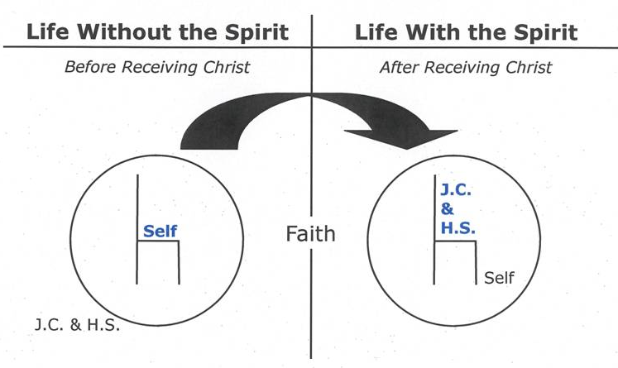

The Holy Spirit’s Roles

The Holy Spirit is a major part of your whole Christian life.
- The Holy Spirit is the one who convinced you of your sin and the need of the Forgiver Jesus Christ.
- He is also the one who granted you faith to see and to trust in Jesus and to bring you new spiritual and eternal life within you.
- He’s the one who brings you an inner assurance that you belong to God.
- He shines the light onto Bible truths so you can grasp them, and see how to apply them into your life.
- He is the one who gives you courage and effectiveness to share the Good News with other people you know.
- And – as we are emphasizing in this article, The Holy Spirit is the one who is available to empower you to life a transformed life.

First need a relationship with Jesus

You may be thinking, I need God’s Holy Spirit in my life! Great, if you don’t yet know Jesus Christ personally, place your trust in Him and you will not only be forgiven and become a part of His special people, but also the Spirit will come into your life.

Mere Resident, or President too?

If you are already a believer in Jesus, then the Scripture clearly teaches that the Holy Spirit is already in your life (Romans 8:9). However, if you are a believer it is possible that the Holy Spirit, while being a resident within your life He may not be your President! That is, He resides within you, but you may not have been yielding your life to His direction and empowerment.

When we trust in Jesus, God’s Holy Spirit takes up residence in our life and begins to direct our lives. That’s what God intends to be true throughout our Christian lives as we progress in following Jesus and mature in faith & character.

Danger – Yet Great Potential

However, if we are not careful, and we willfully choose to live our lives according to our sinful desires – we will squelch and resist God’s Holy Spirit from leading and empowering us (1 Thessalonians 5:19 & Ephesians 4:30).

Here’s what the apostle Paul has to say about the danger we need to avoid and the power we can appropriate as we continually exercise faith, The sinful nature [within us] wants to do evil, which is just the opposite of what the Spirit wants. [The Holy Spirit seeks to direct us and empower us to do what pleases Him] And the Spirit gives us desires that are the opposite of what the sinful nature desires. These two forces are constantly fighting each other, [thus if you choose to take control of your life and do what your self-centered and sinful desires want, then] you are not free to carry out your good intentions (Galatians 5:17, NLT).

Some of the ugly indicators of a self-directed life are that we will “bit and devour each other”. Thus we need to “watch out or you will be destroyed by each other” (Galatians 5:15). Just think of how many marriages, families, and churches, even among believers, are ruined by such natural, sinful tendencies!

Yet, positively Paul says, if we “walk by the Spirit [we] will not gratify the desires of what [our] sinful nature craves” (Galatians 5:160. Furthermore, when we choose by faith to be Spirit-directed moment by moment – our daily lives bring honor to God and build healthy relationships with others. Paul expresses it this way, But the Holy Spirit produces his kind of fruit in our lives: love, joy, peace, patience, kindness, goodness, faithfulness, gentleness, and self-control … (Galatians 5:22-23, NLT).

Three Kinds of Lifestyles
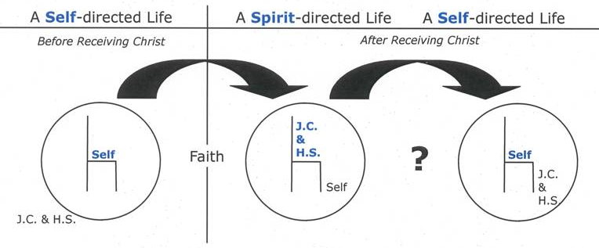
In 1 Corinthians 3, Paul informs us that there are three kinds of lifestyles.

#1. A self-directed life of those without Christ

#2. A Spirit-directed life of Christ-followers

#3. A self-directed life of professing Christians

Dear brothers and sisters, [they are professing believers] when I was with you I couldn’t talk to you as I would to spiritual people [believers who are living Spirit-directed lives, though not perfect]. I had to talk as though you belonged to this world or as though you were infants in the Christian life. … you are still controlled by your sinful nature. … Aren’t you living like people of the world? (1 Corinthians 3:1-3, NLT)

There is clear biblical reason to be concerned that some who profess to be Christians, yet consistently live a self-directed life marked by willful and unrepentant sin, are likely not genuine believers at all. Yet Paul does indicate that there are some Christians who are not living by the empowerment of God’s Spirit.

The Turning Point

If you haven’t yet trusted Jesus as your Forgiver and received Him into your life – do so now and have Him & His Spirit to lead your life with His enabling power.

If you ARE one who has genuinely trusted Jesus as your Forgiver, yet over time you have resorted to living a self-directed life, what are you to do?

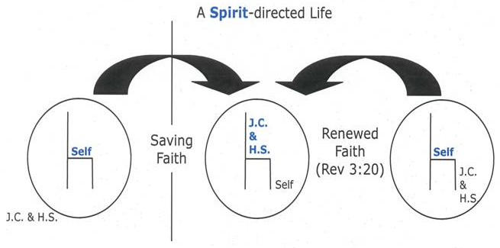

You’ve got 3 important questions to ask yourself and a response:

#1. Are you willing to confess your selfish sins to God?

… do not bring sorrow to God’s Holy Spirit by the way you live. … (Ephesians 4:30, NLT)

If you genuinely ask Him for forgiveness, read what God promises to us:

… if we confess our sins to him, he is faithful and just to forgive us our sins and to cleanse us from all wickedness (1 John 1:9, NLT).

#2. Are you willing to surrender control of your life to God? (Romans 12:1-2)

#3. Do I sincerely desire to be directed & empowered by the Holy Spirit?

I pray that from [God’s] glorious, unlimited resources he will empower you with inner strength through his Spirit (Ephesians 3:16, NLT). [See also John 7:37-39]

If these things are true for you, what do you do next?

♥. By faith appropriate the Spirit’s resuming His leadership & empowerment of your life.

There is a basis for having confidence God’s Spirit will do this in your life. It’s based on God’s COMMAND & God’s PROMISE.

God’s Command - … be filled with the Spirit (Ephesians 5:18, ESV). To be filled with the Spirit means to be directed and empowered by the Spirit.

God’s Promise

This is the confidence we have in approaching God: that if we ask anything according to his will, he hears us. [Is it God’s will for us to be empowered by God’s Spirit? Sure is, He commanded that this be so in our lives!] And if we know that he hears us—whatever we ask—we know that we have what we asked of him (1 John 5:14-15, NIV).

Faith expressed through prayer

We are empowered by the Holy Spirit by faith alone. Genuine prayer is one way of expressing our faith. The following is a suggested prayer:

Dear Heavenly Father, I need You. I acknowledge that I have sinned against You by directing my life my way and not yours. I thank You that You have forgiven all my sins through Christ’s death on the cross for me.

I now freshly re-invite Jesus Christ to take His rightful place on the throne of my life once again. Empower me with your Holy Spirit as You commanded me to be, and as You promised in Your Word that You would do if I asked in faith.

I pray this in the name of Jesus.

I now thank You for resuming the directorship of my life and for empowering me to live as you intend.

Does this prayer express the desire of your heart? If so, you can pray right now and trust God to direct and empower you with His Holy Spirit.

How to know that the Holy Spirit is now directing & empowering you?
- Were you sincere in your prayer of confession?
- Based on God’s promise to forgive & cleanse – has He done this for you?
- Were you sincere in your prayer for Jesus to take His place on the throne of your life once again – and for the Holy Spirit to renew His empowerment of your life?
- On what authority can you have this confidence? You may confidently place your faith in God’s trustworthiness of God to keep His promises.

Do Not Depend on Feelings

The promise of God’s Word, the Bible—not our feelings—is our authority. The Christian lives by faith (trust) in the trustworthiness of God Himself and His Word.

Flying in an airplane can illustrate the relationship among fact, faith, & feeling.
- Fact – God & His Word
- Faith – our trust in God & His Word
- Feeling – the result of our faith & obedience (John 14:21).

To be transported by an airplane, we must place our faith in the trustworthiness of the aircraft and the pilot who flies it. Our feelings of confidence or fear do not affect the ability of the airplane to transport us, though they do affect how much we enjoy the trip. In the same way, we as Christians do not depend on feelings or emotions, but we place our faith (trust) in the trustworthiness of God and the promises of His Word.

“Spiritual Breathing”

Now that you and I have Holy Spirit directing and empowering our lives – how do we keep from digressing back into an ongoing self-directed life? We practice “Spiritual Breathing”.

Spiritual breathing is a powerful word picture that can help us to experience an ongoing dependence upon the Spirit.

It illustrates that we remove the impure and re-appropriate the pure.

Exhale

Exhale: When we exhale, we confess our sin to God as soon as we engage in it and are convicted of it. We affirm that we have usurped the Lord’s place as the director of our lives. We claim a fresh relational forgiveness with God according to 1 John 1:9 (Hebrews 10:1-25).

Inhale

Inhale: We once again surrender the control of our lives to Christ, and rely upon His Holy Spirit to direct and empower us. We ask God with confidence based upon His command (Ephesians 5:18) and His promise (1 John 5:14-15).

Often as needed

We do this as often as we need to. Sometimes it may be once a month or three times a day. It is a means by which we can continual to progress in maturity as the Spirit empowers us – until the day when we are fully perfected when we are united with Christ in heaven.

Now That the Holy Spirit is now Directing & Empowering You

Thank God that the Spirit will enable you:
- To glorify Christ with your life (John 16:14).
- To grow in your understanding of God and His Word (1 Corinthians 2:14, 15).
- To live a life that pleases God, and blesses others (Galatians 5:16–23).

© Copyright 2007 Bright Media Foundation and Campus Crusade for Christ, Inc. Formerly Copyright 2001-2007 Campus Crusade for Christ, Inc. Adapted from Have You Made the Wonderful Discovery of the Spirit-filled Life? written by Bill Bright, © 1966. Published by Campus Crusade for Christ, 375 Hwy 74 South, Suite A, Peachtree City, GA 30269. www.campuscrusade.org
http://powertochange.com/experience/spiritual-growth/spiritfilledlife/ Power to Change is the name of the Cru ministry in Canada.
Further adapted by Paul B. Phair, 6-2014

