MEMBERSHIP APPLICATION
Having trusted in Christ as my personal Savior and Lord, affirming Oakwood’s Statement of Faith, and desiring to be more effective in my service to Jesus and growth in His grace, I hereby apply to be a member of Oakwood Community Church.

Name _________________________________________________________ Phone _________________________
Address ______________________________________________________________________________________
City/State _______________________________________________________________ Zip __________________
Email address __________________________________________________________________________________
Occupation ______________________________________ Date of Birth (optional) ________________________
Employer _______________________________________ Work Phone (optional) ________________________
Marital Status: Previously Married?
□ Married – date married ______________ □ Yes
□ Not married □ Divorced – date divorced _______________
□ Widowed – date widowed ______________
□ No
Family members living with you (name, relationship & date of birth)
______________________________ ______________________________ ______________________________
______________________________ ______________________________ ______________________________
______________________________ ______________________________ ______________________________
______________________________ ______________________________ ______________________________
______________________________ ______________________________ ______________________________
Briefly describe when & how you put your faith in Jesus Christ as your Lord and Savior:
____________________________________________________________________________________________________________________________________________________________________________________________________________________________________________________________________________________________________________________________________________________________________________________________________________________________________________________________________________________________________________________
Why do you think God should let you into heaven? _______________________________________________________
____________________________________________________________________________________________________________________________________________________________________________________________________________________________________________________________________________________________________________
Have you been baptized? _________ When & Where? _______________________________________________
If not, do you wish to be and why or why not? _______________________________________________
______________________________________________________________________________________________
Are you presently a member of another Church? _________ How long? _______________________________
If so, what Church? Name __________________________________________________________________________
Address ________________________________________________________________________
_______________________________________________________________________________
Phone _________________________________________________________________________
List the most recent church in which you held membership or attended regularly (if applicable).
Name __________________________________________________________ City _______________________________
Member? _________ # of years _________
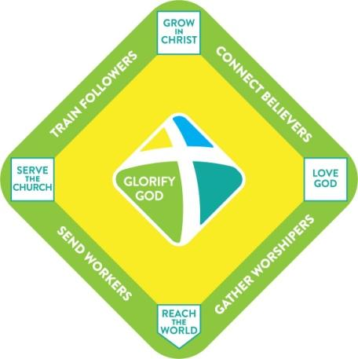
Oakwood Membership Commitment

I commit to cooperate with God’s work within me to be increasingly transformed from an ordinary person into a fully devoted follower of Jesus Christ. As a member of Oakwood, I gladly choose to engage in Oakwood’s discipleship pathway – Love-Grow-Serve-Reach – with the sincere desire to glorify God in my life, service and outreach.

Love God [First Base]
- WORSHIP –
- I will strive to increasingly love God with all that I am (Mark 12:29-30 & Romans 12:1-2). As one important means of loving God, I will give priority to corporately worshipping Him with my mind and heart (Psalms 95:1-7; John 4:24).
- I will strive to spend time regularly reading the Bible and in personal prayer (2 Timothy 2:15; 3:16-17; Colossians 4:2; Psalm 119:11; 1 Peter 4:7; 1 Thessalonians 5:17).

Grow in Christ [Second Base]
- PARTICIPATE IN A COMMUNITY GROUP – I will connect into the life of an Oakwood Community Group (or similar Oakwood gathering) to help build authentic community and to keep moving toward maturity in Christ (Hebrews 10:24-25; John 13:34-35; Col. 1:27-28).
- PURSUE HOLINESS – I will strive to live daily in such a way that my life is pleasing to God through the enabling power of His indwelling Holy Spirit (1 Corinthians 6:10, 20; Romans 6:11-13; Acts 5:41, 42; Colossians 3:1-17; Romans 8:1-15; Eph. 5:1-5,18-21).

Serve the Church [Third Base]
- INVEST IN OAKWOOD –
  - I will use the time and talents God has given me to serve others in our church family and to build up our church body (1 Peter 4:10-11; 1 Corinthians 12:7-11; Rom. 12:3-8) and
  - I will give generously and cheerfully to God through our church (Malachi 3:8-10 & 2 Corinthians 9:7).
- PROTECT OAKWOOD – I will strive to live in harmony and unity with others in our church by seeking to be positive in actions and speech (Ephesians 4:1-6, 25-32; James 1:19-20) and quick to resolve any conflicts that arise with a commitment to Biblical reconciliation (Matthew 18:15-17; Matt. 5:23-24; 1 Cor. 6:1-8).

Reach the World [Home Plate]
- WITNESS IN WORD – I will share the life-changing message of the Gospel of Jesus Christ with those in my home, workplace, community, and world (Matthew 28:18-20; Acts 1:8; 2 Corinthians 5:18-20).
- WITNESS IN DEED – I will adorn the Gospel with loving acts of service and sacrifice (Titus 2:10-14; Matt. 5:13-16; Gal. 6:9-10; Matt. 22:39-40; Luke 10:36-37).

I have read Oakwood’s statement of faith and I am in full agreement with it both in word and spirit. □ Yes □ No
I have also read Oakwood’s constitution, by-laws, and policies. I commit myself to abide by them fully. □ Yes □ No
I agree to allow Oakwood to use my image for promotional purposes (website, social media, brochures). □ Yes □ No
I would like to become a member, but I have the following reservations or uncertainties regarding the commitments related to Love, Grow, Serve and Reach, the statement of faith, and/or by-laws (list any in space below or on separate sheet): □ None

_______________________________________________
Signature of applicant & date

Mail or deliver to the Church office: 11209 Casey Rd., Tampa FL 33618
You may also email to office@oakwoodfl.org

