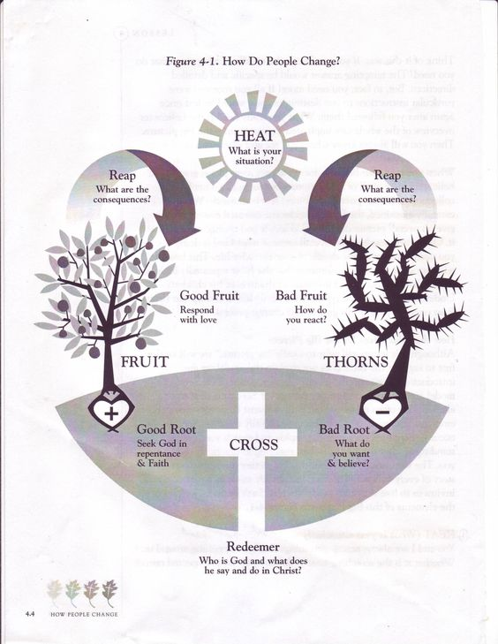

**Cross:** Who is God and what does he say and do in Christ?

**Fruit:** How is God calling me to seek him in repentance, faith and commitment?

**Heat:** What is your situation?

**Thorns:** How do you react? What do you want and believe?

**Obey God**

with sincere desire and ***commitment*** to make progress

“***Heal me, O Lord, and I shall be healed***; save me, and I shall be saved, for you are my praise.”

Jeremiah 17:14

“***Blessed is the man who trusts in the Lord***, whose trust is the Lord. ***He is like a tree planted by water***, that sends out its roots by the stream, and does not fear when heat comes, for its leaves remain green, and is not anxious in the year of drought, ***for it does not cease to bear fruit***.”

Jeremiah 17:7-8

“***Cursed is the man who trusts in man*** and makes flesh his strength, whose heart turns away from the Lord. He is like a shrub in the desert, and shall not see any good come. ***He shall dwell in the parched places*** of the wilderness, in an uninhabited salt land… The heart is deceitful above all things, and desperately sick; who can understand it? ‘I the Lord search the heart and test the mind, ***to give every man according to his ways***, ***according to the fruit of his deeds***.’”

Jeremiah17:5-6, 9-10

“O Lord, the hope of Israel,  
    all who forsake you shall be put to shame; those who turn away from you shall be written in the earth, for they have forsaken ***the Lord, the fountain of living water***.” Jeremiah 17:13

Adapted from ***How People Change*** by Timothy Lane and Paul Tripp

**Turn to God**

in humility, confession & ***repentance***

**Believe the Gospel**

***Trust*** fully in Christ for forgiveness and life

**Good Root**

Trust, love, worship and serve God

**Good Fruit**

Respond with love

**Bad Root**

What do you want and believe?

**Bad Fruit**

How do you react?