Reach the World
Acts 1:1-8

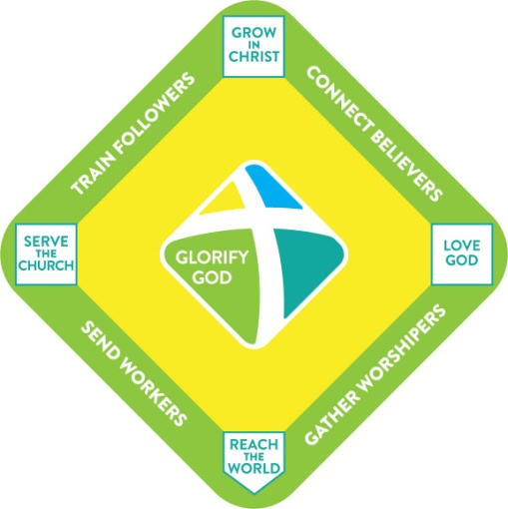
Today we wrap up our short series Discover Oakwood. This has been a five part introduction to what our church is all about - using our baseball diamond visual.

Our mission is to transform ordinary people into fully devoted followers of Christ. [include w/ baseball image]

The first step is to get in the game! Jesus doesn’t want fans, he wants committed followers. Once we get in the game our goal is to get on base and come across home plate as many times as we can. First base involves gathering for worship because we love the Lord with all of our hearts. Second base is about getting connected into the church community so we can encourage and challenge each other to grow in Christ. Then we train and equip believers to serve the church - which is third base. Finally, we seek to send out workers to reach the world with the Gospel, both here in Tampa and all over the world.

That is our focus today - the outcome we work toward: going out into a dark and dying world to reach people with the good news of Jesus Christ. Let’s walk through our passage in Acts chapter 1 and we’ll see three commitments for a life on mission.

For us as a church and for us as believers, this passage calls us to watch, to wait and to witness. The first commitment is to watch.

Commitment #1 - Watch
“He said to them, ‘It is not for you to know the times or seasons that the Father has set by his own authority.” Acts 1:7
- Watch out for Distractions

Nearly every generation in history has predicted the end of the world. Speculation about Armageddon and the rapture and the antichrist is nothing new. And even 2,000 years ago the disciples wondered - since Jesus had risen from the dead… “Are you at this time going to restore the kingdom to Israel?” (v. 6).

The disciples were not very quick to catch on. James and John wanted the best seats in the kingdom of heaven. In just a few years James would be beheaded and later John would be exiled. After the resurrection this question seems to be from the whole group. They had matured some so they didn’t ask about their individual status or rewards - they asked about “Israel.” Wink, wink.

And Jesus answered, “It’s not for you to know…” Oh, how we love to speculate about the future.
- Where will we be in 5 years? 10 years?
- Young people love to dream about who they might marry, where they might live, what they might do.
- Even us older people can live in the future rather than the present - when will Oakwood break 250, 300, 350 in attendance? When will my company reach the next level? When will my kids reach that next stage - moving out, finishing school, landing that first “real job,” getting married, having babies…
- It’s a very real danger to be distracted by a million possible futures.

Hear this - all of us, myself included: “It is not for you to know.” There are lots of things - especially things in the future that it is not for us to know. God the Father has fixed things - he has established a set plan for the future. It is not for us to know the details of those plans but to trust in the One who made the plans.

We need to watch out for DISTRACTIONS - secondary matters that can keep us from the mission in front of us. The one Jesus addressed, about restoring the kingdom to Israel, is still a common distraction today. How many of us have seen charts like this?

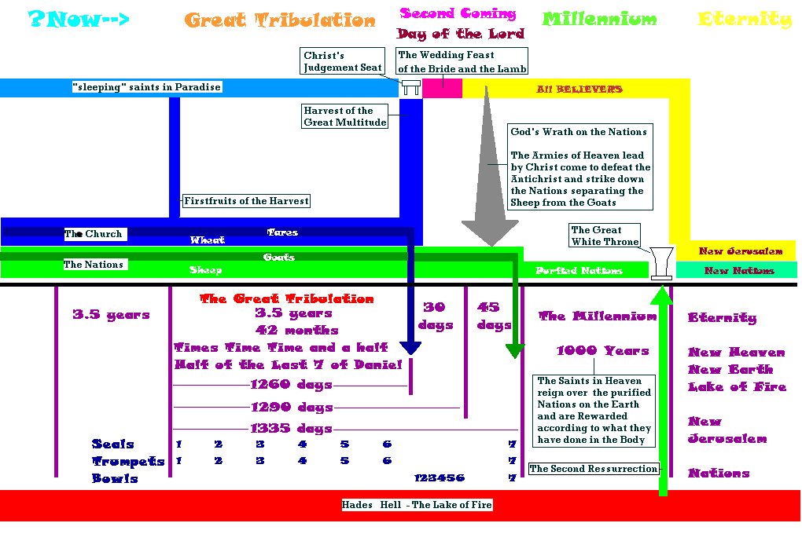
You can’t see the words, nor should you want to. The point is that some people get obsessed with analyzing Biblical prophecy to the point that it’s the only part of the Bible they want to talk about. I confess that I have some charts of my own, but my goal in studying prophecy is to focus on what is clear and leave aside the parts that are hazy. And honest Bible scholars will admit that a lot of end times prophecies are hazy.

So watch out for distractions. Not just about the end times, but about anything else that distracts from the mission. And these come in myriad forms.
- We can focus on anything in the future - not just the antichrist, false prophet and the dragon - some personal or vocational goal… We might consider a missions trip of some kind AFTER we have kids… AFTER the kids grow up… AFTER we both retire… AFTER we have “enough” in savings…
- We can focus on anything in the past - dwelling on past hurts or regrets, “if onlys” and “might’ve beens.”
- Or we can focus on anything in the present other than MAKING DISCIPLES - work, family, hobbies, activities, vacations - even church activities, for their own sake can be a distraction.

Brothers and sisters, “Let’s cast aside EVERYTHING that hinders us.” Obviously we should shake loose from the sin that so easily entangles us. But lots of other distractions can slow us down in this race with Jesus.

Watch out for things that distract from our central mission - to make disciples of all nations. Here at Oakwood we use the language of personal transformation. As you look at your days and weeks and months, how are you investing in the spiritual transformation of other people? Can you look ahead of you to see leaders who are setting the pace for you? Can you look beside you to see believers who are running the race with you? Can you look behind you to see new believers who have gotten into the game? Can you see hurting believers you have encouraged? Distracted believers you’ve helped stir up to love and good deeds?

Watch out for distractions. Also watch out for deception.

Commitment #1 - Watch
“Jesus answered them, “See that no one leads you astray. For many will come in my name, saying, ‘I am the Christ,’ and they will lead many astray.” Matthew 24:4-5
- Watch out for Deception

Frequently in the New Testament believers are warned to watch out for false teachers and false teachings. Wolves will creep in among the sheep and seek to lead believers astray. We should expect this trend to increase as the end of days approaches.

The command to keep watch is military language for sentries - calling us to stay awake through the long watches of the night, ready to sound the alarm. Without getting distracted as the Theology Police, we need to watch out for deception and remain grounded in the truth of God’s Word.

Above all, we need to watch out for the soon return of Jesus Christ our King.

Commitment #1 - Watch
“This Jesus, who was taken up from you into heaven, will come in the same way as you saw him go into heaven.” Acts 1:11
- Watch for the King’s Return

There is a lot we don’t know about how the end of the world will shake out. But this one thing we know for absolute certain - this one thing we can count on without doubt or question. Jesus IS coming back SOON! And when he comes back he will split the sky with a shout of command and the whole world will see him, riding on a white horse as a conquering warrior, leading the hosts of heaven.

As Jesus ascended into the clouds in glory, attended by angels, he will return in great power and glory. Keep watch, brothers and sisters. Our king is coming back soon.
- Woe to the one who knows his king is coming but does not attend to the business his master gave him.
- Woe to the one who instead of caring for the king’s people mistreated them.
- Woe to the one who instead of using the talents entrusted to him buried them out of fear.

Oh, may our King find us WORTHY when he returns! May we be a holy and pure bride worthy of our glorious bridegroom!
- May our King find us WORKING when he returns. May we not be sleeping and slacking off. May we be diligently laboring to make disciples of all nations.
- May our King find us WATCHING when he returns. May we not be distracted and enamored by the things of this world but may we be joyfully worshiping and prayerfully crying out for our Lord and Savior to come back for us!

If we are to be believers on mission and a missional church, our first commitment must be to watch. Second, we need to WAIT.

Commitment #2 - Wait
And while staying with them he ordered them not to depart from Jerusalem, but to wait for the promise of the Father… “You will be baptized with the Holy Spirit not many days from now." Acts‬ ‭1:4-5‬ ‭

There are two definitions to keep in mind with the Holy Spirit - baptism and filling. The new believer in Jesus is baptized, or immersed in, the Holy Spirit at the moment of saving faith. This is a one time, irreversible, life and eternity changing event. In the same moment that your sins are forgiven and you are justified or declared righteous before God the Holy Spirit replaces your old heart of stone with a new heart where He comes to live forever.

Holy Spirit Definitions
- Baptism - one time event, unconditional, unchangeable
- Filling - constant pursuit, conditioned on relationship, changeable

The baptism of the Spirit is a one time event in response to our cry of faith in Jesus. It is an unconditional gift from God, entirely by grace received entirely by faith. You don’t earn this or work up to it. And it is a permanent reality, unchangeable. Once you’ve been baptized in the Holy Spirit you cannot be unbaptized. When the Holy Spirit moves in, He never moves out - praise the Lord!

Filling is different. It is not a one time event or a periodic experience - it is a daily or even a constant pursuit. We are not commanded to be baptized in the Spirit - that is something that happens to you. But we are commanded to “be filled with the Holy Spirit” (Eph. 5:18). So we must actively invite and seek the fullness of the Spirit by developing our relationship with Jesus Christ through prayer, Bible study, obedience, fellowship, ministry, mission - by running the bases and bringing others along with us to also love God, grow in Christ, serve the church and reach the world.

Here in Acts one the disciples were commanded to wait for the BAPTISM of the Holy Spirit that would take place in Acts two. Look at verse 8.

Commitment #2 - Wait
“But you will receive power when the Holy Spirit has come upon you, and you will be my witnesses in Jerusalem and in all Judea and Samaria, and to the end of the earth.” Acts‬ ‭1:8‬

Jesus told his disciples that apart from Him they could do nothing (John 15:8). But He promised that once he left they would do even more powerful and amazing things than he had done because he would give them his Holy Spirit to guide, empower and help them. Here is the fulfillment of those promises - and a few days later these words were fulfilled when the Spirit was poured out in power.

Now let’s be careful here. The disciples were instructed to wait because the Holy Spirit had not yet been poured out - they had not yet been BAPTIZED in the Spirit. All of us here who have trusted in Jesus to save us and committed our lives to following Him have been baptized in the Spirit. So there may still be times when God calls us to WAIT to seek His direction and fuel up with His power.

But other times we need to obey the command to WALK with the Spirit - to keep in step with Him. Listen to Galatians 5.

Commitment #2 - Wait… or Walk!
“But I say, walk by the Spirit, and you will not gratify the desires of the flesh… If we live by the Spirit, let us also keep in step with the Spirit.” Galatians‬ ‭5:16‬, 25
- Is this a time to Wait or a time to Walk?

So here is the point of discernment for us as believers: is this a time to WAIT or a time to WALK? There will certainly be times in our life when God calls us to wait. Jesus spent 40 days in the wilderness before starting his public ministry. Before choosing his 12 apostles he spent the night in prayer on a mountain. Before going to the cross he again withdrew to a mountain to pray. And the gospels show us that he had a regular pattern of getting away for special times seeking fellowship, strength and direction from the Father.

We all need such times with the Lord - times to simply WAIT and be with Him. Phil Vischer tells the story of VeggieTales in his book - Me, Myself and Bob. In the rush to build a business, Phil says he lost sight of his connection with God. Even though the Big Idea behind the whole thing was to impact the world for Jesus, as VeggieTales got successful, Phil became more and more dependent on his business and marketing advisers and less and less dependent on God.

It’s a complicated story, but in the end, Phil lost Veggie Tales. In a funny twist, Barney the Dinosaur ended up buying Bob the Tomato. And as Phil looked back on the death of his Big Idea for Jesus he realized that he had made it all about him. The company became a Phil Vischer thing instead of a God thing - and so God had to take it away from him. Instead of learning to WAIT on the Lord, to trust in the Lord and follow God’s leading, Phil and his team ran ahead, over-extended themselves and ended up losing it all.

Phil’s new company is called JellyFish Labs - and is based on the whole idea of resting in the Lord - like a Jellyfish. Trusting God to direct your life and your ministry. And if you’ve followed Phil through What’s in the Bible and into his new Bible show (which is available through Right Now Media btw) you’ve seen how waiting on the Lord does not mean you stop working. It just means you work differently - with a sure confidence that what you’re doing is for God and about Him not for you and about you.

Sometimes, like Phil Vischer, we need to wait on the Lord. But other times we need to get moving. Sometimes we wait, and wait and wait… and we get stuck second guessing everything, over analyzing everything to the point that we don’t do anything - we don’t take any risks, we don’t ever step out in faith. We become slaves to our own caution and fear, rather than fueling up through a time out with the Lord and then moving forward with boldness and confidence in Him.

In my experience in the church, from my days in youth group as a teenager until now, 30 years later, I feel we have created a culture of CAUTION that exalts safety and resists risk. We need to reclaim the New Testament spirit of boldness in place of the spirit of timidity we have embraced. To a great extent we have waited far too long and it is time to walk forward in the power of the Holy Spirit with the glorious truth of the Gospel to build the church of Jesus Christ against which the gates of hell cannot prevail!

Ulysses Grant became Abraham Lincoln’s bulldog in the battle to preserve the Union during the Civil War. Grant had more than his share of weaknesses but one thing he knew was how to fight and win a battle. After opening up the Mississippi River through the siege of Vicksburg, Grant was transferred east to take over operation of the Army of the Potomac. What he found there as the seventh general to lead that army was a culture of caution, hesitation and second-guessing.

Facing Robert E. Lee in the wilderness of Virginia, Grant ordered an attack at first light. As the sun rose and he did not hear cannons, Grant inquired why the men were not moving and word came back that they weren’t quite ready. Two hours later he pressed again for action and concerns came back about the strength of the enemy’s defenses. Finally, at noon - fully six hours after the order to attack had been given, a slight probing attack was ordered that was, of course, easily repulsed by the Confederates. And only at 2 pm did a full scale attack ensue, by which time reinforcements had come in and the attack was doomed from the outset.

An adviser to Grant summed it up this way:

“This organic weakness was entirely due to not having had in its youth skillfully aggressive leadership. Its early commanders had dissipated war’s best elixir by training it into a life of caution, and the evil of that schooling was unmistakable.” (from Jean Edward Smith, p. 322)

I fear we have done this very thing in the church today. We have trained into ourselves and our young people a life of caution.
- We have sown fear and are reaping timidity.
- We have sown doubt and are reaping lethargy.
- We have sown half-hearted obedience to the great commission and are reaping the worldliness of our children.

Is it a time for you to WAIT or a time to WALK? As a church, I believe it is a time to walk. Fall Festival is just a few weeks away. Should you pray for your neighbors and friends to invite? Of course! But don’t wait more than twenty days to walk over and speak with them or this opportunity will pass.

Regarding missions we are in a season of waiting on the Lord, seeking His will for one or two places we can engage with the gospel and partner with local believers to reach the lost, multiply disciples and churches. Starting in 2019 it will be a time for us to walk forward boldly with the gospel to a world in desperate need.

Commitment #2 - Wait… or Walk!
“But you will receive power when the Holy Spirit has come upon you and you will be my witnesses in Jerusalem and in all Judea and Samaria, and to the ends of the earth.” Acts 1:8
- Is this a time to Wait or a time to Walk?

The first commitment for a missional believer and a missional church is to watch out for distractions. The second is to wait on the Lord and then walk forward in the power of the Holy Spirit. Brothers and sisters, as those who belong to Jesus we HAVE BEEN BAPTIZED with the Holy Spirit. God Himself lives in our hearts and His overflowing power goes with us. This promise applies to us whenever we step out to share the good news. “You WILL receive power.”

God doesn’t promise that His power will flow through us for just whatever we feel like doing. But when we commit ourselves to be Great Commission believers in a Great Commission church, the power of the Holy Spirit will be unleashed in and through us. When we align ourselves with God’s will that the Gospel be proclaimed to the ends of the earth, His power will work through us. Much of the reason that we don’t see God moving in power today is because we are not fully devoted to the mission Jesus has given us. We have settled into a comfortably corrupted version of Christianity that asks almost nothing from us - that allows us to share the gospel once or twice a year, if the opportunity arises.

Brothers and sisters, the will of God could not be more clear. Our single task during our very short time on earth is to make disciples of all nations. This is the singular mission of our church and is the only reason we are here. If we are not making disciples then we are not obeying the Lord. If we are not reaching people with the gospel and training them to follow Jesus and sending them back out on mission, then we are DISOBEYING our commander in chief who has ordered us forward.

Commitment #3 - Witness
“But you will receive power when the Holy Spirit has come upon you and you will be my witnesses in Jerusalem and in all Judea and Samaria, and to the ends of the earth.” Acts 1:8
- A promise and a command.

Notice there are two sides to this commission. First, it is a promise. We WILL receive power from the Holy Spirit. And we WILL be witnesses for Jesus. This mission we are on WILL succeed. Nothing can stop the advance of the church. Nothing can stand against the power of the Gospel. The darkness has no power against the light. The only way darkness can prevail is if the light-bearers all huddle together instead of moving forward into the night. “Hide it under a bushel, no! I’m gonna let it shine!”

Jesus promised to be with us every step of the way. He guarantees that people will respond from every tongue and tribe and nation - so missions will end up succeeding everywhere missionaries go, even if it’s only a few people who find the narrow road and enter through the narrow door.

Jesus promised to give us words to say. So even that part is not up to us - we just need to be faithful to walk across the room or walk across the yard or walk across the street. It doesn’t get much simpler than inviting a friend to the Fall Festival. I appreciate how many of you are excellent at inviting friends to church. Let’s not forget to also invite people to consider the claims of Christ - to study His life and teachings and hear HIS INVITATION to have their sins forgiven and to gain access to a relationship with God that will last forever.

Yes, our mission comes with many comforting promises. But let’s not lose sight of the fact that it is our MISSION. This is the great commission not the great suggestion. We have been commanded to GO and make disciples of all nations. Notice the SCOPE of our mission. The disciples were sent out as witnesses to ALL Judea and Samaria and to the ends of the earth.

Commitment #3 - Witness
“But you will receive power when the Holy Spirit has come upon you and you will be my witnesses in Jerusalem and in all Judea and Samaria, and to the ends of the earth.” Acts 1:8
- To Every Part of Tampa Bay
- To Every People Group on Earth

We have been sent out as witnesses for Jesus to every part of Tampa Bay and to help complete the great commission to bring the Gospel to every people group on earth.

Our first responsibility is the people we already have contact with. Each of us has been positioned on purpose in terms of where we live, work and play. God has determined both our times and our places explicitly to give us contact with people He is calling to come to Christ. Listen to Acts 17:26 in the NIrV:

“From one man he made all the people of the world. Now they live all over the earth. He decided exactly when they should live. And he decided exactly where they should live. God did those so that people would seek him.” Acts 17:26-27 NIrV

Feel the significance of this truth. God has established the minutes of your life and the boundaries of your land SO THAT specific people would seek Him. He has given YOU contact with individuals so you can fulfill Acts 1:8 and be a witness for Jesus to them. Think about your family members. Think about your friends. Think about your co-workers, and associates. Think about your neighbors.

Step one is to have a prayer list. We did this for the Favorite Movie. Continue to use and develop that list now for Fall Festival. Keep it in your Bible or on your car dashboard or on your bathroom mirror so you are regularly reminded to PRAY for the people on your list that God has already given you contact with.

But notice that our mission extends to EVERY PART of Tampa Bay.

Commitment #3 - Witness
“But you will receive power when the Holy Spirit has come upon you and you will be my witnesses in Jerusalem and in all Judea and Samaria, and to the ends of the earth.” Acts 1:8
- To Every Part of Tampa Bay
- To Every People Group on Earth

“All Judea and Samaria.” Samaria was a whole different culture. Jews did not get along with Samaritans. They hated each other. They fought each other. This is why Jesus spelled it out so clearly - you can’t skip over Samaria. You can’t skip over ANY PART of Samaria. You will be my witnesses in ALL of Judea and Samaria.
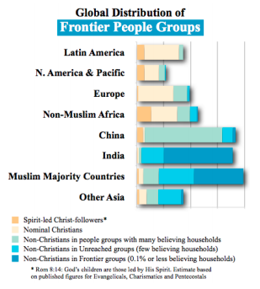
Now, the only way we could reach all of Tampa Bay is in partnership with the other Gospel preaching churches in town. This is why I prioritize networking with other pastors in town. It’s a slow process because we all have problems and programs of our own. But it’s the only way we can reach our city is if we work together as One Church to reach our city. This is also why we need to support the para-church ministries operating here, such as our Cru missionaries at USF and UT reaching college students - and Jill Collins with Love Is ministry, reaching refugees.

But I want to focus as we close this morning on the task of reaching EVERY PEOPLE GROUP on earth. See the church blog for links to some helpful resources from the Joshua Project.

This chart shows where the majority of people groups are that have little or no Gospel witness. You can see the most dark blue is in India and Muslim majority countries. Joshua Project research shows that 25% of the 17,000 people groups on earth have NO GOSPEL WITNESS. They estimate there are 4,751 FRONTIER people groups numbering over 1.8 BILLION people. Read the article I link to from the blog and start using the prayer guide linked to from there as well. The prayer guide highlights the 31 largest Frontier People Groups that represent nearly half of those 1.8 billion people.

As with personal evangelism, mission begins with WAITING on God in prayer - crying out to Him to raise up and send out workers into His harvest field. But waiting must move into walking and witnessing. As I said earlier, Christians in the west have waited far too long and witnessed far too little. It is time to start walking forward in confident faith and in bold obedience to the great commission.

1.8 billion people. Tens of thousands of these souls are dying every single day and plunging into eternal misery apart from Christ. Brothers and sisters, “We have not been called to hold the fort but to storm the heights” (Robert Coleman). WE ARE THE LIGHT OF THE WORLD. The light came into the world to illumine the darkness, to bring hope to the hopeless and life to the lifeless.

We have the roadmap to eternal treasure. We have the living water. We have tasted the goodness and grace of God. Let’s push past our cautious timidity to prayerfully, joyfully and boldly labor with gospel believers from all over the Christian world to reach into the darkest places with the light of Christ. “There is no other name by which people can be saved.” These people have no hope apart from hearing the Word of Christ proclaimed. How can they hear without someone preaching to them? How can they preach unless they are sent out?

May we be a Great Commission Church. May we be Great Commission followers of Christ! This is the “home run” for us at Oakwood - sending out workers to reach the world with the Gospel. It is the natural and intentional result of everything we do - loving God, growing in Christ, serving the church - all of this leads to its fulfillment in going out to share with others the wonderful blessings we have experienced.

Let’s watch out for distractions as we keep watch for the soon return of our King. Let’s wait on the Lord, trusting fully in His power and walk forward with courageous confidence as witnesses who are not ashamed of the Gospel but who are overflowing with so much joy in Jesus that we can’t help but share that joy with others.

Let’s pray as we prepare to gather around the Lord’s table.

