**Four Fields**

Acts 14:1-28 (read 1-7, 21-28)

"Now at Iconium they entered together into the Jewish synagogue and spoke in such a way that a great number of both Jews and Greeks believed." Acts 14:1

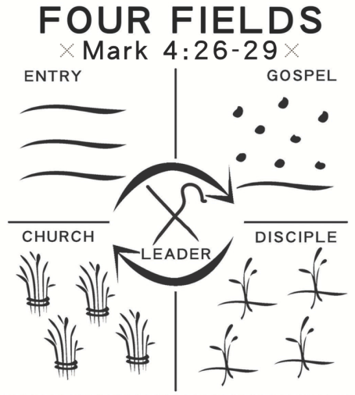

**Four Practices of a Kingdom Worker:**

1. **E_____________ Field**
   * **E_____________** with prayer and care (v. 1, 8)
2. **S_____________ Field**
   * **S_____________** the Gospel (v. 1, 3, 7, 15, 21)
3. **G_____________ Field**
   * **T____________** believers to obey Jesus (v. 1-3)
     + Expecting **O____________________** (v. 4-5, 19, 22)
4. **H_____________ Field**
   * **M_________________** disciplemakers to continue the work (v. 22-23)

"When they had preached the gospel to that city and had made many disciples, they returned to Lystra and to Iconium and to Antioch, strengthening the souls of the disciples, encouraging them to continue in the faith, and saying that through many tribulations we must enter the kingdom of God." Acts 14:21-22

**Four Fields**

Acts 14:1-28 (read 1-7, 21-28)

"Now at Iconium they entered together into the Jewish synagogue and spoke in such a way that a great number of both Jews and Greeks believed." Acts 14:1



**Four Practices of a Kingdom Worker:**

1. **Empty Field**
   * **Enter** with prayer and care (v. 1, 8)
2. **Seeded Field**
   * **Share** the Gospel (v. 1, 3, 7, 15, 21)
3. **Growing Field**
   * **Train** believers to obey Jesus (v. 1-3)
     + Expecting **Opposition** (v. 4-5, 19, 22)
4. **Harvest Field**
   * **Multiply** disciplemakers to continue the work (v. 22-23)

"When they had preached the gospel to that city and had made many disciples, they returned to Lystra and to Iconium and to Antioch, strengthening the souls of the disciples, encouraging them to continue in the faith, and saying that through many tribulations we must enter the kingdom of God." Acts 14:21-22