**Kingdoms in Conflict**

Acts 19:20-41

Jesus came preaching ***“the kingdom of heaven.”*** He said there is a broad path that leads to destruction and most people follow that path. But there is another path, a small, less traveled road that you enter through a small, narrow gate - and that way leads to life!

Jesus told his followers to **expect opposition and persecution**. He said every prophet was treated that way and he himself was opposed, persecuted and ultimately killed. Why should we, his followers, expect different treatment?

Jesus was opposed and persecuted because ***His Kingdom was a threat to THIS Kingdom***. The way of Jesus runs opposite to the way of this world. The more someone has a stake in this world the more they will fight against the kingdom of Jesus because they see that His way and His kingdom threatens the very foundations of their empire.

So it’s no surprise in the book of Acts that **the theme of conflict** runs right through it, as it does through the gospel accounts. Here in Acts 19 we hear a silversmith named Demetrius expressing the conflict very clearly:

“This fellow Paul has convinced and led astray large numbers of people… He says that gods made by human hands are no gods at all.” Acts 19:26

This is not objective, neutral reporting. This is an editorial - ***an opinion piece***. He doesn’t say, “Hey, there’s this new version of Judaism being promoted by a guy named Paul.” He says, “This guy Paul is leading people ASTRAY.” He says “There is a false teacher running around, a heretic trying to fool people… This Paul dares to teach that man-made gods aren’t gods at all! The nerve of that guy!”

The topic today is **IDOLATRY** - and 2,000 years ago in Ephesus idolatry was not an abstract concept, it was a practical reality. Demetrius the silversmith made little, expensive silver statues of **Artemis**, ***the Greek goddess of the hunt*** - and her temple at Ephesus was one of the seven wonders of the ancient world. People worshiped Artemis and honored her particularly on behalf of women, their health and particularly childbearing. One mythical story tells of Artemis helping to bring her twin brother, Apollo, to birth.

This was the great Artemis that Demetrius represented in his little statues - and his business was apparently doing quite well. Feeling threatened by Paul’s teaching and his growing popularity, ***Demetrius called a town meeting***, a gathering of local business people - sort of a chamber of commerce - to discuss the problem.

What this passage shows us is the **three layers of idolatry**.

**Three Layers of Idolatry**

* **Practices** (Money)
* **Values** (Power)
* **Beliefs** (Deity)

On the surface, Demetrius seems only concerned about MONEY. But underneath that practical layer is the issue of POWER. And under both money and power is the deeper, more central issue of truth and meaning itself related to the nature of God.

I hope none of us make and sell statues of Artemis for people to worship. ***Idolatry today is more subtle*** - but no less real. Our culture is filled with idols and our hearts are drawn to worship those idols. Idols like money, comfort, pleasure, power, influence, status, achievement and fame. All idols have these three layers.

For example, consider a young person in their first job:

**Three Layers of Idolatry**

* **Practices** (over-work)
* **Values** (advancement)
* **Beliefs** (success)

The young nurse or the **young business person** puts in crazy hours - on the surface the practical expression of this devotion is over-work. But underneath that commitment and service to ***the idol of work*** is the value, the priority of advancement - the desire to achieve, to move up the ladder. And underneath those practices and priorities is a set of beliefs related to success and happiness. The workaholic BELIEVES that the good life on the other side of a bunch of promotions and raises will be worth their sacrifice, worth their service, their devotion.

Or consider the single person who is tempted to worship **romantic love**.

**Three Layers of Idolatry**

* **Practices** (promiscuity)
* **Values** (love)
* **Beliefs** (happiness)

On the surface you might just see someone who goes out with a lot of people, spends a lot of time in bars and clubs, has a lot of one night stands. But under those practices there are values - a priority is given to the pursuit of love and relationships. And the reason, the fuel for these values and practices are deeply held beliefs about happiness. So many today believe that what their soul needs most is romantic love. If only I have THIS - I will be happy and my life will be full.

***Do you know the best way to identify an idol in your life?*** **Imagine losing it**.

That’s what happened to our friend **Demetrius the silversmith** in Ephesus. He had a good business going selling his Artemis statues. Suddenly Paul’s preaching was leading people - lots of people - to repent of their worship of idols and their devotion to magical arts and superstitious practices. Demetrius was perceptive - he knew that this radical Christian message required total devotion and therefore ran counter to the culture of idol worship in Ephesus and the broader region.

So Demetrius decided to do something about it. He called a town meeting and tried to stir people up to oppose this guy Paul and his message. Let’s look at the ***three layers of idolatry*** there in Ephesus and see what that exposes in our own hearts.

1. **Practices - Taking v. Giving**

“You know, my friends, that we receive a good income from this business.” Acts 19:25

**Demetrius’ practice** was to make and sell shrines and statues of Artemis. He was a business man, seeking to TAKE what he could get from the market there in Ephesus. He wasn’t taking in the sense of stealing, he was exchanging goods for pay - and he must have been a good craftsman because he was making money at it. People sought out his shrines and his statues - he was sought after in the region.

This was business, and I’m not criticizing the principle of doing business. But there can be **a mindset in business to TAKE** rather than GIVE. Some businesses are truly designed to SERVE people; others are designed to USE people. Some prioritize affordable pricing to help people while others try to get maximum profit at the consumer’s expense.

Think of *It’s a Wonderful Life* and the difference between **Mr. Potter** and his Potter’s field of ramshackle houses and apartments rented at exorbitant prices compared to the old Bailey Building and Loan that helped scrape together money from the community to enable working class people to own a nice but affordable home. Or think of **Ebenezer Scrooge** counting his coppers and telling his rats to send out the eviction notices on Christmas Eve.

You can see how the ***principles of the kingdom of God*** are in opposition to those of the kingdom of this world. Christians are called to the practice of giving - sacrificial giving. People of this world tend to embrace the practice of TAKING - maximize what you can get from any person or situation.

That’s the first layer of idolatry we see in Demetrius and in ourselves - the practical layer of what we do. ***Are we givers or takers?*** But that is only the surface layer of idolatry - the practices and behaviors you can. Underneath that is the middle layer:

1. **Values** - Status v. Service

“There is danger not only that our trade will lose its good name…” Acts 19:27

Underneath practices are **values or priorities**. Demetrius was not just committed to selling shrines and statues. He was devoted to the whole pursuit of advancing his brand, building his business. Here in verse 27 he mentions the “good name” of the whole group of artisans who sold this kind of product.

This would be like ***Texas oil workers*** fighting for their industry in fossil fuels or domestic car manufacturers promoting a “buy American” promotion.

As you go about your work from day to day and year to year, what practices do people see? Do they see in you a commitment to give or take? Beneath that do they sense in you ***a commitment to serve*** or a seeking of your own self-advancement?

***What is most important to you?*** What do you most value? Can we sincerely say that we are committed to serving people? Or, if we’re honest, do we prioritize opportunities that we know people will notice?

I’ll be honest that ***pastors are not perfect in this area***. (See how I confessed the sins of others instead of my own? Pastors are artful as well as sinful.) It would be nice if all pastors were like Jesus and we came “not to be served but to serve.” It would be great if we practiced foot-washing and embraced the small and menial and humble. But pastors tend to be among the most vain and shallow, among the most self-promoting and self-seeking.

In my **twenty years** of ministry I can tell you that the most common lesson the Lord has had to teach me is, ***“Darin, it is not about you.”*** And as soon as I learn it and remember to pray and trust and serve - another season of ministry comes along and, guess what? I have to learn the same lesson all over again.

And notice ***how subtle this idolatry is***. Demetrius makes it look like it isn’t about him at all - like his concern is with the reputation and honor of Artemis and the city of Ephesus. He says, “Guys, this will affect our business…”

1. **Values** - Status v. Service

“But also that the temple of the great goddess Artemis will be discredited… robbed of her divine majesty.” Acts 19:27

Demetrius is being so civically minded, right? So concerned about the name of Artemis… Clearly his motives are not mixed at all - they are pure, down to the core.

***What does this silversmith REALLY VALUE?*** What is actually important to him? Is it Artemis at all? He wants everyone to believe that it is. But he has already mentioned money three times, before expressing concern about the honor of the goddess. His real priority is quite obvious to see.

What about us? **What do WE really value?** What is most important to you? I’m sure we all talk a good game about the name and reputation of the Lord Jesus and of our church. But, if we’re honest, don’t we often try to ***USE Jesus rather than SERVE Him?*** Don’t we bring Him a laundry list of requests and even demands? Isn’t it terrible how twisted up we can get even in our spiritual lives - making worship and prayer about US rather than the Creator who made us and the Savior who died for us?

Now let’s look at the deepest layer of idolatry. On the surface are the practices and behaviors of how we live. Under that is what we value, what we prioritize. But the deepest layer is in our hearts - what we believe.

1. **Beliefs** - My god v. The God

“He says gods made by human hands are no gods at all.” Acts 19:26

Demetrius rightly understood Paul’s message - teaching that ***there is only One True God and all other idols are nothing*** - just wood or silver or gold - simply objects made by a person. The Old Testament prophets made this argument repeatedly. Why would you worship something your own hands made? With half of a piece of wood you made an idol, with the other half you stoked the fire. Why bow down to a statue that can’t move or pick itself up if someone knocks it over? How could such a thing help you? It can’t even help itself!

The temple of Artemis took it to another level.

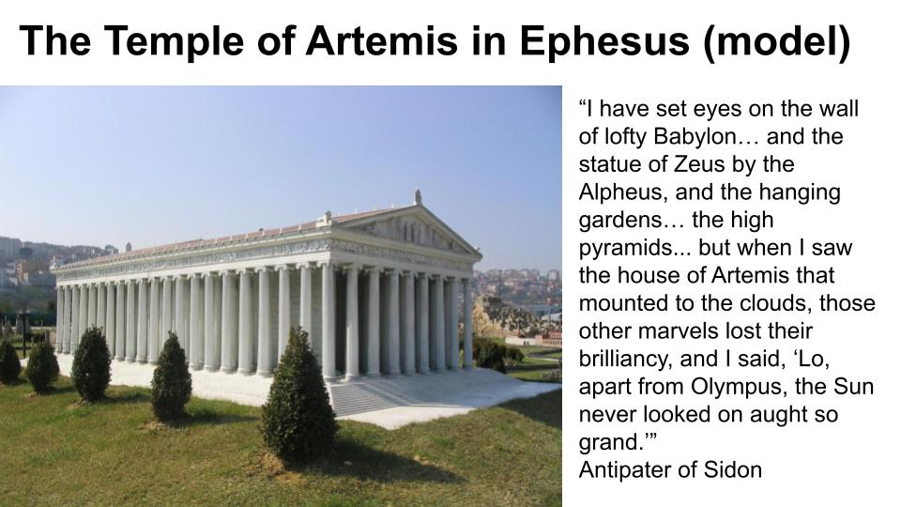

It was considered one of the ***seven wonders of the ancient world***. By the time Paul visited Ephesus in the first century the temple had been destroyed and rebuilt twice and was in its most spectacular form. With the huge pillars around the expansive building and the whole establishment of priests and traditions and celebrations and products it felt like there was a lot more legitimacy to the Artemis thing than just some hand-made statues and shrines.

That temple was originally built over 700 years before Paul’s visit - so over 20 generations had been honoring Artemis (or Diana, her Roman name). Nothing lends legitimacy to a practice like years and decades and generations of PRACTICE. When everyone you know believes something it is natural - really automatic - for you to go along with that belief.

If your **Mom** was convinced that you were conceived after they bought an Artemis shrine… If your **Dad** deeply believed that his hunting expeditions were only successful when he offered a sacrifice and prayer to Artemis… If your **Grandparents** and their grandparents ran their farms outside of town by worshiping and honoring Artemis - you can see where the worship of Artemis would be ingrained in your behaviors, values and beliefs.

That was **THEIR local god** - it was their belief system. ***What is it for us?***

* We talked earlier about the idol of **work** - fueled by a commitment to success, achievement, comfort and materialism.
* We also looked at the idol of romantic **love** - fueled by a culture that worships beauty and attention and unfettered sexual pursuits.
* Another common idol in our Christian culture is **spirituality** - we like to appear very holy and godly and knowledgeable. This one is fueled by pride because “knowledge puffs up,” and the more you play the “church game” the better you can get at it. You can hide any flaws and obviously sins under a facade of Bible knowledge and active service. If you stay busy enough people will assume you love Jesus.

Underneath most idolatry is the **SELF.**

**Three Layers of Idolatry**

* **Practices** (self-indulgence)
* **Values** (self-promotion)
* **Beliefs** (self-reliance)

You can customize ***your personal cult*** around your own desires and preferences. The belief that fuels this one is that you know best, you deserve the best and you are the best one to get yourself what you most need. America loves this one. If we had a giant temple like the Artemis Temple it would be the Temple of the Self and it would be decorated all around with nothing but mirrors.

Now, let’s see how the Gospel calls us away from all of this worship of false gods to wholehearted devotion to Jesus.

|  |  |  |
| --- | --- | --- |
|  | **Idolatry** | **Christianity** |
| **Practices** | Take | Give |
| **Values** | Status | Service |
| **Beliefs** | My god | The God |

We need to continually reorient our hearts and lives around the right set of beliefs, values and practices. If we truly believe there is One True God and His name is Jesus, then we will build our entire life around Him. Based on that firm foundation of truth, we will prioritize love for the Lord and service to Him and to others. And this will result in a lifestyle like Jesus - a life of giving, of sacrificial generosity and service.

Look at **Jeremiah 17** as it contrasts idolatry with true faith.

**Beliefs:**

|  |  |
| --- | --- |
| “Cursed is the man who trusts in man and makes flesh his strength.” Jer. 17:5 | “Blessed is the man who trusts in the Lord, whose trust is the Lord.” Jer. 17:7 |

At the ***deepest level*** we must make a choice - will we root our confidence in ourselves or in the Lord? Will we trust in something other than God or will we “trust in the Lord with all of our hearts”? If we truly trust in the Lord, we will value Him above all things.

**Values:**

|  |  |
| --- | --- |
| “All who forsake you shall be put to shame; those who turn away from you shall be written in the earth.” Jer. 17:13 | “Heal me, O Lord, and I shall be healed; save me, and I shall be saved, for you are my praise.” Jer. 17:14 |

The Bible is filled with warnings for those who turn away from God to worship and serve other gods. The Lord is called “the fountain of living water” (Jer. 17:13) and all ***other gods are empty cisterns***. And yet, like Israel, we constantly turn away from God and get our mouths filled with sand yet again.

May we instead come continually to the Lord - seeking His loving presence, His healing touch, His saving grace and power and goodness.

Beliefs feed values which produce practices.

**Practices:**

|  |  |
| --- | --- |
| “This sin of Judah… is engraved… on the horns of their altars.” Jer. 17:1 | “He is like a tree planted by water… and does not fear when heat comes… does not cease to bear fruit.” Jer. 17:8 |

***Jeremiah confronted the idolatry*** of the people of Israel. For generations they had built altars to foreign gods, established shrines on hills call high places where they worshiped local deities. They had neglected the worship of the Lord at Jerusalem and had adapted to the pagan worship of the people of the land. Those practices grew out of beliefs and values.

And the same is true for **Christian practices**. Because we trust deeply in the Lord, because we value Him above all and His kingdom, we should not be captive to fear and we should always bear fruit in godly living and faithful service.

Let’s watch this seven minute **video** that goes along with your handout for today. This is a counseling tool from Paul Tripp, designed to help us reflect on what is going on in our hearts and lives. Let’s invite the Holy Spirit to speak to us and draw us to the cross!

***Hope and Power to Change - Three Trees*** (7 mins)

[www.oakwoodfl.org/hope](http://www.oakwoodfl.org/hope)