**Sovereign Protection**

Acts 22:22-23:35

***The young missionary led an expedition at night*** - a small group hunting a lion, since several lions had been harassing this African village, killing their cattle and sheep, even in the daylight. As they crept through the brush of the south African savannah, the hunter saw a large lion and took aim with his rifle. He hit the beast but only wounded it, and it charged him while he raced to reload. Unable to reload in time, **the lion attacked him** - breaking his left arm and leaving him bloody and wounded.

His team helped set the break, but pain from the injury would follow him for the next ***thirty years of exploration, missions and advocacy against slavery***.

His name was **Dr. David Livingstone** - a Scottish physician who devoted his life to kingdom work in Africa, at great personal risk and sacrifice. The story with the lion illustrates the many ways God protected Livingstone FROM danger and was with Him IN danger.

Today in Acts 22 and 23 we will see how God protected Paul, illustrating these three sovereign safeguards with the long ministry of David Livingstone and applying them to our own lives today. Here is the overview:

**How God Protects Us:**

1. Positioning People
2. Providential Planning
3. Personal Presences

God uses all kinds of people - both Christian and non-Christian - to protect and assist His people and His purposes. God providentially plans and orchestrates circumstances and events for our good and His glory. And through everything, God is with us personally - assuring us of His presence, comforting and encouraging us every step of the way. Let’s look at each of these sovereign safeguards.

1. **Positioning People**

“As they were shouting and throwing off their cloaks… the tribune ordered him to be brought into the barracks.” Acts 22:23

***Paul was wrongly arrested*** for defiling the temple when, in fact, he had been protecting the purity of the temple by consecrating himself and four other men through a seven day time of worship and sacrifice in the temple area. The Jews from Asia, Ephesus in particular, followed Paul to Jerusalem and stirred up a riot against him. ***The mob started to beat on Paul***, and only when the Roman tribune arrived - the local Roman governing official - did they stop attacking the apostle.

Thankfully, when he heard that a riot was starting in Jerusalem, ***he hustled to the scene.***

1. **Positioning People**

“He at once took soldiers and centurions and ran down to them. And when they saw the tribune and the soldiers, they stopped beating Paul.” Acts 21:32

Now, this move wasn’t entirely selfless service to Paul. The Roman officials were entrusted with the task of keeping the peace. One of the main things that could cost you your job, or your life, was to lose control of your city to mob violence. And Jerusalem in Paul’s day was already notorious for being a city that was difficult to control, and prone to mob violence. So whoever was in charge was highly motivated to keep things under control and prevent reports from getting back to Rome.

Still, it is significant that **this particular, unnamed tribune**, ***was a man of action***. God positioned this particular Roman official in this place at this time to protect Paul. A less decisive, more self-indulgent or more politically minded ruler might have made different decisions - might have delayed, might have been distracted, might have made a deal with the Jews.

Instead, he intervened to get the source of the riot in front of him.

1. **Positioning People**

“The tribune ordered… that he should be examined by flogging…” Acts 22:24

That’s one way to get information from someone. I expect the tribune had found it to be effective. Thankfully, it wasn’t just the action-oriented tribune who was involved. There was also an ***attentive centurion***.

1. **Positioning People**

“Paul said to the centurion who was standing by, ‘Is it lawful for you to flog a man who is a Roman citizen and uncondemned?’” Acts 22:25

Here was the Roman soldier responsible to actually ***oversee the flogging***. The tribune ordered it done, but didn’t have to watch the unpleasantness himself. The centurion did. And thankfully, he was willing to listen to a Jewish rabble-rouser. He certainly could have ignored Paul. He could have assumed Paul was a con artist who deserved a beating. He could have been a twisted masochist who enjoyed watching other men suffer.

But this centurion had enough **compassion or legal sense** to stop the flogging before it started and he was assertive enough to send word back to his superior officer - the tribune.

One more providential placement of a person. When the Jews heard Paul had appealed to his Roman citizenship for protection, they made a communal vow to kill him, and set a plan in motion **to ambush him** on his way to the next hearing. Thankfully, some friendly ears were listening.

1. **Positioning People**

“The son of Paul’s sister heard of their ambush.” Acts 23:16

We don’t know how Paul’s nephew heard of this plot. Did he know one of the Jewish leaders? Did he happen to be hanging around a group of Jewish men as they were talking? We don’t know the details, but we do know that somehow God made sure ***this plot was exposed and Paul’s life was protected***.

That is the first way God protects us. He sovereignly positions people in our lives to help us.

**David Livingstone** experienced this throughout his thirty years in Africa - as he frequently needed guides on his travels, help gathering supplies and assistance when he was sick. In one of the ironies of Livingstone’s life - since he was dedicated to ending the slave trade - two of the men who helped him most at the end of his life and who were with him in his final illness, were slave traders.

But God used even these wicked men to help His servant.

And God does the same thing for us, doesn’t He? You may have a Christian doctor or a Christian lawyer or a Christian financial advisor. But you may have an atheist doctor or a Buddhist lawyer or a Muslim accountant. God can use people of all backgrounds to bless and assist His people. ***Be thankful for the providence of God, arranging the people in your life!***

1. Providential **Planning**

“The tribune said, ‘I bought this citizenship for a large sum.’ Paul said, ‘But I am a citizen by birth.’” Acts 22:28

Here is the second sovereign safeguard: God providentially plans the details of our lives to protect us. ***God saved Paul’s life at this point in Jerusalem through a detail of his birth***. We don’t know how Paul’s parents became Roman citizens, but since Paul was born in the free city of Tarsus to parents who were citizen, he was automatically born a citizen of Rome.

Similar to the rights and protections of being an American today, Paul had the rights of being a Roman. As soon as the tribune heard about this, he treated Paul completely differently. It says in verse 29, “he was afraid.” **He would answer to Rome** for how he treated this citizen named Paul.

Here is another detail of timing that God used to protect Paul.

1. Providential **Planning**

“Paul perceived that one part were Sadducees and the other part Pharisees.” Acts 23:6

The council that Paul was taken before happened to be **a divided council**. Half in the room were of one set of views, and half of the other. Luke summarizes the difference for us in verse 8.

1. Providential **Planning**

“Sadducees say that there is no resurrection, nor angel, nor spirit, but the Pharisees acknowledge them all.” Acts 23:8

Knowing this **difference between the parties**, Paul said, “It is because of my hope in the resurrection that I am on trial today,” and pandemonium broke out in the council as Pharisees leapt to his defense and Sadducees denounced him all the more fervently.

It would be like if you were at a work party and you knew half of the crowd was **Republican and half Democrat**. If everyone started attacking you for your Christian beliefs you could say, “Listen, I just think unborn babies have to be protected, even in the first trimester!” And let the people at the party start to duke it out on the abortion issue - while you slip out the back door. (I’m not saying you should do this - just illustrating a move that Paul made and through which God protected him.)

One more detail to note on this point, that ties 1 and 2 together.

1. Providential **Planning**

“The soldiers, according to their instructions, took Paul and brought him by night to Antipatris.” Acts 23:31

God arranged it so that a conscientious, **activist tribune** was on duty, who responded to Paul’s situation promptly and thoroughly. He gave detailed instructions, down to the number of horsemen and the number of foot soldiers to send with Paul and to do so at night. And so Paul was moved safely from Jerusalem to Caesarea - up the food chain of Roman authority to the governor of the region.

***God is so gracious to protect us***. David Livingstone’s thirty year adventures illustrate this at every point.

Yes, in the end he died of malaria, but for 30 years he braved the dangers of sub-saharan Africa and managed to survive **30 separate bouts with malaria**. He managed to have six children even though his wife died relatively young (of malaria, of course).

You see ***God’s sovereign preparation*** in Livingstone’s life from his earliest days. One of seven children raised in a one bedroom apartment in Scotland, the young David learned to enjoy being outdoors. Since his family was very poor he went to work in a textile factory at the age of ten and learned how to work hard, often 12-14 hour days of detailed hand work BEFORE starting on his school work. With part of his first week’s wages he bought himself a Latin grammar.

A local Catholic man took an interest in young David and tutored him in Latin, helping prepare him for a future studying medicine and advanced theology.

How has God blessed and protected you in your life? How has the Lord brought people into your life to help you? How has He sovereignly directed the course of your life to prepare you for the work and ministry He has for you? One more way God protects us.

1. Personal **Presence**

“The Lord stood by him and said, ‘Take courage, for as you have testified… about me in Jerusalem, so you must also testify in Rome.’” Acts 23:11

Held as a prisoner in the Roman fortress at Caesarea, **the Lord Jesus Himself** stood with Paul and gave him deep, personal reassurance. Hear this today, brother, sister - the Lord Jesus is standing with you, right beside you now, saying these words: “Take courage.”

Do not be discouraged. **Do not lose heart**. Do not be afraid. The Lord your God is with you. He will never leave you or forsake you. TAKE COURAGE. And just as the Lord called and empowered Paul to testify about Him, so the Lord commissions each one of us as well - “as you have testified about me before, you must also testify about me again!”

There is ***no greater protection***, no greater encouragement, no better antidote to fear than the presence of God. “Even though I walk through the valley of the shadow of death,” we read in Psalm 23, “I will fear no evil,” WHY? “For YOU ARE WITH ME.” The presence of God - His power and love and grace and mercy - comfort and encourage us.

This is the most obvious place God blessed Paul with His presence. But notice two others.

1. Personal **Presence**

“Brothers, I have lived my life before God in all good conscience up to this day.” Acts 23:1

The Lord was with Paul every minute of His life in the form of ***Paul’s conscience***. From his early days studying God’s law to his young adulthood as a Pharisee, Saul (as his name was then) was passionate about God’s law. After becoming a Christian, Paul had the additional clarity of the **Holy Spirit** convicting him and guiding him.

Oh, may we all be able to say this at the end of our lives: “I have lived my life before God in ALL GOOD CONSCIENCE.”

The Lord is with us at all times. ***He is protecting us through His presence from our deadliest enemy - SIN***. This is why temptation brings a heat and tension to your chest - because the Lord is right there with you. You know that He is with you, just like you used to know Mom was right around the corner in your house. There’s this unshakeable feeling.

One more way God protects us with His presence - through His Word.

1. Personal **Presence**

“For it is written, ‘You shall not speak evil of a ruler of your people.’” Acts 23:5

When Paul was struck on the mouth he shot back at the high priest, “God is going to strike you, you whitewashed wall!” Those watching gasped at this defiance of the high priest and when Paul was told it was the high priest, he paused. He didn’t quite apologize as he quoted this Scripture, just saying, “I didn’t know…”

This is one of the promises Jesus made about the Holy Spirit - that He would bring to mind all that Jesus taught. We have to work to study and meditate on and memorize God’s Word - but the Holy Spirit uses all of that preparation to bring key verses to mind in intense moments of life.

So here is our summary for today:

**How God Protects Us:**

1. Positioning People
2. Providential Planning
3. Personal Presence

Now think about **what is GUARANTEED** to us in terms of God’s protection. God promises ***to always be with us***, no matter what, to the end of the age and to the limitless ages of eternity. That is unshakeable, constant. God will always be with us.

God’s ***providential planning*** is also guaranteed - right up until our last breath - every detail of your life is orchestrated and directed, guided and controlled by the hand of God. This doesn’t mean everything will go well all the time - or that things will always work out the way we think they should or the way we want them to. Paul never WANTED to be held in prison. But ***he trusted in God’s plans*** even when he was in prison - even when he was floating in the Mediterranean from a shipwreck, even when he was running from the Jews again.

And God always positions the people around us - but there is no guarantee that we will always have nice, helpful, positive people in our lives. Sometimes we will be like Paul, surrounded by enemies on all sides. Sometimes we will be like Jesus, abandoned by all of his followers. Sometimes we will be like David, hiding in caves in the wilderness.

At this point in his life Paul still had several years ahead of him to live and write and help shape the Christian movement. But we know from later in Acts that Paul spent two years under house arrest in Rome. Because of that imprisonment we have the books of Philemon, Philippians, Colossians and Ephesians. Then it seems Paul was released for a couple of years and may have reached Spain as he had desired. But soon after he was arrested again by Nero and executed for his faith.

Did God’s protection over Paul fail? Of course not.

* God always guided ***the people around Paul***, making sure all appointed for eternal life through his preaching would hear the gospel and respond, bringing him key leaders to invest in so they could carry on the work.
* God directed all the details of Paul’s life - ***providentially planning*** and orchestrating everything that happened to him.
* And through all the ups and downs, and right up to the end, God was with Paul - and God’s ***personal presence*** did not diminish for Paul with death but reached its greatest reality so Paul could experience what he had written, “To live is Christ and to die is gain.”

The same can be said for David Livingstone and for the rest of us.

As far as we know Livingstone only led one person to Jesus in his 30 years in Africa. But that one person was a chief who went on to lead hundreds, even thousands to the Lord. And through Livingstone the heart of Africa was opened up for British colonization and missionary travels.

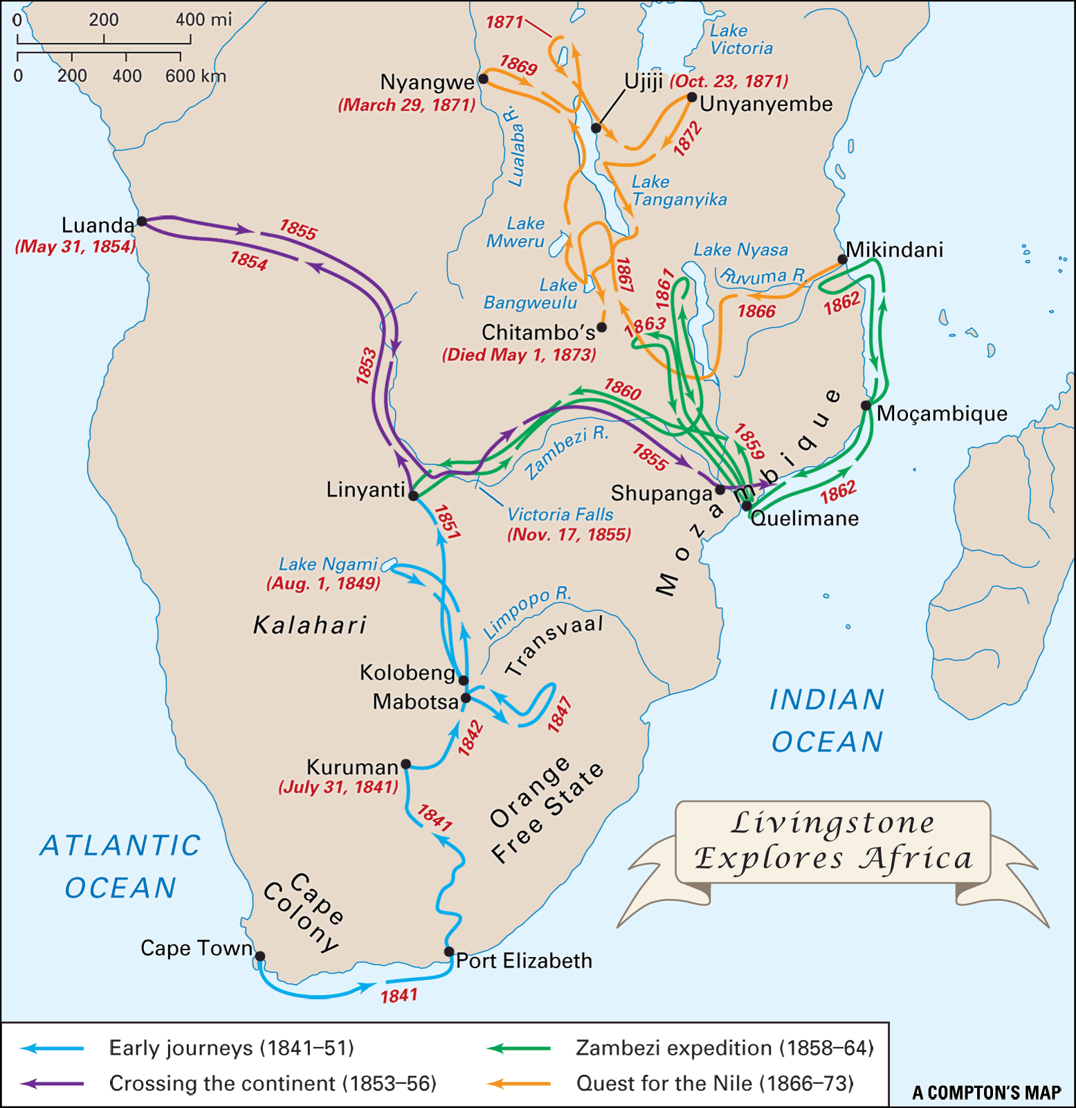

In his first journeys he discovered Victoria falls and then at the top of the map, the Zambezi River.



Then he became the first western explorer to travel ***all the way across Africa***. It is hard to overestimate the dangers that plagued this kind of expedition in the mid 1800s.

And listen to how he described his attitude toward his possessions and really his whole life:

"I place no value on anything I have or may possess, except in relation to the kingdom of Christ. If anything will advance the interests of the kingdom, it shall be given away or kept, only as by giving or keeping it I shall promote the glory of Him to whom I owe all my hopes in time and eternity.” David Livingstone