**The Creator**

Genesis 1:1-5

We’ve seen the foundation for a Christian worldview is God and His Word. The only way to understand ourselves and the world we live in is to **start with God**. That is what the Bible does.

“In the beginning, God created the heavens and the earth.” Genesis 1:1

If you try to live your life without reference to God, it would be **like hiking without a compass.** I was snowshoeing with a friend in the upper peninsula of Michigan once. Let me define those terms. Snow is this cold white material that falls from the sky in the wintertime up north. Snowshoes are large tennis racquet type things that enable you to walk on 3-6 feet of snow in drifts. The UP is the northernmost part of Michigan, where they get a lot of snow in the winter.

Anyway, we were young and strong and set off across a frozen bay of Lake Huron, vectoring to the right toward a landmark we knew from summer camp, wanting to see what it looked like frozen over in the winter. As you might imagine, we never found it. Eventually, the beauty of the Michigan winter gave way to a slight worry about finding our way back to the camp. The sun started getting lower in the sky, and - of course - it started to snow.

Both of us knew the general area, having grown up for years going to that Intervarsity family camp. But we knew it in the summer, without snow. And this snow was over the tops of the smaller pine trees, so any familiar landmarks were gone. We had not set out intending on a long geochaching adventure, so we didn’t have a compass. And this was February of 1999 - before Kristin and I got married - so neither of us had a smart phone.

As we plunged through the woods, aiming generally for the camp, ***we had no way to know if we were going the right direction*** or even generally the same direction. Snowshoeing around the tops of pine trees doesn’t allow for following any pre-made trails. And without a compass or a distant point of reference to follow, all we had was a general sense of which way to go. And after an hour or two huffing through deep snow, you lose even that general sense.

To cut the story short, we eventually heard traffic on our left, which meant we had drifted too far north when we should have been going east and south. But we were glad to get to a road where the snow was cleared and from there, we found our way to the camp entrance and straggled back to camp right around dinner time.

In the woods of Michigan, you would quickly realize your need for some kind of objective guidance - ***a compass or gps to guide you***. You would know immediately not to trust your own instincts. You can wander in circles and never reach your destination.

But that is exactly what people do when it comes to God. They trust their own instincts and ideas - **they wager their eternal souls on vague impressions** about an all-loving, universally accepting God - ***sort of like Santa Claus***. He probably has a naughty list, but only serial killers and genocidal dictators are actually on it.

But God has not left lost in the woods without any clues or directions. **God has given us the Bible** as our compass and guidebook to salvation. And **God has given us Jesus** as the North Star to orient our lives toward Him.

The first thing we learn about God in the Bible is that **He is the Creator**. He made the heavens and the earth. In other words, ***God made EVERYTHING***. In this opening verse of the Bible we learn that there is ONE GOD, the Almighty Creator of all things.

In the ancient world ***most cultures worshiped many gods***, and they often believed the gods were visible in the sun, moon and stars or embodied in the Sea or the lightning or in powerful creatures. In other words, most cultures came to worship the CREATION instead of the CREATOR. And that is what God confronted with the first verse of the Bible.

***In the 21st Century we are too smart to worship the sun or moon*** - we know the one is just a giant ball of hot gas and the other is just a giant rock orbiting around our planet. Neither is a person much less a divine being. How silly to worship them!

So instead, we choose ***a much more enlightened option*** - we choose the most wise, powerful, and glorious being we know to trust and love and serve. The primary deity Americans worship is **the god of SELF**. But the doctrine of God as Creator blasts this idolatry to pieces immediately. Why worship yourself? You are just a mass of cells - a tiny speck that lives and breathes for a few short years and then will die and disintegrate. To worship and serve yourself is just as foolish as worshiping the sun or moon or an elephant or platypus.

Today let’s look at **three applications** of the doctrine of creation. How is it relevant that God made the world and God made you? How does it affect us to know that He is the Creator? The first application is PRAISE.

**Since God Created Everything:**

1. **Praise** His limitless power and creativity

“In the beginning, God created the heavens and the earth.” Genesis 1:1

When you read Genesis 1, **the first response is awe and wonder**. Onto a canvas of blank nothingness, God made the universe. And He did so simply by saying, “Let there be light.”

I don’t know about you, but I don’t have any problem with people believing in ***“the big bang.”*** The fact that the universe is expanding and that astro physicists have concluded that this expansion started at a point in the distant past when there was a massive explosion of matter and energy - they admit - from absolute nothing. Even the most rigid atheist has to admit that there is no scientific explanation for EVERYTHING exploding suddenly from NOTHING. Expansion is simply not an adequate scientific concept to explain the origin of the cosmos.

Just looking up at the night sky moves the heart to worship. Psalm 19 says:

**Since God Created Everything:**

1. **Praise** His limitless power and creativity

“The heavens declare the glory of God, and the sky above proclaims his handiwork.” Psalm 19:1

Just step outside on a clear evening and your mind will be blown by **the enormity of the heavens and the innumerable stars**. And the closer you look, the wonder is not decreased but increased. Hundreds of billions of stars in our galaxy alone - and there are hundreds of billions of GALAXIES. We can’t conceive of numbers like that. The sun is 93 million miles away.

<https://answersingenesis.org/astronomy/the-splendor-of-gods-creation/>

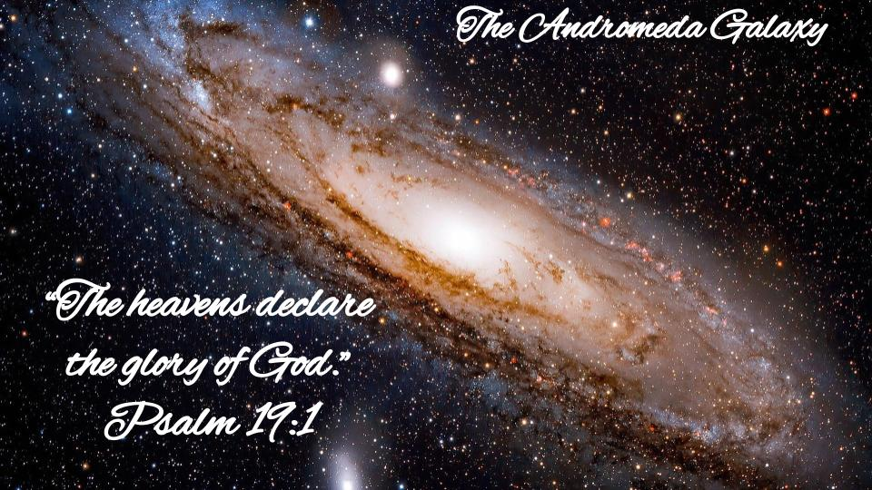

Driving at 65 mph it would take you ***163 years to reach the sun*** - and that’s without any potty breaks. And that’s just the sun, which is relatively close. The next closest star cluster is called Alpha Centauri and it is 25 trillion miles away. It would take you 6500 years in your minivan to reach Pluto at the edge of our solar system. But it would take you ***44 million years to cover that distance to Alpha Centauri***. The scale of our universe is simply staggering.

This image is **the Andromeda Galaxy**, which is the next closest to our Milky Way - roughly the same size - and gives us an idea of what our galaxy might look like from the outside. Hundreds of billions of stars. And there are hundreds of billions of GALAXIES in the universe.

<https://www.sciencealert.com/this-awesome-video-shows-the-scale-of-the-universe-in-the-best-way-possible>

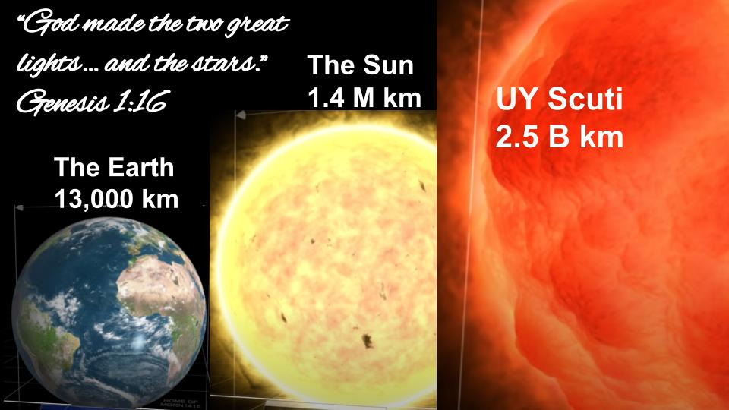

<https://youtu.be/GoW8Tf7hTGA>

We can’t fathom the scale in an image like this. But as big as the earth seems, the sun is 100 times the diameter of the earth, and ***100 million earths would fit INTO the sun***. As large as the sun is, it’s a pretty average size star, with many stars, like this UY Scuti, making even our sun feel pretty inferior by comparison.

And take this in - there are hundreds of billions of these in our galaxy and hundreds of billions of galaxies. And notice **how casually Genesis describes this** monumental, staggering, overwhelmingly incomprehensible demonstration of power: “God made the two great lights - and also the stars.” He simply said, “Let there be lights in the heavens” and whoosh - the stars leapt into being and arranged themselves in the exactly perfect balance necessary for life to exist on our planet.

“The heavens declare the glory of God.” As we contemplate all that God has made, it should move us to worship!

**Since God Created Everything:**

1. **Praise** His limitless power and creativity

“His eternal power and divine nature have been clearly seen, being understood from what has been made.” Romans 1:20

**Creation proves that there is a God**. It doesn’t tell us exactly what God is like - but it proves there is an incredibly powerful and amazingly creative God. The random explosion of matter and energy from nothing whatsoever is not explicable by any theory of physics. ***It takes far more faith to believe that all of this came from random chance*** than it does to believe in an all powerful God. (See *I don’t have enough faith to be an atheist -* Geisler / Turek.)

Let’s shift from the macro to the micro - from the universe to **your own body**. Isaiah 43 says that God created us for His glory.

**Since God Created Everything:**

1. **Praise** His limitless power and creativity

“Everyone who is called by my name, whom I created for my glory.” Isaiah 43:7

He made you to display His infinite wisdom and majestic power. ***God created YOU for His glory***. Scientists used to compare a cell in your body to a factory - describing the level of activity in a single cell. Now they compare a cell in your body to a CITY. That’s how much is going in each and every cell. The DNA from one cell in your body contains the information equivalent of 8,000 books. Your body has around 100 trillion cells. The information in your body alone makes the data in all the libraries in the entire world look insignificant by comparison. If you stretched the DNA in your body out, end to end, it would reach to the sun and back around 70 times. And remember that distance was 93 million miles, each way. (See *The Unshakable Truth*, Josh and Sean McDowell, p. 60-61).

Romans 11 concludes with a beautiful benediction:

**Since God Created Everything:**

1. **Praise** His limitless power and creativity

“Oh the depth of the riches of the wisdom and knowledge of God.” Romans 11:33

That is our first response to God’s creation: worship. Praise Him for His limitless power and astounding creativity. Here is a second application.

**Since God Created Everything:**

1. **Trust** His perfect knowledge and control

“Darkness was over the face of the deep. And the Spirit of God was hovering over the face of the waters.” Genesis 1:2

What is clear about Genesis one is that it is **beautiful poetry**. What is less clear is the exact progression and timing of creation. Verses 1-2 simply state the fact that God created everything.

It’s significant that in the first verses of the Bible we see the **Trinitarian nature of God**. We meet the Holy Spirit right here in the second verse of Scripture and look what He is doing - hovering over the darkness, over the waters. The ocean in Scripture represents chaos, evil and disorder. Have you ever wondered why in Revelation 21, when John saw the new heaven and new earth it says, “There was no longer any sea”? That doesn’t mean there won’t be water or beaches in eternity - it means there won’t be any chaos, disorder or death.

Think of **what the ocean represented in ancient times** - the most powerful and uncontrollable force! Massive size. For most of history the ocean was the end of the world - uncrossable, untameable. Chaos; evil; death; unrestrained power. That is what we live with today. That is what Jesus calmed with just a word of command. And that is what will be full removed for eternity when Jesus comes back to remake everything.

In the original creation, back in Genesis 1 verse 2, God is not explaining the step by step process of how He made the world. He is simply saying - where there was nothing, I spoke and there was something. Where there was darkness, emptiness, disorder and chaos, ***I spoke light, life, order and peace***.

How? ***The Spirit of God*** was hovering over the darkness, emptiness and chaos. And we know from John 1, as we saw a couple of weeks ago, that **the Agent of creation was Jesus**. All things were made by Him and for Him. The words, “Let there be light” came from the lips of Jesus, the eternal Son of God - and in response to those words, ***the Spirit of God brought everything into being*** -

* Into the darkness, He ignited the brilliance of light
* Into the void of space He scattered trillions upon trillions of stars
* He shaped the earth and each day gave it greater form and then filled it with all manner of life.

As we contemplate creation it should move us to praise our Almighty, All-wise, All-glorious Triune God. And it should move us to **trust in Him completely**.

***Who understands something better than its creator?***

Say you had a complicated grandfather clock and it stopped working. You would look for a repair guy who knew old clocks and he could probably figure out what was wrong and get it running again. But if you happened to have an old neighbor from Germany who was a clockmaker - and you invited him over to look at your clock and **he is the one who designed that very clock and made that very clock** - ***wouldn’t you trust him to repair it?***

God is the One who made everything in this world, including you and me. He is the Only One we can completely trust! His knowledge is perfect. His ability is limitless. Listen to Isaiah 40:

1. **Trust** His perfect knowledge and control

“The Lord is the everlasting God, the Creator of the ends of the earth. He does not faint or grow weary; his understanding is unsearchable.” Isaiah 40:28

***Creation did not wear God out***. He did not break a sweat. It did not exhaust His creativity or in any way tax His energy to make the vast cosmos of our universe. He simply spoke and at the word of His command everything leapt into being. Overseeing the universe, holding it all together according to His sovereign will and by His power does not press God to the limit of His ability.

When we think of God struggling to hear everyone at once, or getting a headache from the terrible decisions humans continually make, or getting exhausted from intervening in so many crises all the time - it just shows we don’t understand GOD. ***We project onto God our HUMAN limitations*** in terms of time, attention, power and understanding.

God’s knowledge is complete without any effort. God’s control over the details of the universe is comprehensive without Him having to work at it. **Limitless knowledge and sovereign power are defining characteristics of God** just like math comes easy to a math person, organization comes naturally to an organized person, social cues are obvious to a discerning person and music makes sense to a musical person. All of those are mysterious to me - but I know people who fit each of those.

***God does not get tired.*** He never takes a nap. He never stops paying attention to you. There is not a single millisecond of the day that He takes His eye off of you. He is aware of every detail of your existence, including trillions of facts about your inner molecules that you could never know. And that isn’t hard work for God - that is just God being God. He is the Creator. He is the Sovereign Ruler over all things. He simply knows. He always sees.

**Colossians 1** says that in Christ “all things hold together.” **Hebrews 1** says that Jesus “upholds all things with the word of His power.” This is not a tiring exercise for Jesus. It is simply His nature as the Ruler of all things.

***Do you see why we can trust God completely?*** We agonize over what we don’t know. God doesn’t, because He knows everything. We agonize over what we can’t control. God doesn’t because He controls and directs everything. He sees the big picture. He wrote the story from beginning to end.

So trust Him. Listen to Isaiah 40 as the prophet goes on.

1. **Trust** His perfect knowledge and control

“He gives power to the faint, and to him who has no might he increases strength.” Isaiah 40:29

***This is a call to DEPEND on God completely.*** The Creator and Sustainer of all things has everything you and I need. He has the knowledge we don’t have. He has the power we don’t have. He has the peace and love and hope and joy we don’t have. So come to Him in faith! The test of this is FEAR and WORRY… Look at Isaiah 43.

1. **Trust** His perfect knowledge and control

“But now thus says the Lord, he who created you… ‘Fear not, for I have redeemed you; I have called you by name, you are mine.’” Isaiah 43:1

**We can trust our Creator.** He made us. He has a plan for each of us. He paid the price to redeem us and has called us to Himself. We are HIS. We belong to the Lord!

***How are you doing lately with these first two?*** Have you experienced some part of creation recently that moved you to praise God for His power and creativity? Have you had to trust God with something lately that taught you more of what it means to rest in Him, to depend on Him completely?

To look at it the other way, ***have you been struggling with worry and fear?*** Have you lost sight of the glorious power and awe-inspiring majesty of God? Have you drifted in your confidence and faith in the Lord?

Brothers, sisters - this is where ***we need EACH OTHER!*** If you run long enough on your own you can lose sight of the goodness and glory of God. But if you walk with a few Christian friends, they will keep pointing you back to the wonder and majesty of the God who made us!

One more application:

​​**Since God Created Everything:**

1. **Surrender** your doubts and temptations to Him

“And God said, ‘Let there be light,’ and there was light.” Genesis 1:3

Just as God spoke light into the dark void at the dawn of time, so ***God can speak light into our fears and doubts***, our struggles and temptations. If we let Him! If we ask Him to. Jesus is the Light-Bringer. Apart from Jesus people walk in darkness - surrounded by chaos and evil. But with Jesus, **we can walk in the light** - the light of clear understanding, of righteousness and hope.

**Job’s experience calls us to all three of these applications**. Job was a righteous, God-fearing man in ancient times, probably even before Abraham. He knew God from creation and built a personal relationship with His Creator. This was before the Bible, long before Moses and the ten commandments.

***Job did everything right***. He raised His children to know and serve God. He offered sacrifices for their sins, in case they didn’t. He trusted in God and lived His life in service to God.

And it’s important to note that it wasn’t the devil who brought up the subject of Job - it was God. ***What happened to Job was not a surprise or an accident.*** It was part of God’s sovereign and good plan for this man of God - for his growth ministry and for OUR growth and ministry as we learn from him.

The message of Job’s book is to **praise God, even when EVERYTHING goes wrong** in your life. It is to TRUST God, knowing that He is doing something you can’t see or understand. And, toward the end, it is a call to SURRENDER to the God who is so far above us that we are not in any position to question Him. Look at a couple of verses from Job as we close today.

1. **Surrender** your doubts and temptations to Him

““Shall a faultfinder contend with the Almighty? He who argues with God, let him answer it.” Job 40:2

Job did well for maybe two thirds of the book. But part way through in his journaling and discussions **something shifted.** He became convinced of his own righteousness and felt the need to refute his friends who kept saying that he must have done something to bring this suffering upon himself. So he began to argue with God.

1. **Surrender** your doubts and temptations to Him

“Brace yourself like a man; I will question you, and you shall answer me... Would you condemn me to justify yourself?” Job 40:7-8, NIV

After days and days of listening to Job’s complaints, finally God stepped in. Job cried out for an audience with the Lord, and then, one day, he got it. Job had been the one asking all the questions, leveling all the accusations. But when God showed up everything changed. Now it was God asking the questions; God making the statements.

And the rest of the book is God listing off things He can do, **wondering if Job wanted to attempt even one of them**.

* Did you lay the foundation of the earth? 38:4
* Were you the one who set boundaries for the sea? 38:8
* Can you make the sun rise or set? 38:12
* Can you make it rain or snow or hail? Do you know where those storehouses are? 38:22
* Can you change out the constellations in the heavens? 38:31

Then God lists off a number of animals, wondering if Job was able to understand much less to master any of them? The wild donkey and wild ox, the ostrich and the horse, the hawk and the eagle - these normal creatures are beyond your understanding. So God goes on to the mighty creatures - the Behemoth, which may have been a dinosaur - the Leviathan which sounds like some terrifying sea monster, probably also a dinosaur.

The point is - **we are not like God**. We cannot fathom the wisdom of His creation. We cannot direct and control even the most basic functions on this earth - like how to make it rain.

***So let’s trust the One who made it all*** and who CAN direct and guide it all.  
Let’s surrender our doubts and fears, our temptations and struggles to Him!

**Maybe you feel like Job today**. Maybe you are struggling with pain and losses. Maybe you feel your world is clouded with worry and fear. Maybe you are buried in temptation and the battle with addiction and sin.

First of all, your Creator knows this. Second, your Creator loves you and is calling you to Himself. So don’t question Him, don’t doubt Him.

* ***Praise Him.*** We are limited in knowledge and power. God is not. He is the Almighty Maker of heaven and earth! Worship and honor Him as the Creator!
* ***Trust Him***. We cannot manage things on our own, and we aren’t supposed to. Depend on the Lord, rest in His goodness and sovereign care. And
* ***Surrender to Him.*** Don’t question and resist and complain. Bow down. He’s got you.

God didn’t create everything and then step back to watch it go. He oversees and directs everything. He sent His only Son to intervene in the world and to begin the restoration process that will bring everything back to the perfect peace of the original creation.

***The Holy Spirit is hovering over the ocean of your chaos right now*** - wanting to bring you peace. Come to the Lord Jesus, and bow before Him today!

Let’s pray.