**God Is**

Gen. 1:1; John 1:1-5

“In the beginning,” is the Bible’s way of saying, **“Start here!”** The first verse of the Bible says, “In the beginning GOD.” And the first verse of John’s gospel very intentionally starts the same way.

“In the beginning, God created…” Genesis 1:1

“In the beginning was the Word, and the Word was with God, and the Word was God.” John 1:1

So the “start here,” in the Bible is to **start with the existence and action of God**. First of all, there is a God. Second, this is a God who does things. And third, this is a God who has spoken - a God who makes Himself known. How has God made Himself known? Through the Bible and then through the Lord Jesus Christ.

When it comes to constructing a Worldview there is a question about ***which comes first - God or His Word?*** I have chosen to start with God, so we will look at God’s Word next week. But you could argue that we should start with God’s Word because you couldn’t know anything about God without His Word.

The fact is, ***the two are inseparable***. And that fact in itself is significant. Think about **you and your word**.



Let’s say you promise your kids that you’ll take them to Disneyworld. Even if you take them the very next day ***there is a space in between your promise and the fulfillment of it.*** And you and I both know that any number of things might come up that keep you from fulfilling that promise for a while - the weather, illness, a family crisis, who knows what else!



There is **a practical gap** between you and your word. And there is **a moral gap**. Sometimes we say things that aren’t completely true or aren’t true at all. Someone asks how old you are. Your doctor asks how much you weigh, or how much red meat you’ve been eating. Your small group talks about what everyone is reading in the Bible lately and you tell the truth but from a month ago.

The distance between you and your word is called **hypocrisy**. You say one thing but do another. The larger the gap, the more hypocrisy. By contrast. The closer you are to your word the more you have ***INTEGRITY***. You are consistent with your word and with your values. Hypocrisy fractures us - it breaks down our integrity.

***For God, there is NO GAP between Him and His Word.***

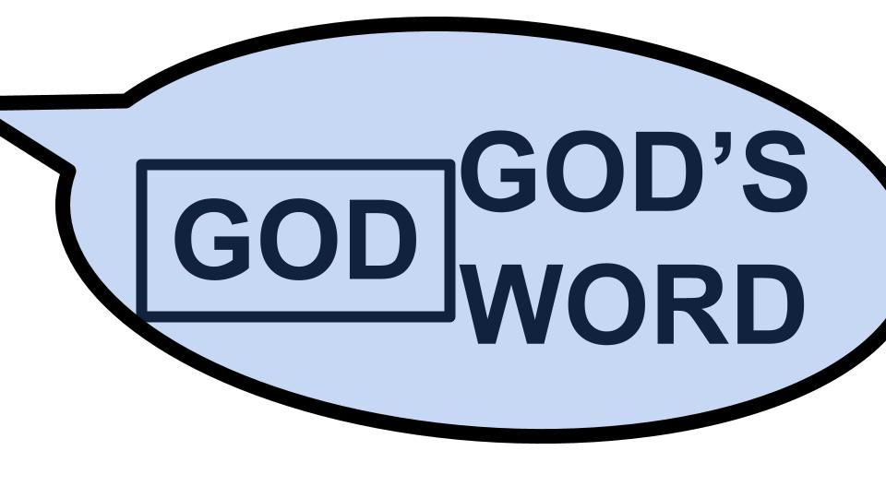

God has ZERO hypocrisy and 100% integrity. **God and His Word are perfectly united**. In Genesis 1, when God said “Let there be light,” there was zero delay in fulfilling that word. He said it and it happened in the same moment. For God, to speak is to act; to promise is to fulfill.

God is so united with His Word that John uses this idea as ***a way to present the Trinity***. “The Word was with God and the Word was God.” God the Father and Son are as closely related as Speaker and Word Spoken - if there was no hesitation, no delay, no hypocrisy, no separation between true intention, verbal expression and actual implementation. Jesus is the perfect expression of the desires, character, power and grace of God. Jesus is God breathed out - God verbalized.

So as we begin to construct a Biblical worldview in this new series called **FOUNDATIONS** - let’s start at the beginning with the cornerstone of our worldview - GOD IS. Here is an overview of this 9 week series.

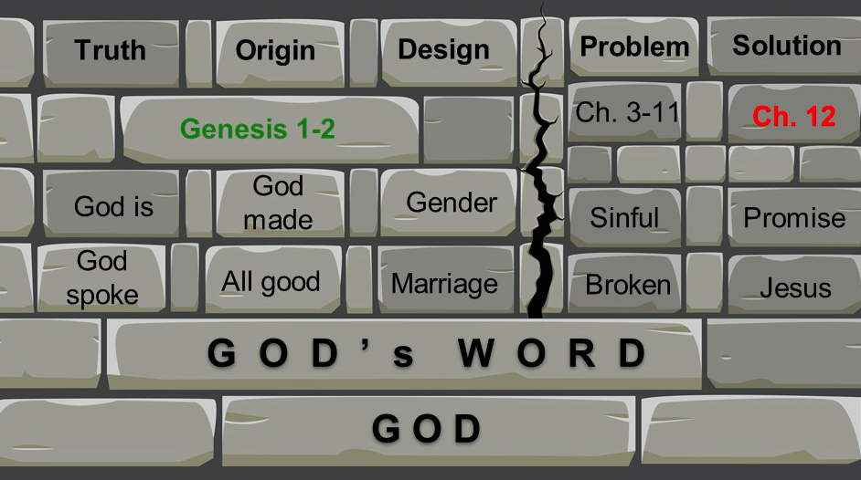

On the unshakeable foundation of God and His Word we will place **10 stones in five categories**: truth, origin, design, problem and solution. Every worldview has to answer the questions of truth and where you find it. Origin - where did this universe come from? Design - how was the world made and how should we treat it and each other? What is the problem with this world - because something is definitely wrong! And what is the solution?

The first question for any worldview is: ***what is your point of reference?*** Are you beginning with yourself and your thoughts, feelings and ideas? Or are you starting with GOD - and seeking the understand the world from His perspective, according to His revealed knowledge and will?

This is our key point for today and for this series: ***GOD is our starting point and our foundation***; God as revealed in His Word. How do we know what is true and real? How do we know where this world came from? How can we understand the design and purpose for our lives? How can we address our problems and seek real solutions? The answers to all of these questions must begin with God.

Our series will be mainly in Genesis 1-12, but for this week and next week we will jump from Genesis 1:1 to a couple of other key passages to deal with God and His Word. For this week, join me in John chapter one. As we construct a worldview, we will begin today with **three key principles**.

**Three Worldview Principles:**

1. To understand the world, start with God
2. To know God, you have to know Jesus
3. If you believe in Jesus, you have to obey Him

**1. To understand the world, start with God**

We’ve already seen ***the first principle*** - in both Genesis 1 and John 1. When you first open the Bible you are immediately confronted with the existence of God. And when you start John’s gospel, the apostle intentionally reminds us of Genesis 1 - saying **START HERE**. This is where to begin. And this shouldn’t surprise us, since Proverbs tells us that ***“the fear of the Lord is the beginning of knowledge.”***

If you don’t know God you will never understand the world or yourself. ***The more you know God, the more you will understand the world and yourself.*** So this leads us directly into the second principle:

**2. To know God, you have to know Jesus - the Word of God**

“In the beginning was the Word, and the Word was with God and the Word was God.” John 1:1

As we saw earlier, ***with God there is no distinction between Him and His Word*** - no separation between what God says and what He does. God has perfect integrity and zero hypocrisy. We see this throughout the Bible as God makes promises and keeps those promises, especially to Israel (and in spite of their flagrant and ongoing failure to keep their promises).

But **the ultimate proof of God’s faithfulness** came in the person of Jesus Christ. Jesus fulfilled all of the promises of the Old Testament - everything God was doing in Israel reached its culmination in Jesus, the Messiah.

* God promised **Adam and Eve** that one of their offspring would crush the head of the serpent, the devil.
* God promised **Abraham** that one of his offspring would bring blessing to the whole world.
* God promised **Moses** a prophet like Him would come, who would bring the fullness of truth to God’s people.
* God promised **David** that one of his offspring would reign on his throne forever.

These are just **four of the 300 plus promises** God made in the Old Testament: the promise of victory over death; the promise of blessing for everyone; the promise of truth fully revealed and the promise of a great King who would reign forever. Jesus won that victory - crushing Satan’s head when he rose from the grave. Jesus offers that blessing to everyone who comes to him in faith. Jesus gives the full light of truth to all who will walk in His light. And Jesus reigns - right now - on His throne in heaven, and will come back to reign on earth soon.

**Jesus is the Word of God** - the complete revelation of God’s **Nature**.

“The word was with God, and the Word was God… In him was life, and that life was the light of men.” John 1:1,4

If you want to know God, you have to know Jesus. ***You cannot know God apart from Jesus.*** He is the “light of the world.” Apart from Jesus, people walk in darkness. They cannot see the truth; they cannot understand God, the cannot know God.

But in Jesus we have the complete revelation of God’s nature. In Jesus we see God manifest - God in the flesh - God made visible.

The Jewish people knew that you could not see God and live. That was the key purpose of **the Temple area** - to create a place where the glorious presence of God could dwell without vaporizing the priests and the people.

Then Jesus arrived and they immediately knew he was **more than just another rabbi**. He taught with authority from Himself, not from rabbis who had come before him. He healed people regardless of how severe their illnesses were. He even raised the dead and commanded storms to be still. The message of Matthew, Mark, Luke and John is that Jesus is the Messiah of Israel and the fully divine Son of God! Jesus Christ is Lord!

If you want to know God, ***you have to know Jesus***. Study the life of Jesus and you will see the love of God, the power of God, the mercy and grace of God, the truth and glory of God. All the fullness of God was pleased to dwell in Jesus. He is the Word of God - the ultimate expression of God’s nature and will. He is also:

**Jesus is the Son of God** - **Eternally** begotten of the Father

“He was with God in the beginning.” John 1:2

***What is this “beginning”?*** As we’ve seen, the gospel of John starts with the same phrase as Genesis, the first book of the Bible. This beginning is in reference to creation, when God said, “Let there be light.” Before this there was only God. But there is no indication in Scripture that God created or gave birth to His Son just before creating the world. It’s clear from verses like this one in John 1:2 that at the dawn of creation, ***Jesus was already there***.

<https://www.gotquestions.org/eternal-Sonship.html>

The doctrine of the eternality of the Son of God is bound up in our understanding of **the Trinity** - that God is ***one God***, eternally existing in ***three persons,*** Father, Son and Holy Spirit. I don’t have time to explain that in detail today but let me show you two key verses that indicate the fact that Jesus was not God’s first and greatest creation, but rather has always been a member of the Godhead.

**Jesus is the Son of God** - **Eternally** begotten of the Father

“Jesus Christ is the same yesterday, and today, and forever.” Hebrews 13:8

“Before Abraham was born, I am.” John 8:58

For Hebrews to claim the unchanging nature of Jesus is to claim his eternality - His pre-existence before time began. Otherwise he changed completely by coming into being at some point in eternity past. There is no greater change than not-being and then being.

And in John 8:58, when Jesus says, “Before Abraham was born, I am,” He was not only saying, “I am one with the covenant God of Israel, Yahweh, who made the promises to Abraham and spoke to Moses as the I am,” He was saying “I AM God - one with the Father, equal with the Father, eternally proceeding from the Father in the joyful, life-giving union of the Holy Spirit.

***C.S. Lewis explained the word “begotten,” in distinction with the word “made.”*** You make something unlike you - a table, a clock, a car or house. It’s a different nature from yourself. ***You “beget” something of your own nature.*** A human begets a human; a beaver begets a beaver; a dog begets a dog. Jesus was not made by God the Father as something distinct from God. Jesus is eternally begotten of the Father - of the same eternal and divine substance as God the Father. He was not made by the Father of some different kind of substance. Jesus was not created at a certain point in time. From eternity past the Son of God has always been - still is - and always will be - in perfectly unified relationship with the Father, in the love of the Spirit.

I’m not saying the Trinity is easy to understand. I’m just saying it’s ***how God has made Himself known in the Bible.*** If you want to know God, you have to know Jesus. The reason we believe in a Triune God is because we believe in Jesus - who is not less than God, nor was He made by God - **JESUS IS GOD**, eternally one with the Father while being a distinct person from the Father. “The Word was with God, and the Word WAS GOD.”

Two more truths to know about Jesus if you want to know God.

**Jesus is the Agent of God** - the **Creator** of all things

“Through him all things were made; without him nothing was made that has been made.” John 1:3

We’ve seen how ***God is perfectly united with His Word***. There is no distinction between God’s will, God’s word and God’s action - He has perfect integrity, honesty and faithfulness.

Isn’t this interesting to see the means by which God made the universe? We see in Genesis that ***God created by SPEAKING*** - He simply said, “Let there be light.” But the One who spoke those words was not God the Father, but God the Son. Jesus was the agent of creation - He spoke the world into being. The Father planned the world. The Son created the world. And the power by which He created the world was the Holy Spirit. So creation was a Triune activity, as are all things.

The Father plans. The Son accomplishes. The Spirit applies. Consider this in your own salvation.

* **God the Father planned your salvation** - Ephesians 1 tells us - before the foundation of the world, according to the perfect purpose of His will.
* **Jesus, the Son, accomplished your salvation** - dying on the cross to pay for your sins.
* **The Holy Spirit applies that salvation to you day by day** - first helping you to understand your need for a Savior, then showing you the truth of all Jesus did for you, coming into your heart to fill and empower and lead you. And the Holy Spirit continues this until the day you die!

John 1:3 makes it clear that Jesus was the agent of creation - actually accomplishing the work. But there are also ***clues that the Holy Spirit was involved***, which we see in Genesis 1:2, as the Spirit was hovering over the surface of the deep. Here is another clue in Psalm 33:

**Jesus is the Agent of God** - the **Creator** of all things

“By the word of the Lord the heavens were made, and by the breath [Spirit] of his mouth all their host.” Psalm 33:6

The word for “Spirit” in both Hebrew and Greek is the word for **breath or wind**. Just as Jesus is the Word of God, ***the Spirit is the breath of God*** - the wind of His movement, the fresh air of His presence, the motion of His life. Think about what your breathing is to you. It is the rhythm of your existence - the breathing in and out of your daily experience. That is what the Holy Spirit is in the Godhead - the rhythm of the eternal dance - the breathing in and out of life-giving love between Father and Son.

***How was the world created?*** By the will of God the Father, through the voice of Jesus the Son, by the BREATH of the Holy Spirit. Creation was a unified activity of the Godhead, as are all things God does.

Jesus was the Agent of Creation. John makes that clear in John 1:3. Paul makes a similar point in Colossians 1.

**Jesus is the Agent of God** - the **Creator** of all things

“By him all things were created, in heaven and on earth, visible and invisible… all things were created by him and for him.” Col. 1:16

**Jesus is the beginning and the end** - the Alpha and the Omega. He brought this universe into being and He will bring it to its ultimate fulfillment when He returns and restores all things in Himself. All of this was created as God the Father’s GIFT to God the Son. And as we see what has happened in history, this whole story of redemption is Jesus giving back to the Father a redeemed and restored, reconciled creation. Do you see the beauty and wonder of the Trinity? How there is a constant back and forth from Father to Son, in the Spirit? The Father entrusts all things to the Son, and the Son does all things for the Father. Self-giving love. That is what God is.

You cannot understand God, much less know Him personally, apart from Jesus. One more truth about Jesus, and we’ll stay in Colossians for the next verse before coming back to John.

**Jesus is the Life of God** - the **Savior** of the World

“He is before all things and in him all things hold together… to reconcile to himself all things...” Col. 1:17,20

Jesus is the **Savior, Redeemer, Restorer** of all things, “whether on earth or in heaven.” This whole world is broken from bottom to top because of US. ***Jesus will fix it all, from bottom to top*** - because of HIM - His limitless mercy, grace, power and wisdom.

Hebrews one says that Jesus “upholds the universe with the word of his power.” He is not only the Savior of the world but also its sustainer. All things hold together in Christ. Jesus not only created you - He spoke you into being in your mother’s womb - **He is also your sustainer**. He keeps you alive - keeps you breathing - moment to moment - at His sovereign decree.

Yes, every hair of your head is numbered - that’s encouraging for those of us who are losing our hair. But so is **every breath you take**. Jesus has those numbered too. He gives you life and breath and everything else - simply out of the overflow of His sovereign goodness. One more point in John.

**Jesus is the Life of God** - the **Savior** of the World

“In him was life, and that life was the light of men.” John 1:4

**Our world was plunged into darkness** because of the rebellion of Adam and Eve - we’ll get to that later in this series. Jesus did not remain at a distance from this darkness. He sent the light of His Word into the darkness at every point in the story, which we see in the Bible. And then Jesus Himself came as the full and final revelation of the love and glory of God.

Jesus is the source of all life - the Creator of all things. And He is the giver of life - the Redeemer of all things. ***You cannot have true life much less eternal life, apart from Jesus***. He alone has that living water you can drink and live forever.

We were all born in darkness, but at some point the light broke through that darkness and Jesus called us into His light. We still stray back into that darkness of sin and selfishness, independence from God - rebellion. But Jesus patiently, graciously calls us back into His light.

Brother, sister, **that is where true life is found** - not in the darkness of your secret sin - but in the true fellowship with God that can only come from holiness and pure devotion to the Lord!

Jesus is the fountain of life - fellowship with Him connects us into the life of God Himself. If you’ve been here long you know I like C.S. Lewis - and my favorite Lewis quote is at the end of Mere Christianity.

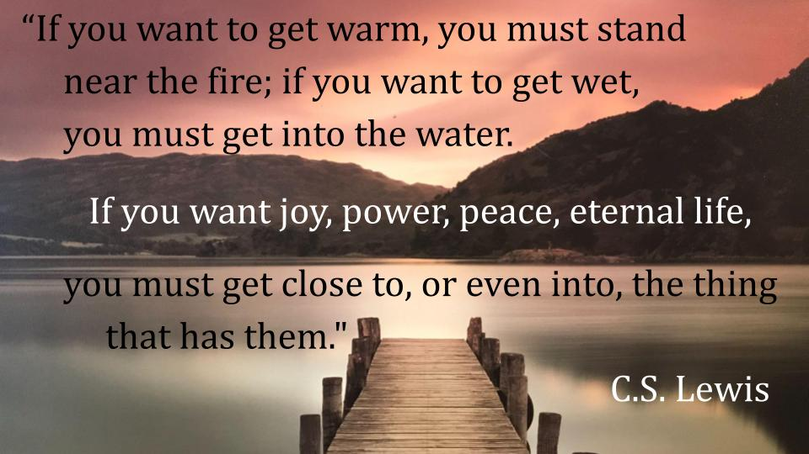

This is the invitation of the gospel - **the invitation of Jesus Himself**: ***come and get this life that is truly life!*** Stop running from one dry well to another. Stop wandering in the desert of your own sin. Come to the water that will satisfy your soul. Come to GOD - the true source of peace, joy, forgiveness, holiness and LIFE.

Come to Jesus!

**To know God you have to know Jesus**

* The Word of God
* The Son of God
* The Agent of God
* The Life of God

**Jesus is the Word of God** - the complete revelation of God’s glorious, loving, holy nature.

**Jesus is the Son of God** - eternally begotten of the Father, perfectly unified with the Father in the love of the Spirit.

**Jesus is the Agent of God** - the Creator and sustainer of all things.

**And Jesus is the Life of God** - the Savior, Redeemer and Restorer of the world.

If you come to Jesus, you come to God. **If you know Jesus, you know God**. If you don’t know Jesus, then the God you think you know is not God. For no one comes to the Father except through Jesus.

One final principle as we close.

**Three Worldview Principles:**

1. To understand the world, start with God.
2. To know God, you have to know Jesus.
3. If you believe in Jesus, you have to obey Him.

Jesus described **a wise man, who built his house on a rock**, and a foolish man who built his house on sand. Most of us enjoy going to the beach, and it’s fun, sometimes, to build a sandcastle. Though you want to be sure that someone adequately applies sunscreen to your back when you work for 2 hours on a sandcastle, otherwise you get quite crispy…

***Building a sandcastle is fun*** - because you know it’s temporary. No one with any sense builds a house without a foundation. Sand is shifting in its nature. A house built on sand will quickly collapse.

**3. If you believe in Jesus, you have to Obey Him.**

“Everyone then who hears these words of mine ***and does them*** will be like a wise man who built his house on the rock.” Matthew 7:24

The wise man is not just the one who HEARS the words of Jesus. He is not even the one who UNDERSTANDS or BELIEVES the words of Jesus. **The wise man is the one who DOES THEM**. By this definition are you wise or foolish? ***Are you building your life on the rock of OBEDIENCE to Jesus?***

Or are you like the wise man who has heard the words of Jesus but then walks away and just keep doing what you’ve always done?

We are working to construct a **Biblical, Christian worldview**. This is the starting point - start with God. You cannot understand this world until you begin to know God. And you can’t know God without knowing Jesus.

***But don’t deceive yourself into thinking you believe in Jesus if you don’t obey Him.*** To believe in Jesus is to call Him LORD - which means Master, Sovereign Ruler of all things. How can you call Jesus Lord and then NOT do what He says? It doesn’t work. If you don’t obey Jesus, then you don’t actually believe in Him, you don’t truly know Him.

One of the most comforting ***signs that you DO belong to Jesus is that you DO obey Him.*** You see the fruit of obedient faith in your life. And when you don’t obey Jesus - when you sin and do something wrong, you quickly feel convicted about it and you get back on the right track.

Let’s hold onto the truth we know and believe: there is One God. We know God by knowing Jesus. And as we know Jesus more and more each day, we joyfully obey Him!

Let’s pray.