**The Flood**

Genesis 6

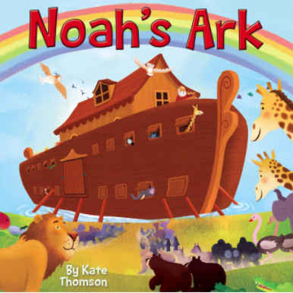

Probably one of the most famous stories in the whole Bible is **Noah and the Ark**. It is often presented like this, for children - with smiling animals, sunshine and a rainbow. Now, granted, it did work out ok for a small percentage of animals and exactly 8 people. But the story of Noah’s Ark is not a cheerful tale for children, it is ***a grim and terrifying warning for adults***.

We talked last week about **the Fall of man** - the reason our world is the way it is; and the reason our hearts are the way they are. ***Our world broke*** the day Adam and Eve sinned. The foundation cracked and sin erupted into the cosmos - bringing disease, disasters and death, spraying everywhere. And just as the world broke, ***people broke*** too - sin spread to every part of everything, and the deepest corners of EVERYONE.

Sin is around us and it is IN US. We all feel it. We all know it. The Bible explains it. And Noah’s Ark, and the Flood, teach us about **the true cost of sin**. Trust me, ***none of the animals were smiling*** when the thunder boomed, the lightning flashed and the rain fell in unending torrents. ***None of the eight human survivors were smiling*** when the door of the ark slammed closed and the overwhelming truth hit home for them with deafening finality: no one else had come. They were the only ones who would survive this flood.

The Ark gives us **hope**, for sure. God has provided a way of salvation. ***But the Flood gives us a clear and powerful warning*** - sin has consequences and judgment is coming. Today we will study Genesis six and two simple phrases:

“And the Lord saw…” (Gen. 6:5,12)

“And the Lord said…” (Gen. 6:7,13)

Here is the simple truth of the Bible: **God sees EVERYTHING**. And the Lord has said what He will do. He did not leave us to wonder and guess at what would happen on Judgment Day. The Bible is filled with ***warnings and exhortations*** about how to prepare for that Day - because it is coming, and coming soon.

Think of **how it was in Noah’s day**. It must have taken decades for Noah to build the Ark. In that time, we know from 2 Peter 2 that Noah was a ***“preacher of righteousness.”*** Both through his words and through his actions, Noah called people to the only place of salvation. He spoke of a righteous and holy God. But the people didn’t listen.

***They were busy, they were distracted***, they couldn’t conceive of a need for a huge boat like he was building. It didn’t make sense. Nothing like a flood had happened before. It wasn’t like hurricane season in Florida where everyone has heard the warnings and should know when it’s time to board up or get out.

But the main reason people didn’t listen to Noah, the main reason they didn’t get onto the Ark, is because **they had set themselves AGAINST GOD**. They had chosen, over and over again, not to seek God, not to follow their consciences. Instead, they had hardened their hearts, so God gave them over to their sinful desires. And Genesis six documents the result.

“**The Lord saw** that the wickedness of man was great in the earth and that every intention of the thoughts of his heart was only evil continually… So **the Lord said**, ‘I will blot out man…’” Genesis 6:5,7

We have four points to cover today - two things the Lord saw and two things the Lord said. The Lord saw. The Lord said. **The application** is pretty clear. If the Lord saw the evil in the world and the sin in the hearts of people then, He still sees that evil in us today. If the Lord said He would punish people for their sin then, He retains that commitment today.

**Only a great fool ignores a warning** about a clear and present danger. When a Cat 5 hurricane is bearing down on your house. When a live shooter has been announced in your school. When a bomb has been discovered in your building. When warnings are given about the integrity of the foundation of your apartment building. Only a great fool ignores serious, life or death warnings like that.

And yet - every day - ***people ignore the clear and serious warnings in the Bible***. Let’s study this passage soberly and learn what God saw and what God said.

**The Lord Saw…**

* Every **Sin**

“The Lord saw that the wickedness of man was great in the earth.” Genesis 6:5

Now, in the movement of the book of Genesis it seems like only a few days went by from creation to Cain and Abel and then to the flood. But Genesis five outlines the first genealogy in the Bible, documenting the fact that there were 1,056 years before Noah was born, and another 500 years before he had Shem, Ham and Japheth. The flood came in the 600th year of Noah’s life, so from creation to the flood **over 1,600 years had gone by**.

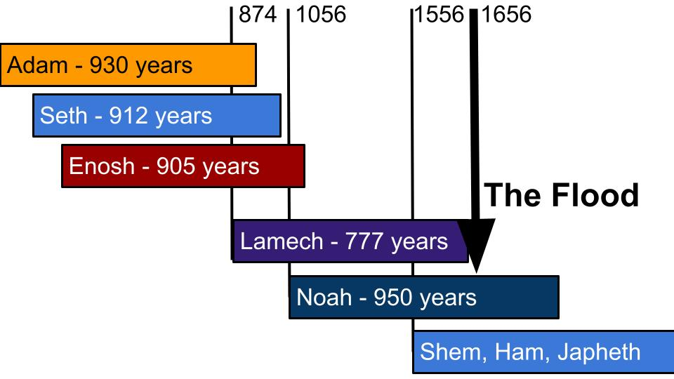

Adam lived 930 years so Noah could not have met Adam himself, and probably in 1,000 years people spread out a good bit. But Noah’s father Lamech almost certainly knew Adam. And ***Noah conceivably could have met and spent time with Adam’s grandchildren.*** Adam and Eve’s son, Seth, died just 14 years before Noah was born. So memory of Adam and Eve - stories about the Garden and the early days of creation - would have gotten to Noah very clearly.

In spite of that long family memory, the people on earth in Noah’s day had lost all fear of God and all love for God. Look at the extent of the depravity on earth in verse 5 - “the wickedness of man was GREAT in the earth.” That’s a serious indictment! But look at verse 11:

**The Lord Saw…**

* Every **Sin**

“Now the earth was corrupt in God’s sight, and the earth was filled with violence.” Genesis 5:11

The wickedness of mankind had become great. When God looked at the earth what He saw was corruption - evil, selfishness. And in particular - **VIOLENCE**. Verse 13 repeats this description, “filled with violence.” Instead of being filled with worship or filled with gratitude or filled with love, the earth was filled with violence. Theft, abuse, slavery, murder, war, treachery - violence within homes, and violence in the streets; violence within families and violence between families. The earth was FILLED with violence.

We got a little picture of this in **the evacuation from Kabul** recently. As soon as the restraint of the American military began to pull back, the aggression of the Taliban moved into the vacuum. In the name of Shariah Law, which they claim is being faithful to their god, they subjugate and abuse women and they systematically hunt down and persecute Christians. The evil in Afghanistan was restrained for 20 years by the power of the US military. Now that our military is gone, there is nothing left to restrain the evil and violence of the human heart there.

But here is our first truth - **THE LORD SAW**. There is nothing that happens on this planet that escapes the Lord’s notice. Whether an act is committed in public, on camera and played on repeat in the news, or if it is done in secret and no one ever finds out - God sees. Listen to this from Luke 12:

**The Lord Saw…**

“Nothing is covered up that will not be revealed, or hidden that will not be known. Therefore whatever you have said in the dark shall be heard in the light, and what you have whispered in private rooms shall be proclaimed on the housetops.” Luke 12:2-3

The Lord sees every sin - every action. He hears every whisper, He sees it all and one day He will bring everything into the light. Revelation 20 describes it as books that are opened:

**The Lord Saw…**

“And the dead were judged by what was written in the books, according to what they had done. Rev. 20:12

The Lord sees everything that happens on earth - and every action, every choice, is documented. ***Massive books*** contain a detailed, moment by moment ledger of everything that you and I have done. The Lord saw.

This should first of all give us great **confidence in the JUSTICE of God**. Nothing escapes His notice, so there will be a reckoning one day. People will be judged based on perfect truth. No one will get away with anything in the end.

We apply that truth to others and we say “Yeah, get ‘em Lord! JUSTICE” But then we pause, right? We hesitate and say, “Hold on” The Lord sees EVERYTHING… Even what is done in secret. And suddenly your heart is in your throat, sweat breaks out on your forehead and you get a splitting headache, right? Everything. Written in books that will one day be opened. Everything exposed. Everything in the dark displayed in the light.

Uh oh.

Yeah, the perfect, infinite knowledge of God is a rightly sobering truth. When the Lord looks into your life, what does He see? Because it’s not just the actions and the words - He sees even into our hearts. Look back at Genesis 6, verse 5.

**And the Lord saw…**

* **Every Thought**

“The Lord saw… that every intention of the thoughts of his heart was only evil continually.” Genesis 6:5

“The wickedness of man was great.” And the earth “was filled with violence.” Everything had been corrupted by sin as people were consumed by their own selfishness, lusts, and violence. Those violent acts grew from intensely selfish and evil hearts.

Notice how **complete the wickedness had become**: EVERY intention… ONLY evil CONTINUALLY. This is complete corruption at all levels. It wasn’t just a passing bad choice here and there - like people always describe mass shooters. “Oh, he was such a good kid, always polite, always friendly…” until he got his uncle’s assault rifle and shot up 30 people in a theater or until he walked into a church and sprayed the congregation with bullets.

The Lord not only sees our actions - He sees right into our hearts. We cannot judge another person’s motives, we can’t know another person’s secret thoughts. But God does. He has perfect X-ray vision to the soul - total perception of the thoughts and intentions of the heart.

It’s important to see how it got so bad on the earth. Look at verse 11.

**And the Lord saw…**

* **Every Thought**

“And God saw the earth… all flesh had corrupted their way on the earth.” Genesis 6:11

Sin doesn’t just happen. We CHOOSE it. Corruption and wickedness does not sneak up on us - it grows from within us. Think about the phrase, “one thing led to another.” Yes, that’s true - through a series of CHOICES - both in the moment and in the days, weeks and months leading up to the moment when you were “carried away.”

This is what sin does - it grows and spreads until it takes over. ***Sin is the ultimate CANCER.*** It starts with a small and apparently innocent thought, but that little temptation, if you let it take root, will grow to take over your entire life.

**Romans 1** gives a powerful and sobering picture of how sin works and what God does as sin takes over.

|  |  |
| --- | --- |
| **3 Exchanges** | **3 Releases** |
| “Exchanged the glory of God for images” v. 23 | “God gave them up in the lusts of their hearts” v. 24 |
| “Exchanged the truth about God for a lie” v. 25 | “God gave them up to dishonorable passions” v. 26 |
| “Exchanged natural relations for those that are contrary to nature” v. 26 | “God gave them up to a debased mind” v. 28 |

This is **the whirlpool of death** that sin sucks people into. One small choice - to worship a created thing rather than the Creator - sets in motion a series of choices that allow sin to take over and drag people down into increasing corruption and slavery.

God sees the choices as they happen. He looks into our hearts and sees the idolatry when it begins. He sees the trades we make - exchanging truth for lies, exchanging a holy, God-honoring lifestyle for a life devoted to sin and self-indulgence.

Romans 1 shows us that **God does not FORCE anyone’s hand**. For those who want to choose sin - who want to choose to reject Him, He lets them go. In the parable of ***the prodigal son*** we see the patience and mercy of the Father. When his younger son comes and asks for his inheritance NOW, the Father doesn’t kick him out with nothing, he divides the estate and gives the young man the half he should have gotten when their father died.

When the father knew his younger son was wasting the money on a sinful, dangerous lifestyle, the patient father did not chase him down and punish him. He waited. And watched. And waited. And when the rebellious young fool finally came home, the Father embraced him and celebrated his repentance and return.

Here is our summary for the first half:

**The Lord Saw:**

* Every **Sin**
* Every **Thought**

When God looked down on the world He had made, what He saw filled Him with sadness. Genesis 6 says, “***He regretted that he had made man on the earth***, and it grieved him to his heart.” Into His good creation, mankind had brought great evil and violence.

The flood seems like an extreme response. But it helps to understand the death of all people and all living things on land if we remember this truth: **the LORD SAW**. We can look the other way and ignore some evil in the world simply because we don’t see everything, we don’t know everything. But God cannot do that. He cannot NOT know. He sees and knows every choice, every action, every thought, every desire.

And what God saw 1,500 years after making the world was a planet filled with evil and violence. Filled with it. And so we move into part two. The Lord SAID.

**The Lord said…**

* **He will Punish sinners**

“So the Lord said, ‘I will blot out man whom I have created from the face of the land.” Genesis 6:7

Because God saw such terrible wickedness everywhere - in every heart, every relationship, every town, every country, He said, ***“I am sorry that I made them.”*** And so He SAID, ***“I will blot them out.”*** When God called Noah to build the ark, He clearly explained why:

**The Lord said…**

* **He will Punish sinners**

“God said to Noah, ‘I have determined to make an end of all flesh, for the earth is filled with violence through them.’” Genesis 6:13

There is **nothing vague or unclear** in these statements. God promised to wipe out every living thing that was not on the ark with Noah. He even specified to Noah how it would take place, through a flood. Verse 17.

**The Lord said…**

* **He will Punish sinners**

“I will bring a flood of waters upon the earth to destroy all flesh in which is the breath of life.” Genesis 6:17

This is an extreme **lesson in CONSEQUENCES**. Who suffers for the sins of mankind? All living things! All of the animals and birds - everything that lived on land. A handful of each species was gathered onto the Ark, but hundreds of millions - billions and billions of living creatures were wiped out along with the sinful, rebellious people.

Imagine ***how it felt for the average person*** on earth in those days. When the dark clouds started rolling in. When the first raindrops fell. When you felt the rumble from something breaking loose underground. Suddenly fear was activated. Suddenly adrenaline kicked in. Farmers ran in from their fields. Mothers called children into their homes. Families scrambled to figure out where the nearest high ground might be.

We can’t be sure **how long it took for Noah to build the Ark**. The text in Genesis 6 indicates that the story began after Noah had Shem, Ham and Japheth, which took place around his 500th birthday. The flood came in Noah’s 600th year. Some have deduced from this that Noah might have taken a full 100 years to build the Ark. There is some poetic justice to this line of thinking - that God gave people on earth a full 100 years to hear about the Ark and come get on board.

The short answer is that we can’t know exactly how long Noah and his sons labored to build the ark.

​​<https://answersingenesis.org/bible-timeline/how-long-did-it-take-for-noah-to-build-the-ark/>

But it is a safe assumption that it was a long time. 50 years. Maybe 60 or 70. They didn’t slap that gigantic ship together in a few weeks or months. So the building of the Ark was itself a form of **GOSPEL PROCLAMATION**. Look at 2 Peter 2:

**The Lord said…**

* **He will Punish sinners**

“If he did not spare the ancient world... but preserved Noah, ***a preacher of righteousness***…” 2 Peter 2:5, NIV

How was Noah a “preacher” or “herald” of righteousness? I believe it was both through **his words** - inviting people to be saved in the Ark, and through **his actions** - building the Ark in which they could be saved.

God, in His mercy, **gave people DECADES for word to spread about Noah** and his enormous boat. They didn’t have Netflix or the NFL in those days - so something like a 500 year old man building a ginormous boat, without any water nearby, would surely have made their local news, and spread around from family to family, town to town.

Lots of people probably made the effort to come visit “Crazy Noah” to see his huge boat. No doubt, when people came, he explained to them that a global flood was coming and the only way to survive it was to come onto the Ark with him and his family.

It is tragically revealing that **NO ONE CAME** - no one listened. ***No one believed*** Noah’s message because no one believed in God or feared His punishment. They didn’t believe God SAW anything they did - or even if He saw what they were doing, they didn’t believe God would do anything about it.

In spite of what God said THROUGH NOAH, no one came. No one believed.

People are doing the very same thing today. In fact, Jesus said this is how it would be.

**And the Lord said...**

“Just as it was in the days of Noah, so also will it be in the days of the Son of Man.People were eating, drinking, marrying and being given in marriage up to the day Noah entered the ark. Then the flood came and destroyed them all.” Luke 17:26-27

People were so unconcerned about Noah and his impossible flood that ***they planned weddings for the final day***. Think how brazen that choice was! “Oh, you say the world is ending on that day - well, I’m going to make that my wedding day!”

It’s all fun and games until the rain starts to fall, and then the ground cracks open and water starts gushing out everywhere.

Put yourself in those sandals. Experience that **dread realization**.

* Noah was right.
* There is a flood coming.
* I didn’t think it was possible.
* I didn’t believe that crazy old man could be telling the truth.
* I thought there would be more time.
* Now it’s too late.
* I have nowhere to run. Nowhere to hide.
* The flood is coming.
* And now it’s here.

You can picture people kneeling in despair as great walls of water closed in on them - very much like the ending of Rogue One; except in Rogue One they died nobly for the rebellion. In the Flood, people died simply because they were too stubborn to repent.

“Then the flood came and destroyed them all.”

So many preachers are out there today whispering the devil’s lie: ***“Did God really say”*** he would punish sin? “Did Jesus ever talk about hell and eternal damnation?” Remember, the devil’s playbook is a one-sheeter. He runs three plays really well. The first one is to **question God’s Word**.

I want to be exceptionally clear today. God really did say that He would punish sinners. Let’s review the specific words God said.

**The Lord said…**

* **He will Punish sinners**

“You must not eat from the tree of the knowledge of good and evil, for when you eat from it you will certainly die.” Genesis 2:17

This was **the original warning** in the Garden. If you eat this fruit, the consequence will be a punishment called death. They did not know what death was - because nothing died. That was a big part of the “knowledge of good and evil” that God wanted to keep them from experiencing. After the fall, God said to Adam:

**The Lord said…**

* **He will Punish sinners**

“By the sweat of your brow you will eat your food until you return to the ground, since from it you were taken; for dust you are and to dust you will return.” Genesis 3:19

In His mercy, God did not strike Adam and Eve dead immediately. But God did pronounce the consequences of their sin - consequences for them, their children and for the whole world. The main consequence for Adam and Eve, as God warned them in Genesis 2, was death. “Dust you are, and to dust you will return.”

We saw in Genesis 6 that God told Noah that judgment was coming for the sin of mankind.

**The Lord said…**

* **He will Punish sinners**

“So the Lord said, ‘I will blot out man whom I have created from the face of the land.’” Genesis 6:7

**Three times** in Genesis 6 God repeats this promise - to wipe out all people and everything else on land. He saw their wickedness and could tolerate it no longer. He regretted making these rebellious and violent people and resolved to start over.

Then in Genesis 7, God followed through on His promise - even giving a seven day countdown while the animals marched to the Ark. If nothing else had gotten the attention of the people around him, surely ***an endless parade of marching animals*** would have made the news.

<https://arkencounter.com/blog/2014/05/05/noah-and-the-animals-part-2-how-did-noah-find-the-animals/>

It is remarkable that exactly **one pair of each kind of animal** - one male and one female - came to Noah. What a spectacle that must have been - the world’s most comprehensive zoological convention - marching in from all over and coming to one place over the course of one week.

***The animals perfectly obeyed God’s command.*** Every pair of every type of animal. Answers in Genesis estimates that around 5,000 total animals came to Noah! How could people have missed that spectacle? Even if they ignored crazy Noah building his giant boat, you would think that a week of animals, steadily streaming toward that giant boat would have attracted at least some people.

The animals perfectly obeyed. **The people on earth were perfectly disobedient**. All 5,000 animals the Lord summoned came and got onto the Ark. None of the people who saw Noah’s ark - not a single one - came with him. Only Noah’s sons and their wives. That was it.

Listen to verse 16 of chapter 7.

**The Lord said…**

* **He will Punish sinners**

“And those that entered, male and female of all flesh, went in as God commanded him. ***And the Lord shut him in***.” Genesis 7:16

Imagine the sound of that **huge wooden door slamming shut**. Feel the finality of that CLUNK. Before that time people could have raced up the plank and joined Noah. After that door was closed, there was no way in - no chance of escape. And the rain was already falling.

***The Lord said that He would flood the earth.*** In His mercy He gave people several DECADES before He wiped them all out. The way of escape was very visible and very accessible. But the day came when it was too late. The door was closed. And then God did what He said He would do. He wiped out everything on earth that breathed air.

Ok. But that was the Old Testament. That was under the Law. (Actually it was long before the Law was even given.) That was before Jesus, before grace. Does God STILL say He is going to punish sinners?

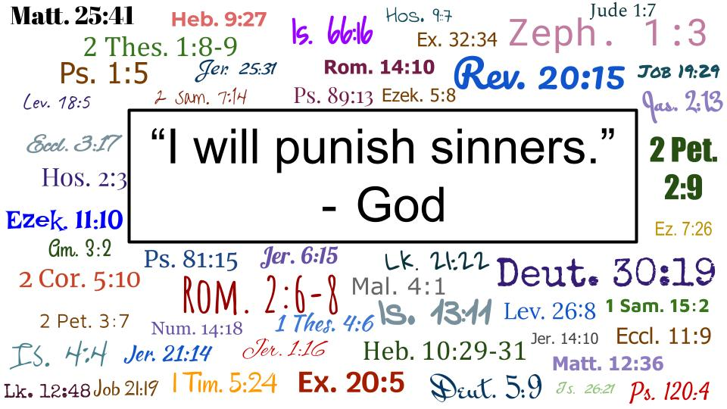

That is just ***a small sampling*** of verses in the Bible that talk about the judgment of God that is coming for sinners. You can see these are verses **from every part of the Bible** - Old and New Testament - Law, poetry, prophecy, gospels, letters, every part.

From the time that God told Adam and Eve, “if you eat this fruit you will surely die,” to the day that Paul wrote, “the wages of sin is death” in Romans 6, the unified testimony of all of the prophets, all of the apostles and every writer of Scripture is that God - in His perfect holiness and justice - has said He WILL punish sinners.

Let me show you three of the clearest, most sobering verses from this list.

**The Lord said… He will Punish sinners**

“He will render to each one according to his works… for those who are self-seeking and do not obey the truth, but obey unrighteousness, there will be wrath and fury.” Rom. 2:6-8

God will render to each one in perfect accordance with what we have done. ***Every word, every action, every motive, every desire*** will be considered. Justice will be absolutely perfect. Nothing will be missed. The Lord sees every action, He knows every thought.

And notice the result of this judgment: “wrath and fury.” This is not a gentle scolding. This is not a slap on the wrist. The final judgment for sinners will be soul-crushing, unimaginable terror - with no place to run, no way of escape.

The story of Noah and the flood is in the Bible to give us an idea of what that day will feel like for people who don’t know Jesus. The sudden rush of terror. The shocking realization that everything they have believed was wrong - that they neglected God, rebelled against His Law and deserve nothing from Him but wrath and fury.

**The Lord said… He will Punish sinners**

“When the Lord Jesus is revealed from heaven with his mighty angelsin flaming fire, inflicting vengeance on those who do not know God and on those who do not obey the gospel of our Lord Jesus.” 2 Thes. 1:7-8

God promised Noah to never again flood the earth with water. But God is on record to say that when Jesus comes back it will be with the **unquenchable fire** of His perfect holiness and awful wrath. Jesus came the first time in humble anonymity. When He comes back, it will be in the full manifestation of His awesome glory. Every knee will bow before Him, every tongue will acknowledge Him in that day.

But for many, many people, **it will be too late** to call on Him to save them. All that awaits them in that moment is the terror of being utterly exposed - of having every act, every thought, displayed for the world to see, and then to fall under the just pronouncement of condemnation. One more verse.

**The Lord said… He will Punish sinners**

“As for the cowardly, the faithless, the detestable, as for murderers, the sexually immoral, sorcerers, idolaters, and all liars, their portion will be in the lake that burns with fire and sulfur, which is the second death.” Rev. 21:8

However you interpret the ***“lake of fire”*** there can be no doubt that it will be unimaginable suffering. “Weeping and gnashing of teeth,” is the Biblical description of those who come under the just condemnation of God. “Outer darkness.” Eternal suffering. Wrath and anger. Fiery torment.

The Lord has said - He WILL punish sinners. ***Only a fool would ignore the clear and consistent testimony of the Bible*** down through the ages. God is on record, clearly and repeatedly, that He will - and He must - punish sinners.

Thankfully that is not the end of the story. The flood vividly presents the powerful judgment of God upon a sinful world. But in the midst of that death and destruction a giant wooden vessel rides upon the storm. In the safety of that Ark eight people survived, along with thousands of animals - enough to re-start creation.

The Lord saw every sin and every thought. The Lord said He will punish sinners. But the Lord has also said something else.

**The Lord said…**

* He will **Save** anyone who comes to Him in faith

“So the Lord said, ‘I will blot out man…’ But Noah found favor in the eyes of the Lord.” Genesis 6:7-8

Even as God pronounced judgment on sinners, He extended His grace to Noah and his family. And through their family God offered salvation to the world.

**The Lord said…**

* He will **Save** anyone who comes to Him in faith

“I will bring a flood of waters upon the earth… But I will establish my covenant with you, and you shall come into the ark.” Genesis 6:17-18

For thousands of years **the Ark has been a picture of God’s grace** - a powerful symbol of salvation. Even when the rain fell for forty days and nights, even when every living thing on earth was destroyed, the Ark rode upon the waves. Noah and his family remained safe and dry, with plenty of food and water - and plenty of work to do in caring for their floating zoo.

**The Lord said…**

* He will **Save** anyone who comes to Him in faith

“By faith Noah, being warned by God concerning events as yet unseen, in reverent fear constructed an ark for the saving of his household.” Heb. 11:7

What was it that saved Noah? It was **the grace of God** - for Noah was not perfect, as the rest of the story in Genesis proves. But it was Noah’s faith in God that connected him to God’s grace. By faith Noah built the ark. By faith Noah went on board. His faith was a personal, internal conviction. But it expressed itself in the very tangible act of building a giant boat and getting on board.

I’ve shared many times that this is my favorite gospel illustration - **a lifeboat**. If we were all on the Titanic and we knew it was going down, the means of salvation would be very clear: get to a lifeboat. And everyone would know that it’s not enough to know there is a lifeboat. It’s not enough to believe the lifeboat could save you. Common sense tells you that you have to GET ON BOARD.

The only people who survived the flood were the eight people who GOT ON BOARD.

Lots of people today know about Jesus. Lots of people believe He COULD save them. But that is not the same thing as being in a committed, personal, covenant relationship with Jesus by faith.

* ***What about you?*** Have you made that once and for all, decisive commitment to Jesus? Have you called on Him to forgive your sins?

**The Lord said…**

* He will **Save** anyone who comes to Him in faith

“By faith Noah… constructed an ark… and became an heir of the righteousness that comes by faith.” Heb. 11:7

Noah was justified by faith alone. It was his trust in the Lord that saved him. “The righteousness that comes by faith.”

* The Lord WILL punish sinners. All of us are sinners. But all of us who call on Jesus to save us have our sins forgiven, so we are pronounced RIGHTEOUS.
* That means we get our final verdict NOW - the verdict Jesus will pronounce when we stand before Him is ours TODAY if we believe in Him. He looks at you and He looks at me and says “JUSTIFIED.” Not only “not guilty” but “righteous!”

***What about your loved ones?***

Have they settled this decision with the Lord? Don’t delude yourself into thinking they will be fine if they keep ignoring Jesus and walking away from Him. God is very clear that only those who belong to Jesus by faith will be saved.

Let’s close today by **praying for our loved ones** who are not on the lifeboat yet - they are not with us in the Ark of God’s salvation in Christ. Let’s pray for them. Let’s gently but persistently keep inviting them, calling them to come with us to the One place of safety and life.

Let’s pray.