**The Millennium**

Revelation 20

Here is an overview of Salvation History:

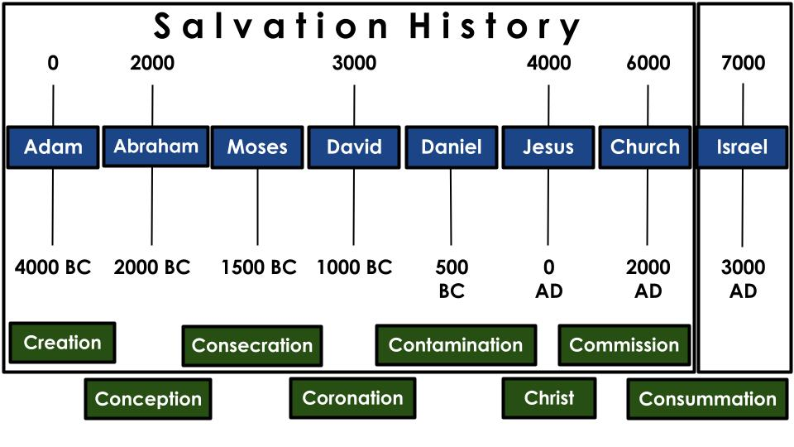

From the **Good Creation** of the world, including Adam and Eve, to the **Miraculous Conception** of Abraham who would become the father of a great nation, to the **Blood Consecration** accomplished through Moses in the Exodus, we see the formation of Israel. From the **Glorious Coronation** of David, at the height of the Old Testament Kingdom to the **Worldly Contamination** of Israel in the times of Daniel and the exile, to the perfect redemption provided in **Christ**, the Messiah, the Savior - we see the rise and fall of Israel. Jesus sent out the Church with the **Great Commission**, while we await the **Final Consummation** of all things in the return of Christ, the Millennium and the final judgment.

That is ***the Bible in one minute***. It is the story of Israel, and it is your story and mine. It is God’s story - the story of Salvation history. And you’ll notice I’ve offset the last 1,000 years on purpose. Let me make it even more clear.

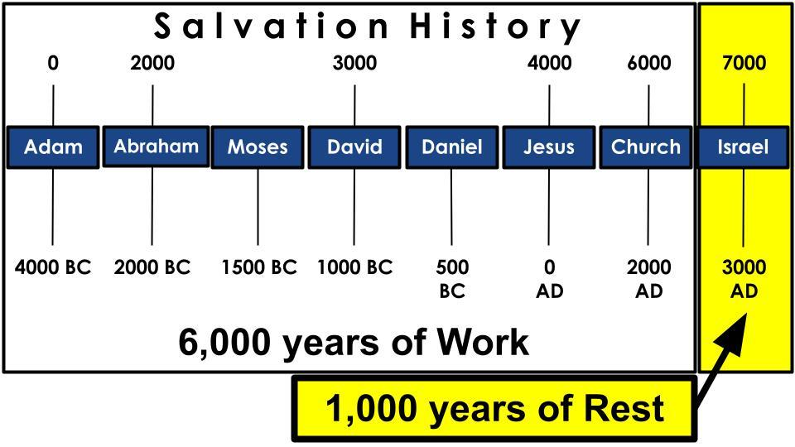

Rabbinic teaching in Jesus’ day theorized that history might well follow a 6,000 year timeframe, followed by **a 1,000 year rest**. If that proves correct, props to those ancient Rabbis! With a little more historical perspective, if we are, in fact, close to the end of the age - this theory could prove exactly right.

(Now, the dates aren’t as clean and perfect as I have them in this chart - they give a round ballpark. Daniel is the biggest fudge, since he was closer to 600 BC. But he’s a bigger deal than Ezra, who did live around 500. No offense to Ezra. It is known that Jesus was born in 4 B.C. and has been well argued that creation could be dated to 4004 BC - so the dates might actually be more specifically accurate than we realize. Especially with a 2033 date from over 100 missions organizations to reach the remaining 2B unreached people with the gospel. That would set up 4,000 years of OT history to the birth of Jesus and 2,000 years of NT history, dating from the resurrection.)

<https://answersingenesis.org/bible-timeline/the-world-born-in-4004-bc/>

That visual timeline provides one explanation for the Millennium - the 1,000 years we just heard about in Revelation 20. If you’re with me in the Bible, let’s take a closer look.

**The Millennium**

“And he seized the dragon… and bound him for **a thousand years**… Those who had been beheaded… came to life and reigned with Christ for **a thousand years**.” Revelation 20:2,4

An angel is sent with a key and a chain to capture the devil and lock him away in the abyss - the timeout chair for demons - for 1,000 years. These are two of the six occurrence of this phrase, “1,000 years” in this passage. ***This is the only place in the Bible where the Millennium is mentioned. But it is mentioned six times,*** and always the same way. If a figurative period of time was intended, John could have used some synonymous phrases such as “the great Day of the Lord” or “this long age” or “this season.”

Exactly six mentions, using exactly the same phrasing, seems to point us back to **Genesis 1 and the six days of creation** - which also use the same phrasing, “There was evening and there was morning, the first day… the second day... “ etc. Six literal days to establish the work week, followed by a day of rest. Six thousand years followed by 1,000 literal years to bring history to its conclusion. We can’t be dogmatic about observations like this, but they do make you pause to reflect on ***the sovereignty of God over the details of history***.

Now, let’s dig into Revelation 20 and we will see **three purposes for the Millennium**. The 1,000 year reign of Jesus on earth proves three theological facts beyond all doubt. Here is number one:

1. The Millennium Proves God’s **Power** over evil

“Then I saw an angel coming down from heaven, holding in his hand the key to the bottomless pit and a great chain.” Revelation 20:1

The primary message of the whole book of Revelation is that **Jesus REIGNS**. ***God is sovereign over all things***, and Jesus - the Sovereign Agent of God to whom all authority in heaven and on earth has been given - reigns over all things.

Throughout history and throughout our lives **we struggle with God’s sovereignty as it relates to evil**. It is hard for us to trust in an all-powerful, all-wise, all-loving God who allows so much evil to go seemingly unchecked in the world - and especially in our lives.

* Why do ***cancer and heart disease*** and strokes and COVID kill so many when they are still so young?
* Why does God allow ***car accidents and mass shootings*** and tsunamis and hurricanes that kill so many?
* Why does God allow civil war and ***genocide and terrorism and slavery***?

The closer you come to any of these things - and a million other expressions of evil in this world - the more difficult it is to make sense of it. But the fact is that God **has** allowed these things, He does allow them - ***so there must be reasons***, even if we can’t understand them. So we must conclude that God’s desire is for us to trust Him just as a parent would say to their child who is starting chemo treatments for leukemia. The child could not possibly understand the reason for the coming sickness and misery and hair loss - but has to trust mom and dad and the doctors that the suffering will be worth it.

In the same way, we have to trust that God has His reasons for allowing evil and suffering in the world as He does. ***But evil will not have the last word.*** And that is the first purpose of the Millennium - to give one final proof of God’s sovereign power over evil and the devil.

As we have many times before in the Revelation, this scene opens with an angel. The angel descends from heaven with two things in his hands: a key and a chain. The key represents AUTHORITY. Who is able to lock and unlock the bottomless pit? God alone. Isn’t it striking that ***the devil does not have the key to his own dark domain?*** No, God has that key and hands it to an angel. Jesus doesn’t have to handle this step. It is delegated to an angelic messenger. And with the key is a great chain.

Now, the devil is a spirit being so the size and material **strength of the chain** is - well - immaterial. The chain is another symbol of power and authority. Being locked in the abyss would be quite sufficient to keep the devil at bay for 1,000 years. But just to add some vivid **finality to his sentence**, we can picture a rottweiler with a strong collar and a heavy chain to hold him back. That is the picture here as the devil is locked up.

1. The Millennium Proves God’s **Power** over evil

“And he seized the dragon, that ancient serpent, who is the devil and Satan, and bound him for a thousand years.” Revelation 20:2

It is significant to notice who does this binding. It’s an angel. And there is no conflict. No battle. The angel isn’t even named, though it might be Michael the archangel, that isn’t stated. So we are left to assume that some unnamed angel with average status and power gets this honor. Think of good old ***Clarence from It’s a Wonderful Life***. “You’re just the type of angel I’d get,” says George Bailey. There goes Clarence with the key and the chain and the devil can’t do a thing but hang his head, ***like a convicted killer being taken off to death row by the bailiff.*** That bailiff might be an old man, a weak man with no gun. But he represents the authority of the court, which represents the authority of the state - so to resist the bailiff is to fight against the full might of the state government.

Just like that, after the return of Christ, the devil is seized, thrown into the abyss and locked up for 1,000 years. ***Clang, you can hear the door slamming shut*** and see the devil locked away in solitary confinement for the whole Millennium.

The devil is currently the “prince of the power of the air,” the ruler of this present evil age. ***But even his present “rule” is limited and delegated.*** He was struck down from heaven and allowed to live for a while on earth, as part of the drama of salvation history that God wanted to play out. Every good story needs a good villain. Lucifer, the most glorious angel, thrust himself into that role of the super villain. His time now is exceedingly short which makes him an even more dangerous enemy, as that roaring lion prowls around trying to take as many to eternal misery with him as he possibly can.

When the devil is released at the end of the 1,000 years, we’ll see how the whole world immediately flocks after him. But for now notice how the last great battle ends.

1. The Millennium Proves God’s **Power** over evil

“They surrounded the camp of the saints… but fire came down from heaven and consumed them, and the devil… was thrown into the lake of fire.” Revelation 20:9-10

Tragically, the devil has one last card to play - ***his familiar DECEPTION card*** - and remarkably, after 1,000 years under king Jesus, people still fall for it. But as at the Return of Christ when victory came through a WORD from Jesus, so victory comes here immediately and decisively from heaven. **No battle. No resistance.** Just fire falling on the armies of the devil and consuming them. Whoof.

For a few days the saints in Jerusalem had to sweat it out while the devil gathered his armies and came to lay seige to the city. But as soon as they were arrayed around Jerusalem God shook His head and did like Sodom and Gomorrah - rain fire. It’s like Sodom and Gomorrah, but actually opposite. In that case, the two evil cities were consumed with fire from heaven, and those outside the city (Lot, Abraham’s nephew) survived. In this case those in Jerusalem survive and those around the city are burned up.

When God aims at someone, He doesn’t miss. 7 trumpets. 7 bowls of wrath. All who oppose God have already suffered terribly for their refusal to repent. This is simply the last straw, the final blow. **God wins. The devil loses.** He gets tossed into the lake of fire with the beast and the false prophet - so now the fake trinity is together in the misery they will endure forever. And look who goes into that lake next:

1. The Millennium Proves God’s **Power** over evil

“Then Death and Hades were thrown into the lake of fire.” Revelation 20:14

***The last enemy to be defeated is death.*** Hades is the place of the dead. Both death and the grave end up in the lake of fire - meaning they end up totally powerless, forever negated. All that is evil, all that is bad, all remnants of the curse, all chaos and destruction will be destroyed. This is the last step of unmaking the world so God can remake it without sin or evil or pain or suffering or the devil or DEATH. All things new means all things corrupted must be purged. The 1,000 years on earth, still within history, completes that final purge.

That’s the first truth the Millennium proves - God’s sovereign power over all evil, including the devil and death. Here is the second truth:

1. The Millennium Proves God’s **Faithfulness** to His people

“They surrounded the camp of the saints, and ***the beloved city***, but fire came down from heaven and consumed them.” Revelation 20:9

Again history focuses on one place - Jerusalem, the beloved city. Jesus will reign on David’s throne in Jerusalem for 1,000 years. One of the main reasons I believe that 1,000 years is a literal, physical period of time on earth is because there are promises God made to Israel in the Old Testament that were never fully realized. I’ll just show you one for the sake of time, but there are several more.

1. The Millennium Proves God’s **Faithfulness** to His people

“The young man shall die a hundred years old, and the sinner a hundred years old shall be accursed.” Isaiah 65:20

Isaiah 65 is part of the prophet’s ***vision of a new heaven and earth.*** But this can’t be the eternal state because it mentions SINNERS and DEATH. And it definitely seems to be about the current, physical, earthly city of Jerusalem:

1. The Millennium Proves God’s **Faithfulness** to His people

“I create Jerusalem to be a joy… They shall not hurt or destroy in all my holy mountain.” Isaiah 65:18,25

Again, who would want to or be able to hurt or destroy in the eternal kingdom? It seems God wants to prove, in Israel, to all the nations, that He alone is God and He is faithful! Add to this ***the physical boundaries of the land of Israel*** - boundaries they didn’t get close to reaching during the conquest of Joshua and even after all the victories of King David. Enemies still remained in the corners of the land - Israel was not able to fully drive them out.

**Imagine Jesus**, of the physical line of David, reigning on the literal throne of David in the literal city of Jerusalem, over the literal, ethnic people of Israel who finally worship Him as their God and King, with every nation on earth living in the peace and under the blessing of His reign…

God has proven His faithfulness to Israel for over 4,000 years. His faithfulness to all of His people will be something we all celebrate and rejoice in for all of eternity. The focus of God’s faithfulness here in Revelation is one specific group in v. 4:

1. The Millennium Proves God’s **Faithfulness** to His people

“And I saw the souls of those who had been beheaded for the testimony of Jesus and for the word of God.” Revelation 20:4

**Beheading** was the standard Roman form of execution for middle and upper-class criminals. It was considered merciful, even honorable, to be beheaded, as opposed to being crucified and having your body exposed to animals. The group referenced here is clearly Christians who have been killed during the Great Tribulation, since the next phrase says, “those who had not worshiped the beast or received its mark.”

The first martyrs of the tribulation cried out to God for justice in chapter 6, when the fifth seal was opened. They asked, “How long!” until justice was done. They were told to rest and wait a little longer until the “full number” of martyrs was reached. That “full number” is in view here in chapter 20, and look what happens:

1. The Millennium Proves God’s **Faithfulness** to His people

“They came to life and reigned with Christ for a thousand years.” Rev. 20:4

Martyrdom will not be pleasant, but this is a **pretty nice bonus prize**. John saw thrones and the ones seated on those thrones, given authority to judge and rule for 1,000 years - will be the tribulation martyrs, and probably all other martyrs throughout history.

God will be faithful to bless those who suffer for the name of Jesus. He knows how to reward those who serve Him. Those who are publicly shamed and beaten and abused and killed will be publicly honored for 1,000 years - seated on thrones as representatives of King Jesus, administering justice and peace in His Name. Nice bonus prize. I’m not saying that we all want to sign up now for the “put me down for the martyr list,” but if it goes that way, it does come with some cool perks.

God is faithful to the ethnic people of Israel, to the Christian martyrs in particular, and also - of course - **to all believers in Jesus**.

1. The Millennium Proves God’s **Faithfulness** to His people

“Blessed and holy is the one who shares in the first resurrection… they will be priests of God and of Christ…” Revelation 20:6

There is some debate on this point, but my main commentary for this series is by **Dr. Grant Osborne**, who was my NT professor in seminary, so most of my detailed insights come from Dr. Osborne. And he thinks this verse indicates that all Christians will come to life for the Millennium. It seems Martyrs will have a special seat of honor - maybe extra authority. But the fact that John sees a FIRST RESURRECTION here and never mentions a second resurrection but only a SECOND DEATH, creates the impression that ***believers will experience the first resurrection and not the second death***, while non-believers will experience the second death and not the first resurrection.

Exodus 19:6 envisioned the day when all of Israel would be a ***“kingdom of priests”*** and 1 Peter 2 declared that (at least initially) fulfilled in the church - “you are a chosen race, a royal priesthood, a holy nation.” Christians will come to life and reign with Christ for 1,000 years - with martyrs playing a more governing, royal role and other believers playing a more religious, priestly role.

So the Millennium will prove God’s power over evil, His faithfulness to all of His people and finally:

1. The Millennium Proves God’s **Justice** to everyone

“Then I saw a great white throne… and I saw the dead, great and small, standing before the throne.” Revelation 20:11-12

Think of all the **white things** in Revelation - the hair of Jesus in chapter one was white with wisdom and holiness; the robes given to the martyrs were white with purity and honor; the horse Jesus rides to lead the armies of heaven is white; and here we see not just a throne, not just a white throne, but a Great White Throne.

Since Jesus is not named here as the One on the throne, we should conclude it is **God the Father on the throne**, with Jesus beside Him - as always - acting as His agent. We know from Acts 17 that Jesus is the appointed judge of all people. So this is simply how God works - the Father decrees, the Son accomplishes, the Spirit applies.

***Earth and sky flee away*** as the glory of God is unveiled in the heavens - again we glimpse the Day of the Lord, the final end of the end that was previewed in the sixth seal, the seventh trumpet and seventh bowl.

It is clear that no one escapes this final judgment before the Great White Throne. Great and small, rich and poor, famous and obscure - it doesn’t matter who you were, you will stand before God in judgment. It doesn’t matter if you died on land or away at sea; it doesn’t matter if your soul has been held in Hades, the place of the dead. Verse 13 shows the sea gave up its dead, Death and Hades gave up their dead.

1. The Millennium Proves God’s **Justice** to everyone

“And books were opened… And the dead were judged by what was written in the books, according to what they had done.” Revelation 20:12

Everyone will be judged, and **the system used will be perfectly fair** and measured. Every detail, every action has been meticulously documented - preserved in a massive library of heavenly books.

Jesus warned people not to judge others because ***“with the measure you use it will be measured to you.”*** **The Golden Rule** is not just a principle for being a nice person - it will establish how people are judged. “Do unto others as you would have them do unto you.” How did you want people to treat you? Is THAT how you treated them?

This is why ***no one will protest or appeal*** in the final judgment. They will immediately see their thoughts, intentions and desires laid bare and will have no recourse but to weep and wail for the punishment that must follow their judgment.

I shared last week how the final judgment for Christians will be different - as it will not end in condemnation but in COMMENDATION as “each one will receive his praise from God.” But there will still be an **EVALUATION of our works**. Even Christians will be judged, “according to what we have done.” We are saved by grace but will be judged by our works. When your wood, hay and straw have been burned up, how many jewels will remain of the work you have done for Jesus?

Before we turn the page to Revelation 21 and the new heaven and earth, we have **the final DIVISION**:

1. The Millennium Proves God’s **Justice** to everyone

“And if anyone’s name was not found written in the book of life he was thrown into the lake of fire.” Revelation 20:15

Here is the fourth and last group to be thrown into the lake of fire. First was the antichrist with his false prophet. Second was the devil. Third was Death and Hades. And finally, all non-believers.

**The lake that burns with fire and sulfur forever**, where people are tormented night and day for eternity, was designed by God for the devil and his demons. But those who refuse to repent, who reject Jesus and His atonement, force God’s hand and by judging themselves unworthy of eternal life, consign themselves to eternal misery in the lake of fire.

One of the most striking realities of the 1,000 year reign of Jesus is this final outcome. 1,000 years. Around 14 generations - living under **the perfectly just and peaceful and blessed reign of King Jesus**. No crime. No evil. Absolute justice. Ideal government. Christians administering the will of King Jesus all over the world.

It’s hard to imagine what that would be like. The first couple of decades would certainly be very messy since the oceans and rivers turned to blood and everything in them died - imagine the beach cleanup needed… Red Tide is pretty wretched if you’ve ever seen that. The start of the Millennium will be nasty unless King Jesus does an instant reset of some kind.

What are these martyrs responsible to oversee? To some extent the rebuilding of a broken world. And this provides some natural consequences for the people on earth who refused to repent through the entire Tribulation. They didn’t enlist in the Antichrist’s army - those people got vaporized before the Millennium started. So the people who live in the Millennium are non-believers who did receive the Mark of the Beast but didn’t join his army. There is a picture of justice for you - now you get to clean up the rubble of the destruction from the demonic hordes of the devil and his false christ. Mutilated dead bodies everywhere. And the reak of rotting ocean creatures.

That’s how I imagine the Millennium will begin. But it will go on for 1,000 years, so after a few decades it should get to be a pretty nice age to live in. We don’t get any of those details - what this chapter shows us is what happens as soon as the devil is released.

1. The Millennium Proves God’s **Justice** to everyone

“Satan will be released… and will come out to deceive the nations… to gather them for battle; their number is like the sand of the sea.” Revelation 20:7-8

Satan was locked up for 1,000 years. Remember the key and the big chain. That ferocious rottweiler is let off of his chain and races all over the earth and it seems like EVERYONE flocks to his banner. They not only believe his lies, they follow him to immediately make war on the saints in Jerusalem. They surround the holy city and lay siege to it.

Is God just to condemn sinners to eternal conscious punishment? The Millennium is one of the strongest proofs that He has no choice. People fuss and complain about evil and suffering in this life - for 1,000 years they won’t be able to complain about any of that. But even when you lock up the devil and even when Jesus reigns on earth for 1,000 years - guess what? People still won’t worship and serve Him - their hearts still remain hard and they just wait for the moment they can get back in service to the devil.

And so, fire came down from heaven and whoosh - all of those stubborn earth-dwellers are swept right up to the Great White Throne of Judgment and then one by one are tossed into the lake of fire with the false trinity and with Death and Hades. Don’t miss that sobering reminder. Death and Hades are in the lake too - so there is no escape from that lake via death - no hope for a purgatory type holding cell like Hades. The final destiny of those who will not bow to King Jesus is eternal suffering.

So this is our summary for today - why does God tack on 1,000 years after the return of Christ?

**The 1,000 Year Reign of Christ Proves:**

1. God’s **Power** over evil
2. God’s **Faithfulness** to His people and
3. God’s **Justice** to everyone

Two quick applications as we close. Since God is powerful, faithful and just - we can **TRUST HIM completely**. “Trust in the Lord with all your heart.” Whatever evil and suffering the Lord has allowed in your life right now, trust Him. Cry out to Him like the martyrs, shout out your “How long, Oh Lord!” He is listening to you. He is your loving Father. He is with you through the Holy Spirit. But He says to you, “Wait and rest a little while longer. Your vindication is coming.”

And finally **Stand Firm** to the end. We have an enemy called the devil. He is no joke. His demons are powerful. Suit up in the full armor of God. Stand side by side with brothers and sisters in Christ. Don’t be naive about the spiritual battle we are in. Keep that breastplate of righteousness in place - protect your purity and holiness. Hold up that shield of faith or the devil’s darts will strike you. And don’t forget the Sword of the Spirit - our offensive weapon - to demolish strongholds and break through every obstacle - we have the promises of God and the unstoppable power of the gospel!

Around 100 years ago there was a pastor in Russia who was taken to prison. His wife and two young children were relocated to a small, dilapidated cabin in Sibera. It was winter. They had almost nothing. They had no way of knowing if they would ever see their Papa again. So the mother and her children sat at their rickety table and ate their last crusts of bread and drank their last cup of tea. They were still quite hungry but as they laid down in their chilly beds the Mama prayed and gave thanks to the Lord, asking for His provision for them and for their Papa.

That night, in the middle of the night, there was an old deacon of a small church. You’ve got to love deacons. He knew that the pastor’s family had been relocated to his region and he knew where they were. The Lord woke him up in the middle of the night and clearly told him to take all the food he had to this pastor’s family. Thankfully, he was the deacon in charge of the food collection for their small, rural church - so he had a good store of food, vegetables and other supplies.

But the deacon protested to God: It’s freezing out! She lives a long way from me. My horse might not make it. I might not make it. Plus there are wolves out there. I don’t think we can make it there and back.

The deacon clearly felt God saying to him, “You don’t have to come back. You just have to go.” What a missionary call! “You don’t have to come back. You just have to go.” So this blessed deacon loaded all the food he had into his cart, hooked up his horse and set out in the middle of that cold Siberian night.

Imagine that mother and her children hearing the knock on their door early the next morning. There was a chilly deacon asking to come in and warm up at their small fire - and bringing with him a cart load of food and other supplies. He brought it all in, prayed for the family and as he left he promised - when you use that up, I will be back with more.

Trust God to provide everything you need. Stand firm in faith - and keep doing the work God has given you to do. “You don’t have to come back. You just have to go.”

Let’s pray.