Gospel Future
Romans 8:18-30

We are studying the GOSPEL in Romans 8. We have seen that the gospel is much more than the forgiveness of sin and entrance into heaven. I consider that ONE DIMENSIONAL Christianity. It’s weak and flat. The gospel is huge and all encompassing!

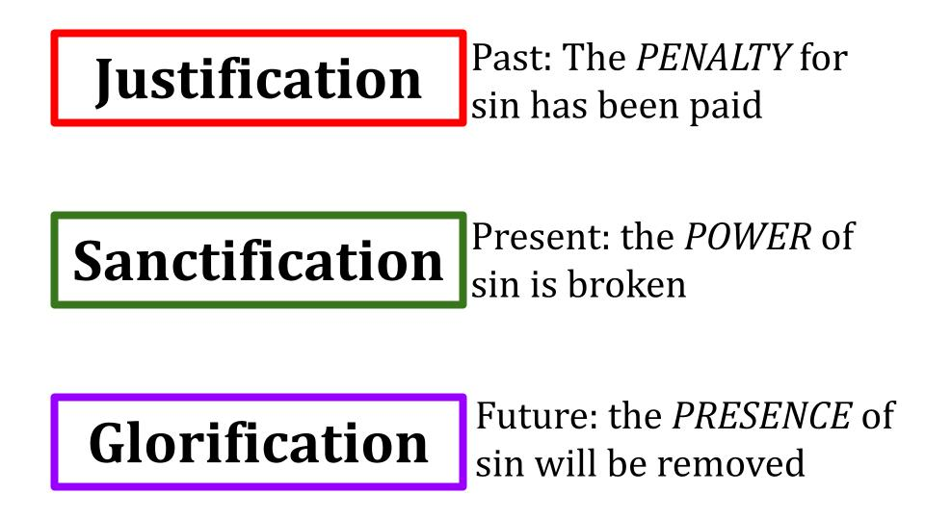
The 3 dimensions of the gospel are past, present and future! Regarding your past, as a believer in Jesus, your sins have been forgiven, the penalty for your sin has been paid! You have been JUSTIFIED - declared righteous in Christ. That is why verse 1 says, “There is now no condemnation for those who are in Christ.

But that is just the beginning of the good news! The gospel not only applies to your past, it applies greatly to your PRESENT! A new law operates over the life of the Christian. “The law of the Spirit of life has set you free in Christ Jesus from the law of sin and death.” The non-believer is under the power of sin - he is a slave to sin. But the believer in Jesus is free from that controlling power and free to love the Lord and obey God’s law. This is SANCTIFICATION - growing into the righteousness of Jesus!

The gospel applies to our past and present - and, of course, it also applies to our FUTURE! The death of Jesus paid the penalty for our sin. The resurrection of Jesus broke the power of sin over us. And the return of Jesus will forever remove the presence of sin from us! Hallelujah for the good news of the finished work of Jesus Christ! Here is a timeline view of our salvation:

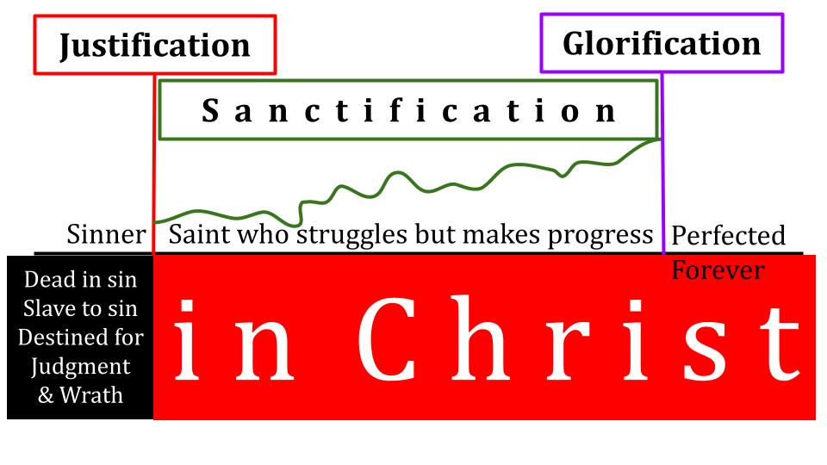
Before you were justified, you were a SINNER. You were blind and dead in sin. You were lost, helpless and enslaved to sin. And you were, therefore, destined for God’s righteous judgment and eternal suffering under His wrath. BUT GOD, being rich in mercy - instead of condemning YOU for the sin in your flesh He condemned sin in the flesh of His Son. Jesus took on your SIN so He could give you His RIGHTEOUSNESS. That is justification.

From the moment you called on Jesus to save you you were transformed - from being IN SIN to being IN CHRIST. At the moment that you were forgiven and justified in Christ, the Holy Spirit started the work of SANCTIFICATION. You are no longer a sinner, now you are a saint - a holy one - in Christ. Yes, you struggle with remaining sin - but you make progress in the power of the Holy Spirit. The path of sanctification is not a straight and easy upward line. It is a jagged roller coaster of twists and turns. But the general trend of the Christian life should be upward - should be one of progress.

And then, when you die or Jesus comes back - you will be GLORIFIED. You will be perfected forever. The righteousness God has already given you credit for in Christ will be REALIZED in your heart and life completely. That is our topic for today - GLORIFICATION. Look at verse 30 - our destination for this morning:

“Those whom he predestined he also called, and those whom he called he also justified, and those whom he justified he also glorified.” Romans 8:30

To God’s work of salvation we could add predestination and calling - but for now just notice the certainty of the progression. From beginning to end, God’s work cannot fail. It will not fail. He who began a good work in you WILL carry it on to completion until the day of Christ Jesus! “God is faithful. He will do it.” The One who justified you is the One who is sanctifying you and He is the One who will glorify you.

Just as Jesus said, “It is finished” on the cross, so one day He will speak over you those final words, “It is finished,” and you will step into heaven GLORIFIED - perfected forever.

This section of Romans 8 shows us the two part process of RESTORATION - first of the world and then of us. Turn back to verse 18.

God will Restore the world beyond its original Goodness
“For I consider that the sufferings of this present time are not worth comparing with the glory that is to be revealed to us.” Rom. 8:18

The Bible is a profoundly REALISTIC book. It does not gloss over the brokenness or sinfulness of the world. It explains those things but does not cover them up or downplay the reality. As the Dread Pirate Roberts told Buttercup, “Life is pain, princess. Anyone who tells you differently is selling something.”

How does Paul describe the present time here? Does he say “Life is good”? No. He describes the present time with one word: SUFFERING. Verse 17 makes it clear that Paul mainly means persecution - suffering WITH CHRIST. But it applies to all evil and pain we experience in this life. And the point is that whatever suffering we experience in this life, once we reach the glories of heaven, all of our questions and complaints will fade away forever. It is not worth comparing our present struggles with the glory we will soon see.

God promises, over and over in the Bible, to RESTORE ALL THINGS when Jesus comes back. In the original creation God looked out over all that He had made and pronounced it VERY GOOD. When Jesus comes back the world will be unmade in fire and blood and then Jesus will remake it - restoring the original goodness, peace and blessing of the garden of Eden and even going BEYOND that goodness.
- What started in a garden with two people will end in a city with countless multitudes from every tongue and tribe and nation.
- What started with innocence will end in blood-bought righteousness.
- What started with the wonder of brand new humans will continue for all time in the grace-enraptured wonder of humans who know we deserve nothing but wrath and suffering but have been given grace and life and joy in Christ!

That is a small summary of “the glory that will be revealed to us.” When Jesus comes back the main glory we will see is HIS GLORY. During his time on earth the full divinity of Jesus was mostly veiled. Only briefly on the mount of transfiguration did three disciples glimpse His full glory. But when Jesus comes back there will be no veil, no covering, no limit - the whole world will see His power and supremacy and in that moment, “every knee will bow before Him and every tongue will confess” Him as King of Kings and Lord of Lords.

As we kneel before the radiance of His glory, and when we see the new heaven and new earth that He unites in Himself - all of our present suffering will fade into a distant and insignificant memory - not worth comparing with that glory before us. Paul uses the same analogy Jesus did for the end times - labor pains.

God will Restore the world beyond its original Goodness
- All creation struggles under the effects of Sin
“The whole creation has been groaning together in the pains of childbirth until now.” Rom. 8:22

I don’t know how labor and delivery went for you - but for me it was quite painless and exciting. For my wife, however, each of her four birth experiences were long, grueling and painful. Caleb, our second son, holds the record in the Anderson house. 23 hours of active labor. Another 8 or so of intermittent labor for over 30 hours of contractions and a whopping 3 hours of pushing at the end. No, Kristin says, 3 and a half. And yes, with an epidural, but it wore off and they weren’t able to kick it back in - so a lot of those hours were undiminished agony.

But - as soon as Caleb was born - a healthy, 8 pound, bloody and disgusting baby boy - as soon as we heard that cry of life, as soon as we held him in our arms - all of that pain, all of that waiting and frustration, all of the morning sickness that was all day sickness, all of the swollen feet and maternity clothes - all of the suffering faded away because the baby had come.

That is what it will be like when Jesus comes back. When we see HIM, all the suffering will seem irrelevant, insignificant; hardly worth mentioning. Right now we suffer. Right now we feel the severe and intensifying pain as of a woman in labor. But some day soon God will bring forth the purpose of all of that suffering. The pain IS for a purpose. Look at what creation is waiting for.

God will Restore the world beyond its original Goodness
- Until sin is removed from People its effects cannot be removed from the earth
“For the creation waits with eager longing for the revealing of the sons of God.” Rom. 8:19
Planet earth is not longing for its own restoration so much as it is longing for the final revelation of the sons and daughters of God! Of course, this is metaphorical language - the plants and flowers and bunnies and birds have no concept of the doctrine of GLORIFICATION we are discussing today. But as flowers decay, and as bunnies are smashed to the ground by the huge hawks we have here in Florida - that collective pain, those dying groans are symbolized here as LONGING.

Since Adam and Eve rebelled against God’s one rule, sin and death entered the world. Sin is the controlling power of this world. And where there is sin, there must be death. The fall of man broke the world - it placed a deep crack into the foundations of the earth. And it implanted sin into the hearts and lives of all people. Until all traces of that sin are removed from us, the effects of sin cannot be removed from the planet.

This is why creation waits for and longs for the “revealing of the sons of God.” When we are finally glorified at the return of Christ, look at the outcome for the world in verse 21:

- Until sin is removed from People its effects cannot be removed from the earth
“The creation itself will be set free from its bondage to corruption and obtain the freedom of the glory of the children of God.” Rom. 8:21
For now, the planet and all things on it are in bondage to decay and corruption. The law of sin and death are operative not only in the hearts of people but also in the fabric of nature.

Modern movies try to convince us that animals are all sweet and innocent, like our golden doodle puppy. In Lion King some lions are violent and the hyenas are terrible, but most of the lions are quite reasonable and friendly. The Madagascar movies have a lion in captivity, and he has to deal with his cravings to eat the other animals, specifically the zebra. But the best example is the Finding Nemo story where the SHARKS have a support group so they can learn to stop eating fish. “Fish are friends, not food.” It’s a funny scene because obviously sharks can’t change their nature any more than lions can. They are carnivores and they have to eat fish to survive. It’s programmed into them just as it is programmed into our puppy to chew on us. We tell him to chew on his toy bones and his chewable bones we give him - but the puppy rightly points out to us - your arms and legs also have bones in them that are nicely chewable for me.

The fact of nature is that DEATH is embedded in everything. C.S. Lewis comments on this in Mere Christianity. He says that people want moral laws to be flexible and personalized - they want it to be soft and warm. But he says, nothing in nature is like that. Think about how nature functions! The big and strong eat the small and weak. Period. Natural law is tough as nails. There is nothing soft about it. Just wander into the African Savannah and see how the lions treat you. Just swim around by the Great Barrier Reef in Australia and see how the sharks treat you.

But the day is coming when this BONDAGE TO CORRUPTION will be removed.

God will Restore the world beyond its original Goodness
“The creation itself will be set free from its bondage to corruption and obtain the freedom of the glory of the children of God.” Rom. 8:21

One day the lion will lay down the the lamb and babies will be able to play with cobras for fun. Snakes will be friendly pets and lions will be cuddly puppies. Even puppies won’t chew on our hands anymore. The earth and everything on it will obtain the same freedom of the glory we will experience when we are fully and finally revealed as the children of God! So that moves us into our second half of God’s transforming, restoring work. Not only will He restore the world, He will restore US!

God will Perfect us into the Glory of Jesus
“The creation itself will be set free from its bondage to corruption and obtain the freedom of the glory of the children of God.” Rom. 8:21

Verse 18 says there is a glory that will be revealed TO US - the glory of JESUS and His eternal kingdom. But verse 21 shows there is also a glory that will be revealed IN US and through us. This is the glory of our redemption and adoption as the sons and daughters of God.

God will Perfect us into the Glory of Jesus
- Revealing us as the Children of God
“As we wait eagerly for our adoption as sons, the redemption of our bodies.” Rom. 8:23
In one sense, we have already been redeemed and adopted. But in another sense, the salvation that God started in us has not yet been completed - and won’t be until Jesus returns. Remember, Paul just wrote in verse 15 that the Spirit we have received is the Spirit of adoption as sons. That is PAST TENSE, completed reality. And by that Holy Spirit we cry out in our hearts, “Abba Father.” And so the Holy Spirit “bears witness with our spirit that we are children of God.” PRESENT TENSE - current reality for Christians. That is the ALREADY side - what the work of Jesus has accomplished for us and in us.

But there is a NOT YET side to our redemption - a fulness to our inheritance that we have so far only glimpsed, but one day we will step into. The first half of verse 23 says, “We who have the first-fruits of the Spirit groan inwardly as we wait.” The Holy Spirit is a down payment - a foretaste - a sign and seal of the full glory that awaits us when Jesus comes back and we step into eternity.

We have been forgiven and justified. But we will, one day, be GLORIFIED. In that moment when you see Jesus face to face all remaining sin will be purged away from you - from your heart and mind and habits and from every part of your life. And you will emerge from that experience with Jesus like the Lord Jesus emerged from the tomb - still you, still human, but GLORIOUS. C.S. Lewis said if we saw ourselves in our future glorified state we would be tempted to WORSHIP.

Think of what it means that on that day we will be REVEALED as the children of God. We say this very casually, “I’m a child of God. He is my Father, I am His Son or His daughter.” But do we realize what this means? To be a CHILD OF GOD is to share His nature. Right now we reflect the glory of God very dimly. The most loving, righteous, godly person you’ve ever known is at best a DIM REFLECTION of the real nature of God. But in heaven God’s glory will shine in us and through us without any of the diminishing effects of sin. We will be LIKE JESUS when we finally see Him face to face. We will be PERFECTED.

God will Perfect us into the Glory of Jesus
- Receiving our immortal Bodies
“As we wait eagerly for our adoption as sons, the redemption of our bodies.” Rom. 8:23

This perfection - this GLORIFICATION - will affect every part of us. Just as the fall has infused sin into every part of us, so the glory of Jesus will infuse and permeate every part of us - including our BODIES.

1 Corinthians 15 describes this glorious upgrade when “the mortal is clothed with immortality.”

The word “redemption” here in verse 23 is the language of the marketplace and specifically of the Jewish practice of BUYING BACK a family member who had been sold into slavery. If someone got so poor that they couldn’t do anything else, they could sell their children or themselves to a fellow Israelite and work for a period of time to pay off their debts. In the middle of that time of working, a wealthy family member could pay the price of REDEMPTION and buy them back from slavery into freedom.

Jesus already paid the price to redeem us from sin - to buy us back from our slavery to sin and the death we deserved because of our sin. But while this payment has been made and was fully sufficient for us, the fact is that sin still remains in us so our full redemption still lies in the future. That is what Paul is talking about here in verse 23. We all feel the reality of our aging, decaying bodies. Just as the world is in bondage to decay, so are our bodies.

I’m 46. When I was 30 I ruptured my right achilles tendon playing indoor soccer - acting like I was still 20. Then when I was 32 I ruptured my LEFT achilles tendon, again, playing indoor soccer. As you can imagine, after that I retired from indoor soccer. And yes, Kristin deserves an award of some kind for taking me through 2 surgeries with 8 weeks of crutches and PT for each. And, of course, that was right when we moved to Kentucky and when Micah was born. Perfect timing.

For the last month or so I’ve been helping with Joel’s high school volleyball team. And it’s been a harsh, cruel reminder to me of my body’s bondage to decay. I remember 20 years ago when I had a 26 inch vertical and could crush a volleyball. Now I have a 6-7 inch vertical and can sort of hit the ball in a generally downward direction. It’s very sad. And my knees hurt if I jump too much. And my muscles constantly remind me that I’m not 20 anymore.

But the day is coming when I will have that 26 inch vertical again - maybe it’ll be 52 inches in heaven. It’s a debatable point whether we might be able to fly like the angels do. Maybe that is one of the rewards you can earn in heaven. Some jewels in the crown give super powers. You can’t prove that they don’t! But for now, we must wait in hope.

God will Perfect us into the Glory of Jesus
- Receiving our immortal Bodies
“If we hope for what we do not see, we wait for it with patience.” Rom. 8:25

No one hopes for what they see. You don’t have to hope for it, because you already have it. No, hope is connected to FAITH. We trust that God will keep His promises to us in Christ. And one of those promises is for new, immortal, glorified BODIES.

For now, we offer our current bodies to the Lord as a living sacrifice - presenting ourselves SUCH AS WE ARE to Him for His use. But for eternity we will serve Him with bodies like Adam and Eve had, but even better. No illness, no weakness, no injuries - no death, no pain. We will be perfected. When our redemption and adoption are fully completed and we receive our immortal bodies - the final effect will be that the image of Jesus will be fully realized in us!

God will Perfect us into the Glory of Jesus
- Restoring in us the Image of Jesus
“Those whom he foreknew he also predestined to be conformed to the image of his Son.” Rom. 8:29

We don’t have time today to discuss the fascinating relationship between foreknowledge and predestination. The point is that God is working His unstoppable plan in us - He who started His good work in us will carry it on to completion until the day of Christ Jesus. And the good work He started is to shape us more and more into the image of the glory and righteousness of Jesus.

Jesus is the MODEL. He is like a sculpture of the ideal man. My brother is two years older than me. In high school he joined the swim team and the gymnastics team. By the time he was a junior, he had built up some decent upper body strength. I wasn’t about to wear a speedo, but the gymnastics leotard seemed tolerable if I could get some biceps and triceps like him. I wanted to grow up like my big brother. And by the time I was a junior and senior, I had. It took a lot of hard work. He helped me along the way, as did our coaches and other team members.

That is what we are doing as Christians. Jesus is our big brother. He is stronger, wiser, better than us in every way. It’s not about his muscles - it’s about his heart, his character, his service, his outreach, his LIFE. As we learn from him and walk with him, we seek to become LIKE HIM. We grow up into His likeness.

And one day - when Jesus comes back - his clothes will actually fit us. We will fully reflect his glory, goodness and righteousness. Right now we all still have a long way to go. But listen to the promise of verse 30.

God will Perfect us into the Glory of Jesus
- Restoring in us the Image of Jesus
“Those whom he predestined he also called, and those whom he called he also justified, and those whom he justified he also glorified.” Rom. 8:30

Think about what this means for you! God chose you, before the creation of the world, to be adopted as His son or daughter. God called you, as your good shepherd, and He enabled you to hear His voice so you could come. At the moment you put your faith in Jesus, God justified you - declared you righteous in Christ. Your sins were nailed to the cross and the perfect righteousness of Jesus was placed upon you like an unstainable white robe. And this process of salvation that stated in eternity past will continue until it concludes with your GLORIFICATION - when God will PERFECT YOU in Christ.

Romans 8:28 may be the most misunderstood verse in the Bible, though it is very often quoted.

“And we know that for those who love God
all things work together for good,
for those who are called
according to his purpose.” Romans 8:28

Does this mean that everything that happens to you is GOOD? Of course not! Bad things happen to everyone. People get sick. They get abused. Wars break out. People die. Those are not good things, they are bad things. This verse does not claim that only good things happen to those who love God.

Ok, then it means that all things will eventually WORK OUT to be good, right? Well, not if you mean good physically, materially, in this world and this life.
- Is that how it was for Jesus? His life ended on a Roman cross.
- Is that how it was for the apostles? Every one of them was killed as a martyr, and John was exiled.
- Is that how it was for Paul? He too was executed for his faith.
Did Romans 8:28 not work out for the one who wrote it?
That verse is not promising only good things for Christians. Nor is it promising an ultimately good outcome for Christians in an earthly, this life sense. Think of persecuted Christians. Does this verse guarantee them deliverance from prison and death? No. It does not. Does it promise that your dementia will clear up or the cancer will go away? No. I’m sorry, but no. What does it promise then?

“...All things work together for good, for those who are called according to his purpose… to be conformed to the image of his Son.” Romans 8:28-29

Romans 8:28 promises Christians two things: sanctification and glorification. Whatever happens - good or bad - in this life - God’s purpose is to use it to shape you to be more and more like Jesus. That’s it. That’s the good. That’s the goal.
- Will your marriage improve? I can’t tell you.
- Will your wayward children come back? No guarantees.
- Will your non-believing family members get saved? Don’t know.
- Will your health get better? That one I can tell you - definitely not. That is a downhill path for sure.

But through it all - know that God is working in you. He is chipping away at your sinful flesh, and He is making you more and more like Jesus, so that he will be the firstborn of many brothers and sisters.

Here is the dual promise of Romans 8:

God will Restore the world beyond its original Goodness
God will Perfect us into the Glory of Jesus
“The sufferings of this present time are not worth comparing with the glory that is to be revealed to us.” Rom. 8:18

In this world, you will have TROUBLE. But take heart, brothers and sisters, the Lord Jesus has overcome this world. And one day soon He will unmake the world and remake it - without sin or death or sadness or pain. And the glory of that moment will make it all worth it in the end!

Let’s pray.

