**Redeeming Love**

Psalm 107

Remember when Jesus sent the disciples across the Sea of Galilee, and as a storm swept down on their little boat? Mark 4 -

“And a great windstorm arose, and the waves were breaking into the boat, so that the boat was already filling. But he was in the stern, asleep on the cushion. And they woke him and said to him, ‘Teacher, do you not care that we are perishing?’” Mark 4:37-38

That must have been **some terrifying storm** that it had 4 experienced fishermen, who had grown up on that Sea, convinced they were about to die. Matthew, the tax collector, a pale little accountant - no offense to the accountants out there - you can see him huddled under the bench, holding on for dear life. But Peter? James and John, the sons of thunder? Notice it says the boat “was already filling.” They were going under. Until…

“And he awoke and rebuked the wind and said to the sea, ‘Peace! Be still!’ And the wind ceased, and there was a great calm.” Mark 4:39

***Jesus scolded the storm*** like an unruly toddler - and it obeyed Him immediately.

“And they were filled with great fear and said to one another, ‘Who then is this, that even the wind and the sea obey him?’” Mark 4:41

The disciples were scared when they thought they were going to drown. They were utterly terrified - undone - when Jesus calmed the storm with a word. And they asked the right question, ***“Who then is this?”***

Now, if these Jewish boys had paid attention in Sunday School, they would have remembered **Psalm 107** and they wouldn’t have had to ask that question.

“Then they cried to the LORD in their trouble, and he delivered them from their distress. He made the storm be still, and the waves of the sea were hushed.” Psalm 107:28-29

Now don’t forget what the sea represented in ancient times. We miss this all important detail. **The sea was THE SYMBOL of chaos** - unpredictable, uncontrolled, lethal. There was no doplar radar. There were no hurricane spaghetti models. If you dared to sail on big waters - even relatively small waters like the sea of Galilee - you were risking your life against impossible odds. If a storm came up, there was no escape, no appeal, nowhere to go. The sea was chaos and the doorway to death - the entrance to the underworld.

But Jesus stood up and **spoke into that chaos and brought peace**.

* Where there was about to be death, Jesus preserved life.
* Where there was weakness, Jesus showed His limitless power.
* Where there was despair, Jesus brought hope.
* Where there was suffering, Jesus became the doorway to healing.

**Psalm 107 is about gospel transformation**. It showcases the power and love of the Lord Jesus. Look at verse 1-2.

“Oh give thanks to the LORD, for he is good, for his steadfast love endures forever! Let the redeemed of the LORD say so, whom he has redeemed from trouble.” Psalm 107:1-2

***Let’s remember all that Jesus has saved us from*** - how He is the Great Redeemer, the Restorer of all things. He saw us in all of our trouble, all of our sin - and came to set us free and bring us home. Give thanks for His goodness, His steadfast love that endures forever. Verse 3 shows us the poetic structure of the Psalm:

“Whom he has redeemed from trouble and gathered in from the lands, from the east and from the west, from the north and from the south.” Psalm 107:2-3

The Psalmist uses the four points of the compass to describe four conditions of people apart from the Lord - and the four ways Jesus redeems us.

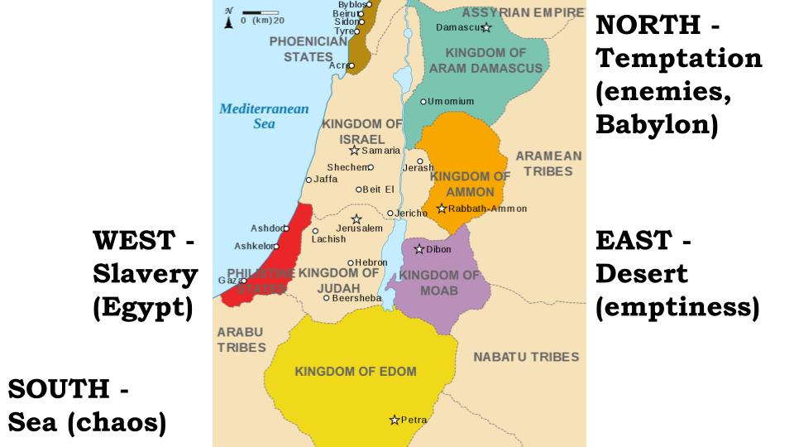

Scholars believe Psalm 107 was written after the exile, since these four directional points seem to **cover all of Jewish history** - from deliverance from slavery in Egypt, through the wilderness wanderings, the conquest of the land, the temptation of idolatry from surrounding nations, the defeat by Assyria and Babylon and the return from exile. Let’s look at each of these four human conditions, then we will close with how Jesus transforms them all.

First we look east, to the desert.

The Eastern Desert of **Emptiness**

“Some wandered in desert wastes, finding no way to a city to dwell in; hungry and thirsty, their soul fainted within them.” Psalm 107:4-5

After being rescued from Egypt, ***Moses led the people to the edge of the Promised Land***, and they could have gone right in. Caleb and Joshua, two of the 12 spies, called for faith-filled obedience - to go right in and attack, trusting the Lord to give them victory. But 10 of the 12 voted against it - saying the nations that lived there were too strong, their cities too fortified. Here is the problem with democracy - what happens when the majority is wrong?

In this case, what happened was **40 years in the desert** - 40 years of wandering until that entire generation of adults had died, outside of the land of plenty God had wanted to give them. What a parable of life! God invites us to blessing in Christ, but some people put off their commitment to Jesus and insist on living their own way for years and years - wandering in the desert instead of coming to the Lord.

The Eastern Desert of **Emptiness**

* We wander in the barren wilderness of stubborn **self-reliance**

“Some wandered in desert wastes, finding no way to a city to dwell in.” Psalm 107:4

Instead of trusting in God’s power and direction, ***Israel chose to focus on their own resources and abilities***. And how often do we do the very same thing?

* God says **GIVE** and we do the math, making excuses based on how we already give so much and don’t have any margin for more.
* God says **PRAY** and we make excuses saying we just don’t have the time - there is just so much important stuff we have to do.
* God says **GO** to serve a friend or neighbor and we make excuses saying we just can’t get invested in another relationship right now - those people are just so needy.

***We focus on ourselves and what we don’t have*** instead of looking at God and what He does have. We are just like Israel. And we wonder why we tend to wander in the barren, fruitless desert of non-productive “Christianity.”

The language here is of a “city to dwell in.” I think the main problem is that ***we HAVE found a city to dwell in***. We have made the desert of this world into a resort - a place where we don’t really need God at all. We have what we need. Even in the church we have built fancy buildings and programs that can function almost entirely without God. ***We feel a lingering concern*** - a gnawing hunger and thirst for more of God, more of His power and life - but we settle back in to our comfortable recliners and flip to the next program instead of crying out to God to change us.

All four of these human conditions - all four sections of this Psalm - turn on the repeated refrain we see first in verse 6:

“Then they cried to the Lord in their trouble, and he delivered them from their distress.” Psalm 107:6, 13, 19, 28

***For Israel this was constant*** - there was no water, so they cried to the Lord and he gave them water. There was no food - so they cried to the Lord and he gave them manna. There was no meat - so they cried to the Lord and he gave them quail. Over and over they called on God to deliver them, and in His infinite patience and mercy, He heard and answered their prayers.

Are we humble enough to pray like this? Are we willing to admit that we are hungry and thirsty, that we are tired of wandering in the desert of self-reliance? That’s what you see when you look east from Jerusalem, across the Jordan River, to the Dead Sea and the barren, rocky region over there. What if you look west?

The Western Stronghold of **Slavery**

“Some sat in darkness and in the shadow of death, prisoners in affliction and in irons.” Psalm 107:10

Travel south and west from Israel and you will be in **Egypt**. 400 years the Lord patiently enabled the Jewish nation to grow in the incubator of Egypt. But when they grew large and strong it made the Pharaoh nervous and he began to put them in their place - increasing their work load, making it clear who was in charge. At the end of those 400 years the slavery and suffering intensified, and Psalm 107 tells us why:

The Western Stronghold of **Slavery**

* We hide in the dark cell of secret **Self-indulgence**

“For they had rebelled against the words of God, and spurned the counsel of the Most High.” Psalm 107:11

Egypt came to represent ***idolatry and compromise***. Jewish leaders would grumble sometimes and talk about “going back to Egypt,” where they had it so good. Once some time has gone by it becomes easy to think back to the “good old days” when everything was so happy and wonderful.

If we let down our guard, we can make this same mistake - coming to envy our non-Christian friends who “have it so good.” They do whatever they want - they appear totally free - they buy what they want, watch what they want, go where they want. So often the wicked seem to prosper.

But the Bible tells us the true story.

The Western Stronghold of **Slavery**

* We hide in the dark cell of secret **Self-indulgence**

“So he bowed their hearts down with hard labor; they fell down, with none to help.” Psalm 107:12

***All sin leads to slavery.*** It may not be obvious at first, but “the wages of sin is death,” always. Anyone who is not committed to Jesus and His way of righteousness is a slave to their own selfish, sinful desires. That is a stronghold of hard labor. A place of despair and darkness - with none to help, no way of escape.

**Sin is a fire.** It always grows - sin always leads to more sin. And sin always destroys. One of the main lies of any temptation is what the devil told Eve - “you will not surely die.” It’s the false promise that no one will get hurt, that no one will know. The fire of sin always spreads and where it goes, it consumes.

All of us struggle with sin - it’s just a question of ***what issues you are dealing with right now***. And we all tend to hide our sin - from ourselves and others. But there is no hope in that - no way of escape until we cry out to the Lord - bringing our secret sins into the light of His glorious grace.

To the east is the desert of self-reliance. To the west is the stronghold of self-indulgence and secret sin. The north is similar, though with more practical, physical consequences.

The Northern City of **Temptation**

* We struggle with the consequences of refusal to **Repent**

“Some were fools through their sinful ways, and because of their iniquities suffered affliction.” Psalm 107:17

Later in Israel’s story the temptation to compromise and seek outside help came from Assyria and Babylon in the North rather than Egypt in the west. Because the Jews repeatedly refused to repent and turn back to the Lord wholeheartedly, ***God eventually sent them into exile***, banishing them from the land He had given them - and giving them over to the consequences of their unfaithfulness.

How often do we make the same mistakes of Israel, refusing to really repent and worship Him with all of our hearts? Not all sickness is because of sin - but Paul says this in 1 Cor. 11:

The Northern City of **Temptation**

* We struggle with the consequences of refusal to **repent**

“That is why many of you are weak and ill, and some of you have died.” 1 Cor. 11:30

This was specifically in reference to abusing the Lord’s Supper, but it shows that ***some sickness is directly related to willful sin***. There is no question that unrepentant sin causes problems - stress, anxiety, sleeplessness, distress. But instead of coming clean, many people turn to forms of self-medication - alcohol, drugs, sex, food, entertainment… And many of those things bring consequences of their own.

We’ve been east, west, north, and now south.

The Southern Sea of **Chaos**

* We stagger, gripped by fear of surrendering **Control**

“Some went down to the sea in ships, doing business on the great waters.” Psalm 107:23

Again, the sea represented the chaos and evil of the world. “Doing business,” was not innocent or neutral - here it represents setting up your life and your own kingdom apart from God and His kingdom. **This is all very Jonah** - when God said go north and east to Nineveh, the prophet went west and south to Tarshish. So the Lord sent a great storm to humble his supposed servant and get him back on track. Come back in a few weeks for a full exposition of Jonah!

The Southern Sea of **Chaos**

* We stagger, gripped by fear of surrendering **control**

“For he commanded and raised the stormy wind, which lifted up the waves of the sea.” Psalm 107:25

This is a clear and striking statement about **God’s sovereign power**. Even the untamable ocean is under the Lord’s authority. The winds blow at His command. The waves rise and fall when He summons them.

This is why the miracle of ***Jesus on the Sea of Galilee*** was so powerful and terrifying to the disciples - because it meant that the Lord of Heaven was standing right there among them. It was that realization that made them terrified.

***I’m sure you feel the chaos of the world today.*** We live near the ocean in the lightning capital of the world. But it’s not the weather that bothers us - it’s the chaotic, unpredictable brokenness of the world - the disease and disaster, how everything breaks down, how people let you down, how your own body is falling apart.

All of life proves to us - over and over - that **we are not in control**. And yet, we love to hold on to the illusion of control. Instead of crying out to the Lord to save us, we default to the little, mostly useless things we can do on our own.

The Southern Sea of **Chaos**

* We stagger, gripped by fear of surrendering **control**

“The reeled and staggered like drunken men, and were at their wits’ end.” Psalm 107:27

Just like **the sailors on the ship with Jonah**, they tried everything in their power to avoid throwing Jonah overboard, even when they knew that was what his God required. They rowed hard for land, they cried out to every other god they could think of. But finally they surrendered to what the prophet told them they had to do - they had to make a sacrifice. They had to let Jonah die.

In response to that act of surrender and faith, the waters calmed for those sailors. In response to the disciples’ cry for help, Jesus calmed the storm and saved them.

I’m sure you’ve experienced this too - when you finally come to your wits’ end:

“Then they cried to the Lord in their trouble, and he delivered them from their distress.” Psalm 107:28

God is so merciful and gracious to meet us at the point of our need. Even when we take forever to actually repent and surrender, like the merciful Father with the **prodigal son**, the Lord is always there with open arms to welcome us home.

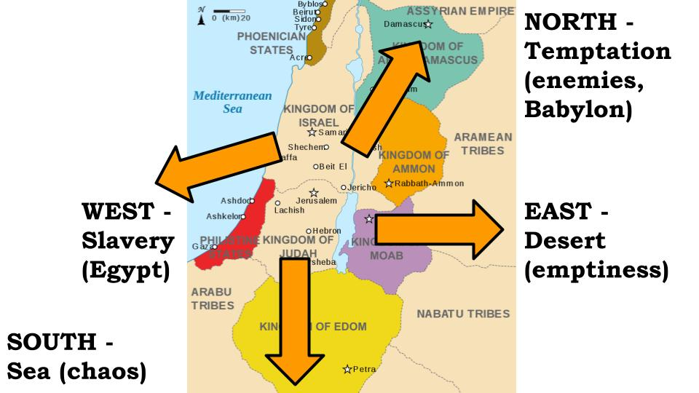

Look at the visual of Psalm 107.

The Psalmist is showing us our options. ***We can go east*** - back into the barren desert of self-reliance, rejecting God and doing what we can do in our own power.

***We can go west*** - back to the slavery of Egypt, to the bondage of secret self-indulgence, living apart from God, outside of His authority and blessing.

***We can go north*** - listening to the seductive voice of Babylon, calling us away from God and His Law to the “freedom” of rebellion and idolatry - refusing to repent when we experience discipline from the Lord.

***Or we can go south*** - taking on the chaos and danger of this broken world, apart from God, refusing to surrender to Him. The four points of the compass, the four conditions of mankind - are meant to show us something: the place we really long to be; the place God has designed us for - the Promised Land God called us to. We have all wandered long enough to the north, south, east and west. ***Are we finally ready to come home?*** 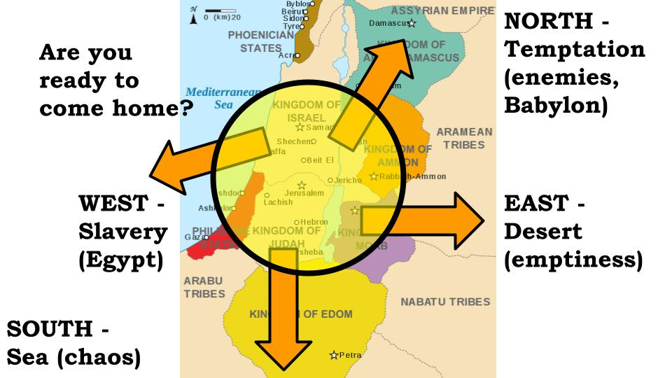

***Are you ready to come home?***

“He turns rivers into a desert, springs of water into thirsty ground, a fruitful land into a salty waste, because of the evil of its inhabitants.” Psalm 107:33-34

After a poetic presentation of the four other options, ***verse 33 shifts into a summary gospel truth***. **First, the bad news**: God turns rivers into a desert. God brings mountains of human pride crashing down. God takes flourishing nations, like ours, who prosper without reference to Him, without deference to Him, and knocks them down into insignificance. There is no guarantee when or how this will happen - but ***it will happen*** to every person, every business, every country that rejects God and goes its own way. Sin always has consequences - like fire, it always consumes. But though “the wages of sin is death, the gift of God is eternal life through Christ Jesus our Lord.”

***Are you ready to come home?***

“He turns a desert into pools of water, a parched land into springs of water.” Psalm 107:35

God brings mountains down, but he also raises valleys up. He humbles the proud, but He exalts the humble. ***When we are finally ready to repent and surrender in personal faith, God turns everything around.*** This is the power of His grace - the wonder of His steadfast love and mercy! Look at the four transformations God offers us in Christ, when we are finally ready to come home to Him!

The Promised Land of **Blessing** in Christ

* Emptiness → **Fullness**

“For he satisfies the longing soul, and the hungry soul he fills with good things.” Psalm 107:9

Instead of wandering in the barren desert of ***self-reliance***, God calls us to the oasis - the unlimited banquet buffet - of full reliance on Him. Physical hunger and thirst are meant to show us our NEED - that we need more than this world can offer us - more than we can scrape together on our own. We need the LORD HIMSELF to satisfy the deepest longings of our hearts. He alone can fill us!

The Promised Land of **Blessing** in Christ

* Slavery → **Freedom**

“For he shatters the doors of bronze and cuts in two the bars of iron.” Psalm 107:16

Instead of hiding in the dark dungeon of secret sin, God calls us into the light of His glorious freedom. Temptation and sin are lies of the enemy that would keep us in shackles. Jesus alone can set us free from that deception and from those strongholds - if we call on Him in faith! He can break any chains and open any prison doors!

The Promised Land of **Blessing** in Christ

* Weakness → **Power**

“He sent out his word and healed them, and delivered them from their destruction.” Psalm 107:20

Instead of struggling with the consequences of our ***refusal to repent*** and come back to the Lord, God calls us to Himself as the source of life, power, love, joy, peace and everything else! We are not guaranteed physical health and healing for every problem in this life - that full restoration must await the new heaven and earth. But God does promise to fill us with His power and His Spirit to do His work - that is beginning the restoration of all things in Christ even now!

The Promised Land of **Blessing** in Christ

* Fear → **Peace**

“Then they were glad that the waters were quiet, and he brought them to their desired haven.” Psalm 107:30

Instead of staggering in fear due to our lack of control, God calls us to the peace that can only come from total surrender to Him. He invites us into the safe haven, the calm, peaceful waters of His loving arms.

**God alone can make these transformations** - He is the Great Redeemer:

The Promised Land of Blessing **In Christ**

|  |  |
| --- | --- |
| * Emptiness → Fullness * Slavery → Freedom * Weakness → Power * Fear → Peace | “Whoever is wise, let him attend to these things; let them consider the steadfast love of the LORD.” Psalm 107:43 |

You can look to the north, south, east or west - you can scramble everywhere and call on every other name -  that can offer you true and lasting peace and blessing. And that name is Jesus.

That’s what the calming of the storm was intended to teach the disciples and us. That’s what Psalm 107 shows so clearly and powerfully. **God calls us to the Promised Land of peace and blessing** - but that place isn’t a place anymore - **it’s a person**, whose name is Jesus.

We will be restless and fearful, we will struggle and scramble until we find our rest in Him.

***This is the story of Israel*** - always turning away, always looking anywhere but the Lord. And it is **your story and mine as well**. We keep running north, south, east and west - and the Lord keeps patiently calling us home.

<https://www.ironbellministries.org/staff-continued>

Gregg Dedrick was a friend of mine in Kentucky. By the world’s standards, he had achieved everything - had reached the pinnacle of success. He had won the rat race of the business world to the point that he became the President of KFC. He was a “Christian” but was pretty much just showing up on Sundays and going through the motions during the week. His marriage was struggling; his kids were struggling. His soul was in shambles.

***And the Lord said, “stop.”*** Gregg went to his wife and shared with her, “I think I’m supposed to quit my job.” She quickly agreed to pray with him about it. Very soon they both felt peace from the Lord and clear confirmation that it was right for him to quit his job and seek the Lord for direction on what was next. They had no idea.

And it’s important to understand that Gregg and his wife were ***not charismatics*** - they were not used to “hearing from the Lord.” But very soon their hearts began to heal, and their marriage began to improve - just shutting out the world and seeking refuge in the Lord. They experienced the repeated refrain of Psalm 107.

“Then they cried to the Lord in their trouble, and he delivered them from their distress.” Psalm 107:28

A week went by. Then two. Then three. Gregg and his wife were asking the Lord, “What’s next? What do we do?” They were used to moving fast and pushing hard. They were not used to being quiet and going slow.

The Lord gave them one word: “Worship.”

They applied that personally and kept seeking the Lord, focusing on Him, trusting in Him. And He continued to heal their hearts and to bless their marriage. They found others coming to them for counseling and healing and found that the peace and recovery they had experienced God began to enable them to share with others.

And they applied the ***“worship”*** directive corporately. They were not musical, but they had a friend who was - so they invited that friend to bring his guitar and they hosted a small worship gathering in their basement. A couple dozen people came. Gregg wasn’t a preacher - he didn’t preach. They just opened their Bibles, read some verses, and sang praises to the Lord.

From those humble beginnings - from that simple turning of the heart - the Lord has brought forth so much fruit! Several months later the Lord led them to an old barn about a mile south of the church I was serving. They renovated the barn and turned it into a haven for worship and prayer they named the Iron Bell. It had open hours during the week for Christians to come and seek the Lord individually. They offered special times for corporate worship. They offered to pray with anyone who was struggling. They experienced the other refrain of Psalm 107:

“Let them thank the Lord for his steadfast love, for his wondrous works to the children of man!” Psalm 107:31

God will give us this same kind of transformation if we will come to the Lord Jesus in faith!

Let’s pray!