Begin with the End in Mind
1 Corinthians 3

When I was young, like 8, 9 years old - my brother and I built a “fort” behind our garage. Dad had lots of tools in the garage, and a good bit of leftover lumber, so my brother and I set to work to build a structure in the tree behind the garage. All I can say is that it’s a good thing it was behind the garage.

We never sat down and drew up any plans. We never consulted with our Dad to see what kind of fort or treehouse we should build. We certainly never asked him to help us. We just grabbed our hammers, a bucket of nails and started pounding boards into that poor, old tree.

As you might imagine, it never became much of a fort; nor was it at all structurally sound. We did not make a plan. We had no sketches or designs. We had no skilled builder guiding us. And the results spoke for themselves.

By contrast, when we lived in North Carolina, the house we were renting was on 3 acres of forested land - with those tall Oak trees you have up north that grow to a hundred feet tall and fill your driveway with acorns. When we moved into that house our boys were small - like 3, 5 and 7 years old (Micah wasn’t around yet). As soon as I saw those trees I started thinking about the treehouse we could build. And it was EPIC.
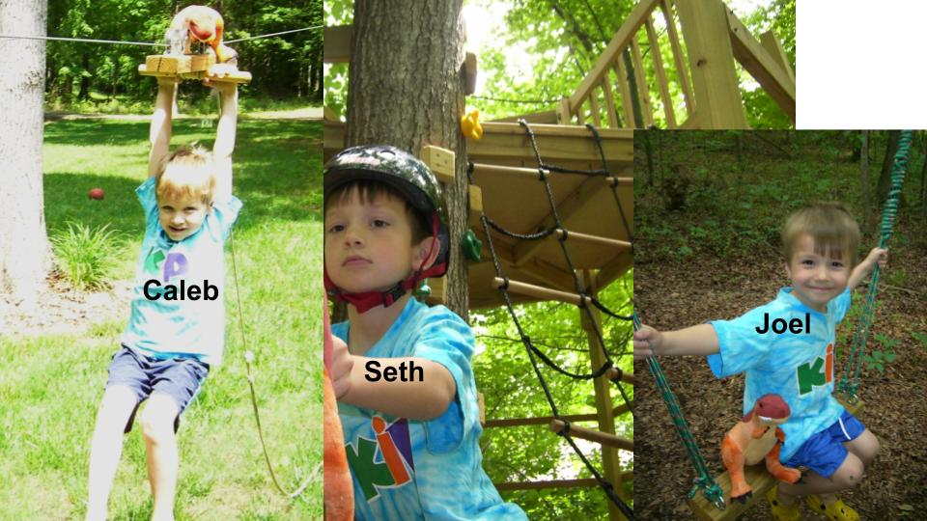
In the end there were three levels, with the crows nest fully 20 feet off the ground. There was a giant swing, suspended by climbing ropes between two trees. And from the driveway to the creek we installed a 100 foot zipline (that only caused two fairly minor injuries while we were there).

This second treehouse of mine involved a lot of planning. It incorporated all of the building experiences I had accumulated from my previous 30 years of life - including helping my Dad build 4 different decks. I made detailed sketches. I updated and improved them along the way. And the results spoke for themselves.

Now consider - how are you building your LIFE?
Are you like 8 year old Darin or 30 year old Darin? Are you just throwing things together based on whatever occurs to you at the moment? Or have you spent the time to make a plan and set up a design for your days and months and years?

One of the essential habits of all successful people is to BEGIN WITH THE END IN MIND.
- Close your eyes right now and imagine your funeral.
- Your life is over. Your friends and loved ones are gathering in black suits and dresses and your casket is at the front of the room.
- Pictures of your life are set up on a table, and a few people are preparing to speak.
- What do you want them to say?
- When people look at those pictures, what do you want them to see?
- As your loved ones look back on your life and legacy, what do you want them to remember?
- That is the end of your earthly life. And it is great wisdom to consider that day and live in light of the outcomes you want.

But, contrary to popular American belief, you will not be there for that event. You will be occupied elsewhere with a much more pressing engagement.

“We will all stand before the judgment seat of God… So then each of us will give an account of himself to God.” Romans 14:10,12

“For we must all appear before the judgment seat of Christ, so that each one may receive what is due for what he has done in the body, whether good or evil.” 2 Corinthians 5:10

It is the pinnacle of foolishness to ignore or downplay the day you will stand before Jesus - it is coming for every single one of us. You WILL give an account. Your Master entrusted time, talent and treasure to you for a specific number of days, minutes and hours. How did you manage what your King gave to you? Were you a faithful steward? Did you work according to the directions and principles of your King?

We will stand before the Lord Jesus - the Judge of all People - and be totally exposed. Every thought, every careless word, every action, every motive behind every action - all of it will be brought into the light of His glory.

Now hear this loud and clear: the judgment of the Christian is completely different from the judgment of the non-believer. The non-believer will be exposed without any defense attorney - without any protection or appeal. They will be immediately convicted for all the evil they did and will pay the price for it forever. Their sin will remain on them and in them - and because they rejected Jesus, they will have no shelter from the just wrath of God that will fall on them like fire.

Judgment of the Non-Believer | Judgment of the Christian
- Sin exposed to Everyone  - No representation or defense  - Guilty of all charges  - Condemned for eternity  - No appeal or hope to change | - Sin exposed to Jesus  - Represented & defended by Jesus  - Not guilty; Righteous on all accounts  - No condemnation; eternal life  - Final evaluation & purification

For the Christian, there is no condemnation. The judgment seat of Christ is not about CONDEMNATION, it is about EVALUATION. It is the final PURIFICATION before we enter glory. It is the process by which Jesus will wipe every tear from our eyes.

So there are two opposite mistakes to avoid here.

Mistakes to Avoid:
- Fear of condemnation
- Presumption of Commendation

On the one hand, the Christian should not live in fear - God’s perfect love drives out fear. We live and serve out of gratitude and love and joy in the Lord. But on the other hand, there is a significant danger of presuming on God’s grace and assuming that what we are doing is all pleasing to God and will be rewarded. The Bible is very clear and explicit that certain things we do and certain ways we do them will win God’s approval and others will not.

Pastor, are you saying it’s possible for a Bible-believing Christian to waste their life and not please God? Yes. Tragically, yes. Remember when the Israelites arrived at the Jordan River and Moses said, “Let’s go conquer the promised land”? 10 spies came back and said, “We can’t do it - they’re too strong.” Only 2 spies said, “God will help us - we can do it!” Majority ruled and the people chose to disobey God’s clear direction, to spurn God’s clear provision for them - and AN ENTIRE GENERATION wasted their lives - literally. In the book of Revelation Jesus calls this “being lukewarm,” and to those who are lukewarm Jesus warns that he is about to vomit them out of his mouth.

So we need to avoid both extremes - not falling into fear of condemnation; but also not presuming on God’s commendation.
That is what we will focus on this morning and through our CALLING series this fall. Let’s take an honest look at our lives and our priorities to see how well they line up with God’s will, His kingdom, His desires and His priorities - and let’s commit right now to make the adjustments the Lord leads us to - to get on track.

Our passage for today in 1 Corinthians 3 ends with these two verses:

Mistakes to Avoid:  - Fear of condemnation  - Presumption of commendation | “If the work that anyone has built on the foundation survives, he will receive a reward. If anyone’s work is burned up, he will suffer loss, though he himself will be saved, but only as through fire.” 1 Cor. 3:14-15

Paul pictures your life as a BUILDING. As Christians, we build on the firm, unshakeable foundation of the Lord Jesus. That is why there is no fear of condemnation. We are secure in Christ. He is our cornerstone and our sure foundation.

But Paul presents two different kinds of building materials - gold, silver and costly stones are the good ones; wood, hay and straw are the bad ones. It’s pretty much the three little pigs, but instead of the Big, Bad Wolf coming to blow your house down, it is the Glorious Lord Jesus Christ coming in fire to evaluate the quality of your workmanship. What do you want to present to Him on that day?

Check out this video of Francis Chan - some of you have seen it before, but it is very relevant to our purpose today:

https://www.youtube.com/watch?v=LA_uwWPE6lQ

Can you imagine an Olympic athlete just clinging to the beam like that and then standing up to do a dramatic dismount pose? Everyone would laugh - including the judges - at how absolutely absurd that would be.

Mistakes to Avoid:  - Fear of condemnation  - Presumption of commendation | “If the work that anyone has built on the foundation survives, he will receive a reward. If anyone’s work is burned up, he will suffer loss, though he himself will be saved, but only as through fire.” 1 Cor. 3:14-15
The judgment of the Christian is not one of Condemnation but of Evaluation and final Purification.

But many Christians are in that exact position right now - paralyzed by fear and doing nothing for Jesus and His kingdom. Just holding on to the balance beam, trying not to screw up. According to Paul, that kind of believer will “get to heaven,” but only as one escaping through fire. The entire house of the life they have built will be burned up as wood, hay and straw. There will be nothing left to present to the Lord Jesus. Just a pile of ashes.

Ok. Do you feel warned? Do you sense the gravity of the situation? Are you motivated to come on this journey to discover your calling over the next 12 weeks?

Good. Now, let’s define calling and then look at the road map we will be following to help each of us discover it.

Calling: your unique Assignment from God
“For we are his workmanship, created in Christ Jesus for good works, which God prepared beforehand, that we should walk in them.” Ephesians 2:10

On the simplest level, your calling is the unique assignment God has for you, right here, right now - in this season of life. It’s a CALLING because it is the voice of God Himself leading you, directing you into Christ-like ministry. God has prepared the good works - we just have to walk in them. But we DO have to walk in them. That was the point of the WARNING part of this message. We will give an account - and a big part of what we answer for is how well we obeyed God’s direction in our lives.

This whole series could be summed up in that single directive: listen to God and obey His calling. Both parts are essential. If you don’t listen you won’t know what to do. But if you listen and don’t obey you won’t change; you won’t WALK IN the good works God has for you.

Remember in Prince Caspian when Lucy saw Aslan in Narnia and knew he was calling her to come, but the other children didn’t see him and didn’t believe her? Everything they remembered about Narnia said they should go one way - only Lucy and her “vision” of Aslan pointed the other direction. There are several helpful applications to that little scene - but the main one is that when God speaks to you, in whatever form, you know He is speaking to you and you know what He wants you to do. It’s just a question of whether you will do it.

Lucy chose to listen to her brothers and sister and to ignore Aslan’s call. And later she answered for it before the Great Lion. In a heartbreaking moment she asks her Master “What would have happened, if I had come to you?”

“To know what would have happened, child?” said Aslan. “No. Nobody is ever told that.” “Oh dear,” said Lucy. “But anyone can find out what will happen,” said Aslan. “If you go back to the others now, and wake them up; and tell them you have seen me again; and that you must all get up at once and follow me--what will happen? There is only one way of finding out.” Prince Caspian, C.S. Lewis
I have to read you a little more:

Do you mean that is what you want me to do?” gasped Lucy.

“Yes, little one,” said Aslan.

“Will the others see you too?” asked Lucy.

“Certainly not at first,” said Aslan. “Later on, it depends.”

“But they won’t believe me!” said Lucy.

“It doesn’t matter,” said Aslan.

“Oh dear, oh dear,” said Lucy. “And I was so pleased at finding you again. And I thought you’d let me stay. And I thought you’d come roaring in and frighten all the enemies away--like last time. And now everything is going to be horrid.”

“It is hard for you, little one,” said Aslan. “But things never happen the same way twice. It has been hard for us all in Narnia before now.”

Lucy buried her head in his mane to hide from his face. But there must have been magic in his mane. She could feel lion-strength going into her. Quite suddenly she sat up.

“I’m sorry, Aslan,” she said. “I’m ready now.”

“Now you are a lioness,” said Aslan. “And now all Narnia will be renewed. But come. We have no time to lose.”

That was Lucy’s assignment - her calling - even though she was the youngest of the four children. She was the one who saw Aslan. She was the one who heard his voice. It didn’t matter how the others responded - it was up to her to obey. And this second time, she did. Aren’t you glad, brothers and sisters, that our Lord gives us second and third chances to respond to His call?

Calling: your unique Assignment from God - the good works He has prepared in advance for you to do, as you make disciples for His glory.
“You are the salt of the earth… you are the light of the world.” Matt. 5:13-14

Your assignment is a combination of disciplemaking and service - or good news and good deeds; salt and light. The Great Commission is to make disciples of all nations. All believers share that single mission. That is the general target we aim for in our lives - obedience to that calling to make disciples for the glory of the Lord.

But within that general target, each of us has an individual bullseye that defines for us the when, where and how of disciplemaking. This series is designed to help you aim the ARROW OF YOUR LIFE.

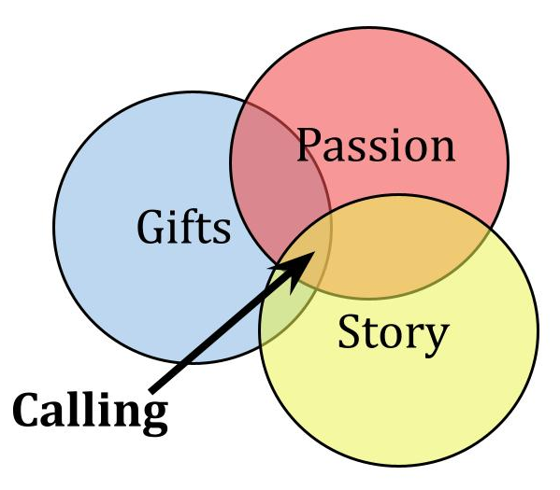
Your ministry direction, or ministry target is determined by this - where is God calling you to LIVE and serve? What people or place or cause is God calling you to engage in? Wherever you focus your time and energy, it should involve both salt and light - proclamation of the good news and demonstration of the love of Christ in good deeds.

For the next three weeks we will study the life of King David to illustrate the three signals from God that inform our calling. You can see them on your handout: Gifts, Passion and Story - convenient that it spells out GPS. Your calling is the convergence of those three circles. Where is God aiming your arrow?

God called David as a young shepherd - first to take on a mighty warrior in single combat, then to minister to an angry, emotionally unstable king and then to serve as king over a rebellious and difficult nation. You tell me which of those three assignments was the hardest. But the point for today is that none of those were suggestions. They were all CALLINGS. They were God’s unique assignment for King David at different points in his life. God aimed this young Jewish boy at a specific and challenging place - the throne of Israel. David first had to conquer Jerusalem - then he was able to move in there. Eventually David’s arrow hit its bullseye on the throne in Jerusalem. But it was a long and winding road to get there.

David’s Good News announcement was what he proclaimed to Goliath - “You come against me with sword and spear and javelin, but I come against you in the Name of the Lord, the God of Israel, whom you have this day defied.” His good deeds followed immediately after as he charged into battle with the Philistine.

He also combined good words and good works with King Saul - speaking to him on numerous occasions, sparing his life and continuing to serve him even when he could have simply killed him and taken the throne.
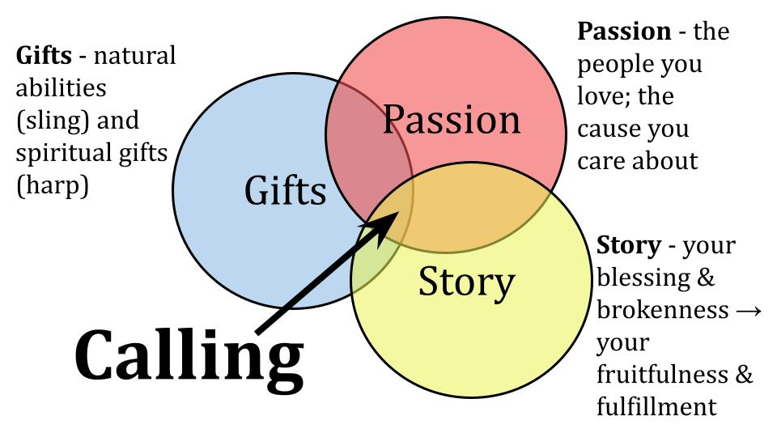
David’s calling came at the convergence of his gifts, passion and story. David used his natural abilities to defeat Goliath. He had trained for years with the sling and stone - had killed both a lion and a bear and chased off many a wolf. The sling represents natural abilities.

And David used his supernatural gifts to minister to King Saul when an evil mood was upon him. Then David would play his harp and Saul would feel better. This was a supernatural enablement, heightening David’s natural musical talent and giving it spiritual power.

David’s story also illustrates PASSION. He loved the Lord above all - which is why we have so many Psalms of David singing praise to the God of Israel. He was passionate for the name and glory of the Lord. And David was deeply devoted to the nation of Israel. Those were the people he loved. Protecting, fighting for and leading the Jewish people was the cause David cared about.

And God wove his calling into his story - combining both his blessedness and brokenness into the way he would serve as King. As the youngest of eight children, David was a nobody - insignificant - last in line. God used that humility to prepare him to lead. But that challenge was also a blessing - David had seven older brothers to learn from, to grow with. Gifts. Passion. Story. That is our GPS.

After David, we will spend eight weeks studying the life of Jonah - mostly a case study in what NOT TO DO. Sent on a mission from God, Jonah ran the other way.

Jonah is the anti-Jesus. He is the opposite of what God wants from us. Jesus, of course, perfectly embodied the One who answers the call of God the Father. He came to live among us. He gave his life entirely to loving, humble, sacrificial service. He perfectly balanced a message of judgment and call to repentance with a ministry of unconditional love and mercy. And just as Jesus was both SALT and LIGHT - so He commissioned his followers to the same kind of ministry.

He didn’t say, “Go and BECOME the salt of the earth and the light of the world” He said, “YOU ARE the salt of the earth and the light of the world.” If you fail to actually be salty and you fail to actually give the light of truth that you have then the world will deteriorate more where you should have preserved and improved it and it will plunge further into darkness where you should have brought the light of God’s truth and grace.
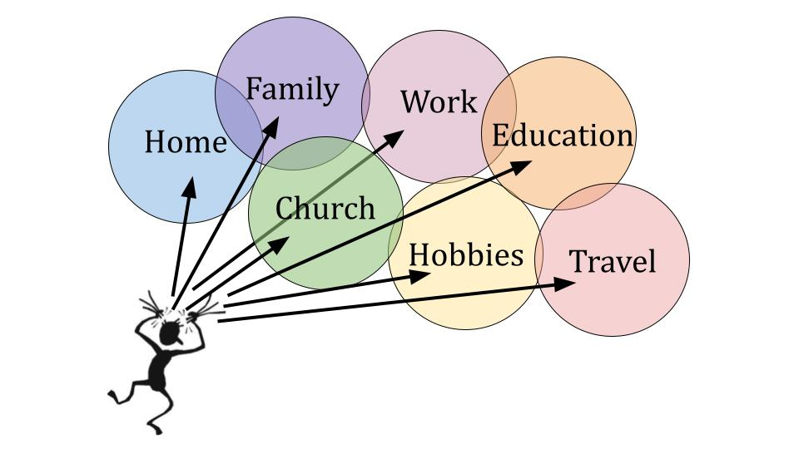
One of the reasons we have limited impact these days is because we scatter our time and effort between the 5-6 different places we live. This is the modern American lifestyle - and we wonder why we are so busy and so stressed - we are literally pulled in 10 different directions!

Think about your last couple of weeks: the responsibilities of work and family, running errands, managing your house, checking in on extended family and friends, trying to get a workout in here and there, trying to grab some time with your spouse, your kids and grandkids - with their complicated array of activities and events.

SQUIRT GUN - and being faithful Christians, in all of these different venues we bring our little Jesus squirt gun and we share a little Jesus everywhere we go.
- You pray for the kids and parents at the soccer game
- You encourage the frazzled Mom sitting beside you in the stands
- You take some time by the coffee maker at work to chat with a co-worker who really needs a listening ear right now and you promise in your heart to really pray for them this week
- You patiently listen to your elderly Mom or Dad as they tell that same story for the 100th time
- You chat with your neighbor about the weather and are sure to work in a mention of yoru church that you love and the amazing pastor you have who is just so young and energetic and just a little full of himself
- You faithfully come to your church committee meeting; you’ve done the reading and you contribute some helpful ideas and commit to do your part over the next month
- You hold the door on Sunday morning, cheerfully welcoming everyone as they come in for worship
- You text a verse of Scripture that was meaningful to you to an old high school friend

There is nothing wrong with any of this - it’s all beautiful and wonderful. But do you see the challenge as it relates to CALLING? Nobody is getting very much Jesus from us - everyone we interact with pretty much gets a drop or two here and there. And then, before we know it, we are empty.

SUPER SOAKER. What if we tried a totally different approach? This is a giant what if - and it might take the whole Calling Series for some of us to really process the impact of it. But what if instead of being scattered between all these different venues of where you live, work, learn, worship, eat and play - what if you CONCENTRATED your time, effort and energy in ONE PLACE? [Aim super soaker into center bucket]

On top of that, what if you grabbed a couple of Christian friends who shared your passion and your interest and you concentrated your time TOGETHER in that same place? Maybe your neighborhood; maybe your workplace; maybe your school; maybe the gym where you work out; maybe the nursing home where you visit your grandmother; maybe something here at Oakwood - but you don’t just give a drop or two, you pour yourself into the kids ministry or youth ministry or your Community Group?

This is what the Calling series will help us wrestle with. You can see on your handout that there is an assessment to do that will give you an overview of your gifts, passion and story. But that is just a starting point. It’s a tool to help you engage with your husband or wife or a good friend or D-Group or C-group. We need help from one another to discern our own strengths and weaknesses, where we should focus our time and effort and WHEN. Timing is everything with this.

The point today is to BEGIN WITH THE END IN MIND. How are you building on the foundation of Jesus? Are you using gold, silver and costly stones? Or are you like me when I was a kid just pounding nails into a poor old tree? Are you just spraying a little Jesus around when you can and reassuring yourself it’s the best you can do right now?

We will all stand before King Jesus one day for that final evaluation and purification. That’s the END we must keep in mind.

Let’s close today with Matthew 25. Close up your worship program. Shut down your Bible app. Close your Bible even and just listen to the words. These are the words of the Lord Jesus Himself. The One to whom we will all one day give an account.

Read Matthew 25
“Then the kingdom of heaven will be like ten virgins who took their lamps[a] and went to meet the bridegroom.[b] 2 Five of them were foolish, and five were wise. 3 For when the foolish took their lamps, they took no oil with them, 4 but the wise took flasks of oil with their lamps. 5 As the bridegroom was delayed, they all became drowsy and slept. 6 But at midnight there was a cry, ‘Here is the bridegroom! Come out to meet him.’ 7 Then all those virgins rose and trimmed their lamps. 8 And the foolish said to the wise, ‘Give us some of your oil, for our lamps are going out.’ 9 But the wise answered, saying, ‘Since there will not be enough for us and for you, go rather to the dealers and buy for yourselves.’ 10 And while they were going to buy, the bridegroom came, and those who were ready went in with him to the marriage feast, and the door was shut. 11 Afterward the other virgins came also, saying, ‘Lord, lord, open to us.’ 12 But he answered, ‘Truly, I say to you, I do not know you.’ 13 Watch therefore, for you know neither the day nor the hour.
14 “For it will be like a man going on a journey, who called his servants[c] and entrusted to them his property. 15 To one he gave five talents,[d] to another two, to another one, to each according to his ability. Then he went away. 16 He who had received the five talents went at once and traded with them, and he made five talents more. 17 So also he who had the two talents made two talents more. 18 But he who had received the one talent went and dug in the ground and hid his master's money. 19 Now after a long time the master of those servants came and settled accounts with them. 20 And he who had received the five talents came forward, bringing five talents more, saying, ‘Master, you delivered to me five talents; here, I have made five talents more.’ 21 His master said to him, ‘Well done, good and faithful servant.[e] You have been faithful over a little; I will set you over much. Enter into the joy of your master.’ 22 And he also who had the two talents came forward, saying, ‘Master, you delivered to me two talents; here, I have made two talents more.’ 23 His master said to him, ‘Well done, good and faithful servant. You have been faithful over a little; I will set you over much. Enter into the joy of your master.’ 24 He also who had received the one talent came forward, saying, ‘Master, I knew you to be a hard man, reaping where you did not sow, and gathering where you scattered no seed, 25 so I was afraid, and I went and hid your talent in the ground. Here, you have what is yours.’ 26 But his master answered him, ‘You wicked and slothful servant! You knew that I reap where I have not sown and gather where I scattered no seed? 27 Then you ought to have invested my money with the bankers, and at my coming I should have received what was my own with interest. 28 So take the talent from him and give it to him who has the ten talents. 29 For to everyone who has will more be given, and he will have an abundance. But from the one who has not, even what he has will be taken away. 30 And cast the worthless servant into the outer darkness. In that place there will be weeping and gnashing of teeth.’
31 “When the Son of Man comes in his glory, and all the angels with him, then he will sit on his glorious throne. 32 Before him will be gathered all the nations, and he will separate people one from another as a shepherd separates the sheep from the goats. 33 And he will place the sheep on his right, but the goats on the left. 34 Then the King will say to those on his right, ‘Come, you who are blessed by my Father, inherit the kingdom prepared for you from the foundation of the world. 35 For I was hungry and you gave me food, I was thirsty and you gave me drink, I was a stranger and you welcomed me, 36 I was naked and you clothed me, I was sick and you visited me, I was in prison and you came to me.’ 37 Then the righteous will answer him, saying, ‘Lord, when did we see you hungry and feed you, or thirsty and give you drink? 38 And when did we see you a stranger and welcome you, or naked and clothe you? 39 And when did we see you sick or in prison and visit you?’ 40 And the King will answer them, ‘Truly, I say to you, as you did it to one of the least of these my brothers,[f] you did it to me.’
41 “Then he will say to those on his left, ‘Depart from me, you cursed, into the eternal fire prepared for the devil and his angels. 42 For I was hungry and you gave me no food, I was thirsty and you gave me no drink, 43 I was a stranger and you did not welcome me, naked and you did not clothe me, sick and in prison and you did not visit me.’ 44 Then they also will answer, saying, ‘Lord, when did we see you hungry or thirsty or a stranger or naked or sick or in prison, and did not minister to you?’ 45 Then he will answer them, saying, ‘Truly, I say to you, as you did not do it to one of the least of these, you did not do it to me.’ 46 And these will go away into eternal punishment, but the righteous into eternal life.”
Pray.

