**The Hallway of your Life**

1 Samuel 16-28

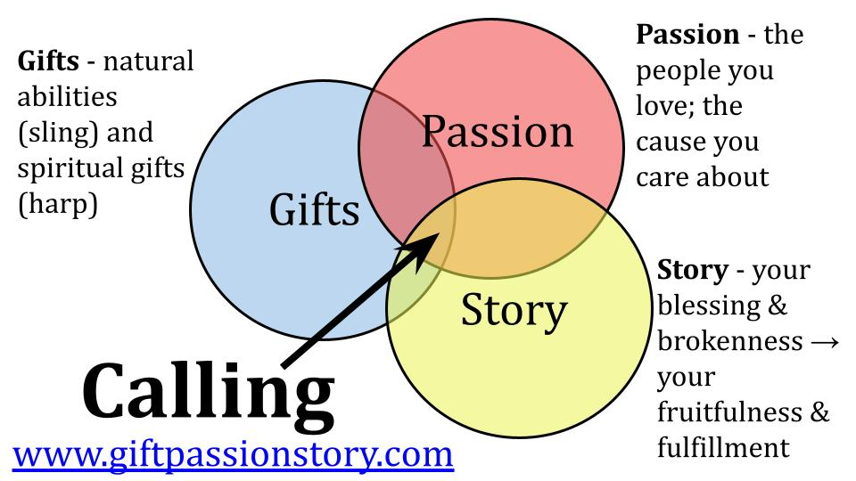

This is our fourth and final week of INTRODUCTION to the CALLING series. We will continue for eight more weeks, using the account of Jonah to apply these GPS principles to our lives.

This is the overview: ***when God calls you, OBEY.*** Listen to the Lord and follow His leading in your heart and life.

The Lord uses **three primary signals** to direct us into our calling - our unique ministry assignment. Ephesians 2:10 says that we are all a masterpiece of God and that He created us to do specific good works. That’s what ***the ARROW represents - the bullseye target for YOU*** in terms of the good works God has prepared and sent you to accomplish. You will find that assignment at the convergence of your gifts, passion and story. We’ve spent the last three weeks looking at gifts and passion. Today we turn to STORY. How does God lead us through both our blessing and brokenness - our success and our suffering?

Once more let’s look at the life of David. Today we will look briefly at four snapshots in David’s life. In each moment **we will see both blessing and brokenness**. Think of this like a ***hallway in David’s house*** with pictures on both sides. On one side are highlights of blessing. On the other side are moments of brokenness. We all have a hallway like this, when we look back on our journey.

Those snapshots on the wall - both the successes and the sufferings - are taking us somewhere. They are ***a hallway to MINISTRY*** - every experience preparing us to serve the Lord by serving others. So, here is the first snapshot:

**Snapshot #1 - Shepherd Boy**

**“**Then Samuel said to Jesse, ‘Are all your sons here?’ And he said, ‘There remains yet the youngest, but behold, he is keeping the sheep.’” 1 Samuel 16:11

When we first meet David, he isn’t even in the scene. Samuel the prophet heard from the Lord that the new king of Israel was a son of Jesse in Bethlehem. Samuel went to see Jesse and meet his sons. He and Jesse both assumed the new king would be one of the three oldest boys. They were of age. They were ready for military service. They were tall and strong.

When those three were not chosen Jesse brought the next four in order of age. But none of those seven boys were God’s anointed. Finally Samuel asked, “Is that it? Are you out of sons?”

Well, Jesse said, there is the little guy.

**Snapshot #1 - Shepherd Boy**

* Humble **Servanthood** as a nobody

**“**Then Samuel said to Jesse, ‘Are all your sons here?’ And he said, ‘There remains yet the youngest, but behold, he is keeping the sheep.’” 1 Samuel 16:11

***David’s first quality noted in Scripture was that he was FORGOTTEN.*** When it came to doing big things for the Lord, nobody thought of little David. He was out with the sheep. He had the lowest, simplest job in the family. No education required. No great skillset needed. Try not to fall asleep.

Do you see the **BLESSING and the BROKENNESS** here? On the one side, David was very blessed to be raised by a faithful Jewish family that took seriously the command of God to be fruitful and multiply. Eight sons meant almost certainly quite a few sisters in there too. How did David develop a heart for the Lord? Almost certainly he gained that from his mom and dad. How did he learn to use a sling and stone? How did he learn to play the harp? Most likley from his parents and older siblings.

And he learned from an early age to SERVE. Some of that blurs into the brokenness side, but a lot of that is very positive. So many ***kids these days never learn to WORK***. They aren’t given chores or responsibilities in the home. They go off to college not knowing how to do laundry or wash dishes or mow the lawn or take out the trash. Not David. He was expected to do his part, even when he was young. That’s a blessing!

But as the youngest he was also largely an afterthought. Birth-order meant significance and responsibility. So David was last in the pecking order. No doubt he had some resentment over being left out with the sheep when the great prophet came over. In all likelihood that was the pattern whenever anyone important came over.

But ***this insignificance was part of God’s preparation for Israel’s greatest leader***. God first taught him HUMBLE SERVANTHOOD as a young Jewish boy tending sheep. You can learn a lot about leading people from caring for animals. Moses was a shepherd for 40 years before leading Israel out of Egypt.

Lots of people today want to lead, but ***very few want to learn how to SERVE***. This was God’s sovereign preparation in David’s life - blessing him with a loving, believing Jewish family; but also shaping his heart through the brokenness of being a nobody. That’s the first snapshot we see in the Bible of David - an insignificant shepherd boy. Here is the second:

**Snapshot #2 - Royal Musician**

“Whenever the harmful spirit from God was upon Saul, David took the lyre and played it with his hand. So Saul was refreshed and was well.” 1 Samuel 16:23

David had already been anointed to be the next King of Israel, but he would have to ***wait nearly twenty years*** before the crown would be on his head. In that time his lesson in humble servanthood continued as he served King Saul, from whom the Holy Spirit had departed. Now the one thing that could soothe the troubled king was David’s music.

We saw this was an example of **a spiritual gift** - how God took David’s natural ability with the harp and gave it supernatural impact to touch Saul’s heart and mind. So David’s first ministry assignment outside of watching the family sheep was to be minister of music to a deranged and unstable king. At first it went well. But it wasn’t long before Saul became jealous of David’s success and popularity and started trying to kill him.

**Snapshot #2 - Royal Musician on the Run**

* Resilient **Faith** as an outlaw

“The next day a harmful spirit from God rushed upon Saul, and he raved within his house while David was playing the lyre… And Saul hurled the spear, for he thought, ‘I will pin David to the wall.’ But David evaded him twice.” 1 Samuel 18:11

Instead of getting better from this music therapy, ***Saul only got worse***. That’s a different lesson for us on only treating symptoms and not dealing with the heart. But from this moment on Saul determined to get rid of David. At first, he just sent David out to war - a plan that backfired because the Lord was with David, so he always came back successful. The more dangerous the attack, the more amazing the victories. As David’s fame spread across the nation, Saul’s jealousy grew, and he became more and more determined to kill David. At one point he mobilized the entire army of Israel to chase David down and try to trap him in a city; or another time in a cave.

On the ***blessing side*** of this stage for David, he was obviously a gifted musician and the Lord used his musical ability to express more than half of the Psalms in our Bible. David was emotionally expressive which helped him connect with the Lord and minister to people - as both a musician and later as a leader. And the times spent on the run, hiding in caves, constantly moving, built in David a ***RESILIENT FAITH*** - an unshakeable confidence in the LORD - that we see in places like Psalm 27, “The Lord is the stronghold of my life - whom shall I fear?”

On the ***brokenness side***, David experienced through this season of life how unpredictable people can be. Saul was super happy with him at first, then murderously angry. Twice David could have killed Saul and chose not to, after which Saul seemed to calm down and repent. But later the angry king fell back into his furious jealousy and went right back to trying to kill David. This was a powerful lesson for David in HUMAN NATURE. He saw the darkness and twistedness of the human heart. And he learned about spiritual warfare as he dealt with Saul being attacked by a harmful spirit.

These difficult, ***painful lessons also built up David’s faith.*** Often suffering and hardship are the sharpest tools that allow God to chip away our worry and fear and unbelief. When you come face to face with cancer or the death of a loved one or the loss of a job - suddenly you have no choice but to trust God and throw yourself on His mercy. That is how it was for David, and it definitely made him stronger in the Lord.

A shepherd boy who learned humble servanthood. A royal musician, running for his life who developed a resilient faith. Now the third snapshot:

**Snapshot #3 - Young Soldier**

“David departed from there and escaped to the cave of Adullam… And everyone who was in distress, and everyone who was in debt… gathered to him. And he became commander over them.” 1 Samuel 22:1-2

David built his reputation in service to King Saul. Saul sent David out on many military missions, and God gave the young man success everywhere he went. The chant the ladies sang after Goliath became a **national anthem** - “Saul has killed his 1,000s, David his 10s of 1,000s.” Oh, how that drove Saul bonkers. Even when Saul sent David on a mission that had no hope of success, David and his growing band of mighty soldiers were miraculously delivered and word of their ability in war and of God’s favor upon them spread throughout the nation and the surrounding regions.

If you look at the list of David’s 30 **mighty men**, several of them are not Jewish. Take Uriah, for example - a HITTITE. David built a great rebel alliance with all of the outcasts and losers in the region of Judea. Everyone who was on the run anyway joined David, who was on the run. He became a sort of Robin Hood for that time period, or a Luke Skywalker if you prefer blasters to bows and arrows.

David faced a great test of leadership and faith in **1 Samuel 30** - when a group of Amalekites made a raid and captured the town of Ziklag, which happened to be where his family was, along with the wives and kids of most of his little ragtag band. They were so scared and angry they actually talked about stoning David!

But David sought direction from the Lord, who spoke clearly to him through Abiathar the priest. Encouraged by the word of the Lord that he would succeed David followed the Amalekite raiders and came upon them in great celebration. They had captured lots of people and spoil from both the Philistines and the Israelites.

* Bold **Leadership** as a Captain

“And David struck them down from twilight until the evening of the next day, and not a man of them escaped, except four hundred young men, who mounted camels and fled. David recovered all that the Amalekites had taken, and David rescued his two wives.” 1 Samuel 30:17-18

By trusting in the Lord and calling on Him for deliverance, David proved not only his wisdom as a leader but also demonstrated the power of God to answer us when we call on Him in faith. Then David wisely took the spoil from this victory and sent it to the people who had been helping him.

* Bold **Leadership** as a Captain

“When David came to Ziklag, he sent part of the spoil to his friends, the elders of Judah, saying, ‘Here is a present for you from the spoil of the enemies of the Lord.’” 1 Samuel 30:26

David showed wisdom in sharing the spoil and illustrated the kind of generosity the Jewish people should expect from a good and faithful king. Most kings tax and take from their people. David gave generously to the people.

So on the ***blessing side*** of this stage, David learned leadership, bold steps of faith and the importance of seeking clear direction from the Lord. His skill in battle and his ability to influence and unite people, even in the face of great danger and adversity and even bringing together people of different cultures and backgrounds - and people with great disadvantages in life.

It’s like God said to David, “Here is your leadership classroom - a cave filled with 400 malcontents who don’t fit anywhere else. If you can learn to lead and care for that bunch, you’ll be able to lead and care for any group.”

This is ***the kingdom principle of little to big***. God doesn’t give anyone major responsibility before He has first tested them with small things. The one who is faithful with a little thing will also be faithful with much. So don’t be discouraged that God calls you to small acts of service, small groups of malcontents (we have plenty of those around here!). Embrace the gift of small beginnings and trust that the Lord will give you exactly what you can handle as you can handle it.

Pastor Peter Scazzero says ***“God is building up your BEING in order to sustain your DOING.”*** If God didn’t first build up your identity and faith in Him - your being - then he wouldn’t be able to give you much in the way of doing. Look at the life of any leader in the Bible. It took time and a long, involved process to prepare them for the big things they eventually did. **God is an amazingly patient crafstman**.

In David’s years as a young leader, a wilderness outlaw, there is also a lot of ***brokenness***. Look, for example, at his family life. Saul tried to snare David with how daughter Merab. David saw through that and didn’t go for it. But Saul’s younger daughter Michal “loved” David and that bait, for some reason, he did take - though it didn’t go well for him or Michal. Later he married another woman named Ahinoam, and after that had this encounter with Abigail.

Abigail’s husband, **Nabal**, refused to provide food for David and his ragtag band. David had been protecting the resources of Nabal for weeks and months - as all of his servants willingly attested. But Nabal was a greedy, grumpy old man and wouldn’t share. David was furious and was coming back with his warriors to wipe out Nabal and his family when Abigail heard what was going on and rode out to meet David, with a present of food for him and his men. She apologized for her husband’s foolishness and lack of hospitality and asked for mercy from the angry captain.

David was so impressed with her wisdom and tact that when God struck Nabal dead soon thereafter, he asked Abigail to be his third wife - which she apparently took to be a good deal. The point for our purposes? ***David was allowing his emotional volatility lead him into impulsive decisions.*** Would that lead him into trouble in the future if he didn’t learn to control it? It sure would.

David ended up having nine wives and lots of children with those nine wives - far more than he could realistically parent. Nine wives and a dozen concubines doesn’t sound like much compared to Solomon’s 600 wives and 300 concubines - but it still gives a window into ***the brokenness of David’s past*** that he didn’t fully deal with until after Bathsheba and then Absalom’s rebellion.

**God was preparing David to lead an entire nation**. He taught David humble servanthood as a shepherd boy; resilient faith as an outlaw and bold leadership as a captain in the army. One more snapshot:

**Snapshot #4 - Great Leader**

“And the king and his men went to Jerusalem against the Jebusites, the inhabitants of the land, who said to David, ‘You will not come in here, but the blind and the lame will ward you off’...Nevertheless, David took the stronghold of Zion, that is, the city of David.” 2 Samuel 5:6-7

One of the last remaining strongholds in the land was Jerusalem itself. They felt secure in their fortified city, but David went with a group up the water shaft. 100 years ago archaeologists discovered a water shaft that runs 52 feet directly vertical. You can see where the inhabitants of the city wouldn’t have considered that a likely line of attack. But Joab led the assault and they captured the city, where David would rule for 33 more years, over the unified nation of Israel.

**Snapshot #4 - Great Leader**

* Sacrificial **Service** as King

“And David lived in the stronghold and called it the city of David. And David built the city all around from the Millo inward. And David became greater and greater, for the Lord, the God of hosts, was with him.” 2 Samuel 5:9-10

Finally, at the age of 30, David became King. He reigned for 6.5 years in Hebron, just over Judah and Benjamin. Then, with the conquest of Jerusalem he reigned for another 33 years over all of Israel. This timeline shows David’s life: 30 years of preparation for his calling to be the Great King of Israel. 40 years serving as King. 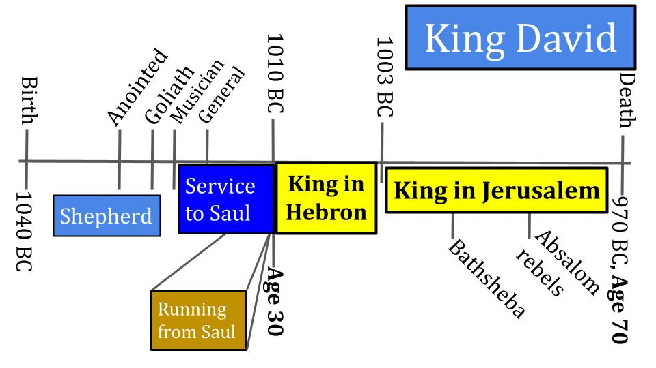

From a ***blessing standpoint***, David was profoundly blessed! God’s Spirit came upon him at his anointing when he was probably only 12 or 13 years old. He knew at a young age that he was chosen for great things, that God was with him. And God was truly with him at every step - protecting him from lions and bears as a shepherd; empowering him to take on and defeat Goliath while still a teenager; giving him gifts in music to write Psalms and minister to a raving king; surrounding him with mighty warriors, godly advisors, prophets like Samuel and then Nathan; strengthening him through great adversity and uncertainty leading up to the difficult assignment of actually being king.

As king, ***David still had to lead the nation in battle*** for his entire 40 year reign. So all those battles, from Goliath and on, were preparation for him. All of the danger and fear that taught him to trust completely in the Lord were preparation for him. Some lessons he learned well and carried through his life. Other lessons he did not learn so well - especially in marriage and parenting - and those consequences place a shadow over his life and legacy.

You can see the ***brokenness*** even in David’s later days. His adulterous relationship with Bathsheba, when he should have been at war with the army, set up his additional betrayal of Uriah - one of his most faithful and capable soldiers. His 9 wives and even more concubines set him up to have lots of children who would inevitably have conflict with each other over succession to the throne. Absalom led a rebellion that forced David to again run for his life, but as a 60 year old King instead of a 20 year old army captain. I expect caves are less comfortable at 60 than they are at 20.

Here is the summary of David’s STORY:

|  |  |
| --- | --- |
| 1. Shepherd Boy | Humble Servanthood as a nobody |
| 1. Royal Musician | Resilient Faith as an outlaw |
| 1. Young Captain | Bold Leadership as a Captain |
| 1. Great Leader | Sacrificial Service as King |

***Do these descriptions remind you of anyone?*** Humble servant; firm, unshakable faith; zealous leadership and preaching; the ultimate sacrificial king… What is large, gray, with huge ears and a long trunk? Well teacher, it sounds a lot like an elephant but I’m going to say, JESUS?

**David’s story is not about David - it’s about Jesus**. The same thing is true for you and me. The details are different, the gifts and passions are customized - but the storyline is actually the same.

* All of us, like Jesus, are ***NOBODIES***. We are born and raised insignificant, with no merit or ability to commend us to God.
* All of us have ***gifts and abilities*** that we are to use where God has placed us. All of us experience **blessing and brokenness** that God uses to shape us and prepare us. He is building up a resilient faith that can weather the storms of life and be an encouragement to others.
* All of us have ***opportunities to influence*** others - our lives touch so many - family, friends, co-workers, neighbors. For David there was a military and political application, for most of us it’s a family and work and church application - but we are all called to influence the people around us and help point them to Jesus.
* And all of us are called to ***sacrificial service***. If King Jesus - through whom all things were made and for whom all things were made - invested his life in service to sinful humans and then gave up his life on the cross - that, too, is the model for us.

David was called to ***a life of service as KING***. You and I don’t have the stress and strain of being king (and let’s be thankful for that!), but we still have the privilege and calling to serve.

***So as you look back on the hallway of your life, what do your pictures look like?*** What are some moments of great blessing and success where you’ve seen God work in you and through you? What are the moments of brokenness and suffering through which God has built up your faith and shaped you, filling you with compassion for others?

As you consider your **gifts and passions, also prayerfully reflect on your story** - and at the convergence of those three signals, you will find your CALLING - your unique assignment for this season of your life. Is the arrow starting to point for you in a specific direction?

[CASH UNDER 3-4 chairs. $100 bills.] Those gifts are symbolic for all of us. Only a few people today sat in the “special chairs,” but all of us have been given way more than $100 to steward on behalf of our Lord and Savior. **The $100 bill** is just a clear indicator to those who hold it that God has given you specific gifts, experiences and resources to steward on His behalf. Truthfully every dollar we have belongs to Him. Every resource we own is because He has entrusted it to us for a time. Every relationship is a gift from him. Every natural ability and spiritual gift are a stewardship. Every day, every minute we are alive God has entrusted to us to manage on His behalf. A small handful through this series will be given the additional responsibility of investing that $100 and reporting back to the elders about how you used it and what God did. The rule is you can’t give it back for a week. You have to hold onto it and pray about it - sincerely asking the Lord to lead you to some way to use it for His kingdom, to bless someone.

How is the Lord calling you to serve? Are you hearing His voice? Are you moving forward in obedience?

Let’s pray.