**Use your Gifts!**

1 Samuel 16

**Calling:** your unique **Assignment** from God - the good works He has prepared in advance for you to do, as you make disciples for His glory.

“We are his workmanship, created in Christ Jesus for good works…” Eph. 2:10

Last week we started a new series on **CALLING**. Calling is not just for pastors and missionaries - ***all followers of Jesus are called and commissioned for ministry!*** You are God’s unique masterpiece, with specific good works He prepared for you to do and that He is now calling you to walk in them. If you missed last week I encourage you to check out that message on our youtube channel or listen on the PODCAST! The overview handout is available, but it will be easier to understand if you get the full introduction.

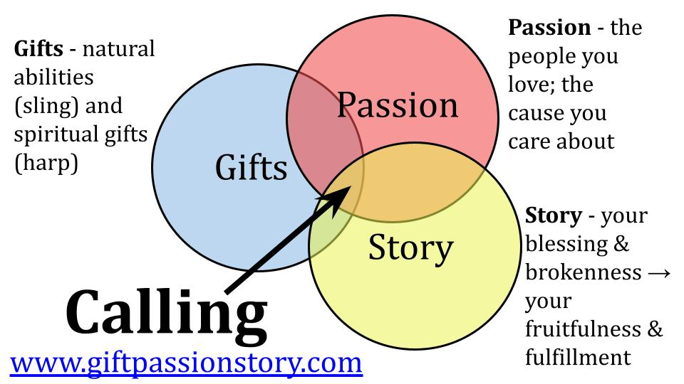

For the next three weeks we are going to walk through the life of David to illustrate the ***three GPS SIGNALS*** that help guide us to our ministry calling. Today we will focus on natural and spiritual gifts. Next week will be about passion. And then we will wrap up this segment by looking at your story - the good, the bad and the ugly.

We are encouraging everyone to **take the free assessment** at Gift Passion Story. Com. It has 155 questions and the last few are ESSAY - but it’s well worth the effort. And follow all the instructions - have your spouse or a close friend take the assessment AS IF THEY WERE YOU - for the most honest answers possible. And process all of this with your Community Group or Discipleship Group.

You have a unique assignment from God! ***You are His custom masterpiece***, “created in Christ Jesus to do good works, that God prepared beforehand, that you would walk in them.” Jesus said to his followers, “You are the salt of the earth… you are the light of the world.” It is our job to bring the salt of God’s love to the broken and dying places around us and to bring the light of God’s grace to those still enslaved to their sin.

David had a unique assignment. Everyone knows **the story of David and Goliath** - when the young shepherd boy faced off against the nine-foot Philistine and took him down with a sling and a stone. That was a significant turning point event for David and for Israel. The young shepherd was called by God to step up when everyone else was stepping back, including King Saul. But that was not the end of David’s ministry calling - it was only the beginning. And that assignment would be messy and challenging every step of the way - just as Jesus’ assignment was. So, should we expect any different?

Many Bible teachers have used Goliath as an inspiring story to encourage believers by saying, “You can take on any giant! What are the giants in your life? With God helping you, you can defeat everyone!” Now, that is a valid application of the David and Goliath story. But there is a BETTER application is to see how **Jesus is the true and better David**.

|  |  |
| --- | --- |
| **David** | **Jesus** |
| Risked his life in battle | Gave up his life on the cross |
| Killed the giant Goliath | Defeated sin and death forever |
| Became King of Israel | Proved He is King of Kings |

David risked his life, but Jesus gave up his life on the cross. David defeated the Philistine champion, Goliath. Jesus defeated sin and death forever through His death and resurrection. David became the greatest king of Israel. ***Jesus proved*** - by rising from the dead - that He is the King of all Kings, the Lord of all people and nations, the One who upholds the universe with the word of His power.

So while it is good and right to use David as an example of courageous faith and obedience, the real purpose of this story is to point us to **the greatest example of obedience - Jesus**. Because Jesus conquered sin, we can live in freedom! Because Jesus conquered death, we need not fear this enemy of all people. Because Jesus reigns over all things, we can trust Him to lead us and strengthen us as we seek to serve Him by using the gifts He has entrusted to us.

So let’s get this point clear as we begin this series on calling.

The David and Goliath story is not about David but is ultimately about Jesus.

Your story is not about you but is ultimately about Jesus too.

If we keep this principle in focus, it will **dispel all the fears** that come along with seeking a clear ministry calling.

* What if people reject me? Well, many rejected Jesus.
* What if it doesn’t work? Well, at first it sure looked like Jesus’ strategy hadn’t worked.
* What if I choose the wrong ministry? Well, the only wrong ministry is the one you don’t choose. Jesus will guide you - the only thing to fear is disobedience to Him.
* What if I delay and disobey? Well, the whole Christian life is under the wonderful grace of Jesus. We don’t work to earn His favor but because we already HAVE His favor. But don’t stay there in delay and disobedience! Let the grace and mercy of Jesus move you into the harvest field!
* What if no one comes with me? Jesus has promised that HE will be with you to the end of the age.

This is the **Gospel banner** that flies over this series, over our church and over our lives:

**Jesus is the Conquering King**

The David and Goliath story is not about David but is ultimately about Jesus.

Your story is not about you but is ultimately about Jesus too.

Your natural and ***spiritual gifts*** were given to you by King Jesus, according to His sovereign wisdom and empowered by His Almighty Spirit. ***Your passions*** were placed in your heart by King Jesus - who has given you convictions about His glory, His righteousness, His compassion - that for you MUST be applied to certain areas of brokenness and pain in this world. And ***your story*** is a small part of HIS GREAT BIG STORY that started when He said, “let there be light,” and will end when Jesus returns and says, “It is finished.”

So, with all of that backdrop and context, **let’s look at David’s life as an example of natural and spiritual gifts**. We will summarize and remember those as his sling and his harp. The sling represents his natural abilities and the harp his spiritual gifts. So be thinking about you - what is your sling? What is your harp? What natural skills and abilities has God given you? And what spiritual gifts has God given you? Taken together, that gift-mix is a key part of how the Lord will lead you into your unique assignment.

We first meet David in 1 Samuel 16 as the prophet Samuel is lamenting the failure of King Saul.

The Lord said to Samuel, “How long will you grieve over Saul, since I have rejected him from being king over Israel? Fill your horn with oil, and go. I will send you to Jesse the Bethlehemite, for I have provided for myself a king among his sons.” 1 Samuel 16:1

***Samuel is the hinge from the time of the judges*** to the time of the kings. He is the one the Lord appeared to when he was just a young boy, serving the high priest in the temple area. Three times the Lord called his name and the boy ran to Eli the priest to say, “Yes sir, I’m here.” Finally the priest realized it was God calling to Samuel, so he said, “When it happens again just say, ***“Speak, Lord, your servant is listening.”***

1. Calling begins by **Hearing** God’s voice and **Obeying** His direction

And the Lord came and stood there, calling as at the other times, “Samuel! Samuel!” Then Samuel said, “Speak, for your servant is listening.” 1 Samuel 3:10, NIV

So that is what Samuel did and the Lord told him that the ministry of Eli was coming to an end because of the priest’s failure to restrain the sin of his sons.

And so, the ministry of **Samuel the prophet** began with the simple words, “Speak Lord, your servant is listening.” Really that is the summary of our whole series. Since Jesus is the King of all Kings, our job is - very simply - to hear His voice and obey His guidance. Whatever He asks of you - that is your assignment.

Samuel had the task of leading the nation of Israel from ***one difficult season to another***. The time of the judges was the dark ages for the Jews. Everyone did what was right in his own eyes. It was a downward spiral of selfishness and sin, ending in terrible civil war. But the word of the Lord coming to this young boy provided **a ray of hope** in those dark days. God had not given up on His people, even though they continually fell away from him.

And their ***lack of faith continued*** under Samuel as the people came together and demanded a King. God was supposed to be their King, but He told Samuel to go along with this request and give them a king - but He told Samuel to warn them what the kings would do: lead their young men into war, conscript their young women into slavery, take funding and land from everyone… But the people were obstinate, and demanded a king.

Saul was the first king - and the people celebrated him largely because he was big and strong. In those days the average height was only five feet tall. Saul stood head and shoulders above most Israelites, so he was probably six feet tall, maybe a little more. The people were thrilled to have a ***big, strong king*** to lead them into battle and bring glory to their kingdom. Can you see the problem already? They immediately began to think of Saul as their True King, not God. ***They didn’t want to trust God*** to lead them in battle - they wanted to trust Saul. They didn’t want to trust God to lead them in what to do - they wanted a human king to tell them what to do.

Well, it wasn’t long before ***Saul let them down***. Samuel gave him one simple rule - wait for me to offer the sacrifices before you go into battle. But Saul grew impatient. The people were restless, the enemy was moving. It was time for war - and the prophet was late. That is on him! So Saul broke the rule and offered the sacrifices himself. And just like every kid who knows he should watch that scene in the movie but does - at that exact moment Mom walks in. So it was with Saul. As soon as the last sacrifice was consumed on the altar, Samuel walked up and said, “What’s all this bleating of sheep and lowing of cattle I hear?”

Because Saul did not listen to and obey the direction of God, the Lord rejected him as king. ***Saul serves as a cautionary tale to all Christian leaders.*** It is possible to be disqualified from leadership if we don’t listen to and follow the directions we have in Scripture. I have seen too many pastor friends and I’ve heard of so many more prominent Christian leaders who have “shipwrecked” their faith and ***demolished their ministry***. Some have fallen into sexual immorality, despite the many warnings in Scripture to guard ourselves especially in this area. Some have fallen into financial traps. Others have fallen into the dangers of abusing power - coming to believe the hype of their own greatness - as Saul did - and failing to listen to God’s Word that says, “Pride comes before a fall, and a haughty spirit before destruction.” It also says, “Everyone who exalts himself will be humbled and everyone who humbles himself will be exalted.”

And so we come back to 1 Samuel 16 and the new direction God gives to Samuel:

The Lord said to Samuel, “How long will you grieve over Saul, since I have rejected him from being king over Israel? Fill your horn with oil, and go. I will send you to Jesse the Bethlehemite, for I have provided for myself a king among his sons.” 1 Samuel 16:1

First, God gave Israel the king they wanted. Then, ***God gave Israel the king they needed.*** Samuel doesn’t get a detailed description of the new king - just the family name. But the old prophet heard the voice of the Lord and set out to obey. As it turned out, Jesse had a lot of sons.

When Samuel saw Eliab, Jesse’s oldest son, he thought he had found the new king.

“When he came, he looked on Eliab and thought, ‘Surely the Lord’s anointed is before him.’ But the Lord said to Samuel, ‘Do not look on his appearance or on the height of his stature, because I have rejected him. For the Lord sees not as man sees: man looks on the outward appearance but the Lord looks on the heart.’” 1 Samuel 16:6-7

That was the mistake the people made with Saul! They only considered his outward appearance - his height and strength and handsome good looks. Turns out, there are much more important factors when it comes to national leadership! Here is our second principle related to calling:

1. **God prefers to use Ordinary people who Need Him more**

“Man looks on the outward appearance but the Lord looks on the heart.” 1 Sam. 16:7

***The primary qualification*** for becoming a Christian is to admit you don’t deserve to be a Christian. The same thing is true for Christian leadership. The main character quality you need to have influence in God’s kingdom is ***humble dependence on the Lord*** - a heart that loves and trusts in Him and doesn’t try to make things about you.

What trips up more leaders than anything else? **PRIDE**. We start to believe the hype - we start to believe that it IS about us. And we start to operate as if everything depends on us - my plans, my meetings, my presentations, my efforts, my ideas. So prayer gets set aside. God gets set aside. It’s all about the Leader. Influence. Power. That is how to short circuit real Christian ministry. Make it about you. Trust me, ***I’ve learned that lesson in every place I’ve done ministry***. And I’m always tempted to slide over onto that throne and just nudge Jesus aside. That’s when **you hear Aslan growl** and you jump up and move over into the shadows, onto your knees.

Samuel was impressed with Jesse’s oldest son, and the next oldest and the one after that. But with each young man the Lord said, “Nope, not that one.” And on through all seven of Jesse’s sons. How many boys can one family have? Samuel asked Jesse, “Is that all of them?” And Jesse said, “Well, there is one more - but he’s just a little guy, out there with the sheep.”

**2. God prefers to use Ordinary people who Need Him more**

“There remains yet the youngest, but behold, he is keeping the sheep.” 1 Samuel 16:11

No one there that day considered David worthy to attend this meeting with the prophet much less a candidate for the crown. But God doesn’t choose based on appearance or physical impressiveness. God looks for ordinary people who are humble enough to need Him. God looks at the heart. He looks for humility and devotion.

This should be very encouraging for all of us today! **What QUALIFIES you** for ministry in the kingdom of God? ***The knowledge that you are not qualified!*** This is the upside-down nature of God’s kindgom. If you think you’re deserving, you aren’t. If you think you aren’t worthy - you are!

Then in verse 12 we come back to the first principle of calling:

1. Calling begins by **Hearing** God’s voice and **Obeying** His direction

“And the Lord said, ‘Arise, anoint him, for this is he.’” 1 Samuel 16:12

One after another the Lord had said no about the other seven sons of Jesse. Now, very clearly, the Lord said “Yes” about David. Was this an audible voice or just a clear feeling Samuel had? We can’t be sure. But what is clear is that Samuel knew. He heard God’s voice and understood.

And when the Lord calls us the same is true - we know. ***God has ways of making Himself understood.*** The problem is not on God’s side of the telephone - the problem is on our end - we either aren’t listening, or we are hearing just fine, we just aren’t obeying.

And notice ***the relational nature*** of calling as well - which brings us to our third principle of calling.

1. God **Confirms** His calling through **Godly** people

“And the Lord said, ‘Arise, anoint him, for this is he.’” 1 Samuel 16:12

Samuel had walked with God his entire life - and had been hearing from the Lord since that first time when he was still very young. What a blessing for young David, to have a godly prophet, familiar with the voice of the Lord, to encourage him and get him started in ministry!

1. God **Confirms** His calling through **Godly** people

“Then Samuel took the horn of oil and anointed him in the midst of his brothers. And the Spirit of the Lord rushed upon David from that day forward.” 1 Samuel 16:13

**The anointing of the Holy Spirit** worked differently before Jesus came, before Acts chapter 2. The Spirit of God rushed on specific people for specific tasks and short periods of time: kings, for example. When Saul disobeyed God’s direction to him through the prophet Samuel, the Spirit of the Lord departed from him. Now the Spirit was poured out on David, though he wouldn’t actually become king for several more years.

The principle here is ***the encouragement and affirmation of godly people in your life***. We do this formally when we call a new pastor or send out a missionary. We call that a **COMMISSIONING**. We gather elders and church leaders together to pray and lay hands on the person and publicly present them to the Lord for a special assignment.

You should think of ***your ministry assignment the same way*** - that as a church the pastors, elders and church leaders are standing around you, praying for you, and laying our hands on you to pray a blessing over you and commission YOU for ministry. Think of your Community Group or D-Group that way - as some godly people who know you, affirming the character and gifting they see in you and praying for the anointing of the Holy Spirit upon you and your ministry efforts.

So as we listen to the Lord for direction into our ministry calling, be sure to also ***listen to the godly people around you*** - especially your SPOUSE - the people who know you best. When a few mature, Jesus-loving people confirm the direction you feel led by the Lord to follow, you can have greater confidence to move that way!

But don’t miss the fact that comes up in the very next verse…

1. God **Confirms** His calling through **Godly** people

“Now the Spirit of the Lord departed from Saul and a harmful spirit from the Lord tormented him.” 1 Samuel 16:14

Godly people will confirm your calling - and ***ungodly people may well oppose your calling***. Jesus is our model for ministry. Lots of people opposed his ministry, especially toward the end. David experienced serious opposition - and everyone who seeks to serve the Lord will face opposition - hopefully not from someone throwing a spear at you; but from people questioning you, calling you narrow minded, wanting you to join them, feeling jealous…

This harmful spirit that came upon Saul sets up our final principle for today.

1. God will use your **Natural Abilities** (sling) and your **Spiritual Gifts** (harp)

“Seek out a man who is skillful in playing the lyre and when the harmful spirit from God is upon you he will play it, and you will be well.” 1 Samuel 16:16

David illustrates for us both **natural and spiritual gifts**. David had developed some significant natural abilities in both shepherding and music. God used both of these in supernatural ways.

David chose to face Goliath not with a sword and heavy armor he had never used before but with ***the familiar sling and stones*** he had used for years when out protecting his sheep. No doubt he had spent many hours practicing with that very sling, to the point that he could hit a wolf in the head a pretty long way off.

Similarly, David had lots of time to practice his music out there on the hills. He wasn’t a beginner plucking out a few notes for Saul. He had developed a natural ability and the Lord blessed that ability with supernatural effect.

1. God will use your **Natural Abilities** (sling) and your **Spiritual Gifts** (harp)

“Behold, I have seen a son of Jesse who is skillful in playing, a man of valor… prudent in speech, and a man of good presence.” 1 Samuel 16:18

Saul sent for David, not only because he was a gifted musician, but because he was a man of character and courage, of “prudent speech and good presence.” And look how the Lord used David in service of King Saul:

1. God will use your **Natural Abilities** (sling) and your **Spiritual Gifts** (harp)

“Whenever the harmful spirit… was upon Saul David took the lyre and played it… So Saul was refreshed and was well…” 1 Samuel 16:23

Here we see an Old Testament example of a spiritual gift in operation. When David played his lyre ***the results were more than just some emotional improvement for Saul***. The effect was spiritual, calming his spirit and restraining the evil spirit that was upon him. It’s safe to assume that David played worship music in his repertoire with Saul. Maybe not entirely worship music from his Jewish upbringing, but probably it was central to his ministry to sing and play songs that exalted the Lord, the covenant God of Israel.

That is what drives out demons still today - ***the Name of Jesus, exalted in worship and faith***. Where the light of Jesus comes, the darkness of the enemy must go. And God blessed David’s ministry of music with supernatural impact.

We experience this every Sunday with **our amazing worship team**. The New Testament lists of spiritual gifts don’t ever mention music as a named gift, but it’s a great illustration of how God takes a natural ability and can elevate it to have supernatural effect. These musicians and singers could use their abilities to play covers in bars or to do karaoke or sing on a cruiseline. I’m not saying there would be anything wrong or sinful about using their talents that way. But when musicians use their gifts to worship - it has more than an emotional effect on those of us who benefit from it. The Lord uses their collective efforts to touch our hearts and speak to us in our souls. The gospel can break through to us in music in ways that the preacher usually can’t.

There are two key passages that describe spiritual gifts in the New Testament:

“Having gifts that differ according to the grace given to us, let us use them: if **prophecy**, in proportion to our faith; if **service**, in our serving; the one who teaches, in his **teaching**; the one who exhorts, in his **exhortation**; the one who contributes, in **generosity**; the one who **leads**, with zeal; the one who does acts of **mercy**, with cheerfulness.” Romans 12:6-8

Romans 12 lists seven **ministry gifts**. Paul’s point is - there are different gifts, so use YOUR gift to its maximum effect. Don’t feel bad that you don’t have another gift. Don’t compare yourself to someone else. Just know your gift and use it!

“For to one is given through the Spirit the utterance of **wisdom**, and to another the utterance of **knowledge** according to the same Spirit,to another **faith** by the same Spirit, to another gifts of **healing** by the one Spirit,to another the working of **miracles**, to another **prophecy**…” 1 Corinthians 12:8-10

1 Corinthians 12 lists 9 gifts sometimes considered sign gifts or relational gifts. Then Ephesians 4 lists five offices within the church. So here is the NT picture of the many spiritual gifts God assigns in the church:

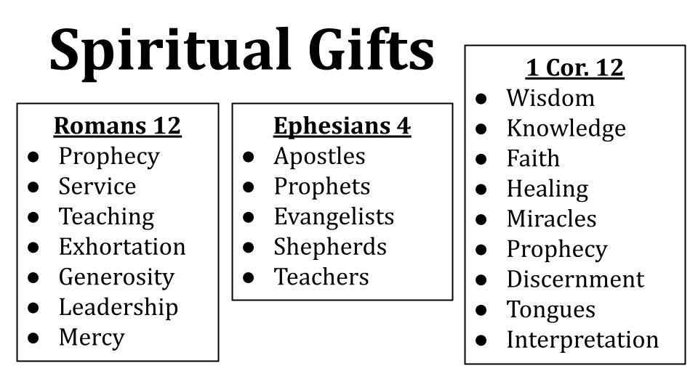

The point is: there are lots of different gifts. No one has all of them. Everyone has one of them. We are a body, and we need each other!

***So, what is your SLING?*** What are the natural abilities God has given you?

***What is your HARP?*** What are the spiritual gifts God has given you?

**Gifts are the first of the GPS signals** that will guide us into our calling - your unique ministry assignment from God.

Come back next week to learn more about ***PASSION*** - how the Lord leads us to a specific group of people or a cause we just can’t stop thinking about. 

Finally, in two weeks we will look at elements of ***STORY*** - How the Lord uses our suffering and success, our brokenness and blessing - how calling changes in different seasons of life.

Take the assessment and begin to process your GPS with the people in your life!

Let’s pray and trust the Lord to guide our steps!