The Beginning
Genesis 1:1-5, 24-31

What does true Shalom look like? What does peace and love and harmony and joy look like? The answer to this question is that we don’t know - and we can’t know because the only world we have known is one broken and corrupted by sin and death, disease and disaster, war and destruction.

In order to even imagine what Shalom looks like we have to go back to the very beginning - to the original creation. We will look at the glimpse of shalom in the Garden of Eden before Adam and Eve ruined it all with sin.

What we will see is that Shalom involves harmonious relationships in every direction: upward with God; horizontally with one another and globally with the world.
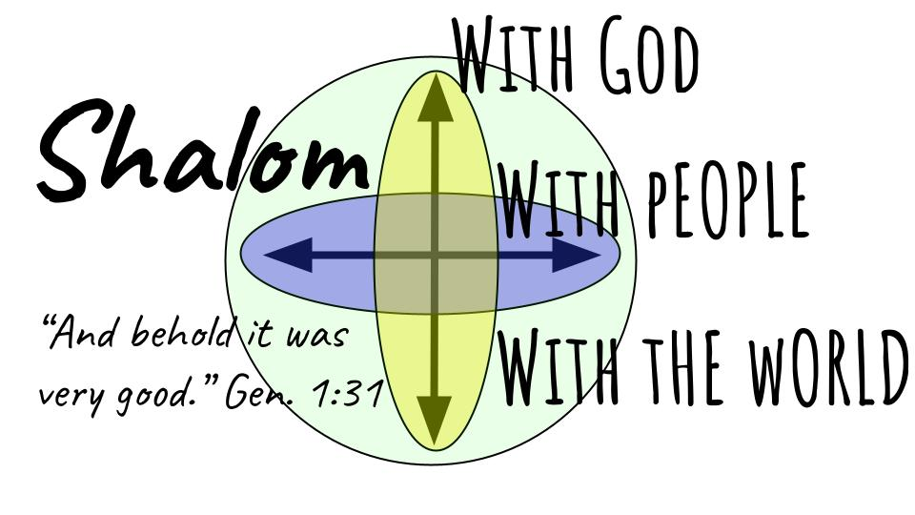
When God finished His work of creation He pronounced it all “very good.” Adam and Eve were placed into a perfect world where there was no death, no disease, no pain, no conflict, no fear, no guilt and no shame. It was a perfect 78 degrees and mostly sunny - we know this because they were comfortable without any clothes. Before you get lost in that image, let’s move on to explain the three dimensions of Shalom.

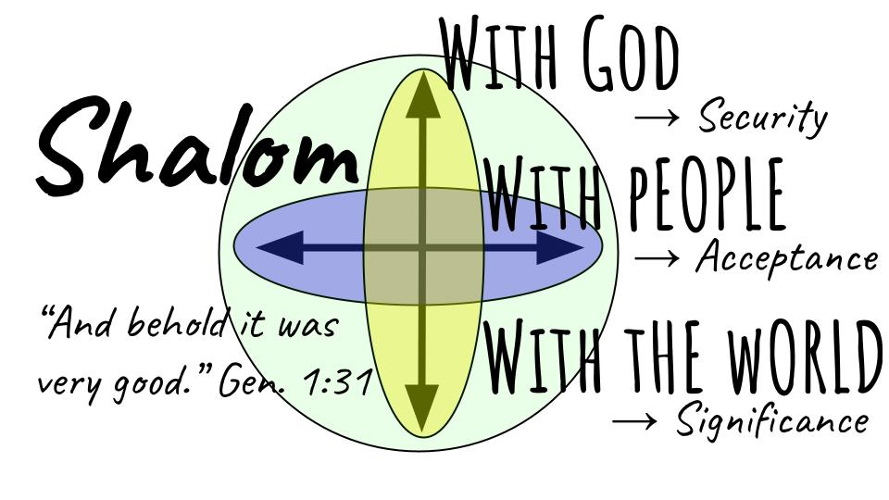
Now, this is woefully reductionistic - much more could be said about each of these categories, but the goal for today is simply to show how GOOD it really was in the original creation and how it will be EVEN BETTER when Jesus makes all things new. Let’s get the picture of SHALOM because what we will see through this six week series is that our calling is to work all of our lives to restore this Shalom as much as we can. That’s what Jordan showed us last week - connecting the First Commission with the Great Commission. Jesus very deliberately didn’t just fill the world with people and civilization and buildings and bridges - He wanted to partner with people to develop the garden of the world together. Of course, people immediately rejected that partnership and went their own way. But in the new heaven and earth the partnership will finally work with those who have freely chosen to embrace it - and we will “reign” with Him forever - again in a world without death or fear or chaos or disorder.

So let’s walk through these three relationships - these three dimensions of Shalom to see God’s great purpose for the One Story He is writing, in which each of us is a small supporting character, working with Jesus - the Hero.

First of all and above all, Shalom means a SECURE relationship with God.

- Shalom is Security with God
“Let us make man in our image, after our likeness. And let them have dominion…” Gen. 1:26
- A defined relationship of Creature to the Creator

We struggle now with the chaos of undefined relationships with unclear expectations and unmet demands. The order of relationship is all wrong, with the creatures trying to dictate terms to the Creator - trying to remake god into an image more to our liking.

But it was not so in the beginning. And there was such security in the clarity of that relationship. God the Creator. People the created ones. The relationship was clear and well defined. God walked with them and spoke with them - the rules and expectations were well defined.

Yes, humankind is created in the image of God - but that does not make us gods - it makes us creations of God, designed to reflect His glory throughout the world He has made for us.

Many parents today follow what is called “child-directed parenting.” I’m not kidding - it’s a real philosophy even though it’s utterly absurd. Let the child set the terms in the home and in school. Don’t you dare bruise their fragile little ego with your rules and discipline. But letting small children make all of their own decisions does not help them feel safe, it actually stresses them out. And loving authority helps kids feel the most safe and secure.

This is how it started with God. He was clearly the One in charge. And Adam and Eve didn’t have a problem with that until the snake slithered in. There was security in the well defined relationship between the Creator God and the people He had made.

- Shalom is Security with God
“Let us make man in our image, after our likeness. And let them have dominion…” Gen. 1:26
- A dignified relationship of Image-bearer to the Father

Not only was the relationship clearly defined, there was great dignity in it. To be made in the image of God is to bear the divine imprint of our loving Father. With that divine image comes the ability to have relationships in the first place - the ability to think and communicate, to love and be loved.

But it is not our ability that gives us value and dignity, it is our HUMANITY that makes us valuable as image-bearers. So even when the ability to move or communicate is limited by the brokenness off this world, the dignity remains because all humans, from the moment of conception, reflect the image of our glorious Creator.

Do you feel the security of this truth? You have dignity, worth and value just because God made you. And He does not make mistakes. He does not need a do-over. He planned every detail of your life, right down to the last atom. You are “Fearfully and wonderfully made” according to Psalm 139.

Oh, we wrestle with great insecurities in this life - magnified by our imperfections and our sins, and aggravated by the sins and judgments of other people. But that was not how it was when SHALOM reigned on earth. And it will not be that way in eternity. There we will have perfect security - resting in our relationship with God as Creator and Father.

- Shalom is Security with God
“And God blessed them… Behold, I have given you every plant yielding seed…” Gen. 1:28-29
- A dependent relationship of Grace-receiver to Grace-Giver

In the original creation there was no tension or frustration in the fact that God was the GIVER and people were the RECIPIENTS. God had given them literally everything they could see, and they had no delusions or confusion about that. Adam and Eve simply received the fruit from the trees to eat and enjoyed the Garden with every good thing for them to enjoy.

Imagine the cool, clear springs - the beautiful waterfalls, the flowing rivers, the deep ponds. Imagine the lush vegetation, without a single weed in sight - everything flourishing and thriving in an environment exactly conducive to growth. It’s not that hard to imagine Eden here in Florida where we are just one step removed from the Garden. For those who come from the North where it was gray and chilly most of the time, where the leaves turn brown and die every fall and where the snow immediately turns to gray slush and then blackened grime; and the salt literally eats your car - up there it’s much harder to imagine the original Garden.

So be thankful for everything God has given to you for your blessing and enjoyment. Don’t compare yourself with someone else unless it’s someone with less than you. Rest in the security and joy of contentment - giving thanks for exactly the life God has provided for you right now. Trust Him for your daily bread and don’t worry about tomorrow.

That’s what shalom felt like with God - one very partial glimpse into that upward relationship. Adam and Eve felt perfectly safe.

- Shalom is Security with God
- A defined relationship of Creature to the Creator
- A dignified relationship of Image-bearer to the Father
- A dependent relationship of Grace-receiver to the Grace-Giver

The relationship was clear and well defined. They knew God - they saw Him. They walked with Him. They had no confusion about who was in charge. And even though God was clearly in charge and clearly God - they felt great dignity in simply bearing His image, and they felt great joy in simply receiving the good things God had made for them.

They knew God personally as Creator, Father and the Giver of every good and perfect gift.

Do you know God this way? Have you tasted the Shalom with God that can be found right now in Christ? Romans 5:1 says “Therefore since we have been justified by faith we have peace with God through our Lord Jesus Christ.” This is our immediate privilege and joy in Christ - as those who have been forgiven and justified by Jesus we HAVE PEACE with God - we are reconciled to the Holy One and have this triple blessing of a defined, dignified and dependent relationship with God.

But the grace of God didn’t stop there in the Garden, and it doesn’t stop there for us today. God created Shalom to be vertical and horizontal.

- Shalom is Acceptance with People
“So God created man in his own image… male and female he created them.” Gen. 1:27
- A defined relationship of Roles assigned

In the original creation there was no conflict between Adam and Eve - no mistrust, no miscommunication, no fear or judgment - only perfect acceptance and mutual delight. Adam was not annoyed with Eve for being a woman - he was blown away by her in every way we can imagine. Eve was not frustrated with Adam for being a man - after all, football and smart phones had not yet been invented.

Our culture makes all this noise about gender roles and gender identity. Everything is a massive power struggle. But there was none of that confusion or tension when peace reigned on earth. Eve was delighted that Adam was strong and able to work the ground longer than she could. Adam was thrilled that Eve was built differently, in ways that complimented him. I mean that she was super organized, which freed him up to be more spontaneous and free-spirited.

From the beginning God made a man and a woman. His original design was the family - the basic social structure for the world. Even the animals were created with this two-by-two order - one male, one female. It is so utterly upside down that this has become a point of contention - that we have to even make statements like this, that marriage always has been and always will be the union of one man and one woman for a lifetime. And that God assigns the gender of a baby at the moment of conception - gender identity is not something you must discover and decide, it is something you must simply accept and acknowledge as part of how God made you.

The roles were clearly defined and there was no conflict or struggle in that. It was just the way that it was, and there was security and acceptance in that clarity and balance.

What is it that makes marriage a challenge for us today? It’s not the role differences, really. It’s the underlying issues of trust and mutual understanding and service. If a woman feels loved and accepted and valued and treasured, she will have very little trouble submitting to her husband and following his lead. But if a woman feels unloved and unvalued, if she does not feel accepted and treasured, she will struggle greatly to trust her husband and follow his decisions.

This is what Emerson Eggerichs calls the Crazy Cycle in his insightful book Love and Respect.
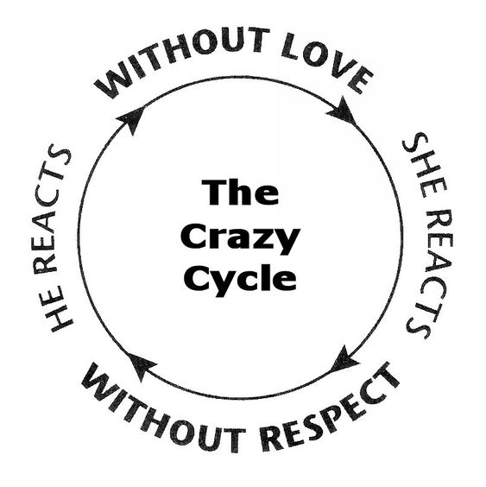
When a woman does not feel loved, it’s like her oxygen supply is cut off and she reacts in ways that come across critical, judgmental, and disrespectful. Men tend not to respond very well when they feel attacked and criticized - so if a man feels disrespected, he is not likely to apologize right away and shower his wife with all kinds of loving words and actions - he will either go cold and freeze up or get hot and upset. Either way it won’t feel loving to the woman, and this will make it even harder for her to be respectful and submissive. And so, the cycle spins on into more and more conflict.

My favorite principle from this material addresses the question - who should break the cycle? Should it be the man, as the servant leader in the relationship? Should it be the woman, as the one who is called to submit? The answer: whoever is more MATURE. So, if you are not the one to break the cycle you are admitting that you are not more mature. And in the moment you’re angry and offended so you don’t care. Fine - you be the mature one for once.

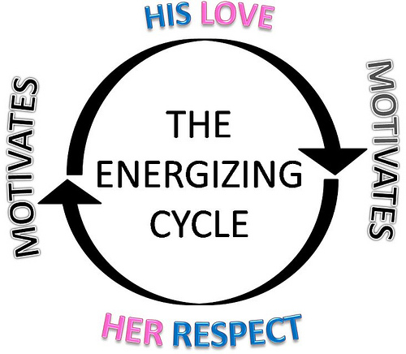
Back to Eden - the crazy cycle didn’t start spinning until the fall. Before that, it was Shalom - the Energizing cycle of mutual love and respect. The woman felt loved and accepted and this naturally and continually motivated her to respect and admire her man. Feeling respected and appreciated, it was easy for Adam to love and care for his wife. That was shalom. A defined relationship with specified roles that no one resented.

- Shalom is Acceptance with People
“And God blessed them and said to them, ‘Be fruitful and multiply…’” Genesis 1:28
- A dignified relationship of mutual Service

The husband-wife relationship was the best single gift God gave to Adam and Eve. The whole garden was really an environment in which that one relationship could grow and flourish. It was central to the BLESSING that God gave the first man and first woman. The command to be fruitful and multiply was not a burdensome task. Even childbearing would not have been a painful experience. Everything about the marriage relationship was blessed. It was all very good.

God fashioned Eve from Adam’s rib, the perfect partner, the balancing complement to him, the “you complete me” to his Jerry Maguire. And the final description at the end of Genesis two sums it up:

- Shalom is Acceptance with People
“And the man and his wife were both naked and were not ashamed.” Genesis 2:25
- A dignified relationship of mutual Service

They not only rejoiced in the defined relationship of man and woman, they were blessed by the dignity and beauty of a relationship that was totally open and vulnerable - perfect transparency and honesty. And yet no shame. No fear. Nothing to hide; nothing to be embarrassed about. No insecurity. Granted, their bodies were the essence of perfection, so what was there to be embarrassed about? But even so it is hard for us to imagine feeling that safe, that accepted, that valuable and worthy.

Think of the privilege we have in marriage - to restore shalom one day at a time with the woman or man God has provided for us! You can’t adopt all the foster kids in Tampa Bay or end human trafficking or put a stop to all abortions in our area - but a place that you can bring peace and harmony, love and acceptance is to your own marriage.

Are you a peace-bringer in your own home? Do you delight in the role God assigned you, or fight against it? For men, that means to lead as a servant leader - initiating spiritual things and caring well for your wife and family. For women, that means submitting and responding joyfully to your husband’s leadership, supporting him and helping him according to his needs.

When you experience conflict, do you fire up the crazy cycle or are you the mature one who takes the hits and breaks the cycle? Even when you feel disrespected, do you respond with love? Even when you feel unloved, do you respond with respect? Are you an agent of grace and acceptance or of judgment and rejection?

What an opportunity we have to showcase Shalom before our kids and grandkids. If you’ve been married over 25 years, please stand up. All of you - anything over 25 years. Ok, over 30 years remain standing. Over 35 years, keep standing. Over 40. Over 45. Over 50. Anyone over 55 years of marriage? 60? Isn’t this an amazing testimony to the goodness of God? What a witness to the gift of marriage and the power of grace to keep a couple together in a culture that celebrates selfishness and finding your “soulmate,” assuming you “married the wrong person.”

- Shalom is Acceptance with People
“Be fruitful and multiply and fill the earth and subdue it and have dominion… over every living thing.” Genesis 1:28
- A dependent relationship of Leadership and multiplication

God’s good design was not just marriage, it was family. MULTIPLY. Fill the earth and subdue it. Exercise your God-given, God-imprinted identity to rule over the world with intentionality and care. Raise your kids to have godly dominion over the part of the world they end up in.

Of course, once sin entered the world the family was damaged and broken right to its core. So the first family interaction we see in the Bible is Cain and Abel - resentment and anger that boils over into conflict and murder. But after Cain killed Abel God gave Adam and Eve another son, named Seth, and through Seth the line of promise began - the lineage of divine blessing that would pass from parents to children and grandchildren all the way to Noah, then Abraham, then David and finally to a woman named Mary and her husband Joseph.

Like marriage, family is a wonderful opportunity to build SHALOM into our world - starting in your own home. Loving and leading your children is your first and greatest assignment from the Lord. The Great Commission to make disciples of all nations must begin first and foremost with your own children (and grandchildren, nieces and nephews).

Now, for those who are not married or who do not have children, the Pauline principle applies. If you are single, especially, you have the freedom and flexibility to devote yourself to kingdom ministry and the discipleship of others, without the challenges of marriage and family. Similarly, if you are married but don’t have children, or if your children are grown and living independently, you have the great opportunity to invest even more in the church and in outreach.

Either way - whether through your family or through direct ministry to others in the broader church family - we have the wonderful privilege to build SHALOM right here in this hurting, broken world. Yes, there will be conflict. Yes, there will be pain and loss. But in the midst of those challenges, the glory of God in the church shines brightest.

And it shines especially bright when we love and accept each other in spite of our differences and our past conflicts and disagreements. Have you noticed that relationships are hard? They take work to maintain… But there is NOTHING in this world more beautiful than a healthy, loving, mutually serving relationship. Nothing.

This is why Jesus’ primary command to his followers was so simple: “Love one another. As I have loved you - now you go and love each other.” That was it. That was the summary application of everything he did and taught. Just love each other. Get that right and the world will believe the rest. Let those relationships break down and the world will struggle to believe a word you have to say.
- Shalom is Acceptance with People
- A defined relationship of Roles assigned
- A dignified relationship of mutual Service
- A dependent relationship of Leadership and multiplication

We saw the upward Shalom of a secure relationship with God. Now we’ve seen the horizontal Shalom of beautiful acceptance with people in marriage, family and the church. Now we turn to the third dimension of God’s original peace: the world.

- Shalom is Significance in the World
“Fill the earth and subdue it and have dominion… over every living thing.” Genesis 1:28
- A defined relationship of responsible Stewardship

It was so clear and obvious back in the Garden - everything had just been created by God. Adam named the animals, but he had no delusions that he was the one who had made them. Adam was responsible to tend the Garden, but he knew that beautiful Garden - including his beautiful wife - were gifts from God he was responsible to steward on behalf of the Creator who had given everything to him.

Now we muddle things up with our modern American way of thinking - that everything we have we have earned and built for ourselves. Of course, we acknowledge our parents who raised us and gave us a head start and for many of us they paid for college and gave us our first car and paid our cell phone bill for the first like 20 years of marriage. It’s a family plan, why break things up?

Some of you didn’t have those kind of advantages, making this even harder for you. If you had a rough childhood and minimal support from your parents, or worse - an abusive home environment you had to survive and eventually escape - then you will very much feel like the life you have built is YOURS, you’ve earned everything you have.

But the truth is that all of us are stewards not owners. This whole universe - including every person and every atom in your own body - belongs to the Creator, not to us. Everything we have - our clothes, our homes, our vehicles, and other things - are simply on loan to us to manage.

And this is our First Commission, as Jordan Raynor called it last week - to exercise dominion over our little slice of this planet. Your work matters. Your life matters. Your things matter. Above all, your relationships matter.

Everything is a stewardship. And you will answer one day to the Lord who entrusted all of these things to you.

- Shalom is Significance in the World
“Fill the earth and subdue it and have dominion… over every living thing.” Genesis 1:28
- A dignified relationship of valuable Dominion

Think about what the Garden of Eden could have been like if the fall had not happened. It was literally a perfect environment. There were no predators. No weeds. No disease. No death. Perfect climate. Ideal conditions for growth. Adam and Eve simply had to cultivate it and rearrange things however they wanted to, to build a house and later tree forts for their kids and play areas for the chimpanzees and pumas.

They had EVERY single kind of plant to enjoy for food. There were no thorns or thistles in their way. Every seed planted would grow and reproduce very quickly. There was no stress or striving when it came to work. Every task was straightforward and very rewarding.

And they could have spread out from the garden as their family grew. They could have built a whole civilization with those amazing bodies - that even after the fall went on to live almost a thousand years.

Look at that job description: “Fill the earth and subdue it.” In other words - make the rest of the world like the Garden of Eden. God gave them paradise to start in - they were supposed to have tons of kids, who would also have kids - and teach them how to walk with God and care for the amazing world God had given them.

Their work mattered. And your work still matters! It’s just much harder now - as we deal with all of the many challenges in this broken, messed up world. But still there are places to cultivate, projects to complete, people to serve. Whatever work you do, it is part of your stewardship and part of how God is bringing peace and blessing to the entire world - through your work.

I was just cleaning our bathroom and realized how filthy the baseboards had gotten. And just that small act of bleach scrubbing the baseboards of a bathroom struck me as restoring shalom. Before I cleaned it, it was super gross - chaos and gross-ness had taken over. After I cleaned it, there was a feeling of order and blessing - peace. Now, don’t be impressed with me - Kristin cleaned the rest of the house. She does an amazing job exercising dominion over our home - making it a wonderful environment of shalom for me and the boys.

Kids, do you see how your CHORES matter? Cleaning your room and your bathroom is part of your responsibility as stewards of those little corners of the world!
- Cleaning jobs matter.
- Building jobs matter.
- Managing finances brings order and direction to lives and companies.
- Medical jobs are so important to fight against disease and death.
- Education is so valuable in shaping young hearts and lives.
- Heating, cooling, plumbing, car repair - all of these jobs are improving lives and bringing a little taste of Shalom to people.

- Shalom is Significance in the World
“Behold, I have given you every plant… every tree… every beast…” Genesis 1:30
- A dependent relationship of Partnership with God

God didn’t set up Adam and Eve with hammocks and iced tea. If they wanted hammocks - they had to make them. If they wanted iced tea, they had to figure out which leaves would work best for that. But they had everything they needed - and the whole situation was designed to remind them of their dependence on God. They couldn’t make the plants grow. They couldn’t force fruit to grow on the trees and vines and in the ground. Only God could produce that growth - and they depended on Him every day to provide for their needs.

But they had to work the garden. They couldn’t just eat all the food - they had to plant and move things. They had to dig up some areas and make gardens. They had to build little fences to keep the bunnies from eating all the tomatoes. No doubt the bunnies were their friends, but those little guys wanted the tomatoes - it wasn’t sin that made them hungry.

Adam and Eve had to work with God to exercise dominion over all of the plants and animals. And God’s intent was for them to partner with Him in filling the entire earth and managing every part of human experience for His glory and according to His desires.

- Shalom is Significance in the World
- A defined relationship of responsible Stewardship
- A dignified relationship of valuable Dominion
- A dependent relationship of Partnership with God

Do you see the beauty and wonder of SHALOM? Upward security with our Creator. Horizontal acceptance with one another. And healthy relationship with the environment and the whole world - as stewards of what God has entrusted to us, exercising dominion in partnership with Him.

This may seem like a strange way to start an Advent series. But I want to show you how the whole Bible presents this story of Shalom - the story of God. It begins in a Garden where the peace and love and harmony is perfect. Upward, inward and outward. Every relationship in perfect balance. Of course, that didn’t last long - before sin came in and messed everything up. We’ll get into the core problem of sin and also God’s plan to restore all things in Christ next week.

This whole series will help you appreciate what the angels announced on Christmas morning - “Peace on earth, good will to men.” The peace God promised that first Christmas is the shalom He built into the original creation and the wholeness and flourishing He wants to work with each of us to bring more and more in this world now.

Once you see God’s glorious plan to restore shalom - you get caught up in the wondrous calling to bring that peace wherever you can!

Let’s pray.

