The Family Business

Good morning, Oakwood. For those of you whom I’ve not met, my name is Mark, and I’m just a guy - blessed with the opportunity to share with you all today - I’ll share right up front that the blessing for me has been in the preparation for today, so I’m thankful to God.

I praise God for what He has done in my life, for the opportunity to share that He may bless you through my story, and I praise God because I know he’s not done with me.

I’ll begin my abbreviated story 10 years before I was born. It’s 1968, on the campus of University of Wisconsin, River Falls, WI, my Dad is a college freshman, and he meets this groovy bass player with a spectacular afro named Fran Sciacca - A few years later, Jan 2, 1972 (52 years ago, the day after tomorrow), Mr. Sciacca shares the Gospel with my dad and my dad accepts Christ. Fast forward a bit, dad and mom meet at Colorado Springs Christian School - the school my brothers and I attended from kindergarten through high school. I and my two brothers arrive and, as God would have it, close family friends, particularly in our youth, are Fran and Jill Sciacca and their family with two sons the same age as me and one of my younger brothers, David - here we are - Babbitt’s on the right, Sciacca’s on the left.

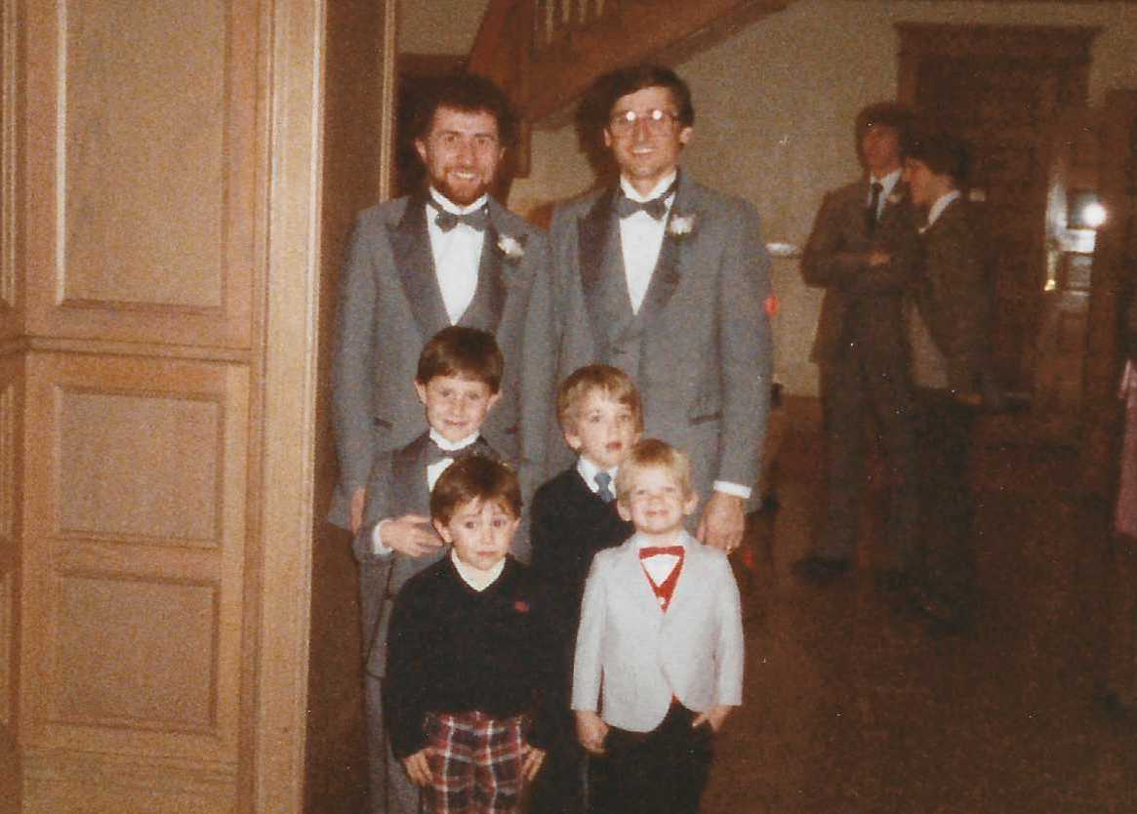 | 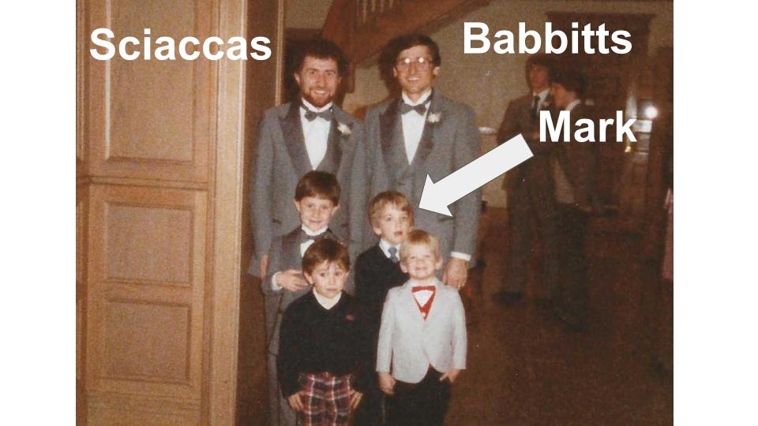

Later, Mr. Sciacca was my HS Bible teacher, his class was amazing - he’s a gifted teacher - in his class we memorized Matthew 5&6 and learned the correct pronunciation of the last book of the OT - Mr. S is Italian, so he used to joke that Malachi was the only Italian prophet.

My Dad and Mom shared the Gospel with me, and I accepted Christ at 6 or 7 - remember it. Later, I was baptized at Living Word Church in Colorado Springs…however, my life has resembled a volatile stock market tracker more than an up & to the right graph…There’s a long list of things that I’ve used to self-medicate…you name it, it’s probably on the list and we’ll leave it at that.

For years I acknowledged there’s a God, that I’m not him, and that I don’t want to be on the wrong side of him - Jesus’ sacrifice dealt with my shame and gave me my get out of hell card, and the Bible was my playbook to pull off the shelf in order to “right the ship” and help me along the way and help me in the story I wanted to write for my life.

Missing the point of God’s story and misunderstanding what the Bible IS led to the “volatile stock market tracker” life. The illusions I had about who God is, and what I deserved as someone who claimed that Jesus was my Savior frequently left me disillusioned, questioning whether the whole thing was “working.” To me, the Gospel had a single purpose: Me.

The beginning of Covid was a wake-up call for me. Again, as God would have it, along came Mr. Sciacca back into my life - this time via his podcast called “The Road to Shalom.”

Looking back over the last three, almost four years, God’s work in my life through Mr. Sciacca’s work is “polishing of one of Yahweh’s monuments in my life.” Yahweh used Mr. Sciacca’s podcast to show me that the Bible is first and foremost a Story. His Story - it begins and ends with Shalom - such a beautiful word - everything existing as it was created to be with perfect harmony flourishing in everything, everywhere - Beauty, Order, and Abundance. Now, much of the Story has been written, and we know who the Hero of the Story is, AND the Story is not over - it’s still happening - right here, right now - we live in Act 5 of the Story!
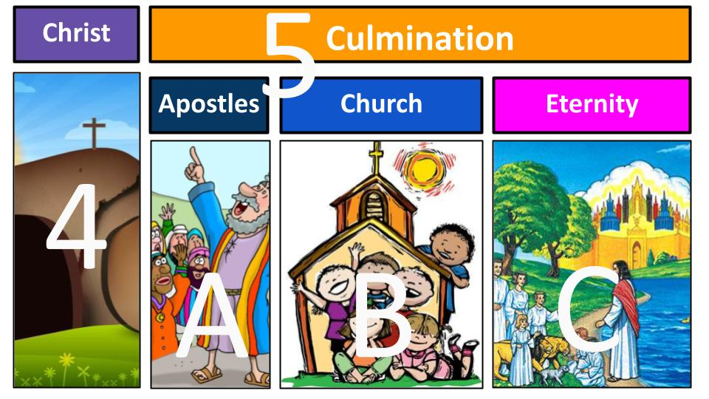
Increasingly so, as we look around this world and all that is happening, we long for the final scene when Jesus returns and completes His Shalomic Restoration Project, but living in Scene B as a Disciple of Yeshua, my role, briefly stated, is to seek the place Yahweh has for me in His Story instead of squeezing Him into the Story that I thought I was writing for myself.

Though we long for Jesus’ return, we are driven by what happened in Act II and Act IV of the One Story - the loss of Shalom and the curse of sin in the world (Act II), and the Climax of the Story in the life, sacrifice and resurrection of Jesus Christ in Act IV.
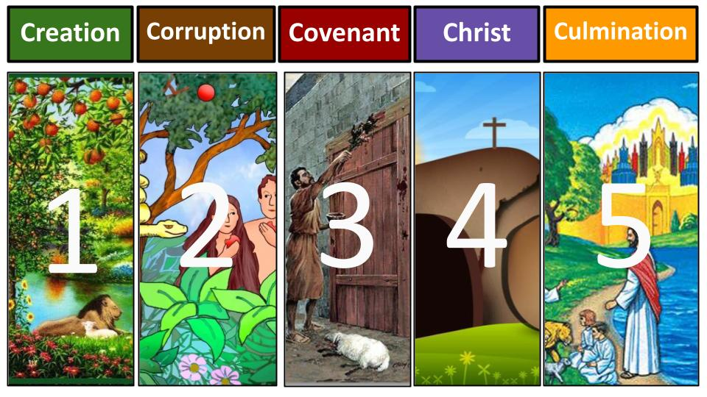
Being driven by Acts II and IV draws us into the river of His Grace and into His FAMILY and into HIS plan for the fullness of time to unite all things in heaven and on earth in Christ Jesus…or, to put another way as we’ve been talking about for the last 5 weeks: God’s mission to restore Shalom - to push back on the curse of sin in this world. So, if God is our Father and we are his children, then His work is our work, and we can call it The Family Business.

To be clear, what I’m calling The Family Business is THE theme that runs throughout the One Story of the One God. Today, we’re going to focus on just two verses in Isaiah 61, verses 10&11, and we will see the way into the family that Yahweh created, what the family does once IN the Family, and how the Family does it - and we’ll give these three ‘bus stops’ on our brief journey a name to help it stick in our minds: The 3 Pillars of The Family Business.

Isaiah 61 - This chapter is so awesome that it gets two appearances in the One Story. The first time when Yahweh speaks through the prophet Isaiah. And the second time: the first two verses of Isaiah 61 - well, the first 1 and a half anyhow - are the scriptures that Yeshua (Jesus) - found to read in the Synagogue as He began his ministry, proclaiming the good news of the Kingdom of God. Pure awesome. God said it twice. Listen to Luke 4 -

“And the scroll of the prophet Isaiah was given to him. He unrolled the scroll and found the place where it was written, ‘The Spirit of the Lord God is upon me, because the Lord has anointed me to bring good news to the poor, he has sent me to bind up the brokenhearted, to proclaim liberty to the captives, and the opening of the prison to those who are bound, to proclaim the year of the Lord’s favor.’” Luke 4:17-19 (Is. 61:1-2a)

Then Jesus sat down while the whole room stared at him in amazement, and he told them that they have seen this prophecy fulfilled right in front of their eyes - in their hearing.

This is His “Mission Statement” - to 1) bring good news to the poor, to 2) mend broken hearts and to 3) set the captives free… to restore shalom inside and out; “to unite all things in Himself - things in heaven and on earth.”

Now, going back to this powerful chapter, so rich with God’s heart for people and vivid imagery of the restoration of Shalom - for the entire world that he created, that has been corrupted by sin and under the curse from Act 2 - Isaiah 61 continues from where Yeshua left off showing that those who receive the Good News, whose broken hearts are bound up - those captives who are set free - the poor, the brokenhearted, the captives - will be called Oaks of Righteousness and that they (that’s US!) will

“That they may be called oaks of righteousness, the planting of the Lord, that he may be glorified. They shall build up the ancient ruins; they shall raise up the former devastations; they shall repair the ruined cities, the devastations of many generations.” Isaiah 61:3-4

1) build up the ancient ruins 2) raise up the former devastations and 3) repair the ruined cities - the devastation of many generations - and that thru THEM by His Spirit, thru their participation with Him in His Shalomic Restoration Project, Yahweh will be glorified - the invisible God WILL be manifest to all peoples - to all nations. The last two verses that conclude the chapter are where we’ll focus today, and they start with what we can recognize as the only reasonable response to the all-encompassing majesty of His work in us and thru us:

“I will greatly rejoice in the Lord, my soul shall exult in my God.”
Isaiah 61:10

Look at the parallelism here - where the author repeats himself - saying the same thing, two different ways to make the point kind of jump off the page in the mind.

In the voice of the whole people of God, Isaiah says, “My soul shall exult in my God” - the word “exult” carries this meaning of Joy at triumph - so, the core of us, the soul, is overflowing with triumphant joy. Why? Because the hero has won!

What follows is the first reason for triumphant joy, AND the first of our three Pillars of The Family Business.

Pillar 1: The Way Into the Family: Salvation
“…for he has clothed me with the garments of Salvation; he has covered me with his robe of righteousness,” Isaiah 61:10

Again, we have the parallelism and in these synonymous statements we have the imagery of being clothed and covered - clothed with the garments of salvation and covered with His robe of righteousness. The righteous life Jesus lived is credited to us, His life, His love, His acts of service and justice are all credited to US in Him - that when Yahweh looks upon us, He sees Jesus’ robe of Righteousness - we are covered by His Righteousness.

Maybe this imagery reminds you as well of the last stanza of the hymn “My hope is built on nothing less.”

When he shall come with trumpet sound,
O may I then in him be found:
Dressed in his righteousness alone,
Faultless to stand before the throne
-Edward Mote

We are Justified - declared righteous - because of Jesus. Borrowing from another song, “What can wash away my sin? Nothing but the blood of Jesus.”

While difficult to miss, it’s nonetheless worth acknowledging that we are not clothing ourselves here. A quick recap from Darin’s message two weeks ago, we are saved:

Pillar 1: The Way Into the Family: Salvation
- By Grace alone
- Thru Faith alone
- In Christ alone
- For God alone

This is the invitation into the Family for all who declare Yeshua as Lord.

For a long time, this place of understanding of Yeshua’s atonement for my sin and His solution for my shame and guilt is where my understanding of the Gospel kinda stopped so that I could go on with my own agenda thinking I had my get out of hell card tucked in my pocket. And, not surprisingly, I continued to search for a purpose - for some noble why or what to do. So when I finally came to see and understand that the Bible is a Story, and that I’m IN the story, I also found that this purpose I sought was there all along.

To be driven by Act II and Act IV is to be motivated by what happened in each of these Acts of the One Story. Brothers and sisters, when we start to grasp the magnitude of the loss of Shalom in Act II - that everything everywhere was corrupted by sin, the natural result is a deeper appreciation and gratitude for what happened in the Climax - in Act IV. And, when we do, we rejoice! Or putting it the other way, we say that our souls exult - we have Joy at the Triumph - in what Yeshua did for us to restore Shalom between us and Yahweh. Yeshua IS our Shalom with Yahweh. Jesus is our peace with God, and because of Jesus we are no longer God’s enemies - we are his children.

If God is our Father and we are his children, then his work is our work, right? So we gotta dig deeper here - maybe think of it this way: There’s the WHAT and the HOW of His work, ok? If the Family Business is Selling Groceries, then everyone in the family would have a part to play in selling groceries - some clerks, some re-stocking the shelves, others perhaps driving trucks to bring the food to the store, but you can’t have someone out back selling weed, right? That’s not WHAT the family does in the business. And you can’t have someone working as a cashier who is cussing out the customers - that doesn’t fit the CULTURE of the family business. It’s about what we do AND how we do it…

OK so what does this family DO?

Pillar 2: What the family Does in The Family Business

“…for he has clothed me with the garments of Salvation; he has covered me with the robe of righteousness, as a bridegroom decks himself like a priest with a beautiful headdress, and as a bride adorns herself with her jewels.” Isaiah 61:10

The second reason for our souls to exult in our God, the second Pillar of The Family Business, is what the Family DOES - and why our souls exult in our God has everything to do with the results & we’ll get to that.

Here we see that all who put their faith in Jesus are clothed in garments of salvation, covered with His robe of righteousness - and Isaiah is giving us an image of what that LOOKS like - a bridegroom decked with a beautiful headdress, and a bride adorned with jewels.

Becky and I were married at the Chapel of Love. Well, that’s what we call it; most people just call it the Douglas County Courthouse. Now, seriously, it was beautiful for us. We wore the best clothes we had, family came in from out of town, and there in the presence of God, family members, a good family friend, and the judge who happened to take our “case,” we each said “I do” and put the rings on as the symbol of our covenant commitment to each other.

Now, I don’t claim to know much about the customs of ancient Jewish culture, but you don’t have to, to see that the wedding ceremony was much more ornate and purposeful in their culture than Becky and I putting on our best clothes to be married at the courthouse. The daughter of good friends of ours is getting married in March - they were engaged in February of this year - that’s 13 months of planning, and even that doesn’t seem to match up with the magnificent ritual adornment here.

If clothing us in the garments of salvation and covering us with the robe of righteousness LOOKS like the bridegroom and bride’s adornment in ancient Jewish culture, then it’s clearly a big deal.

We exult in our God that he has covered us - atoned for our sins - by the blood of Jesus. We also recognize that the price for being clothed was immense, staggering. So costly it begs the question, “what for?” Did the creator of the universe take on the nature of a servant, being made in human likeness, and humble himself to death on a cross, all so that we could live our best lives now? Did Yeshua lay down His life, so that we could huddle together with other believers, sing kum-bay-ah, and insulate ourselves from all that yucky non-biblical stuff out there in the world?

The ornate adornments donned by the bride and groom are likened to being clothed with the garments of salvation and covered with the robe of righteousness. The garments are precious and beyond measurable value. And just like a wedding ceremony isn’t the end, neither is the clothing.

Big brother Jesus gave us His robe of Righteousness to cover us - to Righteous-ify us - to Justify us - not only to save us, but also SO THAT we would grow into it. He gave us a uniform to wear to symbolize our inclusion in the family and our calling into the family business.

Growing into His robe, or Sanctification, is what Mr. S calls “The Great Reversal”. The Great Reversal happens, over time, by the Spirit of Yahweh at work within us to transform us to make us more and more like our older brother, Yeshua, and less and less like our ancient father, Adam - to, piece by piece, chunk by ugly chunk, get the corruption of sin OUT. And it’s not a lightswitch, nor is it for sissies. It takes time, and it’s difficult - even painful at times!

For what purpose? Why is Jesus transforming us and making us more and more like Him? Is it to become more knowledgeable and more religious-looking? Let’s hope that’s not the reason. Now, don’t get up and leave, okay? It is absolutely true that there are personal and relational blessings of the Great Reversal to create a more pleasant and less selfish and sinful person. That’s true. What’s also true is that the fruit of The Great Reversal is not just for us to share with each other as fellow disciples. Yahweh’s transformation OF us is also FOR the World around us - to bring Restoration - to Build Up, Raise Up, Repair - to push back on the CURSE from that very first sin that messed everything up. This is what the Family of Yahweh DOES in the Family Business.

Pillar 2: What the family DOES in the Family Business - Righteousness: Good Deeds

“For he has clothed me with the garments of salvation… as a bride adorns herself with her jewels… so the Lord God will cause righteousness and praise to sprout up before all the nations.” Isaiah 61:10-11

How do we push back on the curse? With our behavior is where we’ll start because that’s the first thing listed that sprouts up before all nations. Righteousness. Good Deeds.

What does it mean to live Righteously? And what are Good Deeds? Is it a matter of helping people and being kind? Well, yes, but it goes much deeper than simply “being a good person” or “doing the right thing.” Righteousness in the Bible is a standard of ethical conduct between people, rooted in the fact that all of humanity bears the image of God, and as such, all deserve to be treated fairly and with dignity. Said a bit differently, Righteousness is Yahweh’s definition of “being a good person” and it’s behavior that reflects the heart of Yahweh.

To BEHAVE righteously is to treat all people as fellow divine image bearers, and when anyone is not treated with the dignity and fairness that a fellow image bearer should be treated, Justice is the word that means to fix that. That’s why, in the One Story, Justice and Righteousness are inextricably linked. To DO Justice is to work to right those wrongs…work against the curse to restore Shalom in the world around us where the corruption of sin in all people creates injustice.

Unfortunately, many of us kind of recoil when we hear words like Justice and Injustice. Those words make their way into many a facebook or twitter feed these days, and before anyone gets uncomfortable, let’s remember that Justice was Yahweh’s word before it was employed by many of the “social causes” of our day. I’m not going down that rabbit hole, but I will say that there’s a reason the world resonates with righting wrongs and treating people with dignity, and that is because we are ALL created in the image of Yahweh, and Yahweh's definition of Righteousness and Justice is to care for ALL people as fellow image bearers.

Advocacy is to DO justice - it is to open our mouth for the one who cannot speak for themselves. To care for all people as fellow divine image-bearers and to advocate for the most vulnerable is doing Righteousness.

Brothers and sisters, Jesus covered us with his robe that we would grow into it, SO THAT we would be HIS hands and feet and DO what He does - and let’s remember that He laid down his life while we were still sinners.

Here’s how The Bible Project guys said it:

“If God declared someone righteous when they didn’t deserve it, the only reasonable response is to go and seek righteousness and justice for others. This is a radical way of life, and it’s not always convenient or easy. It’s courageously making other people’s problems my problems.” The Bible Project - Justice

THAT’s the Family Business - God’s business. And who IS Yahweh?

“Father to the fatherless and protector of widows is God in his holy habitation.”
Psalm 68:5

Which is why

“To do righteousness and justice is more acceptable to the Lord than sacrifice.”
Proverbs 21:3

What does this look like these days, here in Tampa Bay?

Florida 1:27 is a movement of churches and individuals taking action together to radically change the foundation of the child welfare system in Florida. Oasis Pregnancy Care Centers serve life - very directly - by advocating for the unborn through the provision of tangible resources to help pregnant women give birth instead of choosing the evil alternative that the injustice of our society calls “healthcare.” These and other movements and organizations are impactful and inspirational, but how about us “regular” folks tho? I mean, I don’t have a foundation like that - I’m happy to support them - and we do - but what about DOING JUSTICE within the smaller circles of this world where we LIVE?

Think of it this way: covered in His robe like the precious jewels the bride is adorned with, God leads some people to places around the world to work in The Family Business there, but most of us, I’m convinced, are right where He wants us geographically. Like Boaz or Job making a tangible physical difference for the poor, right where they lived. Or those who serve in Oakwood’s ESL ministry, using their gifts to make a tangible difference for fellow image bearers to help them learn English and improve their ability to navigate life in predominantly English-speaking Tampa Bay.

Or Mike and Kathy - not Kristen’s parents - a different Mike and Kathy that I met over at Feeding Tampa Bay’s Trinity Cafe 2 on Busch who serve the hungry every Tuesday. Mike and Kathy’s primary ministry is an inspiring example of Yahweh using tremendous pain to restore Shalom through advocacy for the oppressed - their son was murdered via drug overdose - he was in the bondage of addiction, and his dealer, to make his heroin a bit more potent & keep customers coming back, laced it with fentanyl - a bit too much clearly - and one night Kathy found him slumped over in his bed. Yahweh is using Mike & Kathy to bring hope and tangible support to families with education and resources surrounding drug addiction.

Brothers and sisters, let’s recognize that when Jesus comes back, there will be no need to DO justice or even to evangelize - the curse will be gone! The time for these things is now. And what are the results of DOING Justice, of behaving Righteously? What happens when the Family does the job of the Family Business? Shalom is restored, albeit partially on this side of Eternity, but the curse is pushed back, people are loved, the existence of Yahweh and the righteous nature of his kingdom is proven true, all for His glory.

When we open our mouths for those who cannot speak for themselves - which, by the way, is a pretty cool thing to say about Oakwood’s ESL ministry - the unborn, the oppressed, the orphan, the under-resourced and disadvantaged are lifted up and treated like the image-bearers that they are. And Shalom is restored - piece by piece, heart by heart!

Further, Righteousness and Justice through us is proof to the world of who Yahweh is and a demonstration of the righteous nature of His Kingdom. It’s the love of God in action through us. Some people may never read the One Story of the One God anywhere but in my life, in yours. Yeshua said to “let [our] light shine before men, that they would see [our] blessed deeds and give glory to [our] Father in Heaven.”

What we DO in the family business involves good deeds and also GOOD NEWS. Salt and light. Demonstration of our righteousness in Christ and proclamation of praise to the One who is restoring Shalom in us and through us.

Pillar 2: What the family DOES in the Family Business - Praise: Good News

“I will greatly rejoice in the Lord; my soul shall exult in my God, for he has clothed me with the garments of salvation… so the Lord God will cause righteousness and praise to sprout up before all the nations.” Isaiah 61:10-11

Jesus covered us, that we might grow into the uniform and become more righteous, like Him. Remember 2 Corinthians 5:21 - “God made him who knew no sin to BE SIN for us so that in HIM we might become the righteousness of God.” The role He has for each of us in His Story will LOOK like what Jesus did, and his life involved BOTH good deeds and good news. Notice what God causes to spring up in Isaiah 61 - both righteousness AND praise. Jesus is the Hero and we praise Him.

Verbally. With words. Yes, our lives praise Him too - our actions, our good deeds. But people can’t “see our good deeds and praise our Father in heaven” if they don’t know the love of the Father expressed in the person of Jesus Christ. How will they know if they never hear? The Family Business proclaims the victory of King Jesus with our deeds and with our mouths. It’s Salt AND Light, not one or the other, it’s BOTH.

When I see a good movie, I naturally tell people about it, don’t you? The fact is that The Princess Bride is the best stand alone movie ever made. It just is. The fact Darin knows this is why we joined this family.

You know where I’m going with this analogy, don’t you? If we tell people about great movies we’ve seen, how much more then, would we be compelled to tell people about the good news of Jesus and His Victory?

Remember the One Story. In the beginning, everything flourished in perfect harmony - nothing taking away from anything else - complete beauty, order and abundance. In Act II of the story, SHALOM was lost. Brothers and sisters, the fall from Genesis 3 is not the story of how Adam and Eve got us all kicked out of the garden. It’s not. Everything BROKE that day when the toxic tentacles of corruption began to affect and infect EVERYTHING. The Victory of King Jesus is His victory over ALL of that. When we realize the problem of the deep internal corruption of sin in us and in everything around us, the only answer to that is for people to HEAR the good news of Jesus and His victory. His TOTAL victory!

Can you imagine a story without a climax? Wouldn’t be a story, would it? What if Westley never came back for Buttercup? What if Inigo never saved Westley so he could save Buttercup and the whole kingdom? We are indeed Story DWELLERS, but we are also story TELLERS. We would not be good story-TELLERS if we neglected the climax of the One Story of God - the victory of King Jesus through His death and resurrection

Introducing people to Jesus is most effectively accomplished in relationships, and this is why I’m convinced that we are EXACTLY where Yahweh wants us - geographically and relationally.

Relationships require getting close with people and being transparent - vulnerable, even, because people don’t care what you know until they know that you care. It’s true. And while telling someone that they NEED JESUS may be true, it’s certainly not the most effective way to show them.

In the Chosen, Mary of Magdala’s friends asked her what happened to her and she said that she was one way before Jesus and now she’s another - that’s the most relatable example of Proclaiming the Kingdom of God in relationships. Sharing before Jesus I was___ and now I’m____ - He’s MY hero.

What the Family DOES is like two sides of the same coin. On one side we have BEHAVIOR - GOOD DEEDS, and on the other, we have our VOICES, proclaiming the GOOD NEWS. When the world around us sees those two match up, the coin begins to spin, and the world sees Yeshua and our Heavenly Father by His Spirit like a sphere - in three dimensions.

Okay, so far we have seen the way INTO the Family, and we’ve seen what the Family does in the Family Business. The last Pillar of The Family Business is HOW the Family does the Family Business.

Pillar 3: How the family does The Family Business

“For as the earth brings forth its sprouts, and as a garden causes what is sown in it to sprout up, so the Lord God will cause righteousness and praise to sprout up before all the nations.”
Isaiah 61:11

Isn’t this beautiful? Using words like a painter uses a brush to create the vivid image in the mind - we see LIFE coming forth from the earth, beauty arising out of the garden. Notice where the credit is given for the sprouting of life from the earth and garden. The credit is given to the earth - to the garden. It’s clear what is making this life and beauty to grow.

Pillar 3: How the family does The Family Business: Trust His Timing

“So the Lord God will cause righteousness and praise to sprout up before all the nations.”
Isaiah 61:11

The sprouting will happen. How do we know that? Because He said it would. That’s it. How the Family does the Family Business is first by trusting His timing.

It’s interesting that there’s no mention of specific timing here other than to liken it to how it happens with the earth and a garden. It’s just what it does when it does. When the time is right, the seed sprouts. And how do we know when the timing is right? When we see the sprouts is how.

If you have the tendency to be impatient like me and you’ve been watering that garden, every day for the past however many days and nothing is happening, you might start to wonder if the seeds are bad, or if the soil wasn’t cultivated well enough, or if the seed was planted too deep or something. But, you keep watering it - you’ve come this far, what’s another day? And then it happens - usually pretty quick right? Yesterday, nothing. This morning, there’s a new sprout there, and it’s big!

What are you waiting for from the Lord right now? What seeds have you planted and you’re waiting for God to bring forth “righteousness and praise,” from them? Maybe you’ve been serving and sharing with a friend or family member about Jesus, but they haven’t responded yet. Maybe you’ve been working hard at your job for years and things are extra frustrating and challenging right now. Thorns and thistles are part of the deal since the curse. But the Lord WILL bring forth righteousness and praise. He will. In you and through you.

Brother, sister - trust His timing.

Just like the seed doesn’t sprout when we tell it to, the Lord’s timing is not governed by the watch on our non-dominant wrist. It’s His timing - and truly, we don’t even know what it’s like to live outside of chronological time, right? The concept is completely foreign, but Yahweh is not bound by time like we are, and his Power is the engine that drives the Family Business.

Pillar 3: How the family does The Family Business: Depend on His Power

“So the Lord Go will cause righteousness and praise to sprout up before all the nations.”
Isaiah 61:11

His Power is altogether different than we can imagine.

When we plant a garden, we cultivate the soil, remove the weeds & rocks, plant the seeds, water, make sure the garden is in a place where it will receive good sunlight…and the seeds sprout, because that’s what the garden does.

And just like the garden causes the seed to sprout, it is Yahweh who causes Righteousness and Praise to sprout up before all nations, so we proclaim in unison with our brother Paul: “I have been crucified with Christ. It is no longer I who live, but Christ who lives in me.”

If you’re like me you probably find yourself trusting in your own power, your own ability. I know in my head that the Lord “WILL CAUSE” good fruit to sprout up in me and my family and among our friends. But I want the results faster - in myself especially - which leads me to trust in MYSELF with all my heart and lean heavily on MY OWN understanding. Same with my kids. I see such good fruit growing in them, and I can sometimes get impatient and think that I can force it with some stern talk or some creative forms of bribery or manipulation. Thankfully I never do that in my marriage.

But when we yield to Him because it’s all Him - In His timing and by His Power, we Praise Him for the Results.

Pillar 3: How the family does The Family Business: Praise Him for the Results

“I will greatly rejoice in The Lord; my soul shall exult in my God…so the Lord God will cause righteousness and praise to sprout up before all nations.” Isaiah 61:10a,11b

We started in verse 10 with the only reasonable response to the all-encompassing majesty of His work in us and thru us for His Glory, and here at the end of verse 11 in God’s timing, by His Power, righteousness and praise sprout up - the result of His work in us and thru us - for His Glory. The entirety of the Family Business is wrapped in Praise because that’s the only reasonable response.

The last HOW of the Family Business, Praising HIM for the Results, has to do with the posture of our souls in light of Yahweh’s work to restore Shalom inside and out - everywhere - “to unite all things in Himself - things in heaven and on earth.”

It’s the CULTURE of the Family Business. Remember the Grocery Store analogy. All members of the Family have a role to play that directly contributes to the Family Business - that’s the WHAT. Praising HIM for the Results is the Culture of the Family Business…it’s our only part of the HOW - acknowledging the simple truth that all we do is submit to His Timing and His Power and that HE makes the growth happen. Acknowledging that this is all IN His timing BY his Power and For HIS Glory is the opposite of self-righteousness, isn’t it?

Praise isn’t just what we do on Sunday mornings when we come together and sing. More frequently, Praise is us pointing to Him in our everyday lives.

Pause and take the time to Polish God’s Monuments in your life. It’s the same God then as now. That’s why I like using His OT covenant name - it reminds me that the God we pray to and trust is the same God who revealed himself to his people as Yahweh - check out the story, SEE and FEEL what he’s done and give Him the praise - it is the only reasonable response. Read this book like the gripping, world-changing STORY that it is. And please remember, the Story is not OVER.

Let’s pray

Benediction: Titus 2:11-14

____________________________________________________________________________

