The Hero
Isaiah 9,11

As we walk through our Advent season this year, we are reflecting on what Jesus came to accomplish. Here is what the angels announced to the shepherds the day Jesus was born:

“Glory to God in the highest, and on earth peace among those with whom he is pleased.” Luke 2:14
- Our dual purpose: to Glorify God and bring Peace to people.

Two purposes: to glorify God and bring peace to people. We’ve seen the last few weeks that these are God’s two purposes in the whole story He is writing. The One story of God is not about you or me or even David or Moses - it’s the story of GOD, documenting His glory and goodness and expounding His plan to bring peace to the earth. The center of that plan was the arrival of Jesus Christ, the Son of God.
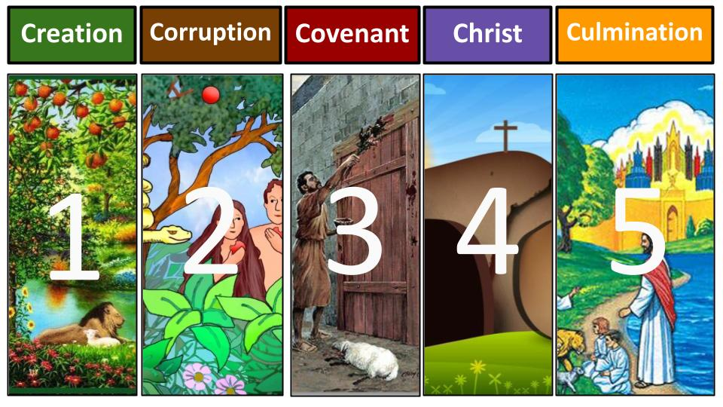
We walked through the five acts in the story of God last week and saw that the climax, the key turning point is CHRIST. Since Jesus came we live in the final Act, the culmination of the plan as Jesus builds His church and the knowledge of His glory spreads to all nations before Jesus comes back to make all things new and bring complete PEACE back to His creation.

The key point as we look at the One Story is that it is GOD’S story, and our job is to find our place in that story - not try to write our own stories in which we are the heroes. Jesus is the hero. We are tiny supporting actors. And to find our place in the story we have to know the plot, which is all about restoring SHALOM - joining Jesus in bringing peace on earth, good will to men.

We saw that Shalom is 3 dimensional - upward it is peace with God, security in relationship with Him. Horizontally it is acceptance with people - love, harmony, and unity. Globally it is about doing meaningful work in the world that contributes to the flourishing of everyone on our planet.

God created everything very good - in perfect shalom. And Jesus will restore all things when He returns. For now, we work with Jesus to not only proclaim peace in Him but to bring peace. We are agents of shalom: healers, unifiers, helpers, restorers.

Today we will study Isaiah 9 and 11 to focus in on what Jesus came to do. We will see the four goals of His life and ministry and as followers of Jesus our application is to make these the four goals of our lives as well.

What Jesus Came to Do:
- Reveal the Truth about God
“The people who walked in darkness have seen a great light; those who dwelt in a land of deep darkness, on them has light shone.” Isaiah 9:2

Isaiah lived in a time of increasing darkness. The northern kingdom of Israel fell to Assyria about twenty years into the ministry of Isaiah.
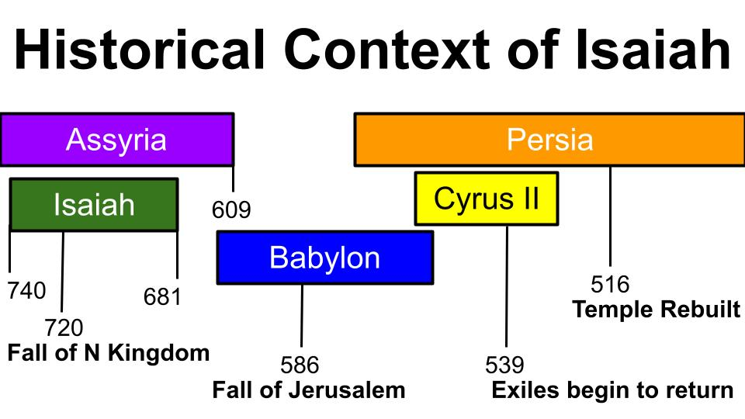
The southern kingdom would fall to Babylon about a hundred years after Isaiah died. Isaiah lived and prophesied in the shadow of great empires. The threats around him and his people were not symbolic or vague - they were very real and very concrete, in the form of powerful armies and aggressive kings. But into this darkness, the word of God through His prophet was a LIGHT OF HOPE.

What Jesus Came to Do:
- Reveal the Truth about God
“The people who walked in darkness have seen a great light; those who dwelt in a land of deep darkness, on them has light shone.” Isaiah 9:2

The job of the OT prophet was not just to FORETELL what God was going to do, but also to FORTHTELL the truth about who God is. Really forthtelling was the primary job and foretelling was a supporting ministry to validate the truth God was speaking through his servants.

Of course, Jesus was the ultimate revelation - the ultimate LIGHT of the world, revealing the truth of who God is. Do you have any doubt at all that the LIGHT Isaiah mentions there in verse two is about Jesus? Look back at verse 1!
What Jesus Came to Do:
- Reveal the Truth about God
“But in the latter time he has made glorious the way of the sea, the land beyond the Jordan, Galilee of the nations.” Isaiah 9:1

In Jesus’ own day the religious leaders questioned whether anything good could come from Nazareth in Galilee. They should have studied their Bibles more closely, especially when Jesus had the audacity to call himself the “light of the world.” They should have gone to their concordance or searched in their Bible app to find Isaiah 9.

A new WAY was going to be opened - Isaiah would later describe a HIGHWAY that would connect Egypt in the south with Assyria in the North - with Israel as the connection between them. A highway for the nations of the world to come to the Lord. And the source of this new way of salvation? GALILEE.

The hometown of Jesus was Nazareth in southern Galilee. And his main base of ministry operation was in Capernaum in central Galilee. That is where the light of God’s revelation was concentrated during the life of Jesus. The Jews would have expected Jerusalem to be the focal point. The Temple area. But Jesus intentionally moved around the towns and villages of Israel, bringing the light of truth to the wayward people of God who had been dwelling in darkness for 400 years; without the word of the Lord through any prophet since Malachi.

That was the first thing Jesus came to do: to reveal the truth about God; to bring light into a dark world.

That is our task as well, as followers of Jesus - to bring the light of Jesus to the people around us who live day by day in the darkness of unbelief, false religion and our increasingly secular culture.

Christmas is a wonderful opportunity for us! In most places we are still allowed to say the word CHRISTMAS - which literally means the celebration of Christ; the MASS where we worship Jesus, the Messiah.

So let’s take advantage of this Christmas season to pray for and reach out to our friends, family, co-workers and neighbors and bring the light of Jesus to them. Who can you share with this week? How can you encourage them with a note or a text or a call or a visit? We always write a Christmas letter with our annual family update - and are sure to include a couple of sentences about Jesus in there. Kristin picks out some kind of Jesus-focused card to enclose it in, along with our latest family picture that we hope isn’t too terribly awkward. “Come on boys, get your matching polos on and get out here with the dogs!”

Use this Christmas season to shine the light of Jesus in your own home especially. Find an advent reading plan. Study this part of Isaiah 9-11. Read the familiar Christmas passages with the shepherds and the wise men and talk about them with your kids and grandkids.

Look at the result of this revelation of truth about God!
What Jesus Came to Do:
- Reveal the Truth about God
“You have multiplied the nation; you have increased its joy; they rejoice before you as with joy at the harvest.” Isaiah 9:3

Seeing the truth about God - KNOWING GOD - brings great joy. This is the good news the angels announced - good news of GREAT JOY that would be for all the people. And notice it is a light and joy that MULTILPLIES the nation. The good news of Jesus doesn’t just GROW the people of God, it enables us to MULTIPLY!

In ancient times there was no greater joy than at the harvest time. We have the great privilege of living in the harvest time of salvation history, as God is finishing the work of gathering in His people from every tongue and tribe and nation. We cultivate relationships, plant seeds of the gospel, water those seeds with love and reap the harvest whenever we can. Jesus came to mobilize and multiply the nation. He continues to use us for that purpose as well - that the light of the knowledge of His glory would continue to spread!
That’s the first thing Jesus came to do. Second:

What Jesus Came to Do:
- Resist the Enslaving powers of evil
“For the yoke of his burden… and the rod of his oppressor, you have broken as on the day of Midian.” Isaiah 9:4

I phrased this one more for us than for Jesus. Jesus came to “break the power of cancelled sin and set the prisoners free,” as the old hymn says. He came to defeat the controlling power of sin in our hearts through His death and resurrection. He broke the rod of the oppressor - meaning sin and death and Satan. The yoke of our burden - the bondage of slavery to our own selfishness and pride.

The healing ministry of Jesus and how he set people free from the power of demons is the application for us. We are the hands and feet of Jesus now to love the unlovable, touch the untouchable and release the oppressed, proclaiming the year of the Lord’s favor.

It is our job to push back against the darkness of evil and injustice. We are to be agents of righteousness, justice, and PEACE. Are you getting the point from this series so far? Jesus didn’t just save us FROM the power and penalty of sin. He saved us FOR the purpose of making us ambassadors of true and lasting SHALOM.

You can’t take on every aspect of evil and injustice in this dark and broken world, but you can bring salt and light to one place. You can bring healing and restoration to one person. The work you do day to day is part of that calling. Have you noticed that things break? Some of you are in the business of fixing things that are broken. You are resisting the darkness - you are pushing it back a little at a time. Some of you are in the business of fixing PEOPLE that are broken. You are in the battle against death itself! You are pushing back the darkness. Fighting for one more day. One more breath sometimes.

Jesus came to win the decisive battle in the fight against sin and death. But He won’t get rid of sin and evil and injustice completely until he comes back. Until then, you and I are the ones responsible to fight on His behalf.

How are you resisting evil? Where are you engaged in the battle against sin and death and injustice? How are you actively working to restore a little shalom? You are working directly with Jesus in that. It’s slow, hard , sacrificial work. But you will connect more with the heart of Jesus as you serve and as you labor. Philippians 3 tells us there is a fellowship in sharing in His sufferings. The powers of darkness and evil are deeply embedded in this world. We need not fear them but we must not ignore them.

Let’s take FOSTER CARE as an example. Every day 20 kids are placed in the system in the Tampa Bay area. Why is that? Because the family unit is broken - because people are slaves to their selfishness, addictions and sins. And that means that children are abused and neglected and must be removed from those homes.

Now, our little church can’t fix the problem of foster care in Tampa Bay. We can’t take on 20 kids every day. At any given moment there are around 800 children in our area needing placement into a good, loving home. That need is beyond us. But we can do our part! We have over a dozen families who have fostered or adopted children over the last thirty years or so. Oakwood has always had a heart for children and at-risk teens. We hope to expand our ministry to those who are called to foster or adopt - and help other families take steps to address this great need in our city.

Our church on its own can’t fix this problem. But THE CHURCH of Tampa Bay absolutely can. And I’m very glad to let you know that Tampa Bay 4 Christ - a network of likeminded gospel churches that we are a part of - is growing and connecting as much as we can in order to take on issues like this one TOGETHER. The church divided has not made much of a dent in this problem. But if we can come together as the One Body that we are, following the heart of Jesus for hurting people and fighting together for the weak and vulnerable - we can make progress in protecting the unborn, supporting single mothers and providing safe places for the orphans in our city.

You may be called to minister to women in crisis pregnancies. You may be called to help addicts in recovery. Your assignment may be to fight against human trafficking or to bring healing to those coming out of the trade. You may be led to serve in a school as a tutor or big brother or big sister. You may help with our ESL program or serve newcomers to our country in other ways. There are limitless numbers of ways to bring light into darkness.

Where are you engaged in the battle?

We bring the light of truth and the salt of change in JESUS’ Name. When we do it in collaboration with other believers the power is multiplied. Look at verse five for the results of Jesus’ ministry and ours:

What Jesus Came to Do:
- Resist the Enslaving powers of evil
“For every boot of the tramping warrior… and every garment rolled in blood will be burned as fuel for the fire.” Isaiah 9:5

These are symbols of warfare - and the promise here is that warfare will end. Peace will come. In the Messiah who breaks the yoke and shatters the oppression. Think of what WAR is - the ultimate division, the greatest level of conflict. It starts between two people, escalates to family groups against each other and grows into nation against nation and people against people full scale war.

Jesus is the great PEACEMAKER - the great unifier. Look at how verse five flows directly into the familiar words of verse six.

What Jesus Came to Do:
- Resist the Enslaving powers of evil
“For to us a child is born, to us a son is given; and the government shall be upon his shoulders.” Isaiah 9:6

The Messiah would come to reign on a throne - to build a government, a KINGDOM. But notice the Messiah is a CHILD. A baby boy who will be born. A child king. Isaiah himself experienced the birth of a son as the initial fulfillment of this prophecy. This was the sign the evil king Ahaz refused to ask for in chapter seven and was given - that a young woman would conceive and give birth to a son. Then in chapter eight Isaiah’s own wife had a son that God told them to name MAHER-SHALAL-HASH-BAZ.

Rough name that means “quick to the plunder; swift to the spoil.” We might shorten it to “Get the goods.” Nickname could be “get it.” Get it quick. It means that judgment and defeat is coming - soon - you will be plundered; you will be captured. Enemies are coming.

And they came. During the ministry of Isaiah - exactly as he prophesied in chapter 7 and 8 - before his son had grown up, Samaria was conquered, and the northern kingdom of Israel carried off into captivity in Assyria.

But Isaiah’s son Maher-shalal-hash-baz was not the ultimate fulfillment. That was the initial reality for Israel. But another child would be born - born to a VIRGIN this time - and the government would be on his shoulders. He would bring a new kingdom in - a whole new era of peace and love and justice.

What Jesus Came to Do:
- Resist the Enslaving powers of evil
“And his name shall be called Wonderful Counselor, Mighty God, Everlasting Father, Prince of Peace.” Isaiah 9:6

You’ll notice our outline today follows these four titles of Jesus. The Wonderful Counselor reveals the truth about God. Mighty God resists the powers of evil in this world. The everlasting Father renews hearts and the Prince of Peace reunites the remnant of God’s people. I’ll sum that up for us at the end. For now just notice how Jesus, the Mighty God, brings PEACE by breaking the enslaving yoke of sin and death over the world.

Isaiah 11 looks ahead to the second coming of Jesus when he will completely remove evil and injustice from the world.

What Jesus Came to Do:
- Resist the Enslaving powers of evil
“With righteousness he shall judge the poor… and he shall strike the earth with the rod of his mouth…” Isaiah 11:4

That passage goes on to describe wolves dwelling peacefully with lambs, leopards with goats, baby calves with lions and infants with cobras.

What Jesus Came to Do:
- Resist the Enslaving powers of evil
“They shall not hurt or destroy in all my holy mountain; for the earth shall be filled with the knowledge of the Lord…” Isaiah 11:9

That is the final outcome - the glory of King Jesus filling the world as the waters fill the seas - and the peace of King Jesus bringing an end to all hostility, evil, sin and death forever. Hallelujah, come Lord Jesus!

As followers of Jesus, our calling is to reveal the truth about God and resist the enslaving powers of evil - fighting against the darkness wherever and however we can. Third:

What Jesus Came to Do:
- Renew the Hearts of sinners
“And his name shall be called Wonderful Counselor, Mighty God, Everlasting Father, Prince of Peace.” Isaiah 9:6

Our amazing Prince of Peace - by dying on the cross and rising again - reconciled us with the everlasting Father and transformed our hearts so the Wonderful Counselor Holy Spirit could live inside us. This is the power of the gospel and the wonderful doctrine of RENGERATION by which sinners become saints, the spiritually dead come to life in Christ and your heart of stone becomes a heart of flesh where the Holy Spirit takes up residence. Let’s flip ahead to chapter 11 again:

What Jesus Came to Do:
- Renew the Hearts of sinners
“Righteousness shall be his belt and faithfulness the sash around his waist.” Isaiah 11:5, NIV

Jesus Himself IS righteousness, justice, faithfulness and love. He is the embodiment of all perfection in human form. No doubt Paul was inspired by this image when he described the armor of God in Ephesians 6. God gives us the belt of truth and the breastplate of righteousness to go with the helmet of salvation and the shield of faith.

At the moment of salvation Jesus takes His robe of perfect righteousness and wraps it around the sinner who repents. As soon as you called on Jesus to save you, you were “dressed in his righteousness alone, faultless to stand before the throne.” This is what Jesus does - He renews us from the inside out, changing us completely.

You and I can’t do THAT for another person - but we can encourage their hearts. Proverbs says that “life and death are in the power of the tongue.” Our words can either bring life and build people up or bring death and tear them down. The apostle Paul warns churches to stop “biting and devouring each other,” and instead to bear with each other and build each other up in the Lord.

As we seek to restore shalom in this broken world, our priority is right here IN THE CHURCH. Jesus said His new command was that his disciples LOVE ONE ANOTHER. In the same sacrificial, servant-leadership of Jesus Himself we are to love and serve and encourage and challenge one another.

Whose heart can you bring renewal to today? Who can you encourage and build up? Maybe with a text or via social media - but think outside of the box and consider actually meeting with someone face to face. Think about sending a card made of paper and filled out with ink and delivered with a stamp. One more thing Jesus came to do.

What Jesus Came to Do:
- Reunite the Remnant of God’s people
“In that day the Lord will extend his hand yet a second time to recover the remnant that remains of his people.” Isaiah 11:11

Jesus was clear that His mission was to gather in “the lost sheep of Israel.” He deviated on a couple of exceptional occasions - into Samaria and with a Gentile here and there - but His ministry was laser focused on the Jews.

The story of the book of Acts is the shift of the early church from a mostly Jewish makeup to becoming a mostly Gentile movement. Paul’s experience reaching out to Jews in synagogues and increasingly being chased away and attacked illustrated the prophecy of Isaiah 66 that God’s people would be hardened so their eyes wouldn’t see the truth and their ears wouldn’t hear it. The work of God was shifting to the nations.

But the heart of the NT is UNITY. Ephesians 2 describes how Jesus broke down the dividing wall of hostility between Jew and Gentile to make ONE BODY in Himself. So our job is to continue to gather in the sheep of Jesus - both Jew and Gentile - until the gospel reaches to the ends of the earth.

How can you be a UNIFIER? What broken places can you mend? Where can you bring healing to a relationship or family or group or ministry?

This is our four-part calling as followers of Jesus:

Who Jesus is | What Jesus came to do
- Wonderful Counselor | - Reveal the Truth about God
- Mighty God | - Resist the Enslaving powers of evil
- Everlasting Father | - Renew the Hearts of sinners
- Prince of Peace | - Reunite the Remnant of God’s people

- We follow our Wonderful Counselor in revealing the truth about God. Jesus is the LIGHT of the world, and He has sent us out to bring His light into a dark and deceived world.
- We follow our Mighty God in resisting the oppressive powers of this present darkness - fighting back against evil, injustice, sin, and death in Jesus’ name, with the power of the gospel and the guidance of the Holy Spirit.
- We follow our Everlasting Father in bringing renewal to the hearts of sinners. Through Jesus even the most lost and sinful person can be reconciled with God and adopted into His family. And within the family of God, we must create and nurture relationships that encourage and build each other up.
- Finally, we follow the Prince of Peace in reuniting the remnant of God’s people - calling them in from the nations and gathering them in unity and love into the church, the One Body of Jesus.

Do you see how Jesus is the HERO of the whole story of God? Our job is not to BE the HERO ourselves, but to point people to the hero and continue the work He started. We get off track when we make the story about US instead of about Jesus. We lose the plot of the One Story of the One God and end up in a convoluted “choose your own adventure” in which we set the agenda, and we get the spotlight.

But focusing on Jesus corrects that. We can see in history and in our own lives how the arrival of Jesus changed everything. He is the prince of peace - in whom we see the glory of God and through whom we proclaim peace on earth, good will to men.

Like the angels, let’s sing the glory of King Jesus, the Prince of Peace. And like the wise men let’s bow before the King of Kings who came to change the world!

Let’s pray.

