The Plan
Ephesians 1

“In the beginning God created the heavens and the earth.” And at the end of the six days of creation God pronounced it all “very good.” That was the last time this world has experienced SHALOM. We saw last week that Shalom is health, wholeness and harmony in three directions: upward with God, inward with people and outward to the world.
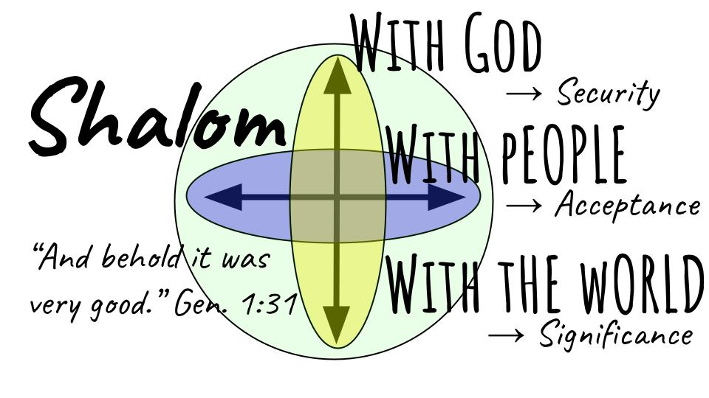
It’s vital that we understand the original creation in order to know the good and loving nature of God, who started everything out in perfect goodness and peace - and who promises to restore all things in Christ. Look at how the story of God ends, in Revelation 22.

“Then the angel showed me the river of the water of life, bright as crystal, flowing from the throne of God and of the Lamb through the middle of the street of the city; also, on either side of the river, the tree of life with its twelve kinds of fruit…” Revelation 22:1-2

Did you catch all the intentional ties back to the original creation?

“Then the angel showed me the river of the water of life, bright as crystal, flowing from the throne of God and of the Lamb through the middle of the street of the city; also, on either side of the river, the tree of life with its twelve kinds of fruit…” Revelation 22:1-2

The last we see of the Garden of Eden is Adam and Eve looking back as they are banished from the Garden due to their sin. An angel stands there guarding the entrance with a flaming sword. But in Revelation we see that the way back into the presence of God and into the peace and blessing of His Garden has been opened! And, of course, we know how: the flaming sword of the angel of justice fell on Jesus, so it will no longer fall on us. Justice has been satisfied, and for all who have been reconciled to God through Jesus, the way into His eternal kingdom stands open.

- Not four rivers as in Genesis, but a single river flowing from the very throne of God.
- The tree of life that Adam and Eve could have eaten from and lived forever is once again available to the people of God!
- No more separation between heaven and earth! Now the kingdom of God is with mankind - everything united, everything bound together in perfect peace.
- SHALOM.

Here is how Paul sums up the plan in Ephesians 1.

The Great Story of God begins and ends with Shalom
“According to his purpose, which he set forth in Christ as a plan for the fullness of time, to unite all things in him, things in heaven and things on earth.” Ephesians 1:9-10

Shalom is the essence of UNION. It is the uniting, binding, reconciling, healing glory of Jesus to bring people and things together - even heaven and earth themselves. And that is precisely the picture of Revelation 21 and 22 - the end of the story - the uniting of all things in Jesus. The bride of Christ - the church - is presented as a glorious city descending from heaven to earth. The dimensions of the city are way too enormous to work practically in our current understanding of astronomy and the delicate balance of the solar system.

We all experience this reality every day in our relationships. Shalom is when things go well. Hell is when things go badly. Division, conflict, selfishness, and pain are the products of sin that bring hell into the fabric of our world. Healing, reconciliation, peacemaking, and love are the products of Jesus and bring shalom into a world in desperate need of good news.

People don’t realize this is what is happening - but since Shalom is coded into human nature through the image of God, people intuitively know what fits with Shalom and what does not. C.S. Lewis calls it the “straight line” of natural law. Everyone knows that you should tell the truth. When someone lies to you, you don’t like it - it damages relationships. So, when you lie to someone else, you know that it’s wrong. You have “crossed the line.”

You should be faithful to your husband or wife. If you commit adultery and break your marriage vows you know, deep in your spirit, that you have broken the line - and your conscience will not let you rest until one of two things happens. Either you must straighten out the line with the new person by marrying them, or you must reject the concept of a straight line and harden your heart to a new crooked definition of love that lets you do what you want to do.

It’s possible for a bone to heal in a crooked way - human bones are amazing in this way. But you will walk with a limp for the rest of your life. It’s better to set the bone correctly and let it heal properly, back into the straight line that God intended.

Have you been living with the deep internal tension of living out of alignment with God’s will? It’s a hard way to live! The straight lines of truth, honesty, love, justice and goodness are all around you - boxing you in.

Stop fighting the straight lines - and recognize that there is a clear and inflexible definition of right and wrong and your job is to submit to it. It’s called SHALOM. God designed it - so He defined it. We can’t rewrite it. We can’t adjust it. It just is. We see it in the Garden, we know it’s coming in even more fullness and wonder in the New heaven and new earth.

We feel the goodness and glory of Jesus moving the whole world toward Shalom. It will go kicking and screaming, but I have good news today - Jesus wins. Shalom is our eternal destiny. It’s just a question of how much we help Jesus as opposed to how much we kick against His straight lines along the way.

Ok. That’s the overview - the big picture. The beginning and the end. When God created the world, it was perfectly good - heaven and earth united; security in relationship with God; harmony and acceptance in relationship with one another; significance and purposeful work in relationship to the world. Shalom.

Before we fill in the middle let’s pause for some personal reflection.

- What is the meaning of life?
- Who are you?
- What is your purpose on earth?

I certainly hope you have some good answers to these questions. But most people today - most people around us - have no idea. They are literally grasping at straws.

If you looked at your life as a STORY - who is the main character? What is the plot?

Listen to this insightful quote from Fran Sciacca’s excellent book “Have we lost the plot?”

“Most middle-class Americans tend to worship their work, work at their play, and to play at their worship. As a result, their meanings and values are distorted. Their relationships disintegrate faster than they can keep them in repair, and their lifestyles resemble a cast of characters in search of a plot.” Gordon Dahl, in Have we Lost the Plot by Fran Sciacca

Let this sink in for a minute. Most of us - even good church-going believers - tend to worship our work, work at our play and play at our worship. Ouch. It’s painful because it hits so close to home, right? If we’re honest, work is our first priority and what we build our lives around. Hobbies and recreation have become a massive industry and where is that more true than here in Florida? We WORK at our play, don’t we? And we do worship. We go to church once or twice a month. But are we really devoted to worship as a lifestyle? Are we committed to daily Bible reading and prayer?

And the reason our values are distorted, and our priorities are out of whack is that we “resemble a cast of characters in search of a plot.” What is YOUR STORY? Who is the hero? What is the conflict? What is the plot line?

The American default is that YOU are the hero of the story, and you get to design the plot however you want - a sort of “choose your own adventure.” Whatever you think will provide “your best life now.” Oh, fit Jesus in there - for sure. He will maximize your pleasure forever in this place called “heaven,” and he will minimize your pain right now through this thing called “prayer” and also “fellowship,” and stuff.

We would all say that Jesus is the hero of the story - but we have reduced him to a ticket to heaven. Thank you, Jesus, that you died on the cross so I could live with you in heaven forever.

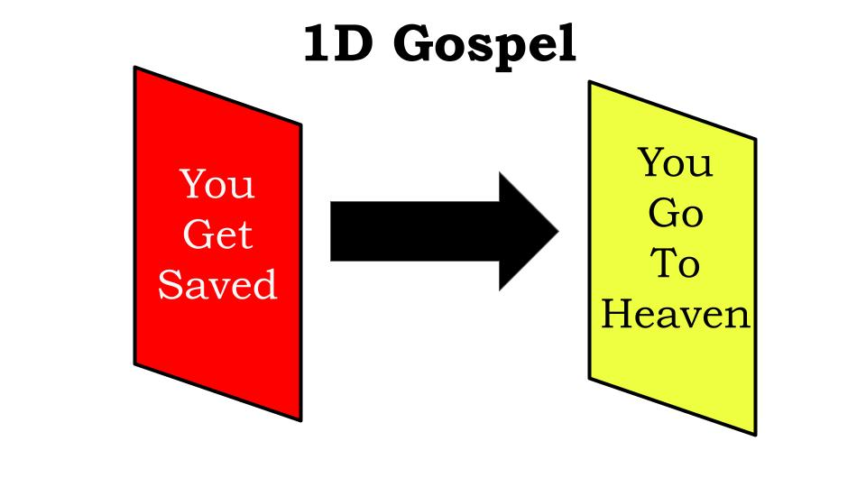
Do you see the problem with that thinking? It is certainly true, but It is a FLAT or One Dimensional Gospel. “Jesus died for you.” Yes, amazing! Your sins are forgiven, now “You will go to heaven” when you die.

Lots of Christians today have this shallow understanding of Jesus and the gospel that basically mashes these two walls together. The gospel takes away your sins so you can go to heaven. Period. End of story.

What does that leave out? Oh, nothing much - just your entire life!
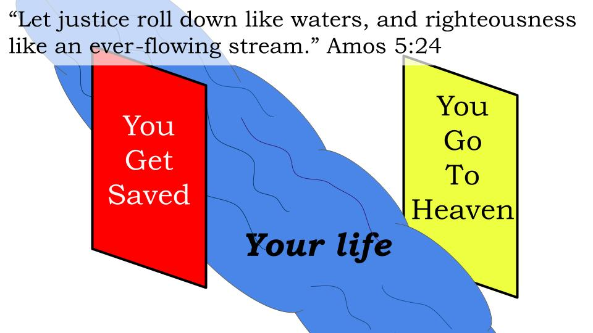
God’s purpose is to work IN YOU so He can work THROUGH YOU. We aren’t saved BY good works, but we are saved FOR good works. When Amos says “let justice roll down” and Micah says “no justice, love mercy and walk humbly with your God” and Isaiah says that our calling is to “bring good news to the poor” and that true fasting is to “loose the bonds of the oppressed,” they are talking about OUR LIVES as followers of God.

God didn’t send His only Son to die for your sins just so you could go to heaven when you die. God did it so you would become a totally different kind of person - the kind that loves Him so much that you love other people and devote your life to not just praying that the kingdom of God would come on earth but to helping the kingdom come, a little here, a little there.

I’m hoping this series is a wake up call for us. I’m praying - for all of us - that God will give us ears to hear and eyes to see the reality of our own hearts. Every one of us - at any given minute of the day - can fall back into a self-centered storyline. We say Jesus is Lord and it’s about Him but a few minutes later we are living like it’s all about ourselves.

But the one story of God shows us the better way of actually following and serving Jesus. It expands our gospel understanding from a shallow “Believe in Jesus to go to heaven when you die” to its glorious 3 dimensions - enough to fill our lives and to fill eternity!

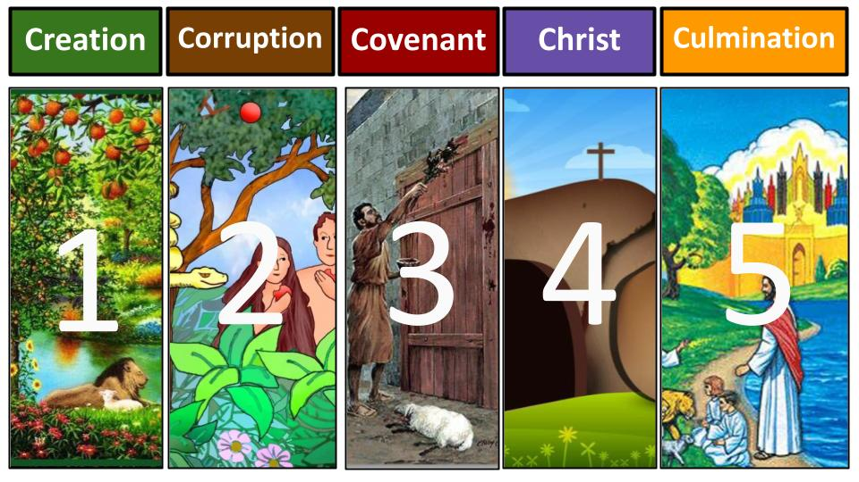
We’ve seen the beginning and the end - under the broad and wonderful heading of SHALOM. God started this whole thing with perfect peace, love and union in all three relationships - upward, inward and outward. God will finish history with shalom not just restored but perfected in all three relationships. Here is the flannelgraph overview of the story:

The story of God has five major acts. It started with creation and the Garden of Eden where it was very good. It ends in eternity with the new heaven and the new earth perfectly united in Christ forever. The beginning and the end are all about SHALOM - vertical peace with God, horizontal love and harmony with one another, global purpose and oneness in the world. But when you go back to the beginning you see that shalom didn’t last very long.

Act 2 took place in Genesis 3. There was one rule in the Garden - one tree Adam and Eve could not eat from: the tree of the knowledge of good and evil. Oh, brother, sister, friend - can you imagine what it was like to NOT HAVE the knowledge of good and evil? You can see that innocence in the heart and eyes of a child - and you can almost see the light go out when suddenly the darkness of evil breaks in. Our oldest son, Seth, was two. We dropped him off in Sunday School and they had this awesome train set he really liked. After service we picked him up and asked how it went and he was beaming from ear to ear - “It was great. I got the train.” Oh, what train? “Well, all the trains. Another boy wanted them but I pulled and I pulled and I got it.” Ok, so you ended Shalom for another boy. Perfect. Great day for you - maybe not so great for him.

“I pulled and I pulled and I got it.” Doesn’t that describe our day to day life a lot of the time?

Act two in the story is called CORRUPTION. The day that Adam and Eve ate the forbidden fruit everything in the universe changed. Everything flipped upside down. Everything was damaged - especially the human heart. The virus of sin got baked into the human heart from that moment on - and it passed on from every set of parents to every child ever born. Shalom was lost. Not completely lost - but damaged almost beyond recognition.

Remember what happened right away after they ate the fruit? The Bible says “their eyes were opened and they realized they were naked.” The very first effect of sin is guilt and shame. Whether it was days or months - Adam and Eve had enjoyed the joy of innocence - a relationship utterly unclouded by guilt and fear and shame and sin. But all of that disappeared the instant they rebelled against God.

Guilt and shame led them to hide from God and each other. Vertical shalom was broken - their relationship with God was now polluted with their disobedience. And their horizontal relationship with each other was also fractured. Guilt and shame led immediately to blame. God asked what happened and Adam pointed directly to Eve - sold her out instantly. Eve pointed right to the snake - he tricked me!

Do you see how helpful it is to know our family story? I know this has never happened to you guys - but it happens to me all the time, so humor me. I don’t get up early enough and don’t really read the Bible or spend my time with the Lord - and end up running around through the day not really walking with the Lord but more running from Him - hiding. Instead of taking responsibility for my personal sin and failure, I look for someone to blame. I know no one will believe me if I point to Kristin so I look for someone in the church. Yes, that guy - that’s why I’m impatient and irritable today - certainly not MY fault!

Guilt. Shame. Hiding. Blame. The hallmarks of sin and the descriptors of hell. The day Adam and Eve ate that fruit they didn’t go straight to hell - but hell came straight to them. Shalom was broken and they started to die. Their perfectly healthy bodies started to break down. The world they lived in turned against itself and the animals started eating each other, the plants started growing over each other, even the weather itself got all twisted up on itself. Conflict. Disorder. Chaos. Division. This is anti-shalom. It is the path to hell.

Oh, we remember Act 1 - but it’s a distant memory. We live with the effects of Act 2 - corruption. It explains so much about this world we live in. Thankfully that’s not the end of the story, right?

Act 3 is God’s covenant work in history - starting with Adam and Eve right there in the Garden and promising to crush the serpent’s head; and on to Noah before the flood and then Abraham and Moses and David. Those are the five primary promises of God in the Old Testament, they build beautifully upon one another and we could spend a whole year going through the Bible story. But the point is that God started right away to limit the damaging effects of sin and to bring shalom back to those who would trust in Him.

His main plan involved the Jewish people - starting with an old, infertile couple named Abram and Sarai. From those two God built a nation that has endured all the way to the present conflict in the Middle East - against all odds! But it wasn’t about the Jews, and it wasn’t about the land - it was always about GOD and the means He provided to cover sin and begin to repair those three relationships: upward, inward and outward.

Do you see how we often read the Bible without the big picture of the one story? If you do that, you will make ABRAHAM the hero or MOSES or DAVID the heroes. They aren’t. God is the hero - and really the whole Bible points to Jesus as the Hero who was coming, or the One who came.

Think about it. How do you read about Abraham? God called him to leave his family and his ancestral land and his pagan gods and set out on adventure. Inspiring! He trusted in the quiet voice of God and set out. So YOU should be like Abraham and when He calls you to set out on a new adventure you should trust in God and go, even when it doesn’t make sense.

Ok. That’s how most of us were taught to read the Bible. Be like Abraham. Be like David. Dare to be a Daniel.

But do you see how it makes THEM the hero and by extension it makes YOU the hero?

Instead, look at the grand story of God. Look at how Shalom was lost and how - every step of the way - God enlists people into His plan to restore that Shalom. Abraham is not the hero of the story of Abraham. Jesus is!

How did God fulfill the promise to Abraham about becoming the father of many nations? Through JESUS. Abraham is your father and my father IN CHRIST. Stars in the heavens - look up and count them. That’s how many descendants you’re going to have. How many actual sons did Abraham have? Two. One the anti-shalom way. One the shalom way.

We could do this with Moses, with Elijah, with David, with Daniel. None of those guys are the heroes - all of them point to Jesus! The hero in the background of every page of the Old Testament is the Promised One - the Coming One - the Messiah, the Prophet like Moses, the Priest like Aaron, the King like David. Come back next week to study Isaiah and see Jesus as the obvious hero of his great prophetic book and of the whole story.

Because Act 3 - the Covenant - is all setup for Act 4 - the Climax of the story in CHRIST. The whole Bible is just rising action until Jesus appears. And since He came, everything is falling action until He comes back. The Bible is one unified story and it’s about Jesus from beginning to end. He is the hero.

And what Jesus - the Hero - achieved - is SHALOM. He brought healing to our upward relationship with God, reconciling us with a complete and permanent cure for the corruption of our sin. He brought restoration and unity to our inward relationships in the church, reconciling us with one another so we can obey His main command to love each other. And he brought purpose and meaning to our outward relationship with the world - as we join Him in bringing shalom to the people and places we visit every day.

Look again at Ephesians 1.

“According to his purpose, which he set forth in Christ as a plan for the fullness of time, to unite all things in him, things in heaven and things on earth.” Ephesians 1:9-10

This was God’s plan for the fullness of time: to unite all things in Christ; both heavenly things and earthly things. All of it. Healed, reconciled, united - SHALOM. This wonderful truth moves Paul to pray for the believers in Ephesus for spiritual wisdom and understanding to know the riches of their inheritance in Christ - to know that it’s not just a ticket to heaven, shallow gospel thing. It’s an all-encompassing, life-altering, mission-inspiring, world-filling plan! Look at the end of Ephesians 1.

“And gave him as head over all things to the church, which is his body, the fullness of him who fills all in all.” Ephesians 1:22-23

Hold on. God’s plan for the fullness of time is to unite all things in Christ. He is healing and restoring this entire messed up universe in and through Jesus. But the means by which God is doing that is what? THROUGH THE CHURCH. The Body of Christ IS the fullness of Him who fills all things in all ways.

And so, with the outpouring of the Holy Spirit in Acts 2, Act 5 began with the apostles and the early church - The Culmination of God’s plan to restore shalom.
That work that started in Acts continues today as the church grows and shares the gospel of the kingdom in every tongue and tribe and nation - until Jesus comes back and makes all things new, finally uniting heaven and earth again as it was in the garden - and we will reign with Him forever and ever. Amen.
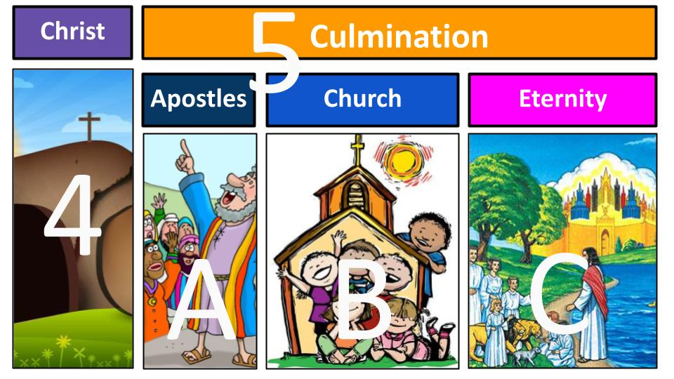
Act 5 has 3 Scenes. It begins with the age of the apostles as documented in the book of Acts and written about in the epistles, the letters that make up most of the New Testament. The apostles established the core doctrines of Jesus and the main structures of the church - spreading the message throughout Israel and the middle east and all the way to Rome.

From there the story moved into Scene B - our part. The church age. This scene ends when Jesus comes back and completes the Shalom project, uniting heaven and earth once and for all in His eternal kingdom. But for now, the story continues as Jesus builds His church and the gospel of the kingdom spreads to every tongue and tribe and nation. Our calling is to be salt and light, bringing the Shalom of King Jesus into the dark and broken parts of the world where we live.

We are called to not only be peace-MAKERS but to be peace-BRINGERS: agents of Shalom.
Come back to this visual here with 1D gospel.

Yes, if you called on Jesus to save you, you have passed through the curtain of His blood and you have been forgiven and set free from the penalty of sin. And yes, when you die you will go to heaven to be with Jesus - praise the Lord!

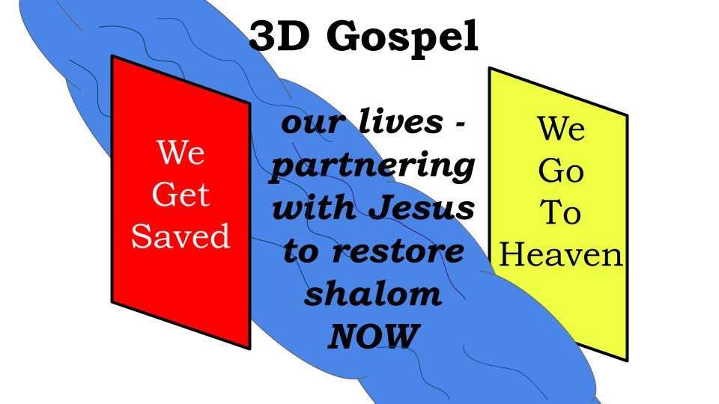
But in between your conversion and your death there is this middle area. What is the purpose of your life? What is the PLOT for the story you are writing with your minutes and days and years?

Are you caught in the trap of this world so that you “worship your work, work at your play and play at your worship?” Are you struggling to find purpose and to find a plot for your life?

Or have you found in Christ the HERO to rally behind? Have you found in His Story the plot to follow? Because it is the story of peace - the restoration of all things - about healing and justice and peace forever and forever.

We often think of our missionary task as rescuing people from the river of this world - the current of temptation that is drawing them to everlasting destruction. We stand on the banks of the river and throw lifelines in, hoping to pull a few out here and there.

But the better analogy is that there is a RIVER - the River of Life - that has been flowing since the Garden and that will run down the middle of the eternal kingdom of God. It is the River of God’s own Life - His love, His peace, His restoring grace. And when you get saved, you get drawn INTO that River.

And once you’re in the current of God’s restoring, transforming grace and glory, you bring love and truth and justice and righteousness wherever you go - and you try to draw people INTO the river of grace with you. This is what the prophets were writing about through the entire OT. Listen to Amos 5.

“Let justice roll down like waters, and righteousness like an ever-flowing stream.” Amos 5:24

God confronted His people with their complacency and lack of love for Him and each other and the world. He grew tired of their religious rituals because their hearts were not in it. And the evidence of that was how they treated one another - especially the most vulnerable among them. Had they really loved God, they would have loved the hurting and poor, the orphan and widow, the refugee and foreigner among them. Instead, they oppressed the poor and abused the weak.

So, God exhorted them, over and over, to let justice roll down; to seek righteousness and goodness and love; to protect the orphan and the widow and the foreigner.

We love the word “JUSTIFICATION.” We celebrate the wonderful gospel truth that at the moment you trust in Christ you are JUSTIFIED - declared righteous in Christ on the basis of His perfect life, death, and resurrection.

But the word “justified” is built on the word RIGHTEOUSNESS. To be justified is to be declared righteous - or to be “righteous-i-fied.” The righteous life of Jesus is imputed to you as a credit. And from that moment on the righteousness of Jesus - His love, His power, His goodness, His restoring SHALOM - is infused into you through the Holy Spirit of God. Having been declared righteous, as a follower of Jesus you should increasingly BECOME righteous - becoming more and more like Him.

Which means you should become an agent of righteousness - a BRINGER of God’s peace, justice and love.

Do you see how that is the big story of what God is doing in history? That is the purpose of your life and mine? It’s not about you and it’s not about me. It’s about Jesus from start to finish - about the Shalom He created when He first said, “Let there be light,” and about the Shalom He will restore perfectly when He comes back. Until then, He is working through us – through the CHURCH - to bring His grace and truth, His love and justice to a broken and hurting world.

Brothers and sisters, this week - “Let justice roll down like waters, and righteousness like an ever-flowing stream.” Bring God’s restoring grace with you into every relationship, every conversation, every work project, every family discussion. This is why you are still breathing air: because there are good works God has uniquely designed and positioned you to accomplish.

Right after Ephesians 2:8-9 where Paul talks about being saved by grace through faith - not by works so that no one can boast. Immediately after those wonderful gospel verses Paul wrote Ephesians 2:10.

“For we are His workmanship, created in Christ Jesus for good works, which God prepared beforehand that we should walk in them.” Ephesians 2:10

We are the masterpiece of God - we are the great temple He is building of living stones - brick by brick, filling the world with life and love, with peace and joy in Christ. How do we do this? Through good works every day - small things and big things. Just loving people, serving them, praying for them. And ultimately, drawing as many as we can into the flowing stream of God’s Water of Life.

Be peace-bringers this week! Find your place in the great story of God!
Let’s pray.

5 Acts

1 Plan - to restore all things in Christ
- Eph. 1:10 “as a plan for the fullness of time to unite all things in him” (the mystery of his will)
- Eph. 1:23 “the church, which is his body, the fullness of him who fills all in all”
- Eph. 2:14 “he himself is our peace who has made us both one”
- Eph. 2:15 “one new man in place of the two, so making peace, and might reconcile us both to God in one body”
- Eph. 2:22 “in him you also are being built together”
- Eph. 3:10 “now through the church the manifold wisdom of God” (mystery hidden for ages)
- Eph. 3:19 “that you may be filled with all the fullness of God” (PLURAL - all y’all)
- Col. 1:17 “in him all things hold together”
- Col. 1:20 “through him to reconcile to himself all things… making peace by the blood of his cross”
- Col. 1:27 “this mystery which is Christ in you, the hope of glory”

