The Transformation
Ephesians 2:1-10

When Jesus hung on the cross, as his human body was about to give out, he said those history changing words: “IT. IS. FINISHED.”

What was finished? The project labelled humanity wasn’t completed. The planet called earth was still a mess. The story of God had reached its peak but there were still lots of pages to be written.

So what was finished in that moment? The work of Jesus. His suffering. His being obedient unto death, even death on a cross. His drinking of the cup that was brimming over with the just wrath of God. That was accomplished as he breathed his last breath.

He did not fail. He did not give up. He did not abandon us to save himself. He did not rebel against the Father’s plan. He finished the agonizing, soul-crushing, soul-saving work. And the whole world groaned under the strain of it - the sun turned black in the sky, the ground shook, the fabric of the universe trembled as God the Father unleashed the torrents of hell on God the Son.

“There on the cross, as Jesus died, the wrath of God was satisfied. For every sin on him was laid. Here in the death of Christ I live.”
- In Christ Alone, by Getty and Townend

A liberal denomination asked the Getty’s if they could print In Christ Alone in a new hymnal a couple of years ago - but they wanted to change that phrase from “the wrath of God was satisfied” to “the love of God was magnified.” And to their credit, Keith and Stuart said no. The song is a complete package, and it says what it needs to say.

Jesus paid the full price for your sin and mine. He didn’t hang there and say, “It’s mostly done.” “Nearly there.” He said: DONE. Accomplished. It is finished.
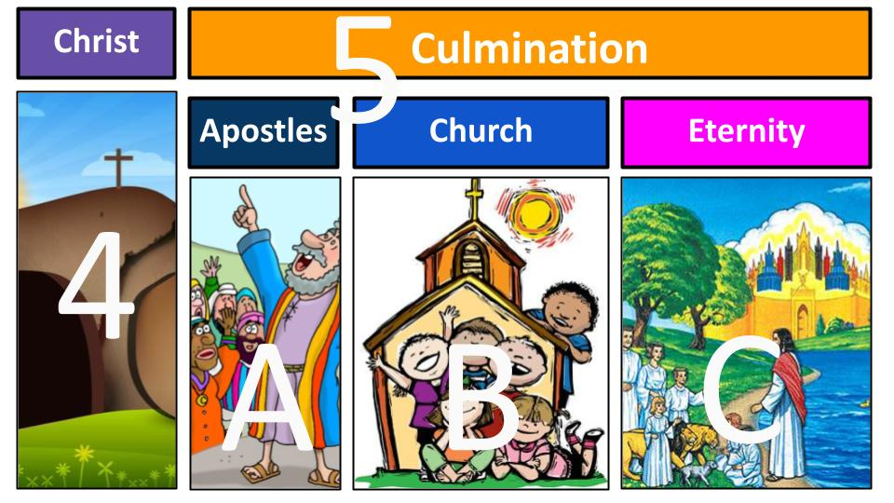
As we’ve seen in the One Story - the death and resurrection of Jesus is the climax of the story in which Jesus is the Hero. But it’s not the end of the story. It sets up the final chapters in Act 5. Scene A shows the transformed and Spirit-filled apostles preaching Jesus and founding the church. Scene B is the ongoing, unfolding story of the Church - the story God is still telling right at this moment. Scene C of Act 5 is Eternity, after Jesus comes back and makes all things new.

Acts 1, 2 and 3 looked ahead to Christ. And Act 5 looks back on Christ and that finished work. Look at verse 7 of Ephesians 2 that we just heard.

“So that in the coming ages he might show the immeasurable riches of his grace in kindness toward us in Christ Jesus.” Ephesians 2:7

The purpose of the sacrificial work of Jesus by which you and I are made alive, raised up and seated with Christ is right here - to create an eternal showcase for the glorious riches of God’s infinite grace. This is what we will celebrate and rejoice in FOREVER: God’s overflowing kindness and mercy.

The cross of Jesus - that appeared to be his greatest defeat - was actually His ultimate victory, because it enabled the deep internal transformation of the heart that sinners like us needed to join in the shalom-restoring operation of God.

So, let’s be encouraged today in the amazing grace of our salvation! We will see in Ephesians 2 four dimensions of the gospel.

We are saved:  - By Grace alone  - Through Faith alone  - In Christ alone  - For God alone | “For by grace you have been saved, through faith. And this is not your own doing; it is the gift of God, not a result of works, so that no one may boast.” Ephesians 2:8-9

This is the transforming glory and power of the gospel. This is the heart of the Bible story. Because of Christmas, Easter was possible. Because Jesus came as a fully human child, he was able to bear the sins of humans like us. Because he finished the work on the cross, you and I can be forgiven, set free and raised to new life in Him. And don’t miss the last one: because Jesus has given His righteousness TO US - we can and must let His righteousness shine THROUGH US. We do not live for ourselves anymore - our lives are not our own - we were bought with a price and therefore must honor God with all that we are and have. We live for GOD alone.

First, Paul is very clear that we are saved by grace alone.

We are saved:
- By Grace alone
“And you were dead in the trespasses and sins in which you once walked.” Ephesians 2:1-2

What a picture! Literally the walking dead. Let’s get this right in terms of what God saved us from. We were IN our sins. We were walking in them, devoted to them, enslaved and consumed. And even though physically we were alive, spiritually we were dead.

We are saved:
- By Grace alone
“Following the course of this world, following the prince of the power of the air… carrying out the desires of the body…” Eph. 2:2-3

Did you get the checklist there? The world: check. The devil: check. The flesh: check. That’s where we lived. That’s who we were. Dead in sin - devoted to ourselves, the devil and this fallen, broken world. The result?

We are saved:
- By Grace alone - deserving Destruction
“And were by nature children of wrath, like the rest of mankind.” Eph. 2:3

This passage should remind us of Genesis 6 and the lead up to the flood. “The inclinations of their heart were only evil all the time.” The world was filled with violence, wickedness and evil. God was fed up. And His just wrath was poured out on a world deserving nothing but destruction.

But remember in the flood a small group was saved! Noah and his family. The Ark could have saved hundreds, thousands of others. But no one else responded to the prophetic work and word of Noah, even though the NT calls him a preacher of righteousness (2 Pet. 2:5).

We are again living in days like Noah - everyone does what is right in their own eyes. Selfishness is glorified and conflict and violence erupt all around us. You and I were like this before Jesus change us. We were DEAD:

We were D.E.A.D.:
- D - dead spiritually
- E - enslaved to our own desires
- A - aligned with the devil
- D - deserving destruction

This was our condition before Christ. We were spiritually dead. Our hearts were cold toward God and resistant to the truth. Our spiritual eyes were blind, our ears were closed, our necks were stiff. We were following the ways of the world and the devil, enslaved to our own selfish desires. We were aligned with the devil and serving his purposes, directly counter to God and His kingdom. And therefore, we were deserving of destruction - God’s just condemnation and wrath.

Do you see why our salvation is by GRACE ALONE? What do we deserve from God? The answer is “death and hell.” Say it with me - what do we deserve from God? Death and hell. Right. By nature and by choice, we were children of wrath.

We are saved:
- By Grace alone - deserving Destruction
“And were by nature children of wrath, like the rest of mankind. But God…” Eph. 2:3-4

BUT GOD. On our own, we were helpless, sinful, enslaved and DEAD. That dead thing is a pretty good catch-all category. Dead people are notoriously bad initiators. But God. Even when we were dead in our sins - He sent Jesus to save us. Even when we deserved nothing but judgment and condemnation, He sent Jesus to die for us. Even when there was nothing attractive or appealing about us, God sent His only Son to pay to price to bring us into a reconciled relationship with Him.

It was all grace. Not one microgram of merit. Not one fraction of an ounce of our own worthiness. Grace alone.

We are saved:
- Through Faith alone
“But God, being rich in mercy, because of the great love with which he loved us…” Ephesians 2:4

Entirely because of His love and mercy and goodness and grace - God saved us. He did the work. The only thing you and I did was say “yes.” God will not force anyone’s hand. But as soon as you bow the knee and call on Jesus, God rescues you from sin and death - He saves you. BY FAITH ALONE. Ephesians 2:8-9 are two of the most important verses in the Bible.

We are saved:
- Through Faith alone
“For by grace you have been saved, through faith. And this is not your own doing; it is the gift of God.” Ephesians 2:8

Could it be any more clear? Paul not only spells it out positively - salvation is by grace through faith. But he carefully negates the prominent human idea that our works might have something to do with it. “This is not your own doing.” It is a complete gift.

We are saved:
- Through Faith alone
“Not a result of works, so that no one may boast.” Ephesians 2:9

Remember, the Jewish mindset was that it was all about keeping the Law, the Torah - obeying the commandments, following the traditions. Circumcised on the eighth day; eating kosher; avoiding contact with pagan Gentiles; offering sacrifices on schedule; keeping the sabbath. Right down the list. Works. Works. Works. Works.

Now, the Old Testament is actually about being saved by grace through faith as well - but the Jewish people had lost sight of that by wrapping layer upon layer of human tradition on top of God’s Word. Why? So they could BOAST. So they could take credit. So specific groups of scribes and religious teachers could maintain CONTROL. Credit and control.

And aren’t those the very things our human hearts still want today? Credit and control. If I earn even some little part of my salvation, I feel good about my efforts. I deserve some credit! And if my fate depends on me, I feel some degree of control about the outcome.

But if I have to trust completely in God to save me - if it’s all about HIM - then I have to give up any sense of taking credit and all idea of being in control. Yep. That’s the kicker. Faith is not taking control, it’s letting go. It isn’t asserting yourself, it is surrendering yourself.

And that is wonderfully good news!

We are saved:
- Through Faith alone - perfectly Powerless
“Not a result of works, so that no one may boast.” Ephesians 2:9

Because you and I were perfectly powerless to save ourselves. Remember the whole thing about being DEAD. But in that place of unworthiness and helplessness, God saved us. Jesus died for your sins. He took your place. He paid your debt. He set you free. Jesus did ALL THE WORK.

So trust Him completely. Worship Him wholeheartedly. Give thanks passionately. And rest in the finished work of Jesus. There is nothing left for you to do. There is nothing you can possibly add, even if you really, really tried.

What’s your part? Believe. Trust. Rest. Rejoice. Give thanks. We are saved by grace ALONE through faith ALONE in CHRIST ALONE. That’s our third dimension of gospel glory.

We are saved:
- In Christ alone
“But God… even when we were dead in our trespasses, made us alive together with Christ.” Ephesians 2:5

Verses 5-6 have three special verbs that each include the prefix WITH - meaning WITH CHRIST. So literally here it would be with-made-alive-us-with-Christ. The “with-made-alive-us” is one word in Greek, connected then with the prepositional phrase “with Christ.” You can see why the translators did what they did - “made us alive together with Christ.”

We are saved:
- In Christ alone - covenant Creations
“But God… made us alive together with Christ… and raised us up with him and seated us with him…” Ephesians 2:5-6

Here we see and celebrate the gospel doctrine of UNION WITH CHRIST. We have every spiritual blessing in Christ because to be saved is to be united with Jesus forever - to be bound together with Him heart, soul and body. This is the miracle of saving grace, received by faith alone - that we are made new in Christ, re-born spiritually through the blood of the eternal covenant.

Brother, sister, friend - there is only ONE PLACE of salvation - just like the ark that Noah built. The only safe haven from the just wrath of God is the PERSON of JESUS CHRIST. He alone is the way, the truth, and the life. There is no other way to be forgiven and reconciled with God.
Everyone on this planet is either safe and loved and alive IN CHRIST, or they remain dead IN SIN.
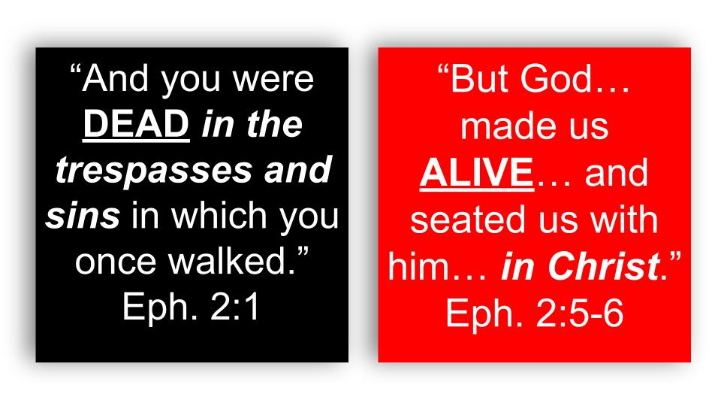
Those are the only two conditions. Everyone is born with the sinful nature of Adam. And they willfully choose to follow that nature, becoming sinners by choice as well. As a result, people are dead in sin. The only way to escape that is to put your faith in Jesus - to be united with Him and experience His resurrection life.

So let’s not deceive ourselves that there is some third option for “friendly, suburban neighbor,” or the category my high school buddy liked, “sincere Buddhist rice farmer.” Apart from Jesus people are dead in sin. Period. Destined for hell and eternal suffering.

It’s like the Passover in the OT - either the blood of the Lamb has been applied and the angel of death can pass over you, or the blood has not been applied and death is coming. It’s very black and white, even though our culture loves the 50 shades of gray. There are no shades of gray with salvation. It is in or out. Dead or alive. In Christ our outside of Christ. Yes or no.

We are saved:
- In Christ alone - covenant Creations
“But God… made us alive together with Christ… and raised us up with him and seated us with him…” Ephesians 2:5-6

If the grace of God has been applied to you by faith, then you stand before God IN CHRIST - united with Him in His life, in His resurrection, and in His ascension. Think of those three stages of the EXALTATION of Jesus. First, he came back to life - he took that eternity changing breath. Then he stood up and walked out of the tomb. 40 days later he ascended into heaven, taking his seat at the Father’s right hand in glory.

Those same things happened to you at the moment you trusted in Jesus. God breathed life into your dead soul and made you alive with Jesus. Then God raised you up and walked you out of your tomb, breaking the chains of sin and death that held you captive. And then God raised you up with Christ and seated you right there with Him in the heavenly places.

Spiritually you are not just alive - you are already seated in the highest position of power and glory in the universe, in Christ.

Think of what it is to PRAY. Specifically to pray IN JESUS’ NAME. It means you approach the God of all glory, the creator of all things and the Lord of heaven and earth - as if YOU were JESUS. In His name; in His authority; on His behalf; for His glory.

You aren’t making a long-distance phone call across an old static-y land line. You are sitting right next to God the Father and in the loving union of the eternal Holy Spirit you are whispering to your Abba in the very words of Jesus Himself. “Hey Dad, let’s go to McDonalds.” When I say those words, I have zero doubt or hesitation about my Father’s response. Done. He’s probably already in the car. I could say “golf course,” or “steak house” or “broken sink.” And he’d be ready to go for any of those as well.

My Dad is very generous and fairly predictable so if YOU said any of those words to him - including “broken anything” he would come and help you out as well. But you’d be approaching him IN MY NAME, wouldn’t you? You wouldn’t just call saying, “Hey this is Dave - can you help me out?” You’d say, “Hey, this is Dave from Oakwood - Darin said you like McDonalds and golf - let’s play Friday!” Trust me, you’d have a golf buddy and enjoy a McMuffin on the way.

Do you feel the joy of your salvation today? We are saved by grace alone - it’s 100% God and 0% us. We are saved by faith alone - it is 0% works and 100% trusting in the finished work of Jesus. And we are saved in Christ alone. His name is the only name under heaven by which we can be saved. Outside of Christ people are dead in sin. Only IN CHRIST is there forgiveness, freedom, love and life. One more wonderful dimension of gospel glory.

We are saved:
- For God alone
“But God, being rich in mercy, because of the great love with which he loved us…” Ephesians 2:4

Why did God save any of us? Entirely because of HIS MERCY. Simply because He IS LOVE. Father, Son and Holy Spirit - God has eternally existed and always will exist as an overflowing fountain of love. He doesn’t need us to experience or show love - but God is so abundant in love that He created out of the overflow of His creative, loving JOY. He set history in motion entirely for His own glory - to express the loving nature of His very being.

We are saved:
- For God alone
“So that in the coming ages he might show the immeasurable riches of his grace in kindness toward us in Christ Jesus.” Ephesians 2:7

It is our joy right now to sing the glorious grace of Jesus. And it will be our joy for the endless ages of eternity to continue singing and telling of His immeasurable grace. One of the reasons we need eternity for this is because there are so many stories to tell and so many to hear! We have a tiny sample in the Bible of God’s grace in the lives of some key figures. But even guys like Moses and David who fill a lot of pages - there is tons more we don’t know about God’s infinite kindness to them.

And the same is true of YOU. Think of this. Part of the joy for OTHER BELIEVERS in our eternal home will be listening to YOU share the riches of God’s grace in your life right now.

Do you see how your life and your experiences - the highest highs and the lowest lows - are really not about you at all? They are all about God - His purposes, His faithfulness, His goodness and glory!!!

Our job is simply to reflect that glory and goodness right back to our Creator and Savior.

We are saved:
- For God alone - reflecting Righteousness
“For we are his workmanship, created in Christ Jesus for good works, which God prepared beforehand that we should walk in them.” Ephesians 2:10

There’s that word “created,” and again that wonderful phrase IN CHRIST. We are creations of the new covenant - rescued from our position in sin to a new condition and position in Jesus Christ. We - together as the global body of Christ - are the great masterpiece of King Jesus. We are the story He is writing. We are the tapestry He is weaving. We are the portrait He is painting. We are the BRIDE He is preparing. We are the TEMPLE He is building… brick by brick… where He will live forever.

What is our part in this? GOOD WORKS. God prepared specific tasks, special assignments for each one of us. Our job is simply to “walk in them.” Good works are NOT AT ALL what save us. Hear this:

We are not saved BY good works.  We are saved FOR good works. | “For by grace you have been saved through faith. And this is not your own doing… not a result of works… For we are his workmanship, created in Christ Jesus for good works…” Ephesians 2:8-10

This is why Paul and James were not in conflict in the New Testament. They were not writing opposite things but complementary things. Paul would have agreed with James completely that “faith without works is dead.” 100%. Real saving faith is not shown in WORDS but in deeds. It is by their FRUIT that you will know a real follower of Jesus. Words can be deceiving. Passion can be misleading or short-lived.

Consider the wonderful word RIGHTEOUSNESS. It’s the basis for our word JUSTIFICATION.

We are saved:
- For God alone - reflecting Righteousness
“For we are his workmanship, created in Christ Jesus for good works, which God prepared beforehand that we should walk in them.” Ephesians 2:10

Immediately after Ephesians 2:8-9 comes verse 10. There is a profound analytical observation! Verse 10 comes after verses 8 and 9. Thanks pastor. But remember the theological significance of Ephesians 2:8-9 - we are saved by grace alone through faith alone in Christ alone. It’s all grace. It has nothing to do with our works or worthiness.

FOR we are His workmanship. This is why no one can boast - because God is the One who created us first physically and then re-created us in Christ. We are double-creations of the God of all grace and goodness.

And what did God create and re-create us FOR? FOR GOOD WORKS. He prepared them uniquely and sovereignly for each of us as individuals and for each local church - “that we should walk in them.”

Look at it this way, in the words of Pastor Colin Smith. “There is a righteousness Jesus gives us and a righteousness he calls us to.” That’s in his book, Momentum. Jesus gives us His righteousness at the moment of salvation in the act of justification. As soon as you call on Jesus to save you, He declares you righteous - justified - and moves you from being dead in sin to being alive in Him.

But as soon as Jesus declares you righteous, He begins to MAKE you righteous. He calls you more and more to grow up into Him. It’s like wearing your big brother’s letterman jacket and it doesn’t fit you, but you want to grow into it - so you hit the gym and work out and learn all the tips and tricks you can to be like your big brother. You becoming a better football or soccer or basketball player doesn’t change the nature of your relationship with your brother - he is going to love you whether you play or not - it’s just a sign of your admiration for him that you want to be like him, even in the sport of his choice.

I bet most of us when we think about RIGHTEOUSNESS translate it in our minds into HOLINESS - meaning, yes, I get saved and need to become more like Jesus - resisting sin and reading my Bible and becoming more and more godly in my behavior. Yes, that is true, for sure. But the Bible word righteousness is connected both to holiness and to JUSTICE. As those who are justified in Christ, we should increasingly live out the Kingdom vision of our Lord of freedom for captives and justice for the poor and oppressed. We should take literally His command to “love your neighbor as yourself.”

This is how this message fits with the rest of the One Story series.

The great story of God began with perfect Shalom in the garden. It will end with Shalom totally renewed and perfected in the new heaven and new earth. The climax

We are saved:
- By Grace alone (deserving destruction) v. 1-3
- Through Faith alone (perfectly powerless) v. 8-9
- In Christ alone (covenant creations) v. 5-6
- For God alone (reflecting righteousness) v. 4,7-10

Dead in sin
- Walking in sin
- Following the devil
- Enslaved to our own desires
- Destined for wrath
BUT GOD…
Alive in Christ
- Because of God’s great love (not our worthiness)
- When we were dead (only by grace)
  - God gave us life with Christ v. 5
  - God raised us up with Christ. v. 6
  - God seated us with Christ
- In order to show the riches of His grace and kindness v. 7-8
  - By grace you have been saved - not bc of you
  - No one may boast
- For we are His masterpiece - created in Christ Jesus for good works
  - A holy temple, built upon Christ, growing together as a dwelling place for God (2:21-22)

