Be Filled
Romans 8:3-11

Some of you are here because you were personally invited by a friend. Thank you so much for responding to that invitation! And thank you to everyone who has made an effort to invite a friend to this short series.

This series is called The Invitation. We are walking slowly through Romans chapter 8 to reflect on the five astounding gifts God offers everyone in Jesus Christ.

God’s Astounding offer of Eternal Life in Jesus Christ:
- Be Forgiven (v. 1)  - Be Free (v. 2)  - Be Filled (v. 3-8)  - Be Fruitful (v. 9-11)  - Be Family (v. 12-17) | “There is therefore now no condemnation for those who are in Christ Jesus. For the law of the Spirit of life has set you free in Christ Jesus from the law of sin and death. For God has done what the law… could not do. By sending his own Son… to be a sin offering.” Rom. 8:1-3
,
By committing your life to Jesus, you can have all of your sins forgiven. You can be set free from the power of sin in you and over you. You can be filled with the Holy Spirit of God and connected with the life of Jesus right now. That’s our lesson for today. Fourth, you can be fruitful - living a life that matters now and forever. And finally, you can become a part of God’s forever family.

As you can see in verses one and two, all of these gifts are available IN CHRIST JESUS and nowhere else. If you missed last week, you might go back and watch or listen to that message to appreciate all that Jesus saves us from. Until you understand the BAD NEWS of your sin you can’t appreciate the GOOD NEWS of your salvation.

This next section of Romans 8 shows us a three-part CYCLE of spiritual fullness.

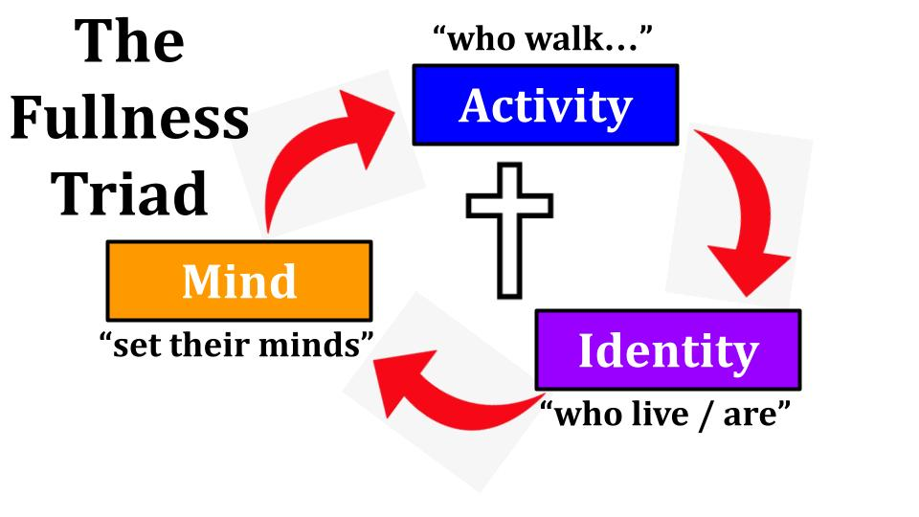
The recognition of all God has DONE in verses 1-3 flows immediately into what we must DO in verses 4-11. And it’s not a step by step, do these three things sequentially process - like you can stop doing the first thing once you’ve gone on to the second one. All three happen at the same time and mutually reinforce each other and flow back into each other. I was tempted to shift the order to put behavior last, but the Holy Spirit inspired the apostle Paul to put Activity first, so we will follow the order in the passage.

The first part of this fullness triad is activity - it’s about our behavior.

The Cycle of Spiritual Filling:
- Your Activity - Becoming more like Jesus
“In order that the righteous requirement of the law might be fulfilled in us, who walk not according to the flesh but according to the Spirit.” Rom. 8:4

Here is the PURPOSE of verses 1-3. “In order that.” Why did God make it possible for us to be forgiven and set free from sin through the death and resurrection of King Jesus? This is the reason. This is the purpose. “In order that the righteous requirement of the law might be FULFILLED in us.”

God has a standard called PERFECTION - holiness, justice, goodness - LOVE. This is the righteous requirement of His law. Here it’s the Law of Moses Paul is talking about - the Old Testament code, built around the 10 commandments and the great Shema to “love the Lord your God with all your heart, soul, mind and strength.” Jesus said that is the first and greatest commandment. It sums up what God requires - everything.

What does God want from you? Oh, nothing much - just all of your heart, soul, mind and strength. Just this little thing called holiness or, a more modern understanding - PERFECTION.

But notice the phrasing and the progression here in Romans 8.
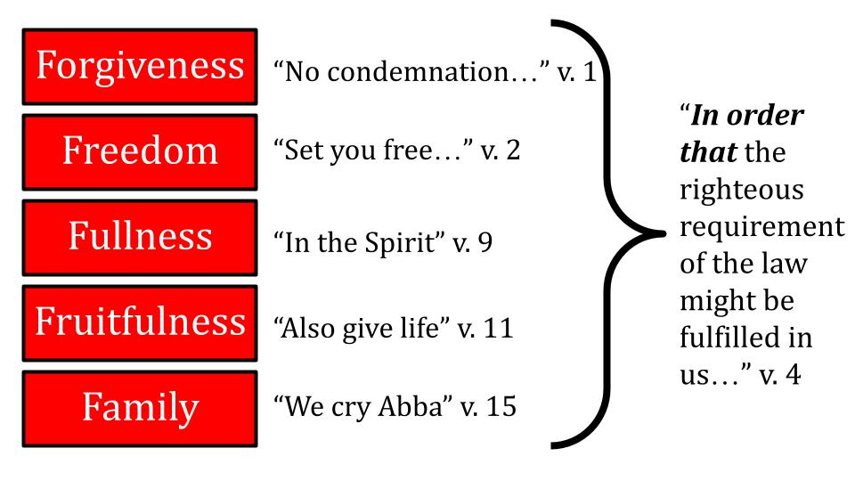
- “There is no condemnation in Christ Jesus.” Rather, there is forgiveness and life.
- There is a new law for those in Christ Jesus - not the law of sin and death anymore but the new law of the Spirit of life.
- Why did God give us this forgiveness and freedom? Why did God send His only Son to be a sin offering for weak, rebellious, idolatrous sinners like us?

“In order that” the righteousness He has always required might finally be FULFILLED IN US. God knew we could never live up to that standard on our own. So He provided a way for that standard to grow up INSIDE US - through Jesus.

When you commit your life to Jesus to be your Lord and King, several things happen all at once. It’s like an action scene in a book where the author takes you into a slow-motion replay of what’s happening all over a battlefield because you can only take in one snapshot at a time. Aragorn is zooming in with Legolas and Gimli on a ship filled with ghostly reinforcements. At the same time Gandalf and Pippin are fighting orcs on the streets of Minas Tirith. And elsewhere on the battlefield Merry is saving Eowyn by stabbing the chief of the Nazgul. That’s all in the Lord of the Rings if I lost you for a second. Epic final battle for the fate of middle earth.

If you could enter slow motion at the moment of your salvation you would see all five of these gifts happen at once.
- Jesus’ blood covers your sins as soon as you call on Him in faith and you are forgiven.
- At the same moment the Holy Spirit breaks the power of cancelled sin and sets you free from its controlling power.
- Not only are you rescued from the dungeon of your sin and brought into the stronghold of Jesus’ kingdom, your heart is transformed and you become a temple of the Holy Spirit where God Himself moves in to dwell forever.
- With this forgiveness, freedom and filling comes a new set of desires and new power to live differently and start bearing fruit that will last for eternity.
- And at the same time you are adopted as a son or daughter of God - reconciled with Him and united with your forever family of brothers and sisters in the church throughout all of history and all across the globe.

It’s pretty spectacular when you begin to understand the total transformation that your salvation entails. This is what I’m trying to summarize in this series: forgiveness, freedom, filling, fruitfulness and family - all the gifts God gives us IN CHRIST. And all for the purpose of fulfilling His righteous requirement in us.

The Cycle of Spiritual Filling:
- Your Activity - Becoming more like Jesus
“In order that the righteous requirement of the law might be fulfilled in us, who walk not according to the flesh but according to the Spirit.” Rom. 8:4

But here we see the shift from God’s work to ours. He fulfills the requirement of the Law in us through Jesus’ atoning work by which we are justified, declared righteous. THEN we start walking, we start living in line with that new reality. The order is essential to understand the gospel. It’s not that we satisfy all of God’s requirements and THEN are declared righteous. It’s that we are declared righteous and THEN we are able to start living in line with His law. It’s not that you can be good enough to earn God’s stamp of approval. It’s that you can have His stamp of approval IN CHRIST and then you can actually start being good.

Now that you have been born again as a new creation in Christ, it’s time to start WALKING.

Now a brand-new believer is a BABY Christian and you expect them to stumble and fall, to cry and fuss, to poop their pants. But that baby stage should not go on forever. Men, looking at pornography is baby stuff. That’s called pooping your pants. We expect some of that as teenagers are bombarded with hormones - they’re going to step in it a couple of times. But the teen years are like potty training - or like learning how to walk.

Ladies, gossip is baby Christian stuff. Talking about other people to feel better about yourself is what we expect from middle schoolers, but that we should grow out of as we mature.

Materialism is baby stuff - spending every dollar you earn or going into debt - that’s for the young and immature believer who hasn’t learned to be a steward of their resources.

Workaholism is a trap for the immature who hasn’t learned to worship God with all of your heart and instead you stumble into the worship of money or the pursuit of your own advancement, the building of your own kingdom and glory.

Failure to prioritize your marriage is little kid stuff. Yes, you’ll stumble into run of the mill selfishness early in your marriage - being late for dinner, forgetting birthdays and anniversaries, not scheduling date nights.

How about this one? Failure to spend time with the Lord. That’s baby stuff. That’s Christianity 101 - learning to read your Bible and spend time in prayer. Sometimes we can feel all “grown up” that we’re not legalists who have to have a full 30-60 minutes of quiet time every morning. But while avoiding legalism might be a concern for 1% of the people in this room, straight laziness and lack of discipline is probably a major problem for the other 99% of us.

How is your WALK?

Aren’t you encouraged that the expectation is that you WALK according to the Spirit, not that you have to run or sprint or do elaborate in and out of cones exercises or cross fit your way in the Spirit? Just walk. One foot in front of the other. Take one step. Then another step.

If you’re not in the habit of reading the Bible and praying, start with 5 and 5. Read one chapter for around 5 minutes. Spend another 5 minutes praying based on what you just read. That’s a baby step. From there you might grow to 10 and 10 or 20 and 20. Get a journal to write things down and celebrate answered prayers and insights as God speaks to you through His Word.

Walking according to the Spirit, not according to the flesh is the ACTIVITY of the Christian life. It’s how you increasingly become more like Jesus and less like Adam, less like the world.

A helpful strategy is to identify one fruit of the Spirit to work on for this month. Love, joy, peace, patience, kindness, goodness, faithfulness, gentleness, self-control. Just pick one. Jesus has all of them perfectly. We are deficient in all of them. But think like someone with a personal trainer. What needs the most work right now?

- If it’s gentleness, you might read the gospel accounts with a view to understanding and appreciating the gentle compassion of the Lord Jesus and praying for the Holy Spirit to help you apply that gentleness every day.
- If it’s self-control you might read the story of King David, along with the Psalms of David and see what he did well and what he did not do as well in the area of self-control.
- If you need to grow in love or joy, do a key word search in your Bible app and focus your Bible reading where those words are prominent. 1 John is all about love. Philippians is all about joy.

Identify an OUTCOME and plan out HABITS that will help you grow more like Jesus in that area of focus. H2O - habits to outcomes. I stole that phrase from the KC underground and the Disciples Made podcast. This is a great discussion point for Discipleship Groups - get honest with a just 2-3 other believers this winter and talk about how you can grow to be more like Jesus.

It starts with ACTIVITY. Walking more and more like Jesus. Read the Bible with a simple commitment to obey the Holy Spirit as He leads you. Learn to walk ACCORDING to the Spirit, in step with the Spirit. Learn to ignore and resist the flesh - your old selfish, sinful ways of thinking and acting. Replace those with new habits and patterns that line up with the righteousness of God.

Like toddlers who wobble less and walk more we should grow to be more and more like Jesus. You should not be the same next year as you are this year. You should be more in tune with the voice of the Holy Spirit and more familiar with walking according to His leading. You should be more familiar with your own flesh - with your old selfish, sinful tendencies so you are better at defending against them.

The Cycle of Spiritual Filling:
- Your Identity - Belonging more fully to Jesus
“For those who live according to the flesh set their minds on the things of the flesh.” Rom. 8:5

Our translation shows us this is a different word in verse 5. There we WALK according to the Spirit. Here we LIVE according to the Spirit, not the flesh. The Greek word is ONTES:

The Cycle of Spiritual Filling:
- Your Identity - Belonging more fully to Jesus
“For those who [are being] according to the flesh set their minds on the things of the flesh.” Rom. 8:5

This is about your BEING, your identity - who you are, that flows out of and back into what you DO. People who are being and living according to their sinful flesh think about their own desires and the things of this world. Conversely, verse 6:

The Cycle of Spiritual Filling:
- Your Identity - Belonging more fully to Jesus
“But those who live [are being] according to the Spirit set their minds on the things of the Spirit.” Rom. 8:6

Two ways to live: according to the flesh and according to the Spirit. All of us are born in our sinful flesh, so our default humans setting is to selfishness and sin - to the flesh. But in Christ you were born again and received a new identity, a new heart, a new set of desires. And those came to you in the person of the Holy Spirit.
At the moment of salvation, you were BAPTIZED in the Holy Spirit - transformed in your inner person so that your old heart of stone was replaced by a new heart of flesh and instead of being a temple for your selfishness, you became a temple of the Holy Spirit of God Himself.

The baptism of the Spirit is a once in a lifetime event and it happens at the moment of salvation. The FILLING of the Spirit is daily, constant, moment by moment reality. We can either seek His filling or not seek it. There are things that BLOCK the filling of the Spirit and things that facilitate the filling of the Spirit.

You are never commanded in Scripture to be BAPTIZED in the Spirit - you just are immersed in Him as soon as you put your faith in Jesus. You are commanded to be baptized in water as a sign and symbol of your baptism in the Spirit that already occurred. You are not commanded to baptize yourself with the Spirit. But you ARE commanded, in Ephesians 5:18, to be filled with the Spirit. It doesn’t say “fill yourself” up with the Spirit, but rather BE FILLED - let God fill you.

That’s what Paul is getting at in this part of Romans 8. How do we let God fill us with more of Himself? It’s this three-step cycle of activity, identity and mindset - this A.I.M. of your life - that lets you place yourself before God so He can fill you. I like to think of God as the fountain of life at the center of reality. He is always overflowing with love, joy, power, and life. But we don’t always experience His love and peace and goodness flowing into us and through us because we are distracted by the things of this world, we are deceived and led back into sin, we stumble and fall into our old ways of thinking and acting. In other words, we go back to the flesh instead of walking in the Spirit.

As you walk in obedience to the Spirit and the Word of God it will increasingly shape your IDENTITY. It will become part of who you ARE. You will identify less as Dave or Terry or Sarah or Luke - and more as a child of God, a follower of Jesus, an heir of the kingdom, a servant of God. You will BELONG more and more to Jesus. His identity will become yours.

Look at verses 8-9. This is IDENTITY language.

- Your Identity - Belonging more fully to Jesus
“Those who are in the flesh cannot please God. You, however, are not in the flesh but in the Spirit if in fact the Spirit of God dwells in you. Anyone who does not have the Spirit of Christ does not belong to him. But if Christ is in you… the Spirit is life…” Rom. 8:8-10

Did you catch all the INs there? You can either be IN THE FLESH or IN the Spirit, which is another way of saying being IN CHRIST. And it goes both ways - you are in Christ and in the Spirit and the Spirit is IN YOU, Jesus is in you.
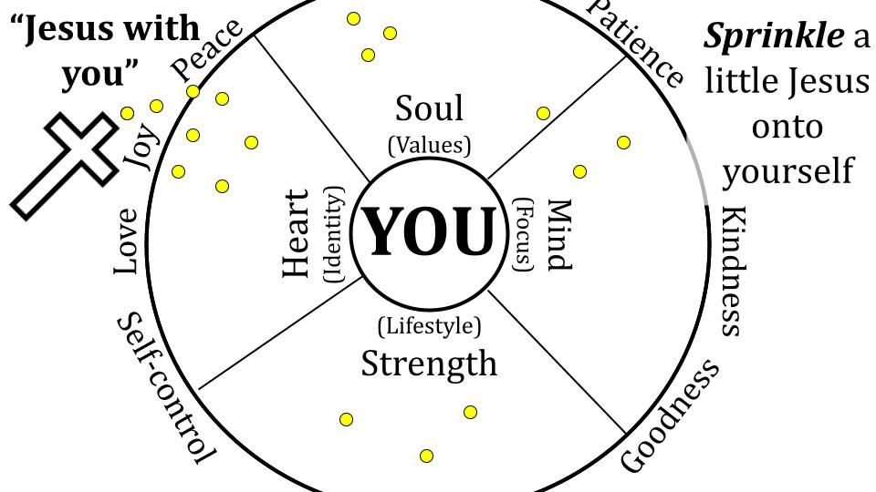
A lot of people take this approach with Jesus - trying to sprinkle a little of him into their lives. If you think about your heart, soul, mind and strength - you can see the danger of this thinking. You’re in control. You don’t have to give everything, just bits and pieces here and there. Yeah, I’ll add a little Jesus to my thoughts, a little to my values, a little to my lifestyle.

Is that what God wants of us? Again, that’s how it starts for a BABY Christian. As we grow, it should be more like this.
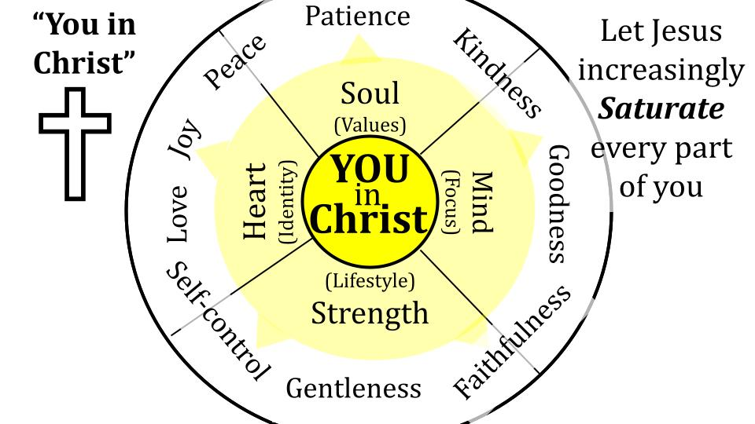
It’s not YOUR LIFE and YOUR HEART with a little Jesus on top. It’s all you are IN CHRIST. It’s SATURATION. Filling up every part of you with every bit of Jesus that you can. It’s centering your heart, soul, mind and strength in who you are in Christ.

This is what Paul is getting at in Romans 8 - walking in the Spirit, BEING in the Spirit. Shifting the belonging of who you are more and more to Jesus.

Which describes you better? Jesus with you? Or you in Christ? If you were honest about your life right now would you say that you are a SPRINKLER or that you really do BELONG to Jesus at the center of who you are? Are you letting Jesus fill more and more of you?

- Your Identity - Belonging more fully to Jesus
“But if Christ is in you, although the body is dead because of sin, the Spirit is life because of righteousness.” Rom. 8:10

Growing more and more into Jesus is a back-and-forth process of death and resurrection. The old you keeps dying more and more, the new you grows stronger and stronger. The body of flesh is dead because of sin - the old you is nailed to the cross, that’s not you anymore. The new you is in Christ, bound to His life, raised up and seated with Him in the heavenly places, as it says in Ephesians 2.

That’s who you ARE. That’s your identity. Belonging to Jesus. A life that is filled with the Spirit starts with activity, moves through identity, and increasingly shapes your MIND.

The Cycle of Spiritual Filling:
- Your Mind - Being more Focused on Jesus
“For to set the mind on the flesh is death but to set the mind on the Spirit is life and peace.” Rom. 8:6

Apart from Jesus people are in the flesh, that’s their identity, their condition, and therefore their mindset. Remember how it was before you committed to Jesus. You just went along with your desires - your activity, identity and behavior were all united around YOU. Just like a child. For kids, the center of the universe is the great I. Everything is about you, how you feel about it, how it affects you. Thinking of the needs and desires of someone else is difficult and is one of the main blessings of having more than one child - so kids can learn that there is at least one other person in the universe.

If you keep living like that, look at the results you can expect in verse 6. To set the mind on the flesh is DEATH. That’s the outcome. That’s the result that will come if you walk according to the flesh, if you are being according to the flesh and you set your mind on the flesh. That selfish, me-centered approach will eventually be the death of you. And it will happen spiritually before it happens physically.

I wish this were only a phenomenon for non-believers. But we can all think of long-time believers who have fallen back into the flesh and paid severe consequences for it. If I just consider friends of mine who were PASTORS - actually paid, full time ministers of the gospel - I can think of five who experienced the negative reality of Romans 8:6.
- One is in prison for sexual contact with a teenage girl.
- One was fired for embezzling over $10,000 from his church.
- Three had their wives leave them - leaving their kids and the church and just running off. I don’t blame the ladies in those cases btw - the guys bear the primary weight of responsibility for failing to love and care for their wives well.

My point is that even those of us who serve the Lord and the church in ministry every day can fall into the trap of selfish, sinful, flesh-oriented choices that bring discouragement, frustration and despair to our own families. I wish I could tell you that I’ve always done the right thing in this area and haven’t had my share of slips and falls - my stumbles and screw ups. But you’d just have to look over at Kristin and the boys to see them shaking their heads so I can’t get away with claims like that.

Thankfully it works both ways. Yes, the mind set on the flesh leads to death, but the mind set on the Spirit is LIFE and PEACE. The more we learn to walk with the Spirit and set our minds on God and His Word the more He will fill us and bring His life and love and peace and joy to us and others through us.

The Cycle of Spiritual Filling:
- Your Mind - Being more Focused on Jesus
“For the mind that is set on the flesh is hostile to God, for it does not submit to God’s law, indeed it cannot.” Rom. 8:7

One more negative picture of our condition apart from Jesus. Those who are in the flesh CANNOT please God. They are incapable. Why? Because their sinful, selfish flesh is actively in rebellion against God. They don’t submit to God’s righteous standards because they cannot. But let’s not end on a negative point.

The Cycle of Spiritual Filling:
- Your Mind - Being more Focused on Jesus
“Those who are in the flesh cannot please God. You, however, are not in the flesh, but in the Spirit.” Rom. 8:8-9

Paul goes to great lengths here to show the stark contrast between those who are in the flesh and those who are in the Spirit. He isn’t talking about super spiritual Christians in contrast with bad Christians. He’s talking about followers of Jesus in contrast with those who don’t follow Jesus.

And writing to believers in Jesus Paul helps them see who they are in Christ and all that we have in Him. To belong to Jesus by faith is to be united with the Holy Spirit forever. He lives in you and is with you all the time, every minute of every day. It’s not a question of if the Spirit is there it’s a question of whether you are walking with Him, whether you are setting your mind on Him, whether Jesus is becoming more and more central to your identity.

How is your spiritual gas tank today? Would you say you are at least half full? Or are you more of a half empty kind of person? What are the things that you do that help fill your tank spiritually?

Here is our lesson for today:

The Cycle of Spiritual Filling:
- Your Activity - Becoming more like Jesus
- Your Identity - Belonging more fully to Jesus
- Your Mind - Being more Focused on Jesus

These aren’t things you graduate from - but rather things you get better at, more natural like walking and talking. Like a familiar relationship.
- What’s a step the Holy Spirit is leading you to take? What’s a habit or behavior you know the Lord would have you commit to in this new year? What’s one characteristic of Jesus you know you need to grow in? What habits will help you grow in that area? Commit to take a step this week.
- What’s central to your identity? What makes you YOU? What, if you lost it, would be most devastating for you? Do you belong primarily to Jesus or does your heart really belong to your job or to another person or to some desire or dream of yours?
- What fills your thoughts? What is your mind set on? Is it the desires of your sinful flesh or is your mind filled with the things of God? What would help you set your mind more fully on Jesus and His kingdom?

As we gather around the Lord’s table today let’s take a couple of minutes to really reflect on these questions. Get the elements from the stations and come back to your seat. As you hold the bread and the cup - as you reflect on the body and blood of the Lord Jesus, given for you - think about how much of yourself you are really giving back to the Lord. Can you sincerely say that you are trying to give all you are to Jesus as Lord? If not, confess to the Lord the ways you’ve been holding out and holding back. And ask the Holy Spirit to show you one commitment you can make today and start walking differently this week.

Let’s pray.

