Be Fruitful
Romans 8:9-13

Today and next week we wrap up our short series on The Invitation.
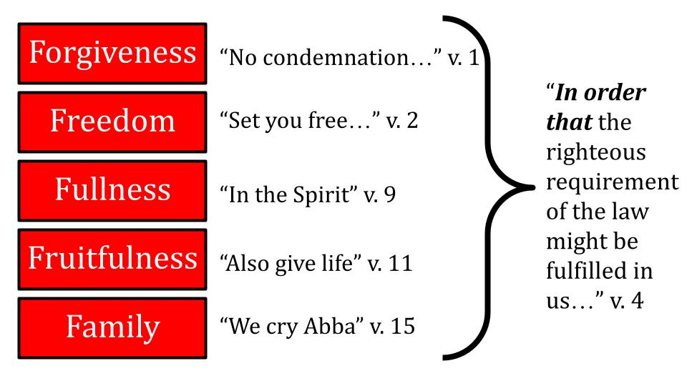
Last week we saw the PURPOSE of the five gifts God offers us in Christ is “in order that the righteous requirement of the law might be fulfilled in us.”

Think of how significant that purpose is. All that God expects of us - all that He requires of us - His standard in the Law He gave through Moses, which is perfection - can be fully realized in us. That’s what all of these gifts are for!

We are walking slowly through Romans chapter 8. Today we will drill down into this wonderful gospel word: RIGHTEOUSNESS. This is the word that changed history in the protestant reformation. Listen to Martin Luther:

“Though I lived as a monk without reproach, I felt that I was a sinner before God with an extremely disturbed conscience. I could not believe that He was placated by my [religious practices]. I did not love, yes, I hated the righteous God who punishes sinners, and ... I was angry with God.” Martin Luther

“As if, indeed, it is not enough, that miserable sinners, eternally lost through original sin, are crushed by every kind of calamity by the law of the decalogue, without having God add pain to pain by the gospel and also by the gospel threatening us with his righteousness and wrath!” Martin Luther

Luther understood the phrase “the righteousness of God” to mean only the holiness of God, or the righteous requirement of God. So, where Romans 1:17 says that the “righteousness of God” was revealed from heaven he took that to be a revelation of judgment, as if the light of God’s glory shone out from eternity to expose the wicked sinners who could not possibly live up to the holy standards of the Mosaic law.

This is what Luther, a Catholic MONK - understood by “the gospel.” He did not see any good news there - but only bad news that gave him great anxiety and depression over his own sins and the relentless demands of a holy God upon someone who could never pray enough, never learn enough Scripture, never make enough sacrifices, never do enough confession.

That is the product of RELIGION. You work and work. You stress and worry. You do all you can and then some because you feel the weight of God’s just requirement pressing down upon you. Some of us can relate to that at times in our “Christian” lives.
- Have you prayed enough?
- Have you read the Bible enough? Have you memorized enough?
- Have you given enough financially and to the right ministries?
- Have you served enough, really sacrificed, and invested enough time?
- Have you loved and cared for others enough?
- Have you shared the gospel enough - with enough people and assertively enough with the people close to you?

Do you see how - even when you take really good things like this - there is no such thing as “enough?” More is always possible, and if it’s possible then it must be required. You feel the weight of that! And you feel the pressure that wore down even this medieval German monk. If you’re honest you might even spill in your journal words like this, “I HATED the word the ‘righteousness of God.’” Luther goes on:

“Nevertheless, I beat importunately upon Paul at that place, most ardently desiring to know what St. Paul wanted… At last, by the mercy of God, meditating day and night, I gave heed to the context of the words, namely, ``In it the righteousness of God is revealed, as it is written, `He who through faith is righteous shall live.''' Martin Luther

Here was the breakthrough moment - the path to illumination through Romans 1:17. Did you see what Luther saw? The key phrase is right there - “through FAITH.” Not “through works.” Not through “sincere effort.” Not through disciplined religion. Through faith. Period. That’s it.

Luther BEAT on Paul. He studied Romans and Ephesians and Paul’s other writings. He pounded on them over and over until finally the light turned on. Don’t you love that phrase? “To see what Saint Paul wanted.” What a description of Bible study! Luke, what are you getting at here? David, what’s the point in this Psalm? John, why are you so emotional about this? James, does it have to be so black and white?

“There I began to understand that the righteousness of God is that by which the righteous lives by a gift of God, namely by faith. And this is the meaning: the righteousness of God is revealed by the gospel, namely the passive righteousness with which merciful God justifies us by faith.” Martin Luther

Here is the seed form of the reformation doctrine SOLA FIDE - faith alone. From this seed grew the entire protestant movement. From this tiny mustard seed of gospel understanding. But this was utterly different from the rock-hard slab of religion Luther had been believing. Nothing could grow from that rock. The gospel seed broke down the concrete of religion and exploded up into a tree of life and love and godliness and doctrine and church structures.

“Here I felt that I was altogether born again and had entered paradise itself through open gates. There a totally other face of the entire Scripture showed itself to me.” Martin Luther

Here is the understanding of the righteousness of God - yes, it is a requirement that God demands of us - but it is also a GIFT He gives to us in order to satisfy His own demand.

Do you feel that gospel truth like Martin Luther did?

The righteousness of God is both a demand and a gift. If you won’t receive the gift, then you must face the demand. But if feeling the force of that requirement brings you to your knees before the God of all mercy and grace you can receive the gift and find that the righteous requirement of the law has been fully met in you! With His righteousness Jesus also gives the power of God, the wisdom of God, the glory of God and every other spiritual blessing.

So, let’s beat on Paul here in Romans 8 and see what the apostle wanted. We will see three sides of righteousness, like three faces of a glorious diamond.

- The Gift of Righteousness - Justification
- The Fruit of Righteousness - Sanctification
- The Harvest of Righteousness - Impartation

When you first receive the gift of righteousness it is a tiny seed of faith, but that little seed immediately begins to grow in you like the mustard seed of the kingdom Jesus described. The seed of the gospel will always produce the fruit of the Spirit - love, joy, peace, patience and all the rest. And as that fruit grows in you it will produce a harvest of righteousness as the life of Jesus flows INTO You and through you to the world.

First, we see that righteousness is a gift.

- The Gift of Righteousness - Justification
“You, however, are not in the flesh but in the Spirit, if in fact the Spirit of God dwells in you. Anyone who does not have the Spirit of Christ does not belong to him.” Rom. 8:9

The two conditions of life Paul describes in Romans 8 are life in the Spirit and life in the flesh. All people are born in the flesh - his word for the sinful nature we inherited from Adam. This simply documents theologically what we all know experientially - that we are naturally selfish and drawn to the things of this world rather than the things of God.

The good news of the gospel is that you can be born again of the Spirit so your condition changes from being dead in sin to being alive in Christ. This recaps our series so far:

Gifts God Offers Everyone in Christ:
- Forgiveness (v. 1)
- Freedom (v. 2)
- Fullness (v. 3-11)

In Christ there is no condemnation because He experienced that condemnation for us on the cross. In Christ there is no more slavery to sin because the new law of the Spirit of life sets us free from the old law of sin and death that once controlled us. And in Christ we have the Holy Spirit of God living inside us, so we can experience the fullness of His love, power, direction, and glory if we take advantage of the FULLNESS CYCLE we discussed last week - engaging our activity, identity, and mindset toward the Spirit instead of toward the flesh.

- The Gift of Righteousness - Justification
“You, however, are not in the flesh but in the Spirit, if in fact the Spirit of God dwells in you. Anyone who does not have the Spirit of Christ does not belong to him.” Rom. 8:9

So here is the first side of righteousness for today - JUSTIFICATION. At the moment you put your faith in Jesus, you are declared righteous - justified. Jesus takes all of your sin upon Himself, and it is nailed to the cross with Him; and He takes all of His holiness and perfection and puts it on you like a glorious, radiant robe. You are no longer IN THE FLESH, but now live in the SPIRIT. You have entered the kingdom of God and now have a new identity and a new position before God.

You are no longer IN SIN, deserving condemnation, you are IN CHRIST, deserving COMMENDATION. Do you see that wonderful phrase at the end of verse 9? You BELONG TO Jesus by faith. You are His and He is yours. You can say it both ways: you are in Christ and He is in you. Go on to v. 10.

- The Gift of Righteousness - Justification
  - The Holy Spirit brings the life of Christ into your heart
“Anyone who does not have the Spirit of Christ does not belong to him. But if Christ is in you, although the body is dead because of sin, the Spirit is life because of righteousness.” Rom. 8:9-10

This is an important thing to understand about God. He can’t just look at a sinner and pronounce them forgiven. He wants to, but He can’t. It’s like making a rock so big He can’t lift it. It’s a spiritual impossibility because it would go against God’s just and holy nature to look at a sinful person and pronounce them forgiven and fit for heaven.
Many people today have this Santa Claus idea about God that there really is no naughty list - that, in the end, God will let everyone into heaven except maybe the really terrible axe murders and child predators and sadistic dictators. There are a few real baddies that we all agree shouldn’t make it in. But everyone else, people sort of hope God will grade on a curve and give a little wink and a nod and say, “Come on in.”

But pronouncing someone forgiven who is a selfish sinner who consistently wronged his wife, neglected his kids, was rude to his co-workers, harsh with his clients - not an axe murderer but just a run of the mill selfish person - pronouncing that person “forgiven” would be the declaration of a falsehood. And God cannot lie. He cannot tell a falsehood. God cannot be UNJUST. Being omniscient He cannot be unaware of sin. Being totally righteous He cannot ignore sin and leave it unpunished. Plus, God has said, hundreds of times in Scripture that He WILL punish sin - so God CANNOT break those promises, which would also make Him a liar.

Do you see the problem? As much as people might think they want a Santa Claus type grandfather in the sky who will just accept everyone and look the other way at sin, that is simply not the nature of the One True God as revealed in Scripture.

He cannot just forgive and accept everyone. UNLESS they come to Jesus in faith.

For a lot of things there is no silver bullet, no miracle cure. But when it comes to sin there is. His name is Jesus. And He can take away your sins. Every one of them. Forever. Sin is the cancer is that is killing you, killing everyone on this planet and destroying everything else in the process. That’s why Jesus came. That’s why he died on the cross: to pay the price of your sin and mine so we could be FORGIVEN.

So, look back at verse 10. IF Christ is in you - if you belong to Jesus by faith - the body is dead. Your old, sinful self was crucified with Jesus and its hold over you is broken. Why? Because of sin. Sin required a death. Jesus gave himself - He died for you. But for that sacrifice to apply to you, you also have to die. That’s what the Bible calls repentance. To really commit to Jesus in faith you have to let go of your old, sinful self by turning away from it and renouncing it.

So, the body is dead, but the SPIRIT is LIFE because of righteousness. Through that act of repentance and faith you are born again - you come to life spiritually and Jesus comes to live in your heart in the person of the Holy Spirit. And the Spirit of God can bring you the life of God BECAUSE OF RIGHTEOUSNESS.

Do you see the beauty of this truth? Because of the righteousness Jesus gives you in the moment of your justification - being declared righteous - the Spirit of God can give you life. Without that righteousness, no life. But because of that justification, God connects you with His own life and power and love and goodness and everything else. More could be said on this, but that’s what the last three weeks have been about so we will go on to the second side of righteousness, moving from justification to sanctification; from the seed to the fruit.

- The Fruit of Righteousness - Sanctification
  - The Holy Spirit grows Christ-like Character in you
“Although the body is dead because of sin, the Spirit is life because of righteousness.” Romans 8:10

The kingdom of God starts like a small seed - the tiny seed of faith takes hold of the life God offers in Jesus. And as soon as you receive the gospel by faith, that seed begins to take root in your heart, bringing the life of God into your mind, your emotions, your relationships, your day to day work - everywhere that you will let the Holy Spirit reign.

“The Spirit IS LIFE.” The gospel is the seed. The Holy Spirit is the water. Your heart is the soil. When a seed has good soil and regular water, what happens? It grows.

And as the life of God grows in you, FRUIT begins to develop.

- The Fruit of Righteousness - Sanctification
  - The Holy Spirit grows Christ-like Character in you
“But the fruit of the Spirit is love, joy, peace, patience, kindness, goodness, faithfulness, gentleness and self-control.” Galatians 5:22-23

Notice that it isn’t the “FRUITS” of the Spirit but rather the “FRUIT” singular. It’s a package deal. If you have the Holy Spirit, you get all of His love, joy, peace, patience and the rest. If you don’t have the Holy Spirit, you are stuck with the works of the flesh, your old body of sinful desires.

Do you see yourself growing in these areas?
- Are you more loving and generous than you were last year?
- Are you more joyful, more grateful, more filled with hope?
- Are you increasingly filled with peace instead of worry and fear?
- Are you more patient and understanding with others?
- Are you more disciplined and in control of yourself?

This is what the fruit of the Holy Spirit looks like IF we walk with Him. That’s what last week was about. A life of FULLNESS is what produces a life of FRUITFULNESS.

Remember we saw last week that the baptism of the Holy Spirit happens at the moment of salvation, when the Spirit of God comes to live in you forever. But the filling of the Holy Spirit is day by day, moment by moment. It is not automatic or guaranteed. You can live one day very full of the Spirit and the next day very distant from the Spirit of God.

It is possible to RESIST the Spirit to GRIEVE HIM, to ignore His leadings and harden our hearts against His conviction. It is possible to give the devil a foothold. Demons cannot possess a follower of Jesus, but they can harass us and make us ineffective and fruitless.

This is why the Christian life needs both offense and defense.

- The Fruit of Righteousness - Sanctification
  - The Holy Spirit grows Christ-like Character in you
“For if you live according to the flesh you will die, but if by the Spirit you put to death the deeds of the body, you will live.” Romans 8:13

DEFENSE means knowing our selfish, sinful inclinations and building the strength and assembling the resources to resist them. “Put to DEATH” the deeds of the body. That is not casual language. Fight sin. Kill sin.

Do you know your sinful habits and temptations? Because the first thing our sinful flesh does is that it HIDES. We can grow accustomed to our short temper or our self-focused attitudes or our quick impulse purchases or our lazy avoidance of the alarm clock.

This is why it’s so important to have 1-2 close Christian friends you meet with regularly - so you can share your struggles and pray for each other. And so you have a couple of other people to help you see your blind spots and keep growing rather than becoming complacent.

That is true on OFFENSE as well. It is easy for us to get in a rut with our spiritual disciplines. Maybe you’ve been reading the Bible for years but you’re not feeling close to the Lord, not feeling filled up with the Spirit, not making progress in your spiritual life. Maybe it’s time to mix things up and stay in one book of the Bible for a while; or just one passage like Romans 8. Maybe instead of reading a dozen chapters this week, just memorize one verse each day. Maybe instead of running through your standard prayer list of family and friends and their health concerns, download the 31 frontier people groups from the Joshua Project and pray for one of those every day. Maybe instead of reading on your phone you should get out an old paper Bible and make notes in it with a real live pen.

The point is to shake things up. And just as it helps to have a friend or two when you attempt a new diet and exercise program, it helps to have a friend or two when you attempt a new spiritual training program. Encourage each other! Challenge each other! And look at the promise in verse 11!

- The Fruit of Righteousness - Sanctification
  - The Holy Spirit grows Christ-like Character in you
“He who raised Christ Jesus from the dead will also give life to your mortal bodies through his Spirit who lives in you.” Romans 8:11

The very power of the resurrection is the same power that dwells in us, in the person of the Holy Spirit. And through that limitless power the Spirit of God will give LIFE and love and joy and peace to us as we walk with Him, set our minds on Him, build our identities on Him. That is the FRUIT of righteousness - our sanctification. We become more like Jesus in His character. Finally, we also become more like Jesus in His ministry.

- The Harvest of Righteousness - Impartation
  - The Holy Spirit leads you into Christ-like Ministry
“So then, brothers, we are debtors, not to the flesh, to live according to the flesh…” Romans 8:12

Before Jesus we were in debt with our sin - we all had unpayable fines against us. But Jesus paid all of that for us, releasing us from those debts forever. As a result, we have a new debt -to HIM. We owe nothing to our sinful flesh - there is no remaining obligation to sin. But we owe EVERYTHING to the Lord, who gave everything for us. Look ahead to verse 17.

- The Harvest of Righteousness - Impartation
  - The Holy Spirit leads you into Christ-like Ministry
“Fellow heirs with Christ, provided we suffer with him in order that we may also be glorified with him.” Romans 8:17

As children of God, we are heirs of His eternal kingdom - princes and princesses forever. But with that royal status comes significant expectations that we would live up to the family name. “PROVIDED we suffer with him.”

The call of Jesus is to “take up your CROSS daily and follow” after Him. Jesus promises everlasting comfort and joy, but in this life He says, “You will have tribulation.” The world hated our Master, of course it will hate us too.

One of the ways Jesus grows His character in us is through specific ministry assignments. We saw last week that activity comes first in the fullness triad. The Holy Spirit shows us a step to take and when we obey Him, when we follow His leading, we grow. When we resist or ignore His leading, He waits. Oh, the Holy Spirit is so patient. But He rarely gives a NEW assignment until we have fulfilled the previous one.

Often these assignments require that we make a sacrifice of some kind to help someone else. Maybe just giving up an hour to meet with someone you’d rather not. Or doing some little task in the house that you don’t enjoy. But sometimes they’re big, with long-lasting implications - like taking in a foster child or adopting.

I’ve shared recently how my parents liked to take in strays. They took in three foster daughters, two they later adopted. In addition, on two or three occasions we hosted a missionary family for their home assignment. The first time I think they had three kids. The second and third times they had five kids. And they stayed with us for the better part of a year when they came. My brother and I were not thrilled to have these little boys chasing us around all the time. The Lord led my parents to offer this kind of hospitality - and we all had some sacrifices to make.

Let’s keep things in perspective now. In the old days when missionaries left home and went off to serve the Lord overseas, they packed all of their possessions in a casket because sailing for 3-4 months to the other side of the world was a one-way trip and you weren’t coming back until you were dead. No facetime or zoom. Some letters that took months to get home and back. But the sacrifices were real and lasted for years if not for a lifetime.

Often our sacrifices are more along the lines of skipping a restaurant meal this month to sponsor a child with Global Fingerprints or being the one to take out the trash.

But those small acts of obedience grow us and help us experience the power of the Holy Spirit working in us and through us. There is a special fellowship when we share in the sufferings of Christ. And sometimes that means actual persecution. Sometimes it means that people will fuss at us or fuss about us.

Again, here in the U.S. we are not risking prison or death when we share about Jesus. Usually, the most we risk is a little awkwardness in a relationship with a neighbor, co-worker, or family member. Maybe they’ve said that politics and religion are off limits as topics. Don’t be obnoxious about it, but I have some people in my life like this and I just say, “Some things are too important to me to not talk about.” I don’t push things hard, but I try to gently bring up some spiritual topic and see if anything might have changed.
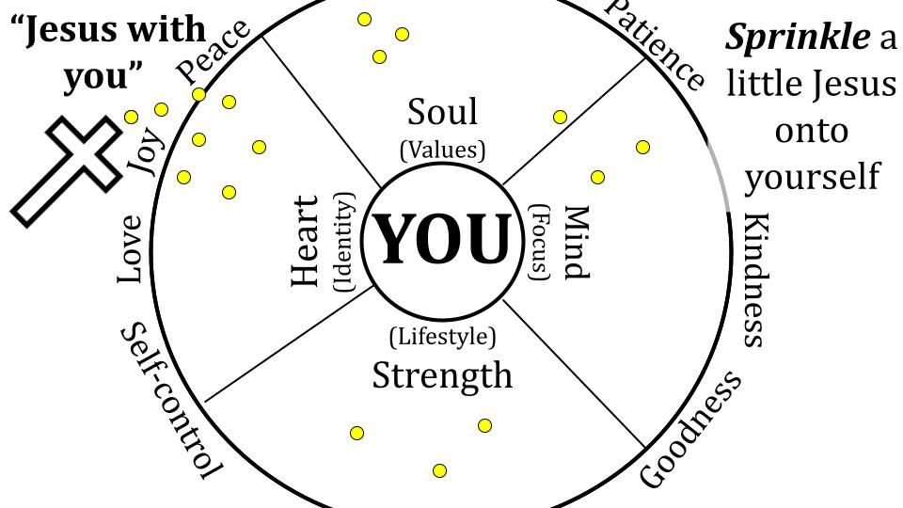
Last week we saw the shift from a JESUS WITH YOU approach to a YOU IN CHRIST attitude. Lots of people try to “sprinkle Jesus” into their hearts and lives. But they still remain in charge. They set the agenda and decide where to let Jesus rule and reign. But Jesus doesn’t want us to love Him with a little heart, a little of our minds, a little here a little there. He wants EVERYTHING.

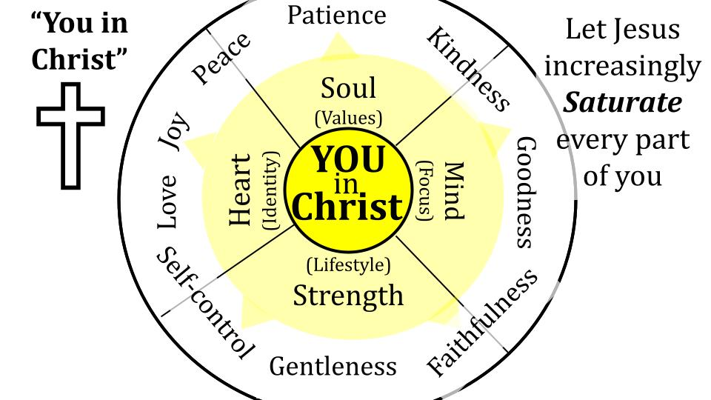
So we need to increasingly see ourselves IN CHRIST. As those who have been united with Him by faith, we should actively seek to let Him fill every part of us - heart, soul, mind and strength. Our goal is SATURATION with Jesus - that His life and love and character would increasingly grow in us and shine through us.
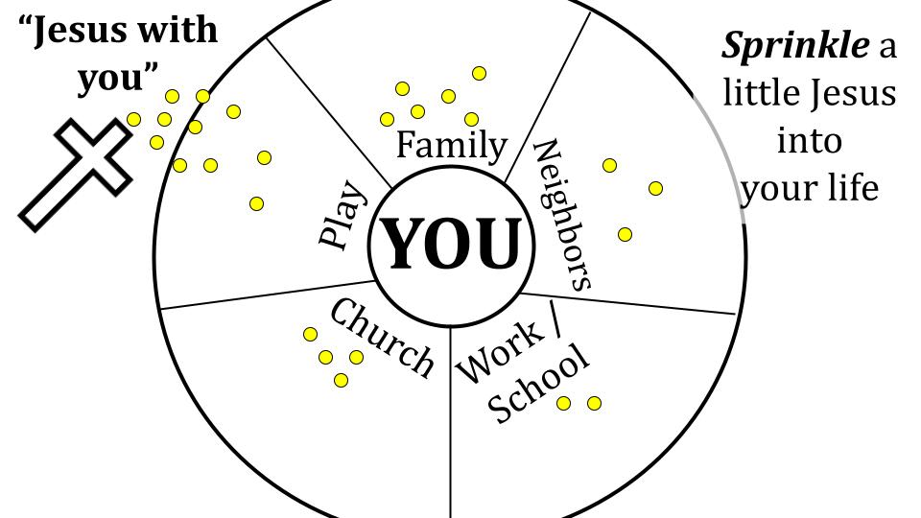
We need to make this same progression in ministry. Often, we can try to sprinkle a little Jesus into the various parts of our lives. Yes, we want Him with us - but only to a certain degree, only in certain doses at certain times. Again, it’s my agenda, my timing, MY LIFE. Yes, I bring Jesus to work sometimes, or to school. Yes, I want Jesus in my home and family, a bit here and there. Yes, I want to bring a little Jesus to my neighbors, but let’s not get carried away with that. Sure, I will let Jesus have a little say in my hobbies and my church involvement, but nothing to extreme or radical. Do you see the problem?

Living more and more IN CHRIST, should lead us to a missional lifestyle that is more and more CHRIST IN US.
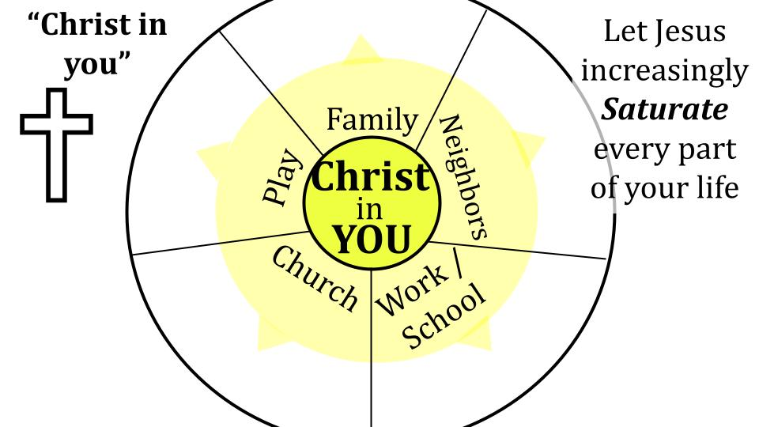
Again, the goal is SATURATION - that Jesus would fill every part of our lives as much as He possibly can. If Jesus had complete authority over your home and family, what would that look like? If Jesus 100% had His way with your career and work life, what changes would that require? If Jesus had free reign to direct you through His Spirit in your church involvement, your hobbies and relationships with friends, family, and neighbors, how would those interactions change and develop?

Character and ministry calling are inseparable. As the Holy Spirit develops the fruit of Jesus’ character in you, the Spirit will lead you to LIVE more and more the way Jesus lived, doing what He did. The love of Jesus is the most powerful thing on earth - when you really experience it, you really want to share it with others.

Whatever else the Lord may lead you to in ministry, we all need to keep praying. One of the ways we are most like Jesus is when we pray for other people. And there is a special fellowship in His sufferings when we sacrifice time and energy to intercede for people. This is what Jesus is doing non-stop right now. He lives to intercede for us and for everyone. He is at the Father’s right hand pleading for us right now.

When we pray, we join Him in that work. It’s hard. Prayer is hard for so many reasons. But if we want to be fruitful, we need to grow in prayer as we grow in all the other fruit of the Spirit.

So, let’s practice now for a couple of minutes. Ask the Holy Spirit for one name. One person you can pray for. And spend the next couple of minutes praying. If you want to use the prayer board and post a supplication the prayer team will join you in that prayer. You can see we’ve printed Philippians 1:9-11 in your worship program and it’s up on the screen as a guide for our prayers.

“And it is my prayer that your love may abound more and more, with knowledge and all discernment, so that you may approve what is excellent, and so be pure and blameless for the day of Christ, filled with the fruit of righteousness that comes through Jesus Christ, to the glory and praise of God.” Philippians 1:9-11

Take a couple of minutes to pray and I’ll close us.

