The Fruit of Connecting
Ephesians 5:15-21

Ok, we are going to try to cram all of Ephesians 5 into one message. It can’t be done, so you all have homework to do to study, meditate on and apply this whole inspiring chapter. If you’re single, focus on the first part. If you’re married, focus on the last part.
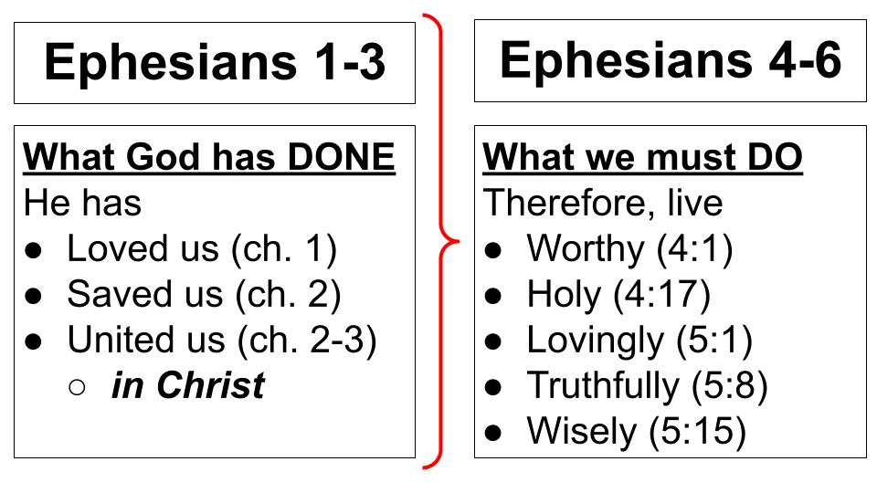
This chapter has the three remaining “Therefore, live” exhortations. “Walk in love” (5:1-2). “Walk as light” (v. 8) - not falling into error or led astray by deception but living in line with our true identity in Christ. And v. 15 “Walk as wise” not foolish, not wasting time, not getting drunk.

Three chapters of gospel truth lay the foundation for three chapters of gospel application. Based on all God has done for us in Christ - how He loved us and adopted us into His family; how He saved us from being dead in sin and made us alive together with Christ; how He tore down the dividing wall of hostility and united us into one body - Jew and Gentile alike. Based on all of this incredible gospel truth, THEREFORE, we must live differently. We must walk WORTHY of our calling. We must walk in holiness, putting off the old self and putting on the new self every day, with help from one another.

And today we see the call to walk in love, in light and in wisdom. We will focus in on the results of this gospel transformation in the passage we just read: four marks of a Spirit-filled, gospel-transformed church. Let’s dive right in.

The Marks of a Spirit-Filled Church:
- Worshipful Connection
“Be filled with the Spirit, addressing one another in psalms and hymns and spiritual songs.” Ephesians 5:18-19

We cannot fill ourselves with the Spirit - only Jesus can do that. But there are things we can do to seek the Spirit’s filling, or to prevent His filling. Paul’s prayer in Ephesians 3 shows us how to seek His filling - by experiencing the love of Christ in a deep and personal way, “How wide and long and high and deep is the love of Christ - to know this love that surpasses knowledge, and so BE FILLED to the measure of all the fullness of God.” It is significant that Paul PRAYS for this filling to occur - modeling for us the call to pray for each other even as we pray for ourselves to experience the fullness of the Holy Spirit.

And in chapter four we saw a series of instructions about relationships in the church, referring to how we speak to one another, forgive one another and build each other up - lest we “grieve the Holy Spirit,” by doing harm to a member of the body of Christ. It is possible to quench the Holy Spirit, to resist the Holy Spirit, and to harden our hearts to His still, small voice.

Let’s remember above all that the Holy Spirit is a PERSON, not a POWER to be manipulated. Yes, the Holy Spirit is fully God and therefore has all the power of the Godhead. But He is a person to know and love and trust and listen to, not a genie to appease and coerce and use for our own purposes.

So as we walk worthy of our calling in Christ, as we live out the gospel transformation Jesus won for us on the cross, we must learn to WALK WITH the Holy Spirit, listening to Him and following His leading so we can increasingly be filled with the fullness of God in terms of His character and fruit growing in us and in terms of our awareness of His presence with us.

What follows the command to be filled with the Spirit are five participles. Quick grammar lesson. The “-ing” ending shows that “addressing one another” modifies that primary command to be filled. It has some of the force of a command but it’s significant that Paul presents these five participles as RESULTS and as a package. If we are filled with the Spirit, we will increasingly do these things. These are the signs or marks of a Spirit-filled life and a Spirit-filled church.

We will connect with each other in worshipful ways. Our conversation will consistently give praise and glory and honor to the Lord Jesus.

- Worshipful Connection
  - Exalting Jesus through sanctifying interaction
“Be filled with the Spirit, addressing one another in psalms and hymns and spiritual songs.” Ephesians 5:18-19

This may sound a little odd, but I bet you’ve known people like this - the praise of Jesus is always on their lips. They are quick to say, “Praise the Lord,” or “Hallelujah” which is the Hebrew for PTL. They love to pray with you and always start their prayers with gratitude and worship.

Obviously, this applies to our formal gatherings, but the phrase, “addressing one another” is more about common speech and daily interaction than formal worship. We should be such “people of the book” that Psalms and hymns and spiritual songs are in our thoughts and on our lips.

It’s like your mom always told you - what you put into your mind is what will come out of your mouth - “garbage in, garbage out.” What are we filling our minds with? A quick litmus test for what is in your heart is to watch what comes out of your mouth. If your thoughts and words are filled with anger and bitterness, with resentment and mean gossip - what does that tell you about your heart?

Do you see the wisdom of how Paul instructs us here? He doesn’t say, “Force worship into your daily language artificially. Fake it until you make it. And then, if you do it long enough, you’ll at least LOOK LIKE you’re filled with the Spirit.” He says, “Be filled with the Spirit” and you will see these things growing in you - you will see your daily conversation be more about Jesus.

As a quick aside, it is significant that in this vivid description of being filled with the Spirit and the comparable one in Colossians 3, “Let the word of Christ dwell in you richly,” neither passage makes any reference to speaking in tongues. If Paul expected unknown languages or private prayer languages to be used in regular church interaction, we might have expected him to say so in places like this.

I am not saying it’s wrong to speak in tongues or to have a private prayer language - many of my closest pastor friends in town are more charismatic in their personal experience and church culture. But I am saying that Paul’s teachings on tongues are very explicit - if someone speaks in an unknown language in a public gathering it MUST BE INTERPRETED or it will confuse everyone present - both believers and non-believers. Much of what is thought of as the gift of tongues is actually the practice of a private prayer language and people have simply not been well trained that such a prayer language should be used in PRIVATE. In public, Paul says, it’s better to speak one word people can understand than 1,000 words they cannot understand. You might be edified by connecting deeply with the Holy Spirit in groans that words cannot express, but the people around you won’t be edified because they cannot understand your groanings.

I don’t share this so we can be critical of people who worship Jesus differently than we do, but so we can be more understanding. When I hear someone “speaking in tongues” in a public prayer gathering or worship service I truly don’t judge them, I give thanks that they are trying to worship and seek the Holy Spirit in the best way they can, as they have been taught. I think of it like listening in on their private prayer conversation with the Lord and that attitude lets me rejoice with a brother or sister who is rejoicing, or to mourn with a brother or sister who may be mourning.

And that is really what Paul is getting at here - our relationships with one another should be marked by worship - they should exalt the Lord Jesus whether we are rejoicing or mourning. This doesn’t mean that when you see someone who has just lost a loved one you should be all “If you’re happy and you know it clap your hands…” There is a discernment side to all relationships. But just sitting with someone in their grief, just being with them and reading some Scripture - eventually - and praying FOR THEM and later praying WITH THEM can be a wonderful act of both love and worship.

Our mouths speak out of the overflow of our hearts. What is your heart overflowing with? That will show you what you really love. The more we know Jesus and experience His love, the more THAT will fill us and overflow in our conversations. Look back at the beginning of the chapter.

- Worshipful Connection
  - Exalting Jesus through sanctifying interaction
“Walk in love… But sexual immorality and all impurity… must not even be named among you as is proper among saints.” Ephesians 5:2-3

Paul calls us to be imitators of God, as His beloved children, and to walk in love as those who have been bought by the blood of Christ. Then he strongly warns against a specific threat to our relationships: immoral, impure TALK. The behavior is obviously ruled out as well, which becomes clear down in verse 5 and 8 and so on. But the specific danger here is having people TALK ABOUT impure things because that talk is contagious. Such things must not even be NAMED among us.

- Worshipful Connection
  - Exalting Jesus through sanctifying interaction
“Let there be no filthiness nor foolish talk nor crude joking, which are out of place, but instead let there be thanksgiving.” Ephesians 5:4

It may seem like a joke to make fun of your husband or wife or to casually appreciate the physical features of a man or woman to whom you are not married - but we must remember that our words have power to build up or to tear down. And we must be careful not to tear down or trip up our brothers and sisters in Christ. Rather, we should redirect such interactions to thanksgiving and worship and the Word of God.
Our relationships should have a SANCTIFYING, purifying effect on us - moving us increasingly to love and treasure and worship Jesus. That is the first mark of a Spirit-filled church - worshipful connection. Second:

The Marks of a Spirit-Filled Church:
- Joyful Devotion
  - Enjoying Jesus in personal communion
“Singing and making melody to the Lord with your heart.” Ephesians 5:19

Paul starts with our words but moves quickly to the heart. If we don’t mean the words they will ring hollow to the people around us and certainly also to the Lord. These first two marks are closely related and they mutually reinforce each other. What we talk about will affect what we love and what we love will affect what we talk about.

Does your heart SING to the Lord? I’m not talking about music necessarily. Some of you are musical and naturally sing throughout the day. Some of us are less musical and our hearts sing in other ways. I was really helped several years ago by a book called Sacred Pathways by Gary Thomas.

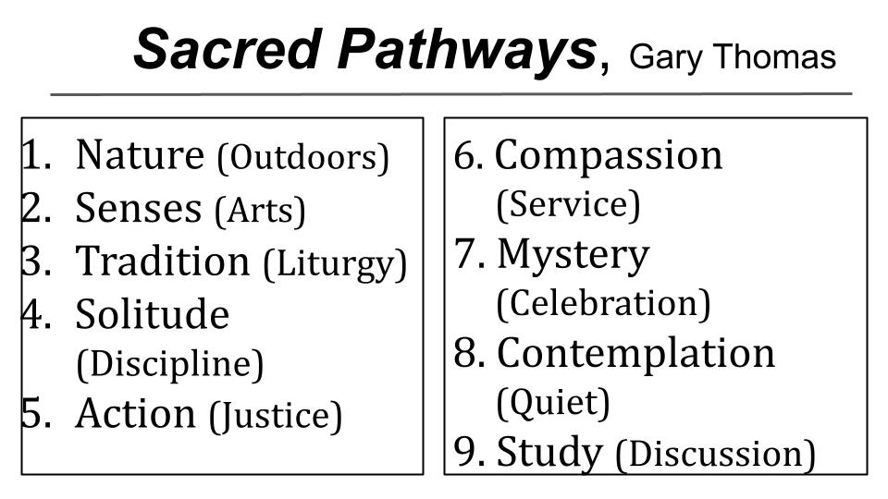
Thomas describes nine different ways Christians throughout history have connected more closely with Jesus. Everyone can benefit a little from all of them, but you will naturally gravitate to 2 or 3. The point is not to get hung up on how your mom or favorite hero was close with Jesus - but to figure out how YOU feel closest to the Lord.

Some people love to be outside, while others find it very distracting. Some love incense and artwork, unleashing all of their senses in worship. Some enjoy ancient traditions and liturgies, written prayers and seasonal practices. Some appreciate extended times of silence and solitude along with strict disciplines. Others are activists who feel closest to God when they are working for a cause, fighting for justice. Some are caregivers who love Jesus by loving the least of these. Others enjoy mystery and dreams and visions and stories of miracles and divine intervention. Some are blessed by contemplative, resting prayer and spiritual breathing and other exercises that quiet the mind and allow you to focus in on the Lord. Finally, some love to study - they love books and theology and the detailed analysis of Bible passages.

Thomas concludes by saying that your heart is a GARDEN - and you must TEND TO IT.

“We were made to love God… Each of us stands before an open plot of land. God will search heaven and earth to provide us with what we need to plant and maintain a beautiful garden of love, intimacy and fellowship with Him.” Gary Thomas, Sacred Pathways p. 223

Learn your favorite pathways and don’t look down on people for theirs. Learn from others but lean into the ways God has uniquely wired YOU to connect with HIM. As Richard Foster said so well in his classic book A Celebration of Discipline, the hallmark of the disciplines is JOY.

The Marks of a Spirit-Filled Church:
- Joyful Devotion
  - Enjoying Jesus in personal communion
“Singing and making melody to the Lord with your heart.” Ephesians 5:19

God wants your heart to SING with His praises. He wants you to delight in Him, to enjoy deep and personal communion with Him. Skye Jethani’s book With is a great resource to explore your heart and motivations for spending time with the Lord. He calls us to grow from COMMUNICATION with God to COMMUNION with God.

Often our prayer and Bible times can be very TRANSACTIONAL - study the Word, get a verse or two - say your prayers, check off the list. We try to communicate with God, but rarely feel we are COMMUNING with Him. As one of our elders is fond of saying, “Quality time happens in the midst of QUANTITY TIME.”

Jethani quotes a contemplative prayer leader from centuries ago describing the process of prayer like this.

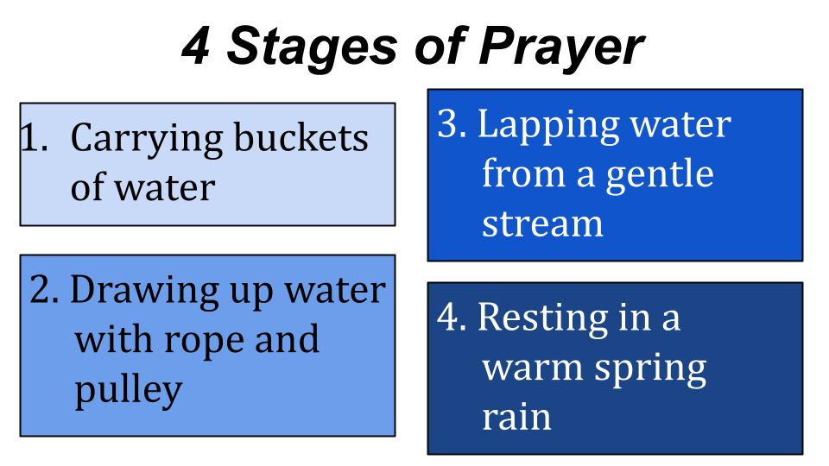
Prayer usually starts feeling like WORK - like hauling buckets of water. It’s heavy. It’s tiring. It’s not super rewarding. You know you need the water. But the effort and struggle cause many people to give up after just a minute or two.

Eventually there is a shift and you feel it get a little easier, like you’ve got a rope and pulley by the well. You aren’t just carrying the water, now you can drink a little of the goodness of God and shift from work into worship. Stage 3 you feel a movement from you exerting all the effort to feeling the shepherd lead you to streams of water that He has provided. You aren’t trying to manufacture anything now, you are more able to rest and receive. And sometimes you experience stage 4 - if only briefly - where the rain of God’s love and grace falls on your heart and mind and you simply bask in His goodness and glory.

The best single piece of advice I can give you for drawing closer to God is to USE SCRIPTURE. Don’t just READ the Bible, learn to PRAY THE BIBLE. Don’t just study the words on the page, learn to meditate on them, to turn them slowly over in your mind. It helps me a lot to write a verse out, visually. I know the ladies have offered a class before about artistic Bible journaling, where they get all the colored markers and pens and bedazzle a verse. Have at it.

The point is to find YOUR WAYS of drawing closer to the Lord so your heart SINGS His praises. Share with one or two others the things that help you draw near to God so He can draw near to you. Try something new. And don’t kid yourself that you can accomplish the same thing in 5 minutes as you can in an hour, or in half a day. Sometimes it can take an hour to move through each stage of prayer.

As we are filled with the Spirit we will see worshipful connections and joyful devotion. Third:

The Marks of a Spirit-Filled Church:
- Grateful Integration
  - Thanking Jesus for Everything
“Giving thanks always and for everything to God the Father in the name of our Lord Jesus Christ.” Ephesians 5:20
Is this comprehensive enough for you? ALWAYS and for EVERYTHING. Even hardship? Yep. Even when you’re in prison, Paul? Yep. Even when you’re about to be executed in Rome just for being a Christian? ALWAYS. For everything. No - he can’t mean that, can he? Well, he says it the same way in 1 Thessalonians.

- Grateful Integration
  - Thanking Jesus for Everything
“Rejoice always, pray without ceasing, give thanks in all circumstances; for this is the will of God in Christ Jesus for you.” 1 Thessalonians 5:16-18

Not only should we give thanks in all circumstances, but we should REJOICE always. Pray continually. Give thanks always and for everything - THIS IS THE WILL OF GOD for you.

We wrestle with knowing and doing “God’s will” don’t we? Well, we don’t need to. It’s right here. GIVE THANKS.

God is good. (You say - All the time). All the time (you say - God is good).

I learned that at camp. It’s an example of worshipful connection and joyful devotion. It may not feel true for you right now, but it IS true. God is good even when life is hard. He is doing something in you and around you. You just can’t see the finished work. The sculptor has the right to use the hammer and the chisel, doesn’t he? The potter has the right to mold the clay and doesn’t usually consult with the clay as to what the clay might prefer at this moment in terms of moisture levels and heat levels, right?

The Marks of a Spirit-Filled Church:
- Grateful Integration
  - Thanking Jesus for Everything
“Giving thanks always and for everything to God the Father in the name of our Lord Jesus Christ.” Ephesians 5:20

This is INTEGRATION - it is incorporating every part of life into one. It is living wholehearted, not half-hearted; not divided. We often compartmentalize, giving thanks for SPIRITUAL things but secretly being angry about many other parts of our lives.

Are you INTEGRATED? Do you have INTEGRITY? We always hope our buildings do, right? If a building lacks integrity the joints and I-beams and nails and screws and what-not are not all fitted together as strong as they should be and in high winds or in an earthquake, certain parts will fail, and the whole building may collapse.

Jesus said the same thing is true for us - regarding whether or not we hear His words and DO THEM. That is integrity. That is character. That is wisdom. That is how to have a life built on the solid rock of King Jesus. We gratefully and joyfully surrender ALL OF LIFE - every single part of it - to His sovereign rule. We are, after all, His Creations - so the Creator has all the rights of use, doesn’t He? We are, as well, His Subjects - He is our Lord, we are His Servants, and the King has all the rights of leadership, doesn’t he?

Let’s pause for a moment right now and just give thanks. Take a few deep breaths and breathe in the goodness of God and breathe out your gratitude. God is good - all the time… All the time - God is good.

Pause.

One more mark of a Spirit-Filled Church.

The Marks of a Spirit-Filled Church:
- Mutual Submission
  - Honoring Jesus by Serving His Bride
“Submitting to one another out of reverence for Christ.” Ephesians 5:21

When we are walking with the Spirit and filled with the Spirit, He changes everything. He changes our hearts and minds and totally changes our relationships. This verse swings into a household code where Paul addresses husbands and wives, children and parents, slaves and masters. And that’s the point - the gospel changes EVERYTHING - it impacts every part of our lives, every relationship.

And what those relationships look like is mutual submission. Feel the impact of this verse. “Submitting to one another out of reverence for Christ.”

Notice what it does not say:
- Submitting to one another when the other person is in the right.
- Submitting to one another when you are feeling good and everything is generally going your way.
- Submitting to one another when you have plenty of time and energy.

We could go on. The point is to BE LIKE JESUS - who knelt to wash His disciples’ feet. The Ultimate Master lowered Himself to the place of the most menial servant. If our Lord and Master served us so sacrificially, how ought we to serve one another?

This is what Jesus asked of His disciples - No, it’s what he COMMANDED them - “Love one another.” That’s the assignment. “As I have loved you,” (and remember, I JUST washed your feet), “that is how you are to love another.”

This is not at all the way of the world or our culture. We are trained to be assertive, not submissive. The type A, go-getter, close the deal, win the day type person is the one who gets all the awards and recognition. The one who defers and who steps back, who avoids the spotlight and is content to serve rarely gets a mention or a minute in the video montage.

Paul’s immediate application is to marriage so let’s go there for a minute. Our english translation says “Wives, submit to your husbands” but the word SUBMIT isn’t actually there. It’s carried over from verse 21. So the command is “submit to ONE ANOTHER” and then is applied to wives, children and slaves. “Wives, to your husbands; children to your parents; slaves to your masters.”

This is truly profound if we process it correctly. Husbands and wives are to submit to ONE ANOTHER mutually and joyfully and reverently in the Lord. Neither is to be selfish or manipulative, taking advantage of this expectation on the other - both is to be generous and sacrificial, seeking to outdo the other in love and good deeds. But God knows that submission is the harder calling for wives to husbands, for lots of reasons - so the command anticipates our need, and illustrates the beautiful structure of AUTHORITY God has placed into the family and into society.
Wives who freely and joyfully submit to their husbands, with unconditional respect, will find their husbands more loving and affectionate because - as Emerson Eggerichs teaches in the Crazy Cycle videos - respect is the oxygen to a man just as love is oxygen to a woman. So ladies, if you want love the coin you purchase it with is respect. Men, this doesn’t get you off the hook for loving your wives even if they aren’t always respectful. If you want to win her respect, the coin you purchase it with is love. PROVE IT. Unconditionally.

How can you provide truly unconditional love or respect?

Only if you are having all of your needs met by Jesus. Only then. But if you are filled with the Spirit, guess what? The Holy Spirit of God is meeting all of your needs according to His glorious riches - and your husband or wife can benefit from the overflow.

The same principles apply to parents with their children and bosses with their employees. Our overall attitude should be one of MUTUAL submission - seeking to honor and serve Jesus by loving and serving people in His name and for His glory.
- Those of you with children, do you serve and care for them sacrificially or do you yell at them and try to get them to serve and cater to you?
- Those of you with employees, do you seek to serve and love and bless them or just squeeze out of them every bit of productivity you can?
- Those of you with friends, do you strive to use them and make them listen to you and take care of you or is it your goal in every relationship to give and give and love and serve?

Especially within the church, we are called to love and serve and SUBMIT because we are caring for the BRIDE OF CHRIST. At the end of his teaching on marriage Paul has this striking line where he says, “I’m not even talking about marriage anymore, this is about CHRIST AND THE CHURCH.” What?!?

Your marriage is not about you and your spouse - it’s about Jesus and His Bride. Husband, you are preparing your wife for her real wedding day to King Jesus, when our Lord and Bridegroom comes back for us. Wife, same deal - you are helping your husband prepare for his real wedding day, he too is part of the Bride of Christ and your job is to help present him to Jesus without blemish or spot or wrinkle, without any stain of selfishness or sin.

Parents, you are preparing your kids for their spiritual wedding day. Just as you prepare your daughters to be beautiful, pure, loving, respectful brides - so you need to prepare them for the day they meet Jesus face to face. Just as you prepare your sons to be strong, holy, loving, humble servant leaders for their wives, so you need to prepare them to be men of faith and love, of passionate devotion and prayer, who treasure Jesus above all things.

Leaders, you are preparing everyone in your influence for their final exam - the real one that matters most when they will answer to King Jesus for everything they have done and said and thought, or have failed to do or failed to say. Not many of us should dare to be teachers or small group leaders or bosses - because we will be judged more strictly. Woe to us if we cause even one of these little ones to stumble!

Here is our summary for today:

The Marks of a Spirit-Filled Church:
- Worshipful Connection
  - Exalting Jesus through sanctifying interaction
- Joyful Devotion
  - Enjoying Jesus in personal communion
- Grateful Integration
  - Thanking Jesus for Everything
- Mutual Submission
  - Honoring Jesus by Serving His Bride

Each of us should be defined by these things and growing in them, and increasingly our whole church should look this way.
- Our words and our interactions, our relationships should be more and more filled with WORSHIP. The goodness and glory of Jesus should be on our lips.
- He will be on our lips because increasingly he is on our hearts. We sing and make music in our hearts to Him because Jesus is our greatest treasure, our deepest delight. And we share that passion with one another.
- The tone of our meetings and our relationships then is gratitude and joy. We learn to give thanks always and for everything and to help each other do so as well. Even when it hurts; especially when it’s hard - we help each other, comforting one another as the Lord has comforted us.
- And we learn more and more to submit. We let the hard, stubborn, selfish OLD ME die and wither away and let the new ME in Jesus, the humble, loving, sacrificial me grow up and flourish and take over. We don’t insist on our own way but follow the way of Jesus who humbled himself and went all the way to the cross for us.

That’s what a Spirit-filled church looks like. That’s a church I want to be a part of, don’t you?

Let’s pray that the Lord would make this more and more true of us here at Oakwood!

