**Just Obey (4/21/24)**

**Discussion Questions**

**Summary:** James shows us what true religion - real saving faith - looks like. There are three tangible marks of a genuine follower of Jesus: 1) you manage your emotions and words; 2) you actually love people (especially the most vulnerable) and; 3) you win the battle against temptation and sin. In the end it’s not about what you know or what you say, it’s about what you *actually do*. If James were here today he might well say, “You want to follow Jesus? Just do it.”

*“But be doers of the word, and not hearers only, deceiving yourselves.”* James 1:22

**Three Signs of Genuine Faith in Jesus:**

1. You manage your emotions and **Words** (v. 19-20,26)
2. You actually **Love** people (v. 22-25, 27)
   * Start with orphans and widows
3. You **Win** the battle with temptation and sin (v. 21, 27)
   * By daily **Receiving** God’s Word (v. 21b, 25)
   * By actively **Obeying** God’s Word (v. 22-24)
   * By deliberately **Resisting** your sinful desires (v. 21a)

**S.** Lord, what do you want to **Say** to me?

**O.** How would you have me **Obey** your Word?

**S.** Who can I **Share** this with?

**Get Started:**

1. Do you remember the original Nike “Just do it” campaign? What do you remember? How did it make you feel? Why?
2. What is the difference between what our culture means by “just do it” and what James means in this passage?

**Dig In:** Read James 1:9-27

1. What stands out to you in this passage?
2. Why do you think James opens this section with our words and relationships (v. 19)? What does anger reveal in our hearts? (v. 20)
3. What is “the implanted word” in v. 21? How do you receive that word “with meekness”?
4. What does the mirror illustration communicate (v. 23-24)? How does the Law of God (the Old Testament) serve as a mirror for us (v. 25)?
5. What does our treatment of the weak and vulnerable (v. 27) reveal about us?

**Move Forward:**

* We did an S.O.S. in the service Sunday. Did anyone hear something specific from the Lord in that time or since then? How is the Lord leading you to obey this passage?
* With whom have you tried to share these principles and practices? How has that gone?

The whole point of this series is to “be doers of the word and not hearers only, deceiving” ourselves. So let’s practice the S.O.S. exercise.

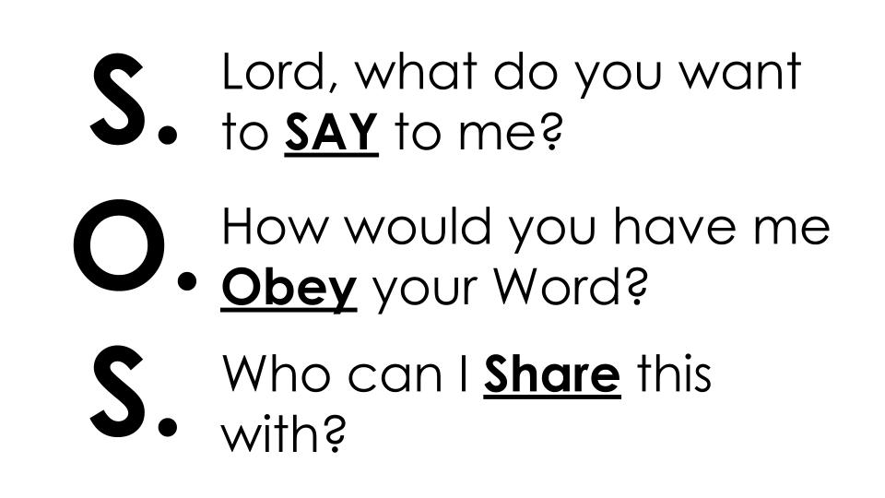

Have someone set a 3 minute timer and everyone take 3 minutes with this passage open in front of you to pray and ask the Lord these three questions.

You may want to break into micro-groups of 3 to share how the Lord is leading you.

* Be sure someone writes down what is shared so you can encourage each other throughout the week and touch base next week on how it went.
* Take some time to pray for one another, to have the wisdom and strength to be *doers of the Word* and not hearers only.