Just Rejoice (4/7/24)
Discussion Questions

Summary: We’ve called this whole series, “Just do it,” based on James 1:22 - “But be doers of the word and not hearers only, deceiving yourselves.” A Christian life of obedient, fruitful faith begins with a new perspective that is able to rejoice in suffering. And that new perspective becomes a call to prayer. Be encouraged and challenged as we begin our “just do it” journey, cultivating the obedience of faith!
“Then he went home, and the crowd gathered again, so that they could not even eat. And when his family heard it, they went out to seize him, for they were saying, ‘He is out of his mind.’” Mark 3:20-21 (see Jn. 7:3-5)

A New Perspective:
- Rejoice when you face challenges (v. 2)
  - Because God is your Owner (v. 1)
  - Because testing helps you Grow (v. 3)
  - Because endurance leads to Maturity (v. 4)

A Call to Prayer:
- Ask for wisdom (v. 5)
  - Because God is Generous and the source of all good things (v. 17)
  - Because God is Faithful (v. 6)
  - Because this world is not your Home (v. 1,7-8)

Get Started:
- Share about a time you have been on rough waters (literally, in a boat with choppy seas). Why were you there? How did it feel? How did it work out?
- How has your life felt that way recently? What have been the unexpected bumps and challenges that have come your way?

Dig In: Read James 1:1-8
- What stands out to you in this passage?
- Why does James call us to rejoice in our sufferings? What good results come from difficult situations?
- What does it mean to be “single-minded”? How does James describe the “double-minded” person?
- What does this passage teach us about God?

Move Forward:
The whole point of this series is to “be doers of the word and not hearers only, deceiving” ourselves. So let’s practice an exercise called an S.O.S.
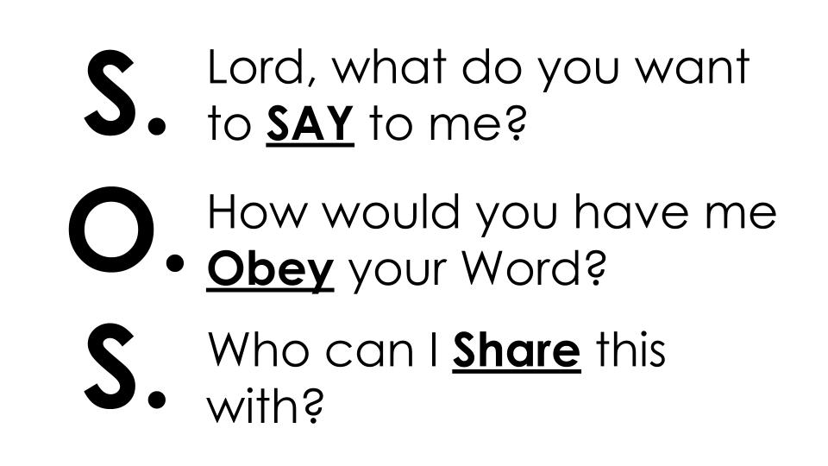
Have someone set a 3 minute timer and everyone take 3 minutes with this passage open in front of you to pray and ask the Lord these three questions.

You may want to break into micro-groups of 3 to share how the Lord is leading you.

- Be sure someone writes down what is shared so you can encourage each other throughout the week and touch base next week on how it went.

“Everyone then who hears these words of mine and does them will be like a wise man who built his house on the rock. And the rain fell, and the floods came, and the winds blew and beat on that house, but it did not fall, because it had been founded on the rock. And everyone who hears these words of mine and does not do them will be like a foolish man who built his house on the sand. And the rain fell, and the floods came, and the winds blew and beat against that house, and it fell, and great was the fall of it.” Matthew 7:24-27

- Take some time to pray for one another!

