**Abide**

John 15:1-5

Last week we gave out the ***Spiritual Life Worksheet*** as a tool we are starting to use regularly at Oakwood. It is a way for you to work out with the Lord how you can draw close to him this fall and live more fully in line with His will for you.

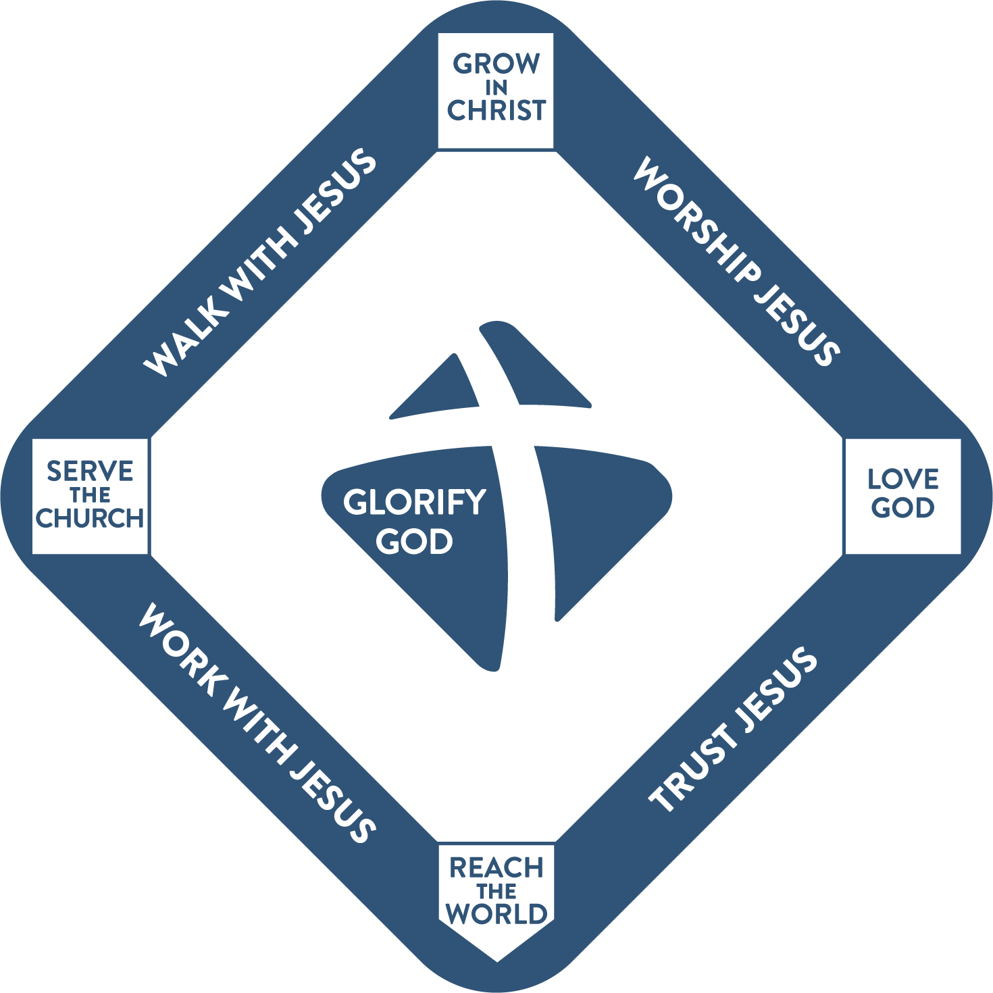

You can see we use this baseball diamond to visualize **our discipleship pathway**. First, it conveys that all believers are “in the game.” Christianity is not a spectator sport. Jesus wants followers, not just fans. And the baseball analogy is helpful because everyone knows the goal is not to get on first base and just stand there forever. You want to keep moving around the bases. And everyone knows that baseball games never end. You just keep playing and playing.

What we added with the spiritual life worksheet is the internal, ***Spirit-empowered MOTIVATION*** to run the bases. What fuels our love for God is that we know Him and therefore TRUST Him. You can’t get into the game of discipleship in the first place if you don’t place your faith in Jesus. And in every season of life we have to continue to fix our trust and confidence in the Lord. In turn, our love for Jesus should be expressed in WORSHIP. Not just attending services, but a life of worship, enjoyment and passionate devotion to the Lord Jesus. This is what moves us to grow more and more into His image and likeness – that He is the supreme treasure of our hearts and focus of our minds.

Growing in Christ is about walking daily with Him in a living relationship. It is about listening to the Holy Spirit as you read God’s Word and responding in obedient faith, which will move you to serve the church and increasingly join God’s work of transforming the world through the gospel.

In a couple of weeks, we will introduce a ***verbal commitment*** we invite you to make together with us. We are giving everyone time to prayerfully work through this little worksheet so the commitment has personal meaning for everyone and is not just a rote set of statements.

**Our Spiritual Life Commitments:**

* We will trust Jesus completely
* We will worship Jesus passionately
* We will walk with Jesus faithfully
* We will work with Jesus diligently

You can see on the worksheet itself there is a little more clarification for each statement. So ***take the next couple of weeks to pray*** about this as you study John 14 and 15 and invite the Lord to speak to you. After you finish writing out your commitments, **meet with one or two other believers** to share with each other and encourage each other. That step is critical as it will help you clarify your own plans, prompt some additional ideas and set you up to have ongoing accountability and support to FULFILL your commitments.

As everyone knows who has ever made a new year’s resolution – if you don’t ***share your goals and plans*** with a couple of other people; and ideally work on them together, you won’t stick with them for very long. The same is true of spiritual disciplines and a rule of life. You certainly need to reach an agreement with your spouse, if you’re married, and to consider your stage of life, the age of your kids, your work schedule right now, etc.

Ok, let’s come back to John 15, which is the main inspiration for the spiritual life worksheet. Look at verse 5.

“I am the vine; you are the branches. Whoever abides in me and I in him, he it is that bears much fruit, for apart from me you can do nothing.” John 15:5

There is the key word: **ABIDE**. We abide in Jesus. He abides in us. Then we bear much fruit, as we are connected with Jesus, the life-giving vine. Apart from Him, we don’t bear fruit, and in fact we can’t accomplish anything of value.

There’s ***a serious tone to this passage***, as we study the first five verses of chapter fifteen. On the one hand there is a wonderful invitation into the full life of Jesus – to be united with Him in living faith and filled with the fruit of His Spirit.

On the other hand, there is a warning that we all need to hear about living independently from Jesus. “The branch cannot bear fruit unless it abides in the vine.” And branches that don’t bear fruit are broken off and thrown away.

It feels to me like Moses at the end of Deuteronomy as he sums up the Law of God and the choice before God’s people.

“See, I have set before you today life and good, death and evil. If you obey the commandments of the Lord your God that I command you today… then you shall live and multiply, and the Lord your God will bless you… But if your heart turns away, and you will not hear, but are drawn away to worship other gods and serve them… you shall surely perish. I call heaven and earth to witness against you today, that I have set before you life and death, blessing and curse. Therefore choose life, that you and your offspring may live, loving the Lord your God, obeying his voice and holding fast to him, for **he is your life.**” Deut. 30:15-20

We saw the last couple of weeks, in John 14, that ***God’s love language is OBEDIENCE***. Like any Father with his children, the sign of love for God is obedience to Him. And Jesus did not change that. He confirmed it. “If you love me you will obey my commands.”

The reason for this is not that God is a harsh task-masker and rule maker. It is that God knows the best thing for us is HIM. ***He is our LIFE***. Jesus is the vine. If we stay close to God and walk with Him, things will go well. If we ignore God and grow distant from Him, we will shrivel up and wither away on the inside. So He commands what is best for us. And we must choose.

***Do we choose life? Do we choose blessing?*** Do we choose Jesus and abide daily in Him?

Or do we choose death and curses? Do we choose to drift away from Jesus and gradually disconnect from Him?

This part of John 15 is an exhortation to find in Jesus your life, your cleansing and your heart’s true home. **Three gifts** that can only be found in Him.

**Find in Jesus:**

1. The Source of **Life**, now and forever

“I am the true vine, and my Father is the vinedresser.” John 15:1

Some of you are into gardening, I’m sure. I’m just glad if my lawn is green. Yes, it’s mostly weeds, but that only bothers me if the weeds have those grabby little seeds that get all over the dog’s legs. Those weeds I seek and destroy. The rest, if they’re green, we get along peacefully.

All that to say, ***I’m not that familiar with gardening*** much less operating a vineyard. I like grapes as much as anyone and certainly appreciate grape juice and grape soda and sparkling grape juice and other products that come from grapes.

But seeing God as a gardener and Jesus as a vine is out of my usual world. I’m no more of a shepherd than I am a farmer, but ***seeing God as a loving shepherd*** who leads the sheep and calls them to follow and picks them up when they fall and even whacks them a little with his stick - is more familiar.

Seeing God as a gardener who prunes the vine and breaks off fruitless branches seems harsh. Not as warm and fuzzy as the shepherd. But there are important principles involved that I learned from some articles online.

<https://lancaster.unl.edu/hort/articles/2005/prunegrapevines.shtml#:~:text=The%20purpose%20of%20pruning%20is,growth%20for%20the%20following%20season>.

<https://yardandgarden.extension.iastate.edu/how-to/how-prune-grapevines-home-garden>

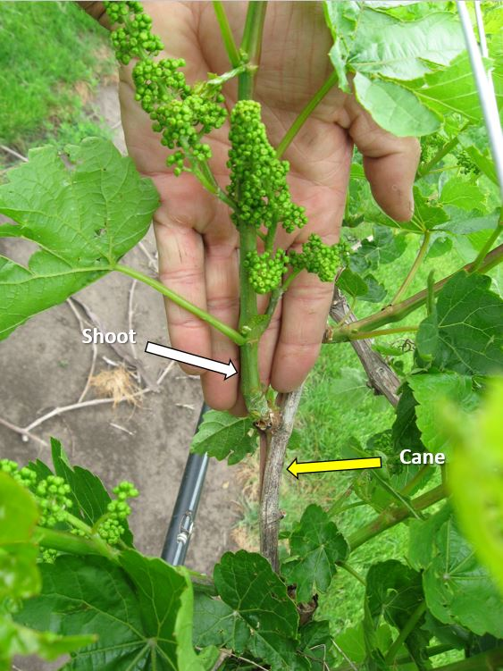

***The goal of the vinedresser is to maximize yield.*** Grapes produce clusters from the previous season’s growth. Two-year-old shoots won’t produce anything, they are just in the way. For large, healthy grape clusters, the vinedresser has to trim away around 90% of the previous season’s canes and buds so the remaining 10% get adequate nourishment to grow large clusters.

Think of that. If you are tending a grapevine, in the offseason ***you need to prune away 90% of the shoots from the last year*** to give the remaining canes and buds the best opportunity to produce large, juicy clusters.

90%.

***I wonder what is in the way of our growth in the Lord.*** Is it possible that 90% of our time, schedule, priorities, and possessions are in the way of our growth in Him?

“People are just too busy to live emotionally healthy and spiritually rich and vibrant lives… Love, joy and peace are the triumvirate at the heart of Jesus’s kingdom vision… And all three are incompatible with hurry.” *The Ruthless Elimination of Hurry*, John Mark Comer

***John Mark Comer was as successful as you can be*** as an American pastor. His church grew by 1,000 members every year for its first seven years. He was invited to speak at the big conferences, he was featured in the magazines. But do you know what you concluded? You can gain a large church and forfeit your soul. You can be successful as a pastor and utterly fail as a follower of Jesus.

John Mark was withering up inside as he was racing from meeting to meeting, from event to event. Until, in desperation, he called his friend and mentor John Ortberg. Ortberg shared a conversation he had had years before with Dallas Willard. Willard is one of the gurus of Christian spirituality. He told John Ortberg:

“If you want to be all you can be for Jesus, *you must ruthlessly eliminate hurry from your life.”* Dallas Willard

A nice sentiment, right? The word ruthless is well chosen here. It won’t be easy.

Think of what PRUNING is. ***You need sharp shears.*** You cut away the dead wood but also living shoots in order to make room for the remaining canes to produce new buds and new, super fruitful shoots.

For maximum life, there must be death. There must be REDUCTION. Trimming. Pruning. Verse 2.

**Find in Jesus:**

1. The Source of **Life**, now and forever

“Every branch in me that does not bear fruit he takes away, and every branch that does bear fruit he prunes, that it may bear more fruit.” John 15:2

***Do we really believe that JESUS is the true source of life?*** Do we really believe that He is the vine? Or, if we’re honest, do we believe that OTHER THINGS will give us the happiness and security we long for? Have we bought into the marketing schemes of modern America? Do we, deep, down believe the American gospel that more stuff will make us happier? More. More. More.

***The Christian life is a constant pruning away*** of dead, sinful things that weigh us down AND of good, living things that are not sinful but are still in the way of the best things. It is so true that the enemy of the best is not the worst, but the good. As Steven Curtis Chapman said 20 years ago, we are “playing Gameboy sitting in the middle of the Grand Canyon; eating candy sitting at a gourmet feast.”

“For many of us the great danger is not that we will renounce our faith. It is that we will become so distracted and rushed and preoccupied that we will settle for a mediocre version of it. We will just skim our lives instead of actually living them.” John Ortberg (in *Ruthless Elimination of Hurry*)

Hurry. Busyness. Corrie Ten Boom said, ***“If the devil can’t make you sin, he’ll make you busy.”*** Our lives often feel like one unrelenting sequence of DISTRACTIONS and demands.

* Why couldn’t you make it to the worship night last Tuesday? Oh, just too busy.
* Why haven’t you had a quiet time in two weeks? Life is just so busy.
* Where were you last Sunday for worship service? Had a bunch of things to catch up on.
* We haven’t seen you at small group for a while, everything ok? Oh yeah, just a lot going on right now.

Sound familiar? I bet it does because it’s ***how we are wired in modern life***. It’s all we know. If you haven’t read Comer’s book, I really recommend both Ruthless Elimination and his new book Practicing the Way. Very powerful exhortations to examine our lives and PRUNE – trim away the dead wood and the excess activity to make room for what matters most.

**Find in Jesus:**

1. The Source of **Life**, now and forever

“Every branch in me that does not bear fruit he takes away, and every branch that does bear fruit he prunes, that it may bear more fruit.” John 15:2

Let’s pause here and feel the force of verse 2. This is a serious warning from King Jesus. Fruitless branches are taken away. What does that mean? He explains it more in verse 6.

**Find in Jesus:**

1. The Source of **Life**, now and forever

“If anyone does not abide in me he is thrown away like a branch and withers; and the branches are gathered, thrown into the fire, and burned.” John 15:6

Is this a reference to SALVATION? Yes. Unmistakably yes.

It’s not that you lose your salvation, it’s that you aren’t really saved. You never were. The sign of true, living faith in Jesus is FRUIT. If there is no fruit in your life – no growth in love, joy, peace, patience… no service to others, no worship or ministry – then you are not a follower of Jesus. You are just playing a game. Just kidding yourself and others.

A lot of Christians refer to **the parable of the Sower** as a way of justifying fruitless seasons of life. Remember, the Farmer cast seed on the hard path, the rocky soil and the thorny soil. The seed on the path couldn’t grow at all because the ground was so hard, the birds just ate that seed. In the rocky soil, there was some initial growth, it looked good at first. But Since the soil was shallow the plant didn’t last long, but withered in the sun. Same with the thorny soil, the plant tried to grow but was choked to death by “the cares of life and the deceitfulness of wealth.”

If you think to yourself, ***“I’m just rocky soil or thorny soil,”*** what you are concluding is that you are not really a follower of Jesus. You might have made some kind of profession of faith when you were younger. Your faith might have looked real for a minute. But if the cares of life and the deceitful promises of wealth have choked your faith and prevented any fruit from growing in your life, then you were never really connected to the vine called Jesus.

There’s another kind of soil, called **GOOD SOIL**. That’s the person who is saved. That’s the one who has been changed by Jesus, who has the Holy Spirit and is producing FRUIT. Maybe a smaller yield. Some fields produce 30 times what was sown. Others produce 60 or 100 times what was sown.

But all good fields produce FRUIT. All good branches on the vine produce GRAPES.

***What is the fruit growing from your life?***

Have you found in Jesus your true source of life and joy and blessing? Or if you’re honest, are you trying over and over ***to abide in this world***? Are you tapping your roots into money and romance and family and possessions and success and reputation and business…?

A lot of church-goers want Jesus as a source of life FOREVER. ***They want that ticket to heaven.*** They certainly don’t want that scary place called hell. But they don’t really want Jesus as their source of life NOW. Not yet. Maybe a little later. For now I want to chase after girls or guys… I want to get that first million… I want to get that next raise… We have to save for that nice house… We really need that nice vacation…

So we chase and we chase, from one mirage in the desert to the next. It’s always just over the next ridge; just around the next corner. “If the devil can’t make you sin, he’ll make you busy.”

How busy are you? How much is your life defined by hurry and hustle?

***Are you ready to drop out of the rat race and ABIDE in Jesus?*** He IS the source of life. But abiding in Him doesn’t happen automatically. You have to ruthlessly eliminate hurry from your life. You have to prioritize your relationship with Jesus above everything else.

And that will involve pruning.

**Find in Jesus:**

1. Forgiveness and **Cleansing**, initially and ongoing

“Every branch that does bear fruit he prunes, that it may bear more fruit.” John 15:2

Jesus is the source of life now and forever. He is the bread of life and the living water. He is the true vine. The second gift Jesus offers is GRACE: forgiveness and cleansing. The word for “prune” is the same word as “clean.”

**Find in Jesus:**

1. Forgiveness and **Cleansing**, initially and ongoing

“Already you are clean because of the word that I have spoken to you.” John 15:3

***Jesus “cleaned” his disciples by preaching the good news*** of the kingdom to them. They heard and believed and were forgiven for all their sins and changed from the inside out. The Word of Jesus - the gospel - is what enables us to be forgiven and washed clean in the first place. As soon as you hear and believe, calling on Jesus to save you, you are CLEAN. Forgiven. Free. Washed. Spotless. Justified.

But the saving work of Jesus doesn’t stop with that sinner’s prayer. He will keep cleansing you, keep pruning you, ***keep shaping you until you are PERFECT.*** The initial work of salvation is called justification. That happens at the moment you first call on the name of Jesus. And at that same moment begins the process of SANCTIFICATION that will continue your whole life as the Father prunes, the Spirit convicts and the Lord Jesus cleanses you from all unrighteousness.

Romans 8 says, “Those he predestined he also called, those he called he also justified, those he justified he also glorified.” God never stops working in us. His love is relentless. Determined. C.S Lewis calls it INEXORABLE. Unstoppable. Sometimes it feels intolerable because pruning is painful. It is not comfortable to be pruned. Parts of us are cut away.

“You asked for a loving God: you have one. The great spirit you so lightly invoked, the ‘lord of terrible aspect’, is present: not a senile benevolence that drowsily wishes you to be happy in your own way… but the consuming fire Himself, the Love that made the worlds, persistent as the artist’s love for his work and despotic as a man’s love for a dog, provident and venerable as a father’s love for a child, jealous, inexorable, exacting as love between the sexes.” C.S. Lewis, *The Problem of Pain*

Four analogies of love in the genius of C.S. Lewis.

* An artist’s love for his work. Never finished. Always perfecting.
* A man’s love for his dog. Cannot tolerate a role in dead fish. Will not allow annoying habits to continue. Trains the dog.
* A father’s love for his child – cannot be merely kind and tolerant, but must discipline, must correct, must rebuke.
* And the love between husband and wife – that will tolerate no rival, that demands everything in order to give everything.

If we can conceive INEXORABLE, determined love in those examples, can’t we imagine that God’s love for us is even higher, more relentless than that? “You asked for a God of love. You have one.” “God has paid us the intolerable compliment of loving us, in the deepest, most tragic, inexorable sense.”

To these examples Jesus adds that of a gardener.

**Find in Jesus:**

1. Forgiveness and **Cleansing**, initially and ongoing

“Every branch that does bear fruit he prunes, that it may bear more fruit.” John 15:2

***How is God pruning you right now?*** He “whispers in our pleasures, speaks in our conscience, but he shouts in our pain. Pain is his megaphone to rouse a deaf world.” God will not leave us content in our sin and neglect of Him, the Great Good of our souls.

So He prunes and trims. He cuts and chisels. He is determined to make us HOLY. To make us like Jesus in every way. Perfect. Sanctified. One more Lewis quote – you would like to be a comfortable little cabin but ***God is making you into a palace*** because He intends to live there Himself.

So if your suffering has advanced to higher degrees it may mean that your love is maturing. Consider painful pruning an honor. God sees the fruit in you and wants to see more.

I bet most of us would be ***glad to grow out of our childish sins***, our fleshly immorality and worldliness – and think God would be content with that progress. Certainly it’s a good step to take. Let’s not stay in the traps and cesspools of this world, indulging our selfish desires with pornography or the female version of it – shopping. An alternate expression of female selfishness: criticism. One more, I’ve heard is a thing: gossip.

I wonder if a lot of us do the work of getting those visible sins to be mostly managed, at least out of sight most of the time. We don’t cuss and swear anymore (in public). We don’t say unkind things very often; we don’t lose our tempers (much). We see a pretty girl walk by and we don’t do the full head and body turn, we just note the event and move on. We see the “sale” sign but stick to our shopping list. We hear the start of a juicy story, but guide the conversation elsewhere.

***But for most of us, growth stops there.*** We’ve gone from being children to being teenagers or young adults. But God wants us to keep growing; to keep maturing; to keep producing more and better fruit. So he keeps pruning. He keeps watering. He keeps fertilizing.

Now, let’s pause here and give thanks for the fruit we do see. I don’t want to be overly critical here. Look at the fruit of the Spirit:

“But the fruit of the Spirit is love, joy, peace, patience, kindness, goodness, faithfulness,gentleness, self-control; against such things there is no law.” Galatians 5:22-23

If you see any of these in your life, think of each one as a nice, ***juicy cluster of grapes.*** Picture God Himself testing those grapes, feeling their ripeness. Eventually, plucking the cluster and enjoying each grape, one by one. He sees your love. He sees your heart. He enjoys your joy in Him, your worship, your devotions. He appreciates your peace and patience, your willingness to wait and endure and not fully understand. He admires your kindness and thoughtfulness, the way you serve other people. He acknowledges your goodness and how difficult it is to be upright and godly in this dark and immoral world. He sees your faithful giving and praying and ministry on that committee. He smiles at your gentleness to young children, grandkids, preschoolers in Treehouse. He is thrilled by your progress in self-control. He remembers you as a middle schooler and, like a good parent, he sets his hand on your shoulder and says, “I’m so proud of who you are becoming.”

***Celebrate the fruit God is growing in you.*** That’s why He is pruning you – because He sees such good fruit. One more gift.

**Find in Jesus:**

1. Your Heart’s True **Home**, to rest and remain

“Abide in me, and I in you. As the branch cannot bear fruit by itself, unless it abides in the vine, neither can you, unless you abide in me.” John 15:4

Here is the heart of this whole message in John 14-17. Abide. Dwell. Remain. Live. Abide is the best English translation because it means both dwell and remain. Remain by itself just means “stay put.” Abide is more homey. ***Live there.*** Make this your heart’s true home.

And notice it isn’t just where we live – it’s where JESUS lives too. We dwell in Him; He dwells in us.

You are a branch needing the nourishing sap of the vine. Drink in His love, His goodness, His grace, His power. Abide in Him.

**Find in Jesus:**

1. Your Heart’s True **Home**, to rest and remain

“I am the vine; you are the branches. Whoever abides in me and I in him, he it is that bears much fruit, for apart from me you can do nothing.” John 15:5

This is our memory verse because it restates and summarizes the whole section. Rest in Jesus. Remain there. Now and forever. Focus your heart and mind on the Lord Jesus. Remember that He lives in you in the person of the Holy Spirit. Listen to the Spirit. Obey the Spirit’s leading.

And you WILL bear much fruit. Both in terms of character growth and ministry impact.

Squeeze your hands together real tightly. Imagine you have a grape seed in there. Now come on - really concentrate. ***Make a grape***. Go. Come on. I’d freak out up here if one of you suddenly opened your hand and there was a grape. [I show a grape in my hand.]

We all know this much about gardening - you can’t just make a grape appear suddenly even if you have a healthy grape seed. That seed needs **the right conditions** to germinate, grow up into a stalk and produce fruit. It needs soil and fertilizer, water and sunshine and a good bit of TIME.

***What do you need to grow up in Christ?***

* You need time alone with the Lord. Time in God’s Word. Time in prayer.
* You need time with other believers. You need some good Christian friends to meet regularly with for encouragement and prayer and the application of Scripture.
* You need to worship in ways that fill your mind and heart with the gospel and the glory of God.
* You need to KNOW JESUS - to know what He is like and to know Him personally.
* You need to walk with Jesus - to faithfully live for Him each day.

This is our summary for today:

**Find in Jesus:**

1. The Source of **Life**, now and forever
2. Forgiveness and **Cleansing**, initially and ongoing
3. Your Heart’s True **Home**, to rest and remain

**Then you *will* bear Fruit**

***Jesus is the VINE*** - the source of life both now and forever. Jesus is the Savior - the One who can forgive your sins and purify you from all unrighteousness. He can pronounce you justified and do the work of sanctification in you day after day. And Jesus is the true resting place of your heart. He is what your soul longs for. So learn to live with Him – to dwell in Him. To remain with Him throughout the minutes of your day.

Nicholas Herman was born in 1611 in rural France. Raised by poor farmers, Nicholas joined the army to be sure of regular meals and served in the army for the 18 years. In the middle of that time he had a spiritual awakening while looking at a barren tree in the winter. He knew it would blossom again in the spring, but at that moment it looked dead, like he felt. Suddenly he felt hope in the God of creation, the God of renewal who brings life to the spiritually dead.

In the course of the 30 years war Nicholas was injured and walked with a limp the rest of his life. He tried to serve as a valet and a footman, but found he was “a great awkward fellow who broke everything.” So he followed his uncle into a monastery in Paris where he served as a cook for most of the next 30 years, until his death at the age of 80. He became well known throughout the region for his simple but deep spirituality and his way of “doing everything for love.”

“This brother forgot himself and was willing to lose himself for God… he no longer thought of virtue or his salvation... he had always governed himself by love without interest.” about Nicholas Herman

Nicholas chose to remain a lay brother in the Carmelite order, not advancing in rank. Even when he worked to repair sandals, when he couldn’t stand to serve in the kitchen, he continued to walk around barefoot.

"We can do little things for God; I turn the cake that is frying on the pan for love of him, and that done, if there is nothing else to call me, I prostrate myself in worship before him, who has given me grace to work; afterwards I rise happier than a king. It is enough for me to pick up but a straw from the ground for the love of God." Nicholas Herman

Of course, we don’t know him as Nick. We know him by his monastery name, Brother Lawrence. The Bishop who described him in the quote earlier conducted four interviews with Nicholas toward the end of his life and gathered every letter they could find from him and put that together in the book we know called *Practicing the Presence of God.*

“The time of business does not with me differ from the time of prayer; and in the noise and clatter of my kitchen, while several persons are at the same time calling for different things, I possess God in as great tranquility as if I were upon my knees at the blessed sacrament.” Brother Lawrence, *The Practice of the Presence of God*

***Nicholas learned to ABIDE.*** He learned to make GOD His true home. He lived as if there was no one but Him and God in the world and did everything for the love of God.

"Men invent means and methods of coming at God’s love, they learn rules and set up devices to remind them of that love, and it seems like a world of trouble to bring oneself into the consciousness of God’s presence. Yet it might be so simple. Is it not quicker and easier just to do our common business wholly for the love of him?" Brother Lawrence, *Practicing the Presence of God*

Oh brothers and sisters, may we learn to walk with Jesus like this! He is the source of life – the true vine. He is our Savior, who forgives and cleanses us, purifying us from all unrighteousness. And Jesus is our dwelling place. He lives in us and in Him we live and move and have our being. Let’s pray.