**Spiritual Life at Oakwood (5.0)**

*“I am the vine; you are the branches. Whoever abides in me and I in him, he it is that bears much fruit, for apart from me you can do nothing.”* John 15:5, ESV

**OUR DEFINITION OF SPIRITUAL LIFE:**

The love of Christ compels us to bring glory and honor to His Name. As those transformed by His graceand filled with His Spirit, we seek to join God’s work of spreading the love and truth of Jesusto every person and place we possibly can.

**OUR COMMITMENTS:**

1. ***We will trust Jesus completely***
   * through enduring, Biblically-grounded faith

John 15:1-11

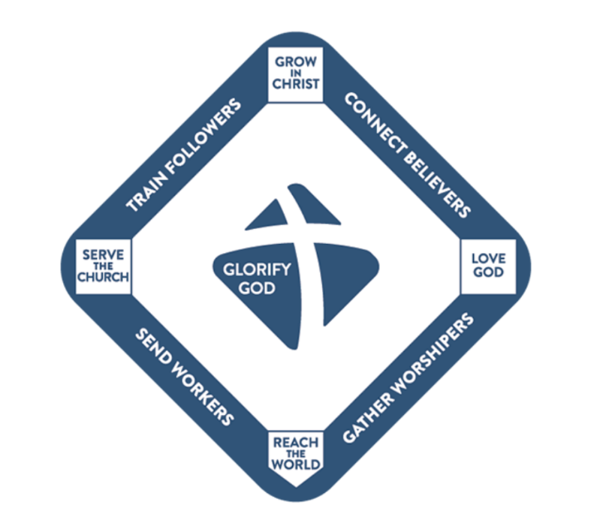

**Worship Jesus**

1. ***We will worship Jesus passionately***

**Walk w Jesus**

* + through joyful disciplines that prioritize quality time with Him

Deut. 6:4-9

1. ***We will walk with Jesus faithfully***

**Trust Jesus**

**Work w Jesus**

* + through Spirit-empowered, relationship-enhanced formation

Eph. 4:17-24

1. ***We will work with Jesus diligently***
   * through gift-developing, world-changingkingdom service

Isaiah 61:1-11

Our mission is to join God in His work

of transforming people and communities

through the gospel of Jesus Christ

**Spiritual Life Worksheet**

Use this page to prayerfully establish your “rule of life” for the next few months – the habits and rhythms that will help you draw close to Jesus and live in fruitful kingdom service. Consider time-honored practices like Scripture reading, meditation, and memorization; quiet, contemplative prayer in addition to intercession; Sabbath, solitude, retreats, fasting; service, generosity, hospitality, witnessing, etc. This exercise will be enhanced with one or two other believers to help you discern and clarify God’s will for you and will enable you to be an encouragement to them.

**MY COMMITMENTS:**

1. ***I will trust Jesus completely***
   * through enduring, Biblically-grounded faith
   * How are you? How is your heart?

**Love God**

_______________________________________________________________________

_______________________________________________________________________

1. ***I will worship Jesus passionately***
   * through joyful disciplines that prioritize quality time with Him
   * How is your time with the Lord? What might help you draw closer to Him?

**Grow in Christ**

______________________________________________________________________________________________________________________________________________

1. ***I will walk with Jesus faithfully***
   * through Spirit-empowered, relationship-enhanced formation
   * How is the Lord shaping you right now? How could you cooperate more fully with this formation process?

_______________________________________________________________________

**Serve the Church**

_______________________________________________________________________

1. ***I will work with Jesus diligently***
   * through gift-developing, world-changingkingdom service
   * Where do you see the Lord working around you? How could you join Him?

_______________________________________________________________________

**Reach the World**

_______________________________________________________________________