The Bowls of Justice
Revelation 16:1-21

The book of Revelation has been building to this moment. The seventh seal on the scroll was opened, which activated the seven trumpets. The seven trumpets were sounded, and the last one activated this outpouring of seven bowls. This is the full and final justice we celebrated last week in chapter fifteen with another worshipful interlude:

“Then I saw another sign in heaven, great and amazing, seven angels with seven plagues, which are the last, for with them the wrath of God is finished.” Revelation 15:1

This book shows us what the final justice of God will look and feel like. It’s hard to fully understand what all the symbols mean, but what is crystal clear is that the enemies of God will get what is coming to them in the end. We’ll see in chapter 20 that every individual will get perfect justice based on the books that are kept in heaven documenting all that is said and done. Here as the bowls of God’s wrath are poured out we see God’s global justice.

That’s the brief summary of the whole book and our lesson for today: God’s perfect justice is coming… in force. People can ignore these warnings. They can downplay the message, pointing to the symbolic nature of these visions. But however you choose to interpret the bowls, it is clear they are about God’s wrath and judgment against evil.

With these seven bowls “the wrath of God is finished.” We’ll hear a loud shout from heaven today saying, “It is done.” Just as Jesus shouted from the cross that atonement was finished, so Jesus will shout from heaven that JUSTICE will be finished. On that great Day of the Lord – when the last trumpet sounds.

We will see the three PURPOSES for God’s perfect justice: to unmake the world, unmask the beast and unveil God’s power. First.

God’s Perfect Justice is Coming:
- To unmake the world for the Evil that fills it
“Then I heard a loud voice from the temple telling the seven angels, ‘Go and pour out on the earth the seven bowls of the wrath of God.’” Revelation 16:1

Seven angels. Seven bowls. The number of completion. Seven last plagues. Seven terrible judgments to bring history to an end and bring evil to its knees. We will need two more chapters to zoom in on God’s justice coming against the immorality of Babylon and the injustice of the kingdoms of this world. But now the bowls are poured out.

God’s Perfect Justice is Coming:
- To unmake the world for the Evil that fills it
“So the first angel went and poured out his bowl on the earth, and harmful and painful sores came upon the people…” Revelation 16:2

As with the trumpet judgments, the bowl judgments again call on the imagery of the 10 plagues against Egypt in the Exodus account. Boils on the skin were plague number six of ten against Egypt. Water to blood was number one. Darkness was number nine. The sun scorching everyone is a new one – but that is just a clever variation on the judgment against Egypt because everyone knows the primary God of the Egyptians is Ra, the sun god.

The key point here in Revelation is WHICH PEOPLE suffer these plagues:

God’s Perfect Justice is Coming:
- To unmake the world for the Evil that fills it
“Harmful and painful sores came upon the people who bore the mark of the beast and worshiped its image.” Revelation 16:2

The wrath of man falls heavily on the saints, so the martyrs pile up under the throne of God, dressed in white, waiting for the full number of their fellow martyrs to come in.

But the wrath of God also falls heavily in the Revelation.

So we see an increasingly stark DIVISION between those who are sealed with the mark of God on their foreheads and those who wear the mark of the beast. During the great tribulation no one can escape wrath. It’s just whether you want to face the wrath of man or the wrath of God. Pick one.

Whose seal will you wear? The mark of God saying you belong to Him? Or the mark of the beast saying you belong to the devil?

Right now these are not literal signs people can see – but they are no less real. Everyone is marked with one or the other. If you don’t yet belong to the Lord Jesus, the default setting is to belong to this world.

In the end, all who follow the devil, the dragon and his minions – all who accept the mark of the beast, will come under the just wrath of God. The first bowl of His judgment will fall on all the dry land, and everyone with the mark of the beast will suffer terribly as sores break out all over their bodies.

God’s Perfect Justice is Coming:
- To unmake the world for the Evil that fills it
“The second angel poured out his bowl on the sea and it became like the blood of a corpse…” Revelation 16:3

The seal judgments affected one quarter of the world. The trumpets affected one third. The bowl judgments affect all that is left: 100%. Can you imagine? The entire ocean – all the oceans suddenly are blood. Every living thing in the oceans is dead. Floating, rotting corpses – everywhere. Imagine the smell.

Florida residents who have been through Red Tide have a tiny preview of how devastating this judgment will be.

God’s Perfect Justice is Coming:
- To unmake the world for the Evil that fills it
“The third angel poured out his bowl into the rivers and springs of water and they became blood.” Revelation 16:4

With the third bowl not just the oceans, but now all the freshwater rivers and springs – which would immediately pour into all the lakes and ponds – all blood. Nothing to drink. No fish to be caught. No place for the ducks.

All living things are dead or dying. The beautiful world God made and blessed, commanding all living things to be fruitful and multiply, to fill the earth… Everything on this amazing blue planet is turning RED. The hospitable garden is becoming a barren desert. God is unmaking everything He made. Tearing it down piece by piece.

The angel in charge of waters says:

God’s Perfect Justice is Coming:
- To unmake the world for the Evil that fills it
“Just are you, O Holy One… For they have shed the blood of saints and prophets, and you have given them blood to drink.” Revelation 16:5-6
All of chapter fifteen was a worship song celebrating God’s justice. Again we hear the affirmation from heaven of the justice of what God is doing. Poetic even. At this point in the tribulation it seems the saints have all been killed, so the only people left are those who chose to worship the beast. They shed the blood of the saints and now all they have left to drink is blood. Justice. Notice who responds to the water boss angel.

God’s Perfect Justice is Coming:
- To unmake the world for the Evil that fills it
“And I heard the altar say, ‘Yes, Lord God the Almighty, true and just are your judgments.’” Revelation 16:7

The altar itself, in the throne room of God in heaven. The altar agrees with the angel. God is just. He is true. Everyone will get what they deserve in the end.

Bowls of wrath have been poured onto the earth, into the sea and onto the fresh water. Just one part of creation left: the skies, the heavens.

God’s Perfect Justice is Coming:
- To unmake the world for the Evil that fills it
“The fourth angel poured out his bowl on the sun, and it was allowed to scorch people with fire.” Revelation 16:8

Again, here in Florida we know to respect the sun. You go to the beach; you wear plenty of sunscreen. We did a four-hour float on the Rainbow River, starting at 10 am… The sunscreen was all washed off by noon, but we had two hours left. It was a bloodbath. I’ve never seen such red, angry skin before.

But this judgment goes beyond sunburn. This is straight up scorching fire.

God’s Perfect Justice is Coming:
- To unmake the world for the Evil that fills it
“They were scorched by the fierce heat, and they cursed the name of God… They did not repent and give him glory.” Revelation 16:9

Here is why God’s judgment has to be poured out full strength: because of the evil that is inside the human heart. What choice does God have? Can he just let wicked humanity continue to live forever on earth when the inclinations of peoples hearts are only evil all the time, as in the days of Noah before the flood?
Even when God’s power and judgment are so tangible the consequences are on their skin, in their drinking cups and scorching them with fire every time they step outside, still people will not repent, but will double down on their anger, cursing God for his judgments.

Bowls poured out on the land, the sea, the rivers and the sun. Creation in reverse. Uncreation. Why? Because evil and unbelief fill the earth. That’s the first purpose of God’s perfect justice. Two.

God’s Perfect Justice is Coming:
- To unmask the beast and the Consequences of following him
“The fifth angel poured out his bowl on the throne of the beast, and its kingdom was plunged into darkness.” Revelation 16:10

You can imagine, at first this must have felt like RELIEF. At least that fiery sun is gone! But, as with the plague on Egypt, this is TOTAL DARKNESS, like being in a cave hundreds of feet underground. You can’t see your hand in front of your face. Everything would grind to an immediate halt.

God’s Perfect Justice is Coming:
- To unmask the beast and the Consequences of following him
“People gnawed their tongues in anguish and cursed the God of heaven for their pain and sores. They did not repent of their deeds.” Revelation 16:10-11

Now people are in total darkness but still suffering from the scorching burns from the sun. What a preview of hell. Outer darkness but also burning pain. Do you see what God is doing here? He is showing us what the broad road of this world leads to: utter destruction. The world is unmade in the first four bowl judgments. Now with the fifth bowl, PEOPLE are unmade.

Their evil souls are exposed in that even now, with God’s power and holiness on full display they still don’t repent.

This is what C.S. Lewis presents in the Great Divorce. People in hell, described as a bus stop in a drab little village called “Grey Town” where no one does anything or goes anywhere. Quite similar, actually, to Dr. Seuss’s Waiting Place.

…for people just waiting. Waiting for a train to go or a bus to come, or a plane to go or the mail to come, or the rain to go or the phone to ring, or the snow to snow or waiting around for a Yes or a No or waiting for their hair to grow. Everyone is just waiting.

This is the danger of human nature: people get STUCK. It happens to all of us. I won’t apologize to my wife for being rude and insensitive, I’d rather wait for her to just get over it. I know time is slipping away with my kids, but I’ll just turn on Netflix and get through another day. I get angry doom-scrolling my friend’s social media and I know I should go make some new memories, but something else pops up on the screen and I just zone out again.

The warning of Scripture is that this condition of being stuck will go on FOREVER.

Do you feel the force of this? People gnawing their own tongues. People cursing God for the pain and suffering they have brought on themselves. People refusing to repent. Unwilling, even under the most terrible punishment, refusing to repent and admit they were wrong.

That is the worst kind of suffering because it is INSIDE YOU. Lewis describes how important character is in Mere Christianity. If you only lived 70 or 80 years on a trajectory of selfishness or bitterness or lust or anger it could only grow to a certain finite level. But if you stretch that line out into ETERNITY, he says, “that would be hell indeed.”

The unbelievable blessing of life right now is the possibility of change. The unending and honestly unimaginable torment of hell will be the impossibility of change. The darkness here with the fifth bowl judgment is a preview of that utter despair. Total darkness. You can’t go anywhere or do anything. You just sit there in your misery. Alone. Furious. Angry at God but mainly angry at yourself for placing yourself in this situation.

By this point in the great tribulation it seems the only ones still alive on earth are those who have chosen to take the mark of the beast. They have formally and officially chosen this world and the antichrist to serve, rejecting Jesus and his kingdom. Now they must live with the consequences of those choices. And don’t forget, we have two more chapters of this before Jesus comes back. No fair skipping a Sunday! We have to get through this. It’s like eating your broccoli. There’s no cheese sauce to put on this. Just choke it down.

God’s Perfect Justice is Coming:
- To unmask the beast and the Consequences of following him
“The sixth angel poured out his bowl on the great river Euphrates, and its water dried up, to prepare the way for the kings of the east.” Revelation 16:12

Bowls one through four did creation in reverse, unmaking the world. This is the Exodus in reverse. Instead of leading God’s people out of slavery and misery into the promised land, this is opening up the promised land to enemy invasion from the east. Look at the map.

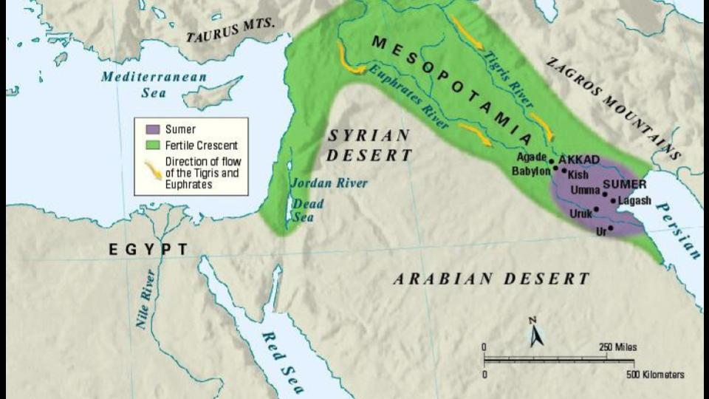
The Euphrates creates a long barrier between Israel and the entire middle east. If that dried up entirely it would open the way for all of these northern and eastern enemies of Israel - Iran, Iraq, Afghanistan - to march down to Jerusalem unimpeded.

Opening a way through the water was God’s sign of deliverance of His people first at the Red Sea under Moses and again at the Jordan River under Joshua. Walking across on dry ground. The ocean is a picture of chaos and evil, God subdues evil and destruction and leads His people through a WAY of salvation. But now it’s the opposite:

God’s Perfect Justice is Coming:
- To unmask the beast and the Consequences of following him
“The sixth angel poured out his bowl on the great river Euphrates, and its water dried up, to prepare the way for the kings of the east.” Revelation 16:12

God is drying up a great river to make a path for Israel’s historic enemies! And look what happens next.

God’s Perfect Justice is Coming:
- To unmask the beast and the Consequences of following him
“And I saw, coming out of the mouth of the dragon, and out of the mouth of the beast… three unclean spirits like frogs.” Revelation 16:13

From the false trinity now come three demon-frogs. Another judgment that had come upon Egypt is magnified to mythical proportions.

God’s Perfect Justice is Coming:
- To unmask the beast and the Consequences of following him
“For they are demonic spirits, performing signs, who go abroad to the kings of the whole world, to assemble them for battle.” Revelation 16:14

Just as the beast and false prophet were able to perform great signs, with supernatural power to deceive the nations, now again the servants of the false trinity are allowed to perform signs to lead the whole world astray, calling them to come and fight directly against God!

God’s Perfect Justice is Coming:
- To unmask the beast and the Consequences of following him
“To assemble them for battle on the great day of God the Almighty.” Revelation 16:14

The devil will do this again in Revelation 20 at the end of the 1,000-year reign of Christ. And again, the whole world will flock to his banner to come and fight against God and His people.

The book of Revelation now, and the Great Tribulation when it takes place - create a dividing line between all people. The decision is to believe in and follow Jesus or not; to choose this world and the devil who rules it or Jesus and His kingdom.

There is no middle ground. No option C. And there are serious consequences for whichever choice you make. Serious. Eternal consequences. Look at the contrast in verse 15.

God’s Perfect Justice is Coming:
- To unmask the beast and the Consequences of following him
“Behold, I am coming like a thief! Blessed is the one who stays awake, keeping his garments on, that he may not go about naked and be seen exposed!” Revelation 16:15

When Jesus comes back it will be like a thief in the night. It will be like the flood in Noah’s day. No one will see it coming. The question is whether people are paying attention or if they have fallen asleep. And it’s also a question of if you sleep in pajamas or… not.

Here are the two outcomes: either you are awake and dressed, or you are asleep and exposed. Everyone who belongs to Jesus by faith is dressed and has the ability, by the Holy Spirit, to stay awake and remain faithful. Everyone who denies Jesus or doesn’t choose to trust in and follow Jesus is already asleep at the wheel and in danger of being caught by surprise and have all their deeds exposed.

This is what God’s perfect justice is coming to do: unmake the world for the evil in it and unmask the beast and the consequences for following him. One more purpose for this terrifying judgment.

God’s Perfect Justice is Coming:
- To unveil God’s power and the Justice of His wrath
“And they assembled them at the place that in Hebrew is called Armageddon.”
Revelation 16:16

Everything in history is building toward one final battle, and it will take place on a hill called Megiddo, near the Jezreel valley where Barak and Deborah defeated the Canaanites.

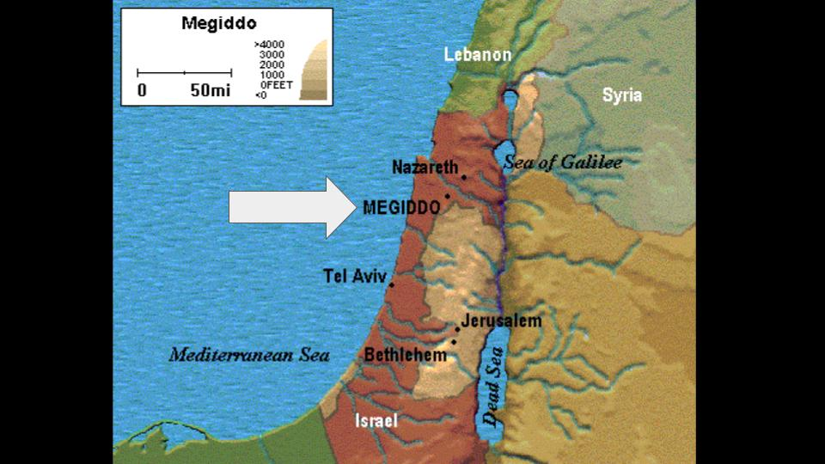

This is the kings of the whole world coming together against the God who is pouring out these terrible plagues. How else could God respond to this kind of open defiance? What is He supposed to do? Shrug and ignore the gathering of all the kings against Him?

The book of Revelation is a powerful and final defense of the justice of God. We will see that is a key purpose for the millennium, when King Jesus will reign on earth for 1,000 years. Even after a full millennium of peace and justice under King Jesus, do you think everyone on earth will worship God and trust in Jesus? No! At the first opportunity they will follow the devil and gather to fight against God.

God’s Perfect Justice is Coming:
- To unveil God’s power and the Justice of His wrath
“The seventh angel poured out his bowl into the air, and a loud voice came out of the temple, from the throne, saying, ‘It is done!’” Revelation 16:17

7 seals. 7 trumpets. Now 7 bowls. This is the seventh bowl in a sequence of 3 sevens. In other words: this is not the beginning of the end, it is the END of the end. This is the actual Day of the Lord. We’ve seen previews of this Day throughout the book: the sixth seal, the seventh trumpet, now we hear the final declaration: IT IS DONE. Enough. Game over.

This is like Jesus on the Sea of Galilee when He spoke to the storm and said, “Be still!” Suddenly all the storm and chaos stopped. Instantly, at His command.

This is like Jesus on the cross, enduring the fullness of God’s wrath against sin, and as His body gave out in exhaustion He said, “It is finished,” and breathed his last.

The One who said, “Let there be light,” to begin history will bring history to a close with these words, “It is done.”

God’s Perfect Justice is Coming:
- To unveil God’s power and the Justice of His wrath
“And there were flashes of lightning, peals of thunder, and a great earthquake…” Revelation 16:18

The birth pains of Matthew 24 all build up to this – the completion of all the groaning of history, the end of God’s work in history. Jerusalem splits into three parts. The cities of the nations collapse – all of them!

God’s Perfect Justice is Coming:
- To unveil God’s power and the Justice of His wrath
“And God remembered Babylon the Great, to make her drink the cup of the wine of the fury of God.” Revelation 16:19

More on Babylon next week. She made the nations drink the wine of her immorality, so God will make her drink the wine of His righteous fury. God is perfectly just. Remember the blood judgments earlier. The people of earth shed the blood of the saints, so God gives them only blood to drink. “It is what they deserve.”
In the end God will give every person EXACTLY what they deserve. Perfect justice is coming. And in that day will people finally repent? Huge 100 pound hailstones will fall…

God’s Perfect Justice is Coming:
- To unveil God’s power and the Justice of His wrath
“And they cursed God for the plague of the hail, because the plague was so severe.” Revelation 16:21

No. Still they don’t repent. Three times we see the refusal of these earth-dwellers to repent – even under the most terrible outpourings of God’s judgment. No repentance. No heart change. They are stuck in their sinful condition. Hailstones the size of Saint Bernards falling all around them, but still, they don’t repent.

All of this, the 7 seals, 7 trumpets, 7 bowls - the Day of the Lord - is the full and final unveiling of God’s awesome power and inescapable justice. “The fear of the Lord is the beginning of wisdom.” Everyone will end up with that wisdom, but lots of people will get it the hard way, when it will be too late to repent. “Every knee will bow” before King Jesus, but in the end lots of people will be forced to bow as those who have been conquered rather than those who have willingly pledged themselves to the King. So here is our summary:

God’s Perfect Justice is Coming:
- To unmake the world for the Evil that fills it
- To unmask the beast and the Consequences of following him
- To unveil God’s power and the Justice of His wrath

The 7 bowls of God’s last judgments will accomplish three purposes. First, God will unmake the world He made because – as in the days of Noah’s flood – the world has become filled with evil and violence. Second, God will unmask the evil of the beast and the consequences of following him. All who receive the mark of the beast are rejecting Jesus and His kingdom and choosing the devil and this kingdom of the earth. Finally, God’s judgment will unveil His power and justice in a final and irrevocable way.

Jesus Himself gives us the application:

“Behold, I am coming like a thief. Blessed is the one who stays awake, keeping his garments on, that he may not go about naked and be seen exposed.” Revelation 16:15

The Lord Jesus is coming back soon. No one knows the day or the hour. It will catch us all off guard. So, we must stay awake. We must pay attention. We must stay dressed for work in service to the King and His kingdom. We must resist the temptations of the world and the beast, so we are not exposed as sinners and idolaters on that day.

Let’s pray.

