The Bride of Christ
Revelation 21:9-27

Here we arrive at the grand finale of the Bible – with a stunning description of the bride of Christ, the holy people of God. Now, we follow a literal interpretation of Scripture. But sometimes the most literal interpretation is figurative. For example, will the church look like a literal gigantic cube coming down from the sky to be attached to a renewed earth?

What we see here is a cube 1,400 miles on each side that unites with the earth. There is no practical way to attach such a huge object to the earth, and even if we were able to build tethers strong enough to keep our planet attached to this enormous square city, the impact on the planet would be catastrophic.

Of course, God can do whatever He wants and many times in Scripture we see God overriding the normal systems of nature – as with the parting of the Red Sea and when Jesus walked on water, or calmed the storm with just a word.

But my general take on this chapter is that the huge square city is figurative, representing the PEOPLE of God throughout all of history, now finally united as one holy nation. And in this moment heaven and earth are finally and forever united. No longer any separation between God and people; between heaven and earth; between one nation or culture and another. Everything is brought together. God’s plan for uniting and reconciling all things in Christ is completed.

So I wonder if this giant cube is similar to the 144,000 in Revelation 7 – a symbolic visualization of all of God’s holy people. We can’t be definitive either way on points like this. But it is important to understand that sometimes the “literal” interpretation of a symbolic vision is a symbolic interpretation.

For example, are the “pearly gates” described here literal enormous pearls? Are the streets of gold literal golden streets with gold so pure it is clear as glass? Some of you may be really attached to these visual conceptions of heaven. But let’s at least recognize that it’s POSSIBLE that the huge pearls are symbolic of Israel as God’s gateway to salvation in Christ. Let’s recognize that the pure gold of the streets might symbolically represent the holiness of all believers who have been forgiven and transformed by faith in Jesus.

Here is one reason I think Revelation 21 is mostly symbolic.

“For I consider that the sufferings of this present time are not worth comparing with the glory that is to be revealed to us. For the creation waits with eager longing for the revealing of the sons of God.” Romans 8:18-19

There is a GLORY that will one day soon be revealed TO US and THROUGH US, when the Sons and Daughters of God are revealed. There is also this verse.

“Beloved, we are God's children now, and what we will be has not yet appeared; but we know that when he appears we shall be like him, because we shall see him as he is. And everyone who thus hopes in him purifies himself as he is pure.” 1 John 3:2-3

The theological term is GLORIFICATION. At the moment you put your faith in Jesus you were JUSTIFIED - declared righteous before God. As you grow in the Lord throughout your life you are SANCTIFIED, becoming more holy and righteous, loving, joyful, peaceful and patient as the Holy Spirit develops that fruit in your life. When you die or Jesus comes back you will be GLORIFIED. The last remnants of your sin and shame will be burned away and your mortal body will be clothed with immortality - PTL!

To see Jesus as He is in all of His glory will purge away all of our remaining sin and sadness and we will be LIKE HIM – glorious, perfect, holy, righteous. That’s what Revelation 21 illustrates for me in a beautiful, poetic, symbolic way. Could it be literal? Sure. Again, God can do whatever He wants. If He wants a 1,400 mile cube attached to the earth forever, it is within His capability to do it and within His prerogative to do so. He doesn’t ask me for approval on that kind of thing.

What we see in Revelation 21 are 4 Characteristics of believers in the new heaven and earth. Let’s take them one at a time to really appreciate and be blown away by what this is promising us.

The Eternal Glory of God’s People:
- Beloved Bride of Christ
“Then came one of the seven angels… ‘Come, I will show you the Bride, the wife of the Lamb.’” Revelation 21:9

The seven bowls of God’s wrath were poured out on the earth to unmake and purge away the remaining sin and sinners. One of the angels who poured out one of those bowls now steps forward and invites John to see something amazing: the Bride, the wife of the Lamb.

The first description of believers is this – the most striking of them all – that we are the BRIDE of Christ.

The Eternal Glory of God’s People:
- Beloved Bride of Christ – chosen, transformed, Treasured
“Then came one of the seven angels… ‘Come, I will show you the Bride, the wife of the Lamb.’” Revelation 21:9

We know that God loves us. He is our Father in heaven. He is our Good Shepherd. He proved His love for us by sending His only Son to die for us on the cross. But now we see that the reason Jesus gave His life for us was for the joy set before Him of redeeming selfish, sinful people to become His holy bride.

One of the most difficult assignments in the Old Testament was that of Hosea the prophet. God wanted to help Israel understand how He felt about their idolatry. So he told Hosea to go marry a promiscuous woman. Hosea did this, and his wife soon betrayed him by running around and sleeping with other men.

- Beloved Bride of Christ – chosen, transformed, Treasured
“When the Lord began to speak through Hosea, the Lord said to him, ‘Go, marry a promiscuous woman and have children with her, for like an adulterous wife this land is guilty of unfaithfulness to the Lord.’” Hosea 1:2, NIV

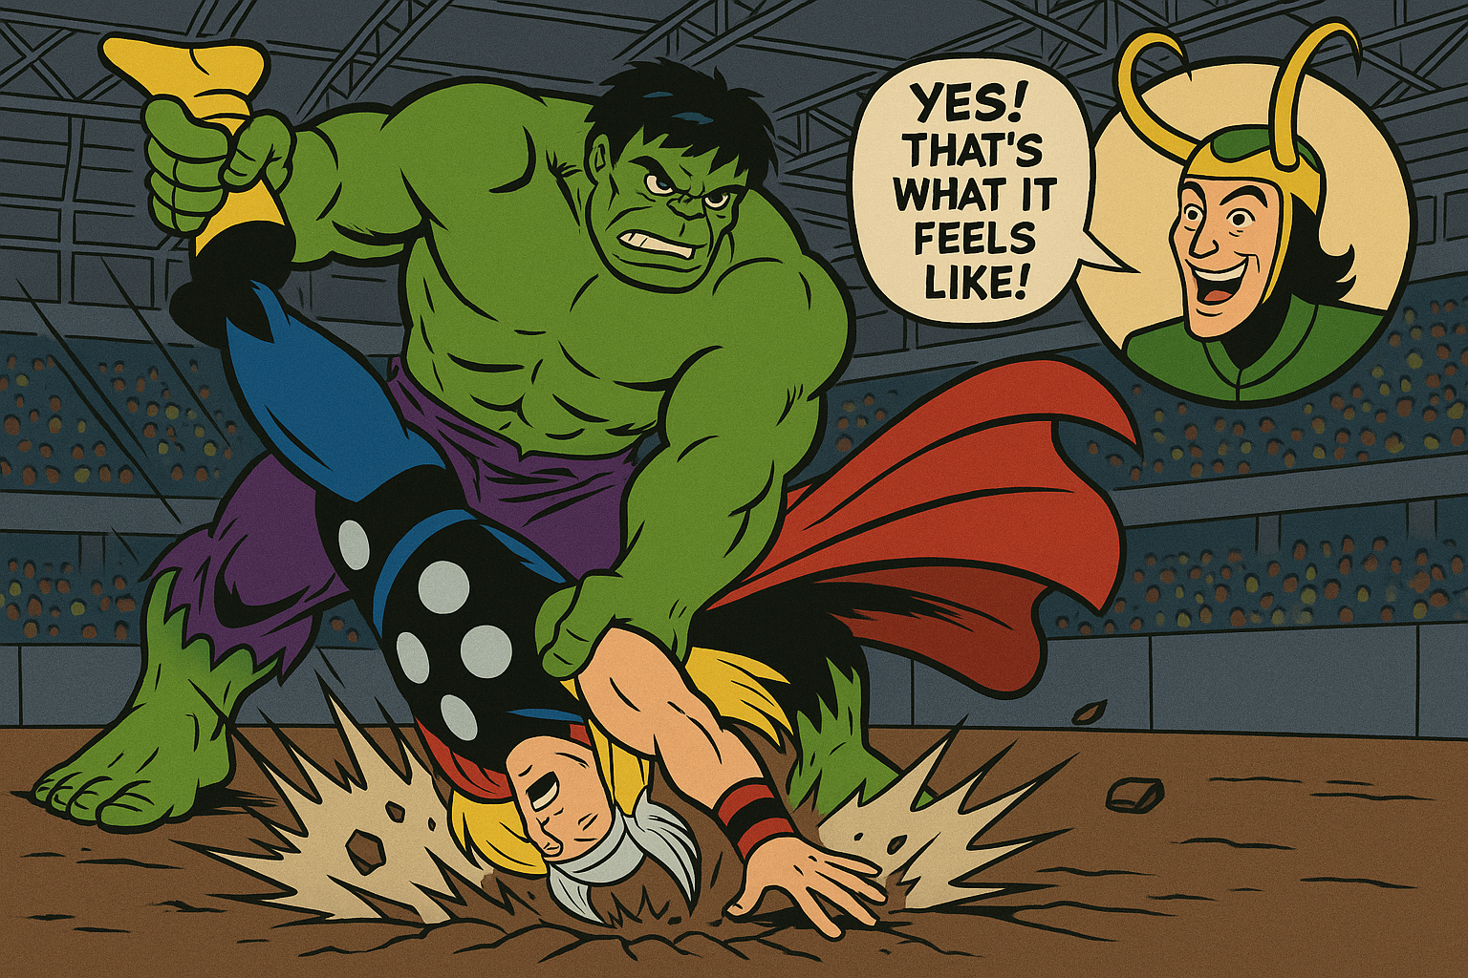
It’s like the moment in Thor Ragnarok when the Hulk fights Thor one-on-one,
and ends up grabbing Thor by the feet and whapping him one way, then the other like a dog with a squirrel. Loki jumps up ecstatic because the Hulk did that to him in a previous movie. So, Loki says, “Yes! That’s what it feels like!”

That’s what God is doing with Hosea. He is showing all of Israel what it felt like to be their God. It felt like a husband who is constantly betrayed by a promiscuous wife cheating on him.

The incredible thing about the book of Hosea is that God still chooses Israel to be His own. Hosea had three children, rapid fire. The third one God told him to name, “Not my people.” But just one chapter later, God promised this to Hosea.

- Beloved Bride of Christ – chosen, transformed, Treasured
“And I will have mercy on No Mercy, and I will say to Not My People, ‘You are my people’; and he shall say, ‘You are my God.’” Hosea 2:23

Even though Israel was so unfaithful, like a wayward and promiscuous wife, God promised to win her over and to change her from the inside out. He would have MERCY on the child named “No mercy,” and would rename the child “Not my people,” to become “My people.” More than that, we see here God calls His people, “My bride.” Beloved. Chosen, changed, transformed, treasured.

Just pause for a second and reflect on this incredible truth. If you have put your faith in the Lord Jesus, this applies to you.

The Eternal Glory of God’s People:
- Beloved Bride of Christ – chosen, transformed, Treasured
“Then came one of the seven angels… ‘Come, I will show you the Bride, the wife of the Lamb.’” Revelation 21:9

Once you were NOT a part of God’s holy people, but now you are a part of God’s people. Once you were unloved, but now you are loved. Once you were outside of the redemptive mercy of God, but now you are forgiven, free from sin, and covered with the loving mercy and grace of King Jesus!

When God looked across time, He chose YOU to be a part of the glorious bride of Christ! He sent Jesus to die for you to pay the price for your redemption and transformation. The result is that Jesus will treasure you for all of eternity, as a husband delights in his bride!

That’s the first characteristic of believers we see in Revelation 21. There are three more.

The Eternal Glory of God’s People:
- Holy City of Jerusalem
“And he carried me away in the Spirit to a great, high mountain, and showed me the holy city Jerusalem, coming down out of heaven from God.” Revelation 21:10

Mountains in the Bible represent places where heaven and earth meet – where holy people have encounters with God.
- Where does Abraham offer Isaac as a sacrifice?
- Where does Moses go to receive the Law on tablets of stone?
- Where does Elijah have his contest with the prophets of Baal?
- Where does Solomon build the temple?
- Where is Jesus transfigured before his disciples?
- Where does Jesus pray before he is crucified?
- Where will Jesus come back in His glorious return?

Did you know that the Garden of Eden itself was actually a mountain? It had to be because four rivers flowed out from it in all directions, which could only happen if its elevation was higher than everything around it; like a mountain. And Eden is where the original contact took place between God and people.

Why was it such a problem that the people of earth built a huge tower in Babel? They were trying to create their own mountain to be LIKE God instead of going up a natural mountain to encounter God.

The Eternal Glory of God’s People:
- Holy City of Jerusalem – pure, Beautiful, secure
“And he carried me away in the Spirit to a great, high mountain, and showed me the holy city Jerusalem, coming down out of heaven from God.” Revelation 21:10

Check out the Bible Project for more on mountains. Very cool theme in Scripture.
https://bibleproject.com/videos/the-mountain/ [just for blog, not service]

Where did Jesus give his first major sermon? We call it the sermon on the… MOUNT. Jesus is the new Moses. He receives revelation from God the Father and brings it back to all who will listen.

But teaching alone could not unite sinful people with the holy God of heaven. To accomplish that, Jesus had to carry a cross up a mountain and be killed there. Then, after rising from the dead, he met his disciples on a mountain in Galilee and showed himself to be the true bridge between God and people – the meeting place of heaven and earth.

John is brought up onto a mountain to get a fresh vision from the Lord. What he sees up on the mountain is the holy city, Jerusalem – a city known for being up on a mountain. The truth is that Jerusalem is only a little bit elevated above the surrounding area. But for the Jewish people, it is the primary mountain, the central place on the planet where they would gather to worship the Lord.

There are a number of Psalms called Psalms of Ascents that the Jews would sing as they walked to Jerusalem for their annual festivals like Passover. No matter where the Jews were coming from, they always thought of it as going UP to Jerusalem, and they sang about it that way too – as if Jerusalem were the highest mountain in the world, because that is where you went to meet with God.

This made Jerusalem the most glorious, the most beautiful of all cities – because it was chosen and set apart by God as the place where He would meet with His people. But now John sees Jerusalem even MORE glorious! This is a restored and beautified version of the holy city from history! Completely pure and untarnished. No sin or idolatry or compromise. This is the glorious, beautiful meeting place of God and man.

The Eternal Glory of God’s People:
- Holy City of Jerusalem – pure, Beautiful, secure
“The wall was built of jasper, while the city was pure gold, like clear glass.”
Revelation 21:18

The dimensions of the city and the height of its walls would have been meaningful to ancient people who were concerned about things like military attacks and sieges. To us 144 cubits or 216 feet doesn’t matter much. You probably don’t know how tall your house is, though you almost certainly do know the square footage of your house, especially if you have young children. Then you need all the square footage you can get.

If you lived in ancient times and had ever been through a time of siege, with giant stones getting flung into the city from trebuchets and flaming arrows coming over the walls to set houses on fire, the height and strength of your city walls would be a real and pressing concern.

Along those lines, you would also be aware of the strength of your front gates. You wanted to keep bad guys out and let good guys in who would bring items of trade and merchandise and food.

The Eternal Glory of God’s People:
- Holy City of Jerusalem – pure, Beautiful, secure
“But nothing unclean will ever enter it, nor anyone who does what is detestable or false, but only those who are written in the Lamb’s book of life.” Revelation 21:27

This holy city has restricted access. Like Disneyworld. You can’t just walk in. You have to prove who you are and that you really bought a ticket. You have to be in their books. It’s the same with Jesus. You can only get into His heavenly city if you are in His book.

You get into His book by simply calling on Him to forgive your sins and become your Lord and Savior. At that moment of saving faith Jesus takes all your sins away so you are no longer unclean, but are forgiven and righteous before God. No longer detestable or false, no longer in your sin

These are the characteristics of God’s people. First, we are the beloved bride of Christ. Second, we are the Holy City of Jerusalem. Third, we are:

The Eternal Glory of God’s People:
- United with God
“Showed me the holy city Jerusalem… having the glory of God, its radiance like a most rare jewel, like a jasper, clear as crystal.” Revelation 21:10-11

Isn’t that incredible? The holy city that represents US “having the glory of God.” Having it.

Now, in one sense, we ALREADY have the glory of God. We already are the temple of the Holy Spirit, and by having the Spirit of God in our hearts, we HAVE the glory of God. We have His power, His wisdom, His goodness, His love living inside us. If we don’t live out that glory, it’s not something lacking on HIS part but on our part.

So, there is an already side to the glory of God in us. But there is also a NOT YET sense. We don’t yet have the fullness of God’s glory. We currently just have a foretaste, a preview, an appetizer. We don’t yet have the whole enchilada. That is coming when Jesus returns to make all things new.

This vision John sees is of that full realization of God’s glory in us.

The Eternal Glory of God’s People:
- United with God – filled with His glory, power and Presence
“On the gates the names of the twelve tribes… and the wall of the city had twelve foundations…” Revelation 21:12, 14
There is a lot of detail here, mainly to blow our minds. Enormous individual pearls that function as gates for the city. 12 foundation stones covered in precious gems. All of this symbolic of the glory, beauty and perfection of THE CHURCH! These symbols are of you and me! Yes, they are all FROM JESUS, but it is HIS glory and beauty and holiness applied to us in our eternal transformation and glorification!

Let’s just zoom in on one of the details here. Verse 16.

- United with God – filled with His glory, power and Presence
“The city lies foursquare, its length the same as its width… 12,000 stadia (1,380 miles). Its length and width and height are equal.” Revelation 21:15

Now, aside from the fact that this city is absolutely HUGE, what is the significance of it being a perfect cube? Again, the Jewish people would have understood this immediately.

Within the temple, there was one area that was a perfect cube: the holy of holies in the inmost sanctuary of the temple, where the ark of the covenant was kept. Only the high priest could go into this most holy area, and only once a year on the Day of Atonement.
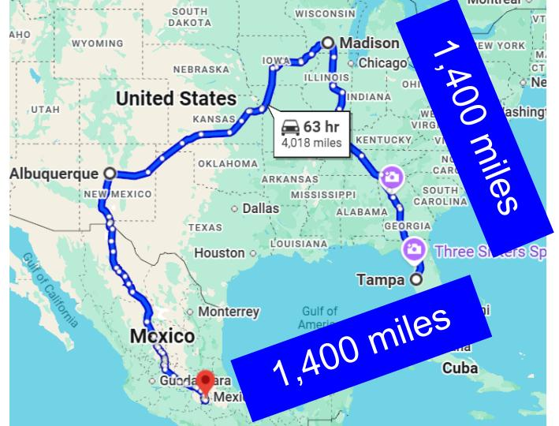
Just to give you an idea of what these numbers are like. 12,000 stadia is just about 1,400 miles. That’s the distance from here to Madison, Wisconsin; and from Madison to New Mexico, and from NM to Mexico City and back to Tampa.

The holy city of Jerusalem, the new heaven would fill that whole area – almost exactly half of the United States in terms of square mileage.
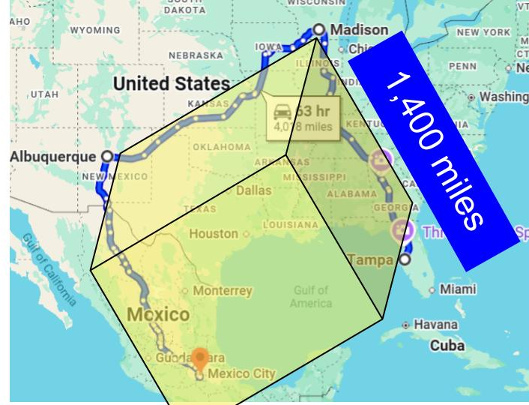
But keep in mind the new Jerusalem is not a square, but a CUBE. So, it’s as tall as it is wide and long. Again, I think this is symbolic of COMPLETION – the whole people of God from every generation and from every nation. 12,000 stadia is 12 x 1,000 just as the 144,000 is 12 x 12 x 1,000.

It is the full number of the gentiles who were to be saved, plus the “all Israel” Paul mentions in Romans 11. Everyone whose name is written in the Lamb’s book of life. Every single person God called to Himself who responded in personal faith. This is what is meant by the 12 pearly gates named for the 12 tribes of Israel and the foundations of the city named for the 12 apostles: the COMPLETION of the people of God. The union of Jew and Gentile in Christ.

- United with God – filled with His glory, power and Presence
“On the gates the names of the twelve tribes of the sons of Israel… And the wall of the city had twelve foundations, and on them were the twelve names of the twelve apostles of the Lamb.” Revelation 21:12, 14

No longer is there any separation between God and people: this is a picture of complete union with God. Just as the high priest had access to the holy presence of God, now ALL of God’s people have that same kind of access. The glorified people of God, covered in precious gems and radiant like gold without a single flaw or defect – the glory of God fills the city of God with His power and presence forever.

- United with God – filled with His glory, power and Presence
“And I saw no temple in the city, for its temple is the Lord God the almighty and the Lamb.” Revelation 21:22

There is no need for a temple or priests and Levites to manage it. God Himself is the temple, along with Jesus the Lamb – the once-for-all sacrifice for sinners like you and me.

- United with God – filled with His glory, power and Presence
“And the city has no need of sun or moon to shine on it, for the glory of God gives it light, and its lamp is the Lamb.” Revelation 21:23

Verse 25 says there will be no NIGHT there anymore in the city of God. God’s own glory will give light to the new Jerusalem. Jesus, the Light of the World will shine at the center of the city and the whole world will walk in the light of His glory. And that is the fourth and final characteristic of believers in the new and united heaven and earth. Not only will we be united perfectly with God, but also perfectly united with one another!

The Eternal Glory of God’s People:
- United as God’s Global church
“By its light will the nations walk, and the kings of the earth will bring their glory into it.” Revelation 21:24

This does not mean that in the end everyone will be saved. The Bible does not teach universal salvation. Verse 27 makes that clear: nothing unclean will enter the holy city or the new heaven and earth. Only those whose names are written in the Lamb’s book of life – only those who have called on the Lord Jesus to save them – will live forever with the Lord in His renewed and eternally united heaven and earth.

But this glorious vision in verse 24 of kings bringing their glory into the holy city and vere 26:

The Eternal Glory of God’s People:
- United as God’s Global church – from all nations, Blessing the whole world
“They will bring into it the glory and honor of the nations.” Revelation 21:26

Everything that is good and righteous and beautiful and holy and honorable will be brought into the holy city. This is an important idea for the architects and builders among us, for the inventors and engineers. Jordan Raynor has helped me appreciate this truth: some of what we create and preserve in this life will come with us into eternity. Not everything we build here will make it through the final purge of Jesus’ judgment.

Anything we do for our own glory or in our own strength; anything contaminated by our selfishness and sin will not make the cut.

But the things we build and improve and create for the glory of God and by the power of the Spirit – some of that will be brought before the Lord Jesus and dedicated to Him as an offering of praise.

The glory of the nations!

This gives me hope that there will be Chinese food and Indian food and Blaze pizza and Culver’s cheese curds and Reese’s peanut butter cup Blizzards in the new heaven and earth. These things that are glorious now will be enjoyed and even improved as we reign with Christ forever.

God’s intention from the beginning of creation was for people made in His image to reign with Him for the blessing of the whole world. Those desires will be fully realized in the new heaven and earth as the glory of the nations comes into the holy city and then goes back out as God’s people reign with Him over the whole world and, in fact, the whole universe. Star Trek may be proved prophetic as our reign extends into the cosmos.

It is true what God said at the tower of Babel - “Nothing will now be impossible for them,” when people work together in unity. “Fill the earth and subdue it,” will be our mandate forever. With the power and glory of God filling us and guiding us, as a unified people working together to steward this new earth, united with the new heaven, nothing will be impossible. And the result will be limitless, unending blessings for everyone in the Lamb’s book of life.

Here is a quick preview of next week as we conclude this great book of Revelation.

The Eternal Glory of God’s People:
- United as God’s Global church – from all nations, Blessing the whole world
“They will need no light of lamp or sun, for the Lord God will be their light, and they will reign forever and ever.” Revelation 22:5

The idea of heaven as a place where you float on a cloud and play a harp for the endless ages of eternity was thoroughly de-bunked by Randy Alcorn in his book, Heaven and more recently by many others like Jordan Raynor.

We will worship the Lord Jesus forever as the predominant reality of our experience. But part of that worship will be to serve Him by exercising dominion over this world to be a blessing to one another.

So here is our summary for today.

The Eternal Glory of God’s People:
- Beloved Bride of Christ – chosen, transformed, Treasured
- Holy City of Jerusalem – pure, Beautiful, secure
- United with God - filled with His glory, power, and Presence
- United as God’s Global church - from all nations, blessing the whole world

This beautiful chapter, filled with inspiring visions, shows us four characteristics of God’s people. First, we are the beloved bride of Christ: chosen, transformed and treasured by the Lord forever. This point alone should blow our minds and fill us with joy. Jesus chose US to be His own bride to love in this life and for all of eternity. He died on the cross to cleanse and remove our sins and change our hearts so we will be able to be faithful to Him forever as His greatest delight.
Hear this: Jesus treasures you. He delights in you. He doesn’t just tolerate you. He loves you as His very own bride.

The holy city of Jerusalem, the new heaven, is pictured as a giant cube with 12 pearls for gates, with 12 foundations covered in precious gems, representing the holiness and purity of God’s transformed people. When Jesus comes back and we see Him face to face we will be like Him, eternally GLORIFIED. All remaining sin will be purged away, along with all guilt and shame and sadness. And we will be changed in the twinkling of an eye – our mortal bodies clothed forever with immortality.

In Christ, brother, sister, you are already pure; already forgiven and cleansed, already righteous and holy. You are no longer a sinner but are now a SAINT through your union with the Lord Jesus. Therefore, you are beautiful to Him, radiant, glorious and pure. And you are forever secure in His love. Nothing and no one can snatch you from the Father’s hand. You are safe in His love forever.

Not only are you beloved and holy. Third, we are united with God. In the new heaven and new earth, there will be no more separation from God, but heaven and earth will be united forever. God Himself will be the temple in the new creation, and we will worship Him face-to-face. The New Jerusalem is a perfect cube, forever attached to the New Earth. The point of the cube is not architectural design but to remind us of the holy of holies in the temple. But that holy place will not be restricted access anymore – God’s presence, power, and glory will be accessible to all of us all the time!

And one more. We will not only be united perfectly with God forever, we will be united perfectly with one another forever, so we can have dominion over the new earth and the renewed universe, reigning with Christ over all things to bless the whole world.

Let’s pray and give thanks for these great and precious promises – the glory that awaits us in the new creation!

