The Final Judgment
Revelation 20:11-15

Ok, there are some heavy things to process today. We have been walking through the book of Revelation for a lot of this year, and we knew it would bring us to the end of the world, including the final judgment here in chapter twenty. But when you are facing intense realities, you want the TRUTH right? Better, for example, to know you have brain cancer so you can deal with it as such, than to believe you have some kind of seizure disorder and end up not actually dealing with the core problem!

Let’s consider as we begin today, what is the alternative to a great final judgment? Would it be better if there was no final accounting? Would God be more loving, righteous and good if He didn’t provide a final evaluation and ultimate determination for all people?

This is a version of the problem of evil.
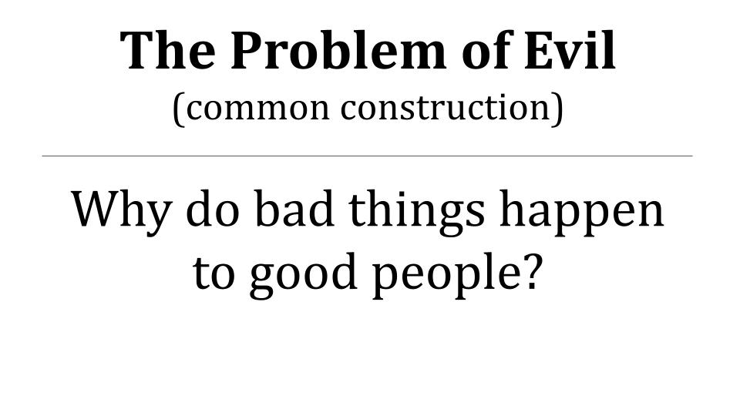

Atheists and non-religious people like to attack the idea of God using this formulation: Why do bad things happen to good people?

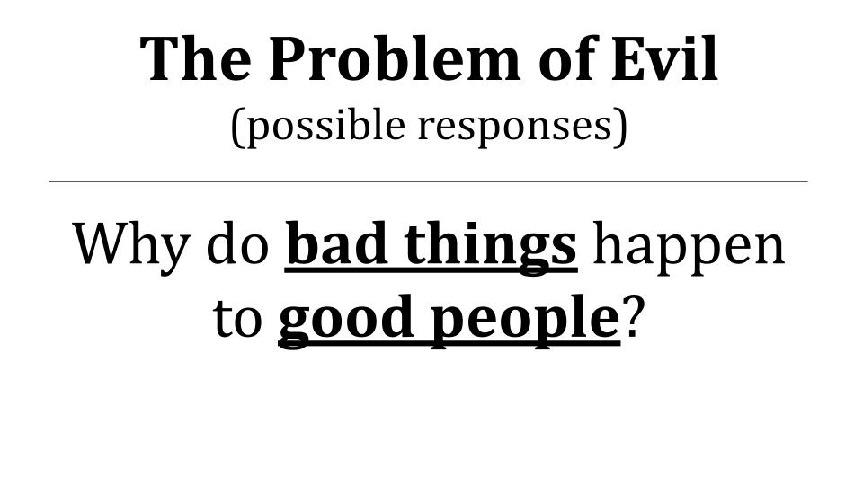
We can respond to these questions in various ways. Two good places to start emerge from the question itself. For example, what makes someone GOOD? Who determines whether a person is good and therefore deserving to avoid certain bad things? Or, from the other side, who gets to determine what is a BAD THING? Are all painful experiences ultimately bad in their entirety? Are we in the best position to determine that? Haven’t we all experienced to some degree that hard, painful experiences can end up being GOOD THINGS in the final analysis? “Whatever doesn’t kill you makes you stronger,” right? “No pain, no gain.” Or as we used to say in gymnastics, “Pain is weakness leaving the body.” But cliches aren’t going to bail us out today. Here is one of the toughest questions people can ask and wrestle with.

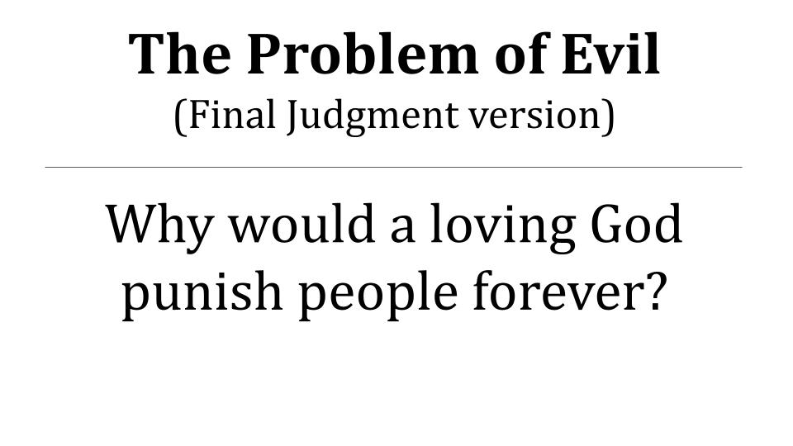
In a day and age when parents aren’t supposed to discipline their children at all; maybe not even say “No” to them at all, such fragile snowflakes that they are… it is not popular to think about a final judgment much less an eternal hell.

But consider the alternative. Would a good and loving God IGNORE sin and evil forever? Would that make God BETTER? More loving? More righteous? More just?
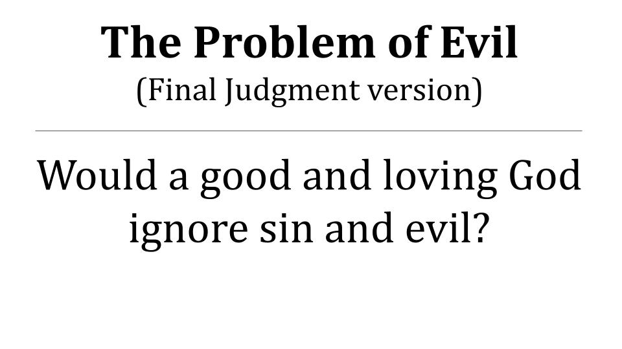
Even our finite human experience shows us that justice is better than injustice. If you have a loved one who is injured or killed, would you rather the perpetrator be released without consequence or do you want human authorities to catch the bad guy and bring him or her to some kind of just accounting? The greater the evil you experience the more you feel that justice must be done. Think of how many movies and TV shows have been designed around this premise! Why do crime and police shows resonate so much? It’s not just that we want to feel smart if we can figure out who dunnit, it’s that there is something inside of us that wants to see the bad guy captured and brought to justice!

And we certainly all feel this truth deep inside as it relates to OURSELVES. We feel the inevitability of judgment and know that we will answer for what we have done – and that it is RIGHT for this to be the case.

Let’s look at just two Bible passages that relate to final judgment. First, one from Jesus.

“Judge not, that you be not judged. 2 For with the judgment you pronounce you will be judged, and with the measure you use it will be measured to you. 3 Why do you see the speck that is in your brother's eye, but do not notice the log that is in your own eye? 4 Or how can you say to your brother, ‘Let me take the speck out of your eye,’ when there is the log in your own eye? 5 You hypocrite, first take the log out of your own eye, and then you will see clearly to take the speck out of your brother's eye.” Matthew 7:1-5

Isn’t there something that just feels very RIGHT about this passage? In the end, people will get what they deserve. So, in the meantime, don’t go around judging other people because your acts and words of judgment will be stored up to be used against you in the final judgment! Here is one from the Old Testament, at the end of Isaiah.

“For behold, the Lord will come in fire, and his chariots like the whirlwind, to render his anger in fury, and his rebuke with flames of fire. For by fire will the Lord enter into judgment, and by his sword, with all flesh; and those slain by the Lord shall be many… And they shall go out and look on the dead bodies of the men who have rebelled against me. For their worm shall not die, their fire shall not be quenched, and they shall be an abhorrence to all flesh.” Isaiah 66:15-16, 24

After all that Israel went through as a nation, after all the times they were conquered and brutalized, carried off into exile… after all the defeats, there is this longing as you read the Old Testament for a final vindication; for God to show up and bring judgment on the enemies of Israel and justice for His holy people.

The whole book of Isaiah ends on this note of final judgment. It seems a rather dark place for the great prophet to land, “Their worm does not die and their fire shall not be quenched.” Why not “mount up with wings like eagles,” or something more bright and positive?

The Bible is primarily concerned with telling us the TRUTH about God, not necessarily making us feel good or happy. And this carries all the way through the book of Revelation, including this section in chapter 20 about the final judgment. Whether or not it makes us feel good and happy, there is TRUTH here for us to grapple with. Today we will see three facts about the final judgment and apply them primarily to OURSELVES. It is clear that these facts apply to EVERYONE on the planet and all who have ever lived on earth. But the main application for us is to ourselves. So here we go.

Three Facts of the Final Judgment:
- You will stand before Jesus, the Judge
“Then I saw a great white throne and him who was seated on it. From his presence earth and sky fled away, and no place was found for them.” Revelation 20:11

This chapter has included some powerful visions and images. First, John saw an angel with a huge, powerful chain to lock up the devil. Then John saw a bunch of THRONES in verse 4, with tribulation martyrs seated on them. After being killed by the enemies of God, these holy martyrs are vindicated before the whole world and are given authority to rule and to JUDGE. They came to life and reigned with Christ for 1,000 years - an entire millennium of vindication! Third, Satan was released from the pit to deceive the nations, and John saw the final battle on earth as the devil’s whole army surrounded Jerusalem. But there wasn’t a grand, dramatic siege or any kind of back and forth with flanking maneuvers or clever bombardments. Fire simply came down from heaven and consumed the devil’s army, then that great and terrible dragon was snatched by the scruff of his scaly neck and tossed into the lake of fire with his two buddies, the beast and the false prophet.

That is the setup for verse 11: a mighty angel with a chain, a bunch of thrones, and the final judgment of the devil, along with his whole army getting vaporized in fire. Then the vision shifts and John sees an enormous white throne. Earth and sky fade away and all he sees is this radiant throne and the glorious God seated on it. Clearly this is the Day of the Lord; this is the final judgment.

And there can be no doubt whatsoever who is seated on this throne. The only two options are God the Father and God the Son. But it is clear from Scripture that it is God the Son seated on this throne.

Three Facts of the Final Judgment:
- You will stand before Jesus, the Judge
“For as the Father raises the dead and gives them life, so also the Son gives life to whom he will. For the Father judges no one, but has given all judgment to the Son.” John 5:21-22

Jesus states this plainly in John 5. And just like Revelation 20, it is an exposition of Daniel 7.

Three Facts of the Final Judgment:
- You will stand before Jesus, the Judge
“As I looked, thrones were placed, and the Ancient of Days took his seat; his clothing was white as snow, and the hair of his head like pure wool; his throne was fiery flames; its wheels were burning fire. A stream of fire issued and came out from before him; a thousand… the court sat in judgment, and the books were opened.” Daniel 7:9-10

The Jewish assumption would have been that God the Father was the judge of all people, and of course He was. But part of what Jesus revealed in His life, teaching, death and resurrection is that God the Father entrusted all glory and power and judgment and vindication to HIM as the all-glorious Son of God. And that, it turns out, is the clear point of Daniel 7.

Three Facts of the Final Judgment:
- You will stand before Jesus, the Judge
“I saw in the night visions, and behold, with the clouds of heaven there came one like a son of man, and he came to the Ancient of Days and was presented before him. And to him was given dominion and glory and a kingdom, that all peoples, nations, and languages should serve him; his dominion is an everlasting dominion, which shall not pass away, and his kingdom one that shall not be destroyed.” Daniel 7:13-14

This is why it was so scandalous and clear and obvious what Jesus was doing by embracing the title SON OF MAN. It wasn’t a humble misdirect away from full divinity, it was a direct and obvious claim to full divinity. “Hey, remember that part of Daniel 7 when this glorious human-type being is giving eternal glory and power and dominion: that’s me!”
Paul expounds on this in Acts 17.

Three Facts of the Final Judgment:
- You will stand before Jesus, the Judge
“The times of ignorance God overlooked, but now he commands all people everywhere to repent, because he has fixed a day on which he will judge the world in righteousness by a man whom he has appointed; and of this he has given assurance to all by raising him from the dead.” Acts 17:30-31

Who else could this judgment apply to? Who else has risen from the dead? God has made it clear, once and for all, the One person to whom we will all give an account, the One before whom every person great and small will stand. Jesus. The Risen One. The Glorious One. The Reigning King is the coming Judge.

And you will stand before Him.

The good news for those who know and trust in Jesus is that your experience before Him will be completely different from the experience of those who do not know Jesus. For all who belong to Jesus by faith Romans 8 tells us “there is no condemnation.” There will be EVALUATION for all believers in Jesus, but no condemnation. Read 1 Cor. 3 for how that will go. It’s very much like the 3 little pigs, just with fire instead of wind. Paul summarizes the reality for Christians in 2 Cor. 5.

Three Facts of the Final Judgment:
- You will stand before Jesus, the Judge
“For we must all appear before the judgment seat of Christ, so that each one may receive what is due for what he has done in the body, whether good or evil.” 2 Corinthians 5:10

A key point of emphasis in these final judgment passages is that EVERYONE will go through it. The great and the small. The powerful and the weak. The dead and the living. Believers and non-believers. Everyone will stand before King Jesus and answer for everything we have done and said and thought. “We must ALL appear before” Jesus. That is the first fact about final judgment: you WILL stand before the Judge and His name is Jesus. The second fact follows.

Three Facts of the Final Judgment:
- Everything in your life will be thoroughly Evaluated
“For we must all appear before the judgment seat of Christ, so that each one may receive what is due for what he has done in the body, whether good or evil.” 2 Corinthians 5:10

For the believer in Jesus there will not be condemnation, but there will still be evaluation as our gold, silver and precious stones are separated from the wood, hay and straw of our lives. Much of what we have done, said and thought will be consumed in the fire of Jesus’ righteous judgment. What remains will be like precious gems in His hand.
In the end you WILL receive what is coming to you – including a final purification and a final declaration.

Three Facts of the Final Judgment:
- Everything in your life will be thoroughly Evaluated
“Therefore do not pronounce judgment before the time, before the Lord comes, who will bring to light the things now hidden in darkness and will disclose the purposes of the heart. Then each one will receive his commendation from God.” 1 Corinthians 4:5

Don’t miss this key point! For the believer there will not be any CONDEMNATION but there will be COMMENDATION! After Jesus burns up the bad motives and the wood, hay and straw, what remains will be the things you did for His glory, by His power - the gold, silver and precious gems of your good works. And Jesus Himself will say to you, “Well done, good and faithful servant!”

The nature and format of that commendation will be customized for you. Some of us would like a big stadium event with a jumbotron and loudspeaker. Many of you would prefer this as a 1 on 1 meeting with Jesus alone.

The point is that all of us will stand before Jesus for judgment. And all of us will receive a complete and perfect evaluation. Right now much of what we do and think is hidden in shadow. But in that moment it will all be out in the light. Revelation 20 talks about BOOKS being opened.

Three Facts of the Final Judgment:
- Everything in your life will be thoroughly Evaluated
“And I saw the dead, great and small, standing before the throne, and books were opened… and the dead were judged by what was written in the books, according to what they had done.” Revelation 20:12

This fact should give all of us reason to pause and reflect. Every single thing you do, think and desire is being meticulously documented in heaven right now. Every detail. Nothing is missed. It is all there in the books.

Your husband or wife can’t see and know the purposes and intentions of your heart. Your family and friends don’t see a lot of what you do and can’t know most of what you think. But The scribes in heaven see it all. They don’t miss a single thing. It’s all being written down. It’s all there in those books.
Three Facts of the Final Judgment:
- Everything in your life will be thoroughly Evaluated
“Death and Hades gave up the dead who were in them and they were judged, each one of them according to what they had done.” Revelation 20:13

Repetition in the Bible is never by accident. It is there to reinforce a point. In this case the phrase, “according to what they had done.” This should remind us of Matthew 25 and the parable of the TALENTS. A wealthy man called his servants before him and gave them financial resources to work with, each according to his ability. One got 5 talents, another 2 talents, and the last one got 1 talent. Even just the one talent was a lot of money back then. The point was to invest that money and earn some kind of return while the boss was away. The man with 5 talents put the money to work and doubled the return. So did the man with 2 talents. But the one who received the one talent was fearful and just hid the money. He didn’t do anything with it. Look at how the master responded.

- Everything in your life will be thoroughly Evaluated
“But his master answered him, ‘You wicked and slothful servant! You knew that I reap where I have not sown and gather where I scattered no seed? Then you ought to have invested my money with the bankers, and at my coming I should have received what was my own with interest.’” Matthew 25:26-27

At least you could have used a savings account! Anything other than burying the money in the ground!

How have YOU invested the resources the Lord has given to you? Your time, talent, treasure, relationships and opportunities? When the Master comes back you will answer to Him. What will the Lord Jesus say to you? What will He commend you for? What will He rebuke you for?

Right after the parable of the talents comes the separation of the sheep from the goats.

- Everything in your life will be thoroughly Evaluated
“Come, you who are blessed by my Father, inherit the kingdom prepared for you from the foundation of the world. 35 For I was hungry and you gave me food, I was thirsty and you gave me drink, I was a stranger and you welcomed me, 36 I was naked and you clothed me, I was sick and you visited me, I was in prison and you came to me.” Matthew 25:34-36

Here it is all about WORKS, all about what you DID, how you responded to the practical needs of the people around you. Were you like the Good Samaritan who saw tangible needs and helped people in real ways? Or were you like the priest and the Levite who crossed to the other side of the road and said to yourself, “Someone else will take care of it”?

These parables in Matthew 25 bring us to the third and final fact about final judgment.

- Your eternal destiny will be determined by your relationship with Jesus
“Come, you who are blessed by my Father, inherit the kingdom prepared for you from the foundation of the world… And the King will answer them, ‘Truly, I say to you, as you did it to one of the least of these my brothers, you did it to me.’” Matthew 25:34, 40

The way we treat the people around us reveals our love for the Lord, or lack of it. This is not salvation by works, it is simply the reality that our works make it clear what we truly believe and what we truly value. You are saved by faith alone, but the faith that saves is never alone. True faith in Jesus produces good works. The seed of faith will produce the fruit of love. If you don’t see love growing in practical ways in your life then you are wise to wonder if you ever received the seed of the gospel into your heart.

Revelation 20 sums up the final reality with another book.

- Your eternal destiny will be determined by your relationship with Jesus
“And I saw the dead, great and small, standing before the throne… Then another book was opened, which is the book of life.” Revelation 20:12

There are two judgments people will face: the judgment of works with all of those books opened that document everything you have ever done or said or thought. Or the judgment of grace, where those books are all set aside and the book of life is opened.

Which do you want to go through?

The good news for all who know and trust in Jesus is that all the books that would condemn you have been nailed to the cross. Everything documented in heaven that you did wrong or the good that you failed to do was taken from your account and applied to Jesus there on the cross. Listen to these gospel verses from Colossians 2.

- Your eternal destiny will be determined by your relationship with Jesus
“And you, who were dead in your trespasses and the uncircumcision of your flesh, God made alive together with him, having forgiven us all our trespasses, by canceling the record of debt that stood against us with its legal demands. This he set aside, nailing it to the cross.” Colossians 2:13-14

To be FORGIVEN is to have all of your debts cancelled; your record fully expunged from sin. At the moment that you call on Jesus to save you all of your sin is transferred from you to Jesus. “He canceled the record of debt that stood against us… nailing it to the cross.”

“My sin, oh the bliss of this glorious thought; my sin not in part but the whole… is nailed to the cross and I bear it no more, praise the Lord, praise the Lord, oh my soul!”

That’s why IT IS WELL with your soul - because your sins have been dealt with and will never be held against you.

You don’t want the judgment by works. Trust me on this one. You want the judgment by grace. You simply want the confirmation that your name is in the Lamb’s book of life. Because then Jesus changes His position and moves from being your judge to being your defense attorney. He comes down from the great white throne and stands beside you. And he only needs one point of evidence. “Look at the book.” Here is the name. It’s right there, written in the red ink of Jesus’ own blood.

If your name is there, the judgment is over. There is nothing more to say. Nothing more to do.

So that’s the big question: is your name written there in the book of life?

- Your eternal destiny will be determined by your relationship with Jesus
“And if anyone’s name was not found written in the book of life he was thrown into the lake of fire.” Revelation 20:15

In the end people will either join Jesus in the new heaven and the new earth, eternally serving King Jesus and rejoicing in His love, OR people will join the devil and the beast in the lake of fire to suffer under God’s wrath forever. That eternal reality will be determined by one thing and only one thing: your relationship with King Jesus.

Have you committed your life to Him or not? Do you belong to Jesus by faith? Have you called on His name to be saved?

John says it so clearly in 1 John 5.
“And this is the testimony, that God gave us eternal life, and this life is in his Son. Whoever has the Son has life; whoever does not have the Son of God does not have life. I write these things to you who believe in the name of the Son of God, that you may know that you have eternal life.” 1 John 5:11-13
That’s the summary. Either you HAVE Jesus or you don’t. You’ve either committed your life to Him in real, personal faith or you have not. “Whoever HAS the Son has life.” John said the whole reason he wrote this letter was so that believers would KNOW that we have eternal life. You shouldn’t wonder or worry about whether you belong to Jesus. The Holy Spirit confirms in your spirit that you belong to Jesus.

It’s like marriage vows. For those who are married among us, I hope you’re not unclear or fuzzy about whether you are married. You either made your vows or you didn’t. It comes down to that and only that.

A lot of people know ABOUT JESUS but have never made their vows.

Think about that reality. Jesus has reached out His hand to you proposing marriage. He says, “Come to me, all you who are weary and burdened and I will give you rest.” He offers you complete forgiveness and eternal life in HIM. He will take all of your sin upon Himself and give you all of His righteousness forever.

But you have to say YES. The ring is right there in His hand, but you have to take it from Him. You have to put it on. John says it this way in his gospel.

- Your eternal destiny will be determined by your relationship with Jesus
“Very truly I tell you, whoever hears my word and believes him who sent me has eternal life and will not be judged, but has crossed over from death to life.” John 5:24, NIV

I love this verse. Two conditions for salvation. First, you have heard the gospel of Jesus. Second, you have believed in Him. That’s it. No good works contribute to your salvation. Faith alone. Just look on Jesus and live. Just call on His name to save you. Just say “Yes,” to His proposal. Receive the free gift of salvation and eternal life. The grammar here is so helpful.

- Your eternal destiny will be determined by your relationship with Jesus
“Very truly I tell you, whoever hears my word and believes him who sent me has eternal life and will not be judged, but has crossed over from death to life.” John 5:24, NIV

- Present tense: hears and believes. If that is your present, current reality then Jesus says you HAVE eternal life right now. It is yours.
- Future tense: will not be judged. Judgment and condemnation for sin happened to Jesus in the past and so will not be in your future.
- Past tense: you have CROSSED OVER from death to life. Done, completed. Finished.

This verse works really well with the bridge illustration of the gospel and the EvangeCube. You feel the reality of moving across the bridge of Jesus’ death and resurrection. You see the words “crossed over.”

Have YOU crossed over from death to life? Are you still living in your own sin? Or have you let Jesus take it all from you?

Have you heard the good news and believed in Jesus? Have you said “Yes” to His offer to forgive and save you?

- Your eternal destiny will be determined by your relationship with Jesus
“And if anyone’s name was not found written in the book of life he was thrown into the lake of fire.” Revelation 20:15

The only way to have your name written in the book of life is to ask Jesus to write it there in His blood. Just say YES to Him. Just call on His name. Say, “King Jesus, forgive me! Save me! I believe in you!”

If you have never done that we want to give you a chance to do it right now. As we sing, “O come to the altar,” (or whatever) we invite you to come right now and say yes to the Lord Jesus; to call on Him right now and ask Him to write your name in the book of life.

