The New World
Revelation 21:1-8

All right! We have come to the end of the book of Revelation and the true end of the world. These next few weeks we get to talk about ESCHATOLOGY - the end of all things! Come on, some of you have to be excited about this like I am! Join me in Revelation 21.

“Then I saw a new heaven and a new earth, for the first heaven and the first earth had passed away, and the sea was no more.” Revelation 21:1

After all the judgments are finally poured out, after all the wrath of man and wrath of God collide, finally we hear “It is done!” and Jesus appears to make all things new! And here is what it looks like: a new heaven and earth. The ocean of chaos that has reigned in the world and in our lives is finally and fully removed. The separation between God and man is replaced by perfect harmony and union. Heaven and earth themselves finally made one in Christ.

Now, there is an important balance to be aware of as we discuss the last things. Most evangelical, Bible-believing followers of Jesus interpret these teachings under the heading of “Realized Eschatology,”: the already and the not yet.
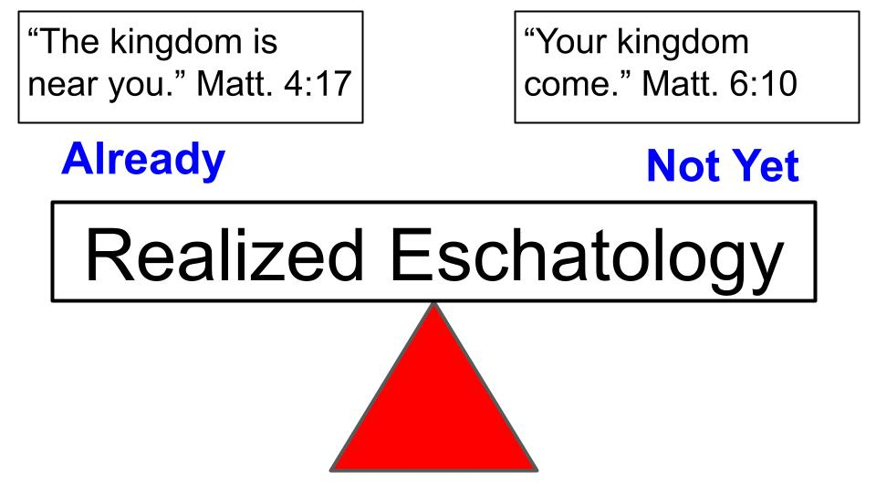
Jesus taught both in His earthly ministry. We feel the tension right away in Matthew 4 and 6. On the one hand, Jesus announced that the kingdom of heaven had arrived in Him. On the other hand, He taught His followers to pray, “Your kingdom come,” and to work with Him along the lines of Isaiah 61 to rebuild the ancient ruins and bring righteousness and peace more into this dark and broken world.

It is no surprise that throughout the last 2,000 years believers have debated this tension.

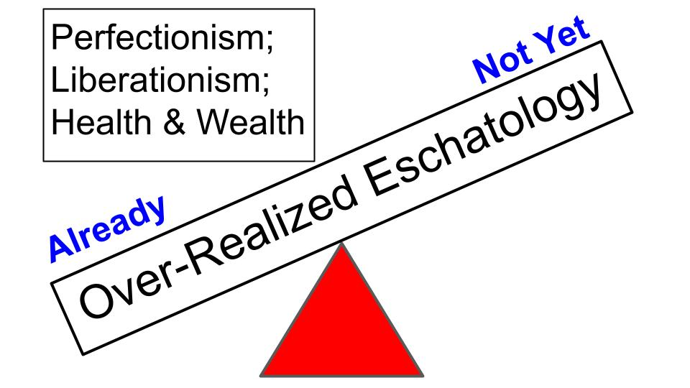
On the one side, if you tip the scales too much to the “already,” you can fall into an “Over-realized” eschatology, trying to bring things that are promised for eternity into our present reality. For example, some believe that Christians can and should attain perfection now – total freedom from sin and total victory over temptation. Others apply kingdom principles to the world, seeking total liberation for all slaves and captives, perfect justice and righteousness under King Jesus for all people. You can quickly see how Old Testament stories and teachings might incline some believers this way with the promises and commands to Israel being applied, for example, in the U.S. under a certain political party or philosophy. Probably the most common use of this has been under the prosperity gospel where preachers will promise health and wealth right now, usually in exchange for financial support for their ministry. If you just believe, God wants to heal you of all of your illnesses and bless you with financial and physical resources right now!

Many of us have been trained to spot these errors. But we may not have been as well trained to spot the corresponding errors in the other direction.
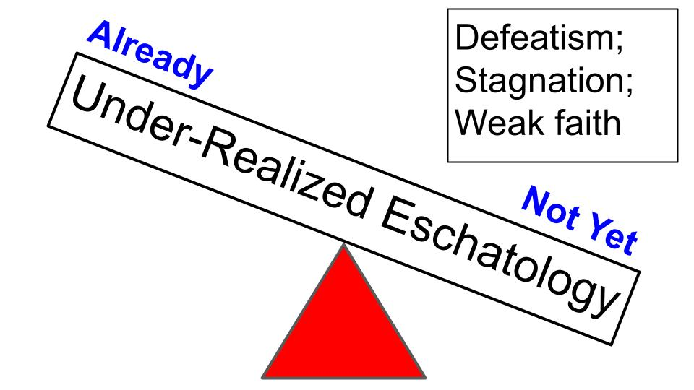
In an “under-realized” eschatology we might incline toward a defeatist approach or discipleship where we so emphasize the sinfulness of people that we come to accept regular failure with regard to sin, temptation and addiction. We may expect the church to have little, if any, influence in this dark and broken world and exercise little faith in our own lives or ministries because we simply don’t expect God to “make anything new,” in this present age.

Hopefully, we can find a better balance today as we walk through Revelation 21.
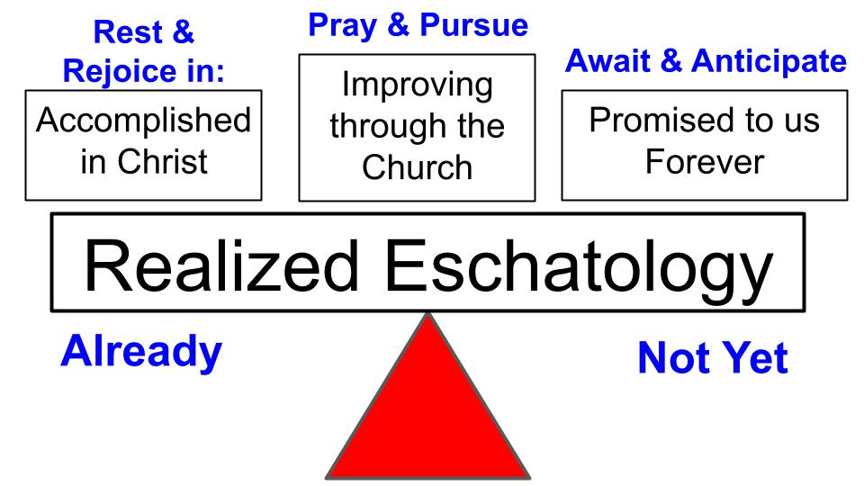
This is our outline for the morning: first rejoicing in what we already have in Christ; then prayerfully pursuing and joining Him in the work of renewal He is doing now; and finally waiting for and anticipating the full renewal He will bring when He comes back. Past, present and future. Let’s jump into Revelation 21.

“Then I saw a new heaven and a new earth, for the first heaven and the first earth had passed away, and the sea was no more.” Revelation 21:1

Ok, if you had to place this verse in the past, present or future, which would you choose? Future, right? When I look around right now, I don’t feel like we see a new heaven and earth, perfectly united in Christ with all chaos and disorder removed…

- Await and Anticipate the Future Promises of God
“Then I saw a new heaven and a new earth, for the first heaven and the first earth had passed away, and the sea was no more.” Revelation 21:1

Just because these are future promises doesn’t mean they are irrelevant to the present. It is very helpful and important for us to meditate on promises like this that we WILL one day enjoy forever. The new heaven and new earth are coming and Jesus WILL make all things new. The ocean of chaos, death and disorder will be fully and finally removed – with all sadness and suffering, all pain and loss, all fear and worry. So most of this verse is future for us to await and anticipate. But there is a sense in which the new heaven HAS already arrived in Christ. So let’s think about that for a minute.

- Rest and Rejoice in the Finished work of Christ
“Then I saw a new heaven and a new earth, for the first heaven and the first earth had passed away, and the sea was no more.” Revelation 21:1

When Jesus arrived and started preaching, it was not a future kingdom He announced that a present one that was “at hand.” And he called it the kingdom of heaven or the kingdom of God. The Bible Project guys prefer the term “kingdom of the skies,” to make the connection with Genesis one explicit. We know from the creation account that “in the beginning God created the heavens and the earth,” or more literally He created “the skies and the land.” This is really important background to Revelation 21.

- Rest and Rejoice in the Finished work of Christ
“In the beginning, God created the heavens and the earth. The earth was without form and void, and darkness was over the face of the deep. And the Spirit of God was hovering over the face of the waters.” Genesis 1:1-2

The first verse of the Bible is about God’s work of creation. And the backdrop to that creative work is darkness, chaos and the ocean. God created from nothing, but ancient civilizations knew that their whole experience was bounded by the sea and the land. The ocean represented disorder and death – the place that if you went too far into it, you would die. Which is why God created LAND as a place where people could live and flourish.

And in the beginning the Spirit of God was already hovering over the darkness and chaos of the ocean bringing peace and order and control to it.

Have you ever wondered why Jesus spent 40 days in the wilderness before he started preaching? He first went to the place of chaos and death to show His mastery over it, He hovered over it in a way and emerged victorious, unlike Israel. He was tempted by a snake in the desert but did not give in.

- Rest and Rejoice in the Finished work of Christ
“Then I saw a new heaven and a new earth, for the first heaven and the first earth had passed away, and the sea was no more.” Revelation 21:1

So, the new heaven, the kingdom of heaven, arrived in Christ in the same way the first skies and land arrived - by the powerful, creative, gracious declaration of God in the face of great danger, disorder and death.

When we face disease, danger, chaos and death in this world we should be comforted by the knowledge that one day Jesus will renew all things. But even now there is reason to rejoice and celebrate that the kingdom of the skies has already broken into this dark and broken world in which we live. Jesus, the light of the world, has stepped into the darkness and the darkness has not overcome His light. That’s what the introduction to John’s gospel presents so vividly and beautifully by juxtaposing Genesis 1 with a new gospel introduction.

In Christ, a new heaven, a new kingdom, broke into this dark land in which we live. A new King arrived who would one day walk on the chaotic waters and speak peace and quiet to them.

- Pray and Pursue the Ongoing work of Christ
“And I saw the holy city, new Jerusalem, coming down out of heaven from God, prepared as a bride adorned for her husband.” Revelation 21:2

Next week we will study in more detail the rest of Revelation 21 and the stunning description of the bride of Christ, the holy city of Jerusalem. Here in verse 2 we just get the summary statement, that the beautiful bride of Christ is a gift from God coming down from heaven.

So now our focus shifts from the past to the present. Yes, we rejoice in the fact that Jesus brought the kingdom into this world through his birth, life, death and resurrection. But Jesus also introduced an ongoing kingdom reality to this world called “the Church,” through which He continues to work with us as HIS BODY. Ephesians 4 is really powerful in this regard.

- Pray and Pursue the Ongoing work of Christ
“He who descended is the one who also ascended far above all the heavens, that he might fill all things.” Ephesians 4:10

Ephesians 1 makes it clear that Jesus came to unite and reconcile all that is broken and separated. Ephesians 3 and 4 teaches that the means by which Jesus does this healing, restoring, reconciling, uniting work is the CHURCH.

- Pray and Pursue the Ongoing work of Christ
“And he gave the apostles, the prophets, the evangelists, the shepherds and teachers, to equip the saints for the work of ministry, for building up the body of Christ.”
Ephesians 4:11-12

The task of church leaders is not to DO the work of ministry, but to equip all the saints – every believer – to pursue your own unique ministry calling, as part of the larger body of Christ that is doing His restoring work on this planet. Come back to Revelation 21 with this context in mind.

- Pray and Pursue the Ongoing work of Christ
“And I saw the holy city, new Jerusalem, coming down out of heaven from God, prepared as a bride adorned for her husband.” Revelation 21:2

The bride of Christ was born in the time of Jesus, through his little band of troublemakers. The church was filled with and empowered by the Holy Spirit on the Day of Pentecost and the believers were enabled to spread out and follow their commission to the whole earth, not just camping out in Jerusalem.

The church is God’s gift to the world, second only to the atoning work of King Jesus on the cross. Just as God always intended for Israel to represent Him in the world and bring justice and peace to the nations, so God wants the church to be the revelation of His glory and power and goodness and love to the whole world. Look at this summary from WIKIPEDIA of the contribution of Christianity to the whole world.
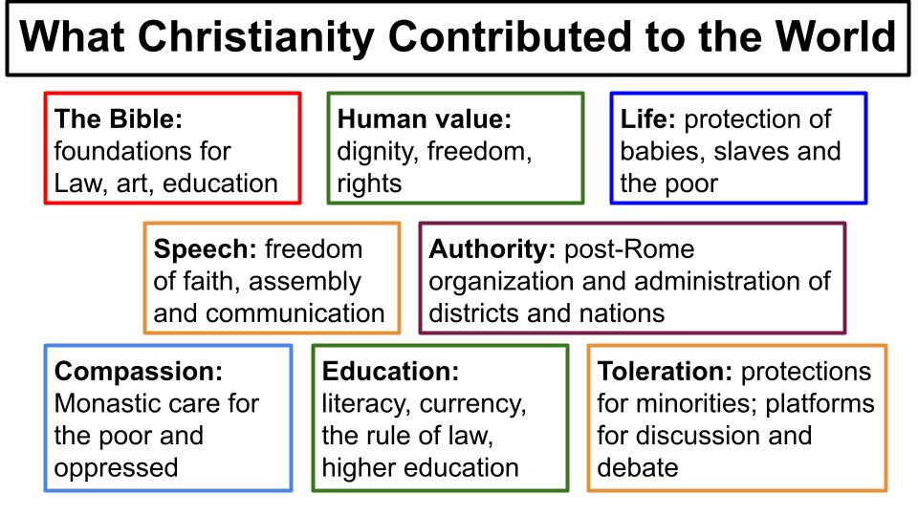
Anthony Esolen has written a four-volume series of books to document the 25 most significant contributions the church has made to the world from things like education to hospitals; from human rights to civic administration. There is no doubt that the church of Jesus has shaped history and blessed the world from when Jesus launched it 2,000 years ago right up to the present day.

- Pray and Pursue the Ongoing work of Christ
“And I saw the holy city, new Jerusalem, coming down out of heaven from God, prepared as a bride adorned for her husband.” Revelation 21:2

Our point for right now is that WE, right here, right now, are the holy city coming down from God in heaven as His gift to the world here in Tampa Bay. How are you PRAYING right now that God’s kingdom would COME where you are? How are you WORKING right now to bring the love and justice and righteousness of God more to bear in your relationships and environments?

Here is the verse Jesus announced as His mission statement, from Isaiah 61:

- Pray and Pursue the Ongoing work of Christ
“The Spirit of the Lord God is upon me, because the Lord has anointed me to bring good news to the poor; he has sent me to bind up the brokenhearted, to proclaim liberty to the captives, and the opening of the prison to those who are bound; to proclaim the year of the Lord's favor.” Isaiah 61:1-2

Not just to announce good news but to BRING that good news as part of the Jubilee celebration of freedom and blessing in the year of the Lord’s favor! Healing for the broken; freedom for the captives; light to the blind. This leads up to the Oakwood verse:

- Pray and Pursue the Ongoing work of Christ
“That they may be called oaks of righteousness, the planting of the Lord, that he may be glorified. They shall build up the ancient ruins; they shall raise up the former devastations; they shall repair the ruined cities, the devastations of many generations.” Isaiah 61:3-4

God’s plan for Israel in the OT and His plan for the Church now is that His people be like a VINEYARD or an orchard, bringing blessing to everyone around us! “The planting of the Lord, for His glory and the good of all nations.”

In your world, where do you see ruins? Where do you see pain and brokenness? Both in the lives of people and in the systems and structures of the world. It is part of our calling to rebuild these ancient ruins, to repair the ruined cities. You can see where people have OVER-Realized passages like this and ended up with a “liberation theology” that loses sight of the gospel of Jesus as salvation by grace alone through faith alone and shifts all the attention to “making the world a better place.” But mostly the evangelical movement of the last 100 years has UNDER-realized passages like this and has under-emphasized the work of justice and the pursuit of shalom.

But personal salvation and joining Jesus in His restoring, rebuilding work are not at odds. Look at how Isaiah 61 puts them together.

- Pray and Pursue the Ongoing work of Christ
“For he has clothed me with the garments of salvation; he has covered me with the robe of righteousness… For as the earth brings forth its sprouts, and as a garden causes what is sown in it to sprout up, so the Lord God will cause righteousness and praise to sprout up before all the nations.” Isaiah 61:10-11

God changes us on the inside, filling us with His Spirit, so we are not just DECLARED righteous in Christ but so we become agents of His righteousness and justice in this world.

Coming back to Revelation 21, we can see both in the first two verses.

- Rest and Rejoice in the Finished work of Christ | - Pray and Pursue the Ongoing work of Christ
“Then I saw a new heaven and a new earth, for the first heaven and the first earth had passed away, and the sea was no more.” Revelation 21:1 | “And I saw the holy city, new Jerusalem, coming down out of heaven from God, prepared as a bride adorned for her husband.” Revelation 21:2

Let’s rest and rejoice in the fact that the kingdom of heaven arrived in King Jesus. The sea of death and destruction was subdued in His death and resurrection as it relates to your heart and eternal soul. Spiritually speaking, the work of salvation in our hearts is DONE. Rest in it. Rejoice in all Jesus has done.

But then notice how the holy city is coming down from God in heaven. Again, God’s people are already HOLY through the finished work of Christ. We don’t make ourselves more holy through our good works or how we pursue justice in this world. But we should prayerfully work to bring more of God’s holiness and justice to bear in the ruins of this world. Jesus announced the good news of forgiveness and salvation but He also demonstrated the inbreaking of His kingdom by healing people and restoring them to their place in society. Let’s join in His work of healing and restoring people and places as we are enabled to as well.

Now look at verse 3 for a future promise.

- Await and Anticipate the future promises of God
“And I heard a loud voice from the throne saying, ‘Behold, the dwelling place of God is with man. He will dwell with them…’” Revelation 21:3

Again, parts of this are already fulfilled in Jesus and the Holy Spirit. We ARE the temple of the Holy Spirit and God’s personal presence does dwell with us and in us through the person of the Holy Spirit. But the full and ultimate fulfillment of this vision is in the new heaven and new earth when Jesus comes back.

So even as we rejoice in our sense of God’s presence and closeness as we pray and sing and read the Bible, we know our experiences of peace and love and joy in the Lord are only glimpses, only appetizers, only brief previews of how it will feel when we see God face to face. Brothers and sisters, the best is yet to come!

- Await and Anticipate the future promises of God
“‘Behold, the dwelling place of God is with man. He will dwell with them, and they will be his people and God himself will be with them as their God.’” Revelation 21:3

One day all sin and sadness will go away, at the moment we see God. Right now we look through a dim and cloudy window. On that day we will see Him with perfect clarity. We will know God even as we are fully known.

- Await and Anticipate the future promises of God
“He will wipe away every tear from their eyes and death shall be no more.”
Revelation 21:4

All separation from God, all distance and guilt and shame will be removed and then all sadness and pain, every tear, every sorrow will be wiped away forever!

It’s really hard for us to imagine these things because they are so different from what we experience every day. This is why it’s important to ANTICIPATE and meditate on how this really will feel when that day comes.

Consider, if you have lost a loved one who knew the Lord, this is his or her reality NOW. All sin and guilt and shame was forever removed, along with all sadness and pain. When your loved one closed her eyes in this world, she opened them to see King Jesus and the first thing He did was to wipe away every tear from her eyes. All sadness replaced by joy. All separation replaced by perfect LOVE.

That is the current, immediate reality for all who die in Christ. “To be absent from the body is to be present with the Lord,” which is better by far than anything we experience in this life.

Death is a defeated enemy. But for those of us still waiting for Jesus to come back, death is still our enemy. We still feel the sadness and loss of those who have gone before us. We rejoice that they are with the Lord, but we grieve that they are no longer with us. Death is the last enemy to be defeated. So await and anticipate the joy of seeing those loved ones again, of being reunited with them FOREVER in the presence of King Jesus.

This is why Christian funerals and memorial services are so helpful for those of us left behind. They don’t complete the grieving process but they help with it. We lay our loved one to rest in the ground, releasing them into the loving hands of the Lord. And we come together with one another to hug and to hold each other, to weep together for the sadness of losing another one to death. Look at verse 5.

- Await and Anticipate the future promises of God
“And he who was seated on the throne said, ‘Behold, I am making all things new.’” Revelation 21:5

We should not grieve like the people around us who have no hope. We have an unshakeable and eternal hope in the Lord Jesus who conquered sin and death already and is coming back SOON to fulfill this promise and make ALL THINGS New!

Jesus IS already seated on His throne. He currently and comprehensively reigns over all things. But He has not yet made all things new. Many things are still broken and messed up. Death still reigns in this world. But brother, sister, rejoice! Jesus is coming back soon and look at verse 6 for what He will say.

- Await and Anticipate the future promises of God
“And he said to me, ‘It is done! I am the Alpha and the Omega, the beginning and the end.’” Revelation 21:6

Just as Jesus said on the cross, “It is finished,” so He will say “It is done!” when He comes back. Just as Jesus silenced the storm on the Sea of Galilee with the words, “Peace, be still,” so He will say to the whole universe: “ENOUGH! It is done.” Stop it. PEACE.

The One who set the universe in motion with the words, “Let there be light,” will bring history to its conclusion when He says, “It is done!”

Think of the areas of pain and sadness in your life. Broken relationships, the loss of loved ones, the aches and pains in your body. The frustrations of work and the hardships of ministry. One day Jesus will cry out, “DONE.” And all of those things will be RIGHT. Every bone that is out of place will be reset in that single moment. Every relationship that is in conflict will be reconciled. Every sadness, every loss will be replaced with wholeness and peace and joy.

- Await and Anticipate the future promises of God
“To the thirsty I will give from the spring of the water of life without payment.” Revelation 21:6

Are you thirsty? Do you long for spiritual water your soul can drink and never thirst again? Do you ache for true and deep and lasting fulfillment and satisfaction? Those are symptoms of living in this broken, barren place we call the world.

We’ll see more of this living water in chapter 22. It flows from the throne of God, from direct, personal relationship with Him. It brings healing and life everywhere it goes. It’s not just a restoration of Genesis 1, it’s the complete fulfillment of what Genesis 1 and the original creation pointed to.

This symbol of living water applies to all three areas of past, present and future.

- Rest and Rejoice in the Finished work of Christ
“To the thirsty I will give from the spring of the water of life without payment.” Revelation 21:6

Jesus offered this reality to the woman at the well in Samaria. He talked about it again in John 7 with reference to the Holy Spirit. Jesus Himself IS the living water. Once you know Him and experience His love and grace your soul

- Rest and Rejoice in the Finished work of Christ
“Jesus stood up and cried out, ‘If anyone thirsts, let him come to me and drink. Whoever believes in me, as the Scripture has said, ‘Out of his heart will flow rivers of living water.’ Now this he said about the Spirit, whom those who believed in him were to receive.”
John 7:37-39

Jesus quoted Isaiah 55 here, as does the book of Revelation. 600 years before Jesus came God promised living water as an open invitation. What is surprising in Isaiah 55, John 7 and Revelation 21 is not that such living water is available from God but that it is available to ANYONE. The Jewish assumption was that blessings like this were only available to Jews. But notice the condition Jesus puts on it: WHOEVER believes in me. That’s it.

- Rest and Rejoice in the Finished work of Christ
“To the thirsty I will give from the spring of the water of life without payment.” Revelation 21:6

Revelation goes back to the Isaiah 55 condition: you have to be THIRSTY. You have to be like the Samaritan woman and acknowledge a felt need for something other than what this world offers and what you already have in your life. So this ties in to the present.

- Pray and Pursue the Ongoing work of Jesus
“To the thirsty I will give from the spring of the water of life without payment.” Revelation 21:6

Just because Jesus promised this living water to all who believe in Him and just because Jesus poured out the Holy Spirit on all of His followers doesn’t mean we are passive. We have to prayerfully place ourselves before the Lord Jesus so He can fill us. Ephesians 5 commands all believers to “BE FILLED” with the Holy Spirit. You can’t fill yourself with this living water, but you can come before God in prayer and humble faith and ask Him to fill you. Ephesians 3 shows us how.

- Pray and Pursue the Ongoing work of Jesus
“[That you] may have strength to comprehend with all the saints what is the breadth and length and height and depth, and to know the love of Christ that surpasses knowledge, that you may be filled with all the fullness of God.” Ephesians 3:18-19

It’s significant that this is a PRAYER. We don’t demand spiritual fullness. We pray for it. And we pursue it by resting in and rejoicing in the love of Jesus that surpasses our ability to fully comprehend it. To know how “wide and long and high and deep” is the love of Christ, with the result that we will be filled “with all the fullness of God.” Revelation 21 shows us this will be a battle.

- Pray and Pursue the Ongoing work of Jesus
“The one who conquers will have this heritage, and I will be his God and he will be my son.” Revelation 21:7

We don’t earn adoption into God’s family, that is a gift directly from the Lord Jesus in response to our faith. But we do have to engage in the spiritual battle by faith, through prayer and by suiting up in the spiritual armor Paul describes in Ephesians 6.

Not everyone will conquer. Some will be defeated by the devil. Even some who appear to be true Christians will be led astray and make shipwreck of their faith.

- Pray and Pursue the Ongoing work of Jesus
“But as for the cowardly, the faithless, the detestable, as for murderers, the sexually immoral…” Revelation 21:8

This list does not sound like followers of Jesus. This sounds like those who refuse Jesus all the way along.

- Pray and Pursue the Ongoing work of Jesus
“As for sorcerers, idolaters, and all liars, their portion will be in the lake that burns with fire and sulfur which is the second death.” Revelation 21:8

The end of Revelation is filled with contrasting destinies. The joys of the new heaven and new earth are not promised as a blank check to everyone. They are guaranteed for those who love and trust King Jesus and who follow Him to the end – to those who OVERCOME all the trials and temptations of this world and remain true to Jesus all the way. To those who refuse Jesus and follow the devil and give in to the temptations of this world, their final destiny will not be the living water and crowns and reigning with Christ forever. Those who refuse King Jesus will join the devil and the antichrist in the lake of fire where they will be punished for their sin and rebellion forever.

- Rest and Rejoice in the Finished work of Jesus
“The one who conquers will have this heritage, and I will be his God and he will be my son.” Revelation 21:7

These categories aren’t always neat and tidy. This one, I think, belongs mainly in the salvation already accomplished in the Lord Jesus. But it certainly has a present application to resist sin and fight the spiritual battle by faith. And it has a future hope to anticipate with our final and eternal rewards.

But the main way we conquer is by simply believing in King Jesus; by choosing Him above ourselves and above this world. By choosing Jesus you are adopted as a son or daughter of God and your eternal destiny is changed forever. Instead of the lake of fire, you will spend all of eternity in the new heaven and earth!

So here is our summary for today from Revelation 21.

Realized Eschatology
Rest and Rejoice in | Pray and Pursue | Await and Anticipate
The finished work of Christ | The ongoing work of Jesus in the world | The kingdom promised when Jesus comes back
“Then I saw a new heaven and a new earth for the first heaven and the first earth had passed away, and the sea was no more.” Revelation 21:1

Really every verse of this section has a past, present and future application. The kingdom of heaven arrived with the birth of Jesus. Let’s rest and rejoice in all that Jesus accomplished in His first coming even as we patiently wait for the ultimate and complete fulfillment of His kingdom when He comes back. And in the meantime, let’s work to join Jesus in His work of restoring and filling all things through His body, the church.

