Poor in Spirit
Matthew 5:1-10

Here is what we learned last week from the first four chapters of Matthew.

Two Declarations of Good News:
- The Kingdom of heaven Arrived in Jesus
- The King (Messiah) from heaven is Jesus

Two Exhortations to Respond to this News:
- Repent by confessing and turning away from your sins
- Commit to Follow Jesus as your King

John the Baptist and Jesus both had the same message: “Repent, for the kingdom of heaven is at hand.” They announced that a new spiritual kingdom had arrived with the coming of Jesus, the long-awaited Messiah and King of Israel. The only appropriate response to this good news is to repent and turn away from your sins and all other allegiances so you can commit all you are and all you have to King Jesus, becoming His disciple.

With this introduction we are well prepared, as Jesus’ early audience was, to hear our King’s teachings so we can arrange our lives around them, so we can FOLLOW the Jesus Way!

This message, the sermon on the mount, was Jesus’ manifesto. It was His beautiful, eloquent, memorable summation of what it means to follow Him. And the introduction to the whole sermon is what we call the Beatitudes, which summarize the lessons of the whole sermon and provide a perfect description of the life God blesses or what a true follower of Jesus looks like.
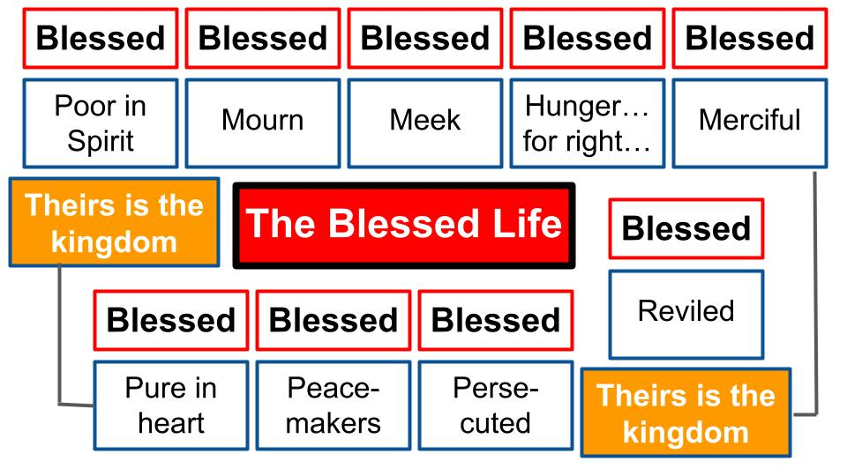
The first thing we notice as we listen to the Beatitudes is the repeated word: BLESSED.

Do you want to be happy? Do you want to be blessed by the Lord? This is what the truly blessed life looks like. This is what a person looks like who is a citizen of the kingdom of heaven that Jesus announced.

The symmetry and poetry of these nine blessings jump off the page when you see how they begin and end with the same promise: “THEIRS is the kingdom of heaven.” These are the people who will dwell with King Jesus forever in His eternal kingdom. But notice Jesus did not say “Theirs WILL BE the kingdom of heaven.” No. Theirs IS the kingdom. Right now. There is a future component to these promises, but there is even more of a present reality.
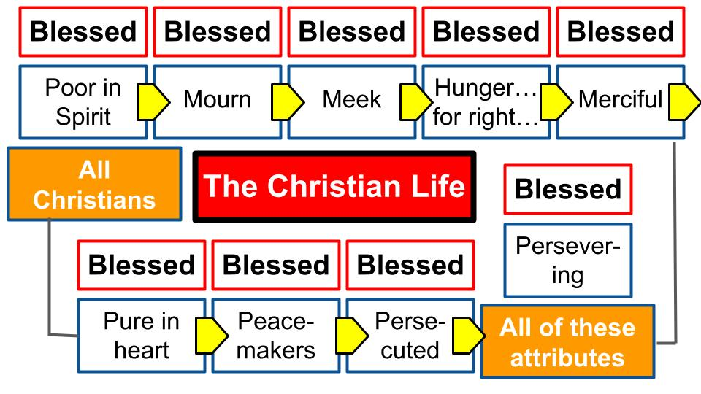
The life that God truly BLESSES is the life of a true follower of Jesus. So, these nine blessed characteristics give us a snapshot of the Christian life.

Martin Lloyd-Jones has an excellent commentary on this called Studies in the Sermon on the Mount. His introduction makes some important observations: first, that these nine characteristics describe ALL CHRISTIANS, not just saints or super-Christians. Every true follower of Jesus must start by being poor in spirit, mourning over their sin and the brokenness of this world and submitting in meekness to the Lordship of Christ. Every genuine Christian will hunger and thirst after RIGHTEOUSNESS. They will first celebrate and be thankful for the righteousness Jesus has given them, but they will also long for and seek MORE of that righteousness. The result of these spiritual roots will be the fruit of a merciful and compassionate heart for others, a purity of devotion and single-mindedness that loves God and His kingdom above all other things and produces a commitment to make peace with people and bring God’s healing shalom to this dark world. And the true believer in Jesus will persevere and endure to the end through all kinds of opposition and suffering and persecution.
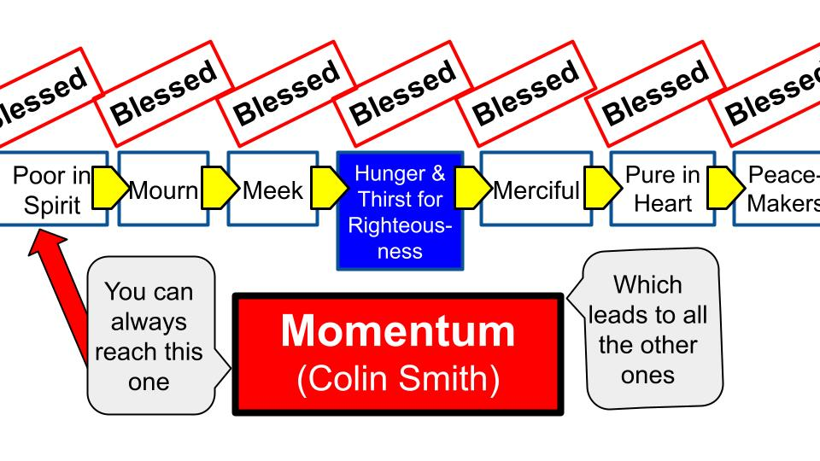
The other pastor and writer who has helped me with the Beatitudes is Colin Smith, who I worked with in Chicago before moving here to Tampa in 2017. His fantastic book Momentum shows the PROGRESSION of one beatitude to the next like someone swinging on rings from one to the other, like American Ninja Warrior.

Pastor Colin helpfully points out that you can’t start with being merciful or pure of heart. Those are too far away to reach at first. But all of us can always reach the first ring: being poor in spirit. All it takes to reach that one is the awareness of God’s glory and holiness in the light of which you see your own weakness and sin. The one who is poor in Spirit knows he or she brings nothing of value to the relationship and simply cries out to Jesus, “Have mercy on me, a sinner.”

Once you grab hold of that first ring – spiritual poverty – it becomes possible for you to swing to the next one – spiritual mourning. This is not just feeling sad. It is a life of repentance and groaning over YOUR SIN, the sins of others and the curse our sin has brought into this world. Pastor Colin also divides the nine beatitudes into three categories.
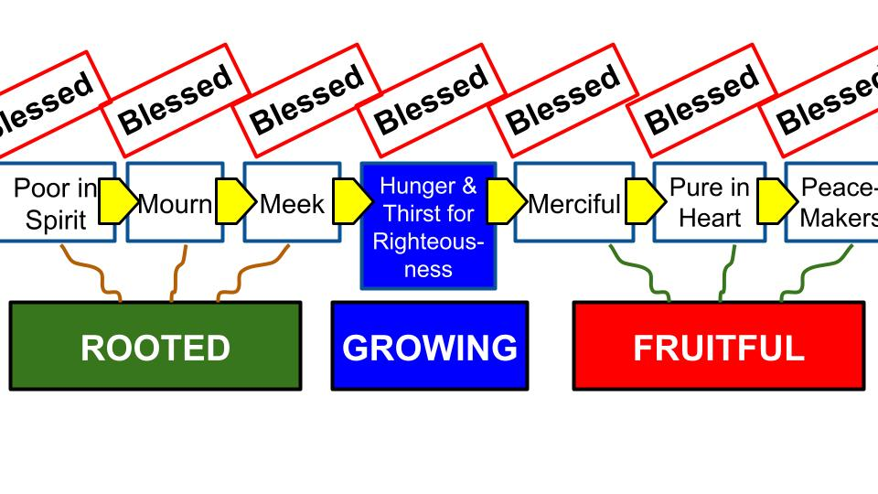
The first three are like the roots of the tree described in Psalm 1. The trunk of the tree is that middle beatitude of hungering and thirsting for righteousness. That is the life of abiding in Christ, not striving to impress others or to achieve a holiness of your own - but a loving relationship with the Lord Jesus that delights in Him above all things and that seeks FIRST His kingdom and righteousness.

Then the fruit of the Spirit will increasingly grow in your heart and life: the fruit of genuine love and mercy for other sinners like you; the fruit of a pure, undivided heart; the fruit of reconciliation, becoming a peacemaker like Jesus; and the fruit of endurance.

That is a preview of what we will be studying and applying for the next eight weeks as we walk slowly through the Beatitudes. This week we will simply reflect on the first one that is a doorway to all the others. In fact, it is the only doorway: being poor in spirit. An old hymn says it beautifully, even if the rhymes aren’t all perfect:
https://www.hymnal.net/en/hymn/h/1058
https://hymnary.org/person/Toplady_Augustus

Rock of Ages (1776)
Nothing in my hands I bring,
Simply to Thy cross I cling;
Naked, come to Thee for dress,
Helpless, look to Thee for grace:
Foul, I to the fountain fly,
Wash me, Savior, or I die.

The author of this hymn, Augustus Toplady, wrote many hymns in the 18th century. He was raised by a single mother in England since his father died in battle around the time that Augustus was born. Mom sent him off to school at an early age and he committed his life to Christ at the age of 16 at a revival meeting in Ireland. He served the church for the rest of his life, writing many hymns along the way, of which this is the most famous by far.

The first line of this hymn sums up beautifully what it means to be POOR IN SPIRIT. Nothing in my hands I bring, simply to Thy cross I cling.

When you come to the Lord, what do you envision in your hands? Do you come to the glorious presence of God with pride in your own devotion, your exemplary service and diligent efforts? Or do you recognize, with the Apostle Paul, that whatever you might have once considered gain you now consider rubbish, just trash? Paul had every reason for “confidence in the flesh,” because of his pure Jewish ancestry, his knowledge of the Torah, his devotion to preaching and protecting the way of the Pharisees. He was advancing ahead of everyone else of his age.

“But whatever gain I had, I counted as loss for the sake of Christ. Indeed, I count everything as loss because of the surpassing worth of knowing Christ Jesus my Lord. For his sake I have suffered the loss of all things and count them as rubbish, in order that I may gain Christ…” Philippians 3:7-8

That is what it looks like to be POOR IN SPIRIT. Extreme humility. Not boasting in anything other than Jesus. “Nothing in my hands I bring. Simply to Thy cross I cling.” Here is how Paul said it to the church in Corinth.

“And I, when I came to you, brothers, did not come proclaiming to you the testimony of God with lofty speech or wisdom. For I decided to know nothing among you except Jesus Christ and him crucified. And I was with you in weakness and in fear and much trembling.” 1 Corinthians 2:1-3

Paul was a bold and confident preacher and leader. But he set all of that aside and chose not to assert himself “in the flesh,” but rather to present Christ and Him crucified. This is why Paul could say in the second letter to Corinth that “God’s power is made perfect in weakness” and “when I am weak, then I am strong.”

We could look at Moses and his insecurity to lead the people of Israel. Or at Gideon who was terrified to lead Israel; or David who said, “Who am I that you should choose me to be king?”

But the greatest example of being poor in spirit is Jesus Himself.

“Who, though he was in the form of God, did not count equality with God a thing to be grasped, but emptied himself, by taking the form of a servant, being born in the likeness of men. And being found in human form, he humbled himself by becoming obedient to the point of death, even death on a cross.” Philippians 2:6-8

Jesus had every reason to be CONFIDENT in His own worthiness - as the fully divine Son of God, the creator and ruler of all things. But Jesus did not cling to His power and privilege. He laid all of that aside, emptying Himself to become fully human and humbling Himself to serve people and lay down His life on the cross. At any moment Jesus could have called down 12 legions of angels to vaporize His enemies and vindicate His glory. But Jesus chose instead to show us what it looks like to be poor in spirit.

“Truly, truly, I say to you, the Son can do nothing of his own accord, but only what he sees the Father doing. For whatever the Father does, that the Son does likewise. For the Father loves the Son and shows him all that he himself is doing… For as the Father raises the dead and gives them life, so also the Son gives life to whom he will.” John 5:19-21

10 chapters later Jesus commanded His disciples to ABIDE in Him as He trusted fully in the Father. To do NOTHING on your own but only what you see God doing. That is poverty of spirit. To trust completely in God and lean not at all on your own understanding. To submit your own desires fully to God’s will saying, “Not my will, but yours be done.”

So let’s look at this first beatitude from two angles. First the WHY then the HOW. Let’s study the two promises regarding being blessed and having the kingdom of heaven. Then let’s consider how to cultivate this attitude and posture of one who is poor in spirit.

Two Promises for the Poor in Spirit:
- Blessing – true Happiness and lasting Joy
“And he opened his mouth and taught them, saying: ‘Blessed are the poor in spirit.’” Matthew 5:2-3

The repeated refrain of all nine of these beatitudes is “Blessed… Blessed… Blessed.” Some translations just say “Happy… Happy… Happy…” This is almost certainly a reference to Psalm 1 and 2.

Two Promises for the Poor in Spirit:
- Blessing – true Happiness and lasting Joy
“Blessed is the man who walks not in the counsel of the wicked, nor stands in the way of sinners, nor sits in the seat of scoffers; but his delight is in the law of the Lord, and on his law he meditates day and night.” Psalm 1:1-2

Psalm 1 presents a contrast between the blessed person who delights in God’s Law and the wicked person who walks with fools and scoffers, rejecting God’s law. The blessed person is like a tree planted by streams that bears continual fruit. The wicked person has the opposite result: being like chaff blown away in the wind.

Psalm 2 ends with the same word with which Psalm 1 opens, creating intentional bookends or framing around this word: BLESSED.

Two Promises for the Poor in Spirit:
- Blessing – true Happiness and lasting Joy
“Kiss the Son, lest he be angry, and you perish in the way, for his wrath is quickly kindled. Blessed are all who take refuge in him.” Psalm 2:12

There are two Hebrew words for “blessed.” Baruk is the one used in priestly blessings, like the high priestly prayer in Numbers 6, “The Lord bless you and keep you…” The one used in Psalm 1-2 is the more common word, “Asherey,” which means more generally “happy.”

The Bible project therefore translates the beatitudes with the phrase, “The good life.”

Two Promises for the Poor in Spirit:
- Blessing – true Happiness and lasting Joy
“The Good life belongs to those who are poor in spirit.” Matthew 5:2-3

That’s a clever way to get at the Hebrew idea of “Asherey.” Baruk is a much more spiritual term that conveys God’s holiness and purity and the Jewish priesthood as intermediaries of these blessing. Those ideas are certainly in the background here in the beatitudes. But the primary meaning is more like “the good life,” or our word “happy.”

But clearly Jesus doesn’t just mean temporarily happy in the things of this world. He means truly, genuinely, deeply happy through a spiritual joy that can only be found in Him. He is referring to the living water he talked about with the Samaritan woman at the well: spiritual water you can drink, and your SOUL will be satisfied. Here is how Jesus described this water:

Two Promises for the Poor in Spirit:
- Blessing – true Happiness and lasting Joy
“Everyone who drinks of this water will be thirsty again, but whoever drinks of the water that I will give him will never be thirsty again. The water that I will give him will become in him a spring of water welling up to eternal life.” John 4:13-14

Oh, to never thirst again! Oh, to have this deep and lasting joy and satisfaction that can only come from the Lord Jesus!

This is why we want to be poor in spirit. The first of our two reasons. Because only to this kind of person does this promise apply. Only for those who are poor in spirit is this kind of lasting joy available, and only in the person of Jesus. He alone has this living water. But like the people of Israel long ago, we tend to turn away from Jesus and look for happiness and “the good life” in other places. Here is how Jeremiah said it:

Two Promises for the Poor in Spirit:
- Blessing – true Happiness and lasting Joy in the Lord
“For my people have committed two evils: they have forsaken me, the fountain of living waters, and hewed out cisterns for themselves, broken cisterns that can hold no water.” Jeremiah 2:13

Anything in this world will eventually break down and let you down. Even the best human relationship cannot satisfy your soul forever. Even the best career or vocation cannot make you happy in the deepest, most lasting ways. Even the best vacations and memory-making experiences cannot provide the living water for which our hearts long. That can only come from God. Only Jesus has that living water: that true happiness and lasting joy.

Now the second promise, the second reason to cultivate poverty of spirit.

Two Promises for the Poor in Spirit:
- The Kingdom of heaven – Now and Forever
“Blessed are the poor in spirit, for theirs is the kingdom of heaven.” Matthew 5:3

Jesus announced the arrival of the kingdom of heaven on earth. In the arrival of the King on earth, His kingdom also broke into our dark and fallen world.
- The light of the world stepped into our darkness.
- The Righteous and Holy One fulfilled the Law of God and taught rebellious sinners what it looks like to fulfill all righteousness.
- The Lamb of God came to take our sin into Himself on the cross.
- The Creator allowed Himself to be crushed so we could become whole in Him.

Wherever Jesus rules and reigns, His kingdom is present. Jesus reigns in the hearts of people and where He is King, the presence of God is manifest, the glory of God is unveiled. WE are the temple of the Holy Spirit. It’s no longer about Jerusalem and a fancy building – it’s about followers of Jesus who love and trust Him – that is where the Kingdom of heaven appears.

That’s the key point here: the promise of the kingdom of heaven is not just that you “will go to heaven.” Yes, that is a wonderful perk. But what the verse SAYS is “theirs IS the kingdom of heaven.” Not “theirs WILL BE the kingdom of heaven when they die.” There is an already and a not yet to this truth.

At the moment you put your faith in Jesus, the kingdom of heaven enters YOU.
For all who are citizens of the kingdom, who belong to Jesus, the only place you could possibly live is with Jesus in His kingdom FOREVER.

For those who are citizens of this world, who don’t love Jesus or seek holiness, they would have no interest in living in His kingdom forever – they wouldn’t enjoy worshiping Him; it wouldn’t be heaven to them, it would be miserable, boring and confusing.

So here is our first half summary:

Two Promises for the Poor in Spirit:
- Blessing - true Happiness and lasting joy in the Lord
- The Kingdom of Heaven - Now and forever

Jesus promises blessing to all who trust in and follow Him, and here describes what His followers look like. First, they are POOR IN SPIRIT. This is the gateway attitude and posture of humble faith that is willing to repent and turn from this world to have Jesus as the pearl of great price or the treasure in the field that it is worth selling all you have in exchange for Him. Jesus promises that those who are poor in Spirit are the truly BLESSED ones. They are the ones who have the actual good life. They are happy now and forever because their happiness and joy are found in Him, the fountain of living water.

And when you have the king, you have His Kingdom. Your citizenship changes from being dead in sin and enslaved to the passions and desires of this world and of your flesh to belonging to God’s spiritual kingdom of the skies. You step into a whole new realm of existence. Something deep and personal and real changes IMMEDIATELY when you commit to King Jesus. And with that immediate change comes an eternal change – you will dwell in the house of the Lord forever!

Now let’s shift from the WHY to the HOW.

Two Descriptions of the Poor in Spirit:
- Poor - humble, prayerful Dependence on God
“Seeing the crowds, he went up on the mountain, and when he sat down, his disciples came to him. And he opened his mouth, saying…” Matthew 5:1-2

This introduction to the sermon is important. These are not throwaway, setup words. They set the scene in very important ways. Why a MOUNTAIN, for one thing? Who went up on a mountain and came back with important words from God?
- MOSES!

Yes, Moses. He went up onto Mount Sinai and met with God for 40 days in a thunderstorm. No one else was even allowed to touch the foot of the mountain or they would die. Only Moses. Only God’s appointed mediator: the one God spoke to who went on to speak to the people.

Moses received the ten commandments directly from the hand of God, carved on STONE to illustrate the permanence of those words. In just a few minutes Jesus will make it clear, “I did not come to abolish the law and the prophets but to FULFILL them.”

Moses went up on the mountain with NOTHING and came back with the ten commandments – the heart of the Jewish Law that they would cling to for generations and protect in the ark of the covenant.

The key word here is DEPENDENCE. If you feel RICH in terms of financial resources or in any other area, you don’t NEED help from anyone else. You are INDEPENDENT. But if you are POOR financially or in any other way, you know that you need help.

So when it comes to God and your SPIRITUAL RESOURCES, do you realize how very POOR you are?
- What was one of the main things Jesus warned people about in His teachings?
- What was a key area Jesus came back to over and over again that was a danger to them practically and spiritually?
- I’ll give you a couple of hints:
  - Remember the guy who built bigger barns to store his successful harvest because his previous barns weren’t big enough?
  - Remember the man who had a poor beggar at his gate but never helped him?
  - Remember what distinguished the sheep from the goats in Matthew 25? How the righteous treated the hungry, the thirsty, the sick, hospitalized, those in prison, immigrants and refugees, homeless people… In other words, how did they treat THE POOR.

So, what did Jesus warn us about? MONEY. Being rich. Look at the parallel passage to Matthew’s beatitudes in Luke.

Two Descriptions of the Poor in Spirit:
- Poor - humble, prayerful Dependence on God
“Blessed are you who are poor… But woe to you who are rich, for you have received your consolation. Woe to you who are full now, for you shall be hungry. Woe to you who laugh now, for you shall mourn and weep.” Luke 6:20, 24-25

In Luke’s account, probably Jesus speaking in a different place at a different time, he took out the phrase “in spirit” and just pronounced a blessing on the poor. Now, we know from Scripture that poverty itself is not a blessing. But wealth presents a serious danger to us spiritually because it makes us feel like we don’t NEED God or anyone else.

So, consider: does this blessing Jesus pronounces apply to you? Are you “poor in spirit”? Are you humble? Are you desperately dependent on God? Do you sing in the depths of your heart, “Nothing in my hands I bring; simply to Thy cross I cling”?

Or, if you’re honest, are you among those Jesus warns most severely? Are you wealthy, comfortable, in control, happy? Do you feel blessed APART from God? Apart from the kingdom of heaven?

A key test of our poverty of spirit is PRAYER. The person who is poor in spirit will pray often because he or she knows how much they need from God. The person who is rich in spirit – our word would be confident, or self-assured – would not pray very much because they would deeply believe that they don’t need much, if anything from God.

Two Descriptions of the Poor in Spirit:
- in Spirit - internal Posture of the heart
“And he opened his mouth and taught them, saying, ‘Blessed are the poor in spirit.’” Matthew 5:2-3

To our modern ears this phrasing feels strange and awkward. But Matthew is not just being creative here. He is referencing something in the Old Testament - several passages, really, if you search “open your mouth.” But this one in particular in Psalm 81:

“Hear, O my people, while I admonish you! O Israel, if you would but listen to me! There shall be no strange god among you; you shall not bow down to a foreign god. I am the Lord your God, who brought you up out of the land of Egypt. Open your mouth wide, and I will fill it.” Psalm 81:8-10

In this Psalm God is pleading with His people to listen to His Word, to come to Him for guidance and help. God is lamenting that the Jewish people kept looking to other nations and other gods instead of calling on Him and trusting in His Word. Read all of Psalm 81 to get the full context and message.

Two Descriptions of the Poor in Spirit:
- in Spirit - internal Posture of the heart
“And he opened his mouth and taught them, saying, ‘Blessed are the poor in spirit.’” Matthew 5:2-3

Here is Jesus – the eternal Word of God - opening His mouth to feed His people. And the first word the Lord spoke was “Blessed.” This is where to find blessing. This is where to find joy; the good life. Right here: in me, Jesus says. You’ve come to the right place!

It’s so important that we read this whole phrase: “Blessed are the poor IN SPIRIT.” Yes, in Luke 6 Jesus contrasts blessings and woes on the poor and rich. But we would have to study that whole passage in its context to dig more deeply into it. Here Jesus makes it clear that the entryway to true blessing is spiritual poverty.

Scripture makes it clear that material poverty is a bad thing to be avoided. Just read the proverbs. Read the Old Testament. God warned His people over and over again of judgment that would come upon them for rebellion and disobedience. The exile from the land, the 70 years of captivity in Babylon, was an AVOIDABLE event. If the Jews had only listened to God’s warnings and appeals through the prophets. If they had only trusted in God’s Law and obeyed His instructions.

The Bible is also clear that money and wealth are DANGEROUS. Paul writes in 1 Timothy 6:

“But if we have food and clothing, with these we will be content. But those who desire to be rich fall into temptation, into a snare, into many senseless and harmful desires that plunge people into ruin and destruction. For the love of money is a root of all kinds of evils. It is through this craving that some have wandered away from the faith and pierced themselves with many pangs.” 1 Timothy 6:8-10

CONTENTMENT. That is the key. Knowing how to rejoice whether you have plenty or whether you have next to nothing. It is not money itself that is a problem it is the LOVE of money that “is a root off all kinds of evils.” See? It’s a HEART ISSUE, not a bank account issue. It’s like any kind of idolatry: a craving that you let grow into an addiction and a form of love and dependence that replaces God.

Two Descriptions of the Poor in Spirit:
- in Spirit - internal Posture of the heart
“And he opened his mouth and taught them, saying, ‘Blessed are the poor in spirit.’” Matthew 5:2-3

It’s a matter of the heart: of the inner YOU. Spirit, mind, heart and soul are terms used interchangeably in the Bible to refer to the internal part of you – the real you – your spiritual self.

Is that inner part of you POOR or rich? Humbly dependent or proudly independent?
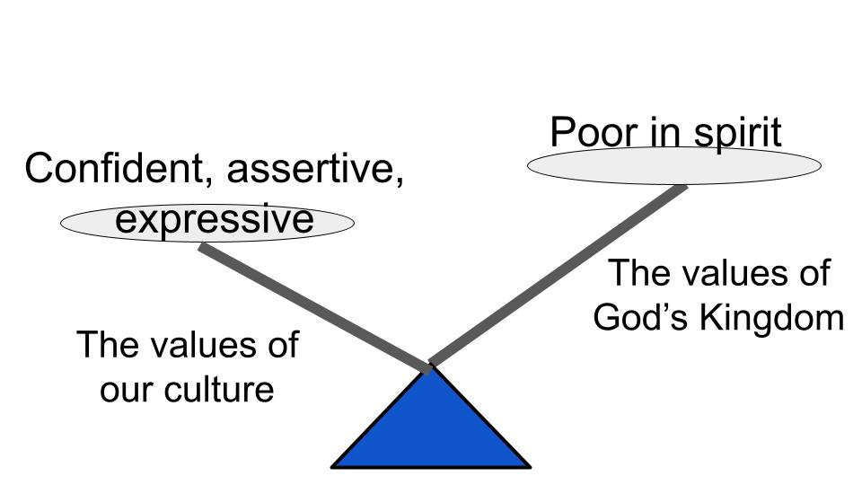
It’s vital that we see how completely counter-cultural these beatitudes WERE in Jesus’ day and still are today. Our culture starts training young children to “be yourself,” and “Let it go” if anyone tells you otherwise and “express yourself,” because you “believe in yourself.”

But Jesus says, “Blessed are the poor in spirit.” So here is our summary for today.

Two Promises for the Poor in Spirit:
- Blessing - true Happiness and lasting joy in the Lord
- The Kingdom of Heaven - Now and forever

Two Descriptions of the Poor in Spirit:
- Poor - humble, prayerful Dependence on God
- in Spirit - internal Posture of the heart

First, we saw two promises for those who ARE poor in spirit. These are the people who are truly blessed, who have true happiness and lasting joy which are only found in the Lord. Not only are these the people God blesses, but these are the ones who HAVE the kingdom of heaven. Not just that they will GO to heaven. But “Theirs IS the kingdom of heaven.” We become citizens of heaven right away - as soon as you commit to Jesus as Lord!

So, what does it mean to be poor in spirit? How can you know if this is you? Well, poor means poor. Not rich. Not wealthy, strong and independent. Instead weak, poor and utterly dependent on God. These are the humble ones, the little children, the ones who cry out to God in desperate faith and know they need Him every minute of every day. And this poverty is not about physical, financial poverty, it’s the internal posture of your heart. It’s about who you are deep inside. “Nothing in my hands I bring; simply to Thy cross I cling.”

Is that you?

Now, as we close, let’s come back to one of the slides we started with earlier. It’s important that we see all nine beatitudes as a PACKAGE and a PROGRESSION.

All nine of these attributes describe every true believer. If you follow Jesus, these will increasingly become true of you, just like the FRUIT OF THE SPIRIT, which are also a package deal. Love, joy, peace, patience, kindness, goodness, faithfulness, gentleness and self-control.

Pastor Colin describes it this way in Momentum. He says the beatitudes describe what a true Christian looks like. It’s like Jesus says, “This is a sandhill crane: long legs, extended beak, red forehead, rusty wings when young that become fully gray.”

You could take a blue heron, duck tape on some stilts and paint its head red, but you wouldn’t thereby change it into a sandhill crane. It would still be a heron, just with some social awkwardness around the ladies.

Do you see the point? Don’t read the beatitudes with a bucket of red paint. Jesus is NOT saying, “Make yourself more merciful. Grit your teeth and become more pure in heart.” It is so important that these aren’t the BE LIKE THIS OR DIE - atudes.

This list is Jesus’ description of what a citizen of His kingdom looks like. How does He know? Because He makes us this way when we are born again into His kingdom. He plants His Spirit inside your heart and the Spirit begins to change you so you look like this. Not like a sandhill crane, I hope, but like this.
The longer you walk with Jesus the more these things will describe you. It’s like Jesus gives you His robe as your big brother and walks ahead of you, encouraging you that you will grow into it. And you will!

And it all begins with being poor in spirit. That’s the gateway. It’s the entry point. It starts with humility and desperation. You can always reach that one, even if all the others seem painfully out of reach. We will take them one at a time.

The main application for today is, don’t look at yourself. Look at God. The more you are captivated by the glory of God the more poor in spirit you will become. If you focus on yourself, you will tip either toward pride or despair. Both are bad. If you focus on God, His glory, His love, His faithfulness, His holiness, you will quickly come to see yourself more clearly in the light of His glory.

The true follower of Jesus has seen the glory of God and has realized, “Nothing in my hands I bring; simply to Thy cross I cling.” We say with Isaiah, “I am undone. I am a man of unclean lips and I live among a people of unclean lips.” We say with David, “Against you, and you alone, Oh Lord have I sinned and done what is evil in your sight.” We say with Peter, “Depart from you Lord, for I am a sinful man.” We say with the tax collector, “Have mercy on me, a sinner.”

Let’s pray as those who are poor in spirit.

