The Meek
Matthew 5:1-10

We are intentionally reading the whole passage of the beatitudes every week so we experience the flow and progression of this powerful introduction to Jesus’ sermon on the mount. Let’s review the last couple of weeks.

Two Promises for the Poor in Spirit:
- Blessing - true Happiness and lasting joy in the Lord
- The Kingdom of Heaven - Now and forever

The repeated refrain of the beatitudes is BLESSED. Jesus is showing us where to find true happiness and lasting joy, and that is in Him and Him alone. There is no other place to find this LIVING WATER: only in the Lord Jesus. The beatitudes open and close with the promise of the KINGDOM of heaven. Those who are poor in spirit – who humbly cry out to the Lord Jesus to forgive them and let them in to His kingdom – gain entry to this place and really this condition of everlasting life. The promise is granted immediately to those who profess their faith in Jesus, and it is a promise of living with Jesus in His kingdom FOREVER.

Do you want the life God truly blesses? Do you want to live in the kingdom of heaven forever? This is the kind of person you must be. First, you must be POOR in spirit. What does that look like?

Two Descriptions of the Poor in Spirit:
- Poor - humble, prayerful Dependence on God
- in Spirit - internal Posture of the heart

To be RICH is to be confident and to feel powerful on your own, apart from Christ. Jesus said it is impossible for a rich person to enter His kingdom, partly referring to those who are materially wealthy but mostly referring to those who have no sense of felt need for a Savior. It is not the healthy who need a doctor but the SICK. It is not the religious Pharisee who goes home from the temple justified before God but the sinful tax collector who simply says, in the poverty of his spirit, “Have mercy on me, a sinner.”

The blessing for the poor is not about material, financial conditions. It is about the internal, spiritual attitude of the heart. Is this you? Are you POOR IN SPIRIT? This is very un-American. The American way is to be confident, to be bold, to be assertive: to be yourself and don’t let anyone get in your way. Pastor Colin Smith has an excellent book called Momentum that describes poverty of spirit this way:

“People who are poor in spirit know that they’re a small blip on the radar screen of eternity. They know God is glorious and awesome in His holiness. They know He owes them nothing, and they see that, even if viewed at their best, they’re unworthy servants who completely depend on His mercy.” Momentum, Colin Smith

To be poor in spirit is to come to the Lord with EMPTY HANDS: to recognize that we deserve nothing from God but His judgment. We don’t bring worthiness or power or anything of value. We are poor. God is rich. We have nothing. He has everything. “Nothing in my hands I bring. Simply to thy cross I cling.”

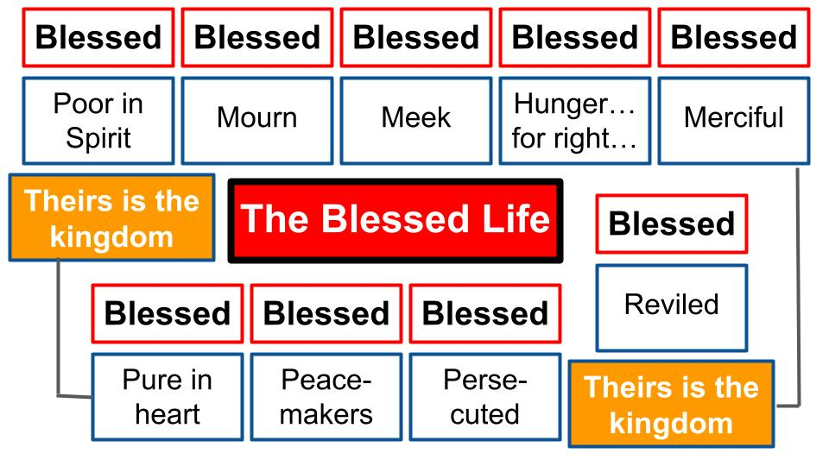
That is the gateway to all the blessings Jesus offers: humble faith, humble dependence on the Lord Jesus. The beatitudes have a very intentional order. You can’t jump directly to being pure in heart or being a peacemaker. You have to develop the character of Jesus by starting with humble faith and moving through the other qualities as the Holy Spirit enables you.

Last week we saw what it means to MOURN. This is not about being sad and depressed all the time, like all Christians should be Eeyore, moaning all the time about how bad your life is and how bad the world is: “Oh well, we’ll all be dead soon anyway… I’m sure it will rain again and we will catch colds be miserable. That’s how it always goes. No point fussing about it.” No, Jesus has something specific in mind when it comes to mourning.

Once Jesus starts to change you, you will grieve over:
- The Disaster of Your Sin
  - Repent for Specific sins
- The Disaster of the Sins of Others
- The Disaster of the Brokenness of this world

Once you humbly surrender your life to Jesus, trusting Him as Savior and following Him as Lord, He begins to change you and your heart begins to grieve over the things that break the heart of God. Like sin.

First you mourn for the disaster of YOUR OWN SIN. You see the cost of that sin to yourself, to those around you and above all to the Lord Jesus. Why did the Son of God have to die on a Roman cross? Why did He have to endure the full wrath of God and cry out, “My God, my God why have you forsaken me?” Why did He have to drink the cup of the righteous fury of God? Because of your sin and mine. A price had to be paid!

But you don’t just mourn for your own sin, you also grieve over the sins of others – not just in how their selfishness affects you but in how their sin damages their soul and harms this world. Which is the other thing you grieve over: the brokenness of this entire world, which is suffering under the curse of sin and death and evil.

This may not feel like a blessing, to be triply grieved all the time. But there is a fellowship of sharing in the sufferings of Jesus and this blessing is only for those who mourn as Jesus did and as Jesus still does.
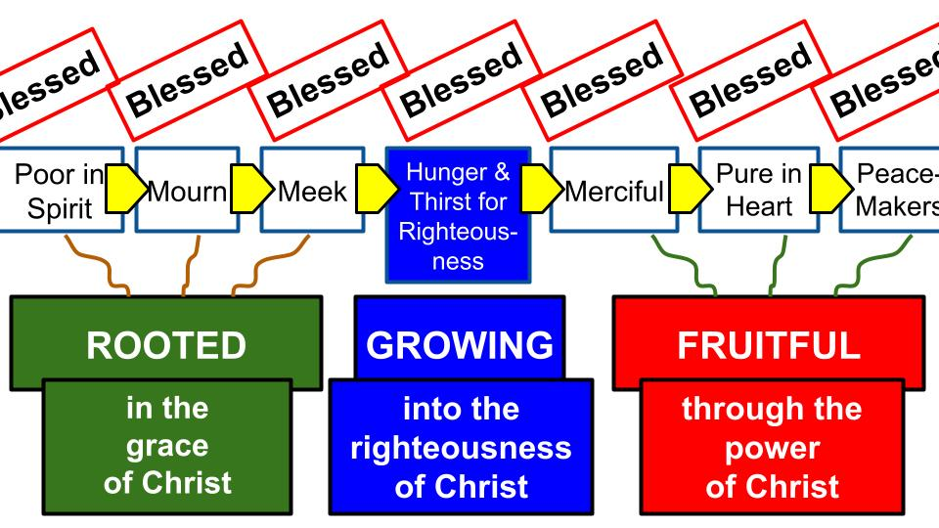
Today we come to the third part of the ROOTS of the Christian life. The first three beatitudes get us deeply rooted in the grace of the Lord Jesus. To be poor in Spirit is to initially express your need for Jesus in personal faith. To mourn over sin is to repent and turn from this world and your own sin to come to Jesus as your King and Savior. And to be meek is mainly to be fully surrendered to Jesus as your Lord. Next week we will see how these roots of faith connect us with the LIFE of Christ and His Holy Spirit so we can grow intentionally and continually as we hunger and thirst for righteousness.

The beatitudes are not about being PASSIVE – just sitting back and letting God zap you with holiness. No. These spiritual blessings are a pathway of ACTIVE faith-filled OBEDIENCE. Jesus is giving us a map for how to grow in Him: not pursuing a righteousness of our own as if we could earn God’s favor by works. Not at all! The first three beatitudes connect us by faith alone to the infinite grace of the Lord Jesus who declares us righteous in Him. Then as Jesus begins to change us from the inside out, our desires change and the Holy Spirit helps us to increasingly DESIRE more of His righteousness, holiness, goodness, faithfulness and love. All the fruit of the Spirit!

So what does it mean to be MEEK? This is probably the most misunderstood of the beatitudes. Most of us probably think of the word “meek” in English to mean “bashful, withdrawn, quiet and unassuming…” and we translate it in our minds to “WEAK.” But that is not the Biblical meaning.

The one in Scripture other than Jesus who was described as being MEEK was Moses. And no one would read any of the Moses stories and think, “That guy was such a wimp!” Not in my Bible! Moses was the original prophet. The original man of God. The bold deliverer of Israel who spoke truth to power and confronted Pharaoh saying repeatedly on behalf of God, “Let my people go!”

And the ultimate MEEK person was the Lord Jesus Himself. He was anything but weak. He was the embodiment of life and power in a human being. The Creator of all things was born as a helpless human baby. He had to learn his ABCs and 123s. He had to learn to walk. He had to re-learn the Bible. But Jesus was FULLY GOD. He had full access to the divine power of the Godhead and used that power at specific moments like when he calmed the storm at sea or walked on water or raised Lazarus from the dead, or later raised Himself from the dead.

Jesus was the ultimate POWER in the universe and the most powerful human to ever live. Yet He did not flaunt that power, but lived in utter simplicity and servanthood. Philippians 2 describes what true meekness looks like.

“Though he was in the form of God, did not count equality with God a thing to be grasped, but emptied himself, by taking the form of a servant, being born in the likeness of men. And being found in human form, he humbled himself by becoming obedient to the point of death, even death on a cross.” Philippians 2:6-8

The One supreme in power and glory laid all His privileges aside and not only came as a weak and fragile human but laid down His life on the cross. That was not weakness. That was the height of strength, self-control and discipline. That was MEEKNESS in its truest form. Pastor Colin defines meekness not as weakness but as “power under control.” So, if you want one word to define each of the first three beatitudes, here is a suggestion:

Humility > Repentance > Surrender
“Though he was in the form of God, did not count equality with God a thing to be grasped, but emptied himself, by taking the form of a servant, being born in the likeness of men. And being found in human form, he humbled himself by becoming obedient to the point of death, even death on a cross.” Philippians 2:6-8

To be poor in spirit is to be truly humble, recognizing you bring nothing to the relationship with God. To mourn is to grieve over your sin and to genuinely repent, turning from your sin and taking hold of Jesus in faith. To be meek is to surrender all you are and all you have to the Lord Jesus. The analogy Pastor Colin uses is of a horse that is broken and submitted to its rider. Horses are not weak, but their power must be controlled, submitted. An unbroken horse is dangerous to be around; its power is unpredictable. But a well trained horse is MEEK, it is “under the hand,” submissive to the guidance and promptings of its rider.

There is a special promise for those who are meek:

Humility > Repentance > Surrender
“Blessed are the meek, for they shall inherit the earth.” Matthew 5:5

This is incredibly counter cultural and counter intuitive. In this dog-eat-dog world, only the strong survive and the biggest prizes go to the most assertive, the dominant, the aggressive. Not the meek. Not those who serve with humility and sacrifice. But Jesus promises the eternal promised land to this group of people, meaning all of his followers.

We will draw from two passages to see what meekness looks like today. Romans 12:1 for meekness in relation to GOD. And Ephesians 5 for meekness in relation to PEOPLE.

Grateful Surrender to the Lord:
“I appeal to you therefore, brothers, by the mercies of God, to present your bodies as a living sacrifice, holy and acceptable to God, which is your spiritual worship.” Romans 12:1

Humble Service to those around you:
“Giving thanks always and for everything to God the Father in the name of our Lord Jesus Christ, submitting to one another out of reverence for Christ.” Ephesians 5:20-21

Both vertical and horizontal meekness are fueled by gratitude for all God has done for us in Christ. You will not submit and surrender to the Lord apart from a deep and personal experience of His mercy and grace. But once you have been transformed by the infinite grace of Jesus, the only appropriate response is one of wholehearted commitment and surrender.

What Meekness Looks Like:
- Grateful Surrender to the Lord
“I appeal to you therefore, brothers, by the mercies of God, to present your bodies as a living sacrifice, holy and acceptable to God, which is your spiritual worship.” Romans 12:1

First let’s look at the vertical expression of meekness in surrender to the Lord. The book of Romans is the fullest exposition of the gospel in the Bible, which builds to this turning point in chapter twelve. Based on “the mercies of God” described in chapters one through 11, Paul says here is the appropriate response: to present all that you are back to God as a living sacrifice.

We don’t currently practice animal sacrifice. But in Paul’s day it was still a very normal experience. So, people knew what it felt like to choose your best one year old lamb every year at Passover. You couldn’t choose a sick, old, crippled lamb. You had to choose the cutest, healthiest lamb and he had to be one year old. And that process, every year at Passover and usually more than that with monthly and weekly sacrifices as well, made the cost of sin very visible and tangible for the Jewish people in particular.

And if the sacrifice system taught you anything it was that there was no HALFWAY. You couldn’t offer PART of a lamb. You couldn’t just offer a lamb chop or two and keep the rest for yourself. When you brought that lamb, you watched the priest slit its throat and roast the whole thing in fire on the altar.

That’s the picture of MEEKNESS. That is total surrender. “Offer your BODIES as a living sacrifice.” Not just your hand or your big toe. Your whole body. All of you.

- Grateful Surrender to the Lord
  - Every part of you
“I appeal to you therefore, brothers, by the mercies of God, to present your bodies as a living sacrifice, holy and acceptable to God, which is your spiritual worship.” Romans 12:1

Remember, these are the ROOTS of genuine, saving faith.
- Humility, being poor in spirit and recognizing you bring nothing of merit to the salvation equation.
- Repentance: mourning over your sin and the brokenness of this world.
- And meekness as true surrender in personal faith in the Lord Jesus.

Humility. Repentance. Surrender. That’s what it looks like to truly respond to the good news of Jesus described in Romans 1-11.
- Rom. 3:23 - “All have sinned and fall short of the glory of God.”
- Rom. 6:23 - “For the wages of sin is death but the gift of God is eternal life in Christ Jesus our Lord.”
- Rom. 5:8 “But God demonstrates his own love for us in that while we were still sinners, Christ died for us.”
- Rom. 10:9-10

- Grateful Surrender to the Lord
  - Every part of you
“If you confess with your mouth that Jesus is Lord and believe in your heart that God raised him from the dead, you will be saved. For with the heart one believes and is justified, and with the mouth one confesses and is saved.” Romans 10:9-10

In order to be saved, notice what you have to CONFESS and believe: that Jesus is LORD. If you make that confession out loud and believe that Jesus died for you and rose again; if you really mean it, then Romans 12:1 will be your natural response because of the gratitude that will fill your heart as you have come to understand the fullness of God’s grace to a wicked sinner like you.

- Grateful Surrender to the Lord
  - All the time
“I appeal to you therefore, brothers, by the mercies of God, to present your bodies as a living sacrifice, holy and acceptable to God, which is your spiritual worship.” Romans 12:1

As those who realize the infinite mercy and grace of God to us in Christ, who died for us and rose victorious over sin and death forever, we surrender every part of ourselves to The Lord ALL THE TIME.

Is this true for you? Are you a LIVING SACRIFICE?

Is your whole life, all the time, every part of you, every minute of every day, devoted to the service of King Jesus? That’s what it means to be MEEK. It means you realize your life is not your own. You were bought with a price, so you know your life belongs to Jesus now and you are simply a steward, managing your minutes and days.

A good test for this is how we walk through suffering. If you still think your life is your own, pain and suffering and loss will be difficult for you. You may believe that God OWES you something. That’s the mindset of RELIGION. You do things for God with the expectation that He will do things for you. If you believe you’ve given enough money and said enough prayers and read your Bible enough and been nice to your neighbors enough - with a mindset of religion – you may really struggle with illness or loss, because you may begin to question the goodness or power of God. Why is He letting you down?

But not if you are MEEK. The meek person is fully surrendered to the Lord. Every part of your heart, soul, mind and strength is devoted to Him. So if He wants to give me just five more minutes in this dark world and then call me home, that’s up to Him not me. If he wants me to live another 50 years in this rickety old body, struggling all the way, that –too – is His prerogative. My life is not mine. It is HIS.

- Grateful Surrender to the Lord
  - Set Apart for God alone
“I appeal to you therefore, brothers, by the mercies of God, to present your bodies as a living sacrifice, holy and acceptable to God, which is your spiritual worship.” Romans 12:1

Think back to that day when you gave your life to Jesus: like your body was a living sacrifice and you placed all that you are on the altar, devoted fully to the Lord alone. Your body, in that moment, was set apart as a holy offering, pleasing and acceptable to God. That was the beginning of your spiritual worship that continues all day, every day. Your life, a holy offering, lifted up to God’s altar in heaven.

Paul always addresses the believers in the churches as SAINTS - holy ones – those set apart for the Lord alone. Do you see yourself that way? Do you see your whole life as a holy and pleasing offering to God? You belong completely to Him, heart, soul and body!

That is the vertical side of meekness: grateful surrender to the Lord. To be meek is to be like a horse that is broken before your Master. You belong to Him. You no longer have any rights, any privileges. You simply serve the Lord.

But the problem with being LIVING sacrifices is that we tend to crawl right off the altar, don’t we? One day we are feeling totally surrendered. The next it’s ME calling the shots. I want to be in charge. I don’t want to take the time to listen for the Lord’s leading. Or maybe I know exactly what He would have me do, I just don’t want to do it…

This is why we need to rehearse the grace and mercy of God, to remind ourselves of His sacrifice for us so we joyfully remain on that altar, continually devoting all we are back to the Lord in worship and service. And those who are surrender to God vertically will find ourselves constantly called to serve the people around us. John says this over and over in His letters, “If you love God, guess what, you will naturally love the people around you.” So let’s look at the horizontal expression of meekness.

What Meekness Looks Like:
- Humble Service to those around you
“Giving thanks always and for everything to God the Father in the name of our Lord Jesus Christ, submitting to one another out of reverence for Christ.” Ephesians 5:20-21

It is significant to notice that meekness and surrender are totally fueled by GRATITUDE, whether expressed in vertical devotion to God or in horizontal service to people. In Ephesians 5 Paul describes what the Christian life looks like; what it means to WALK with Jesus every day. These two verses are a hinge that move the letter into a HOUSEHOLD CODE in which Paul applies the gospel to marriage, parenting and work.

The key word Paul uses here is SUBMITTING to one another. Those who have been shaped by the gospel, who have experienced the overflowing love of the Lord Jesus and realized we were dead in our sin but He rescued us and raised us up from the grave, our gratitude for this mercy and grace will lead us to a life of love and service to the people around us, especially within the church and our own immediate families.

- Humble Service to those around you
  - Starting with your immediate Family
“Giving thanks always and for everything to God the Father in the name of our Lord Jesus Christ, submitting to one another out of reverence for Christ.” Ephesians 5:20-21

Notice it DOES NOT say “submitting to the people you really like who are always kind and loving to you.” Not so much. Submitting to ONE ANOTHER – meaning everyone in your church whether you like them or not, including everyone in your household. Why? Not at all because of how they treat you but entirely out of reverence for Christ.

Humble service is our act of WORSHIP. You are a living sacrifice. What that looks like day to day is exactly what the life of Jesus looked like day to day. He was the ultimate living sacrifice and eventually dying sacrifice, laying down His life for you and for me.

- Humble Service to those around you
  - Starting with your immediate Family
“Wives, submit to your own husbands, as to the Lord… Husbands, love your wives.” Ephesians 5:22,25

Now, some bad characters have taken these verses to mean that wives must submit to their husbands, but the husbands should not submit to their wives. WRONG. The verse that sets up this whole section is verse 21 that is a universal command to ALL BELIEVERS. So, the only way to dodge that command to “submit to one another out of reverence for Christ,” is to say that you don’t answer to Christ – meaning you are not a Christian. If you do follow Jesus and have been changed by His grace, then submission to the people around you is a command not an option, whether you are male or female, married or single, rich or poor.

We already saw that meekness is about surrendering all you are to the Lord in grateful worship and devotion, so how could you withhold from that service a relationship like your marriage? And don’t miss the model for all of us: JESUS. He gave us an example, and all of us are to follow that example by washing each other’s feet and carrying our own cross.

- Humble Service to those around you
  - Starting with your immediate Family
“Now as the church submits to Christ, so also wives should submit in everything to their husbands. Husbands, love your wives, as Christ loved the church and gave himself up for her.” Ephesians 5:24-25

Don’t miss how strong these instructions are. Wives are to submit IN EVERYTHING to their husbands. Not “most things.” Not “when you feel like it.” Not “when he deserves it.” Not “when you agree with his ideas.” EVERYTHING.

Men, lest we stop listening right there, go on to the next verse. LOVE YOUR WIVES in what way? “However you want?” “Whenever you feel like it?” “When she has done enough based on your reckoning.” No. No. No. The model and pattern for loving our wives is “as Christ loved the church,” and in case that wasn’t clear enough, Paul adds “and gave himself up for her.” So, the way we are to love our wives is with submissive, sacrificial, self-giving, unconditional love.

Intense right? That is what meekness looks like. Gratitude fueled, joyful submission to one another, first in your immediate family.

- Humble Service to those around you
  - Following the Sacrificial example of Jesus
“Giving thanks always and for everything to God the Father in the name of our Lord Jesus Christ, submitting to one another out of reverence for Christ.” Ephesians 5:20-21

Our surrender and submission to the Lord in worship and to one another in service is UNCONDITIONAL. It is out of gratitude for all Jesus has done for us and out of reverence for Him above all. Our pattern is to follow His example, to walk in His steps. Listen to Philippians 2.

- Humble Service to those around you
  - Following the Sacrificial example of Jesus
“Do nothing from selfish ambition or conceit, but in humility count others more significant than yourselves.” Philippians 2:3

Again, we need to feel the force of these commands. How much are we allowed to do from selfish ambition or empty conceit? Precisely NOTHING. Not a single thing. Rather, in humility we are to consider other people more important than we are. That is MEEKNESS.

The opposite of meekness is what our culture calls assertiveness or aggression. It is all about doing things from selfish ambition because you consider yourself more important than others. We have to keep going on Philippians 2.

- Humble Service to those around you
  - Following the Sacrificial example of Jesus
“Let each of you look not only to his own interests, but also to the interests of others. Have this mind among yourselves, which is yours in Christ Jesus.” Philippians 2:4-5

The natural human condition is to look out for your own interests. Selfishness is baked into this world. You don’t have to train a small child to grab a toy from a sibling or take the best spot on the merry go round or the best color popsicle from the container. You have to very intentionally and consistently train your young kids to think of others, to put the needs and desires of others ahead of their own.

How? By showing them what the Jesus life looks like and by helping them embrace that mindset as their own. The mindset of meekness. “Have this mind which is YOURS already in Christ Jesus.” The attitude of submission and service.

Philippians 2 goes on to describe how Jesus humbled himself and submitted to the Father’s will by taking on full humanity and then dying on a cross. So our model, our example of true meekness is crucifixion. Self-sacrifice.

HOW can we possibly do this? The answer is back in Ephesians 5, just before the command to submit to one another in everything.

- Humble Service to those around you
  - Empowered by the Holy Spirit
“Be filled with the Spirit, addressing one another in psalms and hymns and spiritual songs, singing and making melody to the Lord with your heart…” Ephesians 5:18-19

The only way to surrender all you are to the Lord and to serve others humbly and sacrificially is if you are FILLED with the Spirit! There is no way in our own strength to force ourselves to this kind of vertical worship and horizontal service. You can’t will your way to meekness. The Holy Spirit has to grow this fruit in us.

The phrasing is so important here. It doesn’t say “FILL YOURSELF” with the Holy Spirit, but to BE FILLED. Only God can fill you with His Spirit. You can’t do it yourself, you can’t manipulate the system. It isn’t a karma type situation where you are so impressively hard working and spiritual that God has to fill you with power and wisdom and love. No. The way to be filled with the Spirit is clearly expressed back in Paul’s prayer in Ephesians 3.

- Humble Service to those around you
  - Empowered by the Holy Spirit
“Being rooted and grounded in love, may have strength to comprehend with all the saints what is the breadth and length and height and depth, and to know the love of Christ that surpasses knowledge, that you may be filled with all the fullness of God.”
Ephesians 3:17-19

This is the PRAYER OF FAITH – simply trusting in the finished work of Christ, experiencing the overflowing, infinite quality of His love for you. If you know that love personally, deep in your heart, and if you pray for the Lord to fill you, that is how to be filled “with all the fullness of God.”

So here is our summary for today:
What Meekness Looks Like:
- Grateful Surrender to the Lord:
- Every part of you
- All the time
- Set apart for God alone
- Humble Service to those around you:
- Starting with your immediate Family
- Following the Sacrificial example of Jesus
- Empowered by the Holy Spirit

Meekness is first vertical, gratefully surrendering all you are as a living sacrifice to the Lord. Every part of you, placed on the altar of worship, committed joyfully and gratefully to Him alone and Him above all. This isn’t just a one-time thing and then your life is your own again. This is all of your life, all the time, being set apart for God alone. At the moment of saving faith, you become a holy one, a saint, set apart for God.

Vertical meekness naturally produces horizontal meekness in humble service to the people around you. This begins with the people closest to you – in your marriage, parenting and work. You submit to one another out of reverence for Christ. The model for our submission and service is Jesus Himself “who loved us and gave Himself for us.” So according to Philippians 2 we are to “do NOTHING from selfish ambition or empty conceit but to embrace the mindset of Jesus who humbled himself and followed the path all the way to death on the cross.”

And don’t miss the wonderful promise for those who are meek!

The Promise for those who are meek:
“Blessed are the meek, for they shall inherit the earth.” Matthew 5:5

It is not the aggressive or selfish or domineering who will inherit the new heaven and new earth. It is the MEEK who will dwell in the land forever.

It sure seems like the strong survive and “to the victor belong the spoils.” But the kingdom of God is upside down. It is the poor who are rich; the weak who are strong; the servants who are the greatest, and the meek who win in the end.

This requires a strongly established FAITH in the Lord Jesus to let go of your desires and perceived “rights” to grab all you can while you can. For those who trust in the Lord with all of our hearts, we can let go of this whole world and seek His kingdom first and foremost, surrendering all we are and all we have first to God and then to each other in service and loving, joyful sacrifice.

The only way we will become like this is as we see how JESUS was like this and realize that is why He died for us and gave up all He had for us. When we see just how MEEK Jesus was, not insisting on any of His rights, then we can be meek ourselves.

Let’s pray.

