Blessed are the Merciful
Matthew 5:7
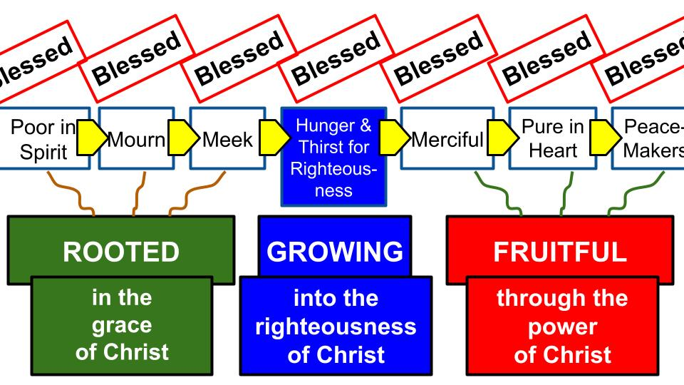
We have seen the symmetry and progression of the beatitudes, first the roots of faith, then the life of faith that produces growth, now we see the FRUIT of genuine faith in Jesus, giving us mercy for others, pure hearts and the ability to make peace with the people around us.

It is vital to maintain the gospel orientation of the beatitudes and not turn them into a new set of laws like “BE poor in spirit… BE those who mourn… BE meek… Be merciful. BE pure in heart. Be peacemakers.” And then you will be blessed. No. First of all, that’s not the way Jesus taught them. And second, that would contradict the rest of the New Testament and the good news of salvation by grace alone through faith alone in Christ alone. Paul said it this way in Galatians:

“Did you receive the Spirit by works of the law or by hearing with faith? Are you so foolish? Having begun by the Spirit, are you now being perfected by the flesh?”
Galatians 3:2-3

Salvation is by faith alone from start to finish. It’s not that we begin with faith in Jesus and then perfect ourselves by good works. Paul calls that “THE FLESH.” And our best efforts and willpower and good intentions do not add anything to our salvation. That is the grace of God and His powerful work from beginning to end. Jesus is the alpha and the omega, the author and finisher of our faith. A few verses later Paul concludes:

“For all who rely on works of the law are under a curse; for it is written, ‘Cursed be everyone who does not abide by all things written in the Book of the Law, and do them.’ Now it is evident that no one is justified before God by the law, for ‘The righteous shall live by faith.’” Galatians 3:10-11

In Paul’s day it was a question of Jewish customs like the sabbath, annual festivals and food requirements. Oh, and circumcision. That was a big one. But Paul makes it very clear, here and in Romans, that if you trust in the Law (even the Law of Moses which Paul insists is good), you are under a curse and obligation to obey every last word of it. And that none of us can do. If anyone got close it was Paul himself.

So let’s be sure we don’t make the mistake of the Judaizers in the early church and create a new set of laws that believers must obey for us to consider them “saved.” At times in recent history different rules and requirements pop up that are presented this way, possibly related to alcohol or music styles or the interpretation of certain doctrines. I’m sure you see the point with the beatitudes and the sermon on the mount. Jesus didn’t say and we are not saying that there are 9 laws or 100 laws you must follow so that God will accept you. No. Jesus said and we are saying that if you trust fully in Him, He will begin to change you by His grace and His Spirit and you will more and more look like Him with these characteristics.
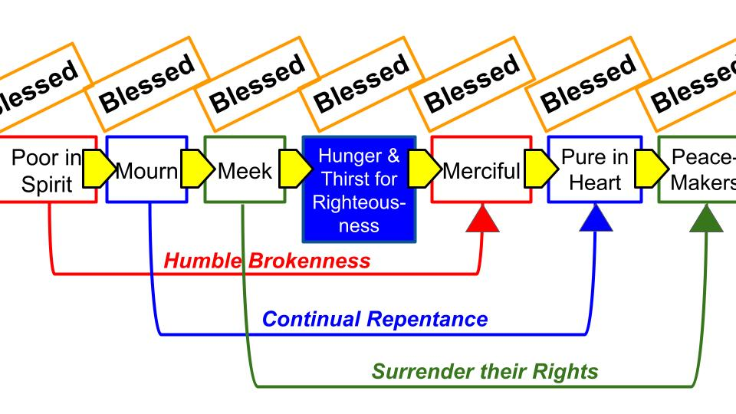
As we move now to the FRUIT of the beatitudes, let me show you another fun detail about how the beatitudes are arranged. There is a clever and intentional PROGRESSION Jesus presents here that was pointed out in the commentary by Dr. Martin Lloyd Jones Studies in the Sermon on the Mount. First, MLJ argues that the Beatitudes are sequential, each one necessary for the ones that follow after. Then he points out this connection between ONE and FIVE, TWO and SIX, THREE and SEVEN.
- There is a special necessity of being poor in spirit if we are to become merciful. Only when you humble realize your desperate need for grace from the Lord will you be truly compassionate to the sins and needs of others.
- There is a similar necessity to mourn over your sin and truly repent if you want to become truly pure in heart. Only a deep awareness of your own sin will enable you to resist those sins and grow in loving God with all of your heart.
- Finally, to become a peacemaker who reconciles relationship with others you must be truly meek yourself. Only one who understands submission and surrender of your own rights will be able to ask for such surrender from others.

Dr. MLJ says it’s important not to get too worked up over structural connections like these but I find them very interesting and significant. It mainly confirms the sequential beauty of the beatitudes but it also shows the interwoven connections: how all of the expressions of the character of Christ intersect with the others in important and beautiful ways.

Today we will study and pray for more of the MERCIFUL heart of Jesus.

“Blessed are the merciful, for they shall receive mercy.” Matthew 5:7

Each of the beatitudes fits with all the others as a synopsis of the gospel and the character of Christ. But each of the beatitudes also stands alone as its own jewel in the crown of King Jesus.

Who will receive mercy from the Lord Jesus? Only those who show mercy. Again, this is not a law. It is not karma. It is not a good work that you do and thereby earn your salvation. Imagine if that was the case. How would you ever know you had been merciful and compassionate ENOUGH?

Matthew 25 could be read that way, with Jesus saying the way we treat the poor and vulnerable is how we treat Him and will determine our eternal destiny. “Whatever you did for the least of these brothers of mine you did for me.”
- The hungry, the thirsty, the immigrants, the incarcerated, the sick, the homeless.

If you devoted your entire life, like Mother Theresa, to serving the poor and caring for the sick and dying, would you thereby EARN your salvation? Could you ever have certainty and assurance of salvation based on having done ENOUGH? Isn’t there always “a little more,” you could do or could have done? Mother Teresa had mangled feet because whenever a box of shoes came in she gave them all away and wouldn’t take new shoes for herself, so she always had old broken-down shoes that didn’t fit her and didn’t protect her feet. You can google “Mother Teresa’s toes” and see for yourself.
https://covdio.org/mother-teresas-toes/

I am not at all trying to diminish the love and sacrifice of a long time missionary and servant like Mother Teresa. What I am trying to make clear is that no amount of service and sacrifice can SAVE you. If someone is here today who is feeling called to overseas missions along the lines of Mother Teresa, by all means, join a missions organization, visit a poor area in the world and follow through on your call to serve. But don’t for one second believe that your commitment, your sacrifice, your service will add a single point to your salvation. Your forgiveness was purchased with the blood of Jesus, and all you do your entire life, no matter how noble and heroic, cannot add to a single drop of His blood.

Ok then. So, what does this beatitude mean? Only the merciful ones will receive mercy. Let’s turn just one chapter later to hear Jesus say the same thing in a slightly different way.
“For if you forgive others their trespasses, your heavenly Father will also forgive you, but if you do not forgive others their trespasses, neither will your Father forgive your trespasses.” Matthew 6:14-15

We will get to this in a few weeks. It comes right after the Lord’s Prayer where Jesus taught us to pray, “Forgive us our debts as we have forgiven our debtors.” Again, this is not a law you must obey for a certain amount of time and to a certain degree of sincerity and thereby earn your salvation. Again, how would you ever know if you had forgiven enough people sincerely enough? One major problem with salvation by works, aka RELIGION, is that there is no way to know “how good is good enough.”

Thankfully, that’s not what Jesus is teaching here. The point of being merciful and receiving God’s mercy is the same as being forgiven and then forgiving others. It’s about experiencing the infinite, miraculous grace of Jesus. Once you realize the extent of His mercy to you, how much Jesus has forgiven you, it would be completely bizarre if you didn’t have mercy on others and be quick to forgive them.

Later in Matthew Jesus teaches a parable about a man who is forgiven like 5 million dollars in debt. But he turns around and nearly beats to death a guy who owes him 5 measly dollars. 5 bucks. One Starbucks drink. Ok, half of one. The rich man who forgave him the 5 million fins him and is like, “What are you doing? Don’t you have any idea what it cost me to forgive you? And here you are beating up a friend of yours for just a few dollars?”

Do you know how merciful God has been to you? Do you realize how much it cost for God to forgive all your sins? If you do, it will make you very compassionate to other people and quick to forgive them when they sin against you. Flipped around the other way, if you DON’T have mercy and compassion for people and if you DON’T forgive people when they sin against you it reveals something deeply wrong with your heart: that you have not really experienced the mercy and grace of Jesus. In other words, you aren’t a Christian. You haven’t been born again. The grace of Jesus hasn’t yet started to change you.

And that’s what the beatitudes show us: what a true follower of Jesus looks like! Someone who is poor in spirit, who mourns over their sin, who is meek and submissive to God and others, who hungers and thirsts after righteousness. With those roots in place, growth will naturally begin to happen and the Holy Spirit in your heart will begin to produce the fruit of mercy and compassion for others, of purity of heart, meaning sincere devotion to God above all and of being a peacemaker who reconciles people at war with God and others. You become an ambassador of the kingdom to the blind, struggling and dying in this dark and broken world.

So what does it mean to be MERCIFUL? We will see there are two important sides to a merciful person: first a genuine compassion for the needs of others and second a willingness to ACT on behalf of those people. We will draw these principles from two parables later in the ministry of Jesus. Let’s start with the inward component of true compassion then go on to the outward actions that flow from a merciful heart. We pick up the first account in Luke 10.

And behold, a lawyer stood up to put him to the test, saying, “Teacher, what shall I do to inherit eternal life?” 26 He said to him, “What is written in the Law? How do you read it?” 27 And he answered, “You shall love the Lord your God with all your heart and with all your soul and with all your strength and with all your mind, and your neighbor as yourself.” 28 And he said to him, “You have answered correctly; do this, and you will live.” Luke 10:25-28

This is fascinating. Jesus grants, for the sake of argument, that perfect obedience to the Law of Moses could earn you salvation and eternal life. If you truly love God with all of your heart, soul mind and strength and love your neighbor as yourself, you will earn a spot in heaven and live forever with God. In other words, Jesus says, “Go for it. Let me know how it goes.” As you can imagine, that’s not the end of the story.

But he, desiring to justify himself, said to Jesus, “And who is my neighbor?” Luke 10:29

Now we see the lawyer’s motives: to justify HIMSELF. No offense to lawyers, but they don’t get any good press in the ministry of Jesus. This guy wanted to TEST Jesus and thought he could outsmart this backwater Rabbi with one of their impossible questions from seminary. “What must I do to be saved?” Since Jesus granted his answer from the Law of Moses, the lawyer went on to the follow-up, equally impossible question: WHO is my neighbor? In other words, is EVERYONE my neighbor? Are we all supposed to serve everyone in the whole world? Are we all commanded by the Law to embrace a vow of poverty and give all we have to the poor all the time?

To answer this question, Jesus tells a provocative and memorable story.

Jesus replied, “A man was going down from Jerusalem to Jericho, and he fell among robbers, who stripped him and beat him and departed, leaving him half dead. 31 Now by chance a priest was going down that road, and when he saw him he passed by on the other side.” Luke 10:30-31

What a tragic tale for the evening news! A man is traveling alone and goes through a dangerous ravine, known for the bandits who pounce on unsuspecting travelers. The robbers appear, take everything of value from the man, beat him up for good measure and leave him “half dead.” Just as we are about to lose hope, a priest appears and suddenly we think the beaten-up man will be ok. But even though the priest SAW HIM, he just walked by and kept going. Ouch.

So likewise a Levite, when he came to the place and saw him, passed by on the other side. Luke 10:32

Just as we lose hope when the priest walks by, more hope appears in the form of a Levite. If the priest was too busy, surely the Levite, a temple servant, will help this nearly dead Jewish man! No. Just like the priest, the Levite saw the man there but simply moved over to the far side of the road and passed on by.

Is there no hope for this poor man who was robbed and beaten? Just when all hope seems lost, an unlikely hero appears.

But a Samaritan, as he journeyed, came to where he was, and when he saw him, he had compassion. He went to him and bound up his wounds, pouring on oil and wine. Then he set him on his own animal and brought him to an inn and took care of him. Luke 10:33-34

Do you see that key phrase: “He had compassion”? It means he was moved deep inside, like deep in his gut. His heart was moved. That’s the first part of our definition of MERCY.

- Mercy is a deep internal Compassion for the needs of others
But a Samaritan, as he journeyed, came to where he was, and when he saw him, he had compassion. He went to him and bound up his wounds, pouring on oil and wine. Then he set him on his own animal and brought him to an inn and took care of him. Luke 10:33-34

Mercy begins with a genuine feeling of pity and compassion for someone in need. It’s hard to imagine someone more in need than this man who was robbed, beaten and left for dead. In the story, we assume the beaten-up man is Jewish, which makes it very surprising that the priest and Levite ignore him and even more surprising that a SAMARITAN stops to help him.

The parable of the “Good Samaritan,” has become a cliche in our day, but to feel the force of it we would have to change it to the “Good Terrorist,” or something like that. A pastor and a seminary professor drive by and ignore the person in the bad bike wreck, but a friendly gang member, a compassionate terrorist, a generous bank robber, stops to help the one in need.

Here is Jesus’ conclusion to the story:

- Mercy is a deep internal Compassion for the needs of others
“Which of these three, do you think, proved to be a neighbor to the man who fell among the robbers?” He said, “The one who showed him mercy.” And Jesus said to him, “You go, and do likewise.” Luke 10:36-37

The command in Leviticus is to “Love your neighbor as yourself.” The lawyer here knew that and had wisely combined it with the great Shema in Deuteronomy 6 to love God with all you are. So, Jesus agrees with him and says, “OK. Go do that and you’ll be fine.” Look at the context in Leviticus 19.
And you shall not strip your vineyard bare, neither shall you gather the fallen grapes of your vineyard. You shall leave them for the poor and for the sojourner: I am the Lord your God. You shall not steal; you shall not deal falsely; you shall not lie to one another… You shall not take vengeance or bear a grudge against the sons of your own people, but you shall love your neighbor as yourself: I am the Lord. Leviticus 19:10-11,18
There are more instructions there about not cursing the deaf or cheating the blind, not abusing the poor or giving preference to the poor either. But the key point is that we are talking about your LITERAL neighbor: the person right beside you. And that clearly includes the sojourner, the immigrant who is passing through your land and might want to eat a grape or two.

So here is the first part of our definition of mercy.

- Mercy is a deep internal Compassion for the needs of others
But a Samaritan, as he journeyed, came to where he was, and when he saw him, he had compassion. He went to him and bound up his wounds, pouring on oil and wine. Then he set him on his own animal and brought him to an inn and took care of him. Luke 10:33-34
It is clear how this internal feeling must produce practical action, which is the second part of genuine mercy.

- Mercy produces practical Action to address those needs
But a Samaritan, as he journeyed, came to where he was, and when he saw him, he had compassion. He went to him and bound up his wounds, pouring on oil and wine. Then he set him on his own animal and brought him to an inn and took care of him. Luke 10:33-34

It is possible the priest and Levite were comparably moved in their hearts as the Samaritan was. But if they were, it wasn’t true mercy because they didn’t actually stop to help him. So, if they had a brief feeling of sympathy for the man it wasn’t true mercy in their hearts because they ignored or suppressed it rather than acting on it.

This is why the parable of the Good Samaritan has endured through the ages as a powerful and practical example of true compassion. It is clear, it is memorable and it illustrates what true mercy IS and what mercy ISN’T. Shockingly, as a story told by a Jewish rabbi, the hero of the story is not a Jewish leader but instead a detestable, compromised, idolatrous Samaritan. Let’s turn to Matthew 25 for the external, practical side of Mercy.

- Mercy produces practical Action to address the needs of others
Then the King will say to those on his right, “Come, you who are blessed by my Father, inherit the kingdom prepared for you from the foundation of the world. For I was hungry and you gave me food, I was thirsty and you gave me drink, I was a stranger and you welcomed me.” Matthew 25:34-35

Jesus presents the final judgment in Matthew 25 as the end of the day separation a shepherd does of sheep and goats. Even to us modern people who don’t work regularly with sheep and goats the difference between them is obvious – almost as much so as cats and dogs. It’s a total difference in species; two very different kinds of animals.

Notice the absolute contrast between the sheep and the goats in this final judgment.

Then the King will say to those on his right, “Come, you who are blessed by my Father, inherit the kingdom prepared for you from the foundation of the world.”  v. 34 | Then he will say to those on his left, “Depart from me, you cursed, into the eternal fire prepared for the devil and his angels.” v. 41

The sheep are called BLESSED and are welcomed into God’s eternal kingdom. The goats are called CURSED and are immediately cast into the fires of judgment. And don’t miss the last verse that sums up the destiny of these two groups.

“And these will go away into eternal punishment, but the righteous into eternal life.” Matthew 25:46

Now, this passage is absolutely NOT teaching salvation by works. It’s not that you score points by helping out the poor. It’s that loving your neighbor is one of the surest signs that you actually trust in and follow Jesus.

Jesus said the way to know who his disciples are is by their FRUIT. The first fruit the Holy Spirit produces in a disciple of Jesus is LOVE. Or the synonym used in the beatitudes: MERCY.

- Mercy produces practical Action to address the needs of others
“For I was hungry and you gave me food, I was thirsty and you gave me drink, I was a stranger and you welcomed me.” Matthew 25:35

Mercy is first an internal compassion for the needs of others. But the proof that the compassion is real is that you DO SOMETHING to help with the needs of others. As those poets from the 80s and 90s said so eloquently: Love is a VERB. DC Talk. Classic. They spelled it LUV, but we can forgive them that – they were trying to develop rap as a Christian music genre.

Jesus pronounces a blessing on those who are merciful and promises that those who DO show mercy will receive mercy themselves. We see that blessing spelled out in more detail in Matthew 25, described as eternal life, eternal joy in the Lord in His everlasting kingdom.

Toward the end of the sermon on the mount Jesus warns his disciples about false teachers and says:

- Showing mercy to others is not a work that Earns salvation but a Fruit that grows in the life of one who is saved
“You will recognize them by their fruits. Are grapes gathered from thornbushes, or figs from thistles? So, every healthy tree bears good fruit, but the diseased tree bears bad fruit.” Matthew 7:16-17

This is not just good advice for spotting false teachers; it is true of all people. Healthy trees bear good fruit; diseased trees cannot bear good fruit. Jesus goes on:

- Showing mercy to others is not a work that Earns salvation but a Fruit that grows in the life of one who is saved
“A healthy tree cannot bear bad fruit, nor can a diseased tree bear good fruit. Every tree that does not bear good fruit is cut down and thrown into the fire. Thus you will recognize them by their fruits.” Matthew 7:18-20

One of the recurring principles in the Bible is “You reap what you sow.” The key application of that is in the parable of the soils: everyone will reap what they have sown in terms of the seed of the gospel. Is your heart GOOD SOIL that receives the gospel of King Jesus with faith and allows it to bear much fruit in your life? Or is your heart filled with rocks and weeds, so it is not able to bear fruit for the Lord?

Are you seeing the FRUIT OF THE SPIRIT in your life consistently and growing?

- Showing mercy to others is not a work that Earns salvation but a Fruit that grows in the life of one who is saved
“But the fruit of the Spirit is love, joy, peace, patience, kindness, goodness, faithfulness, gentleness, self-control.” Galatians 5:22-23

Even this list is not comprehensive, but it certainly gives a good idea of the fruit the Spirit of God produces in those who walk with Jesus. And don’t miss the first one: love. The beatitudes give us another list to consider whether those character qualities are visible in us and growing.

- Showing mercy to others is not a work that Earns salvation but a Fruit that grows in the life of one who is saved
“Blessed are the poor in spirit… those who mourn… the meek… those who hunger and thirst for righteousness… the merciful… the pure in heart… the peacemakers.”
Matthew 5:3-9

These are sequential and build on each other or GROW from each other. But it’s also important to remember the beatitudes are a PACKAGE DEAL. If you have JESUS, you will consistently and increasingly have these qualities because the Holy Spirit of Jesus will be sure that you do.

So here is our summary for today:
What it means to be Merciful:
- Mercy is a deep internal Compassion for the needs of others
- Mercy produces practical Action to address the needs of others
- Showing mercy to others is not a work that Earns salvation but a Fruit that grows in the life of one who is saved

Jesus pronounced a blessing on those who are merciful for they are the ones who will receive MERCY from God. What is mercy? It begins inside us as a deep internal compassion or pity for the needs of others. The Good Samaritan shows us that mercy begins with a feeling of sympathy, as for the man who was robbed and nearly beaten to death. But that parable also shows us that true internal compassion will always produce practical action to help the one you are merciful toward.

The beatitudes are not showing us the WORKS we must do to be saved, but rather what a truly saved person looks like. Mercy, for example, is not something you must work hard to show enough of and then God will accept you. No, it is through God’s infinite mercy that Jesus died for you and you are accepted by Him. Then, with the Spirit of God living inside you, He will increasingly help you bear the fruit of mercy, compassion and service to others.

Some of you know the face of Jeremy Renner who played the role of Hawkeye in the Avengers films. He is one of the great characters in these truly epic movies. Back in 2023 Renner had a terrible accident and it was only through a series of miracles that he survived.


This is the snow removal machine that ran Jeremy over as he tried to save his nephew Alex. This is no little snowblower, it was a 14,000-pound machine with heavy duty metal tracks. Those tracks ran Jeremy over and broke 38 bones, crushing his rib cage and making it nearly impossible for him to breathe. Thankfully his nephew was there, and Alex raced to some neighbors who also came to stabilize Jeremy for the 45 minutes it took for an ambulance to get up the mountain to Jeremy’s vacation home in Reno. After 12 days in the hospital Renner was able to return home. It took him several surgeries and months to recover to the point of walking at all. But he was determined to not just walk but to run and act again in action movies.

This is the selfie Jeremy posted just a couple of days after surgery. That bruised eye on his left had popped OUT of his head during the accident and he described looking at one eye with the other eye. You can see why I had to read his whole book.

Renner is very clear in his book what got him through the incident itself and his recovery.
It was LOVE. His love for his family and their love for him. And look at what Jeremy says at the end of the book, summing up what he learned from the whole experience.

“I could have real impact, and this aligned with my deepest love anyway, which is children. I’m the oldest of seven kids and it’s part of my birthright to care about young people; I’d grown up that way, and it is a fundamental element of who I am… I care way more about action – actually doing something screams love and it screams that someone cares.” My Next Breath, Jeremy Renner

Jeremy and his friends and family started a summer camp for foster kids in the region – a haven of love and support for kids who are greatly lacking that kind of support system. They called it Camp Rennervation.

Do you see what this superhero from Hollywood learned – and all he had to do was die and come back to life?!? Love is the main thing: showing mercy and having compassion for other people. And if you care about people you have to DO something to help them.

Now, I wish I could tell you that Jesus was central to this change in Jeremy Renner. Maybe that has become part of his story since he wrote the book last year. There were a couple of small indications of faith in something – the universe, destiny, love itself. Not much recognition of an all-powerful God or a wise and sovereign God. But still, what was clear to Jeremy and what he wanted to share in this book is that love is the main thing life is about and you have to build your whole schedule and priorities around your family and the people you love most and share that love with others as you have opportunity.

Come on people. If Hawkeye can get there, can’t we as well?

Let’s pray.

