Hunger and Thirst
Matthew 5:1-10

We are working our way through the beatitudes, Jesus’ masterful introduction to the sermon on the mount, which was His incredible summation of His kingdom teaching. It was His manifesto, articulating His mission and what His followers would look like and do.
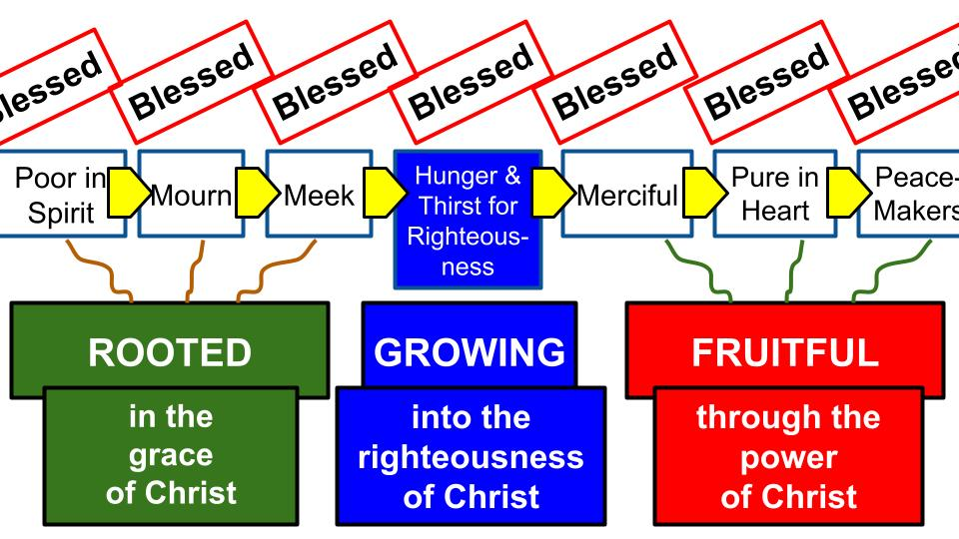
We have seen how the beatitudes are sequential: each one propels you to the next, building momentum in your spiritual life. We have seen that there are three parts, with hunger and thirst right in the middle. The roots of faith produce the FRUIT of faith. In between is the lynchpin - the trunk of the tree, if you will.

Once you have received the seed of the gospel; once you have committed your life to Jesus as your Savior and Lord, you have received His righteousness as a gift, and the Holy Spirit comes to live in your heart to help you GROW more and more into the righteousness of Christ, bearing His fruit. Pastor Colin sums it up this way:

“The mark of a true Christian is not that you feel righteous but that you long to be more righteous than you are.” Colin Smith, Momentum

The feeling of being righteous can quickly become pride and lead to judgmentalism of others that you perceive are not as holy and righteous as you are. True righteousness comes with humility and increasing poverty of spirit that sees your own weakness and sinfulness more and more in the light of God’s perfect holiness, glory and power. That is how Paul, at the end of his life and ministry, could say he was the chief of all sinners. It’s not that he was getting worse as a sinner, it’s that he was more and more aware of the sinfulness in his heart.

“Christ’s people hunger and thirst for righteousness because although we know we’re forgiven and accepted before God on the basis of all Christ is and all He’s done, we also know how far we are from all Christ calls us to be.” Colin Smith, Momentum

So today let’s reflect on the two sides of RIGHTEOUSNESS: first, the righteousness Christ gives us and second, the righteousness He calls us to. The blessing for those who hunger and thirst for righteousness is that they will be satisfied. The counterpoint to this promise is if we hunger and thirst for anything else, we will NOT be satisfied. Nothing in this world can fill the hole in us that only God Himself can fill. Do you long for more of HIM? Or are you chasing after other things and continually finding that they let you down?

First: the righteousness Jesus gives us!

- Rejoice in the Righteousness Jesus Gives you
“You gave them bread from heaven for their hunger and brought water for them out of the rock for their thirst, and you told them to go in to possess the land that you had sworn to give them.” Nehemiah 9:15

Hunger and thirst remind us of the origin story of Israel. Right after the Lord delivered them from Egypt, they were in the wilderness, in the massive desert between Egypt and Israel. If you’ve ever been to the area around the Dead Sea, south of Jerusalem, you know how barren and desolate it is - like Tatooine where Luke Skywalker grew up.

Do you remember the story? Nehemiah sums it up by reminding God’s people of how faithfully and consistently He provided for them both food and water, continually. But early on, the people doubted and complained, and faced some severe consequences as a result.

- Rejoice in the Righteousness Jesus Gives you
But the people thirsted there for water, and the people grumbled against Moses and said, “Why did you bring us up out of Egypt, to kill us and our children and our livestock with thirst?” So Moses cried to the Lord, “What shall I do with this people? They are almost ready to stone me.” Exodus 17:3-4

So even though hunger and thirst were meant to make Israel depend on the Lord and rejoice in how He provided for them, their needs instead made them complain as they gave in to fear and even got to the point of threatening to stone Moses to death. So hunger and thirst became signs of Israel’s LACK of faith. Instead of resting in God’s power and rejoicing in His provision, the Israelites went the other way by doubting God’s power and complaining about His plans.

- Rest and Rejoice in the Righteousness Jesus Gives you
  - Don’t doubt God’s power and Complain about His provision
“Blessed are those who hunger and thirst for righteousness, for they shall be satisfied.” Matthew 5:6

What do you hunger and thirst for? What do you desire in the deepest part of your being? Is it more of JESUS? More of His kingdom and righteousness? Or, if you’re honest, do you long for more of this world? Toward the end of the sermon on the mount, Jesus gives this promise to expand on the one here about hungering and thirsting for righteousness. Right after the COMMAND to seek first the kingdom of God and His righteousness comes this beautiful promise:

- Rest and Rejoice in the Righteousness Jesus Gives you
  - Don’t doubt God’s power and Complain about His provision
“Ask, and it will be given to you; seek, and you will find; knock, and it will be opened to you. For everyone who asks receives, and the one who seeks finds, and to the one who knocks it will be opened.” Matthew 7:7-8

Are we those who rest in the provision of Jesus? Are we the ones who rejoice in all God has given us in Christ? Are we content and even joyful in the Lord? Or are we just like Israel in the Old Testament? Do we doubt and complain at every turn? Doubt is revealed in complaining. You may think you have really strong faith. But your worries and complaints will betray what you really believe.

If we appreciate what it cost the Lord Jesus to give us His righteousness, everything else in this life – even our most difficult suffering – will fade into insignificance.

- Rest and Rejoice in the Righteousness Jesus Gives you
“Therefore, since we have been justified by faith, we have peace with God through our Lord Jesus Christ. Through him we have also obtained access by faith into this grace in which we stand, and we rejoice in hope of the glory of God.” Romans 5:1-2

Past completed reality: we HAVE BEEN JUSTIFIED. Therefore, we HAVE peace with God in Christ. We stand, right now, by faith alone in the grace of the Lord Jesus. As a result, we rejoice in the Lord and in the promise of God’s glory being revealed in us one day. This enables us to even rejoice in our sufferings, which contribute to God’s work in our hearts and lives.

This is the righteousness Jesus gives us. We hunger and thirst for MORE, but Jesus can only call us to more righteousness because He has already given us HIS OWN righteousness. Jesus is our big brother, who gave us His robe of perfect holiness, love and power – now our job is to GROW UP into that righteous robe. How do we grow up in Christ? We hunger and thirst for more of His righteousness. We seek after what is already ours. We become who we already are in Christ.

- Prayerfully Pursue the Righteousness Jesus Calls you to
“Blessed are those who hunger and thirst for righteousness, for they shall be satisfied.” Matthew 5:6

Now, just because Jesus has saved us and justified us and filled us with His Spirit does that mean we can sit back and coast into eternity? Do we have any responsibility for our own growth toward maturity in Christ?

100% yes. We absolutely do. Dallas Willard, one of the best leaders on the spiritual life of the 20th century, summed it up this way:

“Grace is opposed to earning, it is not opposed to effort.” Dallas Willard

This is a really important principle. We don’t just sit around and wait for a lightning bolt from heaven to zap us and make us more righteous. No, there are DISCIPLINES we can and must practice that enable us to obey Colossians 3, to “set your minds on things above, not on earthly things.” And Romans 12:2 “BE transformed by the renewing of your minds.” And Philippians 4, right after we are commanded not to worry, Paul exhorts believers to THINK about whatever is pure and noble and right and just. So, how do we do this? Three ways to prayerfully pursue more of the Lord’s righteousness. First:

- Prayerfully Pursue the Righteousness Jesus Calls you to
  - Cultivate your Appetite for God and His Word
“Blessed are those who hunger and thirst for righteousness, for they shall be satisfied.” Matthew 5:6

Just like with the literal food we eat, an appetite can and should be cultivated. Left to myself, I would eat nothing but ice cream and Reese’s PB cups. Thankfully, God gave me a loving and sensible wife who provides a healthy, balanced diet for our whole family. I still make sure there is ice cream in the freezer, but we don’t get to eat it at every meal.

How do you cultivate your physical appetite? It helps to find healthy alternatives to the sugary, high fat things we might all like to eat all the time. Several years ago, Kristin and I were introduced to the different brands of soda water. People told us how unhealthy diet soda is for you, so we tried some of the flavors of Bubly and LaCroix and found that some of them are actually very tasty. So now soda water feels like a treat to us. When you drink the amount of regular water you are supposed to every day, even bubbly water can come to feel like a treat.

I have never been a big fan of oatmeal. Unless it had a ton of brown sugar in it. But Kristin has convinced me of how tasty it can be with fresh fruit and nuts (and still a little brown sugar). Same thing with fast food and carbs in general. It is possible and helpful to find alternatives to Chick-fil-a and Culvers all the time. At least I’ve heard that’s the case.

Notice the word “YOUR” appetite. Just like with regular food, you design the healthiest and most interesting menu you can for YOURSELF and learn to enjoy it. But don’t go on from your appetite to judge everyone else who eats differently from you. Sure, feel free to share what you have found helpful and enjoyable. But don’t be that guy who tries to get everyone he knows to be fully keto diet all the time just so everyone else suffers like he does; or she does.

How do you cultivate an appetite for God and His Word? Some of the answer is simply CONSISTENCY. I bet you eat your meals with a good bit of consistency. And even snacks in between meals. How many meals have you missed in the last week?

But another answer is VARIETY. It’s important to find a Scripture reading plan that you find interesting and relevant. There are hundreds of different plans you can find in the Bible App, many of them tailored to a specific need or concern. Anxiety. Addiction. Fear. Relationships. Money. Success. Peace. Purpose.

The point is to find a spiritual menu that helps YOU cultivate YOUR appetite for God and His Word. Borrow ideas and practice from others but don’t be a slave to what someone else likes or does.

- Prayerfully Pursue the Righteousness Jesus Calls you to
  - Fill your heart and mind with Scripture
“Do not be conformed to this world, but be transformed by the renewal of your mind, that by testing you may discern what is the will of God, what is good and acceptable and perfect.” Romans 12:2

The second key to pursuing righteousness is to fill your heart and mind with Scripture. Regardless of what you might have heard, multi-tasking is actually not possible. The only way to do two things at one time is if one of them doesn’t require your direct attention. You can knit and watch football, but that only works until you get to a tricky transition in your knitting and then it needs your conscious attention. Yes, I know all kinds of things about knitting.

The good news about not being able to multi-task is that you can train your mind to focus on the Word of God. Memorizing and meditating on Scripture can create new pathways in your brain that replace old, sinful patterns of thought like worry, fear and addiction. Studies have proven that our brains develop channels that our thoughts run in like water flowing to riverbeds in a field. The only way to make your thoughts go someplace else is to dig new channels, deeper than the old ones.

- Prayerfully Pursue the Righteousness Jesus Calls you to
  - Fill your heart and mind with Scripture
“If then you have been raised with Christ, seek the things that are above, where Christ is, seated at the right hand of God. Set your minds on things that are above, not on things that are on earth.” Colossians 3:1-2

Where do we find these “things above,” on which to set our minds? God’s Word alone can be trusted for this task. No devotional, no other book, should be placed above the Bible itself for shaping your mind. Yes, devotionals and biographies and other books can be helpful supplements. But the best way to know what righteousness is, so you can cultivate your appetite for it, is to study, meditate on and apply God’s Word.

Specifically, within Scripture, we need to focus on the gospel itself.

- Prayerfully Pursue the Righteousness Jesus Calls you to
  - Fill your heart and mind with Scripture
    - With a focus on the Gospel
“That you, being rooted and grounded in love, may have strength to comprehend with all the saints what is the breadth and length and height and depth, and to know the love of Christ that surpasses knowledge, that you may be filled with all the fullness of God.” Ephesians 3:17-19

Dig the roots of your heart and mind into the love of the Lord. Personally know and experience how wide and long and high and deep is the love of Christ for you. That is how to BE FILLED with all of the fullness of God: by regularly knowing the love of Jesus.
One more key to growing up in the righteousness Jesus calls you to.

- Prayerfully Pursue the Righteousness Jesus Calls you to
  - Establish daily Priorities and practices that serve God’s kingdom
“Whatever is true, whatever is honorable, whatever is just, whatever is pure, whatever is lovely, whatever is commendable, if there is any excellence, if there is anything worthy of praise, think about these things. What you have learned and received and heard and seen in me—practice these things, and the God of peace will be with you.” Philippians 4:8-9

Right after instructing believers not to WORRY but instead to replace the bad habit of worry with the better habit of PRAYER, Paul tells the church to fill their MINDS with good things (clearly meaning the things of God in Scripture). Then don’t miss where that leads. “What you have learned and received and heard,” meaning THE GOSPEL Paul shared with them. What you have SEEN in me – meaning the example Paul set of how to live life. PRACTICE these things.

Do them. Don’t just hear the teachings of Jesus – do them. Apply them. THEN the God of peace will be with you.

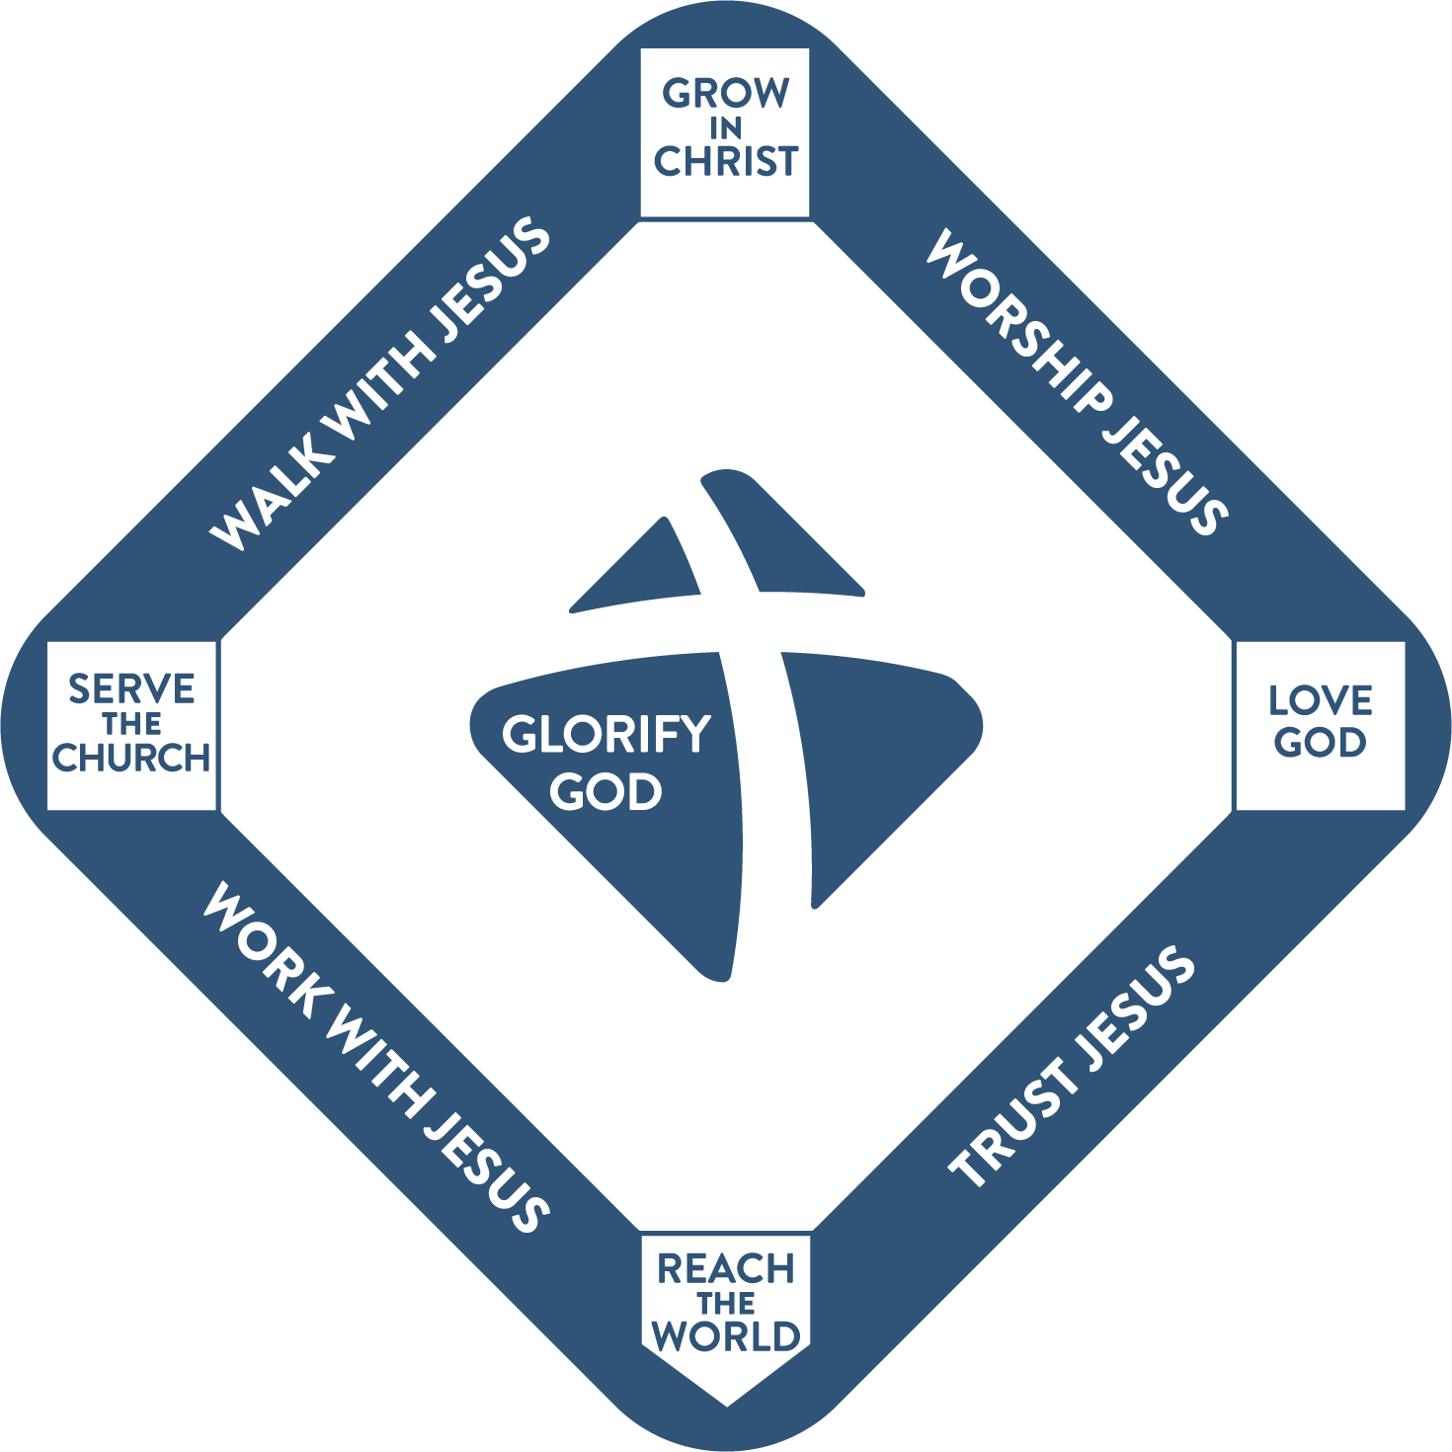
This comes down to priorities and practices. The common way to refer to Christian priorities and practices is to call them SPIRITUAL DISCIPLINES. Some of us have gone through material by John Mark Comer, like his Ruthless Elimination of Hurry and his follow up book Practicing the Way. Both books are important and helpful. First you have to ruthlessly eliminate hurry from your life. Only then can you start to build a schedule that feeds your soul and enables you to BE WITH JESUS, so you increasingly become LIKE JESUS and practically DO the kinds of things Jesus did.

This is what our Spiritual Life Worksheet is for: to help you prayerfully consider, and work with a friend to express, the practices that will help you right now to love God, grow in Christ, serve the church and reach the world.

So here is our summary for today:

- Rest and Rejoice in the Righteousness Jesus Gives you
  - Don’t doubt God’s power and Complain about His provision
- Prayerfully Pursue the Righteousness Jesus Calls you to

There is a righteousness Jesus GIVES US entirely through His grace and finished work on the cross. We cannot add to that work or take away from it. Our job is to rest in the Lord and rejoice in all He has done for us and given to us. Unlike Israel in the OT, we don’t want to doubt the love of God and complain about His provision. Instead, we need to fix our faith completely in the goodness of God, no matter what we are going through.

That is the gospel foundation: the forgiveness, righteousness and blessing Jesus gives us completely for free, in response to our faith in Him.

On that foundation, we seek to build with gold, silver and costly stones to the glory of God. And that’s the point: we DO seek to build. We hunger and thirst for more of Jesus’ righteousness to be visible in our lives. We long for more of His justice and love and goodness to be manifested in this world. We don’t just PRAY “your kingdom come,” we WORK to bring a little more of His kingdom every day.

So, we rejoice in the righteousness Jesus gives us. Then we prayerfully pursue the righteousness He calls us to. We hunger and thirst for more of Jesus, by cultivating an appetite for God and His Word. None of us naturally eat was is healthy for us or do what is best for us in terms of diet and exercise. Those habits and practices must be cultivated and practiced, just as spiritual appetites and practices must be developed and applied.

“Set your minds on things above!” “Be transformed by the renewal of your minds.” Let Scripture do its work in you as you memorize and meditate on God’s Word and let the Bible reshape your mind to be more like Jesus.

And that will lead you to adjust your priorities and habits, as you develop a plan for your spiritual life and for your ministry life.

Let’s take a few minutes right now to invite the Lord to speak to our hearts about 1) the righteousness He has given us and 2) the righteousness He calls us to.

