The Pure in Heart
Matthew 5:8
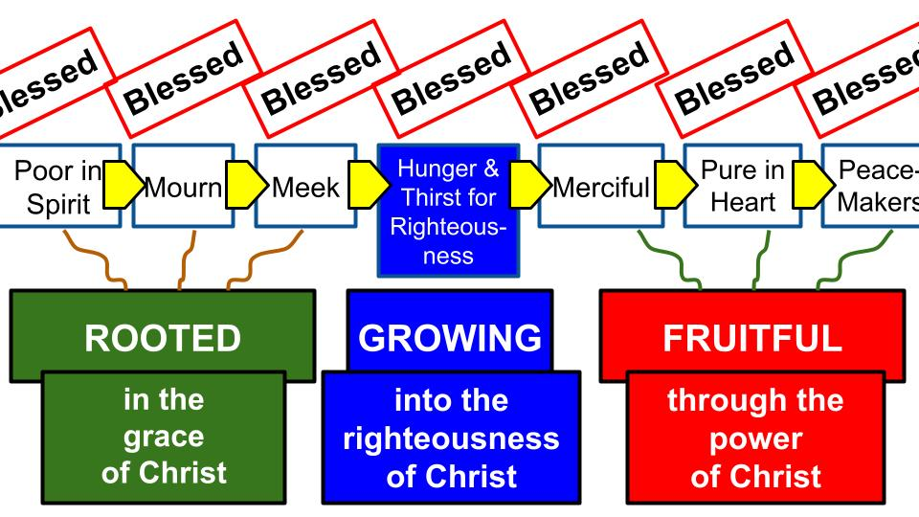
So far in the beatitudes we have seen the ROOTS of faith, how to grow in Christ and now we are exploring the FRUIT of faith. One of the keys for understanding and applying the beatitudes is that they are SEQUENTIAL. You can’t jump directly to being pure in heart. You have to work your way there from humble poverty of spirit through mournful repentance to meek surrender. With those roots of faith in the love and grace of Jesus you connect with His life and power and Spirit and increasingly hunger and thirst for righteousness. You are filled with gratitude for the righteousness Jesus has GIVEN YOU through His sacrifice, yet you still hunger for more of His righteousness to be manifested in your heart and life.

From these roots of faith and from the power of the Holy Spirit you will GROW more and more into the likeness of Jesus, and that will make you merciful for the needs of others. And it will make you pure in heart, with single-minded devotion to Jesus’ kingdom above all.
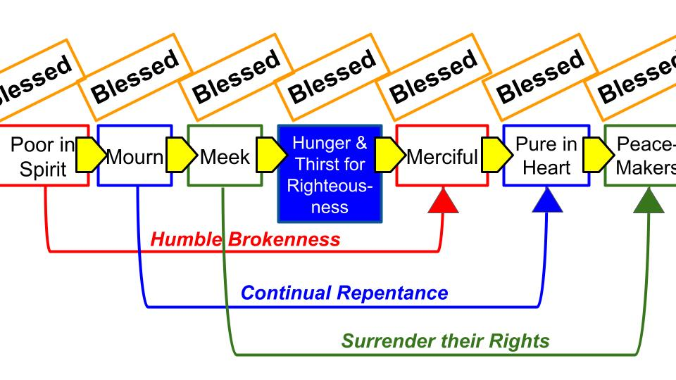
We learned from Martin Lloyd Jones that not only are the beatitudes sequential, but there are special connections among them. Only one who is poor in spirit will be able to really be MERCIFUL to the hurting and broken in this world. Someone who is confident and bold in this world will struggle to be sympathetic and compassionate toward the weak and downtrodden.

Similarly, the only ones who have a chance of becoming more pure in heart are those who have truly MOURNED over their sin. Only sincere repentance and continual repentance prepares your heart for untarnished devotion to Christ. Only by confessing sin and dragging it into the light; only by truly turning from that sin and committing fully to Jesus can you begin to experience this thing called being “pure of heart.” Look at the wonderful promise for those who are pure in heart:

“Blessed are the pure in heart, for they shall see God.” Matthew 5:8

What a gift! What a promise! To SEE God as He actually is… To perceive the goodness and majesty and glory of the Lord! This happened a few times in the Bible, so let’s look at one of the dramatic examples, in Isaiah 6.
“In the year that King Uzziah died I saw the Lord sitting upon a throne, high and lifted up; and the train of his robe filled the temple. Above him stood the seraphim. Each had six wings: with two he covered his face, and with two he covered his feet, and with two he flew.” Isaiah 6:1-2
The only setting we get is the death of a king. Uzziah was actually one of the GOOD kings of Israel who reigned a long time! 52 years! But he finished poorly because he went into the temple of the Lord and tried to do the work that was reserved only for priests. So he was stricken with leprosy and died in isolation and pain from that leprosy.
The introduction to Isaiah’s experience – also in the TEMPLE of the Lord, just the one in heaven instead of the one on earth – is the death of a king who demonstrated IMPURITY of heart; a divided love. On the one hand, he led God’s people well for 52 years. On the other hand, he wanted to serve God in his own way, even if it violated the Law of God.
That was the time in which Isaiah the prophet had a vision and what he saw was the Lord, high and lifted up on His throne. Mighty angels surrounded Him and sang:
“And one called to another and said: ‘Holy, holy, holy is the Lord of hosts; the whole earth is full of his glory!’ And the foundations of the thresholds shook at the voice of him who called, and the house was filled with smoke.” Isaiah 6:3-4
Isaiah was understandably overwhelmed with this experience. The foundations of the heavenly temple shook, the whole area filled with smoke.

“And I said: ‘Woe is me! For I am lost; for I am a man of unclean lips, and I dwell in the midst of a people of unclean lips; for my eyes have seen the King, the Lord of hosts!’” Isaiah 6:5

This was God’s own prophet! Yet before the glory and majesty of God on His throne, even the holy prophet felt undone, felt lost without hope of recovery. Why? Because of his own unclean LANGUAGE and the tarnished WORDS of all of God’s people. Suddenly Isaiah felt accountable for every careless word he had ever spoken and everything he had heard from the Israelites as well.

Jesus taught that our WORDS reveal our HEARTS. “From the overflow of the heart the mouth speaks.” This was the issue over which Isaiah felt undone, exposed and deserving judgment from the holy God of heaven. Thankfully, God had already prepared for this exact situation.

“Then one of the seraphim flew to me, having in his hand a burning coal that he had taken with tongs from the altar. And he touched my mouth and said: ‘Behold, this has touched your lips; your guilt is taken away, and your sin atoned for.’” Isaiah 6:6-7

Where did salvation come from? From the altar in the heavenly temple!

What means did the angel use to purify Isaiah’s unclean lips? A coal from the altar of God! In other words, something from the place of true SACRIFICE where atonement could be made. And the result: “Your guilt is taken away, and your sin atoned for”!

The only reason Isaiah was able to see God and LIVE was because a price was paid for his sins and his guilt was atoned for. The same is true for you and me.

“Blessed are the pure in heart, for they shall see God.” Matthew 5:8

There is a blessing for the pure in heart – they are the ones who will see God and worship Him forever with unending joy. But all of us who see these words should feel like Isaiah: undone before the glory and majesty of the holy God of heaven. None of us DESERVE to see God and live. All of us should fall to our knees and cry out for mercy. And not just because our LIPS are unclean but because every part of us is unclean!

None of us deserves this blessing to see God because none of us are truly pure in heart. But I have good news for you today: JESUS was completely pure in heart and He can GIVE that purity to each one of us, and through Jesus even sinners like us can see God and live.

What we will learn from Scripture today are Four descriptions of someone who is pure in heart – two negations and two affirmations. In essence, to be pure in heart is to be UNDIVIDED in your love and loyalty. It is very rare to find this kind of person today, since almost everyone takes the practical approach of not having “all of your eggs in one basket.”

At a glance that may appear like wisdom along the lines of: have a couple different hobbies so if you can’t keep playing pickle ball forever you can fall back on golf. But apply it to your marriage: be sure to have a couple girlfriends in the background in case things don’t work out with your wife. Or apply it to GOD: “Don’t put all your eggs in one basket! Yes, worship Jesus and follow His teachings, but let’s not get carried away! You know what’s pretty helpful from day to day? MONEY. You know what is pretty useful to listen to and rely on? Your own thoughts and plans and desires.”

Purity of heart is also called INTEGRITY: that you’re not different in how you appear compared with how you actually ARE. Let’s see what Scripture has to say about the pure in heart, starting in James chapter one.

- The Pure in Heart rejects Divided loyalties
“If any of you lacks wisdom, let him ask God, who gives generously to all without reproach, and it will be given him. But let him ask in faith, with no doubting, for the one who doubts is like a wave of the sea that is driven and tossed by the wind.” James 1:5-6

The book of James is one of the most practical and challenging books in the whole Bible. James pulls no punches and gets right to the point. Can you be more tongue in cheek than that first line, “If any of you lacks wisdom”? On the off chance that any of you run into this like once in your life. Just in case there is someone in the whole city of Tampa who finds himself in this position, here is something to consider…

Clearly, we all lack wisdom all the time so here is some good advice from James. Try this: ask God for wisdom. He has a lot of it. And, turns out, He’s very generous with those who DO ask Him for wisdom. No reproach even! He doesn’t complain when we keep coming back for more wisdom, more grace, more strength, more endurance.

Then whatever you ask God for - wisdom, strength, guidance – ask IN FAITH. That means you believe God exists and that He answers prayer. Ask with PURITY OF HEART. Not a divided heart that sort of believes in God but sort of doesn’t believe either.

Don’t be like a wave of the sea that goes one way this second and the next it goes the other way, blown and tossed by the wind.

How are you doing with this? Is your heart divided in its loyalties and beliefs? Do you believe in the Lord one second but then start doubting Him the next?
- What are your health issues? I know most of you don’t have a cancerous brain tumor, but there are several in the church family with serious health problems too.
- How is your extended family? Are you frequently worried about kids, grandkids, parents and siblings?
- How is your work and your finances? Are you content and at peace one day but then stressing and freaking out the next?
- Do you fixate on the future or the past? Have you trusted in Jesus for your past sins and struggles, but maybe it’s harder to trust fully in Him for your present and future?

Do you see how it’s so hard to be pure in heart? Our hearts are naturally divided. We love and trust Jesus one second but doubt and question Him the next. We are like waves of the sea, blown this way and that. But the pure in heart must reject these divisions! James tells us why:

- The Pure in Heart rejects Divided loyalties
“For that person must not suppose that he will receive anything from the Lord; he is a double-minded man, unstable in all his ways.” James 1:7-8

Prayer is important. But the WAY we pray matters. Yes, we should ask God for wisdom and everything else we need. He is a good, good Father who knows what we need before we ask but who waits for us to ask because that builds up our faith and increases His glory in our eyes.

When YOU pray, do you ask in faith or with doubts mixed right in there? The one who prays with a divided heart “will not receive ANYTHING from the Lord.” To be double-minded is to be unstable, in danger of collapsing, and such a person’s prayers will not be effective.

Now, let’s be careful again that we not turn the beatitudes into LAWS, with the idea that if you pray hard enough and believe hard enough you will earn your salvation and find ways to manipulate God. No, no. It’s not that you have to do these things long enough and hard enough and THEN you will be blessed. It’s if you really trust in Jesus and commit to follow Him, you will increasingly see these things describe you because Jesus changed you at the moment you trusted in Him and His Spirit moved in at that very moment and is producing His fruit in you every minute of every day.
All these blessings come to the person who is united with Jesus by faith. You have them all or you have NONE of them. If you see these things in your life, it’s not that YOU are so amazing, it’s that the grace and power of JESUS are so amazing. Do you see the roots of faith in your life? Humble brokenness and dependence on Jesus. Spiritual mourning over sin with true confession and repentance. Meek surrender and submission to Jesus and others. A hunger and thirst for more of Jesus, more of His righteousness, wisdom and power. And the fruit then grows from these signs of genuine relationship with the Lord: mercy and compassion for others; increasing purity of heart and single-mindedness; a desire to make peace among others and endurance through opposition and persecution.

The person who is pure in heart first rejects divided loyalties. second:

- The Pure in Heart repents of sinful Desires
“But each person is tempted when he is lured and enticed by his own desire. Then desire when it has conceived gives birth to sin, and sin when it is fully grown brings forth death.” James 1:14-15

This is why purity of heart is connected to mourning over sin. We can’t grow in single-minded devotion to the Lord unless we genuinely grieve over our sin. James makes it clear that no one can blame GOD for their sin. God is not tempted by evil nor does He tempt anyone. SO where does sin come from?

Our own divided, corrupted hearts. Our own sinful desires. Desire is conceived like a tiny seed that grows inside of you until it gives birth to sin. Sin then starts to grow up and when it is full grown, it kills you. It’s like the little shop of horrors. You plant a small seed that over time germinates into a plant. Eventually the plant demands stronger food – your own blood. And when it’s full grown it does everything it can to eat you, whether you sing love songs or not.

- The Pure in Heart repents of sinful Desires
“What causes quarrels and what causes fights among you? Is it not this, that your passions are at war within you? You desire and do not have, so you murder.” James 4:1-2

James picks up on this theme again in chapter four of his book. Where does temptation and sin come from? Our own sinful hearts. Where does conflict and division come from? Same answer. “The passions that war within you.”

- The Pure in Heart repents of sinful Desires
“You covet and cannot obtain, so you fight and quarrel. You do not have, because you do not ask. You ask and do not receive, because you ask wrongly, to spend it on your passions.” James 4:2-3
Again, James ties the issue of a divided heart back to unanswered prayer. Why does God sometimes refuse to answer our prayers? Because we ask selfishly, according to our own desires, not seeking HIS WILL. Sometimes we don’t ask God at all! “You do not have because you do not ask.” Maybe James will let up at this point… Not so much!

- The Pure in Heart repents of sinful Desires
“You adulterous people! Do you not know that friendship with the world is enmity with God? Therefore whoever wishes to be a friend of the world makes himself an enemy of God.” James 4:4

Here we come to the “heart” of the issue. Are we really pure in heart, loving God with all we are? Or, in reality, are we actually spiritually adulterous? Are we friendly with the world – and even a little TOO friendly?

Friendship with the world is hatred toward God. Enmity. Conflict. Rejection. So here is our first half summary: the what NOT to do of being IMPURE in heart.

- The Pure in Heart rejects Divided loyalties
- The Pure in Heart repents of sinful Desires
“You adulterous people! Do you not know that friendship with the world is enmity with God? Therefore whoever wishes to be a friend of the world makes himself an enemy of God.” James 4:4

First, we have to recognize how divided our loyalties really are. We have to genuinely grieve over our sinful desires and turn away from them. We have to identify the places in our lives that represent divided loyalties and issues in which we are flirting with or outright loving the world.

Jesus presented it as a broad road that most people take that leads to destruction. His way he called narrow and the small gate that few can find. You have to turn OFF of that broad road and the only way off of that slippery slope to hell and eternal destruction is on your knees, crawling through the doorway of faith in Jesus you access through repentance.

This is what positions us to move toward greater purity of heart. It lets us bring our selfishness and sin to the Lord Jesus so He can purify us, as He did Isaiah. When you feel undone before the holiness of God and cry out for mercy, He reaches down to cleanse you and purify you inside and out. Now let’s turn from the negatives we must reject to the positives we must embrace as those who are pure in heart.
- The Pure in Heart embraces Wholehearted love for God
“Teacher, which is the great commandment in the Law?” And he said to him, “You shall love the Lord your God with all your heart and with all your soul and with all your mind.” Matthew 22:36-37

Now, let’s not get carried away with this verse. It’s just the one verse Jesus used to sum up all of the Law and prophets and explained was the first and most important command in the whole Bible. Ok, it’s kind of a big deal. Do you see how this represents so beautifully what it means to be pure in heart? To be united in heart, soul, mind and strength. This is right out of Deuteronomy 6, the focal point of the Law of Moses, right after the Great Shema.

Let’s take a few minutes now to reflect on how we are doing.

- The Pure in Heart embraces Wholehearted love for God
  - Identity; Values; Thoughts; Priorities
“Teacher, which is the great commandment in the Law?” And he said to him, “You shall love the Lord your God with all your heart and with all your soul and with all your mind.” Matthew 22:36-37

- Is love for God the center of your identity? That’s what it means to love God with all of your HEART. Your heart is the real you – the center of your being.
- Is God the One you value and treasure above all other things? That’s what it means to love God with all of your soul. You spiritually prize Him and delight in Him deep inside.
- Is God the one you think about most? Do your thoughts dwell on Him like when you were first in love with the one you eventually married?
- And is God the top priority of your life and schedule and checkbook? Can you honestly say that you devote your minutes and days to serving God above all other purposes?

Identity. Values. Thoughts. Priorities. To love God with all we are. It’s a truly impossible calling. There is no way to muscle your way into this kind of wholehearted love. It’s a miraculous transformation Jesus alone can accomplish in you, when you come to Him in humble faith.

Let’s take a moment now to pray about this and to ask Jesus to help us truly love God with all of our heart, soul, mind and strength!

SILENT PRAYER

- The Pure in Heart commits to Practical Obedience to Jesus’ teachings
“This is the great and first commandment. And a second is like it: You shall love your neighbor as yourself. On these two commandments depend all the Law and the Prophets.” Matthew 22:38-40

It’s so significant that Jesus doesn’t stop with just love for God. He immediately adds to it the second which is “like it.” If you love God, you will love what He loves – people. If you claim to love God and don’t love people, you are just lying to yourself.

Pure, undivided love for God first embraces wholehearted love for God, and the natural result of that genuine commitment and devotion is a practical commitment to love and serve the people God loves.

And who is your neighbor? You’re not alone in asking that question. A lawyer once tested Jesus with that exact question, and the answer Jesus gave was the parable of the Good Samaritan. A priest and Levite both walked right past a man who had just been robbed and left for dead. The top religious officials among the Jews ignored the injured man and crossed to the other side of the road. Shockingly, the hero of the story was a random Samaritan who saw the wounded Jew and helped him.

Brothers and sisters, do we LOVE our neighbors? Do we even KNOW our neighbors? Some of us use a tool called BLESS that reminds you to pray for the people who live next to you every day. Do you know the names of your neighbors? Have you talked with them to know if they have kids or grandkids, to find out what they do for work?

No doubt you have other neighbors in terms of people you work with or go to school with or run into regularly at the gym or the hospital or wherever you go.
Jesus summed up His whole ethic in the phrase, “Love your neighbor as yourself.” Do you feel how genius that is and how utterly life changing it is IF we simply obey it? The pure in heart naturally and continually makes an effort to not just KNOW the teachings of Jesus but to DO THEM.

Are we like the fool in Jesus’ parable who heard the teachings of Jesus but did not put them into practice? Then our lives are built on sand and will fall down in the first storm that comes along.
Or are we like the wise man who built his house on the rock? That wise man heard the teachings of Jesus and DID THEM, he put them into practice.

Let’s close where we started, back in Isaiah 6. Remember Isaiah found himself in God’s throne room in heaven and felt terrified and undone by seeing the glory of God exalted on His throne. But Isaiah confessed his sin and cried out for mercy, and God sent an angel to pronounce atonement for Isaiah, touching his lips with a stone from the altar. After this cleansing:

- The Pure in Heart commits to Practical Obedience to Jesus’ teachings
And I heard the voice of the Lord saying, “Whom shall I send, and who will go for us?” Then I said, “Here I am! Send me.” Isaiah 6:8

This whole vision of God and cleansing of Isaiah’s heart and lips is actually His commissioning. The same is true for each of us when we first experience the love and grace of Jesus. You go from being divided in love between Jesus and a million other things, mostly yourself. But when you confess that impurity of heart and call on Jesus to forgive you, He does. Miraculously, He does cleanse your impurity as He did mine. And in the same miraculous moment, Jesus calls you to follow after Him and bring His love to the people around you.

Jesus is calling out today, “Whom shall I send and who will go for us?”

Let’s take a few minutes to pray over our spiritual life commitments. We do this a few times every year. The best application of this worksheet is with one or two close friends to talk over what it looks like for you to apply these promises in your daily life right now:

Spiritual Life Commitments: [the usual slide]
- Trust Jesus
- Worship Jesus
- Walk with Jesus
- Work with Jesus

Let’s pray and then stand to make these commitments to the Lord right now.

