Righteousness
Matthew 5:14-20

Now we come into the part of the sermon on the mount when Jesus repeats the phrase, “You have heard it said… but I say to you…” Setting up Matthew’s conclusion to the whole sermon, about Jesus’ authority.

“You have heard that it was said, ‘An eye for an eye and a tooth for a tooth.’ But I say to you, ‘Do not resist the one who is evil.’” Matthew 5:38-39 | “The crowds were astonished at his teaching, for he was teaching them as one who had authority, and not as their scribes.” Matthew 7:28-29

Six times Jesus says, “You’ve heard it said, but I say.” He is establishing His set of teachings, His way of living – what He expects His disciples to embrace. For a rabbi back then this set of teachings and expectations was considered their YOKE, like what a pair of oxen would share together out in a field. And remember how Jesus described His yoke compared to the heavy and difficult one of the Pharisees and teachers of the law, “MY yoke is easy and my burden is light.”

The question for a new and younger rabbi was whose teaching he would follow; whose yoke would he embrace and modify? The two prominent schools of thought were the Pharisees and Sadducees, which we hear a lot about in the New Testament. Paul takes advantage of a disagreement between those two schools by throwing in a theological grenade about the resurrection. The Pharisees believed in the resurrection of the body and in spiritual beings, but the Sadducees denied these things.

https://www.gotquestions.org/Shammaite-vs-Hillelite.html

Underneath these debates were the teachings of two famous rabbis: Shammai and Hillel. Shammai emphasized the temple and Jewish ritual. Hillel was more open to Gentiles and less emphatic about the temple. So their two approaches were somewhat similar to modern conservative theology and modern liberal theology.

Jesus, of course, did not line up behind EITHER of these two rabbis or behind either major school of teaching w/ the Pharisees and Sadducees. This is why the “I say to you,” was so shocking and why people were so amazed at His authority. He wasn’t appealing to any Jewish traditions or previous schools of authority. He was claiming His own authority. Which brings us to verse 17. What would Jesus say about MOSES, the ultimate Jewish authority? Was Jesus’ new authority a complete replacement and rejection of the Law of Moses?

“Do not think that I have come to abolish the Law or the Prophets; I have not come to abolish them but to fulfill them. For truly, I say to you, until heaven and earth pass away, not an iota, not a dot, will pass from the Law until all is accomplished.” Matthew 5:17-18

There is no way Jesus could have said this more strongly. Not one little Hebrew “i” not one period or semi-colon will pass from the Law. Every single letter, every punctuation mark from the entire Old Testament will not only remain but – incredibly – Jesus promises to FULFILL them all! I like the Bible Project translation of that line: Jesus promises to “FILL THEM FULL.”

You see you have a handout today that sums up Jesus’ teachings on righteousness in one slide:
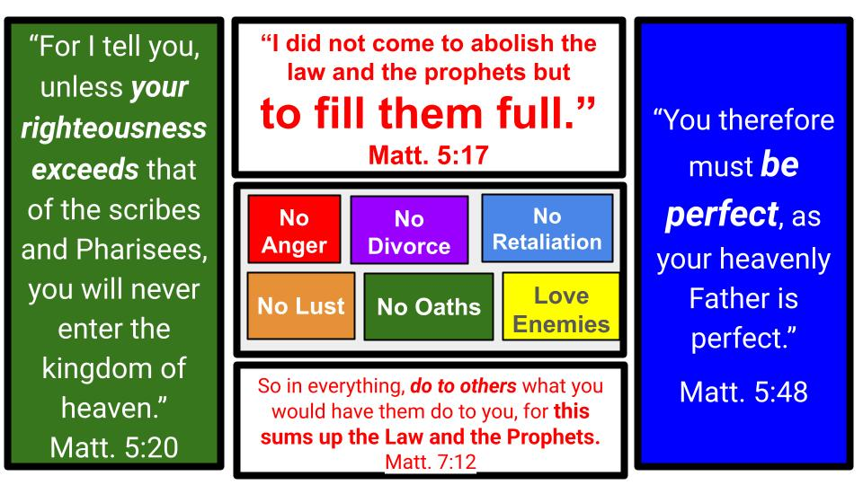
Was Jesus concerned about holiness and righteousness and justice in how His followers would live? Yeah. Just a little. Or completely. In every way.

First, he announced it as His mission to fulfill the Jewish Law. Then He said the requirement for even entering His heavenly kingdom was righteousness beyond the scribes and Pharisees who were known for their strict adherence to the Law of Moses. Then chapter five concludes with the summary sentence, “You must be PERFECT” not patterned after Shammai or Hillel but following the example of God the Father Himself.

You can see the six “You’ve heard it said but I say to you,” regarding anger, lust, divorce, oaths, retaliation and enemies. Then the summary teaching in chapter seven: “Do to others what you would have them do to you.” Yeah, that single teaching sums up what? Just this little document called “the Law and the Prophets.” All of Moses. The entire Old Testament. All of it in one codified teaching: treat others the way YOU want to be treated.

So there you have it. Just be perfect like God is. Just treat others as you want to be treated, in every moment of every day. Then your righteousness will exceed the Pharisees and only then will you be qualified for entrance into the heavenly kingdom of Jesus.

Jesus came to fulfill all of the Law and Prophets. He succeeded in being perfect as God the Father is perfect. And so Jesus did not abolish the Law of Moses or any part of the Old Testament – He filled them full.

Thankfully, because Jesus filled full the righteous requirements of the Law, He has total perfection to share with you and me. Here is how Paul sums up this wonderful gospel truth in Romans 8:

“For God has done what the law, weakened by the flesh, could not do. By sending his own Son in the likeness of sinful flesh and for sin, he condemned sin in the flesh, in order that the righteous requirement of the law might be fulfilled in us, who walk not according to the flesh but according to the Spirit.” Romans 8:3-4

Feel that first sentence. GOD HAS DONE. The gospel is not about what you and I must DO. It is the good news of what God has done! The Law of Moses could not make us righteous; it cannot save anyone because it is weakened by the flesh. Our sinful nature, our selfishness takes the good law of God and turns it into a hammer with which we have to beat ourselves up. Read Romans 7 for Paul’s experience as a Pharisee who did everything he possibly could to obey the Law of Moses.

But then, “thanks be to God,” Paul encountered the Risen Christ and experienced the eye-opening good news that Jesus died for Him and rose again victorious over sin. And so, Romans 8 goes on, instead of condemning us for the sin in our flesh, God condemned SIN in the flesh of His Son. It’s a beautiful gospel turn of phrase.
- Each of us must choose one or the other: be condemned for the sin in your flesh.
- Or ask Jesus to take that condemnation in HIS FLESH for you, on the cross.

Then don’t miss the result: “In order that the righteous requirement of the Law might be FULLY MET in us.” God’s righteousness can be filled up full in you and me! How? Only because Jesus filled it full in His own life. Only because Jesus offers that righteousness to us as a gift of His amazing grace. Read Romans 3 for Paul’s summary of JUSTIFICATION.

Today in Matthew 5 we will see four gifts Jesus gives us of His righteousness. Because he fulfilled all righteousness, He has that perfection to give as a gift to all who will come to Him in faith. What do those gifts look like? First:

4 Gifts of Righteousness from Jesus:
- A New Identity in your relationship with Christ
“You are the light of the world. A city set on a hill cannot be hidden.” Matthew 5:14

We got into this last week. But it’s important to note that Jesus doesn’t command His disciples to “GO BECOME SALT,” or to “Be more salty” or to be like “the light of the world.” He declares it as a fact of their BEING. He announces their new identity as His followers! This is how we know the gospel is not about what people must do but about what Jesus has done! Notice how Jesus announces as accomplished what God promised through Isaiah 600 years before:
“And he said to me, ‘You are my servant, Israel, in whom I will be glorified.’ …He says: ‘It is too light a thing that you should be my servant to raise up the tribes of Jacob and to bring back the preserved of Israel; I will make you as a light for the nations, that my salvation may reach to the end of the earth.’” Isaiah 49:3,6
In His followers, Jesus says the purpose and identity of Israel HAS BEEN fulfilled. This is why Jesus came: to fill it full. “The light of the world,” statement is clearly a reference to this passage in Isaiah 49. In John 8 Jesus states that HE is the light of the world. In the sermon on the mount Jesus makes this declaration and application to all of His followers – and so to the CHURCH as the light of Christ shining in the world.

4 Gifts of Righteousness from Jesus:
- A New Identity in your relationship with Christ
“In the same way let your light shine before others, so that they may see your good works and give glory to your Father who is in heaven.” Matthew 5:16

Since we ARE the light of the world, it follows that our nature as light should be VISIBLE. How is it visible? In our good works that people can see and thereby give glory not to US but to our Father in heaven who has transformed us to be like Jesus.

Who has this new identity? Only those who have entered a personal relationship with Jesus by becoming His disciples. The new identity comes with that relationship and only with that relationship. Apart from Jesus you are dead in sin. IN CHRIST you are alive and full of light. He is the vine; we are the branches. The fruit of salt and light and good works does not come from us, it only comes from Him. “Apart from me,” Jesus says, “You can do NOTHING.”

That was the point of the BEATITUDES: that in Jesus there is blessing both now and forever. Do you want the life God blesses?
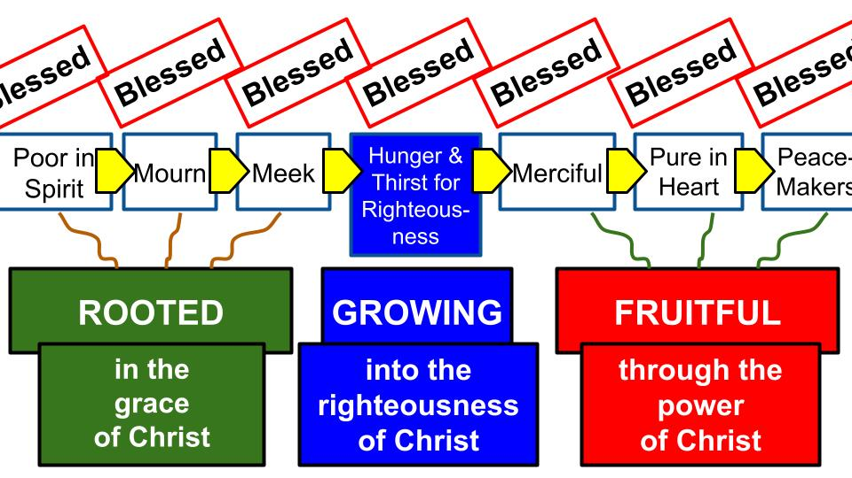
Believe in and follow Jesus. It starts with being poor in Spirit and recognizing that you need something you cannot achieve on your own. Then mourn over your sin and come to Jesus in repentance. Then meekly surrender your life to Jesus. Through that humility, repentance and faith Jesus will give you the righteousness He earned in His perfect life and take your sinfulness upon Himself. And so, you will hunger and thirst for more of that righteousness. Then the fruit of the Spirit will begin to grow in your heart and be visible in your life as you become more merciful, more pure in heart and join God in His work of making peace with others.

4 Gifts of Righteousness from Jesus:
- A New Identity in your relationship with Christ
“You are the light of the world. A city set on a hill cannot be hidden.” Matthew 5:14

This is the first gift of righteousness from Jesus: a new identity in Him through which we BECOME the salt of the earth and the light of the world. The second gift:

4 Gifts of Righteousness from Jesus:
- A New Standard in the perfection of Christ
“Do not think I have come to abolish the Law or the Prophets. I have not come to abolish them but to fill them full.” Matthew 5:17

How did Jesus fulfill the Law and the Prophets? How did He fill them full? First in His own life of perfect righteousness. Jesus set the example of absolute perfection. He showed the world what love and forgiveness look like; what compassion for the poor and mercy for the helpless looks like. He loved his enemies and prayed for those who persecuted him. “Father forgive them, they don’t know what they are doing.”

By fulfilling every requirement of God’s Law and every exhortation of the Jewish prophets, Jesus established Himself as the spotless Lamb of God who was able to take away the sins of the whole world. And so, this is our standard of righteousness, following Jesus.
Apart from Jesus the standards of the world are all over the place. Generally “love” is considered a good thing to be pursued and preserved. But what is love?

As Glinda sang in the new Wicked movie, “Who’s to say if I’ve been changed for the better?”

There is the exact problem: “Who IS to say,” what makes a person better or worse? The two movies are all about the question of who is WICKED and who is good. It is very clear early on that Galinda is not really very good at all, even though everyone sings and talks about her goodness. And by the end of the first movie the “wicked witch” who is green is actually the good one and everyone is attacking her as evil based on a deliberate smear campaign set up by the wizard of Oz who, it turns out, is not really so wonderful after all.

This is the problem with our culture today: there is no standard of what is good. It’s like what Pilate said to Jesus 2,000 years ago: “What is truth?” If there is no God, then there is no truth and there is no morality. Only feelings. You do whatever feels right to you and I’ll do the same and we will simply COEXIST, as the ridiculous bumper sticker absurdly claims. The better one uses those same symbols for all the religions but says CONTRADICT.

But in Christ we have a clear and objective standard: He shows, once and for all, what is good, what is righteous. Do you want to know if you’ve been changed for the better? Look at Jesus. Compare yourself to Him. That’s the only way to know.

A friend introduced me to Jordan Peterson, a famous political commentator and podcaster. It seems he actually is a Christian now, though that remains somewhat debatable. But he did a long episode several years ago comparing the different worldview options with one another. What is the best controlling idea or principle around which to build your life?
- POWER is the idea from nature and evolution: the strongest survives and makes all the decisions. Not the best guiding principle for humans.
- PLEASURE is another option: simply do what makes you feel the best. Again, not the best way to organize your life and priorities, and certainly not the best for a group or a nation.
- UTILITARIANISM: do the most good for the most people. But who defines what is good and does everyone get an equal vote? That gets complicated.
- How about RELIGION? Well, pick one. There are lots to choose from so it’s not easy to figure out which is best. And all of them have had major times of oppression.
- So go with DEMOCRACY: one person one vote. Nice and simple. But what if the majority is wrong, as has happened so often in history?

So, Jordan Peterson, a brilliant thinker and teacher, came to the fascinating conclusion that the single best controlling idea and philosophy is CHRISTIANITY: the law of self-sacrifice and service to others. Of course, he is right. The way of Jesus IS the best pattern, and if everyone just followed His way, conflict would be greatly reduced and love and service to others would make the world a much better place.

4 Gifts of Righteousness from Jesus:
- A New Standard in the perfection of Christ
“Do not think I have come to abolish the Law or the Prophets. I have not come to abolish them but to fill them full.” Matthew 5:17

This is such an important verse for appreciating the Old Testament. Did Jesus and His death and resurrection make the OT irrelevant? If you believe in Jesus and are “saved,” does that mean the OT has no application for you? Now, thankfully the ceremonial parts are not relevant in terms of the temple sacrifices and requirements for being clean, and the annual schedule of festivals and those kinds of things. You are welcome to eat pork if you are so inclined. Or, you’re welcome to avoid pork if you prefer.

The standards that matter are related to the holiness of God. Jesus sums up Matthew 5 and the first part of the sermon on the mount with this summary statement:

4 Gifts of Righteousness from Jesus:
- A New Standard in the perfection of Christ
“You therefore must be perfect, as your heavenly Father is perfect.” Matthew 5:48 | “You shall be holy, for I the Lord your God am holy.” Leviticus 19:2

What is the standard for those who follow Jesus? What are we aiming for? Oh, just this little thing called PERFECTION. Now, we know from Romans 3 that “all have sinned and fall short of the glory of God.” So, though we aim for perfection, we know that on our own we can’t possibly hit that target. And you can see Jesus is updating Moses’ teaching from Leviticus, calling all of God’s people to be holy as the Lord their God is holy. Jesus didn’t throw out that teaching, He made the Trinitarian nature of it more obvious. Jesus did abolish the call to holiness from the OT. He filled it full, first in Himself, then in His followers by giving them a new identity in relationship with Him and by making the calling to perfection clear and explicit. Third gift from Jesus:

4 Gifts of Righteousness from Jesus:
- A New Purpose in the Kingdom of Christ
“For truly, I say to you, until heaven and earth pass away, not an iota, not a dot, will pass from the Law until all is accomplished.” Matthew 5:18

Notice that last phrase: “Until all is accomplished.” What is the ALL to be accomplished? The kingdom. Jesus announced that the kingdom had arrived since He – the KING – had arrived. He taught his disciples to pray “your kingdom come,” and He taught them to seek FIRST the kingdom along with His righteousness.

Jesus is still talking about the Law of Moses and the entire Old Testament. Not one marking from the entire OT will pass away until all is accomplished. Two verses from Ephesians are really helpful in explaining this:

4 Gifts of Righteousness from Jesus:
- A New Purpose in the Kingdom of Christ
“As a plan for the fullness of time, to unite all things in Christ, things in heaven and things on earth in him.” Ephesians 1:10

God’s eternal purpose, the divine mystery set forth in Christ, is to unite what has been divided – primarily Jew and Gentile – which is the message of Ephesians. Jesus knocked down the dividing wall of hostility and made the two into one in Himself. The OT is all about God’s call upon Israel and the judgment of the nations. But there are promises all over the OT about the glory of God being seen by all the nations, and so that people from all over the world will be united one day, gathered all together into one! Listen to this glorious promise in Isaiah 49:

4 Gifts of Righteousness from Jesus:
- A New Purpose in the Kingdom of Christ
“It is too light a thing that you should be my servant to raise up the tribes of Jacob and to bring back the preserved of Israel; I will make you as a light for the nations, that my salvation may reach to the end of the earth.” Isaiah 49:6

The mission of God’s servant, the Messiah, and all of God’s people, is not just the restoration of Israel, but the salvation of people from every tongue and tribe and nation. Look at Isaiah 60.

4 Gifts of Righteousness from Jesus:
- A New Purpose in the Kingdom of Christ
“Arise, shine, for your light has come, and the glory of the Lord has risen upon you… But the Lord will arise upon you, and his glory will be seen upon you. And nations shall come to your light, and kings to the brightness of your rising.” Isaiah 60:1-3

Promises like this are all over the OT, and remember, Jesus didn’t come to abolish a single dotted i or cross of a T. He came to fill them full. And that is precisely what He did through His life, death and resurrection and the commissioning of the church as His body. Look one more time at Ephesians 1.

4 Gifts of Righteousness from Jesus:
- A New Purpose in the Kingdom of Christ
“And he put all things under his feet and gave him as head over all things to the church, which is his body, the fullness of him who fills all in all.” Ephesians 1:22-23

Isn’t this verse amazing? Jesus did not come to abolish the Law or the Prophets but to fill them full. In the same way, He did not come to divide up the world, but to fill the world full of His glory and righteousness and love. How? Through the Church! Through you and me and billions like us all over the world. This is how the knowledge of the glory of the Lord is steadily filling the world as the waters fill the sea.

Brothers and sisters, this is our purpose as followers of Jesus: to fill the world full of the glory of Jesus! This is what it means to seek first the kingdom of God and His righteousness: to fill our relationships and our places that we live, work, study and play with the love and grace and goodness of King Jesus.

4 Gifts of Righteousness from Jesus:
- A New Purpose in the Kingdom of Christ
“Therefore whoever relaxes one of the least of these commandments and teaches others to do the same will be called least in the kingdom of heaven.” Matthew 5:19

So how do we seek first and expand the kingdom glory of Jesus? The clear and simple answer is right here: DISCIPLESHIP. We follow the teachings of the Bible and teach others to do the same.

4 Gifts of Righteousness from Jesus:
- A New Purpose in the Kingdom of Christ
“And whoever does them and teaches them will be called great in the kingdom.”
Matthew 5:19

This is the genius of Jesus’ gospel message and His kingdom strategy: He didn’t build a massive global organization. He set in motion the ultimate viral movement.

This is why the church is unstoppable: because it isn’t a huge company with massive buildings and corporate structures that can be hindered by government policy. Buildings don’t matter; big pyramid schemes aren’t the way. It’s just about small, simple relationships through which you pass on what you have learned to others.

Discipleship has been summed up as one beggar telling another beggar where to find bread. It really is as simple as that. Once you’ve discovered the life-giving bread of King Jesus, you are ready to go and tell someone else about what you’ve experienced.

A few years ago, some of our leadership team read Ying Kai’s Training for Trainers. Ying and his wife Grace tell the story of their ministry in a country in southeast Asia. They went to a group of rural farmers and simply shared the gospel. A couple of the farmers joyfully received the good news. Ying and Grace taught them a simple method to go and share the message of Jesus with their friends and neighbors. Some of these simple farmers didn’t feel ready to go knock on doors and share the gospel.
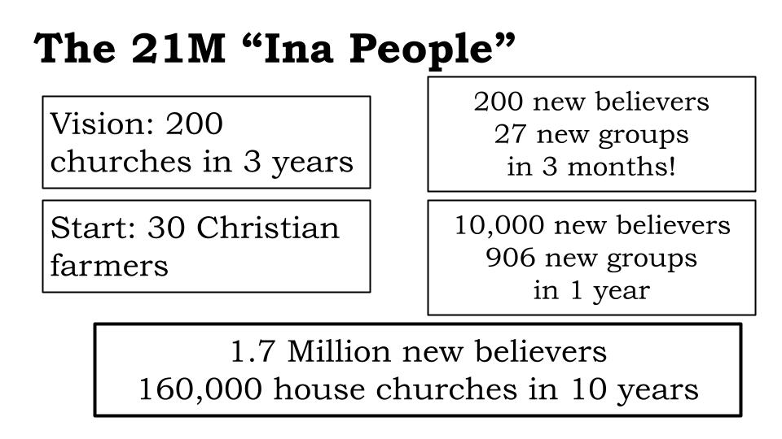
But a few got excited and one older man was determined to share this inspiring message with everyone he knew. In just a few weeks time, the gospel had taken root in the whole farming community and a neighboring area filled with factory workers. Ying and Grace taught these new believers a simple way to organize into small house churches. Their goal was to plant 200 churches in three years. They had 27 house churches in 3 months and 160,000 simple churches in 10 years. This is why they wrote the book Training for Trainers and have been sharing their story and their principles for the last 20 years.

Now, that was in a very unreached part of southern Asia. Will those same practices work here in central Florida? Look again at Ephesians 1

4 Gifts of Righteousness from Jesus:
- A New Purpose in the Kingdom of Christ
“And he put all things under his feet and gave him as head over all things to the church, which is his body, the fullness of him who fills all in all.” Ephesians 1:22-23

If the CHURCH is here in central Florida; if Jesus is working in us and through us… why would these same principles of the gospel and the kingdom NOT work? It’s like G.K. Chesterton said of Christianity in general:

4 Gifts of Righteousness from Jesus:
- A New Purpose in the Kingdom of Christ
“The Christian ideal has not been tried and found wanting; it has been found difficult and left untried.” G.K. Chesterton

That same statement could be made of the CHURCH and the Kingdom. All of the resources and potential are there to fill the whole world with the glory of King Jesus. Have we really tried? Has the church been shown to be lacking in power and resources and love? Or have we simply not tried? That’s our fourth gift from the Lord Jesus:

4 Gifts of Righteousness from Jesus:
- A New Power in the Spirit of Christ
“For I tell you, unless your righteousness exceeds that of the scribes and Pharisees, you will never enter the kingdom of heaven.” Matthew 5:20

How could Jesus command His disciples to be PERFECT as our heavenly Father is perfect? How could He demand that our righteousness exceed that of the Jewish religious leaders? Only because of the gospel: that His plan was to implant His own righteousness, His own love, His own power and goodness – in the person of His own Holy Spirit – into the hearts and lives of His followers.

Again, this takes us back to the Old Testament – the Law and the Prophets – that Jesus promised not to abolish but to fill them full. Look at Ezekiel 37, the chapter about the dry bones of Israel receiving new life when the breath or Spirit of God is blown into them.

4 Gifts of Righteousness from Jesus:
- A New Power in the Spirit of Christ
“And you shall know that I am the Lord, when I open your graves, and raise you from your graves, O my people. And I will put my Spirit within you, and you shall live, and I will place you in your own land.” Ezekiel 37:13-14

Chapter 36 of Ezekiel’s prophecy has some additional details and promises about God changing the hearts of His people by filling them with His own Spirit. Jeremiah, who spoke to Israel about the same time, was given similar promises for God’s people.

4 Gifts of Righteousness from Jesus:
- A New Power in the Spirit of Christ
“For this is the covenant that I will make with the house of Israel after those days, declares the Lord: I will put my law within them, and I will write it on their hearts. And I will be their God, and they shall be my people.” Jeremiah 31:33

Not only did God promise to put His SPIRIT into the hearts of His people, but along with the Spirit of God would come the LAW of God. Do you see how Jesus did not come to abolish the Law but to fill it full? He came to fill US full of His Law by means of His Spirit. Let’s close with one more look at Romans 8.

4 Gifts of Righteousness from Jesus:
- A New Power in the Spirit of Christ
“For the law of the Spirit of life has set you free in Christ Jesus from the law of sin and death. For God has done what the law, weakened by the flesh, could not do.”
Romans 8:2-3

For the follower of Jesus there is a new power and a new LAW. Instead of the law of sin and death controlling us, the Holy Spirit establishes a new controlling power in our hearts and minds and lives. So here is our summary today:

4 Gifts of Righteousness from Jesus:
- A New Identity in your relationship with Christ
- A New Standard in the perfection of Christ
- A New Purpose in the Kingdom of Christ
- A New Power in the Spirit of Christ

Jesus did not come to abolish the OT Law. He came to “fill it full.” He does this first in the hearts of His disciples and then through us, He makes His kingdom advance in the world.

Have you received this new identity in Christ? Have you asked Him to change you from the inside out, taking your sin upon Himself and taking His righteousness upon you?

Have you embraced this new standard of perfection in Christ? Of course, you can’t meet that standard on your own, but only in your relationship with Jesus as you abide in Him.

Have you committed to seek first the kingdom of God and His righteousness? Do you hunger and thirst for more of His righteousness? Only then will you be satisfied.

Have you begun to experience the new power of the Holy Spirit in your heart and life? There is no way to begin to pursue the kingdom standard of perfection or the kingdom ministry of making and multiplying disciples without the power of the Spirit enabling you. Jesus said, “apart from me you can do NOTHING.” He is the vine, we are the branches. Only His Spirit can enable you to bear the fruit of His love and goodness and righteousness.

Let’s pray to give thanks for these gifts of Jesus’ righteousness and to ask for more of Him in our hearts and lives!

Pray.

