Keep Your Word
Matthew 5:33-37

The book of Judges is the horror movie of the Old Testament. The whole book is a cautionary tale of what happens when everyone does whatever is right in their own eyes. It’s chaos, deception, unfaithfulness, immorality, and war. It’s the end of the terrible movie when they all shoot each other and fall to the ground, dead.

Judges gets worse and worse. Just when you think it can’t get darker and more terrible, it does. Jephthah is right at the halfway point of Judges; sort of the tipping point from bad into worse. Here is the setup:

“Now Jephthah the Gileadite was a mighty warrior, but he was the son of a prostitute. Gilead was the father of Jephthah. And Gilead's wife also bore him sons. And when his wife's sons grew up, they drove Jephthah out and said to him, ‘You shall not have an inheritance in our father's house, for you are the son of another woman.’ Then Jephthah fled…” Judges 11:1-3

Sibling rivalry. Many sons from the legal wife. Just one from “another” woman. So Jephthah took off, and “worthless” fellows gathered around him. Then came war. Suddenly his family remembered that Jephthah was the best warrior among them.

Jephthah said to the elders of Gilead, “If you bring me home again to fight against the Ammonites, and the Lord gives them over to me, I will be your head.” And the elders of Gilead said to Jephthah, “The Lord will be witness between us, if we do not do as you say.” Judges 11:9-10

The writer of Judges wants to be sure we don’t miss the vow that was made to Jephthah, with the LORD Himself as witness to it. Then Jephthah had a little back and forth with the king of the Ammonites about who had rightful claim on the land.

“‘I therefore have not sinned against you, and you do me wrong by making war on me. The Lord, the Judge, decide this day between the people of Israel and the people of Ammon.’ But the king of the Ammonites did not listen to the words of Jephthah that he sent to him.” Judges 11:27-28

To this point, aside from Jephthah’s parentage, it all seems ok. But then he gets scared and for some reason tries to make a deal with God.

“Then the Spirit of the Lord was upon Jephthah… and from Mizpah of Gilead he passed on to the Ammonites. And Jephthah made a vow to the Lord and said, ‘If you will give the Ammonites into my hand, then whatever comes out from the doors of my house to meet me when I return in peace from the Ammonites shall be the Lord's, and I will offer it up for a burnt offering.’” Judges 11:29-31

We can only suppose that Jephthah thought that his dog would come out to greet him, or maybe a lamb or a goat that had wandered into the house for some reason.

In terms of the book of judges, the outcome is sort of like Gideon with his many tests of the fleece: it “worked.” The Israelites defeated the Ammonites and Jephthah came home a hero. But then…

“Then Jephthah came to his home at Mizpah. And behold, his daughter came out to meet him with tambourines and with dances. She was his only child; besides her he had neither son nor daughter. And as soon as he saw her, he tore his clothes and said, ‘Alas, my daughter!’” Judges 11:34-35

So now this heroic warrior had to make a decision… Keep his oath to the Lord or save his precious daughter – his only child. Jephthah didn’t need a college degree or a PhD to solve this one. He needed the basic rules of kindergarten: “two wrongs don’t make… a right.” You made a foolish vow. Don’t make it worse by killing your daughter for your own fearfulness and foolishness!

Now let’s look at the Bible passage that – MAYBE – Jephthah had in mind as he carried out his vow. Leviticus 19.

“You shall not steal; you shall not deal falsely; you shall not lie to one another. You shall not swear by my name falsely, and so profane the name of your God: I am the Lord.” Leviticus 19:11-12

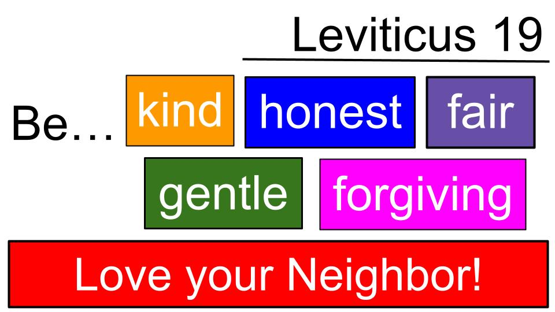
Ok. Yes. Don’t lie. Don’t invoke the name of God in a vow you make and go back on it. That not only dishonors your word, it dishonors GOD. Let’s zoom out from verse 12 and see the broader context of this passage.

So YES - it’s very important to keep your word and fulfill your vows as part of an overall commitment to LOVE YOUR NEIGHBOR.


Key takeaway here… Or to make it a warning:
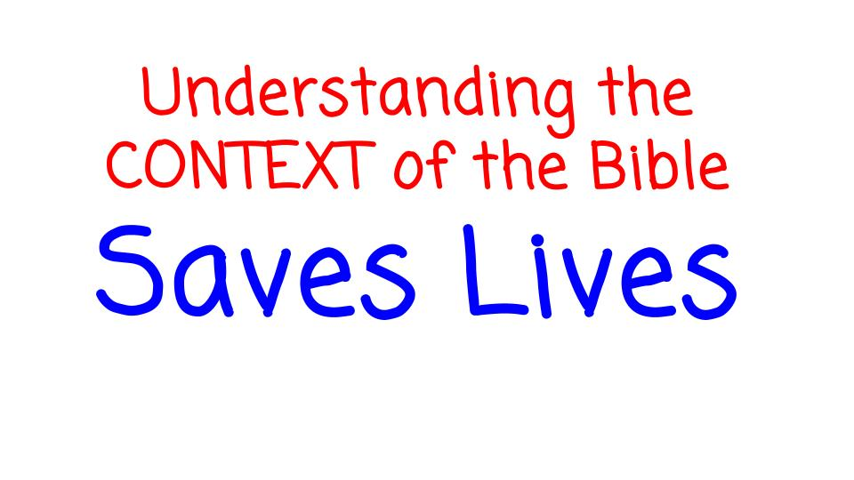

Ok, back to Jephthah’s dilemma. It wasn’t really a dilemma. All he needed to do was REPENT.

The noble thing to do, if someone really had to die in this case, was to take the punishment on HIMSELF. But Jephthah did NOT know the context of Leviticus 19 and did NOT apply God’s Word to His own life. So people died. Read Judges 12 and you’ll see LOTS of people died, because Jephthah did not know what it means to love your neighbor.

Ok, let’s turn to Matthew 5 and see what Jesus does with these Old Testament teachings:

“Again you have heard that it was said to those of old, ‘You shall not swear falsely, but shall perform to the Lord what you have sworn.’ But I say to you, Do not take an oath at all… Let what you say be simply ‘Yes,’ or ‘No.’” Matthew 5:33-34

Jesus is quoting Leviticus 19 here, that we looked at a few minutes ago. So for his disciples who had studied and memorized the Law of Moses, they would have anticipated his teaching in Matthew 7: “Love your neighbor as yourself,” and would have understood how that was the main point of all of Moses’ Law and all of the prophets too.

So here is our main lesson for today:

Love your Neighbor by Keeping your Word
“Again you have heard that it was said to those of old, ‘You shall not swear falsely, but shall perform to the Lord what you have sworn.’ But I say to you, Do not take an oath at all… Let what you say be simply ‘Yes,’ or ‘No.’” Matthew 5:33-34

We will see three reasons to show love in this way, mainly drawn from the character of God. Yes, we are commanded to keep our word. But Jephthah shows us that making vows and keeping them – especially in front of other people – is not the main thing. The bigger deal is to LOVE your neighbor and honor God by doing what you say you will do – as God has done for us, and Praise the Lord for that!

Reasons to love your neighbor by keeping your word:
- God Always keeps His Word
“Remember your leaders, those who spoke to you the word of God. Consider the outcome of their way of life, and imitate their faith. Jesus Christ is the same yesterday and today and forever.” Hebrews 13:7-8

The character of God is always a good place to start when wrestling with heavy matters. This is a powerful truth and a wonderful encouragement to us all: that Jesus NEVER changes. He remains the same, “yesterday and today and FOREVER.”

The writer of Hebrews is talking about human leaders. Which ones should we imitate? The ones who are most like Jesus. The ones who also have integrity; who don’t change with the shifting winds of culture or the applause of the people around them. It seems like every month or so we hear about another prominent Christian leader who has been exposed for a long-standing pattern of sin.

Aren’t you glad that could never be true of our Lord? The Lord Jesus is the SAME. He never changes. He never could change. His nature is fixed and settled, eternally divine, constantly united with the Father and the Spirit in a unity of love, goodness, holiness, justice and grace. And that only scratches the surface. Paul says it this way in his letter to Titus:

Reasons to love your neighbor by keeping your word:
- God Always keeps His Word
“Paul, a servant of God and an apostle of Jesus Christ, for the sake of the faith of God's elect and their knowledge of the truth, which accords with godliness, in hope of eternal life, which God, who never lies, promised before the ages began…” Titus 1:1-2

God never LIES because He never changes. So the promises of God are ironclad. Unshakeable. Perfectly reliable! This is WONDERFULLY GOOD NEWS. This book (the Bible) is full of promises. Hundreds and hundreds of times God has spoken to establish and to strengthen His relationship with sinful people like you and me. The big moments were called COVENANTS, and can be summed up in the Old one and the New one, which are the two parts of our Bible. Paul’s point here in Titus is to tie the faithfulness of God and His inability to lie to the gospel:

- God Always keeps His Word
  - The gospel Covenant rests on a Promise
“Paul, a servant of God and an apostle of Jesus Christ, for the sake of the faith of God's elect and their knowledge of the truth, which accords with godliness, in hope of eternal life, which God, who never lies, promised before the ages began…” Titus 1:1-2

Our hope for eternal life: our confidence in the gospel itself – rests on this firm foundation: the unchangeable character of God and the fact that this God, who never lies, has promised our forgiveness and eternal life in Christ! Paul also makes this point in Galatians 4, referring to Abraham’s wife Sarah and his servant girl Hagar.

- God Always keeps His Word
  - The gospel Covenant rests on a Promise
“These women are two covenants. One is from Mount Sinai, bearing children for slavery… But the Jerusalem above is free, and she is our mother. Now you, brothers, like Isaac, are children of promise.” Galatians 4:24, 26, 28

Isaac was born as the result of God’s promise to make Abraham into a great nation and bless the whole world through him. Ishmael was born as the result of Abraham and Sarah taking matters into their own hands, literally. Ishmael was the son of the slave woman and represents all people born in slavery to their sin apart from the covenant grace of God. Isaac was the miraculous child from an impossible union of a ridiculously old man and an infertile, almost as old woman.

But God promised Abraham that a child from his union with Sarah would be the one through whom blessing would come to the whole world. That promise carried the grace of God from Abraham to Isaac, then to Jacob and the whole nation of Israel, through 2,000 years of near destruction, through seasons when the kingdom of Israel was powerful and prominent in the region and through seasons when the enemies of Israel conquered them and at one point carried them off into exile and slavery. But even then the promise of God remained over Israel and preserved a remnant from Abraham’s line and king David’s line that ultimately led to Mary and Joseph in Bethlehem. And that line of promise stretches all the way to us right here in this room. We, too, are children of the promise. We are blessed by the truth that God never changes and always keeps His promises. The good news of Jesus is called a New Covenant because it is all about God’s promise to bring light and grace and hope and peace to all nations, even ours. Paul sums this up in Romans 4.

- God Always keeps His Word
  - The gospel Covenant rests on a Promise
“No unbelief made him waver concerning the promise of God, but he grew strong in his faith as he gave glory to God, fully convinced that God was able to do what he had promised. That is why his faith was ‘counted to him as righteousness.’” Romans 4:20-21

Abraham believed in the promise of God and so was justified by faith alone. His faith was credited to him as righteousness in the same way God credits the righteousness of Jesus to anyone who puts their faith in Jesus. That’s the whole point of Romans 3-4.

- God Always keeps His Word
  - The gospel Covenant rests on a Promise
“But the words ‘it was counted to him’ were not written for his sake alone, but for ours also. It will be counted to us who believe in him who raised from the dead Jesus our Lord, who was delivered up for our trespasses and raised for our justification.”
Romans 4:23-25

This is a beautiful summary of the gospel: that the PERFECTION of Jesus can be applied to YOU simply for believing in the promise of God as Abraham did. And we know God will keep this promise to forgive and justify us because He has kept all of His promises for the last 4,000 years. God never changes and always keeps His promises. So we can rest confidently in the gospel promise He has made to us in Jesus: to adopt us as His own children and bring us righteous and holy into His eternal home.

So our first lesson about oaths is to love your neighbor by keeping your word as God has to us. Second, we will see the danger of making an oath. We already saw the danger in the life of Jephthah, and how it cost the life of his daughter – his only child. Another example of a tragic and terrible vow is by King Herod.

- A Public Oath can be used to Manipulate others or make yourself look better
“For when Herodias's daughter came in and danced, she pleased Herod and his guests. And the king said to the girl, “Ask me for whatever you wish, and I will give it to you.” And he vowed to her, “Whatever you ask me, I will give you, up to half of my kingdom.”
Mark 6:22-23

Now, the background here is that John the Baptist was in prison but kept confronting Herod the king about his adulterous affair with the wife of his brother, Herodias. So Herodias wanted John dead, but King Herod liked John and respected him as a prophet and holy man. But Herodias had her daughter dance for Herod and a bunch of his powerful friends and, no doubt, the dance was very questionable. But Herod and his twisted buddies liked it, so Herod made this vow to give the girl whatever she asked for. She went to Mommy and Mommy said, “Ask for the head of John the Baptist.” And the girl went with it.

- A Public Oath can be used to Manipulate others or make yourself look better
“And the king was exceedingly sorry, but because of his oaths and his guests he did not want to break his word to her. And immediately the king sent an executioner with orders to bring John's head.” Mark 6:26-27

Just like Jephthah, King Herod had a choice to make and he made the selfish one. All he would have lost by declining the girl’s request was a little embarrassment at a dinner party. But he allowed himself to be manipulated by his mistress and then controlled by his pride. And it cost John his life. Another tragic example of an oath gone way wrong. Here is what the Law of Moses says about vows:

- A Public Oath can be used to Manipulate others or make yourself look better
  - It will not work to manipulate God but He will Hold you to it
“If you make a vow to the Lord your God, you shall not delay fulfilling it, for the Lord your God will surely require it of you, and you will be guilty of sin.” Deuteronomy 23:21

Personal vows were part of regular Jewish worship in ancient times, but they were never intended to be spiritual manipulations or attempts to control God. That’s where Jephthah went badly wrong and showed he didn’t know God or the Law of Moses. The general principle was to keep your word. If you make a promise to the Lord to offer a sheep or ox or make a financial gift to the temple work, then keep your word quickly. Don’t delay.

Here is what Solomon taught in Proverbs.

- A Public Oath can be used to Manipulate others or make yourself look better
  - It will not work to manipulate God but He will Hold you to it
“Don’t trap yourself by making a rash promise to God and only later counting the cost.” Prov. 20:25, NLT

The Proverbs have very practical wisdom for life. In this case, with vows, the wisdom is not to be quick to make a promise and only later on reflect on what is at stake. One more principle for promises.

Reasons to Love your Neighbor by Keeping your Word
- Be Faithful as God is faithful: do what you say you will do
“But I say to you, Do not take an oath at all, either by heaven, for it is the throne of God, or by the earth, for it is his footstool, or by Jerusalem, for it is the city of the great King.” Matthew 5:34-35

This part ties into the attempt at manipulation, as if the greater thing you swear by has greater power in the promise. Notice the decreasing significance. Jesus starts with heaven, then goes to the earth, then to Jerusalem – still significant but not the current throne of God! It is the city of the Great King, not meaning David, but meaning the true Messiah, JESUS!

Love your Neighbor by Keeping your Word
- Be Faithful as God is faithful: do what you say you will do
“Or by Jerusalem, for it is the city of the great King. And do not take an oath by your head, for you cannot make one hair white or black.” Matthew 5:35-36

From heaven to earth to Jerusalem. What’s the next step? Your head. Specifically, the HAIR on your head. You just have to look around this room to prove Jesus’ point: “You can’t make one hair white or black.” We can see that some of you are trying, but you have to keep trying so it’s clear that a comprehensive change can’t be made.

Not sure why people would have sworn by their head. I suppose that means by your life, since a head is pretty necessary for life. But it would seem more probable to go with the Princess Bride and say, “Do not take an oath on the soul of your father, Domingo Montoya, even if that is convincing to the man in black.” Just let your yes be yes. Just keep your word. That’s where Jesus lands this whole section.

Love your Neighbor by Keeping your Word
- Be Faithful as God is faithful: do what you say you will do
“Let what you say be simply ‘Yes’ or ‘No’; anything more than this comes from evil.” Matthew 5:37
Nice and simple. Just say yes or no. Don’t over-complicate it. Just do what you say you will do. As GOD DOES. James repeats the Lord Jesus in his letter.

Love your Neighbor by Keeping your Word
- Be Faithful as God is faithful: do what you say you will do
“But above all, my brothers, do not swear, either by heaven or by earth or by any other oath, but let your ‘yes’ be yes and your ‘no’ be no, so that you may not fall under condemnation.” James 5:12

It’s fascinating that James puts this at the end of his letter as the “above all.” In conclusion of all he has written about he comes back to Jesus’ teaching on vows. Why? Because this is so important to your personal integrity and your relationships. Can people trust you? Can they believe what you say? Or do you feel the need to dress up your promises with elaborate vows?

Jesus comes back to this principle in Matthew 21. We will close with his teaching to the religious leaders of his day.

“What do you think? A man had two sons. And he went to the first and said, ‘Son, go and work in the vineyard today.’ 29 And he answered, ‘I will not,’ but afterward he changed his mind and went. 30 And he went to the other son and said the same. And he answered, ‘I will, sir,’ but did not go. 31 Which of the two did the will of his father?” They said, “The first.” Matthew 21:28-31

The chief priests and elders of the Jews got the answer correct. They knew the better way to honor one’s father: to do the work he instructed you to do.

Do you see the kicker here? The Jewish religious leaders knew well and good what God’s will for them was. Their Father had given them 2,000 years to believe and follow the covenant with Abraham and the Law of Moses. Teachings like, “Love your neighbor as yourself.”

They made a big show of SAYING they would keep the law and even TEACHING the Law of Moses to others with great ceremony and authority. But they did not obey it themselves. Jesus said they tied up heavy burdens for others but made no effort to carry them themselves.

Most of the Jews, and especially the most educated ones and the ones in charge, were like that first son who SAID he would work in the field but in the end didn’t. Now, Jesus applied the parable:

Jesus said to them, “Truly, I say to you, the tax collectors and the prostitutes go into the kingdom of God before you. 32 For John came to you in the way of righteousness, and you did not believe him, but the tax collectors and the prostitutes believed him. And even when you saw it, you did not afterward change your minds and believe him.”
Matthew 21:31-32

The SINNERS were the ones following Jesus in both doctrine and practice. The religious leaders did not believe Him and certainly didn’t follow Him. Jesus was looking for workers in His harvest field. They knew He was claiming to be the Messiah, but they would not believe in or follow Him. So, Jesus said, the obvious sinners were entering the kingdom and pleasing the Father in heaven, when the religious ones were not.

Do you see the danger for us who attend church regularly?

We can fall into the same trap of APPEARING to be all spiritual and SAY the right things. God your Father says to you each morning, “Will you go into my field and work?” And you wake up, read your Bible and pray, saying “Yes, Father, I will.” But then do you go out for the day ready to actually love your neighbor?

Let’s pray as we close that the Lord would help us be DOERS of the Word and not HEARERS only.

Benediction: James 2:14-18

