Radical Generosity
Matthew 5:38-42

“Do not think that I have come to abolish the Law or the Prophets; I have not come to abolish them but to fulfill them… For I tell you, unless your righteousness exceeds that of the scribes and Pharisees, you will never enter the kingdom of heaven.” Matthew 5:17,20

Let’s remember what section we are in here in the Sermon on the Mount. We started with the beatitudes that show what a true follower of Jesus looks like. Then Jesus declared those followers His salt and light - His agents of change in the world. From that intro and declaration, we move into this RIGHTEOUSNESS section of Matthew chapter five. Jesus makes it clear He did not come to abolish the law of Moses or any part of the Old Testament. No. He came to FULFILL them or to FILL THEM FULL.
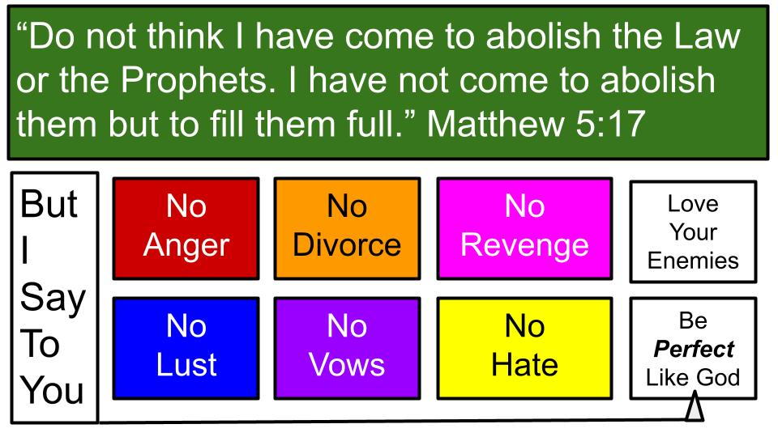
Jesus makes it clear that holiness or righteousness is required even to ENTER His kingdom. And Matthew 5 ends with the command to BE PERFECT as God the Father in heaven is perfect. In between v. 17 and v. 48 with those framing demands for righteousness we have these six “you’ve heard it said but I say to you,” expressions of Jesus’ unique authority and His fulfillment of true holiness, godliness and righteousness.

- It’s not enough to just avoid killing people, we have to avoid the anger that fuels murder.
- It’s not enough to just avoid adultery, we have to uproot the lust and coveting that lead to adultery.
- It’s not enough to follow legal proceedings in divorce, followers of Jesus are to avoid divorce altogether and protect the union of marriage.
- It’s not good to make elaborate vows in the name of Jerusalem or your gray hair or anything else. The thing is to keep your promises even if it costs you.
- Today we will look at the desire for justice and vengeance and next week our overall relationship with those who oppose and persecute us, and the call to LOVE our enemies and pray for them.

This is JESUS’ definition of true righteousness: holiness that flows from the heart, that comes from a relationship with Him. So the key point is that this kingdom requirement from Jesus is IMPOSSIBLE. If this doesn’t make you feel poor in spirit I don’t know what will.

Here is how Jesus concludes the “I say to you,” section about righteousness.
“But I say to you, Do not resist the one who is evil. But if anyone slaps you on the right cheek, turn to him the other also… But I say to you, Love your enemies and pray for those who persecute you.” Matthew 5:39, 44
Famous sayings of the Lord: Turn the other cheek. Love your enemies. Easy peasy. That’s why he saved them for the end of this section on righteousness. None of these commands of the Lord are possible apart from Him. The only way is to let the beatitudes lead you into a living and growing relationship with Him.
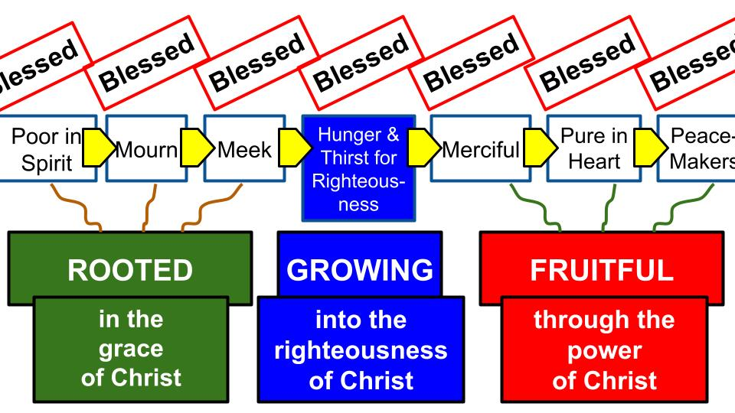
From the roots of humility, repentance and submission we can grow more like Jesus and in Jesus as we hunger and thirst for more of Him. Then His fruit will begin to grow naturally from our hearts and lives - His compassion, His purity, His peace and power to reconcile relationships.

Are you naturally able to love your enemies and always turn the other cheek? Of course not! Nobody is. But in Christ, these things become possible. If you’re struggling to forgive someone right now or to endure some injustice, be encouraged. The first beatitude is to be poor in spirit: to acknowledge that you can’t do it; that you need Jesus. That’s where we all begin. That’s how we all go on every day. We remember that apart from Jesus we can’t do anything. We certainly can’t love our enemies. We can’t turn the other cheek.

Let’s remember this key teaching from Jesus in John 15:

“I am the vine; you are the branches. Whoever abides in me and I in him, he it is that bears much fruit, for apart from me you can do nothing.” John 15:5

If we remain closely connected with Jesus, He promises that we will bear much fruit. Apart from Him, however, we can do precisely NOTHING. So this is the place to focus if you are hurting and struggling today. Abide in Christ. Focus on Him. Draw near to the Lord. Only when we see how much Jesus has forgiven us can we forgive those who hurt us. Only when we experience the fullness of Jesus’ love can we love our enemies as Jesus loved us when we were His enemies. That’s our key takeaway today. But first let’s feel the force of these two commands from the Lord: don’t resist an evil person and don’t refuse a needy person.

Old Testament Justice Fulfilled in Jesus-Empowered Generosity:
- Do not Resist the evil
“You have heard that it was said, ‘An eye for an eye and a tooth for a tooth.’ But I say to you, Do not resist the one who is evil. But if anyone slaps you on the right cheek, turn to him the other also.” Matthew 5:38-39

Here is another direct quote from the Old Testament: eye for an eye, tooth for a tooth. Yes, the Jewish people had heard that one directly from Moses. What was that law designed to do in Israel? That was a very important law to establish PROPORTIONAL JUSTICE. Someone knocks out your tooth, you don’t get to kill them, or banish them from the region or enslave their children. Essentially this established the principle of proportional fines and reparations. Look at Leviticus 24.

“Whoever takes a human life shall surely be put to death. 18 Whoever takes an animal's life shall make it good, life for life. 19 If anyone injures his neighbor, as he has done it shall be done to him, 20 fracture for fracture, eye for eye, tooth for tooth; whatever injury he has given a person shall be given to him. 21 Whoever kills an animal shall make it good, and whoever kills a person shall be put to death.” Leviticus 24:17-21

Notice the framing here to show the value of human life. If you kill your neighbor’s ox or donkey, you pay for it. Basically, “you broke it, you bought it.” But if you kill your neighbor himself, you die. Later in the Law God makes a distinction between intentional murder and accidental man-slaughter, creating a provision to protect the person who accidentally took the life of a neighbor while making sure that someone who planned a murder and carried it out paid for that murder with his life. So what is Jesus saying here in Matthew 5?

Old Testament Justice Fulfilled in Jesus-Empowered Generosity:
- Do not Resist the evil
“You have heard that it was said, ‘An eye for an eye and a tooth for a tooth.’ But I say to you, Do not resist the one who is evil. But if anyone slaps you on the right cheek, turn to him the other also.” Matthew 5:38-39

He was NOT refuting the Law of Moses. He was FULFILLING IT. He was showing the heart behind the Old Testament Law and what it looks like to follow the letter and spirit of that Law. Now we are moving from government laws to be sure the nation of Israel provided justice, into principles for personal relationships.

Leviticus 24 was never meant to be carried out by individuals. Not everyone became a dentist and an optometrist to knock out teeth or blind eyes if they were similarly injured. That was never the point: to get your own justice. No. That was for judges and leaders within Israel to protect people from excessive or unproportional vengeance in personal relationship or in legal court.

- Do not Resist the evil
  - Endure Painful Insults
“But I say to you, Do not resist the one who is evil. But if anyone slaps you on the right cheek, turn to him the other also.” Matthew 5:39

What did a slap on the cheek mean in ancient times? Was it just like a thump to the upper arm? Like a friendly little smack? No. It was a deliberate act of public shaming. To strike a person’s right cheek meant using the back of your right hand. So to turn the other cheek forced the aggressor to use the inside of their hand. The BP shows what that means:

https://bibleproject.com/articles/what-jesus-meant-turn-other-cheek-matthew-539/

“Jesus is not suggesting that his followers should stand around and take abuse. First, turning the left cheek was a bold rejection of the insult itself. Second, it challenged the aggressor to repeat the offense, while requiring that they now strike with the palm of their hand, something done not to a lesser but to an equal.” The Bible Project

Tim Mackie and friends call this creative non-retaliation: a refusal to “resist in kind.” I won’t “play your game.” I won’t return my evil for your evil. I will trust God to vindicate me and expose your injustice in the process. The next example makes this even more plain.

- Do not Resist the evil
  - Concede Unjust Law Suits
“And if anyone would sue you and take your tunic [shirt], let him have your cloak [coat] as well.” Matthew 5:40

It was overtly forbidden in the law of Moses to take a person’s cloak overnight because for most in ancient times that cloak also served as their night bedding. It was an overcoat and also a sleeping bag. So get the picture here. Someone concocts an unjust lawsuit to take the actual shirt off of your back.

You don’t fight the lawsuit. You give up the shirt. And in the process, you go ahead and remove your overcoat, handing that over as well. And that leaves you wearing what? Remember in ancient times they mostly didn’t have underwear. So remove the tunic and the overcoat and there you are standing… naked.

Apparently, we can’t be sure that’s what Jesus intended here, though I think it is funnier this way. And, in a very real way, this IS what Jesus did on the cross. They cast lots for his tunic, deciding not to rip it into pieces. And he had long since given up his cloak. So, there was Jesus on the cross – naked and bloody.

THAT is not an exaggeration. That is simple historical fact. Crucifixion took public humiliation to the maximum extent. That’s what these examples are getting at: issues of honor and status. Jesus says, “Don’t think in those categories anymore.” The Message translation sums up this passage nicely:

“Here’s another old saying that deserves a second look: ‘Eye for eye, tooth for tooth.’ Is that going to get us anywhere? Here’s what I propose: ‘Don’t hit back at all.’ If someone strikes you, stand there and take it. If someone drags you into court and sues for the shirt off your back, giftwrap your best coat and make a present of it. And if someone takes unfair advantage of you, use the occasion to practice the servant life. No more tit-for-tat stuff. Live generously.” The Message

Live generously. Know that justice is coming for everyone. So we don’t have to fight for our own justice now. We can trust that God will give justice in the end. Paul sums up this teaching beautifully in Romans 12.

Old Testament Justice Fulfilled in Jesus-Empowered Generosity | “Beloved, never avenge yourselves, but leave it to the wrath of God, for it is written, ‘Vengeance is mine, I will repay, says the Lord.’ To the contrary, ‘if your enemy is hungry, feed him; if he is thirsty, give him something to drink; for by so doing you will heap burning coals on his head.’ Do not be overcome by evil, but overcome evil with good.” Romans 12:20-21

This kind of living is not possible apart from the love and grace and power of Jesus. We can’t turn the other cheek, give away our financial security or concede to any other kind of injustice without the supernatural power of the Lord. On our own we will be overcome by evil. Only in Christ can we overcome evil with good.

So that’s the first part of fulfilling the justice and righteous living described in the OT and fulfilled in Christ. Here is the second part.

Old Testament Justice Fulfilled in Jesus-Empowered Generosity:
- Do not Resist the evil
- Do not Refuse the needy

Not only does Jesus tell us to no resist the evil who attack us; He commands us to no refuse the needy who ask for our help.

Old Testament Justice Fulfilled in Jesus-Empowered Generosity:
- Do not Refuse the needy
  - Double Inconvenient Demands
“And if anyone forces you to go one mile, go with him two miles.” Matthew 5:41

This was a standard expectation of those living in the Roman empire. Soldiers would march around all over the place and could ask of anyone sharing the road to carry their armor and other equipment for a full mile. The roads had mile markers, so it was easy to know when you had satisfied the requirement. But this instruction for followers of Jesus had to be a startling response for any soldier!

Who would do this? The law required you to carry the heavy equipment for a full mile. At that point you tell the soldier you are glad to go another mile. And you chat with the Roman as you go about WHY you would do this. “Yeah, my rabbi - Jesus of Nazareth - He is all about radical generosity. This wasn’t our idea, it was His, and we do what He tells us to do.”

We saw this in the hurricane cleanup last year. People were amazed that strangers were showing up to help move their wet furniture to the road and help cut up the trees that had fallen all over their yard. Why would you do this when you have problems of your own to attend to? Only Jesus can explain this kind of generosity! None of us would love and serve our neighbors like this on our own. One more example of Jesus-empowered generosity.

Old Testament Justice Fulfilled in Jesus-Empowered Generosity:
- Do not Refuse the needy
  - Concede Costly Requests
“Give to the one who begs from you, and do not refuse the one who would borrow from you.” Matthew 5:42

Now, this one has gotten tricky in today’s world. We have a lot of homeless people here in Tampa. A lot of cardboard signs around. If someone approaches you, they often have a dramatic story that tugs on all the heartstrings. And it’s hard to discern how much is true and how much is a practiced presentation to gather money for beer. So, it’s easy to get jaded and just pass on by these desperate people by the roadside or outside the gas station or other store.

Does this verse mean we should NEVER pass them by, but always hand out some cash? Some people take it that way. Others get creative and put together little care bags with non-perishable snacks, water bottles, and gospel tracts. So, you can give something but not enable unhealthy behaviors. You have to follow the Holy Spirit’s leading for how He would have YOU respond to people like this.

I intentionally described it like the Good Samaritan story. We can easily become like the priest and the Levite who see a person in need and just walk by on the other side, busy without own lives and work demands.

Old Testament Justice Fulfilled in Jesus-Empowered Generosity:
- Do not Resist the evil
  - Endure Painful Insults
  - Concede Unjust Law Suits
- Do not Refuse the needy
  - Double Inconvenient Demands
  - Concede Costly Requests

So, here is our summary. This is RADICAL generosity. Not just a non-retaliation requirement toward those who are evil, but also a generous approach to those who are in need. This is the JESUS WAY. It’s not the easy way. It’s the path of love and self-sacrifice. Next week we will see it’s the way of loving your ENEMIES.

Clearly, this cannot be done apart from the strength, guidance, and extreme love of Jesus in our hearts and working through us. So, let’s stop and pray right now that Jesus will give us all of those things and lead us into His radical generosity in our lives.

Give a MINUTE TO PRAY.
Darin closes in prayer.

