Love Your Enemies
Matthew 5:43-48
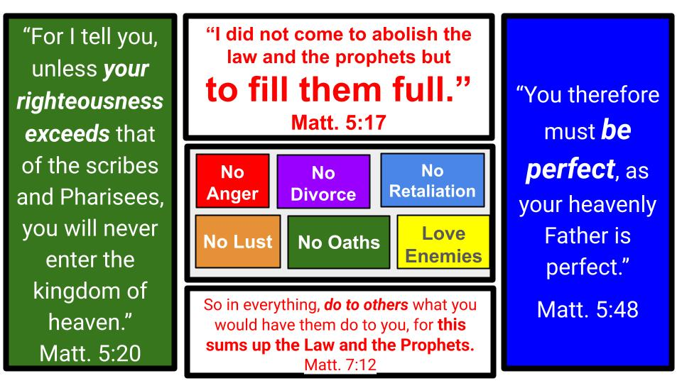
This is the last of the six “But I say to you,” teachings of Jesus, in His sermon section on RIGHTEOUSNESS. What does it look like to fulfill the Law and the prophets? How can our righteousness exceed that of the scribes and Pharisees? How can we do unto others what we would have them do unto us? And, in the end, how can we BE PERFECT as God Himself is perfect?

The simple fact is that we CAN’T. No one possibly could. Which is precisely the point of the sermon so far. Which is why Jesus started with the beatitudes, to make it clear that the only way to live a righteous, loving and holy life is to follow the pathway of faith, repentance and surrender to Him.
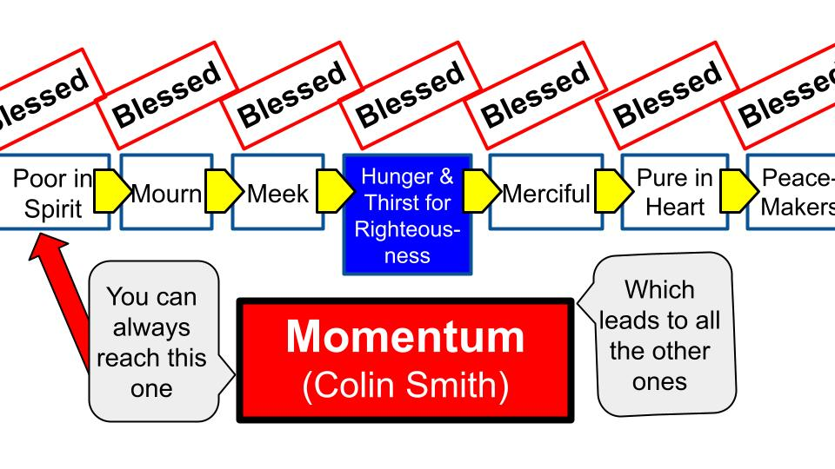
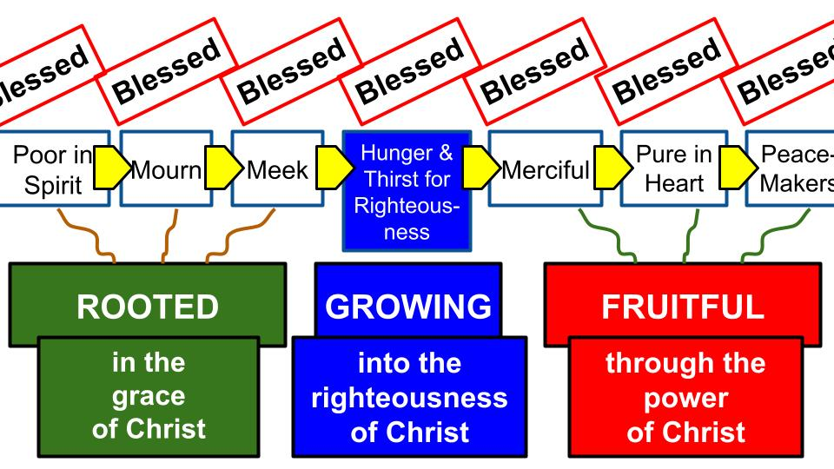
No matter how sinful or lost a person is, you can always reach that first beatitude: the blessing for those who are poor in spirit and recognize they bring nothing of merit to their relationship with God. Only sin. Only desperation. Only humility. But from that first beatitude, you can gain momentum by moving from one to the next.

Humility opens the door to repentance, mourning over your sin, which leads you to meek surrender to Jesus as your king. And those roots of faith enable you to grow more and more into the righteousness of Christ as you hunger and thirst for more of Him and more of His perfection. That fruit will increasingly grow in your heart and life.

So, let’s finish Matthew 5 and the first part of the Sermon on the Mount.

“You have heard that it was said, ‘You shall love your neighbor and hate your enemy.’ But I say to you, Love your enemies and pray for those who persecute you.” Matthew 5:43-44

Now, I’ll save you some time – no need to look through the Old Testament for that verse. Nowhere did God command His people to hate their enemies. There were times they had to FIGHT their enemies and even devote them to total destruction. But there were reasons for those times of war and usually it had to do with the idolatry and immorality of the nations around them who were usually threatening Israel with destruction and forcing them to defend themselves (which continues right up to today, btw).

No, the OT doesn’t tell anyone to hate their enemies. But a good theory for where this saying came from is a note in Qumran, the folks who stored up the dead sea scrolls, and kept good minutes of their meetings in 100 or so BC.

https://www.gotquestions.org/love-your-neighbor-and-hate-your-enemy.html

“The Lord is a jealous and avenging God; the Lord is avenging and wrathful; the Lord takes vengeance on his adversaries and keeps wrath for his enemies. The Lord is slow to anger and great in power, and the Lord will by no means clear the guilty. His way is in whirlwind and storm, and the clouds are the dust of his feet.” Nahum 1:2-3

The Community Rule at Qumran exhorted its members with these words, possibly applying the Nahum passage.

http://graceandknowledge.faithweb.com/matt543.html

“That they may love all the sons of light, each according to his lot in God's design, and hate all the sons of darkness, each according to his guilt in God's vengeance." The Community Rule, Qumran

The point is the distinction between the holy people of God and the wicked sinners outside: the sons of light vs. the sons of darkness. Pretty much Star Wars and the choice between the light and the dark side. Regardless of where the quote came from, here is the teaching of Jesus:

“You have heard that it was said, ‘You shall love your neighbor and hate your enemy.’ But I say to you, Love your enemies and pray for those who persecute you.” Matthew 5:43-44

The natural human response to those that hurt us is to dislike them if not to hate them deeply from our hearts. But Jesus flips this upside down as part of His exhortation to be righteous, holy and perfect – as God our Father in heaven is perfect.

Consider for a moment how God treated us. When we deserved nothing from Him other than His condemnation and wrath, God sent His Son to die for us, to pay for our sin and bring peace to our relationship with Him! Paul sums it up beautifully in Romans 5.

“But God shows his love for us in that while we were still sinners, Christ died for us. Since, therefore, we have now been justified by his blood, much more shall we be saved by him from the wrath of God. For if while we were enemies we were reconciled to God by the death of his Son, much more, now that we are reconciled, shall we be saved by his life.” Romans 5:8-10

We’ll come back to these verses at the end. But let’s not miss this point. The calling of Matthew 5 and the opening section of the sermon on the mount is to BE PERFECT as our heavenly Father is perfect. What did our heavenly Father do for us when we were His enemies? He made the ultimate sacrifice!
What did Jesus do when He was falsely accused, brutally beaten and then nailed to a cross? He prayed, “Father, forgive them, they don’t know what they are doing.”

So that is our main lesson for today: Love your enemies as God has loved you. Forgive as you have been forgiven. Pray for your enemies. Share generously with them. Don’t seek earthly revenge, but trust in God for heavenly reward. Trust God for justice in the end. We will see three key ways to love our enemies as God has loved us. First:

Love your enemies as God loved you
- Pray for those that hurt you
“You have heard that it was said, ‘You shall love your neighbor and hate your enemy.’ But I say to you, Love your enemies and pray for those who persecute you.” Matthew 5:43-44

The first application Jesus has for His disciples to love our enemies is to PRAY for them. What happens when you pray for someone? You ask God to BLESS them. And you begin to desire for them the things you pray for. That is not a natural response. It is supernatural. But it is one of the miracles that happens when you PRAY.

Let’s pause right now and take a moment to pray. Maybe you immediately know whom God would have you pray for right now. Maybe that is your prayer: Lord, whom would you have me pray for? Maybe it’s someone close to you, someone you see every day. Maybe it’s an old relationship that has not had any contact for years. As the Lord shows you the person to pray for, just pray a simple prayer of blessing for them. Ask God to show that person His love, His mercy, His grace.

WHY does Jesus command us to love our enemies by PRAYING for them? He tells us why in Verse 45.

Love your enemies as God loved you
- Pray for those that hurt you
“But I say to you, Love your enemies and pray for those who persecute you, so that you may be sons of your Father who is in heaven.” Matthew 5:44-45

To be “sons of your Father” means to be visibly LIKE your Father in heaven; for people to see “the apple doesn’t fall far from the tree.” In ancient times, this was even more apparent since most sons apprenticed under their fathers (as Jesus did) and took over the family business, whether farming, selling a product, or whatever work it was.

That’s our main point for today: be like GOD, not like your enemies. Don’t treat people as they HAVE treated you, but treat others as GOD has treated you. Don’t repay anyone evil for evil, but turn the other cheek and love your enemies. Pray for them. That’s step one.

The more serious the harm, the more difficult this step will be to take. All the more reason to start with prayer.

Remember in the beatitudes how we don’t start with being merciful, pure in heart or peacemakers. We start at the beginning and only later trust God to bring the fruit of mercy, purity and reconciliation.

If you have been hurt badly by someone, start right there, with prayer, by being poor in spirit. That’s where blessing begins. Jesus mourns with you over your pain and loss. He understands, even if no one else on this planet does. Jesus does. He is the good shepherd who not only walks with you through your darkest valleys, but He carries you through them. Feel His love, His grace, His mercy and ask Him to enable you to forgive and love and pray for your enemy. Second way to love your enemies:

Love your enemies as God loved you
- Share freely with all around you
“So that you may be sons of your Father who is in heaven. For he makes his sun rise on the evil and on the good, and sends rain on the just and on the unjust.” Matthew 5:44-45

What does the world need to flourish? Sunshine and rain. Where do these resources come from? THE SKY. Up above. This is one of the main reasons people worshiped idols and prayed to other gods: in the hope of winning favor with gods that controlled (supposedly) the sunshine and rain.

Of course, we know that there is only One God who controls everything in the universe, including sunshine and rain. But think of how generous God is not only with those two key blessings, but with so many others as well!
- Think about marriage. God has made that gift of relationship available to everyone – and those who remain together as one man and one woman for a lifetime are wonderfully blessed by that common grace.
- Think about family. Parents caring for children. Raising them to become independent and then to start their own families.
- Think about food. That’s what the sunshine and rain provide for everyone on earth.
- Think about creation. The beauty of the heavens above and the living things around us. The excessive generosity and creativity of God in the vast variety of fish and birds and dogs and cats. Amazing!
- Think about government and civilization. Yes, not all governments are very good, but having police and local government to restrain crime and reward work is a wonderful blessing from the Lord. Paul says this explicitly in Romans 13:

Love your enemies as God loved you
- Share freely with all around you
“Let every person be subject to the governing authorities. For there is no authority except from God, and those that exist have been instituted by God.” Romans 13:1

God sends the rain on the righteous and the unrighteous. He establishes government authorities to stop evil and reward good. All of this is called COMMON GRACE. And God is profoundly generous, especially when you think about what the world deserves from Him. People don’t deserve safe streets and fruitful harvests. What we deserve is chaos, disorder, conflict, and death. We deserve the full expression of our sinfulness. But God shares His blessings so freely and generously. It’s amazing the world is as safe and healthy as it is! And that’s only an expression of the grace and goodness of God.

So, our calling is to be like our generous Father in heaven and share freely with those around us. Are you a good neighbor? Do you share your tools and resources and abilities with those around you? And Jesus makes it explicit that this isn’t just about people you know and like and who are friendly with you. Anyone will naturally do that!

Love your enemies as God loved you
- Share freely with all around you
“For he makes his sun rise on the evil and on the good, and sends rain on the just and on the unjust. For if you love those who love you, what reward do you have? Do not even the tax collectors do the same? ” Matthew 5:44-45

The goal is not to be like the selfish sinners around us but to be like our great and gracious Father in heaven. Remember, tax collectors were the worst of the worst in Jesus’ day. Most of them were Jewish people who sold out to the Romans and collected taxes from their Jewish neighbors, skimming a good bit off the top.

So how do we love our enemies? First, we pray for them. Second, we share freely with them from what we have - whether time, talent, or treasure. What do you have that you could share with a needy neighbor or difficult co-worker or estranged family member? One more way to love our enemies.

Love your enemies as God loved you
- Imitate God not the sinners in this broken world
“For if you love those who love you, what reward do you have? Do not even the tax collectors do the same? And if you greet only your brothers, what more are you doing than others? Do not even the Gentiles do the same?” Matthew 5:46-47

Tax collectors were the worst – since they were Jews who should have known better but compromised their culture and relationships to make money. Gentiles were not quite as bad as tax collectors but still tainted, unclean, non-religious, idolatrous barbarians. So to do only what the gentiles would do was quite a slam. Come on… You can’t do better than the politicians and terrorists? They throw parties for each other too, you know?

What about us? Are we any different than our secular neighbors, co-workers and friends? Do they actually throw better parties than we do? Are they more generous with each other than we are with them? Here is the conclusion of the section and of Matthew 5:

Love your enemies as God loved you
- Pray for those that hurt you  - Share freely with all around you  - Imitate God not the sinners in this broken world | “You therefore must be perfect, as your heavenly Father is perfect.” Matthew 5:48

That’s it. Just be PERFECT. Fill up full the righteous requirements of God’s Law. Be holy just like God. How? One of the major tests of our holiness and love – whether we will really be like God – is how we treat those who oppose and mistreat us. Will we love and forgive them or hate and be bitter toward them?

In order to love your enemies, step one is to pray for them. Ask God to change your heart toward those who have hurt you. Begin with just a small prayer, to ask for God’s blessing on them. Then look for opportunities to share what you have with others, regardless of the level of relationship you have with them. Don’t just throw parties and give gifts to people who know and love you, who invite you to parties and give gifts to you. That’s just normal, everyday human life.

Our calling is not to live up to the standards of the people around us. Really to live DOWN to their standards. No. Our calling is to live up to the standard of GOD - which is perfect righteousness; overflowing grace; infinite love. Remember how God treated YOU when you were far from Christ:

“But God shows his love for us in that while we were still sinners, Christ died for us. Since, therefore, we have now been justified by his blood, much more shall we be saved by him from the wrath of God. For if while we were enemies we were reconciled to God by the death of his Son, much more, now that we are reconciled, shall we be saved by his life.” Romans 5:8-10

We were ENEMIES of God. Not like estranged cousins who hadn’t called in a few years. Enemies. Not just in considerate like we didn’t bring a casserole to the family potluck. No. We planted bombs all over the potluck and shot at people like moving targets. Enemies.

And how did God treat us when we had rejected Him, chosen to worship all kinds of other gods, and to serve ourselves instead of Him? In that condition God chose to send His only Son to enter our human condition, to live and suffer and die in our place on the cross. While we were enemies. Not cuddly but wayward children. Enemies. Deserving death, punishment and eternal condemnation.

That’s how God found us. And blessed us. And Jesus died for us. And now He lives to make intercession for us. Jesus still prays for us. He guides us and holds us and empowers us.

That’s how you can love your enemies. It’s not something you can do on your own. Only by the power of the Lord. Only when you are filled with His love.

We still get Christmas cards from a sweet couple in Chicago named Al and Nancy. They were involved in various Bible studies at the church and served sometimes on the welcome team, which is how I knew them. They came to one of the Bible studies I led that went through the gospel of Mark.

Part way through the study Nancy pulled me aside and shared how their house had been robbed a few years before: a bike and some other things stolen right from their porch. Al handled it ok, but it was a home invasion to her and something that filled her with anger and resentment for whatever hoodlum or hoodlums had dared to come and steal from them.

Through that Bible study that showcased the grace of Jesus to die for our sin, the Lord clearly showed her that she had to forgive these thieves. Nancy told me later that she went into the Bible study thinking it was for Al – that he needed to learn some more things about Jesus and the Bible. And he did. But looking back, Nancy realized it was for her. She needed to confront her unwillingness to forgive these criminals. And when she did choose to forgive, she felt an immediate lifting of a weight and sense of freedom from her pain and a much greater sense of closeness with the Lord.

Think of how God has graciously forgiven you. Consider what you deserved from Him and yet what He gave you in the death of Jesus. Now, through Jesus, you have PEACE with God. The price of your sin has been paid. You are reconciled and united with God forever.

So, pray for whoever has hurt you. Ask God to help you forgive them and take steps to show love and generosity to them. Don’t treat your enemies as the world would, seeking revenge. Treat those who have hurt you as God has treated you. Love your enemies and show the world what the grace of Jesus really looks like.

Let’s pray.

