The Grace of Giving
Matthew 6:1-4

We have now finished the first section of the Sermon on the Mount! Lots more to come! But here is what we have covered so far:
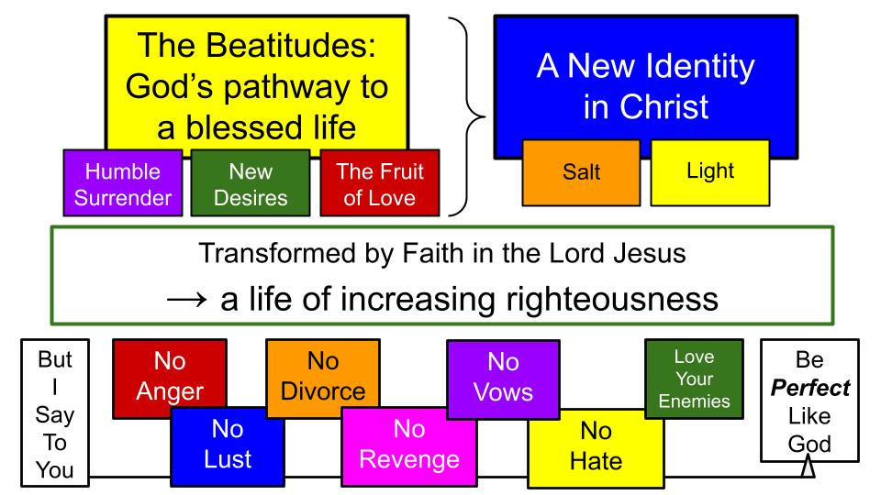
The beatitudes served as the gospel introduction to this masterpiece sermon. Far from a pathway of works, they describe the doorway of salvation by faith alone in Christ alone. As those who trust in the Lord Jesus, He changes us into His salt and light in this world - His agents of ongoing transformation.

The mustard seed of faith changes us into the garden of God’s grace in the world. Read Isaiah 61 for a vivid description of that life. In Luke 4, Jesus used Isaiah 61 to describe His mission on earth. Jesus announced the year of the Lord’s favor which mainly came in Him, but through Him continues through the church, IF we receive the gospel of the kingdom with hearts of good soil so we can produce a harvest by the power of King Jesus and for the glory of God the Father. Then, and only then – as we abide in Christ and depend on the power of His Holy Spirit – we will grow in the righteousness of Christ and pursue the goal of being PERFECT as God is perfect.

We have just finished the righteousness section of the sermon:

“For I tell you, unless your righteousness exceeds that of the scribes and Pharisees, you will never enter the kingdom of heaven… You therefore must be perfect as your heavenly Father is perfect.” Matthew 5:20, 48

So, no one could read or listen to this point and think that lifestyle doesn’t matter or that Jesus isn’t concerned about His followers living a holy life that is completely different from the world. No. He expects a firm commitment to His way of life and His kingdom practices. But Jesus did not establish a religion of works-based righteousness. He showed what faith in Him would produce as the power of His Kingdom broke into this dark and broken world in the hearts of people changed by His grace and love.

Do you see how completely revolutionary the Sermon on the Mount was – and still is today? This gospel of the kingdom changes EVERYTHING! And what a summary we have already heard and studied!

Now we turn the page to chapter six and the middle of this world-changing message.

“Beware of practicing your righteousness before other people in order to be seen by them, for then you will have no reward from your Father who is in heaven.” Matthew 6:1

Don’t miss that key phrase PRACTICING your righteousness. Just because Jesus commands His followers to BE PERFECT doesn’t mean we automatically will be. As with anything worth doing, righteous living requires PRACTICE. And it’s always better as a TEAM SPORT. Here is the summary of what’s coming in chapter 6 as we practice our righteousness together.
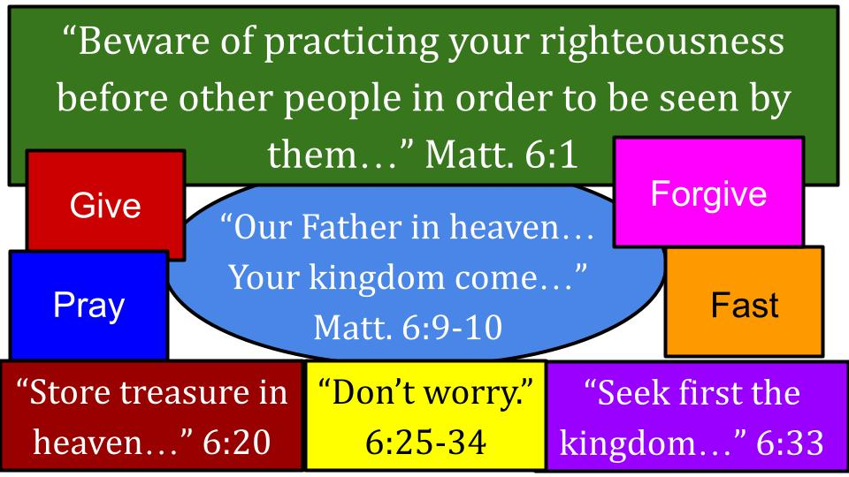
What does it look like to grow in our practice of righteousness? It’s no accident that PRAYER is in the middle of this training ground – in particular, the Lord’s Prayer that focuses on the kingdom of the Lord. And the chapter ends with that command to seek FIRST the kingdom of God and HIS righteousness, trusting in Him for everything else. Those little things like food and clothing. Don’t worry about the small stuff. And it’s all small stuff.

So, Jesus clearly expects his followers to PRACTICE our righteousness, but just to do so in certain ways and avoid the ways of the religious leaders of his day.

So, here is our main point for today:

Practice your Righteousness: give, pray, forgive, fast, invest in eternity
- But not to impress people, there is no Reward from God for that
“Beware of practicing your righteousness before other people in order to be seen by them, for then you will have no reward from your Father who is in heaven.” Matthew 6:1

Let’s not miss what the Lord is saying here. It’s not that we shouldn’t practice disciplines of righteousness. It’s that we should give, pray, fast, forgive and seek the kingdom in the ways Jesus did – not the ways that religious people do, to win approval from other people. God doesn’t reward those ways. You might get a little applause from a few people, but that’s the limit of the reward for when you pray long, extended prayers in public or give large financial gifts in ways that you make sure people see or look really haggard when you fast, and you fuss and whine about it.

So, let’s start with the grace of giving. How should we practice this discipline? There are three important ways to grow in the practice of giving. First:

How to Practice the Grace of Giving:
- Give in Secret – Drawing no Attention to your generosity from others or even yourself
“Thus, when you give to the needy, sound no trumpet before you, as the hypocrites do in the synagogues and in the streets, that they may be praised by others. Truly, I say to you, they have received their reward.” Matthew 6:2

We do have a little offering box in back, but it is intentionally very small and kind of hard to find. Apparently, in Jesus’ time, the offering box was quite large and very visible. And the money was coins, so you could tell when a larger gift was dropped in, compared to a smaller gift. You could hear the splash of coins falling into the box.

It’s very hard to get that same effect from a check in our little wooden box, or even a large wad of cash. It just doesn’t jingle very much. And you’ve probably noticed that we don’t publish a list of our biggest donors. Neither their height nor weight nor how much they give. We sincerely appreciate EVERYONE who gives to support the ministry. And we love the fact that the people of Oakwood love to be anonymous in their practice of giving.

How to Practice the Grace of Giving:
- Give in Secret – Drawing no Attention to your generosity from others or even yourself
“But when you give to the needy, do not let your left hand know what your right hand is doing, so that your giving may be in secret.” Matthew 6:3

Here is another beautiful, memorable saying of the Lord Jesus, the Master Teacher. As you give, don’t even let your left hand know what your right hand is doing. Keep even YOURSELF from being impressed with your own generosity. For sure don’t seek out the attention of other people. But also find ways to conceal your giving from yourself and those closest to you. Why?

How to Practice the Grace of Giving:
- Give in Secret – Drawing no Attention to your generosity from others or even yourself
“So that your giving may be in secret. And your Father who sees in secret will reward you.” Matthew 6:3

Secret giving. Anonymous generosity. Invisible service. That is what God rewards, because He is the only One who sees it. This requires FAITH, as the writer to the Hebrews says:

How to Practice the Grace of Giving:
- Give in Secret – Drawing no Attention to your generosity from others or even yourself
“For whoever would draw near to God must believe that he exists and that he rewards those who seek him.” Hebrews 11:6

Hebrews 11 is the chapter of FAITH that lists one hero after another who trusted in God and demonstrated that faith in specific, tangible ways. The common thread is articulated here: believing not only that God exists but that He rewards those who seek Him. Both parts are necessary for true, saving faith. Faith is not real if it doesn’t count on spiritual, eternal reward. Faith is not real if it doesn’t produce ACTION. As James says in his book, “Faith without deeds is dead.” It’s not real. So this is the second way to practice the grace of giving:

How to Practice the Grace of Giving:
- Give in Faith – Entrusting yourself to the Lord now and forever
“So that your giving may be in secret. And your Father who sees in secret will reward you.” Matthew 6:3

Do you see why giving anonymously, giving in secret, is a good test of FAITH? To trust in an invisible God who rewards things you do secretly… that is true faith. There is no immediate reward. No certificate. No public recognition. Only faith in the God who sees; the God who rewards.

Just a few verses later, Jesus expands on this teaching. He says, “Don’t try to store up treasure on earth. It won’t last. You can’t take it with you.”
- Give in Faith – Entrusting yourself to the Lord now and forever
“But lay up for yourselves treasures in heaven, where neither moth nor rust destroys and where thieves do not break in and steal. For where your treasure is, there your heart will be also.” Matthew 6:20-21

There has been a longstanding debate over the nature of these rewards in heaven. Basically, it comes down to two possibilities:

“But lay up for yourselves treasures in heaven, where neither moth nor rust destroys and where thieves do not break in and steal.” Matthew 6:20
The spiritual reward IS heaven - eternal joy in relationship with Jesus based on faith alone, not works | In addition to Jesus and heaven (by faith alone), there will be special rewards from God based on Works in this life

Notice there is no conflict between the two views. Both could certainly be correct, Biblical teachings. 1 Corinthians 3 seems to indicate the second view:

“Now if anyone builds on the foundation with gold, silver, precious stones, wood, hay, straw— each one's work will become manifest, for the Day will disclose it, because it will be revealed by fire, and the fire will test what sort of work each one has done. If the work that anyone has built on the foundation survives, he will receive a reward. If anyone's work is burned up, he will suffer loss, though he himself will be saved, but only as through fire.” 1 Corinthians 3:12-15

The foundation is Christ alone. There is no other way to be saved: only by trusting in Jesus and committing your life to Him. But on that foundation, there is a question of how we build. How do we invest our time, talent and treasure? Will your work survive the final evaluation, or will it be burned up as wood, hay and straw before King Jesus?

The answer to this question, I believe, is right back in Matthew 6:

- Give in Faith – Entrusting yourself to the Lord now and forever
“But lay up for yourselves treasures in heaven, where neither moth nor rust destroys and where thieves do not break in and steal. For where your treasure is, there your heart will be also.” Matthew 6:20-21

Did you catch that last line? It’s about your HEART. What you give yourself to, what you are devoted to, what gets your time, your money, your attention, your devotion, that is what your heart truly loves. Jesus clearly says, “You cannot serve both God and money.” This world is represented by its currency. The temptation of the world is to serve the desires of the eyes, the desires of our flesh, and the pride we have in this life. OR, the invitation of King Jesus is to seek first His kingdom, to set our hearts on Him and His righteousness alone, and devote ourselves to His priorities and desires above our own.

One thoughtful writer wondered if the reward of growing in Christian character and love for the Lord is a greater CAPACITY to enjoy the Lord and thereby enjoy heaven. Imagine your heart as a large container to hold water or wine. In heaven, everyone’s jar will be full. But is it possible that some jars will be larger than others and able to hold more joy in the Lord?

The way Jesus said it was, “Where your treasure is, there your heart will be also.” Is your treasure here on earth where moth and rust destroy? Or is your treasure, your joy, your delight in heaven? Is JESUS your primary treasure?

Listen to how Paul describes the joy of a certain church to give to help another church.

- Give in Faith – Entrusting yourself to the Lord now and forever
“Begging us earnestly for the favor of taking part in the relief of the saints— and this, not as we expected, but they gave themselves first to the Lord and then by the will of God to us.” 2 Corinthians 8:4-5

This wasn’t a super wealthy church giving from their abundance, but actually a very poor church that insisted on giving to send relief to the starving believers in Jerusalem who were suffering from a prolonged famine.

How could people give in this way and consider it a joy and a privilege? Only by FAITH. “They gave themselves first to the LORD and then to us.” Before you can give generously to another person or ministry, you must first entrust yourself fully to the Lord. Everything you have belongs to the Lord anyway. But it’s an act of faith to acknowledge that truth and then live in light of it.

Paul experienced this blessing of God’s provision through other believers and described it in the letter to the Philippians.

- Give in Faith – Entrusting yourself to the Lord now and forever
“I have received full payment, and more. I am well supplied, having received from Epaphroditus the gifts you sent, a fragrant offering, a sacrifice acceptable and pleasing to God. And my God will supply every need of yours according to his riches in glory in Christ Jesus.” Philippians 4:18-19

What we discover as we give generously and sacrificially to others is that God is the source of all generosity. You cannot outgive God. He will always supply everything we need as a good, good Father. He knows everything we need and promises, as we ask, to provide our daily bread. He gives ACCORDING TO His glorious riches. Not just out of them, but in accordance with and proportional to His infinite wealth.

So the grace of giving is first in secret so only God sees, second it is in faith, entrusting ourselves to the Lord. Third:

- Give in Relationship – Share your finances with others as a Blessing to you
“Yet it was kind of you to share my trouble. And you Philippians yourselves know that in the beginning of the gospel, when I left Macedonia, no church entered into partnership (sharing) with me in giving and receiving, except you only.” Philippians 4:14-15

We noted on this slide that the same word is used to describe sharing in Paul’s trouble as partnership - a word some of you will recognize called koine as a verb or koinonia as a noun. Some translations will say “no church entered into FELLOWSHIP with me in giving,” since the word is koinonia and indicates sharing together. So “partnership” is a good way to express the idea, especially since here in Philippians it has a financial meaning. The Philippian church shared in Paul’s sitution by sharing their finances with him. And he said, in sharing their money they were sharing in his troubles. Sharing LIFE together with him. That’s koinonia.

That’s really what Christian giving should be like: a relational sharing together in a common mission that is really sharing a common LIFE in Christ. Give in RELATIONSHIP mainly with Christ as you give in faith, but also in relationship with other believers as we share in our common mission together. Back in 2 Cor. 8:

- Give in Relationship – Share your finances with others as a Blessing to you
“For they gave according to their means, as I can testify, and beyond their means, of their own accord, begging us earnestly for the favor (grace) of taking part (sharing) in the relief of the saints.” 2 Corinthians 8:3-4

Paul is relaying to the church in Corinth the example of the churches in Macedonia that gave toward the relief of the starving believers in Jerusalem. That included churches like Philippi and Thessalonica and Berea and others north of Greece. They considered it a gift of grace, a great privilege to share in the lives of those suffering believers in Israel and providing some financial relief for them. They not only shared their finances, but in the process shared their LIVES with these struggling believers who could not help themselves at that moment.

Paul says the same kind of thing to the nearby church in Thessalonica:

- Give in Relationship – Share your finances with others as a Blessing to you
“Being affectionately desirous of you, we were ready to share with you not only the gospel of God but also our own selves, because you had become very dear to us.” 1 Thessalonians 2:8

Giving to support a missionary or a church or a pastor having health issues is a giving of your LIFE for the other person’s life. It is a sharing of families together, like an intertwined rope.

We have been so blessed these last 9 months – can you believe it’s been that long already? Since my cancer diagnosis in June of last year people all over the country and even all over the world have been so generous and faithful in SHARING in our journey through prayer and financial giving; but mainly it’s a sharing of RELATIONSHIP. And it means so much to us!

We can’t say enough how special it is to receive cards – like actual hand-written cards that come in the mail with ink on them that says words – but also texts and emails and personal words and hugs. You all have been like those churches in Macedonia, sharing so kindly and warmly in our suffering. And sharing your own struggles along the way.

Do you see the beauty and blessing of SHARING TOGETHER in life and struggles along life’s many ups and downs?

That’s how Biblical giving is designed to work! So let’s finish today back in Matthew 6:

- Give in Relationship – Share your finances with others as a Blessing to you
“But when you give to the needy, do not let your left hand know what your right hand is doing, so that your giving may be in secret. And your Father who sees in secret will reward you.” Matthew 6:3-4
This is the REWARD: the blessing – when we practice the grace of giving as it is – a GRACE, a gift to the Giver – to share in relationship with others in need. So here is our summary for today:

How to Practice the Grace of Giving:
- Give in Secret – Drawing no Attention to your generosity from others or even yourself
- Give in Faith - Entrusting yourself to the Lord now and forever
- Give in Relationship – Share your finances with others as a Blessing to you

The PRACTICE or DISCIPLINE of giving should first be done in SECRET. Just like prayer and fasting, and service to others, practicing our righteousness in secret prevents us from doing these good habits for the wrong reasons. We shouldn’t make big donations of time or money or prayer or finances in order to impress other people. If it’s ever your motive to win the approval of people, Jesus says THAT – their approval – is your only reward.

So, it’s better to give in secret – anonymously – as an expression of your FAITH in the God who rewards those who trust in and serve HIM. Giving may seem like a discipline of the checkbook, but it’s actually an exercise of faith and spirituality. Do we entrust ourselves to the Lord, recognizing that all we have is from Him anyway, and giving it back – laying it back at His feet?

Finally, we give in relationship – as an act of love and fellowship – sharing with others in their time of need.
- Maybe it’s a gift to the compassion fund to help a brother or sister in financial need right now.
- Maybe it’s support to a missionary who has been emailing you and you want to join their regular support team.
- Maybe it’s a new commitment to tithe off the top of your income.

Do you want to know a fun secret? Nobody knows how much you give. Well, God does. But nobody else does. So you know the percentage but no one else is doing that math – and that’s how it’s supposed to be. So you can set your “tithe” at 10% off the top or adjust it to 11% or get crazy at 15%. And you can give 7% to a church like Oakwood and 5% to your favorite ministry in town like Oasis or Better Together or the EFCA. And you can set aside 1% of your income for a missionary who is special to you.

That’s what makes giving fun. It’s really between you and God. And you can get creative about it.

So that’s the takeaway:

Practice your Righteousness
- But not to impress people, there is no Reward from God for that

