How to Pray
Matthew 6:9-13

We have looked at the Lord’s Prayer from a couple of different angles. Today let’s pray through the whole prayer, one step at a time. This is truly the greatest prayer. You can pray the Lord’s Prayer three times a day, every day, your entire life and never fully appreciate the depths of wisdom and grace it invites us into. Here is a simple outline:
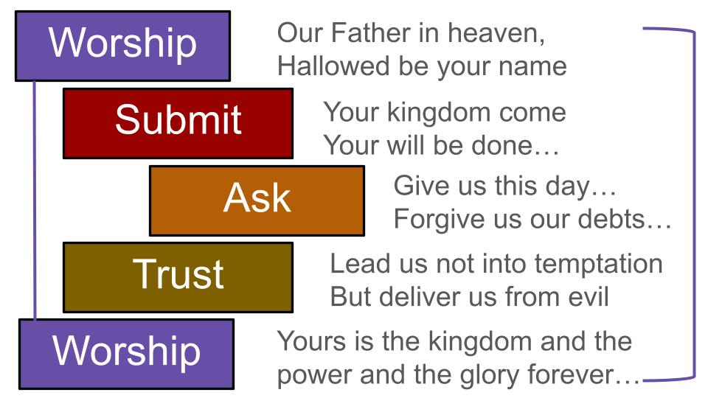
The prayer begins and ends with worship – giving praise and glory to God the Father and recognizing that everything belongs to Him, so we depend completely on His wise and gracious provision. This is why the middle of the prayer features our petition: “Give us this day our daily bread.” Yes, we ask for what we need, but in a specific way, surrounded by worship, gratitude, submission, and faith.

Here is a slightly more complicated outline that will show us more of the depth of this prayer.
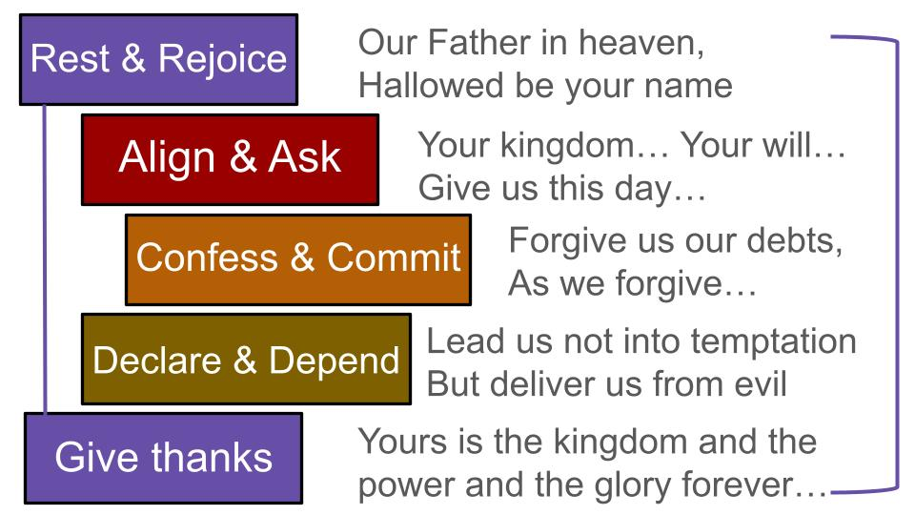
We begin with worship that looks like resting in our Father’s arms and rejoicing in His holy, glorious love. We move into submission as we align with His kingdom purposes and ask for our daily bread to pursue those purposes. Then we confess our sins, asking the Lord to forgive our sins in His infinite grace as we, at the same time, commit to forgive those who have harmed us. Then we ask for God’s protection as we stand firm in the victory of the Lord Jesus who HAS delivered us from evil. And we close as we opened – with worship, thanksgiving and praise to the One who owns and directs all things.

So let’s walk through these five stages of prayer together this morning. First, we begin with worship by resting in the loving arms of our Father in heaven.

Prayer begins with Worship
“Our Father in heaven, hallowed be your name.”
- Rest and Rejoice in God’s Personal Presence

Often we think of prayer as a laundry list of requests. Imagine if your son or daughter came to you that way. Mom! Dad! I need this, I need that, gimme cash… Now, of course, we want to help our children and want to know what they need. Usually we already know what they need before the call or text or visit even takes place. But doesn’t the phone call start with, “Hey Mom! How are you? How is the old guy?”

It’s all about RELATIONSHIP. And the same is true with God. We first come recognizing who He is: our Father. Our loving Father in heaven. So we approach Him with respect, with reverence, with awe. And our first desire in prayer is that His Name would be honored and seen as holy in our hearts and everywhere.

Feel the beauty of this way to open our prayers. “Our Father in heaven, hallowed be your name.” Rest in His loving arms. Rejoice in His presence with us. Start there. Stay there. Take in how amazing the grace is that enables us to approach God at all!

Prayer begins with Worship
- Rest and Rejoice in God’s Personal Presence
“He will tend his flock like a shepherd; he will gather the lambs in his arms; he will carry them in his bosom, and gently lead those that are with young.” Isaiah 40:11

The people of Israel had Psalm 23 from the days of King David, who had been a shepherd himself, so he knew personally what this felt like. A little lamb wandered off, got tangled up in thorns and had to be carried back home.

Here is our little Cockapoo lamb who often needs to be carried in.


His name is Watson, really Dr. John Watson, so he has a British accent, of course.

Here is Watson in the middle, between Mochi and Jarvis.



Jarvis is a little beyond the little lamb stage, but Colton is being a strong shepherd to hold his 50 pounds of Jarvis. This is the best modern idea I can give you of a little lamb being carried close in love.

Prayer begins with Worship
“Our Father in heaven, hallowed be your name.”
- Rest and Rejoice in God’s Personal Presence

So, this is where prayer begins: with worship of the Father who loves us and is with us all the time. Resting in the arms of our Good Shepherd who holds us close to His heart and gently leads those that have young. Rejoicing in His overflowing love. That is stage one of prayer. And it means we have to slow down enough to rest there.

Take a minute now to breath in the first phrase, “Our Father in heaven.” Breathe in that wonderful truth and prayer. Hold that breath for just a second. Then breathe out the next phrase, “Hallowed be your Name.” Breathe in love. Breathe out worship. Rest there. Rejoice there. Abide. Dwell.

Prayer continues with Submissive Faith
“Your kingdom come, your will be done, on earth as it is in heaven. Give us this day our daily bread.” (v. 10-11)
  - Align with God’s Purposes and Ask for His Provision

In the middle of this prayer, as we saw last week, is the petition, “Give us this day our daily bread.” That prayer alone is so profound. We noted last week how Jesus didn’t teach us to pray, “Give ME right NOW everything I want.” He taught us to pray as a FAMILY, as a community, for OUR daily bread. Not everything we want but for our daily needs, which invites us to share with and support one another in answer to our own prayers.

One way to see that your prayers are answered more often is to pray this critical prayer, “YOUR kingdom come, YOUR will be done.” When we pray in Jesus’ name and according to His will, He promises to answer our prayers.

Prayer continues with Submissive Faith
  - Align with God’s Purposes and Ask for His Provision
“Whatever you ask in my name, this I will do, that the Father may be glorified in the Son.” John 14:13

Jesus didn’t just blanket promise to answer ANYTHING we pray. It’s what we ask for IN HIS NAME – which means according to HIS desires, His will. And don’t miss the other qualifier Jesus put on answered prayer: “that the Father may be glorified in the Son.”

That was the whole purpose of Jesus’ life and ministry, to glorify the Father. Read and pray through John 17, which Jesus prayed just before going to the cross. His main desire there at the end of his earthly life was that God the Father would be glorified.

Prayer continues with Submissive Faith
  - Align with God’s Purposes and Ask for His Provision
“Father, the hour has come; glorify your Son that the Son may glorify you.” John 17:1

To the extent that our prayers line up with these desires of Jesus, God will gladly and consistently answer them. Is this how you tend to pray? For the glory of Jesus, leading to the glory of God?

That is the central purpose of God in all of history and in each of our lives: that as Jesus is lifted up, God will be glorified. Prayer begins with worship to our Father in heaven, asking that His Name be honored and revered in all holiness. Then prayer continues with submission to God’s plans and the advancement of His kingdom – which is all about Jesus.

SONG: How Great Thou Art
Prayer begins with worship; continues with submission and faith. The third step in prayer:

Prayer calls on God for His infinite Grace
“And forgive us our debts, as we also have forgiven our debtors.” (v. 12)
    - Confess your sins and Commit to forgive others

All true prayer boils down to the heart’s cry of the tax collector who beat his chest and simply said, “Lord, have mercy on me, a sinner.” There was a Pharisee next to him, Luke 18 shows Jesus teaching. And the religious Pharisee stood up tall and proud, praying with gratitude that he was such a holy person, so different from the sinners and lost people around him – like the sell-out tax collector beside him.

Prayer calls on God for His infinite Grace
    - Confess your sins and Commit to forgive others
“But the tax collector, standing far off, would not even lift up his eyes to heaven, but beat his breast, saying, ‘God, be merciful to me, a sinner!’” Luke 18:13

That is true prayer. That is the heart of it: simply crying out to God for mercy. That is what it looks like to be POOR IN SPIRIT: to humbly fall on your face before God and throw yourself on His mercy. That’s what two blind men did as Jesus approached Jerusalem and the end of His earthly life. They heard Jesus coming by and shouted to get his attention.

Prayer calls on God for His infinite Grace
    - Confess your sins and Commit to forgive others
“The crowd rebuked them, telling them to be silent, but they cried out all the more, ‘Lord, have mercy on us, Son of David!’” Matthew 20:31

Remarkably, Jesus wasn’t too busy to stop for these two irrelevant beggars. He went right to them and asked what they wanted. Naturally, they asked Him to heal them so they could see. Jesus touched them and opened their eyes, and they got up to follow Him. By healing two blind men, Jesus helped everyone to see the truth those blind men were declaring: Here truly was the Son of David from whom mercy could come.

That’s prayer: calling on God for His infinite Grace. Simply shouting out to Jesus for His mercy and His holy touch. We saw last week that when you have experienced the grace of Jesus it is only natural to share that same grace and mercy with others. If you don’t forgive those who have harmed you it shows you have not yet really known the mercy and grace of God for yourself. Step four in prayer:

Prayer is an expression of Jesus’ Victory
“And lead us not into temptation, but deliver us from evil.” (v. 13)
  - Declare God’s Victory and Depend fully on Jesus

Now, why do we need to pray for God to not lead us into temptation? James 1 says explicitly that God never tempts anyone, since He cannot be tempted by evil himself. So are we praying for something that is silly to pray for because it could never happen? Obviously, Jesus taught us to pray this way for a reason.

The two phrases clarify and expound each other, as with all Hebrew poetry that uses parallelism with one phrase then another that are related but different. It isn’t God who DOES the temptation, but God can (at times) allow us into times of temptation where the devil, the world, or our own flesh will tempt us. God is the One who DELIVERS US from the temptation and evil; the One who strengthens us to stand firm through trials when we trust in Him. Jesus, of course, is the example of how to do this. Look back at Matthew 4.

Prayer is an expression of Jesus’ Victory
  - Declare God’s Victory and Depend fully on Jesus
“Then Jesus was led up by the Spirit into the wilderness to be tempted by the devil.”
Matthew 4:1

It’s the same word there for TEMPTATION. Same idea with “being led.” Jesus had to go to the wilderness, where Israel had failed. He had to overcome the temptation through which Adam and Eve had failed. Jesus, the new Adam, overcame the temptation. Jesus, the new Israel, succeeded in the wilderness after 40 days without food.

And so, in prayer, we declare the victory of King Jesus and depend fully on Him. We stand firm IN THE LORD, as we are told in Ephesians 6.

Prayer is an expression of Jesus’ Victory
  - Declare God’s Victory and Depend fully on Jesus
“Finally, be strong in the Lord and in the strength of his might. Put on the whole armor of God, that you may be able to stand against the schemes of the devil.” Ephesians 6:10-11

Jesus assured us, “In this world you WILL Have trouble.” There is no doubt about that. Trials and temptations will come our way. But we can rejoice in that suffering; we can take heart… why? Because JESUS has overcome the world. And He has promised to use even suffering to shape us more and more into His image. In fact, suffering is one of God’s best tools to chisel away our sin and make us more like Jesus. That is Paul’s point in Romans 5 when we “rejoice in our suffering,” because endurance produces character. That is the point James makes in James 1, with the same exhortation to “count it all joy” when we face trials of different kinds because these grow us toward maturity and Christ-likeness. Peter writes the same thing in 1 Peter 1:

  - Declare God’s Victory and Depend fully on Jesus
“In this you rejoice, though now for a little while, if necessary, you have been grieved by various trials, so that the tested genuineness of your faith—more precious than gold that perishes though it is tested by fire—may be found to result in praise and glory and honor at the revelation of Jesus Christ.” 1 Peter 1:6-7

Not only can we endure suffering, testing, and trials – we can and should REJOICE In these trials because they prove our faith genuine. Like a goldsmith heating the metal to remove its impurities, so God uses suffering to reveal and remove the impurities in our hearts, which results in praise, glory, and honor to the Lord Jesus. If our faith is proved genuine in the process. So, as we pray, we declare God’s victory in Jesus as we depend fully on Him. This is not to say that suffering is easy. We pray for the Lord to deliver us from it, leading us through it like the Good Shepherd He is.

Prayer is an expression of Jesus’ Victory
“And lead us not into temptation, but deliver us from evil.” (v. 13)
  - Declare God’s Victory and Depend fully on Jesus

So, let’s pause and pray again, declaring and believing in the full victory of King Jesus over everything in this world, and rejoicing in HIM even though we struggle in this world.
Ok, here is our summary as we follow the early church into the extra ending, the doxology. Prayer begins and ends with worship. Asking our Father for what we need is in the middle but is surrounded by submission to His kingdom and will and faith in His love and plans.

Prayer leads us back to Gratitude and Worship
“For yours is the kingdom and the power and the glory, forever and ever. Amen.” (v. 13b)
- Give thanks and Glorify God for His goodness and love

Your Bible may have a footnote here saying “some manuscripts add” this line. The reality is that this conclusion came along well after Matthew himself was with the Lord in heaven. It was clearly added by the early church and included in the Didache, the worship manual and church handbook of the late first century. So it is certainly helpful and actually Biblical, just from the Old Testament.

After collecting all the supplies for the building of the temple, David prayed this prayer of dedication over the temple that was still to be constructed:

- Give thanks and Glorify God for His goodness and love
“And David said: ‘Blessed are you, O Lord, the God of Israel our father, forever and ever. Yours, O Lord, is the greatness and the power and the glory and the victory and the majesty, for all that is in the heavens and in the earth is yours. Yours is the kingdom, O Lord, and you are exalted as head above all.’” 1 Chronicles 29:10-11

This is why we pray to the Lord, the God of heaven and earth: because everything belongs to Him and He is the One who can provide it for us and for others. Everything in heaven and on earth: all power and provision, all glory and honor. It’s all HIS. And in Christ, God has shared it all with us, the body of Christ.

The early church gave us a nice, simple summary of this passage from 1 Chronicles.

Prayer leads us back to Gratitude and Worship
“For yours is the kingdom and the power and the glory, forever and ever. Amen.” (v. 13b)
- Give thanks and Glorify God for His goodness and love

So again, breathe in and out. Breathe in the truth about God that everything is His. Feel the gratitude for His kingdom, power and glory. Take it into your heart, mind and soul. Then breathe out worship, thanksgiving to Him.

Let’s pray and sing praise as we close today.

