Pray and Forgive
Matthew 6:6-13

The Lord’s Prayer can become so familiar that we rush right past phrases that are deeply profound and have world-changing implications.

“Give us this day our daily bread, and forgive us our debts, as we also have forgiven our debtors.” Matthew 6:11-12

Give us this day our daily bread is the verbal CENTER of the prayer. Notice the structure:
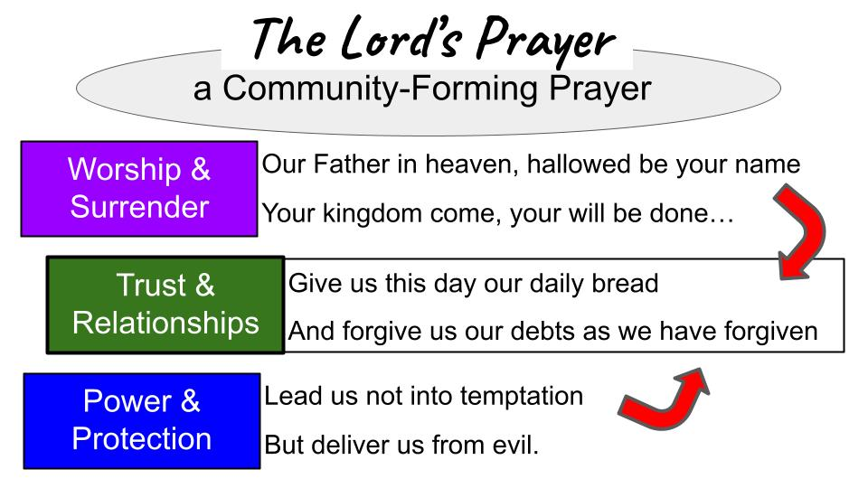

The Lord’s Prayer begins with worship to our Father in heaven, moves into surrender to His kingdom and His will. Then the prayer turns from looking up to the Father to looking over at our brothers and sisters beside us. Give US this day our daily bread.

I bet many of us have translated that to “GIVE ME this day MY daily bread.” And the application is certainly there to pray that way. But it is quite significant that the phrasing is plural and corporate, not singular and individual.

Of course, in Jesus’ day, that corporate, communal idea was assumed and hardly needed to be expressed out loud. But in our modern culture, the opposite is assumed. We all tend to think personally and individually, and only by extension to our families, neighborhoods, and other social groups. Do you see how this prayer is not just a heart-forming prayer but is also a COMMUNITY-forming prayer? We don’t just pray for God to provide for each of us individually, but for ALL OF US together. We don’t just pray for protection for ourselves individually, but for spiritual power and deliverance for all of us as a group!

This shouldn’t surprise us as we go through the Sermon on the Mount, which has the same approach: it is not just a heart-shaping message, it is a COMMUNITY-forming message.

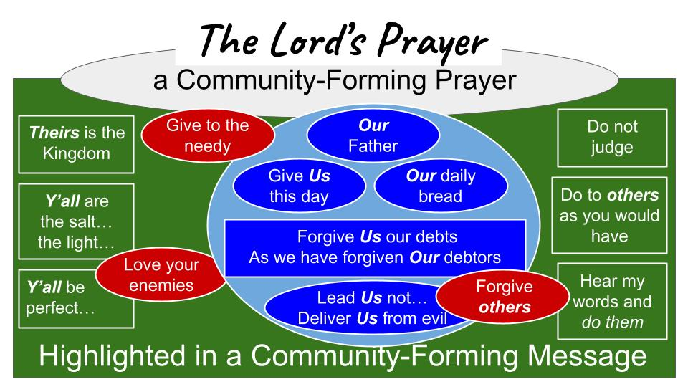
The Lord’s Prayer is at the heart of this sermon: in the verbal center of the message and at the thematic center as well. Jesus is preaching the MANIFESTO of his movement; the calling of His Kingdom. He is shaping the community that will be His people. He is presenting what THE CHURCH will become like as it forms and gets organized.

It will be a group of people who give without expecting applause; who love our enemies and pray for those who persecute and oppose us; a community of grace and forgiveness instead of judgment; a place of obedience, holiness and service, in which the blessing of God is evident.

And what will make all of that possible? PRAYER. The right kind of prayer!
That starts with worship and surrender, looking up in humble dependence on God the Father. It ends with prayer for power and protection from the Lord. And in the middle, it is all about RELATIONSHIPS. We depend on the Lord’s provision, His daily bread, for all of us together – and share what we have with each other. Oh, and let’s not forget how we forgive each other and give grace to each other in the same way God has forgiven and given grace to each of us.

So, our main lesson today is:

Give to Others what God has Given to You

There is a practical side to that when it comes to “daily bread.” We share with those around us some of the day-to-day blessings God has given to keep us going. We SHARE our daily bread and become part of the answer to this prayer right away. But we also share something else even more important than food. We share GRACE with each other. As a community that has been forgiven so much by our gracious heavenly Father, how could we not forgive the other sinners around us?

Just pause for a moment and consider all that God has given you…
- Well, you’re alive, so that’s a good place to start.
- For some of us as we look around this room, we nod to each other and say, “Hey, we are STILL alive, even through some rough physical challenges.”
- You had a family - Mom, Dad, brother, sister – sure, there were difficulties with them, but still God gave you some kind of support system.
- Look around – right here you also have a Spiritual family – some quirky uncles and cousins in here, yes; but still a group of people to love and care for each other through the many highs and lows of life.
- What else has God given you? Daily bread. Food. Shelter. Clothing. Daily necessities.
- What about education, knowledge, opportunities.
- Think about people who encouraged you; mentors, leaders; peers, friends.
- How about skills, training, work to do, ways to serve and make a difference in the world…

Of course, when we stop for a second or two to think about it, EVERYTHING we have is what God has given us. Everything. What possible response to this generosity could we have than to be grateful and generous to those around us?

So, let’s walk through this part of the Lord’s prayer to consider three ways God is calling us to SHARE, to give back, to pay it forward from all He has given to us. First:

Give to Others what God has Given to You
- Practical Goods
“Your kingdom come, your will be done, on earth as it is in heaven. Give us this day our daily bread.” Matthew 6:10-11

Let’s not lose the context of this prayer. As we worship and trust in our Father in heaven and pray that His Kingdom would come and His will would be done, the prayer guides us into what His will looks like. It looks like generous community; loving relationships; sharing what we have with each other. Praying for each other and becoming part of the answer to those prayers. Give US this day our daily bread. Help US become a generous church family that takes care of one another!

God has given you everything you have. Every breath. Every resource. Every piece of bread. Every dollar you have ever earned. Every skill or bit of knowledge that has enabled you to earn those dollars.

One of the main reasons we should pray this prayer regularly if not daily is to be reminded that God is the Giver of everything we need. We are not to depend on ourselves or devote ourselves to the things of this world, but to depend fully on the Lord and devote ourselves fully to His Kingdom above all. We ask our loving Father for what we NEED each day, recognizing it’s not about our individual needs but about the needs in our church family. Give US this day OUR daily bread, so WE can share with each other and know that in that way all of our needs will be met.

So first we give to those around us our practical goods that God has given us. Second: as those who have been given so much grace, we share that mercy and forgiveness with each other as well.

Give to Others what God has Given to You
- Personal Grace
“Give us this day our daily bread and forgive us our debts, as we also have forgiven our debtors.” Matthew 6:10-11

Debts. Think about the debt you owed to God. If your every sin and mistake and bad judgment were tallied up in one long receipt, with each one given a dollar amount that added to your debt – how long would that receipt be? How much would the dollar amount add up to?

I don’t know about you, but I personally don’t want to see that invoice, and I certainly don’t want anyone else to see it.

Think of what Jesus did when He saw your crazy long invoice; your tab at the restaurant called sin. He picked up that tab. He took that invoice and all the debt it stood for – He took it all INTO His human body. Jesus PAID IT ALL.

What did it take for Jesus to make that payment? He had to let those sins come to define Him. He had to BECOME sin for you and for me. He had to let those sins nail Him to the cross. He had to DIE for your sin and mine. That was the payment required to zero out those debts. Death and hell.

What can wash away my sin? Nothing but… the BLOOD of Jesus.

Listen to these words as I read them slowly.

“And you, who were dead in your trespasses and the uncircumcision of your flesh, God made alive together with him, having forgiven us all our trespasses, by canceling the record of debt that stood against us with its legal demands. This he set aside, nailing it to the cross.” Colossians 2:13-14

You and I – what was our condition before Jesus died for us? WE were the ones who were dead. In what sense were we dead? IN our trespasses. We were defined by our sins. We were drowning in our sins. In fact, we had already drowned. Dead and buried.

But God did not leave us there. He raised us out of that grave, out of that toxic swamp of sin, “having forgiven us ALL our trespasses.” How many? All of them. Most of them? All of them. And how did God do that miraculous work of grace?
He had to put those sins somewhere. He couldn’t just look the other way, since justice is an essential part of His nature. Instead of placing those sins on us, where justice says they should go, God placed every one of those sins, the entire ledger, onto His Son. Jesus took our sin. He bore it all in His body on the cross.

Look at those beautiful gospel words: canceling the record of debt that stood against us. He set it aside how? NAILING it to the cross. What a wonderful picture of grace! So, as those who have been forgiven this uncountable amount, how should we treat others?

Give to Others what God has Given to You
- Personal Grace
“Give us this day our daily bread and forgive us our debts, as we also have forgiven our debtors.” Matthew 6:10-11

Later in Matthew, in chapter 18, Jesus tells a parable about a man who was forgiven something in the realm of 5 million dollars. The rich man who held that debt heard the desperately indebted man’s cries for help and forgiveness, and in a moment of amazing grace decided to forgive the entire debt.

Not long after receiving this tremendous gift of forgiveness, the poor man ran into someone on the street who owed him around five dollars. Now, who would even think about an amount like that, given what had just happened? But this guy lost his mind. He started to choke the other guy and demand that the little debt be repaid. He would not hear any of the man’s pleas for patience or his assurances that he would pay the debt in time. No. He demanded the full debt be paid immediately.

Of course, the situation was reported back to the wealthy man who called in the one who had been forgiven the $5M.

“Then his master summoned him and said to him, ‘You wicked servant! I forgave you all that debt because you pleaded with me. And should not you have had mercy on your fellow servant, as I had mercy on you?’” Matthew 18:32-33

The parable is compelling. What kind of ungrateful, greedy, ridiculous fool would demand that a tiny debt be repaid to him when he had just been forgiven 20 years wages in one moment? Here is how Jesus concludes that teaching in Matthew 18.

“And in anger his master delivered him to the jailers, until he should pay all his debt. So also my heavenly Father will do to every one of you, if you do not forgive your brother from your heart.” Matthew 18:34-35

Ok, what is Jesus saying here? He is saying, “If you don’t forgive other people who have harmed you only a little bit in this life, then you haven’t really understood or accepted the infinite grace of God to forgive you for all of eternity.” This is the same way Jesus concludes his teaching on the Lord’s Prayer as well.

Give to Others what God has Given to You
- Prayerful Gratitude
“For if you forgive others their trespasses, your heavenly Father will also forgive you, but if you do not forgive others their trespasses, neither will your Father forgive your trespasses.” Matthew 6:14-15

This is the point of the unforgiving servant. That man acted like he HAD NOT been forgiven a huge amount. He went on to live like someone who still owed a massive debt and so had to squeeze money out of everyone he could. Having received an enormous gift he did not thereby become a GIVER but remained a TAKER, and a mean one at that.

Have YOU been so changed by all God has given you that you are no longer a taker but have become a giver? Has gratitude transformed you from the inside out? If you remain the same person after believing in Jesus as you were before believing in Jesus, what that means is – you haven’t yet understood what the good news is all about. You haven’t really believed in Jesus at all yet. The grace of the Lord Jesus to pay for all of your sins is infinitely more valuable than five million dollars. $5M would help you for a few years in this short, painful life. The grace of Jesus to forgive your sins will help you for the endless ages of eternity in the new heaven and new earth.

When you look at this verse about forgiving others as God has forgiven you, who comes to mind? Who is it that God is calling you to forgive? C.S. Lewis said it well, “Forgiveness is a lovely idea until you have something to forgive.”

This is a specific application of the command of Jesus to “love your enemies and pray for those who persecute you.” The first and best way to love someone who has hurt you is to FORGIVE THEM. You may never see them in person and have the opportunity to verbally pronounce your forgiveness. Maybe you could send a letter or message them on social media. Maybe you just need to write it down in your own notebook or journal and pronounce the forgiveness just between you and the Lord.

To forgive someone is to RELEASE THEM from the justice they deserve. What you find when you release another person is that you are, in the very same act, releasing yourself.

COREY TEN BOOM STORY OF FORGIVENESS
https://guideposts.org/positive-living/guideposts-classics-corrie-ten-boom-forgiveness/

Let’s take a few minutes to pray and bring these issues to the Lord. Look at Matthew 5 and listen to what Jesus just said a few minutes earlier in this sermon.

“So if you are offering your gift at the altar and there remember that your brother has something against you, leave your gift there before the altar and go. First be reconciled to your brother, and then come and offer your gift.” Matthew 5:23-24

Do you see the key point here? It doesn’t matter if you hurt someone else or they hurt you. Either way, the responsibility is on the follower of Jesus to go make it right. You hurt your brother or sister, get up and leave the worship service and go apologize. Go and be reconciled. Make the phone call. Set up the meeting.

Or, someone has hurt you. Maybe yesterday, maybe years ago. Doesn’t matter. The job of the follower of Jesus is to love one's enemies and to forgive the offense.

We are going to go to the Lord’s Table in a few minutes to celebrate His death for us – His body given on the cross for us. In obedience to Matthew 5 and 6, we are first going to give everyone a chance to take care of the business they need to. If you have a relationship that needs attention right now, start by PRAYING about it. Maybe you need to send a quick text saying, “I love you. I’m sorry. Let’s talk later.”

INSTRUMENTAL MUSIC WHILE PEOPLE REFLECT

Pray to close the instrumental time.

Lead into communion

Take communion together, remembering it is a corporate, family affair on purpose.

Pray.

