When You Fast
Matthew 6:16-24

We are in the RIGHTEOUSNESS section of the sermon on the mount. Jesus doesn’t tell his disciples NOT to practice their righteousness, but just to practice these disciplines in the right way. Not to win approval from people but in secret so they are devoted fully to God alone.
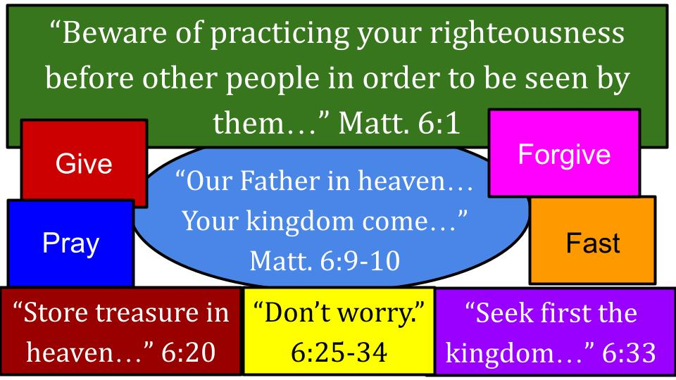
Jesus doesn’t say “IF you give,” or when you feel like praying or If it happens that you forgive someone or if you ever get around to fasting… He says WHEN you give, WHEN you pray, be sure to forgive and WHEN you fast.

So these disciplines are not optional for the follower of Jesus. They are expected.
Here is our focus for this morning.

“And when you fast, do not look gloomy like the hypocrites, for they disfigure their faces that their fasting may be seen by others. Truly, I say to you, they have received their reward.” Matthew 6:16

There is that keyword WHEN. Just a couple of chapters later, the disciples of John the Baptist ask Jesus directly why his disciples don’t practice the regular Wednesday and Friday fasting routines.

“When the disciples of John came to him, saying, ‘Why do we and the Pharisees fast, but your disciples do not fast?’ And Jesus said to them, ‘Can the wedding guests mourn as long as the bridegroom is with them? The days will come when the bridegroom is taken away from them, and then they will fast.’” Matthew 9:14-15

While Jesus was with them, it was a time to learn, to serve, and even to CELEBRATE. Jesus knew it wouldn’t be long before He would be taken from them, and then their time to fast would come. Then they WILL fast.

We remain in that time while Jesus is away from us, though we eagerly wait for His soon return. But now, while He is away, it is our time to pray and fast, in anticipation of the joy that will be ours when our Bridegroom appears in the sky and the last trumpet sounds.

What we will see today in Matthew 6 are four REASONS to FAST, each one supported by a Biblical example of that reason. Conveniently, the reasons all correspond to a letter from the word Fast.

4 Reasons to F.A.S.T.:
- F - Focus on God
“But when you fast, anoint your head and wash your face, that your fasting may not be seen by others but by your Father who is in secret. And your Father who sees in secret will reward you.” Matthew 6:17-18

The what NOT to do in fasting was like giving and prayer - not to be seen by people or to impress people. So again, the way around those bad motives is to practice these disciplines in SECRET. If your focus with any spiritual discipline is to win praise from people whatever attention you win is the only reward for that behavior - whether it’s singing a song, preaching a message, praying in small group, sharing in Bible study or posting a verse to Facebook, whatever.

The main reward is simply to know that our Father in heaven sees our hearts and cares about us. Especially when we are uncomfortable – and fasting is very good at making us feel uncomfortable. Denying food to your body will get some complaints from your stomach pretty quickly. But those feelings of hunger can be useful if they help us direct our attention away from our own desires to focus on God instead.

4 Reasons to F.A.S.T.:
- F - Focus on God devotionally
“But lay up for yourselves treasures in heaven, where neither moth nor rust destroys and where thieves do not break in and steal. For where your treasure is, there your heart will be also.” Matthew 6:20-21

As with all spiritual disciplines, it is a matter of the HEART. That is why secrecy is so important: because it reveals the true motive of our hearts. Why pray? Why give financially? Why set a day or two aside to fast? Why serve at the work day?

Are we trying to store up treasure on earth? Or is our main concern God’s kingdom and matters of eternity? Are we truly focused on God Himself? Is that where our hearts are and where they go?

This is really the main reason to fast: to recalibrate your heart. All of us naturally turn back to this world and our own desires. Fasting is a way to deny those urges and intentionally focus our hearts, minds and bodies on God alone; God above all.

Where is your TREASURE? Is Jesus your primary treasure? Do you delight in Him above all other things? The great Old Testament fast was by Moses on Mount Sinai to receive the 10 commandments. 40 days and 40 nights without any food or water. So this was a miraculous, supernatural fast:

- F - Focus on God devotionally
“And the Lord said to Moses, ‘Write these words, for in accordance with these words I have made a covenant with you and with Israel.’ So he was there with the Lord forty days and forty nights. He neither ate bread nor drank water. And he wrote on the tablets the words of the covenant, the Ten Commandments.” Exodus 34:27-28

Here was the heart of the covenant relationship between God and Israel – the two tablets of stone with the 10 commandments engraved on them by the hand of God Himself. Moses, the great Mediator, in the holy presence of God alone, then coming down with this precious revelation for all of God’s people.

Why did Jesus spend 40 days and nights in the wilderness to start his ministry?

- F - Focus on God devotionally
“Then Jesus was led up by the Spirit into the wilderness to be tempted by the devil. And after fasting forty days and forty nights, he was hungry.” Matthew 4:1-2

Gotta love that Biblical understatement: after 40 days, he was hungry. Yes. Physically, Jesus was on empty. But spiritually, he was on full. 40 days in close communion with God the Father. And after being tempted to turn stones into bread, what passage did Jesus quote to overcome the devil’s temptation?

- F - Focus on God devotionally
But he answered, “It is written, ‘Man shall not live by bread alone, but by every word that comes from the mouth of God.’” Matthew 4:4 (from Deut. 8:3)

Let’s ask ourselves today: do we REALLY BELIEVE this Scripture from both Moses and the Lord Jesus? Do we really live on the word of God and our relationship with Him? Or are we pretty fond of the bread? I think if we’re honest we all like the bread, and the burgers, and the pasta, and the apple pie and the ice cream… now I’m just making you hungry. On PURPOSE - for the next reason to fast.

4 Reasons to F.A.S.T.:
- A - Abstain from usual dependencies
And the tempter came and said to him, “If you are the Son of God, command these stones to become loaves of bread.” But he answered, “It is written, ‘Man shall not live by bread alone, but by every word that comes from the mouth of God.’” Matthew 4:4 (from Deut. 8:3)

Primarily the purpose of fasting is to focus our hearts and minds on God. Part of how that works is to take away one of our usual dependencies, like food. Or caffeine. Or television. Or social media. Or all of the above.

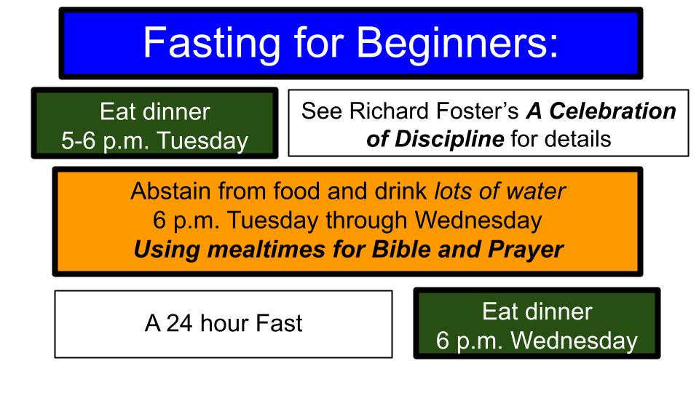
I will suggest just one at a time. A crash course in fasting can overwhelm even the best of intentions. A great way to start, if you haven’t done a food fast before, here is a good approach to try.

The key point on this slide is to first drink LOTS OF WATER, so you don’t risk your body’s health. And a cheat code is if you get lightheaded or need a little boost, have some orange juice on hand for a little pick-me-up. Not Coke. Juice. But water is the main thing. The other key point is to use those mealtimes to draw closer to God. Let every drink of water remind you of WHO you really depend on. WHO is the LIVING WATER to your soul? Feast on the Word of God. Carry a memory verse or two with you throughout the day - maybe one like Deuteronomy 8:3. It was good enough for Jesus in the wilderness, might help us too.

Richard Foster has an excellent chapter on fasting in his classic book A Celebration of Discipline. It explains what your body will go through as you fast, especially for the first time. His analogy is that for those of us who do not fast regularly, our stomachs are like a SPOILED CHILD that will grumble and complain, trying to get us to give in to its demands.

4 Reasons to F.A.S.T.:
- A - Abstain from usual dependencies
But he answered, “It is written, ‘Man shall not live by bread alone, but by every word that comes from the mouth of God.’” Matthew 4:4 (from Deut. 8:3)

For many of us, the better fast is not from food but from PHONE. How much do our thoughts and minds come back to those pings and prompts from these infernal devices? They know what we look for, they study and apply what we click on.

“Man and woman shall not live by LIKES alone.” We shall not live by chat and texts. But oh, it often feels like we do. And I’m 50 years old here. Come on. The Old Testament example of this kind of abstinence fast is Daniel.

- A - Abstain from usual dependencies
“But Daniel resolved that he would not defile himself with the king's food, or with the wine that he drank. Therefore he asked the chief of the eunuchs to allow him not to defile himself.” Daniel 1:8

This was when Daniel and some of the best and the brightest from Israel had been carried off as slaves to Babylon. Daniel knew the king’s food was not kosher, it included things not allowed by Jewish law, and it had all been sacrificed to the gods of Babylon. So Daniel asked his supervisor:

- A - Abstain from usual dependencies
“Test your servants for ten days; let us be given vegetables to eat and water to drink. Then let our appearance and the appearance of the youths who eat the king's food be observed by you, and deal with your servants according to what you see.” Daniel 1:12-13

So, this one is an example of a PARTIAL FAST - drinking water, not wine, and eating vegetables, no meat or anything else. It’s also called a PURITY fast, to deliberately avoid temptations and pressures around us. So a good example of this would be television, music and movies that would compromise our values. Just because everyone at school or everyone around you is watching it, doesn’t mean you should just go along.

As your Mom asked you in these cases, “If everyone went and jumped off a bridge, would you go jump with them?” I actually did exactly that one time. Went with a group of friends from camp and jumped off a bridge in the middle of the night. Thankfully, the senior counselors knew this bridge and swam the water first, so they knew it was safe and deep enough for us rookies. And they made us all wear shoes when we jumped. So the only real casualty from jumping off the bridge was that pair of shoes. And I’m pretty sure the stinky shoes all ended up in someone’s trunk as a prank. Did young Darin have some things to learn… Uh, yeah. Which brings us back to Matthew 6 again for the main point.

- A - Abstain from usual dependencies
“But lay up for yourselves treasures in heaven, where neither moth nor rust destroys and where thieves do not break in and steal. For where your treasure is, there your heart will be also.” Matthew 6:20-21

Where is your treasure? Where is your heart? Do we really love and depend on the things of God and God Himself? Or, if we’re honest, are we pretty dependent on and focused on the things of this world?

Then it might be time for a food fast or a partial fast of another kind. Two more reasons to fast, that are very related to each other.

4 Reasons to F.A.S.T.:
- S - Serve God’s kingdom deliberately
“The eye is the lamp of the body. So, if your eye is healthy, your whole body will be full of light, but if your eye is bad, your whole body will be full of darkness. If then the light in you is darkness, how great is the darkness!” Matthew 6:22-23

Think about your EYES. What do we look at and think about throughout the day? What LIGHT or DARKNESS do we let into our hearts and minds? Or you could say, to paraphrase, the mouth is the doorway to the body. Do we feed our hearts and minds with good, healthy, positive meals or with lots of junk food and even sometimes poison? What are our hearts FULL OF in terms of what we CONSUME practically throughout our days and weeks?

Again, as our parents told us long ago, “Garbage in, garbage out.” If we fill our minds with worldly desires, is it any wonder that what we long for is more of this world? If we fill our stomachs with worldly temptations, is it any surprise that we crave more of this world?

The next challenge coming up in Matthew 6 is to store up treasure in heaven, not on earth, and to seek first the KINGDOM and the RIGHTEOUSNESS of Jesus. A simple way to summarize that is to SERVE others instead of ourselves.

In Luke 16, Jesus told a parable that went like this:

“There was a rich man who was clothed in purple and fine linen and who feasted sumptuously every day. And at his gate was laid a poor man named Lazarus, covered with sores, who desired to be fed with what fell from the rich man's table. Moreover, even the dogs came and licked his sores.” Luke 16:19-21

As we read this, don’t look down at your nice linen shirt, and don’t think about what you had for dinner last night. I sure hope no one is here in purple… That was just a luxury fabric in Jesus’ day and often a sign of royalty. Clearly this particular beggar had hopes from being so close to a very rich person that he might get some scraps or at least some dog food.

“The poor man died and was carried by the angels to Abraham's side. The rich man also died and was buried, and in Hades, being in torment, he lifted up his eyes and saw Abraham far off and Lazarus at his side. And he called out, ‘Father Abraham, have mercy on me, and send Lazarus to dip the end of his finger in water and cool my tongue, for I am in anguish in this flame.’” Luke 16:22-24

I’m sorry, but we have to take our medicine here.

“But Abraham said, ‘Child, remember that you in your lifetime received your good things, and Lazarus in like manner bad things; but now he is comforted here, and you are in anguish. And besides all this, between us and you a great chasm has been fixed, in order that those who would pass from here to you may not be able, and none may cross from there to us.’” Luke 16:25-26

Now, Jesus is not teaching salvation by suffering. But as the beatitudes teach, there is a blessing for those who are poor and thereby become poor in spirit and call on Jesus to save them. The point is that once you die, the situation is fixed. The rich man wanted the tiniest bit of relief for his anguish in hell, but none could be provided. So then, all of a sudden, the dead rich man turned into an evangelist:

“And he said, ‘Then I beg you, father, to send him to my father's house— for I have five brothers—so that he may warn them, lest they also come into this place of torment.’ But Abraham said, ‘They have Moses and the Prophets; let them hear them.’” Luke 16:27-29

Once we realize how serious these issues are and ponder the reality of eternity; what is more important than sharing the gospel with the people we care about?

“And he said, ‘No, father Abraham, but if someone goes to them from the dead, they will repent.’ He said to him, ‘If they do not hear Moses and the Prophets, neither will they be convinced if someone should rise from the dead.’” Luke 16:30-31

So what is the message of this parable of the rich man and Lazarus? Yes, it teaches us about heaven and hell and that the stakes are eternal in terms of whether people believe in Jesus or not. But it also teaches us not to ignore the hurting people RIGHT IN FRONT OF US. So the thrust of it is a lot like the parable of the Good Samaritan. How often do we walk right by people in need as we go from one self-indulgence to the next? Come back to Matthew 6.

4 Reasons to F.A.S.T.:
- S - Serve God’s kingdom deliberately
“The eye is the lamp of the body. So, if your eye is healthy, your whole body will be full of light, but if your eye is bad, your whole body will be full of darkness. If then the light in you is darkness, how great is the darkness!” Matthew 6:22-23

Another important reason to fast is to serve God’s kingdom, to seek His priorities above our own, and intentionally set aside our own desires and comforts for the sake of others. Jesus, of course, is the ultimate example of this as He goes to the cross for us. We join Him in the garden of Gethsemane as He prepares for that terrible sacrifice.

- S - Serve God’s kingdom deliberately
“Then he said to them, ‘My soul is very sorrowful, even to death; remain here, and watch with me.’ And going a little farther he fell on his face and prayed, saying, ‘My Father, if it be possible, let this cup pass from me; nevertheless, not as I will, but as you will.’” Matthew 26:38-39

At several points in his ministry, Jesus withdrew from the crowds for extended times of prayer, to draw strength from God the Father. Here he overtly asks the disciples to stay up and pray with him, but they all just fall asleep, leaving him alone.

But Jesus withholds even SLEEP from himself to prepare Himself to SERVE, saying, “Not as I will, but as you will.” He surrendered Himself completely to the Father’s plan and to our salvation. Jesus embraced His role as the suffering servant, as the Lamb of God.

Now, contrast this with the rich man in the parable. Jesus is the ultimate rich man. He not only has all the wealth and power and glory in the universe, He has all the righteousness, mercy and grace. We are that poor beggar outside His doorstep, just hoping for a scrap or two from the table of Jesus.

Did Jesus simply remain in His mansion, ignoring our need and putting His feet up in heaven? No. Jesus humbled Himself and surrendered all of His needs, saying, “Not my will, but YOURS be done.” He didn’t just feed a few thousand people on a hillside one day. He gave up His life for you and for me, to pay the full price for our sin and feed us with infinite LOVE forever.

Jesus did not come to BE SERVED but to SERVE and to give up His life as a ransom for many – many sinners like you and me. What about us?

4 Reasons to F.A.S.T.:
- S - Serve God’s kingdom deliberately
“No one can serve two masters, for either he will hate the one and love the other, or he will be devoted to the one and despise the other. You cannot serve God and money.” Matthew 6:24

Whom do we really serve? What do we really serve? The currency of this world is MONEY. But it’s also time, energy and love. That poor beggar outside the home of the rich man was looking for food but also for RELATIONSHIP.

Do we live like Jesus, sacrificing our own comforts and pleasures in order to serve others? Or, if we’re honest, are we devoted to this world and the money needed to thrive in it? One more reason to FAST.

4 Reasons to F.A.S.T.:
- T - Together out of love for others
“Your kingdom come, your will be done, on earth as it is in heaven. Give us this day our daily bread…” Matthew 6:10-11

Just a few verses earlier Jesus taught his disciples to pray “Give US this day our daily bread.” Not GIMME everything I want, but Give US the things that we need each day.

One of the first things the early church did after the Holy Spirit was poured out in Acts 2 was share their resources with one another.

- T - Together out of love for others
“And all who believed were together and had all things in common. And they were selling their possessions and belongings and distributing the proceeds to all, as any had need.” Acts 2:44-45

How does God usually answer the prayer, “Give us this day our daily bread”? Yes, it is as we work hard to provide for our own families. But it is also through our church family as we share with one another.

Could it be that the Lord would have you FAST from a dinner out in order to share a gift card with a family in need? Or invite someone over to your house to share a meal together?

Esther is the Old Testament story of fasting for the sake of one another, really to save the whole nation of Israel from a serious persecution in a foreign land.

- T - Together out of love for others
“Then Esther told them to reply to Mordecai, ‘Go, gather all the Jews to be found in Susa, and hold a fast on my behalf, and do not eat or drink for three days, night or day. I and my young women will also fast as you do. Then I will go to the king, though it is against the law, and if I perish, I perish.’” Esther 4:15-16

Here is another extreme fast, going without food AND water for 3 days. But this situation was life and death for all the Jews in that area, and since Esther was placing her own life on the line it seemed reasonable to ask all the Jews to do the same.

And through Esther’s courage, all of the Jews were saved from a murderous plot. God heard their prayers and honored Esther’s faith, intervening to save His people.

And, of course, there is no better example of fasting together and making a personal sacrifice to bless others than what Jesus did for us on the cross. He not only gave up food and water for a couple of days, He gave up His LIFE out of love for you and me.

- T - Together out of love for others
“This is my commandment, that you love one another as I have loved you. Greater love has no one than this, that someone lay down his life for his friends.” John 15:12-13

After washing the disciples’ feet and teaching them about love for one another, Jesus showed them through His own example. This is the greatest love: sacrificing everything.
So here is our summary for today:

4 Reasons to F.A.S.T.:
- F - Focus on God devotionally  - A - Abstain from usual dependencies  - S - Serve God’s kingdom deliberately  - T - Together out of love for others | “But when you fast, anoint your head and wash your face, that your fasting may not be seen by others but by your Father who is in secret. And your Father who sees in secret will reward you.” Matt. 6:17-18

Above all, fasting is about shifting our focus to God. Abstaining from food or tech or other legitimate pleasures helps us break free from our dependencies on those things and apply the truth that we don’t live by bread alone but by the Word of God, and Jesus is our ultimate treasure. Fasting also enables us to serve God’s kingdom by making some small sacrifices, ideally together with other believers out of love for people.

SPIRITUAL GROWTH CONVERSATION & COMMITMENTS

We will… trust, worship, walk, work…

