Do Not Judge
Matthew 7:1-6

Let’s do a little REVIEW as we turn the page to Matthew 7 and the conclusion to the Sermon on the Mount, for our last four messages in Jesus’ Kingdom Manifesto, the Jesus Way.
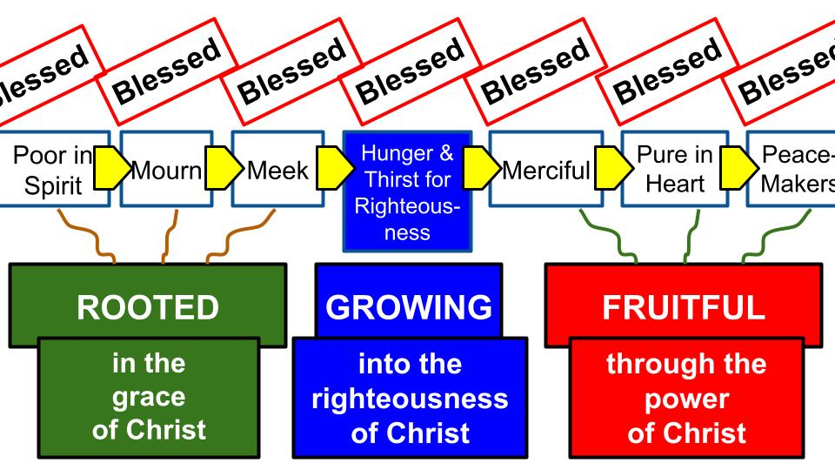
The sermon begins with the beatitudes which provide a GOSPEL GATEWAY to the life God blesses. We saw how these eight blessings are a pathway that progress from one to the other. You can’t jump right to being pure in heart or making peace with an enemy. But you can always reach that first step of being poor in spirit: humble enough to admit your need and cry out to Jesus, “Have mercy on me, a sinner.”

From the gospel roots of humility, repentance, and surrender grows a heart that increasingly hungers and thirsts for righteousness. And that relationship with Jesus as your king will begin to produce fruit in your life of increasing mercy, purity, and harmony in your relationships.
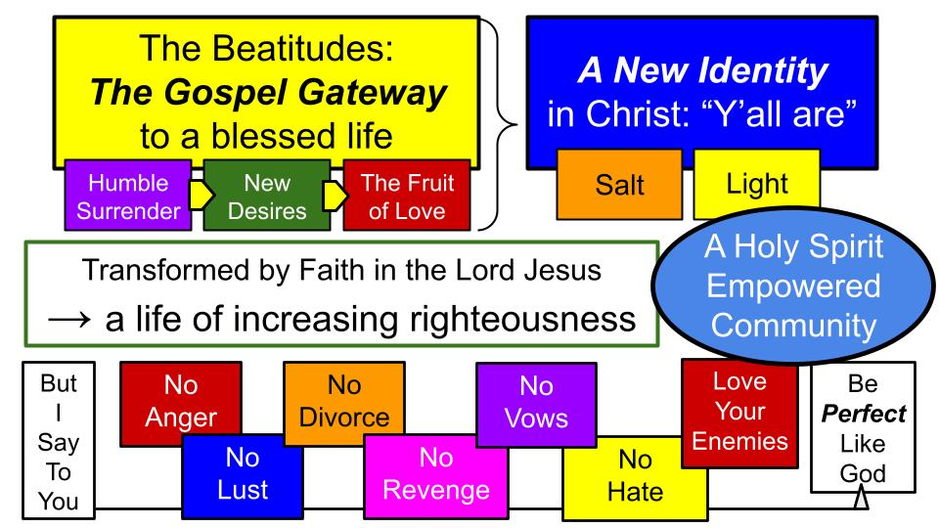
After the beatitudes, Jesus made the striking pronouncement to his disciples gathered on that hill: “You ARE the salt of the earth… you ARE the light of the world.” That was a prophetic, world-changing declaration. Jesus was pronouncing the transformation of heart and life that would take place for all who truly trust in Him. Not just as individuals but as a community, His disciples would become God’s agents of change in the whole world. Not only would we come to PRAY “your kindgom come” but we would seek first that kingdom and His righteousness and begin to see the fruit of transformation in ourselves and the new community Jesus was building by the power of the Holy Spirit.

Here is the Gospel of the Kingdom – the good news that Jesus is King and in a relationship with Him by faith even sinners like you and me can be completely transformed and join a new community of kingdom people. Individuals with a new IDENTITY in Christ, in a new COMMUNITY that would serve as salt and light in a dark and broken world.

Did Jesus come to abolish the Law of Moses and to get rid of the righteous standards of our holy God? He did not come to abolish them but to FULFILL them. Now in a relationship with Jesus true righteousness and holiness, overflowing love even for enemies becomes possible as it never was before.
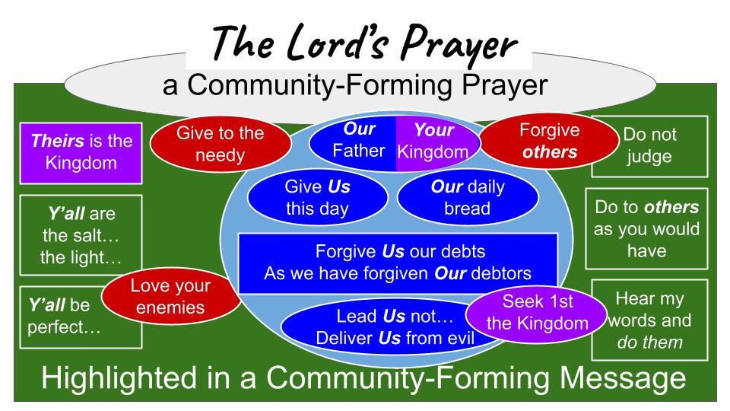
So, Matthew 5 begins with the beatitudes as the gospel Gateway to a new heart, a new identity, and membership in a new kingdom community. Then we turn to Matthew 6 and begin to apply the righteousness demanded of those pursuing PERFECTION in Christ as we hunger and thirst for more of Him. What does that life of righteousness in a community of holiness and generosity look like? It looks like people who GIVE, who PRAY, who FAST and FORGIVE, not to impress people but in devotion to our Father in heaven who sees what we do in secret, and we trust Him to reward us.

And at the heart of this new community of transformed followers of Jesus, we find this unique and powerful prayer we call the Lord’s Prayer. Here is the key to applying the gospel to our lives and living as a transformed community – we pray in devotion to our Father in heaven and we pray TOGETHER in dependence on the Lord. “OUR Father… give US this day OUR daily bread.”

The Lord’s Prayer is a COMMUNITY FORMING prayer exactly in the center of the sermon on the mount which is a COMMUNITY FORMING message. Jesus is showing us how His Kingdom people will function in complete distinction with the people of the world, and how His community will be completely different from the communities and connections of this dark and selfish world.

And do you see in the top right the connection between FORGIVING others and not judging them? If you just pick up right here in Matthew 7 the “Judge not lest you be judged,” may feel abrupt and out of the blue. But in the context of the SOTM it fits perfectly. It is the natural application of the Lord’s prayer “Forgive us our debts” and what follows the prayer in the exhortation to forgive others as we have been forgiven.
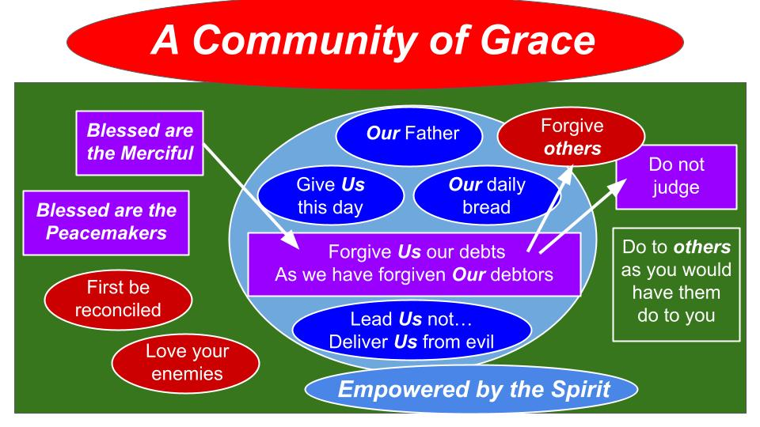
It becomes apparent that Jesus is building a COMMUNITY OF GRACE – responding to the infinite grace of God to us, as He has forgiven us for all of our sins, so we are to forgive one another and even love our enemies. An application of this within our community is not to judge one another but instead, to treat them as we want to be treated; and I don’t know anyone who likes to be judged. Given the choice, I think everyone would choose mercy and grace rather than judgment and criticism.

Today in the first part of Matthew 7 we will see four reasons not to judge. Of course, the main reason should be obvious by now for those who have been listening to the Lord Jesus: God has forgiven US so much, how can we not share that same grace with others? God chose not to judge us but instead to send Jesus to die for us. God forgave us so we can turn around to forgive those who have harmed us.

Reasons not to judge others:
- You are determining the Standard of your own judgment
“Judge not, that you be not judged. For with the judgment you pronounce you will be judged, and with the measure you use it will be measured to you.” Matthew 7:1-2

Ok, that first line just settles it right there, doesn’t it? “Judge not, that you be not judged.” Don’t do it. Why Lord? “Because I said so.” And who are YOU to say so?

Reasons not to judge others:
- Jesus said not to
“The times of ignorance God overlooked, but now he commands all people everywhere to repent, because he has fixed a day on which he will judge the world in righteousness by a man whom he has appointed; and of this he has given assurance to all by raising him from the dead.” Acts 17:30-31

Ah. There you go. If you want proof that Jesus has the authority to talk about judgment, there it is. God has given assurance to everyone with this one simple fact: Jesus rose from the dead. That’s his certificate of authority. That’s his exhibit A for evidence.

Reasons not to judge others:
- Jesus said not to
“Judge not, that you be not judged.” Matthew 7:1

So, back to Matthew 7. Why shouldn’t we judge other people? Jesus told us not to. And He is the ultimate judge, the final authority. So it’s very sensible to listen to what He says. Remember Matthew 28, Jesus said, “ALL authority in heaven and on earth has been given to me.” All of it. Revelation 19 shows us what it will look like when Jesus comes back to judge all people: riding on a white horse, leading the hosts of heaven. And after that comes the final judgment in Revelation 20 when all people from all history will bow before King Jesus and be judged by Him before His great white throne.

Reasons not to judge others:
- You are determining the Standard of your own judgment
“Judge not, that you be not judged. For with the judgment you pronounce you will be judged, and with the measure you use it will be measured to you.” Matthew 7:1-2

Here is a beautiful, POETIC expression of God’s justice. There is a theme throughout the wisdom literature of the Bible, like the Psalms and Proverbs, that evil rebounds on the evildoer.

- The Biblical Rule of the Rebound
“Whoever digs a pit will fall into it, and a stone will come back on him who starts it rolling.” Proverbs 26:27

“Behold, the wicked man conceives evil… He makes a pit, digging it out, and falls into the hole that he has made. His mischief returns upon his own head, and on his own skull his violence descends.” Psalm 7:14-16

The plans that wicked people make OFTEN rebound back on them. Not always, but often. This is Proverbial wisdom. The classic example is a man named Haman who plans to destroy all the Jews, especially his enemy Mordecai. Haman plans this whole parade for himself to be honored and builds a giant gallows for Mordecai to be publicly executed on it. But in the wisdom of God, both sets of plans rebound exactly the wrong way from Haman’s perspective. All of the honors he had planned for himself go to Mordecai. And the huge gallows he had built to have Mordecai executed is what the king used to kill Haman.

- The Biblical Rule of the Rebound: Evil plans often fall back on the evil planner
“So they hanged Haman on the gallows that he had prepared for Mordecai.” Esther 7:10

If you haven’t read the book of Esther recently, it’s an inspiring story of deliverance through faith, family, justice and courage. Haman makes the mistake of trying to have God’s people – the Jews – exterminated; and his evil plans fall back on his own head. It is a fascinating detail of God’s plan to know that, in the end, everyone will be judged by THEIR OWN STANDARD. What perfect justice!

Reasons not to judge others:
- You are determining the Standard of your own judgment
“Judge not, that you be not judged. For with the judgment you pronounce you will be judged, and with the measure you use it will be measured to you.” Matthew 7:1-2

Measurements were common in ancient times when currencies were not universal. Things were bought and sold by weight, which made it possible for people to be very dishonest by having weights that appeared one way but were actually another. So the principle here is, “If you regularly cheat other people by over-charging them for the apples you sell, watch out! Every apple is going to be charged to YOUR account in the end.” Here is how Paul says it in Romans 2:

“You, therefore, have no excuse, you who pass judgment on someone else, for at whatever point you judge another, you are condemning yourself, because you who pass judgment do the same things. Now we know that God’s judgment against those who do such things is based on truth. So when you, a mere human being, pass judgment on them and yet do the same things, do you think you will escape God’s judgment?” Romans 2:1-3, NIV

The way we judge others is a mirror to our own hearts.
- “That person is so materialistic. He only cares about his possessions… Oh, I really want a pickup truck!”
- “That person is so selfish. She only thinks about her own interests and only talks about her own plans… Why won’t anyone just listen to ME for a second?”
- “How can my boss be so harsh? He always comes down on me so hard, like I don’t work hard at all! …What’s wrong with my partner? She is so lazy and never lifts a finger to do anything!”
We give ourselves away when we judge. Best not to do it. That’s reason 1. Number two.

Reasons not to judge others:
- You can’t see the Situation clearly enough because of your own Sin
“Why do you look at the speck of sawdust in your brother’s eye and pay no attention to the plank in your own eye?” Matthew 7:3

Here is the carpenter teaching a lesson, we wonder if his father taught him in the workshop. Hard to do anything with even a small speck in your eye. Certainly, a big chunk of wood in your eye, you’re not going to be able to see anything or do anything.

I certainly wouldn’t want my surgeon coming into the OR with a big plank of wood in his eye. Why don’t you get that thing out of your eye and THEN chop into my brain?

Reasons not to judge others:
- You can’t see the Situation clearly enough because of your own Sin
“How can you say to your brother, ‘Let me take the speck out of your eye,’ when all the time there is a plank in your own eye?” Matthew 7:4

What a memorable visual illustration! And what a powerful exposure of HYPOCRISY. We all THINK we can see the sins of others with perfect clarity. But in fact, we don’t even feel the most obvious problems in our own hearts and lives. We walk around with a huge plank in our own eye all while trying to address the specks in the people around us.

Reasons not to judge others:
- You can’t see the Situation clearly enough because of your own Sin
“You hypocrite, first take the plank out of your own eye, and then you will see clearly to remove the speck from your brother’s eye.” Matthew 7:4

This truth should make us so humble and gracious with other people. Yes, it’s true to state categorically that we are surrounded by selfish sinners. Fact. If you point the finger at anyone on the planet and say, “Sinner,” you are correct. Even the most righteous saints on earth right now still have that lingering remnant of sin. And truthfully, there aren’t very many righteous saints running around, but plenty of selfish sinners. So what does it tell you if you can quickly identify the sin in other people? If you think of yourself as the eye doctor for moral righteousness? You see it all with perfect clarity!

Look in the mirror. That’s what it tells you. The sin you see so clearly may not be the sin of others but much more the selfishness and impatience in your own heart.

Well, how do we remove these giant 2x4s from our own eyes? We’ve already seen this in the Lord’s Prayer.

Reasons not to judge others:
- You can’t see the Situation clearly enough because of your own Sin
“Give us today our daily bread. And forgive us our debts, as we also have forgiven our debtors.” Matthew 6:11-12

Here is the beauty and glory of the gospel! To have these huge chunks of selfishness and proud judgmentalism removed, all we have to do is ASK. “Lord have mercy on me, a sinner.” “Forgive us our debts.” But don’t miss the second half of that prayer, “as we also have forgiven our debtors.” We call on God to forgive us even as we ask Him to help us forgive others. This is reason three to forgive others:

Reasons not to judge others:
- Deal with your own Sin first
“For if you forgive other people when they sin against you, your heavenly Father will also forgive you. But if you do not forgive others their sins, your Father will not forgive your sins.” Matthew 6:14-15

This brings us all the way back to the first beatitude - “Blessed are the poor in spirit, for theirs is the kingdom of heaven.” The blessing of God is reserved for those who are humble enough to admit their need. Only those who are sick know they need a doctor. Only those who are ready to REPENT and turn from their sin can be forgiven and admitted to the kingdom of heaven.

If you don’t forgive others when they sin against you it raises the question of whether YOU have been forgiven by God the Father. Have you really experienced the grace of God to you in Christ? Those who have had all of their sins washed away should be very understanding of sinners like us, and very gracious and quick to forgive those who are weak and selfish as we are. Since Jesus paid your fine of $8M, can’t you forgive your spouse the $5 they owe you for squeezing the toothpaste from the top again? Come on! That’s an obvious one. Close the cap and squeeze from the bottom.

In the end, it’s all about a relationship with God. If you truly trust in Jesus and His amazing grace, that love changes you. Maybe you used to be a judgmental person, but with Jesus, you are becoming a gracious, loving, patient, understanding person. Look at Romans 8 for what God has done for us in Christ:

- Deal with your own Sin first: calling on Jesus to Save you
“For what the law was powerless to do because it was weakened by the flesh, God did by sending his own Son in the likeness of sinful flesh to be a sin offering. And so he condemned sin in the flesh.” Romans 8:3, NIV

What we all DESERVE for our sin is condemnation. We stand before a holy God guilty of uncountable sin – including how we judge others instead of loving them. But God chose not to condemn US for our sin and instead to condemn SIN in the flesh of His Son. Jesus became a sin offering for us – the Lamb of God who took our place.

And what is the result for those who have trusted in Christ to forgive us and make us His own?

- Deal with your own Sin first: calling on Jesus to Save you
“And so he condemned sin in the flesh, in order that the righteous requirement of the law might be fully met in us, who do not live according to the flesh but according to the Spirit.” Romans 8:3-4

God took your sin and mine and placed it on Jesus on the cross. He condemned that sin in the flesh of His Son and Jesus died because of it. Why? So that you and I could be declared RIGHTEOUS in Christ – His perfection applied to us even as our sin was applied to Him. And then God gave us His Holy Spirit to be with us, to guide us, and to empower us to walk in love and grace and reconciliation with others.

And there’s another side to dealing with sin. First there’s the once and for all matter of calling on Jesus to save you. But there’s also the daily and minute by minute reality of praying, “Forgive us our debts.” Those debts keep accumulating, so there has to be a way to deal with them. 1 John tells us what that is.

- Deal with your own Sin first: asking Jesus for His Cleansing grace
“If we confess our sins, he is faithful and just and will forgive us our sins and purify us from all unrighteousness.” 1 John 1:9, NIV

This is part of our DAILY BREAD that we need from Jesus all the time. Isn’t this amazingly good news? Not only does Jesus forgive your sins once and for all when you first call on Him, but He continues to cleanse and purify us every minute of every day as we walk with Him. Don’t miss the IF at the start of this verse. Yes, Jesus is faithful and just to forgive and cleanse us, but we do have to ask Him. We do have to come to Him and humbly pray, “Lord, forgive me… again. Cleanse me… again.” And He does. One more reason not to judge others.

Reasons not to judge others:
- Don’t forget the price of your Salvation
“Judge not, that you be not judged. For with the judgment you pronounce you will be judged, and with the measure you use it will be measured to you.” Matthew 7:1-2

So, we come back to where we started today. It’s not a good idea to judge other people because that isn’t our job: it is Jesus’ job. He is the Judge. Not you. Not me. The impulse to judge other people is a built-in human reminder that we do all DESERVE JUDGMENT. There is a right and wrong, a moral law, that God designed into this universe, and we all know it. Just try to cut in front of a granny at the grocery store. Try to zig in front of that Charger or F350 on Dale Mabry. The granny’s cry of protest and the engine roar on Dale Mabry will remind you that there is a right and wrong, and you have violated it.

CS Lewis said it best:

“These, then, are the two points I wanted to make. First, that human beings, all over the earth, have this curious idea that they ought to behave in a certain way, and cannot really get rid of it. Secondly, that they do not in fact behave that way. They know the Law of Nature; they break it. These two facts are the foundation of all clear thinking about ourselves and the universe we live in.” Mere Christianity, C.S. Lewis

We feel this truth pressing on us. No one can escape the feeling, the deeply powerful conviction, that there is a right and wrong. It is right to help a child who is lost get back to his mother. It is wrong to abuse that child or that mother. It is right to tell the truth at school or at work. It is wrong to tell lies. Not just unhelpful. It is wrong. It is a good thing to share your food with a hungry person. It is a bad thing to ignore the poor and helpless around you. The moral law or natural law is a simple fact of this world and we cannot escape it. And it leads to a troubling conclusion: every one of us fails to meet these standards, so we all have a massive problem as it relates to JUSTICE. Lewis goes on:

“The Moral Law does not give us any grounds for thinking that God is ‘good’ in the sense of being indulgent, or soft, or sympathetic. There is nothing indulgent about the Moral Law. It is as hard as nails. It tells you to do the straight thing and it does not seem to care how painful, or dangerous, or difficult it is to do.” Mere Christianity, C.S. Lewis

Lewis is hilarious. He says, “You may want God to make an exception in your case.” Yes, we may. Of course, we all do. But we know that He can’t make such an exception because it would be unjust, and according to that internal sense of right and wrong, we know God cannot do wrong by others. He must do what is right. And that means we are all in very serious trouble as it relates to justice. We all deserve to be judged.

But, thanks be to God, He has provided a way out, a way of salvation. His name is Jesus. Romans gives us a beautiful and simple summary of how Jesus can offer forgiveness for judgmental sinners like you and me.

Reasons not to judge others:
- Don’t forget the price of your Salvation
“While we were still sinners, Christ died for us… There is therefore now no condemnation for those who are in Christ Jesus.” Romans 5:8, 8:1

Jesus paid the price for your sin and mine. That price was DEATH. We all deserved to die for our sins, but Jesus took that punishment upon Himself. He was condemned so you and I would never face that judgment and condemnation. If you belong to Jesus by faith and are IN CHRIST, then you will never face condemnation for your sin. The final judgment has been taken from you.

So, in summary: Don’t judge people. First, because Jesus said not to – and since He’s the Judge, He’s a good one to listen to on this. If we keep judging and trying to punish other people – in other words, if we don’t forgive and extend grace to others – we are like the brain surgeon with the 2x4 in his eye. Let’s get that plank removed first, and only then go on to the brain surgery on others.

Only Jesus can take that huge plank from your eye. And He will if you just ask Him.

Let’s pray and give thanks for the One who paid for all of our sin!

