Don’t Worry
Matthew 6:25-34

As we begin, let’s feel the force of these commands from the Lord today.

“Do not be anxious about your life, what you will eat or what you will drink, nor about your body, what you will put on. (v. 25)
Therefore do not be anxious, saying, ‘What shall we eat?’ or ‘What shall we drink?’ or ‘What shall we wear?’ (v. 31)
And why are you anxious about clothing? …O you of little faith? (v. 28, 30)
Therefore do not be anxious about tomorrow.” (v. 34)

These are not suggestions or ideas. These are clear and simple commands from The Master to His students; from the King to His subjects; from the Creator to His creatures.

So, let’s get that straight from the jump here.
- Should you worry about health or money or family or the future?
- Should you be concerned and anxious about a decision or plan or something coming up or that might come up later this year?

Hear these words from King Jesus today: “Do not be anxious about your life… Do not be anxious… Why are you anxious about clothing… O you of little faith? Therefore do not be anxious about tomorrow.”

And lest we think it’s only here in the Bible that God instructs us not to worry, here is a preview of where we will land today:

“Do not be anxious about anything, but in everything by prayer and supplication with thanksgiving let your requests be made known to God. And the peace of God, which surpasses all understanding, will guard your hearts and your minds in Christ Jesus.” Philippians 4:6-7

What are we allowed to be anxious about? A few things here and there? The really pressing issues? “Do not be anxious about…” ? ANYTHING. Not one thing.

Well, how can we possibly obey this teaching? The answers are right there in Matthew 6 and in Philippians 4. Don’t worry. TRUST. Don’t worry. PRAY. Here is our lesson from Jesus for today:

Worry is a FAITH problem not a PRACTICAL one

We tend to think that worry and fear are because of our situation. I wouldn’t worry, except that there is so much to worry about! If only I was healthier. If only we had a little more money. If only that new job would come through. If only, if only, if only.

Let’s demolish that one from the Old Testament. King David wrote Psalm 27 in a time of active war. Look at how the great Warrior King faced his fears!
“The Lord is my light and my salvation; whom shall I fear? The Lord is the stronghold of my life; of whom shall I be afraid? When evildoers assail me to eat up my flesh, my adversaries and foes, it is they who stumble and fall. Though an army encamp against me, my heart shall not fear; though war arise against me, yet I will be confident.” Psalm 27:1-3
For David, evildoers surrounding him, armies camping in wait to attack him – these were not figurative ideas. These were literal realities. These were actual swords and spears aimed directly at him. How did David face these literal, tangible fears? He trusted in the LORD. He knew God well enough to trust completely in Him.

“The Lord is my light and my salvation;
whom shall I fear?
The Lord is the stronghold of my life;
of whom shall I be afraid?”
Psalm 27:1

David focused on the God He knew. And the light of that truth drove out the darkness of his fear. The security of His relationship with God drove out the fear of all other dangers. So let’s learn these lessons from David, Jesus and Paul. Let’s trust God more by knowing Him better. Let’s look directly at our worries and fears and banish them in Jesus’ name. Let’s be like King David and do battle against worry by building up our faith in the knowledge, love and power of God.

Worry is a Faith problem not a Practical one
- Trust God more by Knowing Him better
“Therefore I tell you, do not be anxious about your life, what you will eat or what you will drink, nor about your body, what you will put on. Is not life more than food, and the body more than clothing?” Matthew 6:25

What’s the THEREFORE building on here? What’s this “do not be anxious” section of the message responding to? Two topics have been addressed so far in Matthew 6.
- First, Jesus talked about PRACTICING your righteousness. Disciples of Jesus are called to BE PERFECT as our heavenly Father is perfect. In pursuit of that goal we are expected to practice our righteousness, just in certain ways and avoiding other ways.
- “When you give… when you pray… when you fast.” Those were not IF you get around to it instructions, they were directives and expectations from the Master.
- And in the middle of the When you pray section we have the Lord’s Prayer. In the middle of the Lord’s prayer we have the “Give us this day our daily bread,” petition.
- So the therefore “don’t be anxious” is clearly building on those practices of righteousness, and especially the practice of prayer.
- But also there’s the part right after the Lord’s prayer about laying up treasure in HEAVEN not on earth. Why? “Where your treasure is, there your heart will be also.”
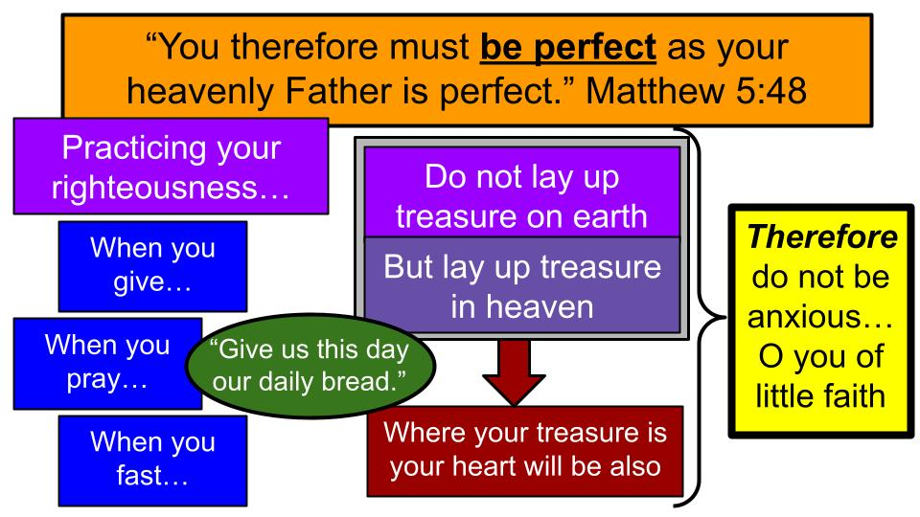
Do you see the setup? If we practice our righteousness with a focus on prayer and especially if we follow the model of the Lord’s prayer, in community seeking the Lord for “our daily bread,” we will be far less prone to anxiety. Similarly, if we store up our treasure mainly in heaven and not on earth, we will have a lot less on earth to worry about. THEREFORE, do not be anxious.

Practice your righteousness in pursuit of godly perfection by giving, praying, and fasting for the Father’s smile alone, not to impress anyone else. Pray to our Father in heaven, surrender to His kingdom purposes, and ask for daily bread as part of a loving community. And store up treasure in heaven, not on earth, so your HEART is invested mainly in the Kingdom and in eternity. This is how to drive out worry with faith:

- Trust God more by Knowing Him better
“Look at the birds of the air: they neither sow nor reap nor gather into barns, and yet your heavenly Father feeds them. Are you not of more value than they?” Matthew 6:26

It’s like Jesus had Florida in mind with the BIRDS. Don’t we have the coolest, hugest birds???

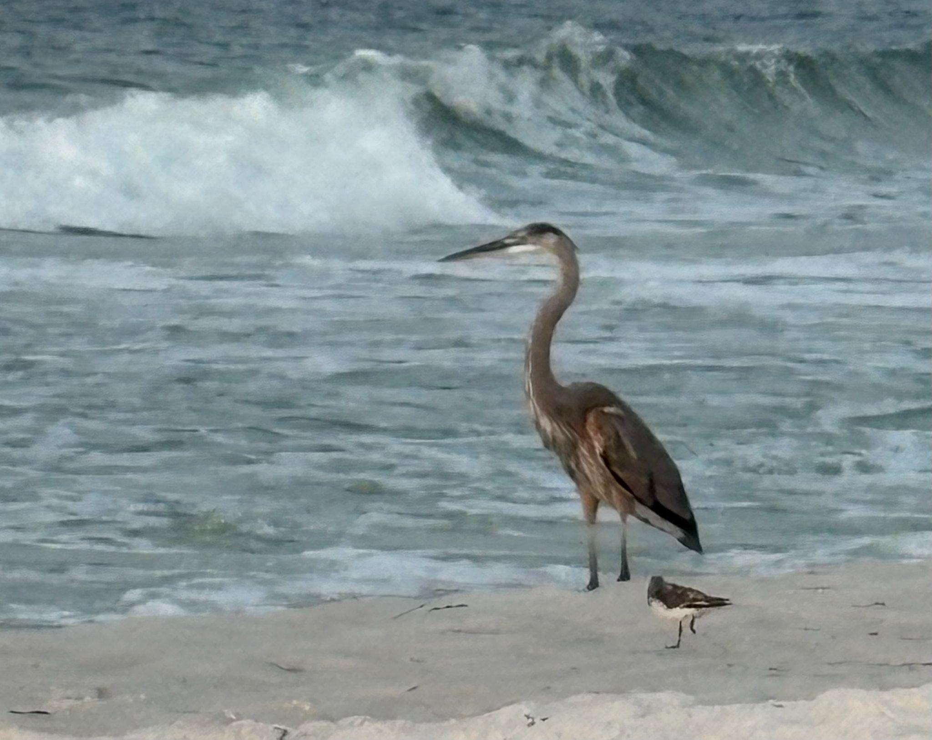
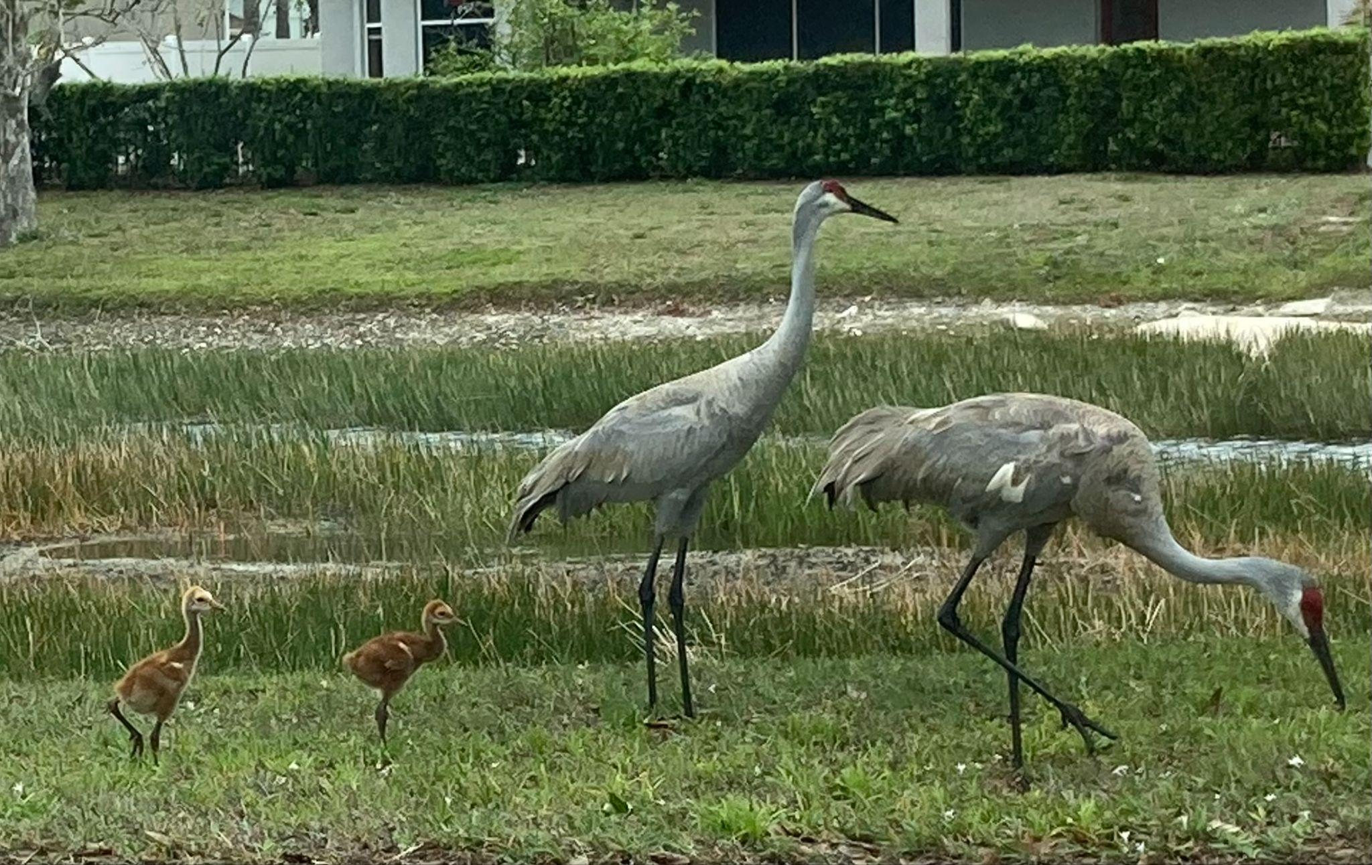


This one even tried to come to church the other day. Or just wanted to see Banner. Listen to what Jesus teaches us by means of the birds:

- Trust God more by Knowing Him better
  - He knows every detail of your life
“Look at the birds of the air: they neither sow nor reap nor gather into barns, and yet your heavenly Father feeds them. Are you not of more value than they?” Matthew 6:26

The birds don’t stress and worry about food. They do get out there and get to work. Those sandhills work all day, every day, poking holes in the ground for whatever tasty treats they find in there. But they don’t have big storage facilities. They don’t have vape shops to help manage anxiety.

The point here is if God takes care of the birds, can’t we trust Him to take care of us? If He knows every detail of the lives of millions and billions of birds, and makes sure each one has food to spare, can’t we trust Him to manage our needs? Aren’t we at least as valuable as the sparrows and chickadees, if not the sandhills and herons?

- Trust God more by Knowing Him better
  - He knows every detail of your life
“Are you not of more value than they? And which of you by being anxious can add a single hour to his span of life?” Matthew 6:26-27

God knows the details of our lives. We don’t know the details. What good does worrying do? What does it accomplish? Does it add a single minute or hour to our lives? It has been proven that stress takes away from our lives.

God knows the days and minutes and details of our lives. We don’t know and we can’t control any of it. So why worry about it? Just a couple chapters later, in Matthew 10, Jesus says it this way:

- Trust God more by Knowing Him better
  - He knows every detail of your life
“Are not two sparrows sold for a penny? And not one of them will fall to the ground apart from your Father. But even the hairs of your head are all numbered. Fear not, therefore; you are of more value than many sparrows.” Matthew 10:29-31

Listen to Psalm 139:

- Trust God more by Knowing Him better
  - He knows every detail of your life
“Your eyes saw my unformed body; all the days ordained for me were written in your book before one of them came to be.” Psalm 139:16, NIV
You see how we are fighting fear and worry with the FACTS of God’s knowledge, love and power? He KNOWS every detail. SO build up your faith in the Lord, the God who knows. And that will lead you to greater peace and less worry. Second:

- Trust God more by Knowing Him better
  - He Cares for every creature in the world
“Look at the birds of the air: they neither sow nor reap nor gather into barns, and yet your heavenly Father feeds them. Are you not of more value than they?” Matthew 6:26

Not only does God KNOW the details of the world, He CARES about them and manages them. “Your heavenly Father FEEDS” the birds. He makes sure each one has sufficient for the day. If we see that with birds, can’t we trust God for our needs? Then from birds, Jesus goes to FLOWERS.

- Trust God more by Knowing Him better
  - He Cares for every creature in the world
“And why are you anxious about clothing? Consider the lilies of the field, how they grow: they neither toil nor spin…” Matthew 6:28

Do you see the lilies and sunflowers out there with shovels and hoes? Are they working and sweating, spinning and struggling?

- Trust God more by Knowing Him better
  - He Cares for every creature in the world
“Consider the lilies of the field, how they grow: they neither toil nor spin, yet I tell you, even Solomon in all his glory was not arrayed like one of these.” Matthew 6:28-29

Even the wealthiest, most successful and famous king in Israel’s history – Solomon – was not dressed with the glory and splendor of a lily in the field. Then Jesus brings the application.

- Trust God more by Knowing Him better
  - He Cares for every creature in the world
“But if God so clothes the grass of the field, which today is alive and tomorrow is thrown into the oven, will he not much more clothe you, O you of little faith?” Matthew 6:30

God not only feeds the birds, but He clothes the flowers. God is the CREATOR of all things, giving us the incredible variety and beauty we see around us. And if God cares for things like grass and flowers, can’t we trust Him to care for US? O us of little faith… Listen to Psalm 19

- Trust God more by Knowing Him better
  - He Cares for every creature in the world
“The heavens declare the glory of God, and the sky shows His handiwork. Day to day they speak, night to night they reveal knowledge. There is no speech, no words, where their voice goes unheard.” Psalm 19:1-3, TLV

The whole of creation cries out the glory and power and creativity of God! And not only does creation prove there is a Creator, the whole universe declares the power of the Lord to also SUSTAIN everything in its perfect balance.

- Trust God more by Knowing Him better
  - He Cares for every creature in the world
“But in these last days he has spoken to us by his Son, whom he appointed the heir of all things, through whom also he created the world. He is the radiance of the glory of God and the exact imprint of his nature, and he upholds the universe by the word of his power.” Hebrews 1:2-3

Jesus – the Creator and SUSTAINER of all things. It is at His word that all things came into being and continue in their being. Do you feel the force of this truth? The wonder and glory of it? You continue to exist because Jesus wills it and speaks it by the word of His power. This truth of being UPHELD by the mighty hand of God, is what encouraged me so much through last summer’s surgery and recovery:

- Trust God more by Knowing Him better
  - He Cares for every creature in the world
“Fear not, for I am with you; be not dismayed, for I am your God; I will strengthen you, I will help you, I will uphold you with my righteous right hand.” Isaiah 41:10

God spoke these words to the nation of Israel as the shadow of Assyria loomed over them and they were about to be taken into captivity. But even with that fear and the challenge they would face for 70 years as slaves, they had these promises from God to be with them, to strengthen them, and to UPHOLD them with His righteous right hand. I like the phrasing in the old hymn, How Firm a Foundation:

“Fear not, I am with thee, Oh be not dismayed
For I am thy God and will still give thee aid
I’ll strengthen thee, help thee and cause thee to stand
Upheld by my righteous, omnipotent hand.”
- How Firm a Foundation, 1787

The righteous hand of God is also the OMNIPOTENT hand of God. We can trust both that God cares for us in righteous, loving ways and that He has the power to intervene on our behalf. He upholds us, even through the darkest times, the deepest valleys. So, we build up our faith in God by knowing Him better – as the God who KNOWS US and who CARES for us. One more vital truth to build up our faith.

- Trust God more by Knowing Him better
  - He Gives us everything we need
“Therefore do not be anxious, saying, ‘What shall we eat?’ or ‘What shall we drink?’ or ‘What shall we wear?’” Matthew 6:31

Here is the third direct command from the Lord Jesus to NOT be ANXIOUS. Don’t be preoccupied. Don’t be concerned with these little things – and yes, they are all little things. Like food and water; clothing and life. What to eat or drink or wear. Remember the birds. Remember the flowers.

Above all, remember our Father in heaven who knows, who cares and who provides for everything we need. As we pray, “Give us this day our daily bread,” we can trust our Father in heaven.

- Trust God more by Knowing Him better
  - He Gives us everything we need
“For the Gentiles seek after all these things, and your heavenly Father knows that you need them all.” Matthew 6:32

This is the whole point of praying to OUR FATHER – is that He loves us and knows us and takes care of us. We don’t pray to a distant, impersonal deity. We pray to our loving Father. When we turn the page to Matthew 7, Jesus will teach us to ASK our Father for the things we need. So here the Lord teaches us not to worry. There He will show us HOW to not worry – by instead coming to the Father in prayer.

- Trust God more by Knowing Him better
  - He Gives us everything we need
“If you then, who are evil, know how to give good gifts to your children, how much more will your Father who is in heaven give good things to those who ask him!” Matthew 7:11

If even the bad parents among us give decent gifts to their children, can’t we trust the infinitely perfect, love-defining God of heaven to give us the things we need? Psalm 23 is wonderfully comforting in the good times and bad times of life. Listen to how that wonderful Psalm ends.

- Trust God more by Knowing Him better
  - He Gives us everything we need
“You prepare a table before me in the presence of my enemies; you anoint my head with oil; my cup overflows. Surely goodness and mercy shall follow me all the days of my life, and I shall dwell in the house of the Lord forever.” Psalm 23:6

Our loving Father in heaven is the Good Shepherd who makes us lie down in green pastures and leads us beside quiet waters. And even when we face terrifying enemies, the Lord prepares a table for us there. He anoints us with healing oil and, in the end, we can say “my cup overflows” because we will dwell with the Lord, in His house, forever. So, let’s finish out Matthew 6 as we listen to our Shepherd and Master.

- Trust God more by Knowing Him better
  - He Gives us everything we need
“But seek first the kingdom of God and his righteousness, and all these things will be added to you.” Matthew 6:33

Our calling is not to be anxious or preoccupied with little things like food, water, clothing and the details of life. Our Father in heaven takes care of the birds and flowers and everything else in the cosmos – we can trust Him to take care of us. And what is OUR PART? What is OUR JOB? But God first in our hearts and lives by seeking His kingdom first, and His righteousness. Store up treasure in heaven, not on earth. Practice our righteousness for the Lord alone, not for people.

What happens when we seek first the kingdom? When we prioritize the things of God and pray, “Your Kingdom come”? All those other things, they get thrown in as well. Our Father knows that we need them. We don’t have to run around like the frantic Gentiles who don’t know the first thing about God or the Bible.

The more we know God, the more we experience the love and faithfulness, the goodness and generosity of our Father in heaven, the more we will trust Him and the less we will worry.

Here is our summary for today:

Worry is a Faith problem not a Practical one
- Trust God more by Knowing Him better
  - He Knows every detail of your life
  - He Cares for every creature in the world
  - He Gives everything we need
- Exercise faith by Praying

The way to combat fear and worry is by building up our faith and knowing God better through His Word. Trust God more by knowing Him better. Know God better by knowing His Word better. Study this book. Meditate on it day and night. And PRAY the Bible. As you read and build up your faith, pray for yourself and others. Draw near to the Lord in prayer. Let’s come back to Philippians 4.

“Do not be anxious about anything, but in everything by prayer and supplication with thanksgiving let your requests be made known to God. And the peace of God, which surpasses all understanding, will guard your hearts and your minds in Christ Jesus.” Philippians 4:6-7

Do not be anxious about… how many things? ANYTHING.

In how many things should we come to the Lord in prayer? EVERYTHING.

Sounds pretty comprehensive. And as we come in prayer, we come in… fussiness and stress? No. with THANKSGIVING. And if we simply obey this teaching of the Lord from Matthew 6, and again here in Philippians 4, what is the promise? PEACE.

We started with King David in Psalm 27, surrounded by armies and enemies but praying to God as His light and salvation, His stronghold. Now look at the main prayer in Psalm 27.
“One thing have I asked of the Lord, that will I seek after: that I may dwell in the house of the Lord all the days of my life, to gaze upon the beauty of the Lord and to inquire in his temple. For he will hide me in his shelter in the day of trouble; he will conceal me under the cover of his tent; he will lift me high upon a rock.” Psalm 27:4-5
How could David get to the point of knowing that the Lord would protect him and lift him high upon a rock? He trusted God more by KNOWING Him better. And David put the kingdom of God first. One thing. Just this one. To know God. To love Him. To be with Him.

There is more in Psalm 27 so use it to read and pray through. As with all Scripture, it will help you know God better and trust Him more. And that will help you worry less and bring you to greater peace.

Let’s pray.

