Treasure in Heaven
Matthew 6:19-24

Here is a simple summary of Matthew 6, the center of the Sermon on the Mount:
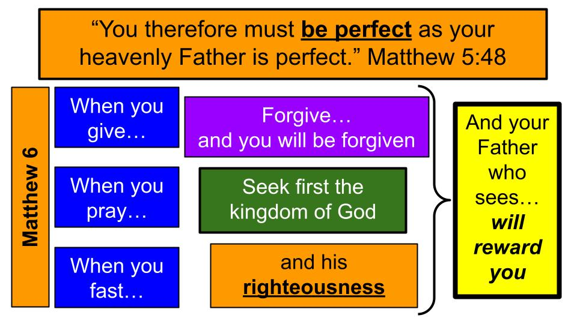
Chapter 5 ended with the summary command to BE PERFECT as God is perfect. That is our standard, that is our calling as followers of Jesus. So it’s no surprise when Jesus continues the message by talking about PRACTICING our righteousness and gives some direction on what NOT to do and what TO DO.

Let’s not miss the “WHEN” directives here. Giving, praying, fasting and forgiving are not optional activities for disciples of Jesus. As we seek FIRST His kingdom and HIS righteousness and pursue perfection patterned after God Himself, we must practice these disciplines of righteousness and do so in the right way: not to win approval from people but only for our Father who sees in secret, for the sake of His reward.

Three times we hear that repetition: when you give… when you pray… when you fast… and all three times there is the result: “Your Father who sees in secret will reward you.” “Your Father who sees in secret will reward you.” “Your Father who sees in secret will reward you.”

In an oral culture like those in ancient times, before newspapers and Tik Tok, repetition in a speech was the key to helping people remember something. So the things that were most important you would repeat. You would help people remember.

So what is the goal for followers of Jesus? The REWARD of God the Father. Not the approval of people. We already saw in the Beatitudes that we should not expect applause and support from people, but rather opposition and persecution – yet knowing there would be blessing in that suffering. Quick review:

“Blessed are those who are persecuted for righteousness' sake, for theirs is the kingdom of heaven. Blessed are you when others revile you and persecute you and utter all kinds of evil against you falsely on my account. Rejoice and be glad, for your reward is great in heaven, for so they persecuted the prophets who were before you.” Matthew 5:10-12

Just to be mentioned in the same company as the prophets of old is quite a reward. But to also to share in the reward of those ancient prophets… The blessing is for those who are persecuted… “for THEIRS IS the kingdom of heaven.” And that’s the promise for those who are persecuted for RIGHTEOUSNESS’ SAKE.

We practice our righteousness. We seek first the kingdom of God and His righteousness. We pursue the perfection of God Himself. And we know that our Father who sees WILL reward us.

Jesus gives us three commands in this part of the sermon. His summary explains the point better than I can:

“Do not lay up for yourselves treasures on earth, where moth and rust destroy and where thieves break in and steal, but lay up for yourselves treasures in heaven, where neither moth nor rust destroys and where thieves do not break in and steal.” Matthew 6:19-20

There is a warning command not to store up treasures on earth and an exhortation command to instead lay up treasure in heaven. So that’s the main idea. Let’s learn from our Master today and try to have ears to hear what He is telling us. Three commands. Here is the first.

Three Kingdom Commands:
- Don’t cling to this World but recognize it is Passing Away
“Do not lay up for yourselves treasures on earth, where moth and rust destroy and where thieves break in and steal.” Matthew 6:19

Jesus came announcing the kingdom of heaven. The spiritual kingdom. The kingdom above. The kingdom of God. He used different phrases at different times, but it’s all talking about the same place, the same reality. In contrast to God’s kingdom is this other place called the world, or the earth.

Which do we live for? It’s easy to hear this verse, which is pretty familiar already, and just assume we are living in light of it and not on the other side of Jesus’ teaching. Oh, I don’t lay-up treasures on earth. I just brought a vanload to Good Will last week. Here it’s not moth and rust so much as sun and mold that destroy. And most of us don’t live in neighborhoods with a lot of crime, but I bet a lot of us do have Ring cameras on the front door to watch for those pesky porch pirates…

Let’s just pause to process the simple fact Jesus is teaching us here: this world is passing away. Everything we “own,” will decompose in a few moments. Isaiah wrote this 600 years before Jesus came on the scene.

- Don’t cling to this World but recognize it is Passing Away
“A voice says, ‘Cry!’ And I said, ‘What shall I cry?’ All flesh is grass, and all its beauty is like the flower of the field. The grass withers, the flower fades when the breath of the Lord blows on it; surely the people are grass. The grass withers, the flower fades, but the word of our God will stand forever.” Isaiah 40:6-8

What is compared to grass here? All FLESH. People. Everyone you know. Every one of us. Oh, our fleeting beauty. Like a rose in a vase on the counter. So pretty today. Starting to wilt tomorrow. In the trash the next day. Like Indiana Jones and the Last Crusade when the guy drinks from the wrong chalice. “You have chosen… POORLY.” And poof. He decomposes into dust in an instant. Maybe better than the guy who looks into the ark of the covenant and melts into goo. Best not to trifle with the holy things of God, whether Old Testament or New.

Three Kingdom Commands:
- Don’t cling to this World but recognize it is Passing Away
“Do not lay up for yourselves treasures on earth, where moth and rust destroy and where thieves break in and steal.” Matthew 6:19

There is the first command from King Jesus – which is really a very serious warning. Let’s go to Luke 12 where Jesus puts this same teaching in a parable.

Someone in the crowd said to him, “Teacher, tell my brother to divide the inheritance with me.” But he said to him, “Man, who made me a judge or arbitrator over you?” And he said to them, “Take care, and be on your guard against all covetousness, for one's life does not consist in the abundance of his possessions.” Luke 12:13-15

Don’t you love that question? Who made me a judge over you? Well… uh. God. Nice little wink from Jesus there, just for his disciples to smile. But the warning applies to everyone listening. Be on guard against covetousness. That’s number 10 of the big 10 commandments. One of the big ones. The closer actually. Ties it all together and gets to the heart of the matter. Yeah, I don’t kill people or cheat on my wife. But covetousness? Well… That’s getting into some personal matters a little.

Jesus is answering a specific question here; a dispute over inheritance. That’s always helpful right? Someone dies and their estate is being divided up. People always handle that beautifully, don’t they? The more money the better it goes, right? Maybe the other way.

But there’s the warning: don’t think your life and value is tied up in your possessions. It’s easy to believe that. So Jesus goes on with a parable.

And he told them a parable, saying, “The land of a rich man produced plentifully, and he thought to himself, ‘What shall I do, for I have nowhere to store my crops?’ And he said, ‘I will do this: I will tear down my barns and build larger ones, and there I will store all my grain and my goods.’” Luke 12:16-18

Now, in this day and age, just about every business person and every small business class would look at this case study from ancient times and say the guy would have been a fool to do anything else, right? You don’t have room on your property for the crops you brought in. Simple solution. Tear down your current storage and build bigger storage.

Isn’t it incredible these days how many storage facilities there are around? Almost as many as there are car washes. I wonder what the things are that we LOVE in our culture? Our cars and our STUFF. Don’t give the stuff away. Store it away. How does Jesus conclude the parable?

And I will say to my soul, “Soul, you have ample goods laid up for many years; relax, eat, drink, be merry.”’ But God said to him, ‘Fool! This night your soul is required of you, and the things you have prepared, whose will they be?’ So is the one who lays up treasure for himself and is not rich toward God.” Luke 12:19-21

Bigger barns. Plentiful harvest. All stored up and secure. Hey there soul of mine: we are all set! We are good for years to come! Eat, drink, be merry. Let’s celebrate!

But how did God assess the situation and decision making? FOOL! Short-sighted fool. You thought you saw so far ahead, but your plans only calculated for a few years – and really you weren’t in control of those years so it ended up being a few seconds. Boom. Heart attack. Dead. Now who gets the big barns? Who gets the harvest? Who inherits the business and the farm? That’s a lot of cabbage. A lot of beets. Summary of the first command:

Three Kingdom Commands:
- Don’t cling to this World but recognize it is Passing Away
“Do not lay up for yourselves treasures on earth, where moth and rust destroy and where thieves break in and steal.” Matthew 6:19

What do we treasure? What do we cling to? What do we count on? Is it all dust in the wind? Sand in our fingers? Flowers in a vase? Beets in a barn?

This world is dissolving before our eyes. If you think otherwise, you just haven’t looked in a mirror recently.

Dating pic / Current pic
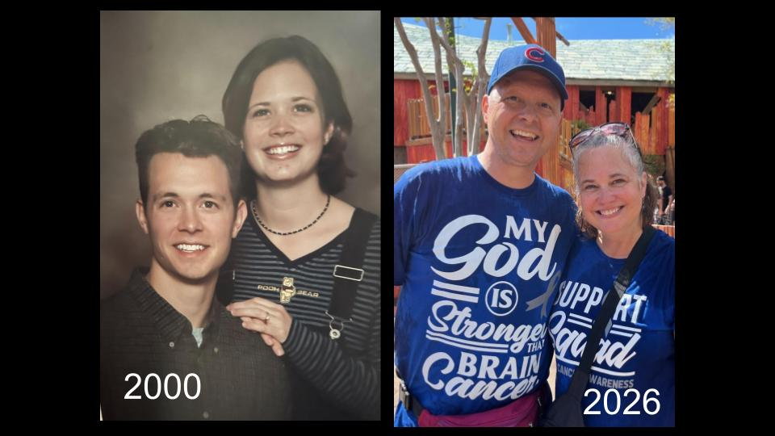

Yes, we look the same. Well, Kristin does. But you can see what aging has done to me. Jesus’ second command gets to the other side of the equation.

Three Kingdom Commands:
- Invest in Eternity and beware of the temptations of Money
“But lay up for yourselves treasures in heaven, where neither moth nor rust destroys and where thieves do not break in and steal.” Matthew 6:20

Where are we storing up treasure? Here on earth? Bigger barns? Bigger bank accounts? Or are we truly investing for eternity? Are we storing up treasure in heaven?

Obviously, Jesus has in mind our physical possessions that can literally be eaten by moths and consumed by rust and stolen by criminals. And he specifically warns us about money, just a few verses later.

Three Kingdom Commands:
- Invest in Eternity and beware of the temptations of Money
“No one can serve two masters, for either he will hate the one and love the other, or he will be devoted to the one and despise the other. You cannot serve God and money.” Matthew 6:24

Money is the concrete example here, but really Jesus is talking about any idol, any other master, any other god we might be tempted to serve. A good test for whether something is too important to you involves these questions:

- Invest in Eternity and beware of the temptations of Money
  - What do you think about, worry about, Trust in and serve most?
“No one can serve two masters, for either he will hate the one and love the other, or he will be devoted to the one and despise the other. You cannot serve God and money.” Matthew 6:24

It’s a matter of the HEART. It’s a question of what we really LOVE. And that shows us who our functional GOD IS. Do we truly trust, worship and serve GOD or, if we’re honest, are we devoted to this world? Jesus will come back to the question of WORRY next week. Food, drink, clothing, comfort. Are those the things we worry about and focus on? Things of this world or things of eternity? God’s kingdom or the kingdom of this world?

One more command from the Lord Jesus here. And, of course, they are all related around the same theme.

- Guard your Heart by directing your Mind to the Lord
“But lay up for yourselves treasures in heaven, where neither moth nor rust destroys and where thieves do not break in and steal. For where your treasure is, there your heart will be also.” Matthew 6:20-21

In the end, the question of treasure on earth versus treasure in heaven is a matter of the HEART. What do we really love, delight in and value? What do we TREASURE? Where do our hearts dwell?

One way to answer that question is to follow the MONEY. What do we literally invest in? Where does our money go? Are we actively engaged in local outreaches and ministries? Are we investing intentionally in world missions?

Where your treasure is, there your heart will be also.

Our hearts and minds follow our dollars. It’s a simple reality of life. Are we spending more on TV and streaming services than we are on kingdom ministry? That translates to TIME management as well. If we pay for the streaming services, we certainly have to use them, right? From treasure, Jesus shifts the metaphor to EYES and LAMPS.
- Guard your Heart by directing your Mind to the Lord
“The eye is the lamp of the body. So, if your eye is healthy, your whole body will be full of light, but if your eye is bad, your whole body will be full of darkness. If then the light in you is darkness, how great is the darkness!” Matthew 6:22-23

What are your EYES letting into your MIND? What do we look at? What do we dwell on? What do we think about? “The eye is the lamp of the body.”

And keep in mind this was 2,000 years ago – long before the internet or social media. But still, the eyes were the gateway to the mind. Turns out, eyes come up early in the Bible. The serpent slithered in and pointed out something pretty to Adam and Eve.

- Guard your Heart by directing your Mind to the Lord
“So when the woman saw that the tree was good for food, and that it was a delight to the eyes, and that the tree was to be desired to make one wise, she took of its fruit and ate, and she also gave some to her husband who was with her, and he ate.” Genesis 3:6

Now, the main temptation was knowledge, but the look of the fruit was appealing too. The desire to be like God, knowing things they didn’t know. And look what happened.

- Guard your Heart by directing your Mind to the Lord
“Then the eyes of both were opened, and they knew that they were naked. And they sewed fig leaves together and made themselves loincloths.” Genesis 3:7

Suddenly through their EYES, their MINDS and HEARTS were changed. They knew something they hadn’t known before. They felt guilt and shame for the first time and though they had always been naked they suddenly felt exposed like they hadn’t before and whipped up some fig leaf coverings.

John’s first letter gives us more insight into this issue:

“Do not love the world or the things in the world. If anyone loves the world, the love of the Father is not in him. For all that is in the world—the desires of the flesh and the desires of the eyes and pride of life — is not from the Father but is from the world. And the world is passing away along with its desires, but whoever does the will of God abides forever.” 1 John 2:15-17

Following the moth and rust warning of Jesus, John says the whole WORLD is passing away. But what will last? The one who DOES the will of God. Obedience. And part of that obedience is intentional protection against temptation. John goes on:

- Guard your Heart by directing your Mind to the Lord
“Whoever confesses the Son has the Father also. Let what you heard from the beginning abide in you. If what you heard from the beginning abides in you, then you too will abide in the Son and in the Father.” 1 John 2:23-24

The good confession of Jesus: the gospel. Holding that before your eyes. Confess Jesus. Believe. Rehearse the mercy and grace of the Lord. Let that truth ABIDE in you. What you heard. Let that truth, that message resonate in your heart. Then YOU TOO will abide in Christ.

So here is our summary for today:

Three Kingdom Commands:
- Don’t cling to this World but recognize it is Passing Away
- Invest in Eternity and beware of the temptations of Money
- Guard your Heart by directing your Mind to the Lord

As those who follow the King – who belong to His kingdom and have been set free from bondage to this world – Jesus calls us to lay up treasure in heaven and to deliberately resist the temptation to store our treasure here on earth.
- Don’t cling to this world – moth and rust are eating it all up. It is all passing away.
- Invest instead in eternity. Store as much treasure THERE as you can and be especially aware of the temptation of money. Money is the currency of this dark and broken world. It helps us feel safe and comfortable and happy.
- But remember the rich farmer with the big harvest. He thought bigger barns were the way to go. He reassured himself how good things were. But then – boom – he died. And where did all that food go? What became of those nice big barns?
- Guard your heart. Think about your eyes. What do you look at, think about, dwell upon? Beware of the desires of this world, the flesh, the eyes – direct your thoughts intentionally to the Lord and fill your mind with Scripture and the things of God.

Come back next week and see how this all ties directly to WORRY. When our hearts get all entangled in the world, we worry about what we could lose. When our hearts belong completely to the Lord and we are well invested in eternity, we worry less about the things of this world. Here is a preview of where Jesus is taking us next week.

“Therefore do not be anxious, saying, ‘What shall we eat?’ or ‘What shall we drink?’ or ‘What shall we wear?’ For the Gentiles seek after all these things, and your heavenly Father knows that you need them all. But seek first the kingdom of God and his righteousness, and all these things will be added to you.” Matthew 6:31-33

Seek FIRST. Put God and His kingdom first in your heart and life. Then you won’t sweat the small stuff – and you’ll see that everything in this world is small stuff.

Be thankful for MOM today. Be sure to call and say, “I love you.” If you were raised, as I was, to know and love Jesus – say an extra thank you to Mom for that. Some of us can give thanks for GRANDPARENTS who taught us to seek first the kingdom and set our hearts and minds on Jesus above everything else.

Let’s pray and give thanks to our generous God and King!

