Ask, Seek, Knock
Matthew, 7:7-12
June 7, 2026

As we come into the concluding section of the Sermon on the Mount, we reach the applications from our wonderful Counselor, our Master Teacher, our Lord and Savior. Let’s not forget who is talking here. Jesus is presenting the manifesto of His kingdom and is inviting all who hear to participate in it – to join the movement that will change the world. But that’s exactly the point, from that moment on the hillside 2,000 years ago until today, people have heard the good news of the kingdom and either committed to it wholeheartedly or have walked away unchanged.

The first word of this sermon is “BLESSED” and leads into the BEATITUDES that show the very counter-intuitive picture of the life God blesses. A life of humility, repentance, submission, growth, integrity, mercy, and persecution. Here is the progression of the beatitudes:
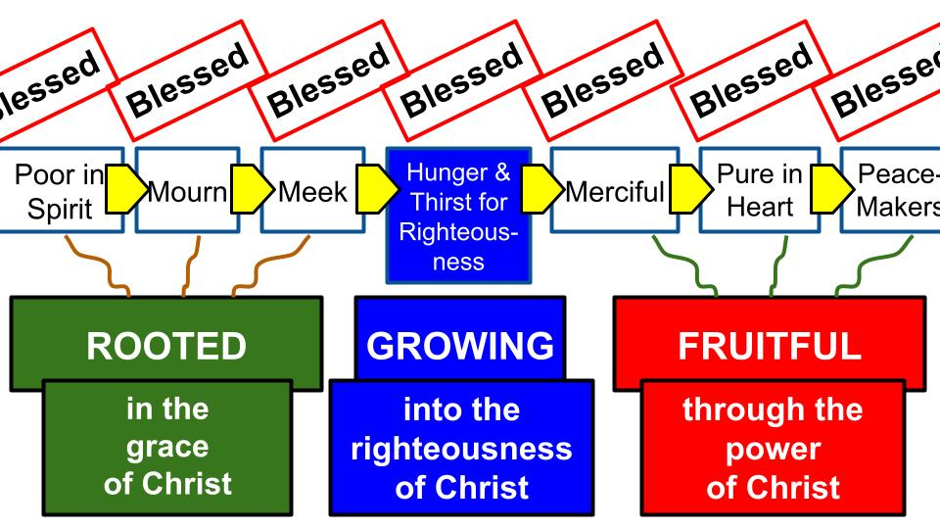
From being poor in spirit to being completely changed by Jesus into a peacemaker and agent of His Kingdom.

In these nine blessings, we see the ROOTS of faith in Jesus, the way to GROW more and more into the righteousness of Jesus and thereby bear FRUIT for Him and His Kingdom.

It turns out this three-part progression matches the structure of the whole sermon: the roots of faith, how to GROW in faith and the FRUIT of faith in Christ.
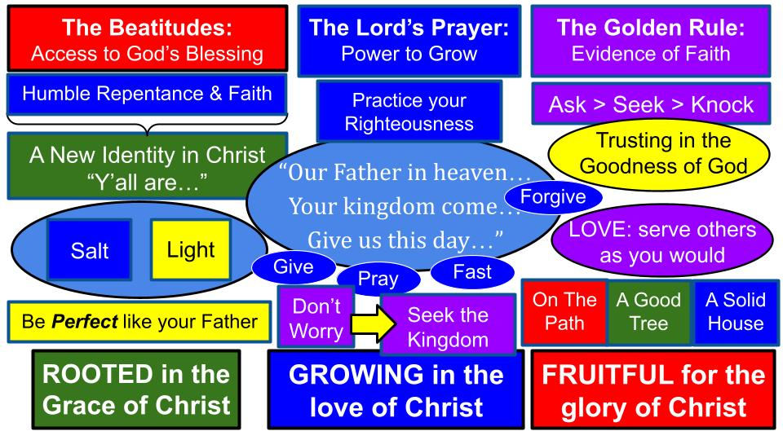
Matthew 5 introduces the roots of faith, starting with the beatitudes and going from there. Speaking to the crowd of would-be disciples, Jesus says, “Those of you who DO follow me, who do trust in me and become my disciples, will be completely transformed and will become the salt of the earth and the light of the world. On your own, you could never love your enemies or stand firm through terrible persecution; you could never be PERFECT as God is perfect. But you are NOT on your own. I am with you now,” Jesus said. “And that changes the whole game. The Kingdom of heaven has arrived, because the KING has come.”

So part one of the sermon shows us the roots of faith in a personal relationship with Jesus, trusting in Him and walking with Him. The second part then highlights the Lord’s Prayer as the first part highlights the beatitudes. Matthew 6 is the center of the Sermon on the Mount, and the feature of Matthew 6 is clearly the prayer the Lord taught us to pray. How can we pursue perfection? How can we practice our righteousness and avoid the hypocrisy of the Pharisees? The answer is right there in the first two words of the prayer: “OUR FATHER.” Only in a personal relationship with God the Father, through Jesus the Son. That is our only hope. That is the only way.

As those who are rooted in the grace of Christ, our calling is to grow in the love of Christ as we pray to our Father and walk with Him each day. Then we will increasingly hunger and thirst for righteousness and see more of His righteousness grow in us day by day. Jesus doesn’t tell us NOT to practice our righteousness, He just tells us not to do it in a fake way, just to impress people. He calls us to pray and give and fast and love and serve with authenticity, as for God alone, practicing these disciplines in secret, for the reward of our Father alone.

As we follow these principles and practice these disciplines our worries about this world will diminish as we learn to seek FIRST the kingdom of God and His righteousness. Our hearts will change because what we love MOST will change, for “where your treasure is, there your heart will be also.” How do we grow in Christ? By experiencing His love. Not just reading about it, but feeling it. Living in it. Abiding in His love and grace. Resting in His arms.

Then the Holy Spirit begins to produce His fruit in us and through us. We are rooted in grace, growing in love and fruitful for the glory of Christ. That is what the sermon on the mount presents and calls us to. It’s all a miracle of grace. It’s not at all something we could produce by our own effort. And the sermon ends to make sure this point is crystal clear: you are IN or OUT. There is no halfway. You either believe in Jesus and belong to His kingdom or you don’t. There is one small gate, and one narrow path – you must humbly crawl through the gate and walk the path while everyone else goes the other way. You can tell if someone belongs to Jesus and His kingdom by the FRUIT of their life. You are either a good tree that produces good fruit like love, joy, peace and patience or you are the other kind. And the sermon ends with a final, memorable illustration of two people building a house: one chooses a firm foundation that will stand through a storm, the other wants to have the best beach view, so doesn’t lay a foundation, but builds right on the sand. Jesus is the firm foundation: the only foundation. Is your life built on Him or something else?
- Are you rooted in His grace?
- Are you growing in His love?
- Are you bearing fruit for His glory?

What we will see in this part of Matthew 7 today is three KEYS to building Kingdom Community. Matthew 6 ended with the clear command to “Seek first the kingdom” and the Lord’s prayer started with the prayer of submission, “Your kingdom come, your will be done” leading to the request in the middle, “Give US this day OUR daily bread.”

“Our Father in heaven… your kingdom come…Give us this day our daily bread…” Matthew 6:9-11
“Seek first the kingdom of God and his righteousness.” Matthew 6:33

So we shouldn’t be surprised that the first key to building the kingdom is praying TOGETHER in faith. Our three keys to kingdom community come right from the familiar instruction of the Lord to “Ask, Seek and knock.”

How to Build Kingdom Community:
- Ask: Pray in Faith Together
“Ask, and it will be given to you; seek, and you will find; knock, and it will be opened to you.” Matthew 7:7

On the one hand, these are general truisms, like Proverbs. If you ask, a person might say yes. Like finding a girlfriend. If you have lost something, it might help to look for it. If you are interested in an opportunity, you should probably knock on that door, see if it opens. You could reverse all of them to say:
- If you don’t ask, people aren’t likely to read your mind and give you things. (That’s a good marriage principle if you aren’t married to someone who is fully omniscient.)
- If you don’t look for something you aren’t very likely to find it.
- If you don’t knock on some doors, you shouldn’t expect very many to open up for you.

There was a great cartoon a few years ago showing why men don’t find things in the fridge or the pantry. “Honey, can you grab me the baking soda?” “Yeah, I looked but I couldn’t find it.” The wife goes to the pantry and immediately finds the baking soda. How did the man look? He opened the door, scanned with his eyes once to the left, once to the right, then gave up. There is a principle here, “Seek and you will find.” Give up immediately and you are not going to find anything.

Now, let’s apply this to prayer. It’s a little bit like the lost, lazy guy in front of the pantry.
- What did I come here looking for? What is the purpose of baking soda? What even IS baking soda? No idea. Discard that search.
- What I see right here is Oreos. I know those are good. Will anyone see me if I snag a couple?
- I also see Doritos. Those are also good. Should I choose between the snacks? Should I go look for something healthier?
- Should I just drink some water and get back to doing dishes?

You close your eyes and bow your head to pray and it’s very similar, right?
- What did I come here for? There was something. Maybe several things… Family member? Friend? Was someone having surgery today? What is the purpose of prayer? What even IS prayer? No idea. Discard that search.
- I wonder if the Rays won. Don’t really care.
- Is the war in Iran over? What IS the price of gas? Maybe I should pray about that. Would it help? Might… Couldn’t hurt, right?
- Whoa. Did I just fall asleep a little bit? Maybe I need to take a little walk…

So, the first part of prayer is discerning and deciding what to ask for. This is why a model like the Lord’s Prayer is so helpful. It guides us as we begin. Let’s start with worship. “Our Father in heaven. Hallowed be your name.” Praise God for who He is. Thank Him for all he has done. That’s a good place to start. What should we ask for in prayer? Ask for God to be glorified. Start answering that prayer by praising Him yourself. Then what? “Your kingdom come. Your will be done.” Then we pray for HIS Kingdom. We’ll be back to that in just a minute. Listen to how Jesus goes on in verse 8.

How to Build Kingdom Community:
- Ask: Pray in Faith Together
“For everyone who asks receives, and the one who seeks finds, and to the one who knocks it will be opened.” Matthew 7:8

This is a remarkable statement! EVERYONE??? Now, Jesus has two chapters of teaching that precede this promise, so we can be sure the “everyone” means those who believe in Him, who trust in Him, who follow Him, in terms of prayers being answered. But the sentence is completely true in the proverbial sense anyway. If you ask for things, you are much more likely to get them, just as if you seek them or knock on the doors. In other words, whatever you go after is what you are likely to get. Are you going after the things of this world, or the things of God and His kingdom? Where are you storing up treasure? In heaven or on earth? Let’s turn over to John’s gospel for more insight on this point.

How to Build Kingdom Community:
- Ask: Pray in Faith Together
“Whatever you ask in my name, this I will do, that the Father may be glorified in the Son. If you ask me anything in my name, I will do it.” John 14:13-14

These are remarkable promises, just for disciples of Jesus. WHATEVER YOU ASK. IF YOU ASK ME ANYTHING. Yes, it must be in the Name of Jesus, meaning according to His purposes and for His glory. But still, these are broad categories of WHATEVER you ask and ask ANYTHING. Just a few verses later, Jesus makes this promise again:

How to Build Kingdom Community:
- Ask: Pray in Faith Together
“Whatever you ask of the Father in my name, he will give it to you. Until now you have asked nothing in my name. Ask, and you will receive, that your joy may be full.”
John 16:23-24

What a beautiful purpose of the Lord: “that your JOY may be full.” He invites us to join in His work not only to accomplish His purposes, but to increase our joy! And part of that is learning to ASK – to pray in faith. And let’s not forget the Lord’s prayer just one chapter ago. When we pray, we don’t just pray individually, we pray in faith TOGETHER:

How to Build Kingdom Community:
- Ask: Pray in Faith Together – trusting the Goodness of the Father
“Your kingdom come, your will be done… Give us this day our daily bread…”
Matthew 6:10-11

Yes, we trust our Father in heaven to take care of our individual needs, but we also pray together, asking for OUR daily bread – for our corporate needs, the shared needs of our church family.
So. What are YOU praying for right now? As you come before your Father in heaven and obey this command to ASK, knowing you will receive… what are you asking the Lord for?

As we pray, we pray in FAITH, trusting in the goodness of our God and Father. Jesus goes on in Matthew 7 comparing our prayers to God the Father to the requests of any child to his or her father.

- Ask: Pray in Faith Together – trusting the Goodness of the Father
“Which one of you, if his son asks him for bread, will give him a stone? Or if he asks for a fish, will give him a serpent? If you then, who are evil, know how to give good gifts to your children, how much more will your Father who is in heaven give good things to those who ask him!” Matthew 7:9-11

This is a simple argument from the lesser to the greater. If you normal humans can take care of your children, can’t you trust your heavenly Father to take care of you? But Jesus goes even further to say “You then, who are EVIL.” You foolish, selfish, worldly, short-sighted idolaters – you are still able to give your kids bread instead of stones, fish instead of snakes – HOW MUCH MORE will your heavenly Father give good things to His children when they ask.

How is your FAITH right now? Do you trust in the Lord with ALL of your HEART? Or do you find yourself DOUBTING the goodness and faithfulness of God? There are two clues here to help us as we pray. First, let’s remember to pray TOGETHER. We pray “Give US this day our daily bread.” We pray for one another and trust together.

And also let’s be sure to focus on the goodness of God: His faithfulness, wisdom, power, and love. That is how to build up our faith. Even when your situation is difficult, you can rest on the unchanging character of God. So that’s our first key to building kingdom community: pray in faith together. Here is the second key.

How to Build Kingdom Community:
- Seek: Pursue Spiritual Priorities Together
“For everyone who asks receives, and the one who seeks finds, and to the one who knocks it will be opened.” Matthew 7:8

Memorable progression today, using the Ask, Seek, Knock structure the Master Teacher gave us. First we ASK in faith. Then we SEEK the kingdom, pursuing spiritual priorities together. With that context, from Matthew 6:33, we can see why Jesus can make these bold promises and assurances that when you ask you will receive, when you seek you will find, when you knock it will be open.

- Seek: Pursue Spiritual Priorities Together
“But seek first the kingdom of God and his righteousness, and all these things will be added to you.” Matthew 6:33
“For everyone who asks receives, and the one who seeks finds…” Matthew 7:8

When we PRAY “Your Kingdom come” and set our hearts and minds and lives to seek His kingdom first: these promises are more likely to apply to us, as in John 14 and 16 where Jesus says, “greater things will you do,” when you pray in my name.

It’s important when we find promises like this in Scripture that we understand the CONTEXT of those promises. Matthew 7:8 is in the Sermon on the Mount: that is its context. You can’t yank it out of context and make it mean, “Name it and claim it.” “Just believe, and all your dreams come true.” That’s Disney nonsense, not Jesus’ teaching.

So, what does it mean to seek first His kingdom? What does it mean to seek so that we will find? Matthew 6 made it clear that the alternative to seeking His kingdom is worrying about the things of this world, and seeking to store up treasure here on earth. He warned specifically about the dangers of money. And he made it clear it’s all about our HEARTS. “Where your treasure is, there your heart will be also.”

Let’s allow Jesus to answer the question of what are the priorities of His kingdom, over in Matthew 25, at the Final Judgment.

- Seek: Pursue Spiritual Priorities Together
“For I was hungry and you gave me food, I was thirsty and you gave me drink, I was a stranger and you welcomed me, I was naked and you clothed me, I was sick and you visited me, I was in prison and you came to me.” Matthew 25:35-36

The poor, the hurting, the vulnerable, the exposed. These are the people Jesus served the whole time he went around in his public ministry. The outsiders. The beggars. The ignored. The unimportant. Outcasts.
- A Samaritan woman who had been married five times
- A demon-possessed man who was naked, living in a graveyard
- Blind men calling out for help
- A paralyzed man so desperate he was lying by a pool of bubbles
- A woman subject to bleeding who could not be in polite society
- Lepers living on the edge of town
- Fishermen; a tax collector; a zealot seeking revolution
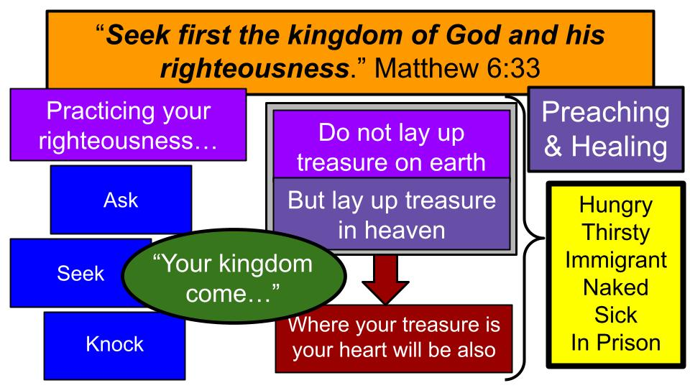
If we just follow the What Did Jesus Do? Principle, it comes down to those two words: preaching and healing. He proclaimed the kingdom and he healed people to demonstrate that what he taught was true. He fed the hungry. He offered himself to the thirsty. He visited Gentiles. He even talked with a Samaritan.

Based on James 1:27 we can safely add orphans and widows to the list. And based on the Great Commission we can be confident that bringing the gospel to the ends of the earth is important to kingdom ministry. In Luke 4 Jesus quoted Isaiah 61 to describe His mission:

- Seek: Pursue Spiritual Priorities Together
“The Spirit of the Lord God is upon me, because the Lord has anointed me to bring good news to the poor; he has sent me to bind up the brokenhearted, to proclaim liberty to the captives, and the opening of the prison to those who are bound; to proclaim the year of the Lord's favor…” Luke 4:18-19; from Isaiah 61:1-2a

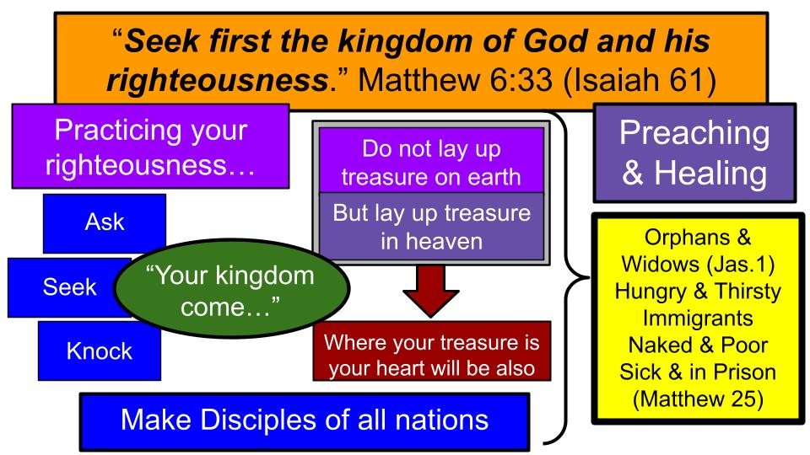
We can see how there is both a preaching side to this and a healing side. Good news must be proclaimed. Freedom must be declared in Christ to break the spiritual chains that bind people. But there are also literal prisons to be opened – literal slaves to set free – and physically sick people who need to be visited and cared for; literally poor people who need hope and help. So we can add to the list of spiritual priorities:
- Reaching the nations
- Making disciples
- Caring for orphans and widows
- Serving the hungry and thirsty
- Welcoming and helping immigrants and foreigners
- Clothing the unclothed and helping the poor and unhoused
- Taking care of the sick and visiting those in prison.

And those are just the ones specifically named in the ministry of Jesus. Obviously, there is room for a lot more ways to serve and build the kingdom. For example:
- Helping single mothers and women in a crisis pregnancy
- Fighting against human trafficking here in Tampa and around the world
- Supporting Bible translation for the remaining unreached people groups
- Coming alongside people who are grieving the many kinds of pains and losses we experience in this broken world

The question is: what does it look like for YOU to build the kingdom and seek first His righteousness? And don’t miss the principle of pursuing spiritual priorities TOGETHER.

- Seek: Pursue Spiritual Priorities Together - Discerning, Trying, Building, Multiplying
“But seek first the kingdom of God and his righteousness, and all these things will be added to you.” Matthew 6:33

These four steps to building kingdom ministry come from the Tampa Underground. Step one is to DISCERN what God is calling YOU to do. Pray. Listen. Study God’s Word. Discuss with others who are close to you.
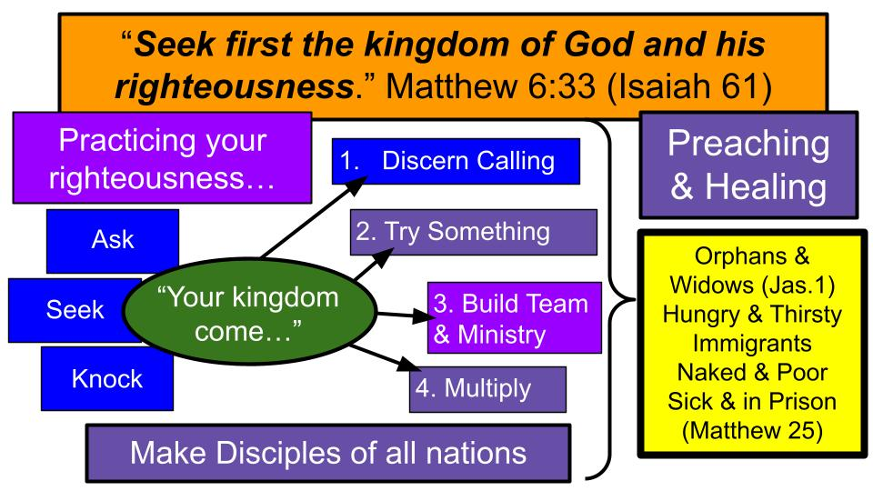
- From discernment, you move into stage 2, which is TRYING. You can’t expect to just snap your fingers and have a fruitful ministry rolling. You have to start by trying one thing. If that one thing doesn’t go perfectly it doesn’t mean to give up, it means to maybe try something else.
- Stage 3 is Building. Once you have tried and found something that works, you lean into it, building a team and expanding your ministry.
- And finally, Stage 4 is Multiplying – sharing what you have learned with others and sending out some of the disciples you have made to go launch their own ministries.
Bobby Stewart shares Tate Benjamin foundation?
ESL as example?

ESL is a great example of this for us here at Oakwood…

Whatever the ministry is, no matter how small it may seem at first, Jesus makes it clear where we should land:

How to Build Kingdom Community:
- Knock: Practice the Law of Love Together – placing the Preferences of others ahead of your own
“So in everything, do to others what you would have them do to you, for this sums up the Law and the Prophets.” Matthew 7:12, NIV

Ask. Seek. Knock. So simple, so memorable, but also so profound. Building ministry and community starts with prayer – asking God for guidance, power, and blessing. Then we seek – pursuing Kingdom priorities together. Finally, we KNOCK – meaning we knock down barriers between us and we knock down obstacles to kingdom ministry. How do we do this? With LOVE. “Love your enemies,” Jesus said back in Matthew 5.

Here is the Golden Rule. “Do to others as you would have them do to you.” Jesus didn’t come to abolish the Old Testament. No, He came to fulfill it. And THIS is what it looks like when the Law and Prophets are fulfilled. It looks like LOVE. It looks like SERVICE; humbly placing the preferences of others ahead of ourselves. In other words, it looks like JESUS.

Paul writes along the same lines in Philippians 2:

- Knock: Practice the Law of Love Together – placing the Preferences of others ahead of your own
“Do nothing from selfish ambition or conceit, but in humility count others more significant than yourselves. Let each of you look not only to his own interests, but also to the interests of others. Have this mind among yourselves, which is yours in Christ Jesus.” Philippians 2:3-5

The example of Jesus is our pattern for life and ministry. How He humbled Himself and lowered Himself as a servant and ultimately to the cross. That is our calling. The downward path to the cross. The path of self-humbling and of service to others. That is what we need to practice together. First within the church and also beyond the church.

How to Build Kingdom Community:
- Ask: Pray in Faith Together
- Seek: Pursue Spiritual Priorities Together
  - Discerning > Trying > Building > Multiplying
- Knock: Practice the Law of Love Together

What’s the next step for you this week? For all of us it should begin with prayer. Maybe grab a friend you know has some common interests and pray together.

Maybe you already have that friend in mind and it’s time to move through those stages of ministry development together. Discern God’s calling. Try something. Try something else. Build on the successes the Lord gives you.

Maybe some of you are already in a mature ministry, like one of our small groups or established ministries. Maybe for you the calling is to MULTIPLY. There could be someone who has been on your heart to invest in and share the ministry with. We encourage our group and ministry leaders to always be looking for an apprentice – someone to bring along to learn from you and to serve with you. Someone who can lead things when you’re away. Someone who can carry on the program without you.

For all of us, it has to come back to LOVE. That is how we knock down walls here in the church and out in the community and all over the world. Treat others the way YOU want to be treated. Who is on your heart to serve? Is there a hurting person near you? Someone who needs help?

Let’s pray and trust the Lord to lead us into His Kingdom opportunities!

