Be Secure
Matthew 7:24-29

Let’s look again at these words we just heard, the words that conclude Jesus’ kingdom manifesto – the Sermon on the Mount.

“Everyone then who hears these words of mine and does them will be like a wise man who built his house on the rock. And the rain fell, and the floods came, and the winds blew and beat on that house, but it did not fall, because it had been founded on the rock.” Matthew 7:24-25

“And everyone who hears these words of mine and does not do them will be like a foolish man who built his house on the sand. And the rain fell, and the floods came, and the winds blew and beat against that house, and it fell, and great was the fall of it.” Matthew 7:26-27

Two kinds of people. Wise and foolish. Storms hit both of them. One had prepared for the storms. The other had not prepared. One had built a sturdy house with a strong foundation. The other really wanted that oceanfront view, so they skipped over the need for a firm foundation and just built right on the sand.
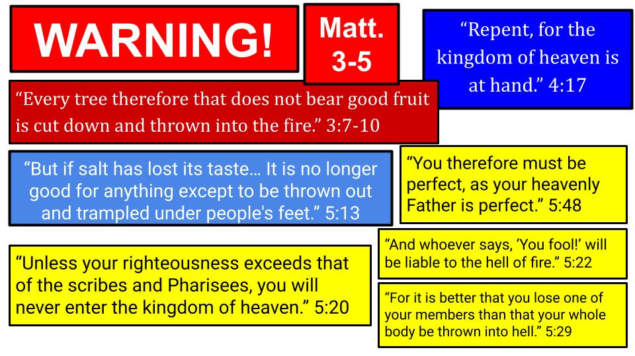
This is a serious warning for all who are paying attention to the Teacher. It’s like your math teacher has been preparing you for three weeks for what she says will be a very difficult test. The wise person will listen to this warning and pay close attention in class, do all the homework and prepare for the exam. The foolish person will ignore the instructions, pay no attention in class, not do the homework and not study at all for the exam. On the day the test occurs, who will be ready for it? Who will do better?

Notice back in Matthew 3 when John the Baptist started the public preaching in Matthew’s gospel with a strong call to repentance and a stern warning about good and bad trees. Jesus comes back to that analogy of trees getting chopped down in Matthew 7. So it’s not that John was having a bad day or being overly grumpy. He was a prophet declaring God’s Word. And Jesus picked up right where John left off, calling people to REPENT. To turn away from this dark and dying world and come, follow Him into a new kingdom, the kingdom of heaven.

The call from John the Baptist and from Jesus is to REPENT: to change your mind and turn around. To go a different way – the way of Jesus, the way of His kingdom.
- The alternative is to be like flavorless salt that gets trampled underfoot.
- To be like a diseased tree that gets chopped down and thrown into the fire.
- To have insufficient righteousness and not enter the kingdom.
- To be overcome by sin and thrown into the hell of fire.

So the call of Matthew 3-5 is to be perfect. To turn from this world and follow a different way, the way of Jesus, in order to escape the judgment coming on this world and to reach the kingdom of heaven: eternal life, the blessing of God. Then we get to Matthew 6, the heart of the SOTM.
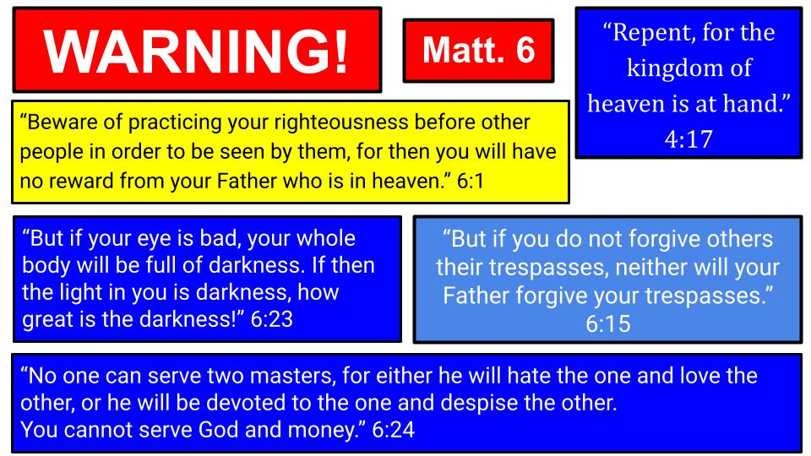
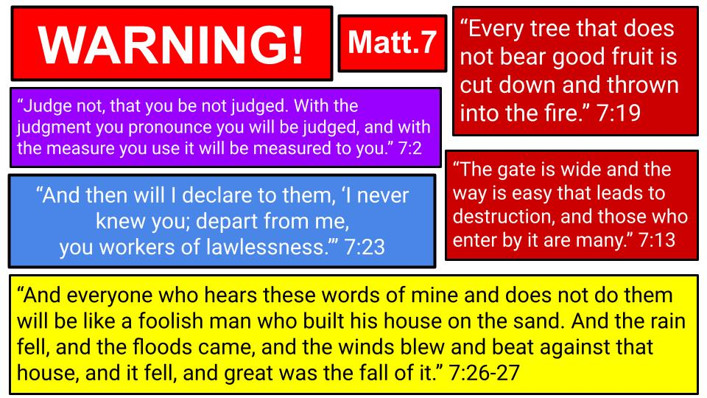
There is the warning about hypocrisy and the possibility of receiving no reward from God. The strongest warning in Matthew 6 has to do with forgiveness. If you don’t forgive others, it says, God will NOT forgive you. And it’s possible, if your eye is bad, to be filled with darkness; which sets up the warning about money being an idol for us that we must be extra careful not to worship or serve ahead of God.

Finally, Matthew 7. Here we find Jesus’ repetition of John the Baptist warning about being a bad tree that gets thrown into the fire. We hear about the danger of judging people and thereby establishing the standard by which we will be judged. Jesus talks about a wide gate and easy road that leads to destruction. Only a few will find the narrow gate and the harder path that leads to life. There is even a danger for those who appear to be followers of Jesus – preaching and healing and doing miracles in His name, but in the end, they will not enter heaven but will be rejected by Jesus, who will say, “I never knew you.”

Finally, the closing words of the whole sermon are about the wise and foolish builders. A serious and final dichotomy. Two kinds of people. For the wise, things work out fine even when the storms come. For the foolish, there is a terrifying destruction, and everything collapses. “Great is the fall” of that house.

Warnings in the Sermon on the Mount
Unsalty salt trampled | Not enter heaven | Thrown in hell
No reward from God | Filled w/ darkness | Not forgiven by God
Judged as you judge | Tree chopped down | “I never knew you”
Road to destruction | Great was its fall

No one can hear this message and think Jesus was pulling his punches. This is serious stuff. This is not just a math teacher; this is The Teacher. This is the Great Judge. This is the King of Kings giving people warning after warning.

And it’s not just here at the beginning of Matthew’s gospel. Look at the last major sermon from Jesus in Matthew over in chapter 25.
- First, there are ten young women waiting for the bridegroom on the wedding day. Five were ready for the big day, the other five were not and missed the party altogether.
- Then there’s a parable about three servants who are each given a significant amount of money. Two use the money wisely and are commended by their master. One chickened out, hid the money, and was sternly rebuked by the master.
- Finally, there is a dramatic description of the final judgment, when Jesus comes back in glory. It will be the end of the day when a shepherd separates the sheep from the goats. In other words, there will be an obvious distinction, just like good trees and bad trees; just like wise builders and foolish ones.

“Then he will say to those on his left, ‘Depart from me, you cursed, into the eternal fire prepared for the devil and his angels. ⁴² For I was hungry and you gave me no food, I was thirsty and you gave me no drink, ⁴³ I was a stranger and you did not welcome me, naked and you did not clothe me, sick and in prison and you did not visit me.’ …Then he will answer them, saying, ‘Truly, I say to you, as you did not do it to one of the least of these, you did not do it to me.’ ⁴⁶ And these will go away into eternal punishment, but the righteous into eternal life.” Matthew 25:41-46

So Matthew’s gospel frames the teaching ministry of Jesus with these serious warnings about heaven and hell; about the final judgment. Let’s turn back to Matthew 7 where we will take a closer look at the warnings and then look at how to know you are secure in a relationship with Jesus. First the warning, then the promise.

Everyone will face the same storms of judgment:
“And the rain fell, and the floods came, and the winds blew and beat on that house, but it did not fall, because it had been founded on the rock. And everyone who hears these words of mine and does not do them will be like a foolish man who built his house on the sand. And the rain fell, and the floods came, and the winds blew and beat against that house, and it fell, and great was the fall of it.” Matthew 7:25-27

Notice the repetition of the storm language: rain, floods, winds. Each house was hit with the same storm. The difference was not the house or the storm. The difference was the FOUNDATION. The wise man built his house on the rock. The foolish man built his house on sand. Jesus was very clear what makes the difference between one and the other.

“Everyone then who hears these words of mine and does them will be like a wise man who built his house on the rock… And everyone who hears these words of mine and does not do them will be like a foolish man who built his house on the sand. And the rain fell, and the floods came, and the winds blew and beat against that house, and it fell, and great was the fall of it.” Matthew 7:24-27

Both of these people heard the words of Jesus. One received the message and applied it. The other rejected the message and walked away unchanged. Are you a hearer and a DOER or a hearer who does not do?

Another way Jesus says this in Matthew 7 is referring to a tree and its fruit.

“You will recognize them by their fruits. Are grapes gathered from thornbushes, or figs from thistles? ¹⁷ So, every healthy tree bears good fruit, but the diseased tree bears bad fruit. ¹⁸ A healthy tree cannot bear bad fruit, nor can a diseased tree bear good fruit. ¹⁹ Every tree that does not bear good fruit is cut down and thrown into the fire. ²⁰ Thus you will recognize them by their fruits.” Matthew 7:16-20
If you’re like me, you may not be able to tell the difference between a blackberry bush and a raspberry bush until you get up really close. We used to go berry picking in western New York when I was young. I could tell where the berries were and was motivated to fill my basket because my aunt made some amazing cobbler. When the cobbler was done I could tell the difference between blackberry and raspberry but on the bush it was just the difference between, “It has berries” and it doesn’t. The bushes that didn’t have berries were useless to us, so we skipped over them and went on to the ones with berries.

Jesus said it’s like that with people. Some have good fruit like he describes in this sermon: they forgive, they pray, they are gracious, they are loving, they are patient. They prioritize the kingdom of God and aren’t all about the stuff of this world.

Jesus said to watch out for wolves who would sneak into the flock. The way to know who was a false teacher and who was dangerous was the FRUIT in their lives. Are they patient and understanding or are they critical and divisive? Do they have a healthy family, with a good marriage and kids who walk with the Lord? Do they humbly serve others or do they complain and look to be served? Even if they know the Bible really well, do their lives reflect the goodness and love of God? Are they growing more in Christlike character? Do they hunger and thirst for righteousness?

In the end, what matters most is your relationship with Jesus. The fruit in your life is one evidence of that relationship. But sometimes behaviors and even ministry involvement can be misleading.

“On that day many will say to me, ‘Lord, Lord, did we not prophesy in your name, and cast out demons in your name, and do many mighty works in your name?’ And then will I declare to them, ‘I never knew you; depart from me, you workers of lawlessness.’” Matthew 7:22-23

Aren’t you troubled by that word “MANY”? Lots of people, on the day of judgment, will be surprised by the verdict – or at least will ACT surprised. But notice the key point there in verse 23.

What matters most in the final judgment is your Relationship with Jesus
“And then will I declare to them, ‘I never knew you; depart from me, you workers of lawlessness.’” Matthew 7:22-23

Jesus comes back to this idea in Matthew 25, describing the final judgment.

What matters most in the final judgment is your Relationship with Jesus
“And when did we see you a stranger and welcome you, or naked and clothe you? And when did we see you sick or in prison and visit you?’ And the King will answer them, ‘Truly, I say to you, as you did it to one of the least of these my brothers, you did it to me.’” Matthew 25:28-40

If we preach the good news and minister to people to impress other people or even to feel better ourselves, it will not help in the final judgment. In the end it’s all about knowing, trusting, loving and serving JESUS. Do we live our lives for Him? Do we love others and serve them for HIM?

Those are the warnings. I wanted to follow the message of the SOTM and the words of Jesus to be sure we felt the warnings. Now let’s close with the promises, and how to be secure in the loving arms of the Lord Jesus. Listen to these words from the gospel of John.

How to be Secure in your Relationship with Jesus:
“I am the good shepherd. I know my own and my own know me, just as the Father knows me and I know the Father; and I lay down my life for the sheep. And I have other sheep that are not of this fold. I must bring them also, and they will listen to my voice.” John 10:14-16

Jesus wants His children to feel safe in His loving arms, as our Good Shepherd.

When you hear Jesus calling your name, you know it’s Him and you come to Him. Feel the force of verse 16, “They WILL listen to my voice.” Why? Because of verse 14: “I know my own and my own know me.” A shepherd in ancient times would call to his flock of sheep and they would come to his voice. He would lead them, as it says in Psalm 23, to green pastures and quiet waters. They didn’t drive sheep like cattle, with horses rounding them up or with metal pokers to jab at them. The shepherd simply walked ahead and called to the sheep.

Here are four signs that you are secure with Jesus. To keep it simple we will make it ABCD.

How to know you are Secure with Jesus:
(A)bandon your sinful ways
“Enter by the narrow gate. For the gate is wide and the way is easy that leads to destruction, and those who enter by it are many.” Matthew 7:13

The first essential step to a genuine and secure relationship with Jesus is to REPENT – to turn away from your selfishness and sin, recognizing that it was leading you to death and eternal destruction. It is good to ADMIT you are a sinner, but you need to go further than that – you need to abandon those sinful ways, truly turning away from your old path and your old life. Here’s how Jesus said it two chapters earlier, in Matthew 5.

(A)bandon your sinful ways
“If your right eye causes you to sin, tear it out and throw it away. For it is better that you lose one of your members than that your whole body be thrown into hell. And if your right hand causes you to sin, cut it off and throw it away. For it is better that you lose one of your members than that your whole body go into hell.” Matthew 5:29-30

This is from the righteousness section where Jesus said, “If your righteousness does not exceed that of the Pharisees you will never enter the kingdom of heaven.” then he closes that section with the command to “be perfect as your Father in heaven is perfect.” In order to be perfect, we must first repent, abandoning our old life and forsaking the selfishness and sin that went with it. Jesus said it like this later in Matthew:

(A)bandon your sinful ways
“Then Jesus told his disciples, ‘If anyone would come after me, let him deny himself and take up his cross and follow me. For whoever would save his life will lose it, but whoever loses his life for my sake will find it. For what will it profit a man if he gains the whole world and forfeits his soul?” Matthew 16:24-26

Take up your cross. A cross was not for comfort and relaxation, it was an instrument of execution. Jesus says to save your life you must lose it. Only by giving up your old life can you come into new life in a relationship with Jesus. Here is how Paul describes it in Romans 6, which we looked at last week with our baptism service.

(A)bandon your sinful ways
“We were buried therefore with him by baptism into death, in order that, just as Christ was raised from the dead by the glory of the Father, we too might walk in newness of life.” Romans 6:4
We practice baptism by full immersion in water because it symbolizes death and burial. Your old life is crucified with Jesus, and you are born again, rising from the dead with Jesus to walk in a new life with Him. So that is step one to a secure relationship with Jesus. Can you remember a time you made a full and clean break with your old life? When you saw that your path was leading you to destruction and you abandoned that path to follow Jesus? Repentance and faith are two sides of the same coin. So that is the second critical step to security in Christ.

How to know you are Secure with Jesus:
(B)elieve in Jesus as your Savior
“Everyone then who hears these words of mine and does them will be like a wise man who built his house on the rock.” Matthew 7:24

Jesus Himself is the firm foundation. To hear and do is to receive His message and believe in Him. This becomes very clear in Matthew 13 with the parable of the sower.

How to know you are Secure with Jesus:
(B)elieve in Jesus as your Savior
“As for what was sown on good soil, this is the one who hears the word and understands it.” Matthew 13:23

The three types of bad soil don’t receive the message of the gospel, or don’t receive it sincerely. But the good soil is distinct from the rocky soil, the shallow soil and the thorny ground by the fact that the good soil person hears and understands the message, receiving Jesus and His Word into their heart. The apostle Peter quotes the prophet Joel with this simple summary of the gospel:

How to know you are Secure with Jesus:
(B)elieve in Jesus as your Savior
“And it shall come to pass that everyone who calls upon the name of the Lord shall be saved.” Acts 2:21, quoting Joel 2:32

Simply to call on Jesus’ name – just to cry out to Him, “Have mercy on me, a sinner,” is how to start a saving relationship with Him. It must first have repentance, turning away from your own path and asking Him for a new life. This is what it looks like to be “poor in spirit” – you recognize the path you are on is sinful and will only lead to death, and that you can’t change on your own. So the key steps to a secure relationship with Jesus are A - Abandon your old life of sin; B - believe in Jesus as your Savior; and C.

How to know you are Secure with Jesus:
(C)ommit to Jesus as your Lord
“Everyone then who hears these words of mine and does them will be like a wise man who built his house on the rock.” Matthew 7:24

To hear the words of Jesus and receive them with understanding and faith is the BELIEVE side of salvation. The other side is to COMMIT to Jesus as Lord of your life. And the sign of that life change is to OBEY His words; to truly follow Him and put His teachings into practice. Paul sums it up beautifully in Romans 10.

(C)ommit to Jesus as your Lord
“Because, if you confess with your mouth that Jesus is Lord and believe in your heart that God raised him from the dead, you will be saved.” Romans 10:9

Notice the two sides to saving faith. Confess that Jesus is Lord and Believe in Him as Savior. Believe that He died for you and rose again, while openly confessing Him as THE Lord and as YOUR Lord.

(C)ommit to Jesus as your Lord
“For with the heart one believes and is justified, and with the mouth one confesses and is saved.” Romans 10:10

It’s not about saying any magic words, it’s about believing sincerely in your heart – in your spiritual inner person. Do you see how these steps are all connected with one another? Abandon your sin; Believe in Jesus as Savior; Commit to Jesus as your Lord. The final step is really a result of the first three, but if you don’t see it happening you would be wise to wonder if you really took the first three steps.

How to know you are Secure with Jesus:
(D)evelop the fruit of Christlike character
“You will recognize them by their fruits. Are grapes gathered from thornbushes, or figs from thistles? So, every healthy tree bears good fruit, but the diseased tree bears bad fruit.” Matthew 5:16-17

How can you tell if you are saved or if anyone else has a real relationship with Jesus? Since we can’t see into a person’s heart, we can only look for FRUIT. Is there evidence of a change of heart and life? Jesus said it this way in John 15.

(D)evelop the fruit of Christlike character
“Abide in me, and I in you. As the branch cannot bear fruit by itself, unless it abides in the vine, neither can you, unless you abide in me. I am the vine; you are the branches. Whoever abides in me and I in him, he it is that bears much fruit, for apart from me you can do nothing.” John 15:4-5

No one can make the fruit of the Spirit grow in their lives. Only God can produce the fruit. Jesus is the vine, we are just the branches. But when we abide in Christ, the fruit will come. When we walk in the fullness of the Holy Spirit, He will produce His fruit of love, joy, peace and patience in our lives. So here are the steps and signs of a true relationship with Jesus:

How to know you are Secure with Jesus:
- (A)bandon your sinful ways  - (B)elieve in Jesus as your Savior  - (C)ommit to Jesus as your Lord  - (D)evelop the fruit of Christlike character | “I write these things to you who believe in the name of the Son of God, that you may know that you have eternal life.” 1 Jn. 5:13

God does not want His children to be nervous or fearful about whether we belong to Him and whether we will live forever with Him in His kingdom. His perfect love drives out that kind of fear. The Bible is full of promises of salvation for all who trust in Jesus and follow Him. The only condition for secure salvation is real trust in Jesus. “By grace you have been saved, through faith.” Faith alone. Christ alone. One more verse from John’s gospel.

“Very truly I tell you, whoever hears my word and believes him who sent me has eternal life and will not be judged but has crossed over from death to life.” John 5:24, NIV

The only condition for having eternal life is BELIEVING in Jesus. Yes, to believe you must hear the message of the gospel and receive it with faith. But that faith in Jesus is what saves you. Nothing more. Look at the assurance in this simple, wonderful verse.

As soon as you hear and believe, you HAVE eternal life. Right at that moment. Those verbs are all present tense. Right away. In the future, you WILL NOT be judged. And the reason you have eternal life now and will not be judged in the future is because you have crossed over from death to life. You have left the path to destruction and entered the narrow way that leads to life.

So do you have the assurance and security that you belong to Jesus? That you know Him in a real personal relationship? One more beautiful verse on assurance:

“For you did not receive the spirit of slavery to fall back into fear, but you have received the Spirit of adoption as sons, by whom we cry, ‘Abba! Father!’ The Spirit himself bears witness with our spirit that we are children of God.” Romans 8:15-16

If you have called on the name of Jesus to save you, then you have been born again in Him and adopted into God’s family as His child forever. The Holy Spirit gives you this deep and personal assurance in your soul that you are God’s child. So you shouldn’t struggle with fear about knowing Jesus and being known by Him. If you don’t have this assurance, then you should meet with a trusted Christian friend and talk about it this week. Go over the steps we have covered today and the Bible verses with each one. Pray together for that deep and abiding security that comes from a secure relationship with Jesus.

Let’s pray together, then we will sing about our Good Shepherd who promises to hold us securely in His mighty hand.

